# Table of Contents

Abstract

1. Introduction
2. Motivation + Literature Review
3. Method
4. Case Study
5. Conclusion

Bibliography

Appendix

Table of Contents

Table of Contents 0

Abstract 2

1. Introduction 3

1.1 The Problem 3

1.2 Project Aim 4

The Business Model Canvas 4

GDPR First Step 4

Privacy By Design 5

1.3 Readers Guide 5

Chapter 1: Introduction 5

Chapter 2: Motivation and Background 5

Chapter 3: Method/Design 5

Chapter 4: Research and Evaluation 5

Chapter 5: Conclusion 6

2. Motivation and Background 7

2.1 Surveying the field 7

Bibliography 8

# Abstract

Hello my name is Maurice and I am writing this test paragraph to experiment with different formatting types. This includes the size of the font I wish to use and how big the spacing will be between lines and possibly paragraphs.

Data privacy is an issue of growing importance. Data creation and collection has increased drastically in the past decade

# 1. Introduction

## 1.1 The Problem

In the twenty-first century, privacy and data protection has become a huge part of every day life, particularly in the working world where businesses must uphold strict policy’s and laws to protect themselves and their customers from data breaches. Failure to meet these privacy demands can result in huge fines and sanctions that can have a lasting effect on any business, large or small. The importance of adhering to data protection laws has increased dramatically with the introduction of the General Data Protection Regulation (GDPR) on the 25th of May 2018.

GDPR directly concerns all organisations within EU member states and any non-EU member state organisation that handles information to do with EU citizens. It imposes strict new rules regarding the collection, storage and use of personal data belonging to EU citizens in which failure to comply with these rules can result in huge fines to businesses or organisations. Prior to GDPR fines of up to £500,000 could have been issued depending on the severity of the breach but with the introduction of the new regulation, fines can reach as much as 4% of annual global turnover or £20 million, with the fine being the larger of the two options (ITG, 2019).

Due to these new strict regulations and even stricter punishments, it is abundantly clear to any organisation or business that privacy and data protection is now an essential part of running any company. Businesses since the announcement and introduction of GDPR have been on catchup trying to change the operation of their business to now comply with GDPR which has imposed a huge cost due to the restructuring, redesign and change of policy, not to mention the cost of the mandatory training of staff. To avoid such heavy costs and problems later in a business’s lifecycle, privacy and data protection must now be treated as an integral part of any business or project during the early innovation stages. Privacy by design should be a fundamental rule when starting any business and therefore privacy and data protection should be considered as the business model and plan is being created.

The problem most unexperienced entrepreneurs and the majority of the general population have is that they don’t understand GDPR and don’t know where to begin in attempting to prepare themselves for its implications. There needs to be a first step to GDPR compliance that starts the discussion within a business that helps prepare them to meet these new obligations and protect themselves by incorporating privacy by design into their business model.

## 1.2 Project Aim

This project aims to address these privacy and data protection issues businesses have in three main ways; provide an easy to use iterative tool like the Business Model canvas which addresses privacy concerns to be used alongside the Business Model Canvas, create a tool suitable to be the first step towards GDPR compliance, and by effectively putting privacy by design into practice early on in the business innovation stage.

### The Business Model Canvas

The Business Model Canvas (Osterwalder & Pigneur, 2010) is an easy to use tool that helps a group or person create an early model of their business during the innovation stage. The Business Model Canvas is highly practical due to its simplistic nature and how it creates a visual representation of their business that can be iterated over time after pivot points in the business’s development. Visually representing information like this is very effective for any group as it creates a brainstorming atmosphere and opens the discussion within the group for possible changes and improvements. The Business Model Canvas has become very successful and popular within the business world and has been adopted by many.

This project intends to address the privacy and data protection concerns a business may face during early innovation stage by following the lead of the Ethics Canvas (Lewis, Reijers, & Pandit, 2018 ), a canvas similar to the Business Model Canvas which addresses ethical issues, by redesigning the Business Model Canvas to address privacy and data protection concerns. It is intended to take advantage of the popularity of the Business Model Canvas and create a canvas to be developed with the BMC which will open the discussion on privacy within a new business or project and be the first step to GDPR compliance. This project will evaluate its use alongside the Business Model Canvas.

### GDPR First Step

General level of knowledge of everything GDPR including compliance and its consequences is extremely low in early innovators particularly innovators leaving or just left college. My aim is to create a canvas tool that requires no previous knowledge of GDPR and introduces all the main concepts and compliance regulations in an easy to use and painless manner. It is my hope that the Privacy Canvas could be the first stepping stone for people trying to learn about GDPR by opening the thought process on privacy and data protection and as it will present it in a far less daunting way than other GDPR introductions. The Privacy Canvas could also be a pre cursor to a “Data Protection Impact Assessment”(DPIA) which is designed for more established businesses that hold highly sensitive data and not suitable to any business or organisation during the early innovation stage.

### Privacy By Design

Privacy by design involves incorporating privacy and data protection into every step a business or organisation makes. It is a very important part of GDPR, and it can be described as “Organisations must implement technical and organisational measures to show that they have considered and integrated data compliance measures into their data processing activities.” (Boardman, Mullock and Mole, 2017).

Businesses who follow the principles of privacy by design by always considering privacy and data protection implications during every action they make are far better prepared to meet GDPR obligations and therefore are protecting themselves in the long run. By incorporating the Privacy Canvas into the early stages of the innovation process and continually iterating it as the business develops, I believe the business will be putting privacy by design into practice and effectively demonstrating compliance which is a principle of GDPR.

## 1.3 Readers Guide

The layout of this report is as follows:

### Chapter 1: Introduction

Chapter 1 has introduced this project by briefly stating the problem and how it can be addressed.

### Chapter 2: Motivation and Background

This Chapter covers the background research that went into this project including analysing the field, similar problems and solutions and my critique of the field that covers privacy and data protection.

### Chapter 3: Method/Design

This chapter covers the various requirements that the Privacy Canvas has as well as the thought process behind my design. It will also cover the technical implementation and the issues I faced.

### Chapter 4: Research and Evaluation

This chapter will cover everything to do with my research and evaluation including my testing process, ethical approval and results.

### Chapter 5: Conclusion

This chapter will summarise my project and cover my personal evaluation, learnings and close with closing remarks and future work.

# 2. Motivation and Background

This Chapter covers the background research that went into this project including analysing the field, similar problems and solutions, and my critique of the field that covers privacy and data protection.

## 2.1 Surveying the field

Todays online world has pushed the issue of privacy and data protection to the forefront which has therefore led to the mass creation of various online tools or compliance checkers. A quick google of “GDPR compliance” will show a plethora of these so-called privacy enhancing tools (PETs) that do little else than take advantage of this sprawling new market by charging subscriptions or memberships. Most of these compliance checkers are like a Data Protection Impact Assessment (DPIA) that test your level of compliance and give you a score rather than being a tool that helps you implement privacy by design by demonstrating compliance over time. It is also clear that the current available tools don’t necessarily help organisations address privacy and data protection concerns during the early innovation stage. They are more suited to established business’ with greater GDPR needs and therefore have bigger GDPR implications. They also have far more knowledge and experience of GDPR because of this. There needs to be a tool suitable for the un-informed population when it comes to GDPR and provide a suitable first step towards understanding GDPR and being GDPR compliant.

It is my opinion that there is a gap in the market for tools that help implement privacy by design. The General Data Protection Regulation puts enough emphasis on the importance of privacy by design that it should be considered a necessity in all modern businesses and that should be reflected in the availability of privacy by design enhancing tools. The European Union Agency for Network and information Security (ENISA) defined a fascinating control matrix for evaluating privacy enhancing tools (PETs) in their report “PETs controls matrix - A systematic approach for assessing online and mobile privacy tools” (D'Acquisto et al., 2016). In this report they state that the assessment of privacy by design is a core focus of their control matrix even though there is not a specific assessment criterion. Instead they analyse how the numerous GDPR principles are put into action like accuracy, purpose limitations and transparency to name but a few. This has greatly impacted my thought process on how to best tackle privacy by design and has therefore had a huge influence on the design of the Privacy Canvas by focusing a great deal on the GDPR/privacy by design principles.

## 2.2 Similar Problems

### The Ethics Canvas

The Ethics Canvas (Lewis, Reijers, & Pandit, 2018) is a tool in which this project heavily analysed and studied due to the numerous similarities between the two projects. The Ethics Canvas is a canvas type tool which has also been based on the Business Model Canvas to tackle ethical concerns in the world of research and innovation of technology in a cooperative manner. It was developed here at Trinity College Dublin in the Adapt centre for digital content technology.

The Ethics Canvas like the BMC is divided into nine specific blocks. Unlike the BMC, they tackle ethical concerns and have been subdivided further into four main groups enhancing the way the canvas is completed. Blocks one and two identify relevant stakeholders. Blocks three to six consider the ethical implications on the previously identified stakeholders where as blocks seven and eight consider the ethical impacts that are not stakeholder specific. The last block, nine, was a place where users of the Ethics Canvas could consider how to overcome these discussed ethical implications. These four groups of blocks together made up the canvas (Lewis, Reijers, & Pandit, 2018). This projects author found this design methodology very interesting and noticed how it enhanced the flow of the canvas when it would be created its users. The author took huge inspiration in the design methodology and transferred the thought process behind to the Privacy Canvas where possible.

The evaluation of the Ethics Canvas conducted by the Ethics Canvas team also offered motivation to this project as their findings regarding the usefulness of the canvas and the effect the canvas had, in terms of impact on design or business model, was positive. The outcome of these findings gave this author confidence that a similar canvas that targets privacy and data protection concerns, the Privacy Canvas, would be effective.

**Figure 1: The Ethics Canvas**

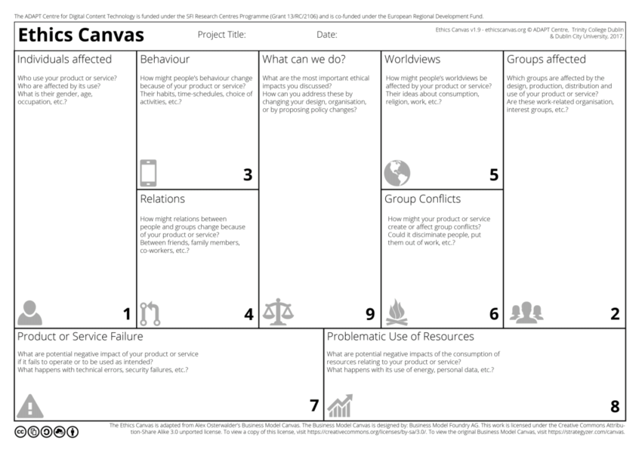

## 2.2 Critique Of Field

dkjcbhbd

# Bibliography

PETs controls matrix - A systematic approach for assessing online and mobile privacy tools. (2019). [online] Available at: https://www.enisa.europa.eu/publications/pets-controls-matrix/pets-controls-matrix-a-systematic-approach-for-assessing-online-and-mobile-privacy-tools [Accessed 28 Mar. 2019].

Itgovernance.co.uk. (2019). *GDPR Penalties and Fines | IT Governance UK*. [online] Available at: https://www.itgovernance.co.uk/dpa-and-gdpr-penalties [Accessed 28 Mar. 2019].

Osterwalder, A., & Pigneur, Y. (2010). Business Model Generation. Hoboken, NJ: Wiley.

Lewis, D., Reijers, W., & Pandit, H. (2018 ). Discussing Ethical Impacts in Research and Innovation: The Ethics Canvas. IFIP TC9 Human Choice and Computers Conference (in press).

Boardman, R., Mullock, J. and Mole, A. (2017). [online] Twobirds.com. Available at: https://www.twobirds.com/~/media/pdfs/gdpr-pdfs/bird--bird--guide-to-the-general-data-protection-regulation.pdf?la=en [Accessed 30 Mar. 2019].

D'Acquisto, G., Domingo-Ferrer, J., Kikiras, P., Torra, V., de Montjoye, Y. and Bourka, A. (2016). Privacy by design in big data: An overview of privacy enhancing technologies in the era of big data analytics. *ENISA*. [online] Available at: https://www.enisa.europa.eu/publications/pets-controls-matrix/pets-controls-matrix-a-systematic-approach-for-assessing-online-and-mobile-privacy-tools [Accessed 1 Apr. 2019].

Ethicscanvas.org. (2017). *The Ethics Canvas*. [online] Available at: https://www.ethicscanvas.org/ [Accessed 4 Apr. 2019].