Loader – until the chart data is obtained via an HTTP Request.

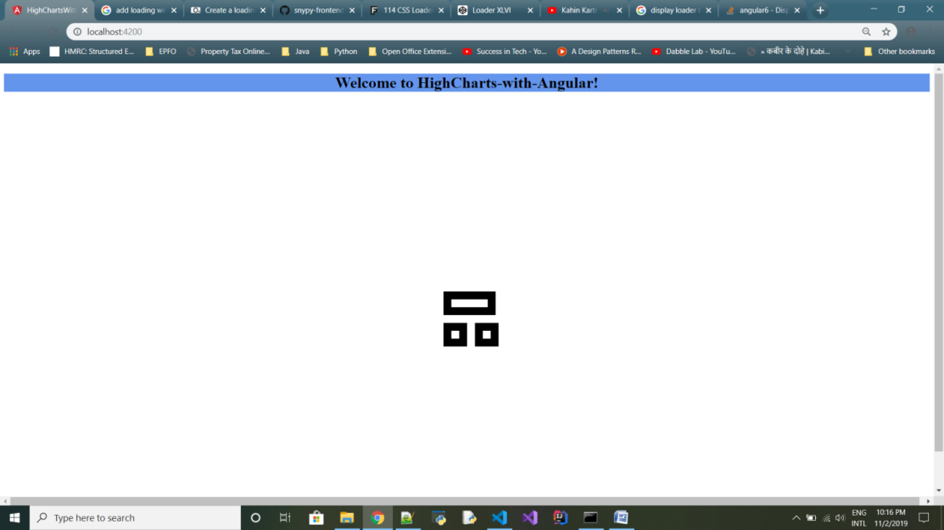

Series 1 (in green) of 2-series data in HighCharts – integrated in Angular project.

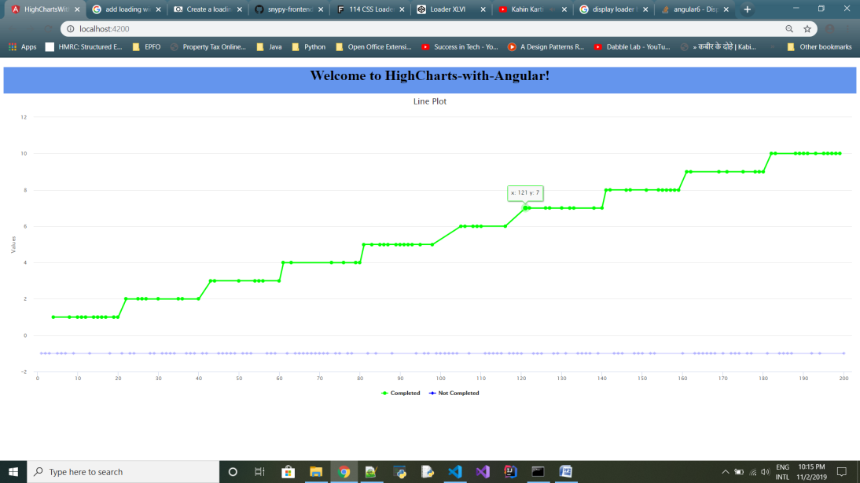

Series 2 (in blue) of 2-series data.