Name:Buda Ioana-Daniela

Lab assistant: Radu Tufisi

Documentatie

Assignment 1 Software Design

***1.Project description***

The goal of this application is the implementation of system for tracking the administrator and regular user activity of a virtual city hall. The activities correspond to requesting documents from the city hall and managing those requests.

***2.ER Diagram***

The diagram represents entity relations in the database “Primarie”.

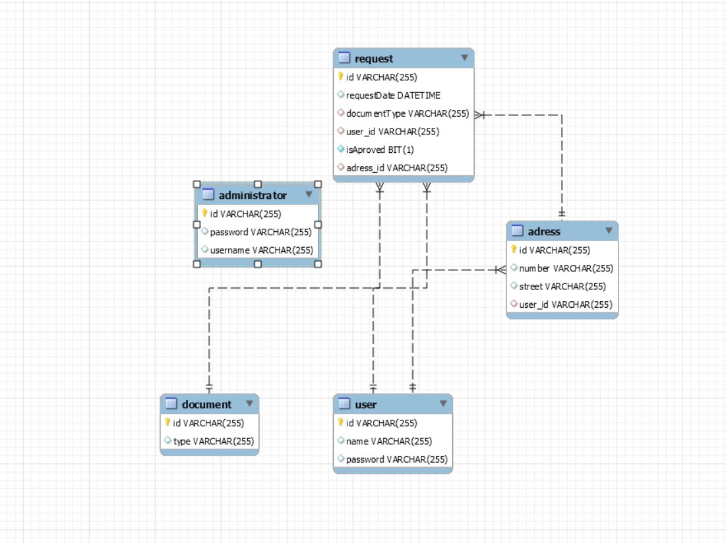

3.Application Architecture

As requested by the homework ‘s specification the architectural pattern used is based on Layers : Repository ,Service and Controller .Related to the MVC design pattern I have also included the Controller in the presentation package together with the view.

The Repository packages contains all the entity classes related operations with the database such as Insert , Delete ,Find ,Update and other operation that require SQL statements . The entity package contains the actual entity (table) classes with the field names and relations generated using JPA.

The service package is an intermediate layer between Presentation and Repository .Also here is where I have performed sorting and filtering of data from Repository.

The presentation package ,as metioned above contains both the views representing the GUI and also the controllers for the main actions of the system users (user and administrator).

The controllers role is to transfer the data between layer and GUI views for managing specific tasks ( Services ,validators, entities and views).