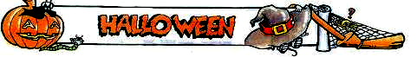

How much do you know about Halloween? Read the text and write the number of a word next to the correct picture. Which words are missing?
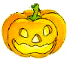
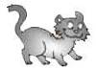
Halloween is celebrated on the last day of October (the 31st).
To celebrate Halloween, children often dress up as ¹witches, ²ghosts and ³mummies, or famous people such as Superman and Spiderman.
One popular Halloween activity is “trick-or treating”. Children dress up in their ⁴costumes, then go to people’s houses. They knock on the door and say “trick or treat?” This means, give us a treat (usually some ⁵sweets), or we’ll play a trick on you. Most people give the sweets.
American teenagers often celebrate Halloween with a costume party. They may also watch horror movies, listen to music or tell each other ghost stories. Visiting ⁶haunted houses and ⁷graves are also popular activities.
One of the most important Halloween symbols is the ⁸“Jack O’Lantern”. This is a ⁹pumpkin that has been cut to form a face. A candle is often placed inside it and people put the lantern in the front windows of houses.
The most common Halloween food is the “toffee apple” (also known as the “candy apple”). This is basically an apple that has been covered in sticky sugar syrup.
Did you know that there really are so-called ¹⁰vampire bats? They live in Central and South America, and feed on the blood of cattle, horses and birds.



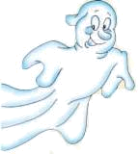
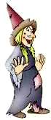

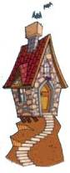

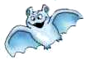

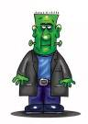

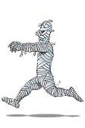
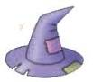
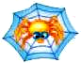
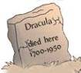
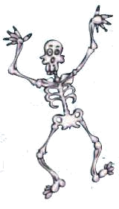

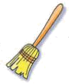
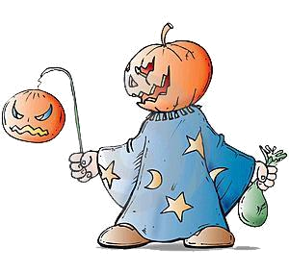
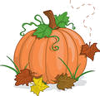
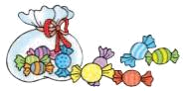

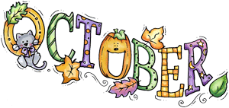
Complete the puzzle. 1
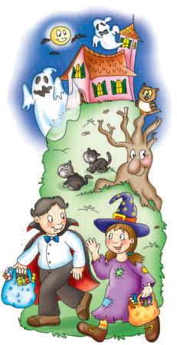
⁹ ⁴
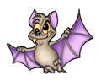
2

¹¹ ⁶ 3

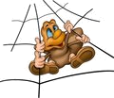
¹⁰ ⁷ ¹ ³
4
5

⁸ 6
⁵

7
¹³ ²
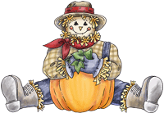
8
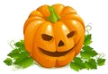
¹² 11 9 10

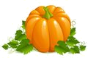
12

13
Read the poem and complete it with the following words.
costumes, brooms, Halloween, moon, hats, scarecrow, black cats, pumpkin, sweets

Halloween is a spooky night.
The …………………… is full and shines so bright.
Children in …………………… of all shapes and sizes
Walk through the streets wearing different disguises.
Each creepy critter searches for ……………………,
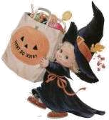
Knocking on doors calling, “Trick or Treat!”
Some wear dresses
And some wear ……………………,
Some bring their teddies
And some bring …………………….
Some ride on ……………………
While others float by,
Some walk together
And some try to fly.
There’s so much to do on this fun holiday,
Like stuffing a …………………… with straw and with hay,
Bobbing for apples until someone wins,
Carving your …………………… with big scary grins,
Joining some friends for a quick game of tag,
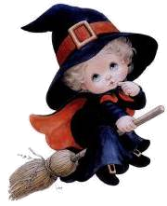
And sharing the sweets in your big goodie bag.
With their bags filled with candy,
All the critters that creep
Find some place cozy
And fall fast asleep.
Happy ……………………!

