Written by Sebuda and Derroylo

Index:
1 Instruction to and Installation of the Bot. 4
1.1 What is Budabot? 4
1.2 Version History 4
1.3 Some Basic Informations about the Bot itself 4
1.4 How to start? 4
1.5 How to change the basic settings of the bot? 5
1.6 How to enable/disable commands, events or complete modules and changing their access level? 7
1.7 How to setup the adminlist? 9
1.8 How to use the banlist? 9
1.9 Chatrelay between two guilds 10
2 List of Commands 10
2.1 Info 10
2.2 Online Commands 10
2.3 Timer commands 11
2.4 Citycloak commands 11
2.5 Bio-Material commands 12
2.6 Guildrelay 12
2.7 Raid commands 12
2.8 Guestchannel commands 13
2.9 Alternative Char commands 13
2.10 Logon Message 14
2.11 Loot commands 14
2.12 Bio Regrowth and Guardian commands 14
2.13 Items commands 15
2.14 Pocketboss and Symbiants 15
2.15 Team Commands 15
2.16 Tower commands 16
3 Developer Informations 17
3.1 Introduction 17
3.2 Filestructure of the bot 17
3.3 Structure for your own modules 17
3.4 Functions of the bot core 18
3.4.1 Create a blob, chatcmd or an itemlink 18
3.4.2 Send a message 18
3.4.3 Registering of commands 19
3.4.4 Registering of Events 21
3.4.5 Register a group of commands 21
3.4.6 Settings 22
3.4.7 Helpfiles 23
3.5 Variables of the botcore 24
3.5.1 Guildmembers 24
3.5.2 Admins 24
3.5.3 Vars 24
3.5.4 Settings of the bot 24
3.5.5 Sender 24
3.5.6 Chatlist 24
3.5.7 Buddylist 24
3.5.8 Type of the message 25

Picture Index:
Figure 1: Settings 5
Figure 2: Symbol Settings 6
Figure 3: Default tell color setting 6
Figure 4: Commando and Event config 7
Figure 5: Commands and Events on config 7
Figure 6: Config of the topic command 8
Figure 7: Config of the online group 8
Figure 8: Config of the online command 9
Figure 9: Adminlist 9
Figure 10: Banlist 10
Figure 11: My first module 17

Instruction to and Installation of the Bot

What is Budabot?
Budabot is an Anarchy Online Chatbot which offers many features to help to manage your guild and also your raids. This guide is meant as a help into your first steps with this bot and isn’t meant to be a full list of all features of this bot since those can change by custom modules of other users. To see a full list of features you should check the in game help files of this bot. To look at them do “/tell botname help”. If you can’t find what you need we are there to help you out. Please don’t send us in game tells, since we want to just play from times to times too☺. You can reach us always over our project Homepage (http://sourceforge.net/projects/budabot), our Forum (http://budabot.sourceforge.net) or the Hackersquest Forum (www.hackersquest.com).

We are hoping that you enjoy this bot since we have spent a lot of time to make it easy usable for everyone.
Greetings Derroylo and Sebuda

Version History
Version 0.5
- First Developer release
Version 0.6
- Second Developer release(see patchnotes.txt for more details)

Some Basic Information about the Bot itself
Coder: Sebuda
Derroylo
Programming Language: PHP5
Operating Systems: Windows (from Version ME)
Unix System (not tested yet but works theoretically too)
Database Systems: MySQL
SQLite

How to start?
As first step you need to have a character, on which the bot should run later and if you want to use this bot as a guildbot or as an orgraidbot you need to invite that character in your guild. As rank he will need at least “Squad Commander” to be able to shows the Tower Attacks.

To start the bot simple click on the chatbot.bat. As you are first using this bot, you need to fill out some information about your Account and more, which will be explained at the given time.

The first questions that are appearing are according to your Account. These are your Account name, Password, dimension and the Character you want to use. Please be aware that you need to care about upper and lower cases. In the next step you will be asked for the Administrator of this bot. This user will be the one that has access to all commands of this bot.

If you are running the bot in your org you need to enter your Guild name in the next step, when you don’t enter it the bot will not be able to get the Members of your org.

In the next setup parts you will be asked if you want to put other bots on ignore. This means if you are running other bots in your org you should enter the name of this bot here, otherwise it can happen that both bots can end in an endless loop sending each other “Unknown Command or access denied”. When you want more then one bot on the ignore list you will need to separate them with a Semicolon.

Now we are coming to the Database settings. Answer here with “no” when you don’t want to use your own setup for the Database. As short explanation the Database is the place where the bot saves for example you’re Guild Members and many more things that are needed for the bot to run.

On the last step you will be asked if you want to enable all Modules by default. These Modules are holding all commands that are provided by the bot. When you enter yes the bot will start with all commands and events enable if no they will be disabled. You can disable or enable the commands later too in game, how to do that will be explained on a later place.

When all was entered correctly the bot should start and will appear online after he logged in.

You can renter the setup every time with deleting the “delete me for new setup” file.

After the bot has started you will notice that the bot is creating a org roster list (when the bot is an member of the org and you have entered in the setup part the name of your guild). This process is needed to get an actual list of the members of the org. After the bot is done with this step, he will automatically restart.

How to change the basic settings of the bot?
After the bot is started up you may want to customize the bot settings for your personal use. The bot offers a few basic setttings that can be changed. These are for example the prefix for the commands used in guild or orgchannel and also the different colors for tells, guild and privatechat text are changable.
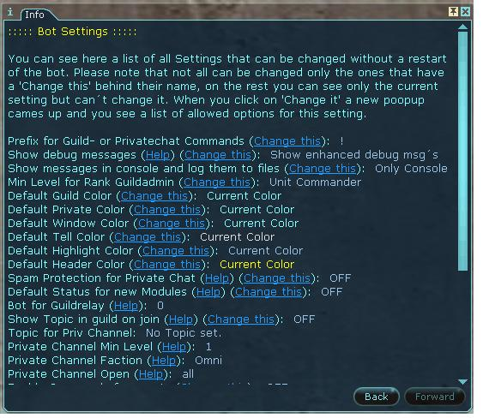
Figure 1: Settings
In the screenshot above you can see an example of the bot settings. Behind the name you can see the current setting for this option. Depending on the setting there can be also a “Help” and “Change this” link. When you are following the helplink you can see a specific help for this setting, as the name of the setting will maybe not give an clue what it effects, so you should read them too sometimes. If the Setting is changable you will see the “Change this” link, when not this setting will be used internal and is only there to give you information on which state this setting is currently.

I will explain the changing of an setting with 2 examples.

First we are going to change the setting of the prefix for commands. Open your settings window (with “/tell botname settings”) and you should see something similar with the following screenshot.
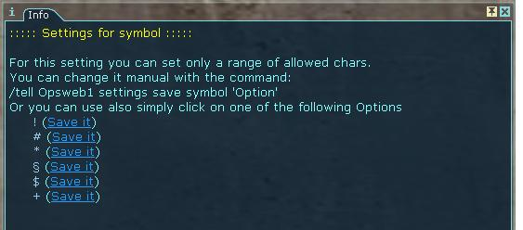
Figure 2: Symbol Settings
Click on the “Change this” link and a new window will be available with the options for this setting. For this setting the bot is giving us a few examples which you can use. Simple click on “Save this” and the bot will save it. At the case the bot isn’t showing a prefix you want to use, you need to change it manually then. For example you want to use the sign “?” as prefix for your commands then simple do “/tell botname settings save symbol ?” and he will save it.
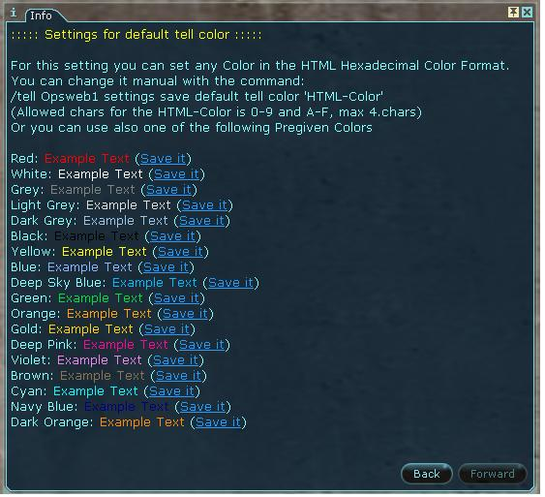
Figure 3: Default tell color setting
As second example we are going to change the default color for tells. Open your settings window again with “/tell botname settings” and click on “Change this” behind the setting for “Default tell colors”. Same as on the first example the bot is showing you a few possible settings for it and you can directly save them with clicking on “Save this”.

How to enable/disable commands events or complete modules and changing their access level?
The bot allows you to enable/disable commands, events or complete modules over the “config” command. Open the config window with “/tell botname config”. Now you can see a list with all available modules with their commands and events.
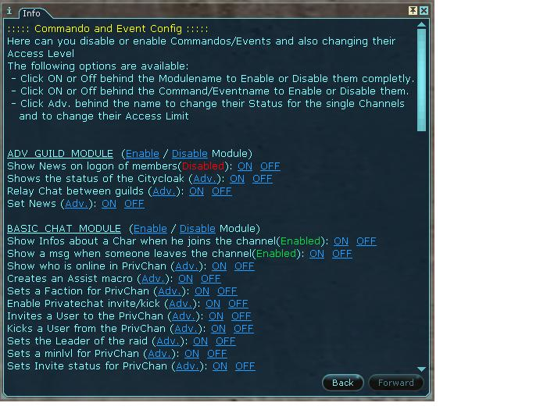
Figure 4: Commando and Event config
The screenshot above shows you an example how the config window looks like. You can identify the modules as their name is underlined. Behind the name you can find two links. One is for enabling and the other one is for disabling the whole module. Maybe you are asking yourself now what an module is, well it is a collection of commands and events that are gathered together to get an easy overview of what the bot offers. For example there is an Module called “BASIC_GUILD_MODULES”. These is holding together the basic modules that are needed to be able to use the bot for a guild. Commands and Events that are in there are the Online/Count/Sm commands, Logon/Logoff Events and so on.

To be able to identify if it is an command or event look at the following screenshot.
Figure 5: Commands and Events on config
You will notice that behind some names stands “Enabled” or “Disabled”. These are the events and can only be enabled or disabled, which you can do directly behind the name with the links “On” and “Off”. Commands have an “Adv.” Link behind their name which is just a short form for Advanced Settings.
Same as the Events you can directly enable or disable them with the links behind it but it is far not that what the bot is offering. Let´s take a look at the Advanced Setting for an command. As an example i am showing now the topic command, which can be found under the “BASIC_CHAT_MODULES”.
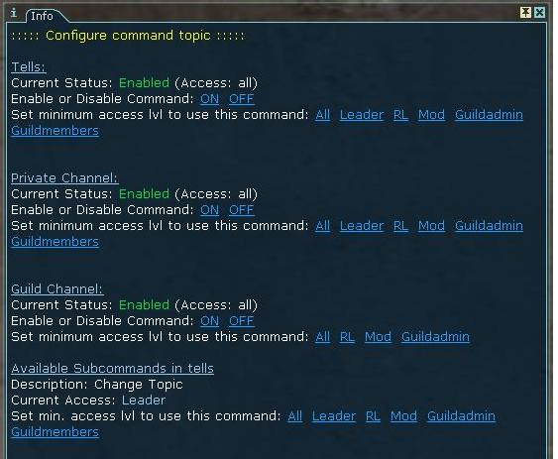
Figure 6: Config of the topic command
In this window you can see the current status of this command in all 3 channels. As you can see, you can enable or disable the command for every single channel. Under the channels you can switch also the required minimum access level that is needed to use this command for the channel. One more thing that you will be notice on the other commands is that behind a Channel the current status says “Unused”. This just means that the command is not available for this channel and can therefore not be enabled/disabled or their admin status changed.

Under the three channels for the command you will see one one more point which is called “subcommand for this command”. Easiest way to explain what subcommands are is an little example. Normally when you are looking at the topic command it allows you to show the current topic and also let you change it but maybe you don´t want to allow everyone to change it. The subcommands are allowing you to set different admin requirements to show and to change the topic.

There exists also another type of config. Open the advanced Config for the online command and you will notice a different view as you have seen before.
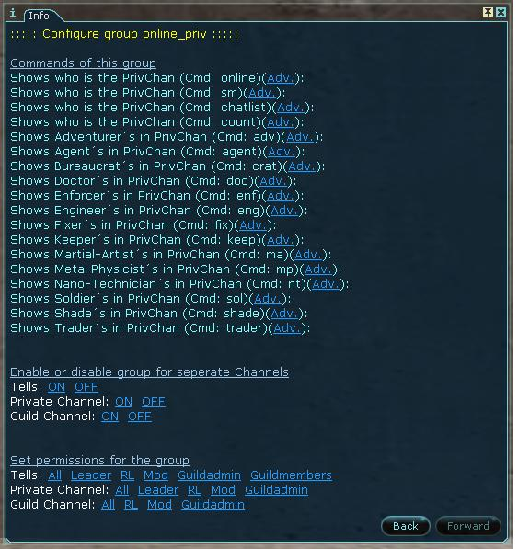
Figure 7: Config of the online group
What you see is a group of commands. The bot gathers all commands together that has nearly the same use. On this window you can change the admin level of the whole group or can enable/disable them all at once but you can set them manually too when you click on the “Adv.” Link behind the command. The window that appears then looks the same as from the other commands.
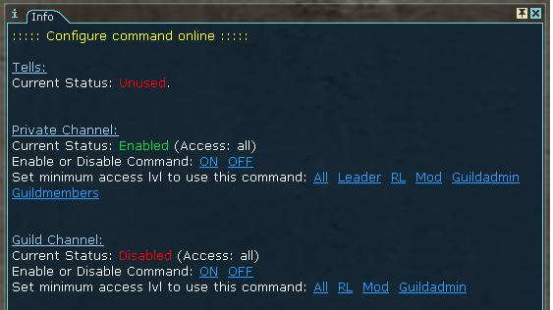
Figure 8: Config of the online command

How to setup the adminlist?
If you are using the bot as raidbot you will need to setup an adminlist. The bot differs between 4 adminlevels. The highest one is mostly you as the Administrator. This admin is set over the setup part of the bot. Next are the Moderators. They are taking care about what happens on your bot and for example they have access to the settings and the config of the bot too and can ban players from it if it is needed. The next lower adminlevel are the Raidleaders. They are leading raids that are hosted by the bot. Last adminlevel isn´t a real level in its meaning since you don´t need to add them manually. These access level is given about the leader command in the Private Group of the bot. Depending on your config of the bot the admins have different access to it´s commands.

To see your current adminlist do “/tell botname adminlist”
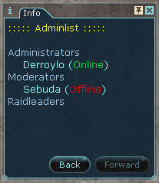
Figure 9: Adminlist
To add or remove someone from the adminlist you need to use one of the following commands.
- Add a new Raidleader “/tell botname raidleader player_name”
- To remove a Raidleader “/tell botname kickraidleader player_name”
- To add a new Moderator “/tell botname addmod player_name”
- To remova a Moderator “/tell botname kickmod player_name”

How to use the banlist?
Incase you don´t want to let a player be able to join the Raidbot you will need to ban him. To see the current banlist do “/tell botname banlist”.
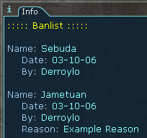
Figure 10: Banlist
When you want to add a player to this list you need todo “/tell botname ban player_name”. The player will now appear on the banlist with info about who banned him and when. If that is not enough you can enter a reason for the ban too. Usefull to remember why he got banned. “/tell botname ban player_name reason enter_reason_for_ban” is the command for it. To remove a ban from a player do “/tell botname unban player_name”.

Chatrelay between two guilds
Let us take the following scneario to explain how the guildrelay system is working. You have 2 guilds, guild1 and guild2, between those you wanna relay the chat. The bot for guild1 is bot1 and for guild2 it is bot2. As first step you need to make sure both bots are using the same Database. When you are using MySQL this is pretty easy, you just need to use to enter on the setup procedure the same Databaseconnection and Databasename. If you are using SQLite(which is it by default) the dabasename and the database filelocation must be the same. Start both bots and enable on both the guildrelay commands (under ADVANCED_GUILD_MODULES) when you haven´t done it already. On the last step you need to enable guildrelay now with the command “/tell botname guildrelay bot_name”. In our scenario it is “/tell bot1 guildrelay bot2” and “/tell bot2 guildrelay bot1”. From now you should see all messages that are written in the guild1 also in the guild2.

List of Commands

Info
This list is only a part of all commands that are supported by this bot. For a full list of features check the helpsystem of the bot with “/tell botname help”.

Online Commands
General Description: Shows the current members that are online in your guild or who is in the privatechannel
Command: online
Description: Executed in the guildchannel it will show the current online orgmembers (if guildrelay is enabled from these guild too) and also the members that are in your guestchannel.
Executed in the privatechanel it will show the players in this channel.
Example: (in guildchannel) !online all Shows all online guildmembers
(in guildchannel) !online nt Shows all Nanotechnicians that are online
Command: count
Description: Executed in the guildchannel it will show the current online orgmembers (if guildrelay is enabled from these guild too).
Executed in the privatechanel it will show the players in this channel.
Example: (in guildchannel) !count all Shows all online guildmembers
(in guildchannel) !count nt Shows all Nanotechnicians that are online
Command: sm or chatlist
Description: Executed in the guildchannel it will show the current online orgmembers (if guildrelay is enabled from these guild too).
Executed in the privatechanel it will show the players in this channel.
Example: (in guildchannel) !sm Shows all online guildmembers
(in privatechannel) !sm Shows all players in the privatechannel

Timer commands
General Description: The timers are seperated into two parts. One for tells and one for guild/priv channels. That means you can set timers in tells which aren´t shown in the guildchannel and only the person who set it can check them.
Command: timer time_of_running_in_min
Description: Sets a timer that runs a specific amount of minutes.
Example: (in guildchannel) !timer 10 The timer will run for 10minutes
Command: timer time_of_running_in_min timer_name
Description: Sets a named timer that runs a specific amount of minutes.
Example: (in guildchannel) !timer 10 test The timer named test will run for 10minutes
Command: timers
Description: Shows all running timers.
Example: (in guildchannel) !timers Shows all running timers from guild/privatechannel.
(in tells) !timers Shows your personal and guild/priv timers.
Command: timer del timer_name
Description: Deletes a running timer.
Example: (in guildchannel) !timer del test Deletes the timer test.

Citycloak commands
General Description: The citycloak command shows you if the cloak of your city is enabled or disabled and how long you can change it´s status. It shows also a history of the citycloak.
Command: city
Description: Shows the current status of your citycloak.

Bio-Material commands
General Description: With this command you can identify a Bio Material that is droping of Aliens at various places.
Command: bio drop_bio_material_here
Description: Identifies the type of the Bio-Material

Guildrelay
Command: guildrelay other_botname
Description: Enables Orgchat relay to another bot.
Example: (in guildchannel) !guildrelay bot Sends all orgmessages to bot.
Command: guildrelay off
Description: Disables guildrelay.

Raid commands
General Description: These commands are only usable in the raidchannel of the bot.
Command: leader
Description: Set someone as the leader of the raid.
Example: !leader Sets yourself as leader
!leader player Sets player as the new raidleader
Command: assist player
Description: Creates an assistmacro for the player.
Example: !assist Derroylo Creates an assistmacro for Derroylo
Command: topic
Description: Shows the current topic of the bot
Command: topic text
Description: Sets a new topic for the bot.
Example: !topic bla bla Sets the text bla bla as new topic
Command: topic clear
Description: Clears the current topic of the bot
Command: minlvl lvl
Description: Sets a min level that is needed to join the raidbot.
Example: !minlvl 140 Only player with lvl140+ can now join.
Command: open mode
Description: Changes the mode of the raidbot.
Example: !open all The bot is open for everyone now.
!open org Only orgmembers can join now.
Command: faction faction
Description: Allows only one faction to join the raidbot.
Example: !faction omni Allows only omnimembers to join the bot.
!faction clan Allows only clanmembers to join the bot.
Command: faction not faction
Description: Allows only one faction not to join the raidbot.
Example: !faction not omni Allows only non omnimembers to join the bot.
!faction not clan Allows only non clanmembers to join the bot.

Guestchannel commands
General Description: Allows the guild to invite non-org player to the guestchannel. You can allow them too to use the guildcommands but these needs to be enabled over the settings command. Note that the gueschannel relay to the org will be disabled if anyone else as a guest joins the Private Channel.
Command: guest invite player_name
Description: Invites a player to the guestchannel.
Example: !guest invite Sebuda Invites Sebuda to the guestchannel.

Command: guest kick player_name
Description: Kicks a player from the guestchannel.
Example: !guest kick Sebuda Kicks Sebuda from the guestchannel.
Command: guest add player_name
Description: Adds a player to the guestlist. He will be auto-invited when he logs on.
Example: !guest add Derroylo Adds Derroylo to the guestlist.
Command: guest rem player_name
Description: Removes a player from the guestchannel.
Example: !guest rem Derroylo Removes Derroylo from to the guestlist.
Command: guests
Description: Shows the current guest of the bot.
Command: guestlist
Description: Shows the current guestlist.

Alternative Char commands
Command: alts
Description: Shows your own alts.
Command: alts player_name
Description: Shows an alt list of another player.
Example: !alts Sebuda Shows the alts of Sebuda.
Command: alts add player_name
Description: Adds another char to your alt list.
Example: !alts add Sebuda Sets Sebuda as on of your alts.

Command: alts rem player_name
Description: Removes a char from your alt list.
Example: !alts rem Sebuda Removes Sebuda as on of your alts.

Logon Message
General Description: Sets a message that is beeing shown on the logon message of an player.
Command: logon your_logon_message
Description: Sets your Logon message.
Example: !logon my new logon msg Sets your logon message.
Command: logon clear
Description: Clears your Logon message.

Loot commands
Command: loot item_name
Description: Adds an item to the loot list.
Example: !loot First-Aid kit Adds First-Aid kit to the loot list.
Command: list
Description: Shows the loot list.
Command: roll
Description: Rolls the loot and shows the winners.
Command: add slot_number
Description: Adds you to the slot.
Example: !add 1 Adds you Slot 1.
Command: setminlvl slot_number level
Description: Sets a minlvl for a Slow.
Example: !setminlvl 1 150 Sets the minlvl from 150 to Slot 1.
Command: pwinners
Description: Shows the current status of the preservewinners modus.
Command: pwinners new_status
Description: Sets the status for the preservewinners modus.
Example: !pwinners on Enables the preservewinners.
!pwinners off Disables the preservinners.
Command: pwinners clear
Description: Clears the preservewinners list.

Bio Regrowth and Guardian commands
Command: guard
Description: Shows the list of players that should be able to cast Guardian. If you have set an assist on a soldier he will be always on the last place.
Command: g
Description: Shows the cast of the Guardian, when it is running out and when it is ready again.
Command: bior
Description: Shows the list of players that should be able to cast Bio Regrowth.
Command: b
Description: Shows the cast of the Bio Regrowth , when it is running out and when it is ready again.

Items commands
General Description: Searches for an item in the AO Itemsdatabase.
Command: items item_name
Description: Search in the Itemsdatabase for the given item name.
Example: !items chosen nano Shows all items that matches chosen nano.
Command: items QL item_name
Description: Search in the Itemsdatabase for the given item name with a specific QL.
Example: !items 235 chosen nano Shows all items that matches chosen nano and the QL235.

Pocketboss and Symbiants
Command: pb pocketboss_name
Description: Searches for an pocketboss and shows the symbs he is dropping.
Example: !pb Brutal Rafter Shows the symbs that drops from this pb.
Command: symb location type
Description: Searches for symbiants that matches the criteria and shows the pb that drops it.
Example: !symb eye infantry Shows all Infantry Eyes that drops from PB´s.

Team Commands
Command: teams
Description: Shows the current team setup and also a Administration window for it.
Command: teams clear
Description: Shows Clears the current team setup.
Command: teams 0 player_name
Description: Removes a player from all teams.
Example: !teams 0 Derroylo Removes Derroylo from all the team he was assigned to.
Command: teams team_number player_name
Description: Adds a player to a team.
Example: !teams 1 Derroylo Adds Derroylo to team 1.
Command: team team_name
Description: Creates a new team with the given name.
Example: !team Tank Team Creates a new team called Tank Team.
Command: team new_team_name team_number
Description: Renames an existing team.
Example: !team Backup TTeam 2 Renames Team 2 to Backup TTeam.

Tower commands
Command: battle
Description: Shows the last attacks on Notumfields.
Command: victory
Description: Shows the last winners of Notumfield battles.

Developer Informations

Introduction
This part is for peoples that want to develop their own modules for this bot. You will find here the needed file structure for your modules, functions that you may find helpful and also some important variables that are provided by the bot.

File structure of the bot
When you open your bot folder you will find several folders. Every one of them has a specific use. Which one it has will be shown in the following table.

Name | Type | Usage
cache | Folder | Cache folder for XML files(from whois or history cmds)
core | Folder | Includes most of the core modules of the bot like admin, settings and config stuff
data | Folder | Mostly the SQLite DB´s are saved here
dll | Folder | Required Dll files for the bot
modules | Folder | Modules that are used by the bot
sql | Folder | SQL Files like the items database and Pocketboss db
chatbot.bat | File | Starts the Bot
config.php | File | Configurationfile for the bot
main.php | File | Includes DLL loading, creating bot/db object creation and the main loop

Structure for your own modules
To start with your own modules you will need to create a new folder in the module folder of the bot. Please use only uppercases names for them (just to use the same format as we do). Go into your new created folder and create a new PHP file with the same name as your new module folder. This file will include later all the registering of the commands/events/settings/helpfiles for your module. This file could look like this for example:
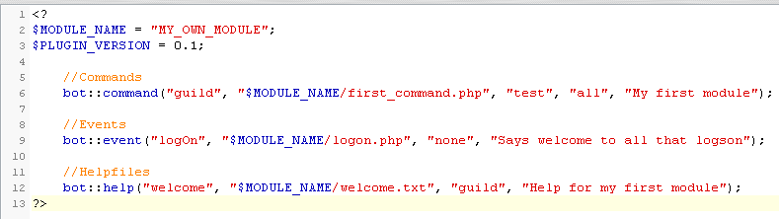
Figure 11: My first module
To see what every bot function can be found too in this manual when you look at the next sites.
Now you just need to write the files that are registered now(first_command.php, logon.php and welcome.txt) and they will be available after the next reboot of the bot.

Functions of the bot core

Create a blob, chatcmd or an itemlink
Function name: makeLink
Description: Creates a Link
Argument: $name
Description: Name of this link
Argument: $content
Description: Content of this link
Argument: $type
Description: Type of this link
Default Value: blob
Allowed content: blob, text, chatcmd
Argument: $style
Description: Style for this link
Default Value: NULL = no style
Functionname: makeItem
Description: Creates an Itemlink
Argument: $lowID
Description: Low ID of the Item
Argument: $hiID
Description: High ID of the Item
Argument: $ql
Description: Quality of the Item
Argument: $name
Description: Name of the Item

Send a message
Function name: send
Description: Sends a message or add/rem/checks a buddy
Argument: $message
Description: The message that should be send or a buddyadd/isbuddy/rembuddy
Allowed content: buddyadd, isbuddy, rembuddy or a text to send
Argument: $who
Description: High ID of the Item
Default Value: NULL = privatechannel
Allowed content: Playername, guild, public channelname

Registering of commands
Function name: command
Description: Adds a command to the bot. This can be configured over the config cmd.
Argument: $type
Description: Type of the command
Allowed content: msg, priv, guild
Argument: $filename
Description: Name of the file that is assigned with the command
Argument: $command
Description: The command itself
Argument: $admin
Description: Access level for this command
Default Value: all
Allowed content: leader, raidleader, mod, admin
Argument: $description
Description: Description of this command(shown on the config cmd)
Default Value: none
Allowed content: text
Function name: regcommand
Description: Adds a command to the bot. Will be active and not configurable
Argument: $type
Description: Type of the command
Allowed content: msg, priv, guild
Argument: $filename
Description: Name of the file that is assigned with the command
Argument: $command
Description: The command itself
Argument: $admin
Description: Access level for this command
Default Value: all
Allowed content: leader, raidleader, mod, admin
Function name: unregcommand
Description: Deactivates an command
Argument: $type
Description: Type of the command
Allowed content: msg, priv, guild
Argument: $filename
Description: Name of the file that is assigned with the command
Argument: $command
Description: The command itself
Function name: subcommand
Description: Adds a subcommand to the bot. This can be configured over the config cmd.
Argument: $type
Description: Type of the command
Allowed content: msg, priv, guild
Argument: $filename
Description: Name of the file that is assigned with the command
Argument: $command
Description: The command itself(must be in pregmatch pattern)
Argument: $admin
Description: Access level for this command
Default Value: all
Allowed content: leader, raidleader, mod, admin
Argument: $dependson
Description: The name of the command to which this subcommand belongs
Allowed content: any existing command
Argument: $description
Description: Description of this command(shown on the config cmd)
Default Value: none
Allowed content: text

Registering of Events
Function name: event
Description: Adds an event to the bot. This can be configured over the config cmd.
Argument: $type
Description: Type of the command
Allowed content: towers, orgmsg, msg, priv, guild, joinPriv, leavePriv, logOn, logOff, 2sec, 1min, 15min, 1hour, 24hrs, setup
Argument: $filename
Description: Name of the file that is assigned with the event
Argument: $dependson
Description: The name of the command to which this event belongs
Default Value: none
Allowed content: any existing command
Argument: $desc
Description: Description of this event(shown on the config)
Default Value: none
Allowed content: text
Function name: regevent
Description: Adds an event to the bot. This will be active and not configurable.
Argument: $type
Description: Type of the event
Allowed content: towers, orgmsg, msg, priv, guild, joinPriv, leavePriv, logOn, logOff, 2sec, 1min, 15min, 1hour, 24hrs, setup
Argument: $filename
Description: Name of the file that is assigned with the event
Function name: unregevent
Description: Deactivates an event
Argument: $type
Description: Type of the event
Allowed content: towers, orgmsg, msg, priv, guild, joinPriv, leavePriv, logOn, logOff, 2sec, 1min, 15min, 1hour, 24hrs, setup
Argument: $filename
Description: Name of the file that is assigned with the event

Register a group of commands
Function name: regGroup
Description: Registers a group of command.
Argument: $group
Description: Name of the group
Argument: $module
Description: Name of the module where these files are located.
Argument: $desc
Description: Text that is shown on the config as description.
Default Value: none
Allowed content: text

Settings
Function name: addsetting
Description: Adds an setting.
Argument: $name
Description: Name of the setting
Argument: $description
Description: Text that is shown on the settings as description.
Default Value: none
Allowed content: text
Argument: $mode
Description: Mode of the setting
Allowed content: edit, hide, noedit
Argument: $setting
Description: Default value for this setting
Default Value: none
Argument: $options
Description: Values that the user can choose from.
Default Value: none
Argument: $intoptions
Description: Values that are assigned to the option that user has choosen.
Default Value: 0
Argument: $admin
Description: Access level for this command
Default Value: mod
Allowed content: leader, raidleader, mod, admin
Argument: $help
Description: Helpfile for this setting
Default Value: NULL
Function name: getsetting
Description: Gets the value of a current setting
Argument: $name
Description: Name of the setting

Function name: savesetting
Description: Save changes to a setting
Argument: $name
Description: Name of the setting
Argument: $newsetting
Description: New Value for this setting.

Helpfiles
Function name: help
Description: Adds an helpfile.
Argument: $command
Description: Name of the command that calls this helpfile
Argument: $filename
Description: Name of the file that is assigned with the helpfile
Argument: $admin
Description: Access level for this command
Default Value: all
Allowed content: leader, raidleader, mod, admin
Argument: $info
Description: Text that is shown on the help command as description.
Default Value: NULL
Allowed content: text

Variables of the botcore
A list of variables that are important for your modules

Guildmembers
Name: guildmembers
Description: Array of the guildmembers with their rank id´s
Type: Array
Keys: Name of a guildmember
Values: Rank id of the member

Admins
Name: admins
Description: Array of the admins of this bot with their rank id´s
Type: Array
Keys: Name of an admin
Values: Rank id of the admin

Vars
Name: vars
Description: Array with diferrent values like guildname(my guild) and guild id(my guild id).
Type: Array
Keys: my guild, my guild id, name

Settings of the bot
Name: settings
Description: Array with all registered settings of the bot. Use the botcore functions to change them or the changes will not be saved!
Type: Array

Sender
Name: sender
Description: Name of the player that has send the message
Type: Variable

Chatlist
Name: chatlist
Description: Array with all players that joined the privategroup of the bot.
Type: Array
Keys: playernames
Values: True when he joined

Buddylist
Name: buddyList
Description: Array with all players from the friendslist of the bot.
Type: Array
Keys: playernames
Values: 1 => he is online, 0 => he is offline

Type of the message
Name: type
Description: Source from where the message came.
Type: Variable
Values: msg, priv, guild, joinPriv, leavePriv, logOn, logOff, towers, orgmsg

