Managing Your PocketnetCore Wallet

Wallet by default is stored in a file wallet.dat and contains the following:

* One more private/public key pairs
* Transactions that are related to those key pairs
* Coin balance for all keys

Private keys stored in a wallet are used to send and receive POC. They are also used in Proof-of-Stake (POS) to win new coins.

Staking

When a node forms a new block, it is using a few transactions (for total of 5 POC or more) as an input (POS input). New block creates a new transaction, which returns the locked amount (the stake) plus the reward won to the same address (key) from which the POS input was derived. Note, that in addition to node rewards content creators and participants of the social network also get to participate in Proof-of-Stake lottery, but they do not need to stake any coins.

Below is a sample screenshot. Address A staked 6 POC and in a winning transaction it receives back the 6 POC plus the win of 5 POC. Note, that Pocketcoin emission will decrease over time and reward will not be 5 POC forever.

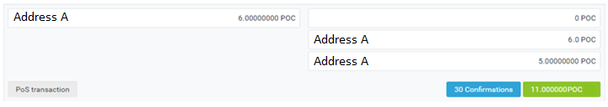

Sending POC

If you are using Pocketnet Core to send POC, you should remember that in cryptocurrency the change comes back NOT to the address you sent from, but to a new address that is generated. These new keys are added to your wallet.dat automatically.

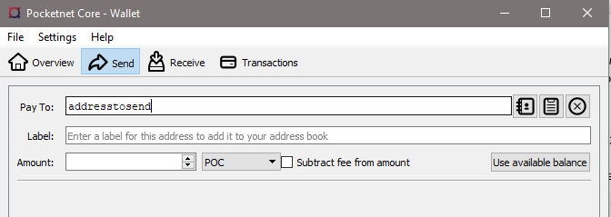

You can see all available keys in your wallet by doing command **listaddressgroupings** in Pocketnet Core

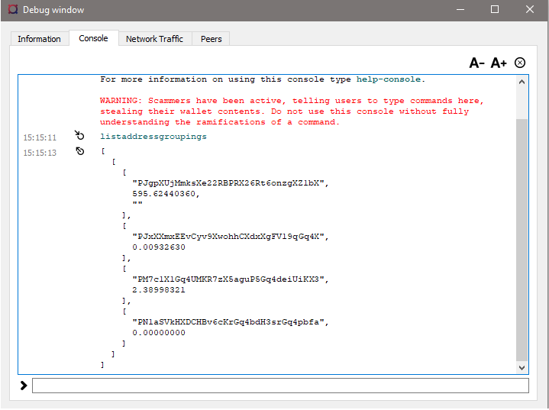

**We strongly recommend to duplicate your private keys to secure cold storage .**

You can get all private keys from your wallet by doing the following command: **dumpprivkey**

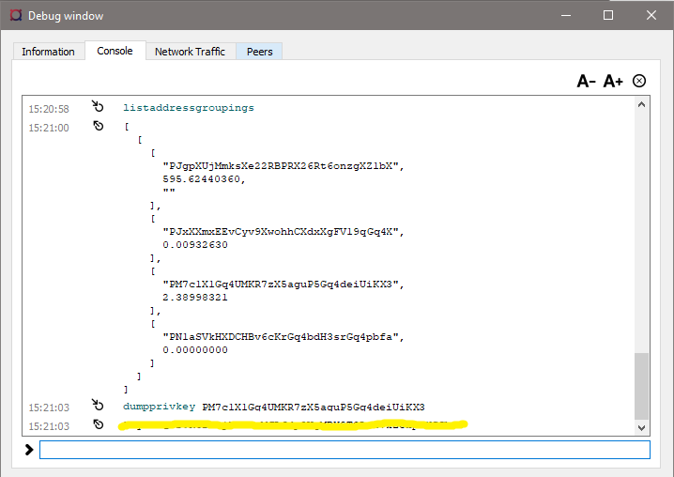

Servicing the wallet

Remember, the wallet is a computer database. It can get corrupted, or your PC might die. That is why you MUST back up your private keys somewhere outside of that PC where you have the node.

If you suspect that something is wrong with your wallet, you can run command

**-zapwallettxes**

This command will rescan the blockchain to confirm your balance.

Last reminder: backup your keys on the node frequently.

