INTERNSPARK INTERNSHIP
Synthesis & Gate Level Simulation
Task 2

Name | Budde Rohini
Title | Synthesis & Gate level Simulation

Objective
The objective of this task is to design a Scan Flip-Flop (scan_dff), a fundamental building block used in Design-For-Testability (DFT) scan-chain insertion. The module supports a normal functional mode and a scan mode that allows test data to be shifted serially through the flip-flop chain.

Design Description
The scan_dff module has five inputs — clk, rst, d, scan_en and scan_in — and a single registered output q. On every positive edge of the clock: if rst is asserted, the output is synchronously cleared to 0; else if scan_en is high, the flip-flop loads data from the scan_in path (scan/test mode); otherwise it latches the functional input d (normal operating mode).

Deliverables
- RTL source file (scan_dff.v) and self-checking testbench (scan_dff_tb.v).
- Functional simulation waveform showing clk, rst, d, scan_en, scan_in and q.
- Console / signal value monitor confirming correct operation in both normal and scan modes.
- Synthesis of the RTL to a gate-level netlist, followed by gate-level simulation to verify RTL ↔ gate-level equivalence.

Tools Used
Verilog HDL for RTL coding, a simulator (ModelSim / Vivado Simulator / GTKWave-compatible simulator) for functional and gate-level simulation, and a synthesis tool (Vivado / Yosys) for converting the RTL into a gate-level netlist._dff.v
The Verilog module below implements the scan flip-flop. It is sensitive to the positive edge of clk or rst, giving the reset asynchronous-style priority while remaining a synchronous, single always-block description that is fully synthesizable.
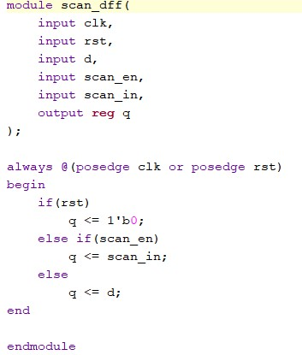
Fig. 1 — scan_dff RTL module (Verilog)

2. Testbench — scan_dff_tb.v
The testbench instantiates the design under test (scan_dff), generates a clock with a 10 ns period (toggling every 5 ns), and declares register/wire signals to drive and observe the DUT.
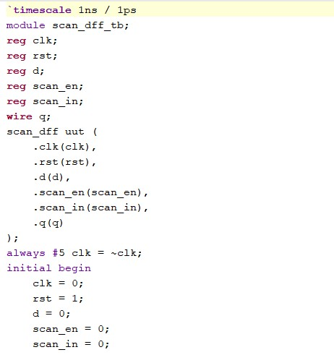
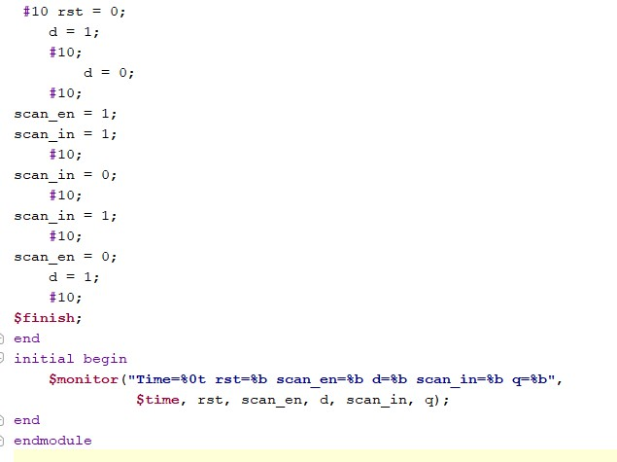
Fig. 3 — Test bench code

3. Functional Simulation Waveform
Output wave form
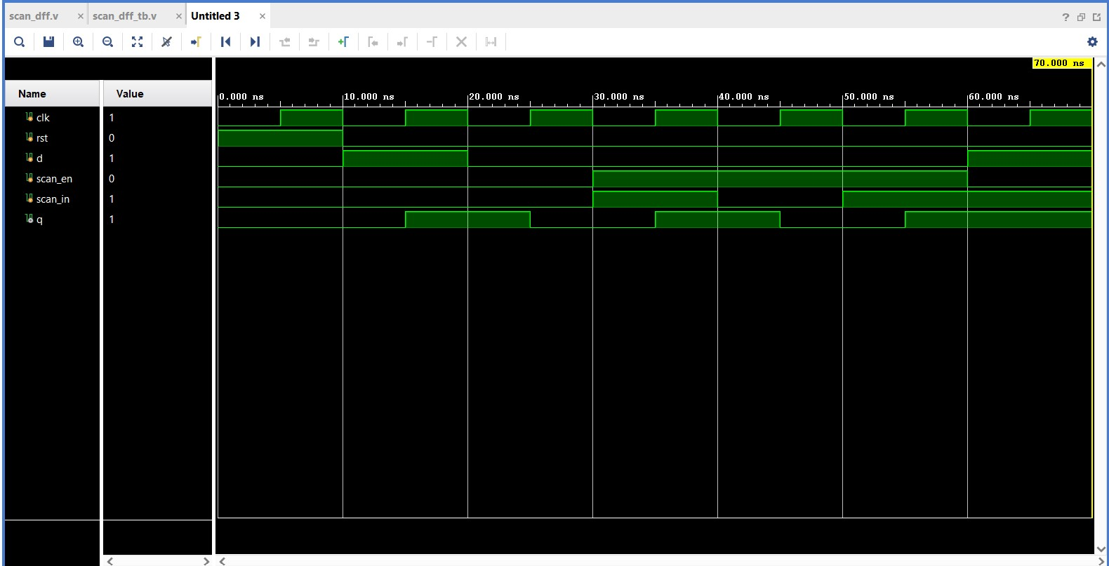
Fig. 4 — Simulation waveform (signal timing diagram)
The table below is a snapshot of signal values at a sampled simulation time, captured from the waveform viewer's signal panel.
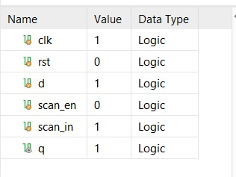
Fig. 5 — Sampled signal values (clk, rst, d, scan_en, scan_in, q)

4. Reference — RTL Design & Verification Flow
The diagram below summarises the general RTL design, functional-simulation and synthesis methodology that was followed for this task — from requirements analysis and RTL coding through testbench creation, functional simulation, coverage analysis and final RTL/gate-level verification.
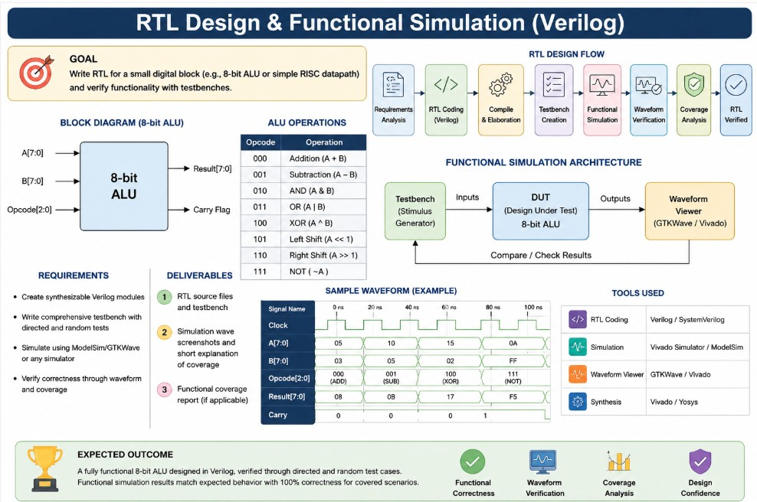
Fig. 6 — RTL design and functional simulation methodology (reference)

