1. To concat the first_name and last_name of employees into a single column named full_name.  
     
    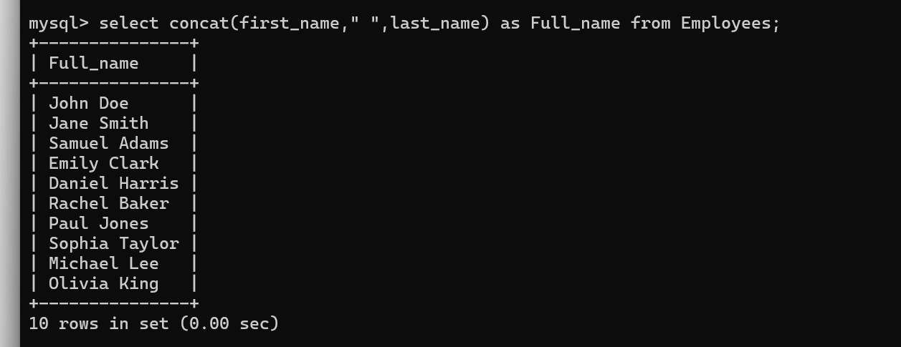
2. Query that retrieves the first and last names of employees, as well as their department names by using a subquery inside the SELECT statement.

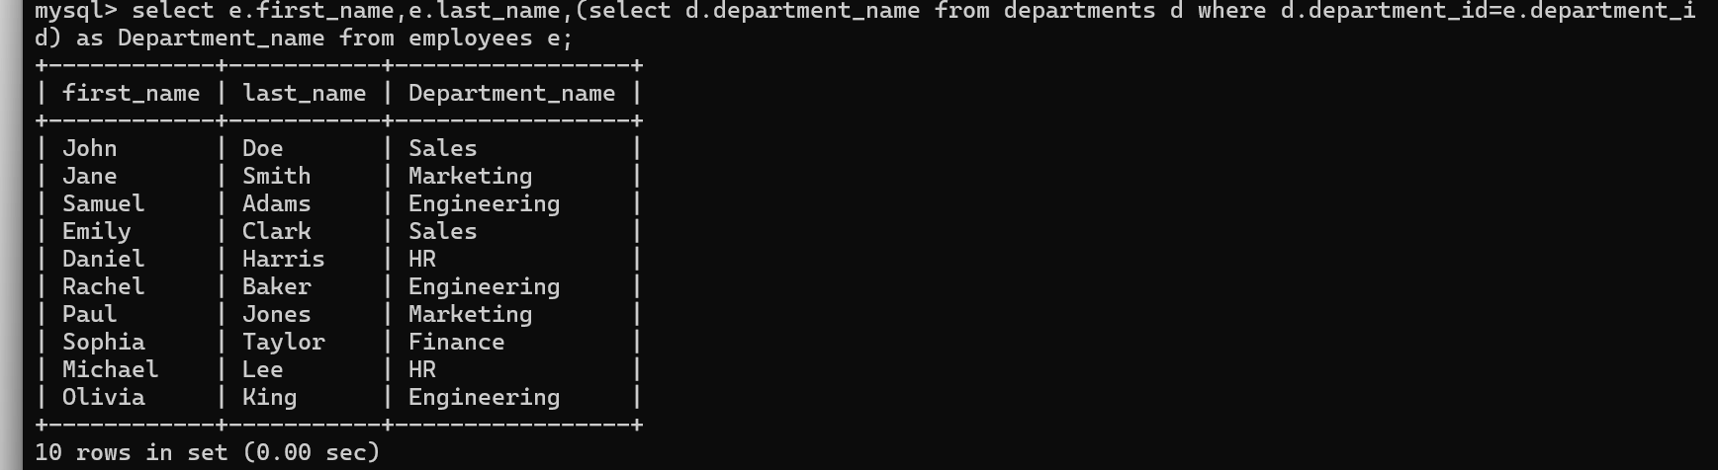

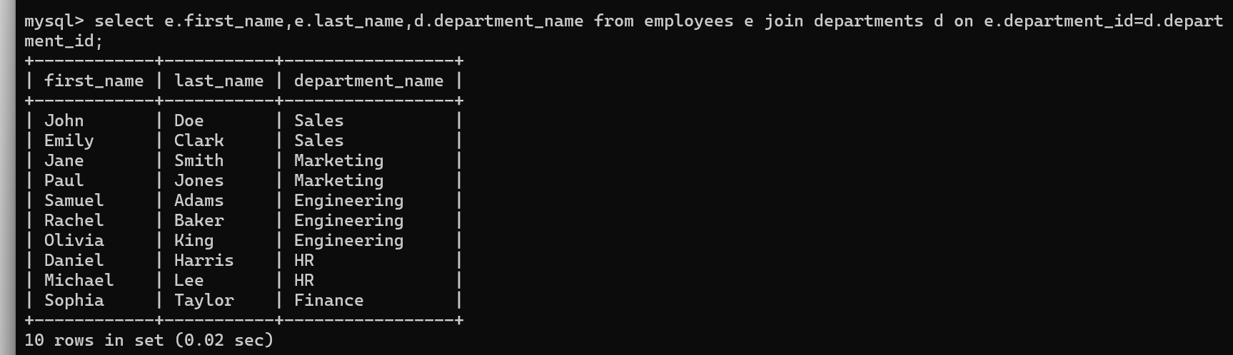

1. Query counts the number of employees in each department.

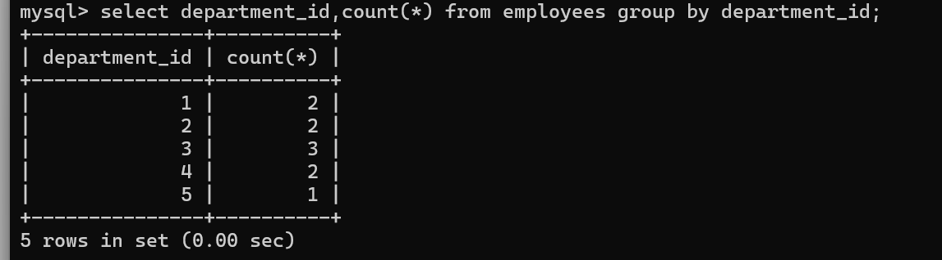

1. Query to lists all departments and counts the number of employees in each department .

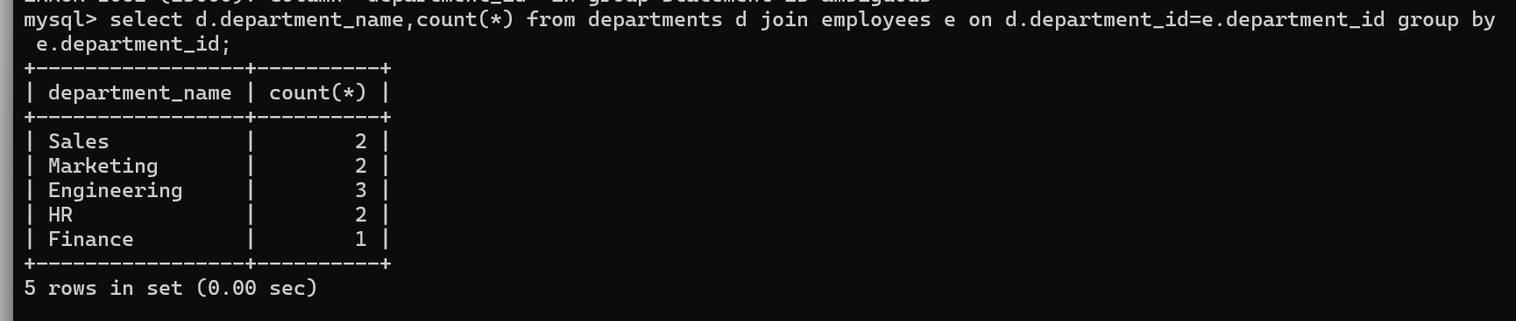

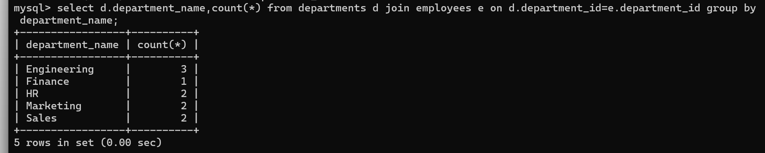

1. To find employees with salary greater than average salary of their department.

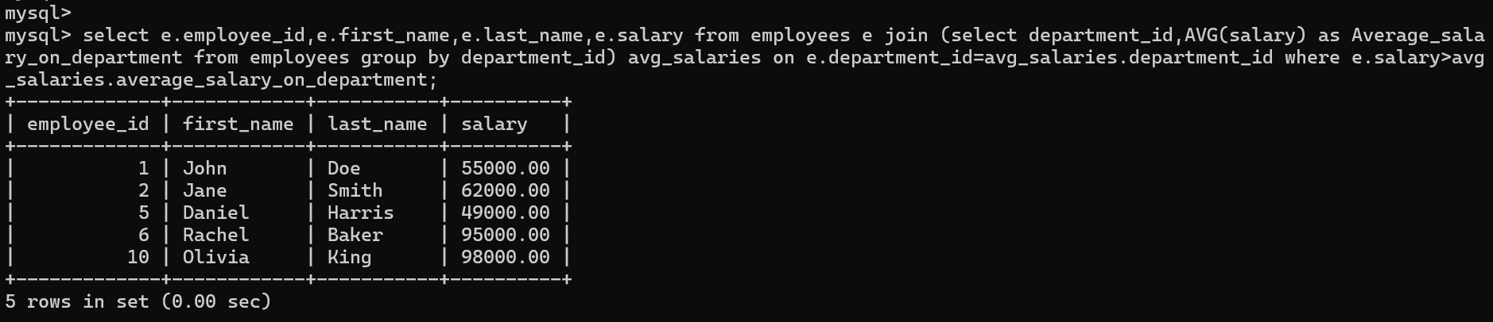

1. To get all employee names in each department.

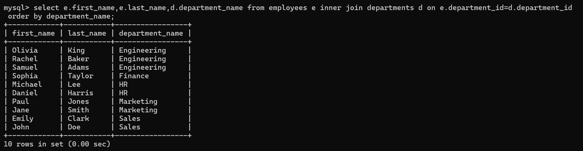

1. 7.Subquery to find the employee with the highest salary in each department.

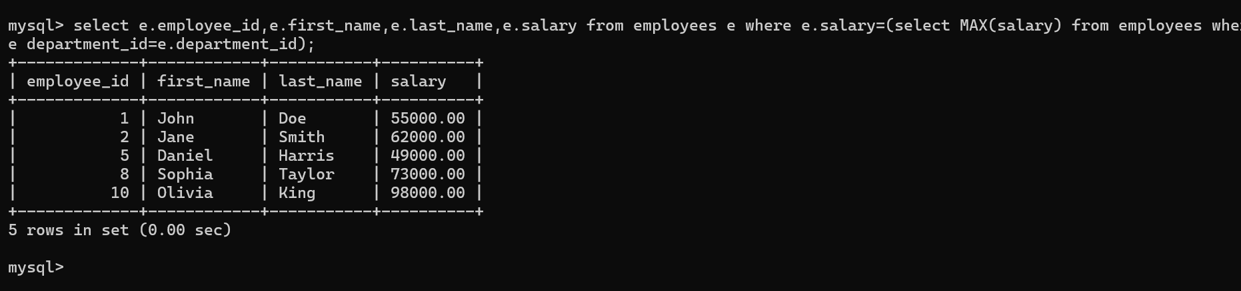

1. Group employees by hire year and calculate the total salary for each year.

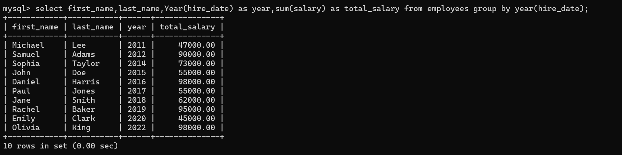

1. Group departments and count the number of employees in each department.

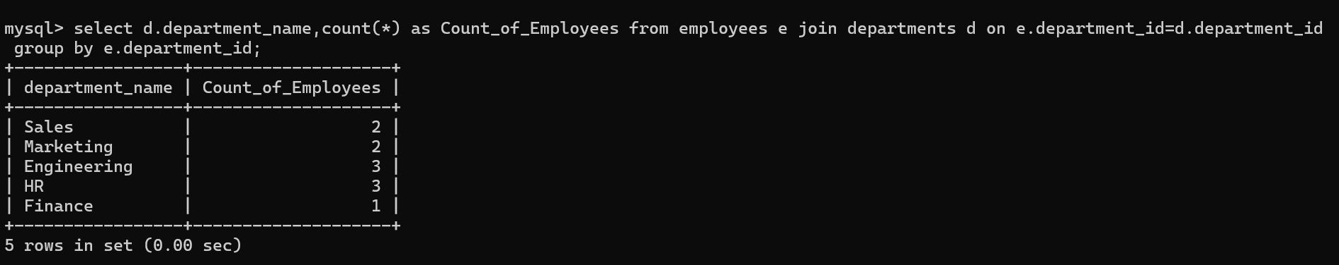

1. Find the highest salary in each department.

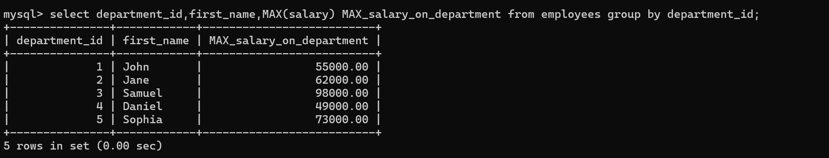

1. Group employees by department and show the average salary in each department.

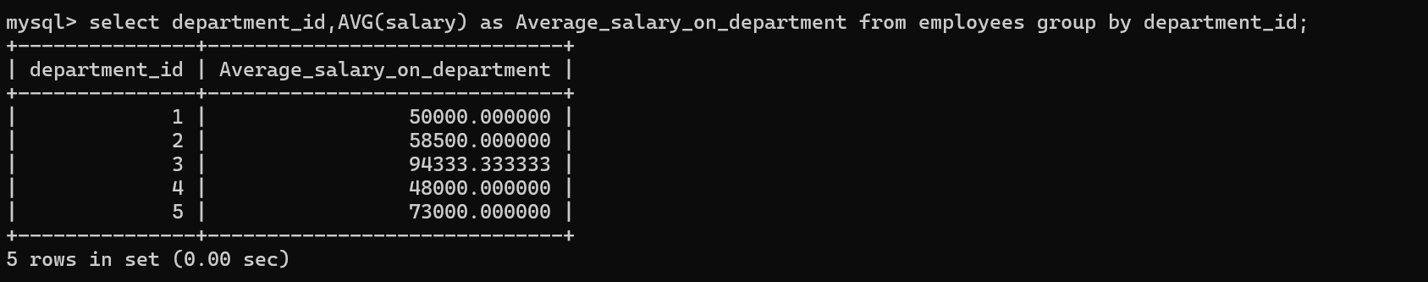

1. Find departments with more than 5 employees.



1. List departments where the average salary is greater than 50,000.

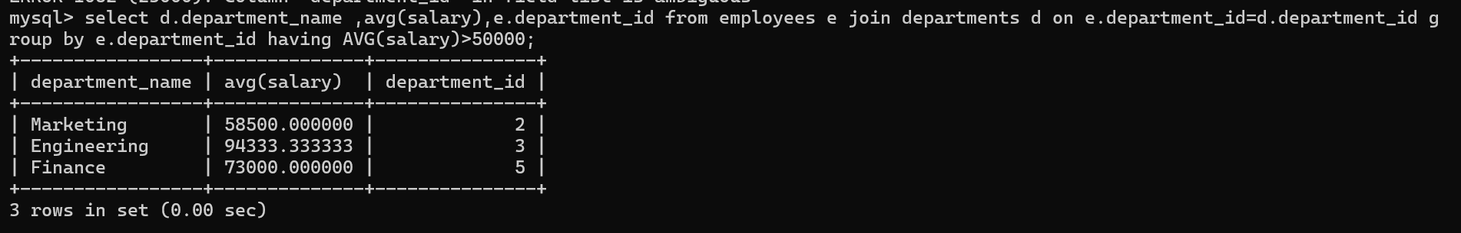

1. List employees who earn more than 60,000 and belong to a department with more than 3 employees.

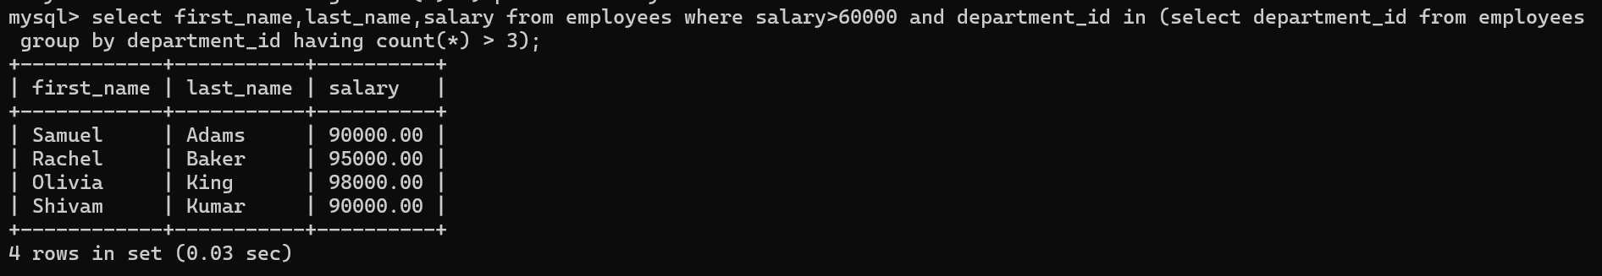

1. Show departments where there is more than one employee with a salary over 100,000.

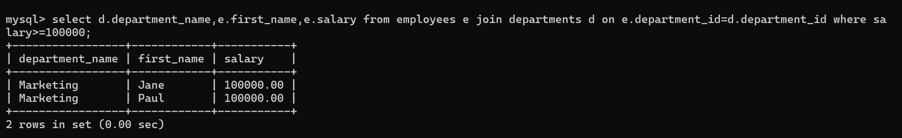

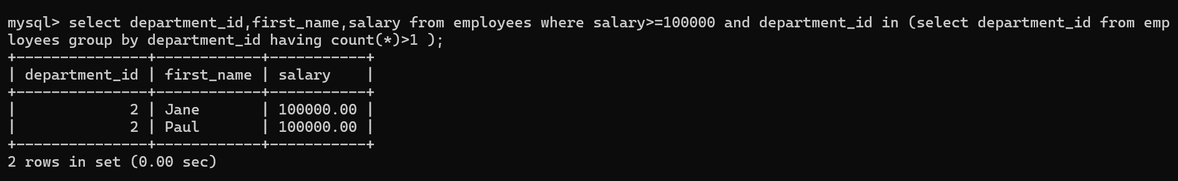

1. 16.Delete an employee with a specific employee_id (e.g., 5)

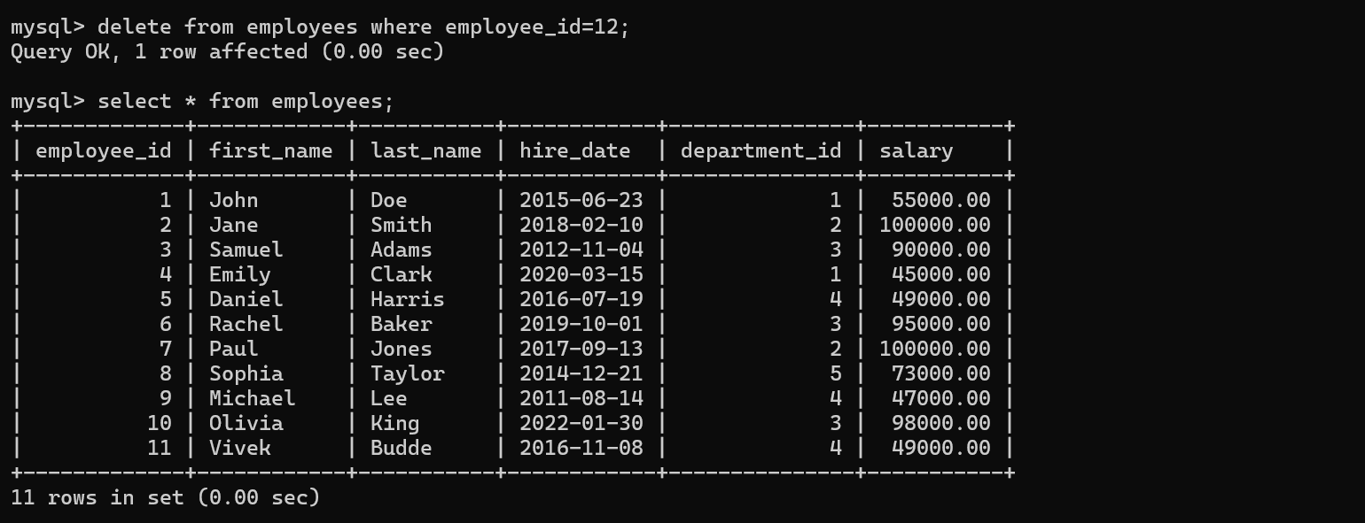

1. Delete employees who have a salary lower than 30,000.

