Solvista

*Math made smart*

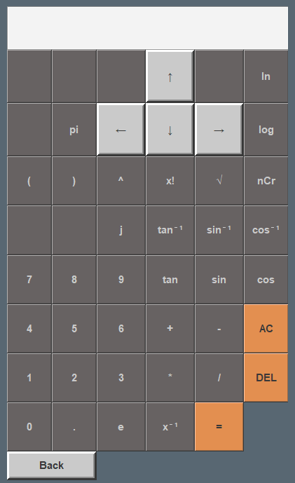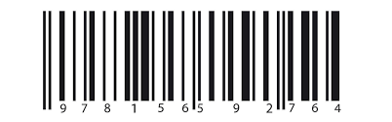

**Key features**

* 5-inch touch screen display with included pen
* Multiple calculators in one device
* Easy-to-use touch interface
* Integrated Camera for Photo-Based Solving

**Important**

* Handle with care
* Rechargeable battery included.
* One-year limited warranty included.
* For customer support contact us,

+94701960880  
[smartwavetechnologies.sl@gmail.com](mailto:smartwavetechnologies.sl@gmail.com)



calculator

Graphing calculator

Write to solve

Take a photo to solve

Simultaneous solver

**Include**

PDF Reader

Controls

Matrix Calculator

Laplace Transform

Fourier Transform

**Include**

