**MANAGING BLOOD AND ORGAN DONATION IN SRI LANKA**

2022_311

Project Proposal Report

IT19112992 - B.N Dullewa

Bachelor of Science (Hons) Degree in Information Technology

Department of Information Technology

Sri Lanka Institute of Information Technology

Sri Lanka

January 2022

**MANAGING BLOOD AND ORGAN DONATION IN SRI LANKA**

2022_311

Project Proposal Report

B.N Dullewa

   Mrs. Uthpala Samarakoon

Supervisor

Bachelor of Science (Hons) Degree in Information Technology

Department of Information Technology

Sri Lanka Institute of Information Technology

Sri Lanka

January 2022

**DECLARATION**

I declare that this is my own work, and this proposal does not incorporate without acknowledgement any material previously submitted for a degree or diploma in any other university or Institute of higher learning and to the best of our knowledge and belief it does not contain any material previously published or written by another person.

|  |  |  |
| --- | --- | --- |
| Name | Student ID | Signature |
| B.N Dullewa | IT19112992 |  |

The above student is carrying out research for the undergraduate Dissertation under my supervision.

2021/03/24

…………………………… ……………………………

Signature of the supervisor: Date

Ms. Uthpala Samarakoon

# **Abstract**

In most of the countries of the world, the demand for blood donations is much more than the supply they are able to get. Sri Lanka is one of the few countries where all blood and blood product needs are met through voluntary, non-remunerated donations and country has been able to keep this status for decades. As for this kind of country, blood donation is the most important thing. Sri Lanka is a shining example of how it is possible to maintain an adequate supply through voluntary donation [1]. At the very outset, this study explored the problem of managing one of the critical health services supplies, the Blood donor management system.

The goal of this project is to provide an online platform to organize blood donation camps. Anyone who is interested in organizing blood camps may register using this application and any organization that wishes to register with this can do as well. The main component of the strategy will help to organize blood donating camps. In addition, this service supplies blood for needy patients, allowing for faster and more secure blood transfusions.

This is a mobile blood donation management application called “DonorMe”, which allows people who want to donate blood to help others in need to do so. It enables people to get select the proper location to hold the blood donation camp, user can get the current availability of registered blood donators detected in the respective blood donation camp’s area, the potential donors will be notified through an auto-generated message and this application will locate the nearest blood donation camp and the camps which are to be held in the future and also camp organizers can get information about the camps which were previously conducted.

*Keywords: blood donor, potential donor, non-remunerated donations*

# **Table of Contents**

**Abstract** iv

**Table of Contents** v

**List of figures** vi

**Introduction** vii

**Background and Literature Survey** 1

**Research Gap** 2

**Research Problem** 3

**Objectives** 4

**Methodology** 5

**System Architecture** 6

**Requirement Gathering and Analyzing** 7

**Software Specific Requirement** 8

**Commercialization** 8

**Work Breakdown Structure** 9

**Grant Chart** 10

**References** 11

# **List of figures**

[Figure 1 Comparison of Annual Blood Collection vii](https://mysliit.sharepoint.com/sites/CDAPSubmissionCloud/2022RegCloud/2022-311-Students/1.%20Project%20Proposal/Report/IT19112992.docx#_Toc95512792)

[Figure 2 Comparison of Annual Blood Collection Bar Chart vii](https://mysliit.sharepoint.com/sites/CDAPSubmissionCloud/2022RegCloud/2022-311-Students/1.%20Project%20Proposal/Report/IT19112992.docx#_Toc95512793)

[Figure 3 Process of Study 5](https://mysliit.sharepoint.com/sites/CDAPSubmissionCloud/2022RegCloud/2022-311-Students/1.%20Project%20Proposal/Report/IT19112992.docx#_Toc95512794)

[Figure 4 system architecture 6](https://mysliit.sharepoint.com/sites/CDAPSubmissionCloud/2022RegCloud/2022-311-Students/1.%20Project%20Proposal/Report/IT19112992.docx#_Toc95512795)

[Figure 5 Work Breakdown Structure 9](https://mysliit.sharepoint.com/sites/CDAPSubmissionCloud/2022RegCloud/2022-311-Students/1.%20Project%20Proposal/Report/IT19112992.docx#_Toc95512796)

[Figure 6 Grant Chart 10](https://mysliit.sharepoint.com/sites/CDAPSubmissionCloud/2022RegCloud/2022-311-Students/1.%20Project%20Proposal/Report/IT19112992.docx#_Toc95512797)

# **Introduction**

Scientists estimate the volume of blood in a human body to be approximately 7 percent of body weight. An average adult body with a weight of 150 to 180 pounds will contain approximately 4.7 to 5.5 liters (1.2 to 1.5 gallons) of blood [2]. Blood is donated in the traditional method through blood donation services or blood banks all around the world in the medical industry. Blood bank is defined as dormitory in which blood is collected as a result of donor blood donation campaigns that are processed and preserved for subsequent transfusion maximally for four weeks. In Sri Lanka, Blood donors do not have a system to connect with blood donation camps and the organizers do not have a system to connect with the donors. Also, organizers do not have a system to manage their blood donation camps successfully.

The annual units of blood collections in Sri Lanka are roughly depicted in the figures below [3]. This emphasizes the importance of the voluntary Blood Donor Service as a primary source of blood in Sri Lanka. According to that information, 2019 shows a decrease in blood donation. This may be due to the covid pandemic situation. It is important to create a system to make it easier for donors across the island to donate blood. It will make it easier for donors as well as blood camp organizers. This project tries to answer this critical issue of an efficient and effective blood donation camp management system. Main features are the donor can check nearest blood camp, organizers can find a place to hold their blood donation camps and it will provide information about the camps previously conducted in selected area.

**Comparison of Annual Blood Collection**

Figure 1 Comparison of Annual Blood Collection

Figure 2 Comparison of Annual Blood Collection Bar Chart

# **Background and Literature Survey**

**Background**

Blood is required for a variety of treatments and procedures, yet it is still a scarce resource. In Sri Lanka, roughly half a million units of blood are required each year. Furthermore, people continue to die in other Asian countries due to an insufficient and inefficient supply of blood products. Hence, Blood plays a key function in healthcare systems, aimed at providing a enough blood availability to fulfill the demand and save lives.

“DonorMe” mobile application allows camp organizers to plan their camp in efficient manner. It is most important to choose a proper location to conduct the blood donation camp. If the organizer determines a place where there are a lot of donators, then the camp will be successful. And it would be better if the organizer could find whether there was a blood donation camp which was previously conducted because it would be unworkable to conduct a blood donation camp again in the same location. Moreover, the organizers have to bear high expenses to advertise the blood donation camp, but it is cost effective if there is a way to inform the blood donors from a different mode.

**Literature Survey**

In this chapter, some key findings and observations from major scholars on the topic of blood donation banking management systems will be presented. The research appears to boost and reinforce the reading by studying and gathering facts relating to the main subject of my focus.

We expect from this research to give out good guidance for blood band organizers. According to the previous studies it was completely clear, mobile blood donation camp management system has not yet been developed yet. There are a few examples that indicate how the optimization of efficient and effective approaches have been developed for a variety of healthcare-related challenges, ranging from resource management in hospitals to the distribution of care services across a region. Previous researchers try to build a connection between donors and blood bank, but they did not pay much attention to the blood camp organizers. All in all it is explicitly shown that the Blood Donation Camp Management systems are a critical and very important requirement in the health services management of any country

# **Research Gap**

To the best of the researcher's knowledge, no research has been done to manage blood camp.

But there has been some research done to manage blood donor information.

The proposed system aims “Design and develop a component to manage the blood donation camps effectively using Google API and social media”.

Research “A” was able to answer burning question of efficient and effective Blood donor Management Information system. Main features are the needy patient, and the donors can directly communicate and a meeting place like interface would allow the connectivity of receiver and the donor. But that research does not discuss the blood donation camp management system. It tries to manage donors and donees [4].

Research “B” was able to answer to connect the requester and donor at any time and from any place. In the event of an emergency, the request can send a message to all qualified donors, as well as data from the blood institute and clinic. They deployed cloud hosting infrastructure to ensure application data accessible at all times and from anywhere. This one does not discuss blood donation camp management system. It tries to manage donors and donees [5].

|  |  |  |  |  |
| --- | --- | --- | --- | --- |
| **Research** | **Select Proper Location to hold Blood donation Camp** | **Send notification to registered donors** | **Locate to nearest Blood donation Camp** | **Provide Information about previous camps which were conducted previously** |
| Research A | No | No | Yes | No |
| Research B | No | No | No | No |
| Proposed System | Yes | Yes | Yes | Yes |

# **Research Problem**

There has been a significant increase in deaths Due to a lack of quick blood donors and the bureaucracy associated with sick people quickly receiving their required blood type. It shows the importance of donating blood. Organizing blood camps can solve this problem. But there is no correct guidance for organizers. Moreover, when donor needs to donate their blood, she/he has to go to the blood bank. It takes time and effort. If it is possible to raise awareness about the nearest camps, it will solve these problems. If the organizers want to hold a successful camp, they have to be careful about the location they choose. Currently there is no system that has been created to conduct organizers. But having a system can be good guidance to the organizers.

It is simple to distribute information about blood donations due to the significant development in the use of social networking sites around the world. However, as evidenced by the number of posts on sites like Facebook and Twitter requesting blood donors, the number of calls for blood donors has been steadily increasing as a result of the use of contemporary technologies. It is difficult to discover the regions where blood donation camps are held and to effectively notify potential donors due to a lack of contact with social networking sites. As a solution, this program uses technology to help discover contributors.

# **Objectives**

**Main Objective**

Design and develop a component to manage the blood donation camps effectively using Google API and social media.

**Specific Objectives**

This paper proposes an integrated Blood Donation Camp Management System which is a web-based application with mobile compatibility designed to manage Blood Donation Campaign dynamically. In Sri Lanka, there is no technology to properly manage blood donation camps. A person who wants to arrange a blood donation camp might use this app to find a location with possible donors. Those who desire to donate blood can obtain information about the nearest blood donation camp. Use a dashboard to keep track of the blood percentages based on data from a blood donation camp.

This function includes blood donation event handling. Use a dashboard to keep track of the blood percentages based on data from a blood donation camp. We do not use the client’s name and instead, we give them a unique ID where the clients could be recognized, and the details could be managed through the ID.

* Select the proper location to hold the blood donation camp.
* If a person needs to organize a blood donation event, the person can easily find a proper area.
* The current availability of registered blood donators detected in the respective blood donation camp’s area
* The event organizer can find how many blood donators are detected in the event area by selecting the area name.
* The potential donors will be notified through an auto-generated message.
* When a person organizes a new blood donating event, registered users will be notified through a message.
* Locate the nearest blood donation camp and the camps which are to be held in the future.
* If a person needs to donate blood, the donor can locate the nearest available blood donation camp and the path via the map.

# **Methodology**

This is a mobile-based blood bank management system that offers several services, including advertising blood donation events to the public society and at the same time allowing the public to request for blood and donate blood. All donors, recipients, and blood donation programs are recorded in the system. This system can also keep track of the donors' donation and blood camp histories as well as the blood bank's blood supply. The advantage of application any person who is interested in donating blood can register himself as a donor. Furthermore, if any general consumer needs guidance for organizing blood camp she/he can get guidance from this application.

The framework selected for the development is Flutter for creating an attractive web-based system. Firebase helps to store data within mobile application. The following diagram illustrates the main components of the project. GitHub, GitLab and Android studio as the development tool and project management tool.

The following is a review of alternative methodologies with relevant illustrations and proper justification of the selected one.

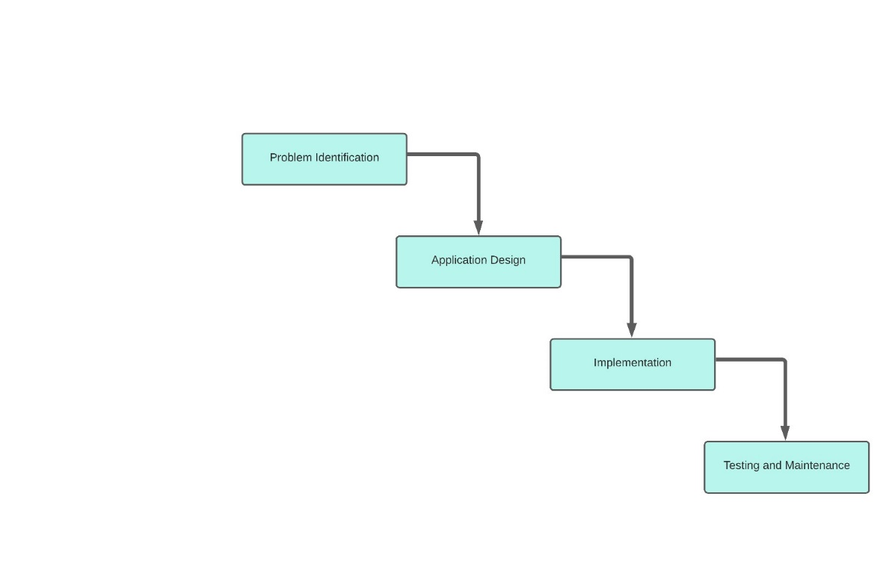

Figure 3 Process of Study

# **System Architecture**

The system architecture is shown in figure

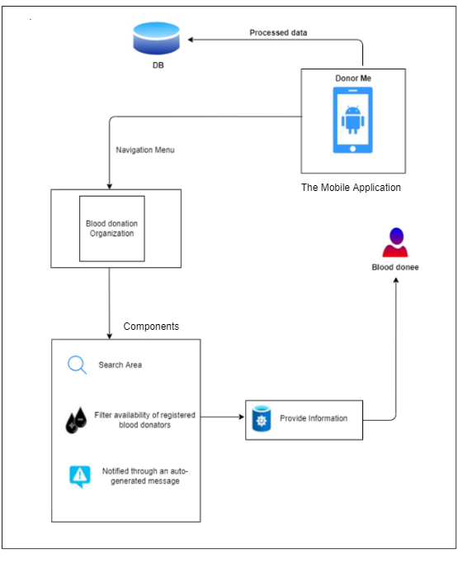

Figure 4 system architecture

# **Requirement Gathering and Analyzing**

For project managers and internal stakeholders, gathering project requirements is the most critical element of the SDLC. During this phase, the client expresses his or her expectations for the project, including who will use the product, how the product will be used, and the specific information that will be included, as well as any special customer requirements for the software.

**Feasibility study**

**Technical feasibility –** Technical feasibility assesses resource such as hardware and software. Analyzes the members of the software development team's technical skills and capabilities. And then determines whether the technology in question is stable and well-established.

**Operational feasibility -** The extent to which the required software performs a series of processes to handle business challenges and user needs is measured by operational feasibility. In this phase the project team determines whether the issues outlined in the user requirements are a high priority.

**Economic feasibility**. – This step determines whether the required software is capable of generating financial gains for an organization. It includes expenses for the software development team, expected hardware and software costs, and the cost of conducting a feasibility study, among other things.

**Implementation**

The project has been developed using mainly Mobile development technologies. The final solution includes an Android mobile application to boost accessibility and user friendliness. Flutter will be use as framework and firebase as the database.

**Testing and Evaluation**

The main objective of the testing and evaluation of the system was to measure the functioning accomplishment of the system as well as the level of user acceptability of the final output of the project. Functional and non-fictional testing will start after the development phase. The application was tested to confirm that it has the functionality that was requested and that it complied with and accommodated all functional requirements.

# **Software Specific Requirement**

**Functional Requirements**

* Login​
* Registration​
* send auto-generated message to register users​
* Locate nearest blood donation camp

**Non-Functional Requirements**

* Availability
* Security and privacy
* Performance
* Usability

**Software Requirements**

* Install the application

**Hardware Requirements**

* Internal Processor i5 core
* Android device

# **Commercialization**

**Our target demographic –** medical sector

**Social Media –** We hope to use Facebook, Instagram, Twitter and Linkedin advertising to determine our target audience.

# **Work Breakdown Structure**

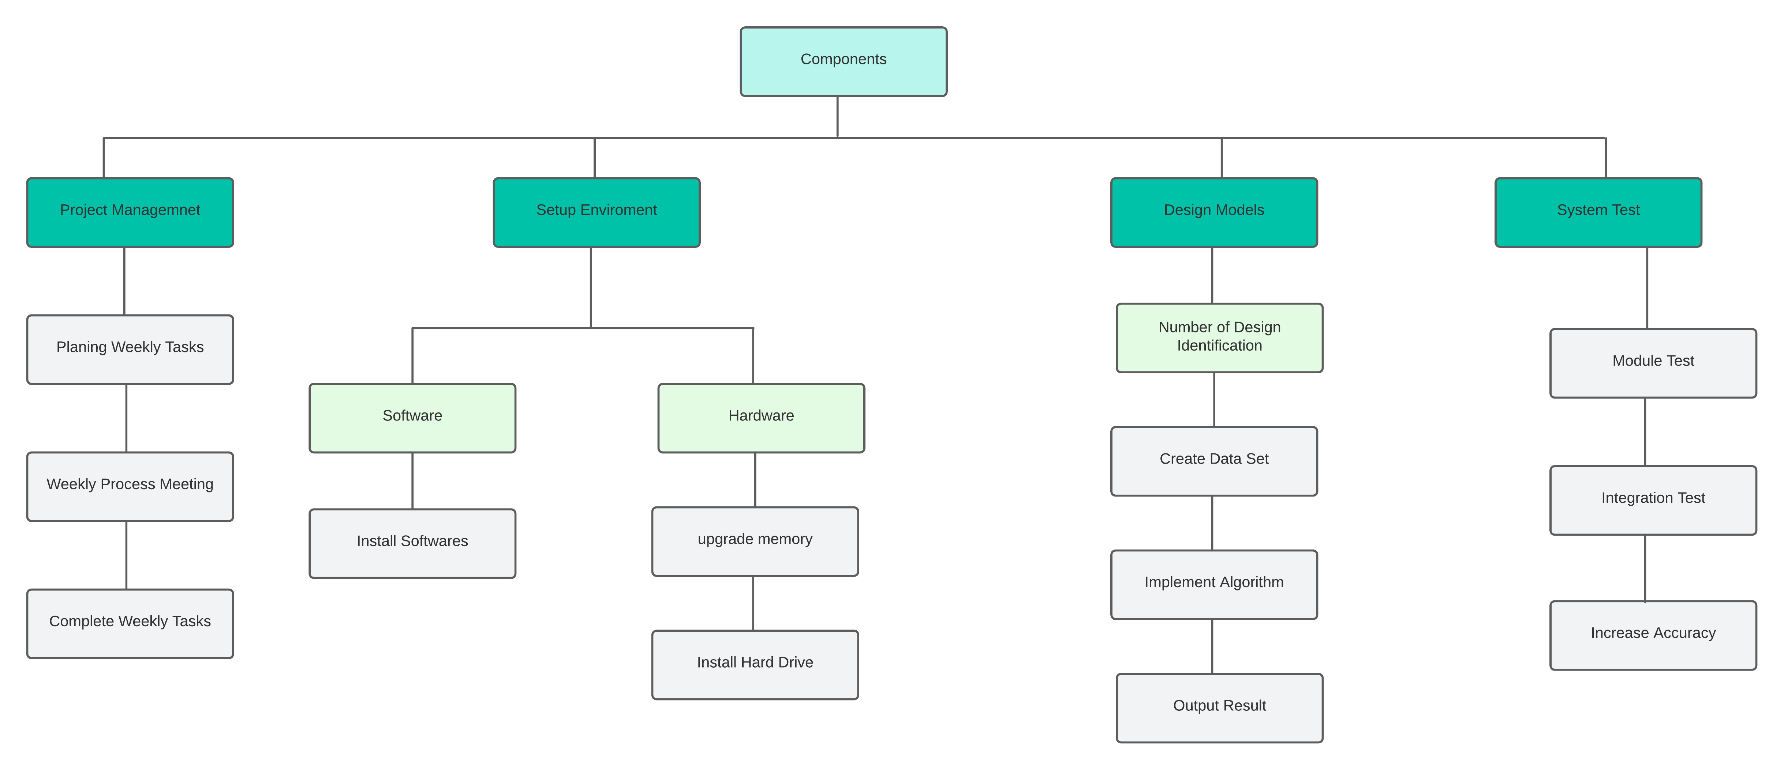

Figure 5 Work Breakdown Structure

# **Grant Chart**

Figure 6 Grant Chart

# **References**

|  |  |
| --- | --- |
| [1] | W. H. ORGANIZATION, "World Blood Donor Day 2020," 2020. [Online]. Available: https://www.who.int/srilanka/news/detail/14-06-2020-world-blood-donor-day-2020. |
| [2] | WONDEROPOLIS, "How Much Blood Is In Your Body?," [Online]. Available: https://wonderopolis.org/wonder/how-much-blood-is-in-your-body#:~:text=Scientists%20estimate%20the%20volume%20of,to%201.5%20gallons)%20of%20blood.. |
| [3] | N. B. T. SERVICE, "ANNUAL STATISTICS REPORT SRI LANKA 2019," 2019. |
| [4] | W.A.V.S.Warnakulasooriya, "Blood Bank & Donor Management," 2019. |
| [5] | S. Periyanayagi1, "BDoor App-Blood Donation Application using," 2018. |
| [6] | T. D. K. C. Padmini, "Present status and future scope of Floriculture industry in Sri Lanka and its potential in women empowerment," *Sri Lanka journal of social sciences,* pp. 1-10, 2017. |
| [7] | "An integrated blood donation campaign management system," 2019. |
| [8] | P. R. -. M. o. H. -. S. Lanka, "National Blood Policy". |
| [9] | WikiPedia. [Online]. Available: https://en.wikipedia.org/wiki/Blood_transfusion_in_Sri_Lanka. |
| [10] | N. B. T. S. -. S. Lanka, "National Blood Transfusion Service - Sri Lanka Facebook Page," [Online]. Available: https://www.facebook.com/nbts.srilanka. |
| [11] | B. M. M. K. J.Terry, "The Psychology of Blood Donation: Current Research and Future Directions," 3 July 2008. [Online]. Available: https://www.sciencedirect.com/science/article/abs/pii/S0887796308000151. |