**MANAGE THE CONNECTION BETWEEN BLOOD BANK AND DONORS ACCORDING TO THE NEEDS**

2022_311

Project Proposal Report

Malkanthi.P.L

B.Sc. (Hons) Degree in Information Technology Specializing in

Information Technology

Department of Information Technology

Sri Lanka

February 2022

**MANAGE THE CONNECTION BETWEEN BLOOD BANK AND DONORS ACCORDING TO THE NEEDS**

2022_311

Project Proposal Report

B.Sc. (Hons) Degree in Information Technology Specializing in

Information Technology

Department of Information Technology

Sri Lanka

February 2022

**DECLARATION**

We declare that this is our own work and this proposal does not incorporate without acknowledgement any material previously submitted for a degree or diploma in any other university or Institute of higher learning and to the best of our knowledge and belief it does not contain any material previously published or written by another person except where the acknowledgement is made in the text.

|  |  |  |
| --- | --- | --- |
| Name | Student Id | Signature |
| Malkanthi.P.L | IT19115108 |  |

The supervisor/s should certify the proposal report with the following declaration. The above candidates are carrying out research for the undergraduate Dissertation under my supervision.

Name of supervisor: **Ms.**

Name of co-supervisor: **Ms.**

Signature of the supervisor: Date:

Signature of the co-supervisor: Date:

**ABSTRACT**

Compared to the currently developed blood donation applications, our mobile application introduces many new features. This application assists the communication between donors and their nearest blood banks according to the needs of the donor and also the blood bank. All blood donors who register through this application will be given an Online passbook instead of the current blood donor passbook which is updated automatically by the system. Donors face detection will be used to access that passbook. Also, Google Map is integrated with this application. During the registration of donors’ system will assist the donors to select the nearest blood banks. When there is an emergency of blood, the system will send a message to chronic donors who are currently near to the blood bank detected using live tracking. Select the registered donors in an emergency according to their eligibility to donate blood and send the notifications to that filtered eligible donors. Relevant donors are chosen automatically by the system based on their blood type and their location, who are tracking using Google Maps. Donors who are not complete 4 months since there last blood donation are excluded by the system. This application sent reminders to the chronic blood donors. Chronic blood donors are eligible to donate blood in 4-month intervals. Such donors are automatically detected ty the system and send a reminder with convenient date and time to donate blood. Also, all registered donors are provided with an online passbook accessible by face detection of donors.

Keywords: Blood bank, Online passbook, Google map, Blood donation, Mobile application, Face detection, Chronic blood donors

**TABLE OF CONTENTS**

**LIST OF TABLES** vi

**LIST OF FIGURES** vi

**1.** **INTRODUCTION** 1

**1.1 Background** 1

**1.2 Literature Review** 3

**1.3 Research Gap** 4

**1.4 Research Problem** 6

**2.** **OBJECTIVES** 7

**2.1 Main Objectives** 7

**2.2 Specific Objectives** 7

**3.** **METHODOLOGY** 9

**4.** **SYSTEM OVERALL DIAGRAM** 11

**5.** **WORK BREAKDOWN STRUCTURE** 13

**6.** **GANTT CHART** 14

**7.** **BUDGET** 15

**REFERENCES** 16

# **LIST OF TABLES**

Table 1. 1 Research Gap with Research Papers 9

# **LIST OF FIGURES**

Figure 3. 1 Face Identification Process 10

# **INTRODUCTION**

## **1.1 Background**

One of the most significant gifts a person can give to society is blood donation. Adults are not at risk when they donate blood. Within a few days, the donor's body can renew blood. It has no effect on the body's metabolism. An unhealthy body need blood for a variety of reasons. He could be suffering from anemia, have undergone surgery, or be involved in an accident. However, because blood is not constantly accessible, such a patient may die from a lack of it. In the event of an emergency, even a pregnant mother may require blood.

When an individual sends blood voluntarily, it is known as a blood donation. Donating blood can be done in two ways: whole blood or specific components. Blood banks are commonly encountered in the blood collection process as well as the procedures that follow. The majority of blood donors in the industrialized world today are unpaid volunteers who donate blood for a group supply. Authorized blood supplies are few in developing nations, so donors frequently donate when family or friends require a transfusion. Donors can also have blood collected for personal use in the future.

Mobile applications have become an integral part of our daily lives [1].So, it is challenging to build a connection between the blood bank and donors. But for those who are interested in the field of blood donation, developing an app like the one above will make their work easier. As just focus on the current communication and interaction between donors and the blood bank, it's noticeable that it's an extremely inefficient and time-consuming process. However, in today's technological world, establishing the connection between the blood bank and the donors through a mobile application would be a very successful and well-planned approach[2][3].

The first phase is to register donors through the application. Instead of just the manual passbook, donors will receive an online passbook. Donors face detection will be used to access that passbook. This enables to access and retrieve data from passbook at any time. It is an efficient and easy process. The previous record of a donor who came to donate blood includes his medical history, blood type, and other facts. Anyone (doctors, nurses) who wishes to know this information can readily access and update it just by detection of faces.

When there is an emergency of blood, the system will send a message to blood donors who are currently near to the blood bank detected using live tracking. Also, during the registration of donors’ system will assist the donors to select the nearest blood banks. Relevant donors are chosen automatically by the system based on their blood type and their location, who are tracking using Google Maps [4].Donors who are not complete 4 months since there last blood donation are excluded by the system. It is possible to improve productivity and effectiveness.

Chronic donors mean donors who are not complete 4 months since there last blood donation.so then Such donors are automatically detected ty the system and send a reminder with convenient date and time to donate blood.

## **1.2 Literature Review**

Various researches have been done on the design and development of blood donation application and research on the views and concerns of the general public regarding such mobile applications. Recent research has shown that Find donors (Apps which help the user find donors), Find centers (Apps which help the user to find centers / hospitals where she / he can donate blood), Records (Apps which record the donation history of the user), Blood types (Apps which explain information about blood types to the user),Blood calculation (Apps which estimate the blood type of a user by using the blood types of relatives),Related to a center (Apps which provide the user with information related to a center or centers such as BTS,hospitals, or laboratories),BD eligibility (Apps which calculate the date on which the user may donate blood based on the date of her / his last) BD General(Apps which provide general information about applications such as the BD process) are currently being developed (Sofia ohubi et al ,2015)[2].

## **1.3 Research Gap**

Some researchers have been done various type of researches about blood donation. But currently there is not fully functional application. Several studies were found from blood donors who were close to where the blood was needed, including GPS mapping of the area. It seems like there are not filtering any relevant blood group and donors who are not complete 4 months since there last blood donation. Filtering blood group is most important because when in emergency messages sent by blood bank will receive every registered donor. Also, once a person has donated blood, he or she will not be able to donate blood again until 4 months later. Then send above mentioned messages to those chronic donors are futile attempt. There are no researches which provide donors with any sort of online passbook.

In my research part when in emergency, system will automatically filtering the relevant blood group, chronic donors who unable to donate blood and nearest donors in emergency area by tracking the GPS. Then send the notifications to those donors. System will automatically send reminders to the chronic donors to after their 4 months completion period of blood donation. That reminder’s include convenient date and time to donate blood. Donors face detection using, the donor who came to donate blood will have his health records, blood type and other information in the donation report. By detecting the face of donor, anyone who wants to know this information (doctors, nurses) can easily access and update that information. These are the research gaps in my research. As I go through research papers, I have come up with a chart which is related to my research area.

|  |  |  |  |  |  |
| --- | --- | --- | --- | --- | --- |
| Research | Live tracking donors via GPS | Filtering eligible donors (blood group, chronic donor, nearby location) | Automatically detect the chronic donors & send reminders | Face Detection | Provide online passbook |
| Gamified Mobile Blood Donation Applications[5] | No | No | No | No | No |
| Blood Donation Application with  Implementation of Machine Learning[4] | Yes | No | No | No | No |
| Preferences and features of a blood donation smartphone app [6] | No | No | No | No | No |
| Android-Based Geolocation Technology on a Blood Donation System (BDS) Using the Dijkstra Algorithm[7] | Yes | No | No | No | No |
| Proposed System | Yes | Yes | Yes | Yes | Yes |

Table 1. 1 Research Gap with Research Papers

## **1.4** **Research Problem**

Identified research questions are,

01) Obtain permission for live tracking

02) Obtain permission for sent messages

03) How to notify the eligible doners by autogenerated massages?

04) How to protect the confidentiality of donors' information

05) How to develop more accurate face detected authentication?

Obtaining valid approval for live monitoring of mobile devices is a problem when registering donors. We must also create the necessary terms and conditions for that.

Permission must also be obtained to send a message to the donor's mobile device when necessary.

The facial recognition authentication method is used to acquire access to the pass book in order to ensure the confidentiality of donor information.

In order to overcome the problem of increasing the accuracy of the facial recognition system, it is hoped to study the new studies conducted on this topic and develop on its effective results.

# **OBJECTIVES**

## **2.1 Main Objectives**

* **Manage the communication between the blood bank and the donors in accordance with their requirements.**

Key objective is to produce a connection between a Blood Bank and a Donor through an emergency application. This will allow the blood bank to quickly meet the demand for blood. Because there is currently no online system, being unable to obtain blood in an emergency could result in death. Also, if a person wants to donate blood, he can do so without difficulty. The lack of an efficient relationship between the two parties indicated above is currently the biggest issue. As a result, this online methodology can be used to handle current problems.

## **2.2 Specific Objectives**

* **Face Detection**

Before a donor donate the blood, his or her previous blood donation records must be checked to see if he or she is qualified. The required party can receive donor information by detecting the donor’s face to obtain such records. It happens that when the donor registers, one current picture of the donor has to be uploaded. Face recognition makes a comparison with that image.

* **Provide an online passbook**

In currently all the blood donors have manual passbook. It contains information about prior blood transfusions, such as locations, dates, blood group, medical history and other details. It's a fair bit of work to keep a manual passbook up to date. The information in the book can be obtained and updated as needed by detecting the donor’s face stated above. Every time you go to donate blood, you will be given leaflets to fill out. An online passbook eliminates the need to constantly fill out such procedures. There is no need to refill the manual once the data has been entered into the application.

* **Send notifications to the registered eligible donors, by using google map**

When in blood emergency, firstly blood bank filter the blood emergency area then filter the blood type. After that, the system will automatically send messages across Google Maps to all donors who meet the above criteria. When filtering above, donors who are not complete 4 months since there last blood donation are excluded by the system.

* **Send reminders to the chronic blood donors**

Chronic blood donors mean to donors who donate blood every 4 months. When they have one blood transfusion, they cannot give blood until 4 months

# **METHODOLOGY**

First and foremost, all blood donors need to use the app to register. They should fill out a form in order to do so. Name, address, phone number, age, date of birth, weight, height, blood type, and nearest blood bank branch are all included. They will be provided an online Individualized Passbook after their account has been setup. It includes the donor's previous medical records as well as the most recent blood donation report. The contents of this book are available for viewing and editing by the appropriate parties. Passbook can be produced in this manner by applying the applicable donor's face detection approach. Upon identification, the donor's face system automatically identifies and accesses the online passbook. This means that the relevant parties should be able to know the medical history of the donor and other details in the passbook. When going to donate blood, this book generally needs you to fill out leaflets with the donor's information. Donors shouldn't have to fill out the leaflets again once they have filled them out and submitted them. In addition, each piece of information should be recorded in the passbook. The necessary parties will update the information to the donor's online passbook.

The blood bank should use Google Maps to identify donors in specific areas and send messages. It has been decided to use Google API technology for this purpose. When in blood emergency situation donee search the emergency area, system will filter the donors who in the emergency area by using google map. Then donee filter the relevant blood group and send the messages to eligible donors. This is when the information provided at donors’ registration comes in useful. System will automatically exclude the donors who have not complete the 4 months after last blood donation. And also, system will automatically send reminders to the chronic donors every 4 months. That reminders include convenient date and time to donate blood.

When detection the face reorganization, it is hoped to use one of the biometric detection technologies based primarily on the processing of information about facial features to automatically identify the face. Accurately locate the key feature points on the face in the picture (such as eyes, nose, mouth, etc.), used to determine the face posture and face alignment.

It can be used for fast matching in 1:1 mode (verification), as well as 1: N (n= large database size) mode (identification). Calculate the similarity of two faces based on feature extraction to see if they are the same person. The input template is considered to have successfully matched with the stored template if the matching score is higher than the pre-defined facial matching threshold. (Figure 3.1)

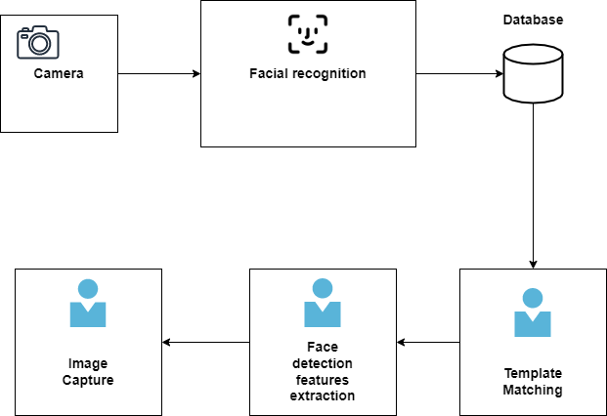

Figure 3. 1 Face Identification Process

# **SYSTEM OVERALL DIAGRAM**

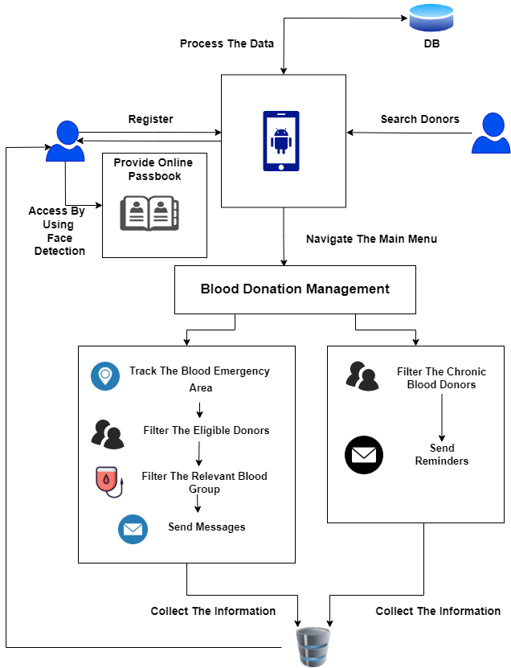

If the diagram above is described simply,

First, all donations should be registered through the application, as shown in the diagram above. After that, they'll get an online passbook. Donor's facial detection technique is used to access the passbook.

In the event of a blood emergency, the blood bank uses google maps to locate the place where blood is needed.

Then filter the donors who live in the area where a blood emergency has occurred. The necessary blood type is subsequently filtered, and the relevant persons are chosen. The system automatically removes donors who have not completed 4 months since their last blood donation, and notifies the remaining donors.

Every four months, reminders are issued to chronic blood donors. Chronic blood donors mean to donors who donate blood every 4 months.

# **WORK BREAKDOWN STRUCTURE**

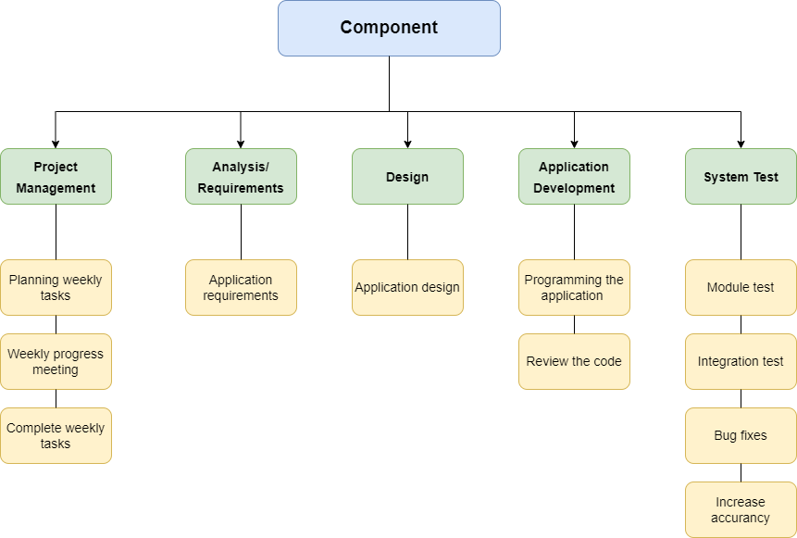

# **GANTT CHART**

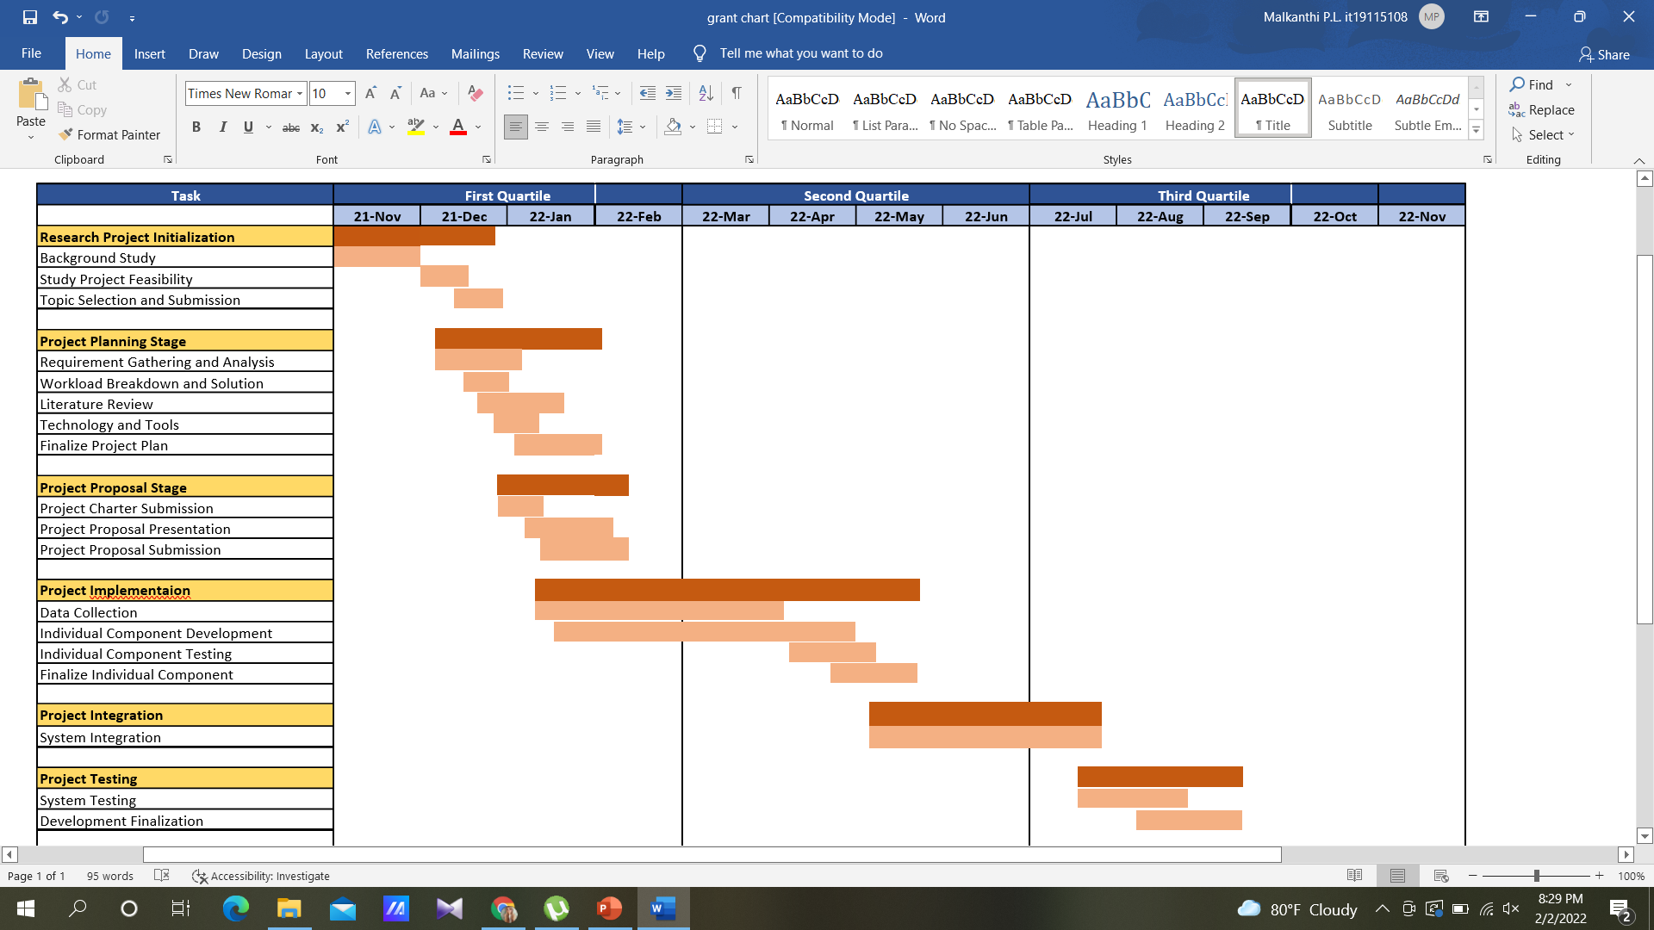

# **BUDGET**

|  |  |  |
| --- | --- | --- |
| Resource Type​ | Amount (LKR)​ | Amount (USD)​ |
| Electricity​ | 8000.00​ | $36.91​ |
| Stationary​ | 4000.00​ | $16.96​ |
| Internet​ | 4000.00​ | $16.96​ |
| Communication​ | 4000.00​  ​ | $16.96​  ​ |
| Software Purchasing​ | 4000.00​  ​ | $16.96​  ​ |
| Total​ | 24000.00​ | $104.75​ |

# **REFERENCES**

[1] B. Martínez-Pérez, I. De La Torre-Díez, and M. López-Coronado, “Mobile health applications for the most prevalent conditions by the world health organization: Review and analysis,” *J. Med. Internet Res.*, vol. 15, no. 6, 2013, doi: 10.2196/jmir.2600.

[2] S. Ouhbi, J. L. Fernández-Alemán, A. Toval, A. Idri, and J. R. Pozo, “Free Blood Donation Mobile Applications,” *J. Med. Syst.*, vol. 39, no. 5, pp. 1–20, 2015, doi: 10.1007/s10916-015-0228-0.

[3] H. Moghaddasi, F. Asadi, A. Hosseini, and Z. Ebnehoseini, “E-health: A global approach with extensive semantic variation,” *J. Med. Syst.*, vol. 36, no. 5, pp. 3173–3176, 2012, doi: 10.1007/s10916-011-9805-z.

[4] S. N. Diba, “Blood Donation Application with Implementation of Machine Learning,” no. April, 2018.

[5] L. Sardi, A. Idri, and J. L. Fernández-Alemán, “Gamified mobile blood donation applications,” *Lect. Notes Comput. Sci. (including Subser. Lect. Notes Artif. Intell. Lect. Notes Bioinformatics)*, vol. 10208 LNCS, pp. 165–176, 2017, doi: 10.1007/978-3-319-56148-6_14.

[6] A. A. Batis and A. Albarrak, “Preferences and features of a blood donation smartphone app: A multicenter mixed-methods study in Riyadh, Saudi Arabia,” *Comput. Methods Programs Biomed. Updat.*, vol. 1, no. February, p. 100005, 2021, doi: 10.1016/j.cmpbup.2021.100005.

[7] S. Ahdan and S. Setiawansyah, “Android-Based Geolocation Technology on a Blood Donation System (BDS) Using the Dijkstra Algorithm,” *IJAIT (International J. Appl. Inf. Technol.*, vol. 5, no. 01, p. 1, 2021, doi: 10.25124/ijait.v5i01.3317.