**DONOR ME: MANAGE THE CONNECTION BETWEEN BLOOD BANK AND DONORS**

Malkanthi.P.L

(IT1915108)

B.Sc. (Hons) Degree in Information Technology Specializing in Information Technology

Department of Information Technology

Sri Lanka Institute of Information Technology Sri Lanka

September 2022

**DONOR ME: MANAGE THE CONNECTION BETWEEN BLOOD BANK AND DONORS**

Malkanthi.P.L

(IT1915108)

Dissertation submitted in partial fulfilment of the requirements for the Bachelor of Science (Honours) Degree in Information Technology Specializing in Information Technology

Department of Information Technology

Sri Lanka Institute of Information Technology Sri Lanka

September 2022

# **DECLARATION**

The following declaration should be made by the candidate following the signature and the date. A candidate, after a discussion with the supervisor/s can request an embargo for a particular dissertation for a given work for a given time or indefinitely. Such an embargo may override the statement made in the dissertation itself.

“I declare that this is my own work and this dissertation1 does not incorporate without acknowledgement any material previously submitted for a Degree or Diploma in any other University or institute of higher learning and to the best of my knowledge and belief it does not contain any material previously published or written by another person except where the acknowledgement is made in the text.

Also, I hereby grant to Sri Lanka Institute of Information Technology, the non-exclusive right to reproduce and distribute my dissertation, in whole or in part in print, electronic or other medium. I retain the right to use this content in whole or part in future works (such as articles or books).

|  |  |  |
| --- | --- | --- |
| Name | Student Id | Signature |
| Malkanthi.P.L | IT19115108 |  |

The supervisor/s should certify the dissertation with the following declaration.

The above candidate has carried out research for the bachelor’s degree

Dissertation under my supervision.

Signature of the supervisor: Date:

# **ABSTRACT**

Blood donation saves lives, and donors' and blood establishments' communication are necessary to this. Smart apps are increasingly seen as an essential tool for communication and could be most effectively used in blood donation if they are created with the needs and preferences of the user in consideration. Compared to the currently developed blood donation applications, our mobile application introduces many new features. This application assists communication between donors and their nearest blood banks according to the needs of the donor and also the blood bank. All blood donors who register through this application will be given an online passbook instead of the current blood donor passbook, which is updated automatically by the system. It is done by scanning a QR code belonging to the respective blood camp or hospital. This process will be successful only if one's identity is proven through the phone's fingerprint, face identification, or any other screen lock type available on the phone. Also, Google Maps is integrated with this application. During the registration of donors, the system will assist the donors to select the nearest blood bank. When there is a blood emergency, the system will send a notification to the blood donors who are currently near to the blood bank using live tracking. Here, chronic donors who are not complete 4 months since their last blood donation are excluded by the system. And predict the monthly blood count for thalassemia.

**Keywords** – Blood donation, Mobile application, Blood bank, Blood donor, Online passbook, QR code, Fingerprint, Face identification, Google maps, Chronic donors, Thalassemia

**TABLE OF CONTENTS**

**DECLARATION** 1

**ABSTRACT** 2

**LIST OF FIGURES** 4

**LIST OF TABLES** 5

**1.** **INTRODUCTION** 6

**1.1** **Background literature** 8

**1.2** **Research gap** 10

**2.RESEARCH PROBLEM** 12

**3.RESEARCH OBJECTIVES** 14

**3.1 Main Objectives** 14

**3.2 Sub Objectives** 14

**4.METHODOLOGY** 16

**4.1 Methodology** 16

**4.2 Commercialization** 24

**5.TESTING & IMPLEMENTATION** 25

**5.1 Results** 25

**5.2 Research Findings** 45

**5.3 Summary of each student’s contribution** 45

**6.CONCLUSION** 46

**REFERENCE** 47

**APPENDICES** 49

# **LIST OF FIGURES**

Figure 4. 1 Register step 01 16

Figure 4. 2 Register step 02 17

Figure 4. 3 Register step 03 17

Figure 4. 4 Register step 04 18

Figure 4. 5 Online Passbook Dashboard 18

Figure 4. 6 Online Passbook Dashboard 18

Figure 4. 7 Face ID Screen 19

Figure 4. 8 Screen Lock Type 19

Figure 4. 9 Face ID Screen 20

Figure 4. 10 Selection of Camp or Hospital 21

Figure 4. 11 QR Scanning 21

Figure 4. 12 After the updating donation records 22

Figure 4. 13 Select the blood group 23

Figure 4. 14 After the sending notification 23

# **LIST OF TABLES**

Table 1. 1 Research Gap with Research Papers 11

Table 4. 21 Business model for Donor me with pricing rates 24

Table 5. 1 Testing Devices 25

Table 5. 2 Functional test types 26

Table 5. 3 Non-Functional Test Types 26

Table 5. 4 Login with empty email and password 27

Table 5. 5 Login with valid email and invalid password 28

Table 5. 6 Login with invalid email and valid password 29

Table 5. 7 Login with valid email and password 30

Table 5. 8 Login with invalid email and password 31

Table 5. 9 Navigate the passbook using invalid screen lock type 32

Table 5. 10 Navigate the passbook using valid screen lock type 33

Table 5. 11 Navigate the passbook using valid face ID 35

Table 5. 12 Navigate the passbook using invalid face ID 37

Table 5. 13 Update the online passbook using correct screen lock type, face ID and QR for blood donation camp 39

Table 5. 14 Update the online passbook using correct screen lock type, face ID and QR for Hospital 41

Table 5. 15 Send the blood emergency notifications to the donors 43

Table 5. 16 Donors receive blood emergency notifications 44

# **INTRODUCTION**

One of the most significant gifts a person can give to society is blood donation. Adults are not at risk when they donate blood. Within a few days, the donor's body can replenish blood. It has no effect on the body's metabolism. An unhealthy body needs blood for a variety of reasons. He could be suffering from anemia, have undergone surgery, or be involved in an accident. However, because blood is not constantly accessible, such a patient may die from a lack of it. In the event of an emergency, even a pregnant mother may require blood. When an individual gives blood voluntarily, it is known as a blood donation. Donating blood can be done in two ways: whole blood or specific components. Blood banks are commonly encountered in the blood collection process as well as the procedures that follow. The majority of blood donors in the industrialized world today are unpaid volunteers who donate blood for a group supply. Authorized blood supplies are few in developing nations, so donors frequently donate when family or friends require a transfusion. Donors can also have blood collected for personal use in the future. Mobile applications have become an integral part of our daily lives [1]. So, it is challenging to build a connection between the blood bank and donors. But for those who are interested in the field of blood donation, developing an app like the one above will make their work easier. If we just focus on the current communication and interaction between donors and the blood bank, it's noticeable that it's an extremely inefficient and time-consuming process. However, in today's technological world, establishing the connection between the blood bank and the donors through a mobile application would be a very successful and well-planned approach.[2][3].

The first phase is to register donors through the application. Instead of just the manual passbook, donors will receive an online passbook. If successful identity is proven through the phone's fingerprint, face identification, or any other screen lock type available on the phone, it will be used to access that passbook. Passbook data will be updated by scanning a QR code belonging to the respective blood camp or hospital. This enables you to access and retrieve data from your passbook at any time. It is an efficient and easy process. The previous record of a donor who came to donate blood includes his medical history, blood donation dates, donation places, and other facts.

When there is an emergency with blood, the system will send a notification to blood donors who are currently near to the blood bank using live tracking. Also, during the registration of donors, the system will assist the donors in selecting the nearest blood bank. Relevant donors are chosen automatically by the system based on their blood type and their location, which is tracked using Google Maps [4]. Donors who have not completed 4 months since their last blood donation are excluded by the system. It is possible to improve productivity and effectiveness. Chronic donors mean donors who have not completed 4 months since their last blood donation.

Thalassemia is an inherited blood disorder that causes your body to have less haemoglobin than normal. Haemoglobin enables red blood cells to carry oxygen. Thalassemia can cause anaemia, leaving you fatigued.

More than 18 million people live in Sri Lanka. Composed of Tamils (18%), and Sinhalese (74%). Thalassaemia was first discovered in Sri Lanka in 1951. Since then, there have been a few reports of additional cases and the occurrence of HbE and HbE/thalassaemia in the population.5-9 Over the past few years, an increased number of patients with the clinical features of severe thalassaemia have been attending paediatric clinics all over the island. Although many of them receive intermittent or regular blood transfusions, nothing is currently known about the specific forms of thalassaemia that are being treated in this way. [8]

As a result, the thalassemia unit requires significantly more blood for transfusions. Some patients want weekly blood transfusion. Then the hospital was struggling to find blood. And there are some sub-specific blood categories. They are red cell packed, leuko depleted blood, washed red cells. These are the subgroups of blood groups. For example, some patients want O positive red cell pack blood. Some patients should also have weekly blood transfusions. If there are some monthly blood predictions for each thalassemia blood center, relevant blood group subcategories count. That would be much better for patients and thalassemia centers.

## **Background literature**

Various researches have been done on the design and development of blood donation application and research on the views and concerns of the general public regarding such mobile applications. Recent research has shown that Find donors (Apps which help the user find donors), Find centers (Apps which help the user to find centers / hospitals where she / he can donate blood), Records (Apps which record the donation history of the user), Blood types (Apps which explain information about blood types to the user),Blood calculation (Apps which estimate the blood type of a user by using the blood types of relatives),Related to a center (Apps which provide the user with information related to a center or centers such as BTS,hospitals, or laboratories),BD eligibility (Apps which calculate the date on which the user may donate blood based on the date of her / his last) BD General(Apps which provide general information about applications such as the BD process) are currently being developed (Sofia ohubi et al ,2015)[2].

The thalassemia, the commonest monogenic diseases, are a group of inherited disorders of hemoglobin.  There are two main types: thalassemia and the homozygous or compound heterozygous states for the thalassemia. They are characterized by profound anemia in the first few months of life; survival is dependent on regular blood transfusions and the use of iron-preventing agents for the rest of one's life. Many of the countries in which the thalassemia occur at a high frequency are experiencing a major demographic transition following improvements in hygiene, diet, and the availability of medical services. Babies and young children with thalassemia, who would previously have died of infection or malnutrition during the early years of life, are now surviving long enough to be present for diagnosis and treatment. Hence, these conditions will pose an increasingly serious public health problem, particularly for the Indian subcontinent and many parts of Southeast Asia.[9]

Most of the Sri Lankan research is done to find the thalassemia patients count in our country. There are 2 main types of thalassemia: alpha and beta. Different genes are affected by each type. As a result, the purpose of this research is to identify types of patients in specific locations and to count the number of patients in those areas. [8] The signs and symptoms you have depend on the type and severity of your condition. Thalassemia signs and symptoms can include:

* Fatigue
* Weakness
* Pale or yellowish skin
* Facial bone deformities
* Slow growth
* Abdominal swelling
* Dark urine

So, researchers looked into how to find these symptoms earlier. And what are the main things to do when you identify these symptoms. How does this disease spread.

## **Research gap**

Some researchers have been done various type of researches about blood donation. But currently there is not fully functional application. Several studies were found from blood donors who were close to where the blood was needed, including GPS mapping of the area. It seems like there are not filtering any relevant blood group and donors who are not complete 4 months since there last blood donation. Filtering blood group is most important because when in emergency messages sent by blood bank will receive every registered donor. Also, once a person has donated blood, he or she will not be able to donate blood again until 4 months later. Then send above mentioned messages to those chronic donors are futile attempt. There are no researches which provide donors with any sort of online passbook.

In my research part when in emergency, system will automatically filtering the relevant blood group, chronic donors who unable to donate blood and nearest donors in emergency area by tracking the GPS. Then send the notifications to those donors. System will automatically send reminders to the chronic donors to after their 4 months completion period of blood donation. That reminder’s include convenient date and time to donate blood. Donors face detection using, the donor who came to donate blood will have his health records, blood type and other information in the donation report. By detecting the face of donor, anyone who wants to know this information (doctors, nurses) can easily access and update that information.

And also, finding the blood count of each hospital wants to get for transfusion to thalassemia patients is a very valuable thing in Sri Lanka. As a result, each hospital can determine the number of blood paints required, which will aid in the reduction of blood waste. Because blood cannot be kept for a long time. Currently, there are no developed applications for this kind of blood prediction.

These are the research gaps in my research. As I go through research papers, I have come up with a chart which is related to my research area. Table 1. 1 Research Gap with Research Papers

|  |  |  |  |  |  |  |
| --- | --- | --- | --- | --- | --- | --- |
| Research | Live tracking donors via GPS | Filtering eligible donors (blood group, chronic donor, nearby location) | Mobile phones’ screen lock type for identification (Face detection, fingerprint, pin code, pattern) | Provide online passbook | Update the online passbook by scanning QR code | Blood count prediction in relevant hospitals for thalassemia |
| Gamified Mobile Blood Donation Applications[2] | No | No | No | No | No | No |
| Blood Donation Application with  Implementation of Machine Learning[3] | Yes | No | No | No | No | No |
| Preferences and features of a blood donation smartphone app [4] | No | No | No | No | No | No |
| Android-Based Geolocation Technology on a Blood Donation System (BDS) Using the Dijkstra Algorithm[5] | Yes | No | No | No | No | No |
| Proposed System | Yes | Yes | Yes | Yes | Yes | Yes |

Table 1. 1 Research Gap with Research Papers

# **2.RESEARCH PROBLEM**

A novel approach to global health [6] that seeks to enhance the delivery of health services to people is the provision of health care via electronic means (e-health). Personal health records (PHRs), home nursing [1], emergency health care information, electronic medical records (EMR), electronic health records (EHR], and health monitoring systems are only a few examples of the various e-health solutions that are currently available. As a result, computer literacy is becoming more crucial and a condition for citizenship.

Due to the difficulty in locating rapid blood donors and the related bureaucracy, there is a considerable rise in fatalities. According to statistics, less than 1% of the 73 countries have donation rates (fewer than 10 donations per 1000 people). 70 of these are transitional or developing nations.

The number of requests for blood donors has been steadily rising as a result of the rapid development in social networking site usage around the world, as evidenced by the number of posts on websites like Facebook and Twitter asking for blood donors. It is challenging to find a blood donor almost anywhere.

Being unable to identify nearby blood donors in an emergency finding blood donors in the area where the event happened might be challenging when there is a time crunch.

Identified research questions are,

01) Obtain permission for live tracking

02) Obtain permission for sent messages

03) How to notify the eligible doners by autogenerated massages?

04) How to protect the confidentiality of donors' information

05) How to develop more accurate face detected authentication?

06) How to enhance passbook access through the mobile phone’s screen lock type

07) How to predict relevant hospitals’ blood count for thalassemia patients ?

Obtaining valid approval for live monitoring of mobile devices is a problem when registering donors. We must also create the necessary terms and conditions for that.

Permission must also be obtained to send a message to the donor's mobile device when necessary.

The facial recognition authentication method is used to acquire access to the pass book in order to ensure the confidentiality of donor information.

In order to overcome the problem of increasing the accuracy of the facial recognition system, it is hoped to study the new studies conducted on this topic and develop on its effective results.

When it comes to thalassemia, major problem is how to find the required blood counts. Because some patients require a weekly blood transfusion of two or three blood paints. Then each thalassemia unit should have considerable blood storage. That’s why it's important for blood prediction for each hospital's blood sub categories to count.

# **3.RESEARCH OBJECTIVES**

## **3.1 Main Objectives**

* **Manage the communication between the blood bank and the donors in accordance with their requirements.**

Key objective is to produce a connection between a Blood Bank and a Donor through an emergency application. This will allow the blood bank to quickly meet the demand for blood. Because there is currently no online system, being unable to obtain blood in an emergency could result in death. Also, if a person wants to donate blood, he can do so without difficulty. The lack of an efficient relationship between the two parties indicated above is currently the biggest issue. As a result, this online methodology can be used to handle current problems.

* **Blood prediction for thalassaemia in each hospital**

Monthly blood prediction for thalassemia is the most valuable thing and there are eight blood groups. Those groups are categorized into three types. Red cells pack, leuko depleted blood, washed red cells. Patients want the above-mentioned blood. So, the system will predict each hospital's relevant blood subcategory blood count.

## **3.2 Sub Objectives**

* **Face Detection**

Before a donor donate the blood, his or her previous blood donation records must be checked to see if he or she is qualified. The required party can receive donor information by detecting the donor’s face to obtain such records. It happens that when the donor registers, one current picture of the donor has to be uploaded. Face recognition makes a comparison with that image.

* **Provide an online passbook**

In currently all the blood donors have manual passbook. It contains information about prior blood transfusions, such as locations, dates, blood group, medical history and other details. It's a fair bit of work to keep a manual passbook up to date. The information in the book can be obtained and updated as needed by detecting the donor’s face stated above & screen lock type as well. Every time you go to donate blood, you will be given leaflets to fill out. An online passbook eliminates the need to constantly fill out such procedures. There is no need to refill the manual once the data has been entered into the application. Donors can update their blood donation record by scanning a QR code. That code belongs to a particular hospital or camp details. When scanning the QR, the system will automatically update the donation date, time, and place.

* **Send notifications to the registered eligible donors, by using google map**

When in blood emergency, firstly blood bank filter the blood emergency area then filter the blood type. After that, the system will automatically send notifications across Google Maps to all donors who meet the above criteria. When filtering above, donors who are not complete 4 months since there last blood donation are excluded by the system.

* **Mobile phone’s default screen lock type**

When a donor comes to the online passbook, they first authenticate their authentication by using the default screen lock type (PIN number, pattern, etc.). Only if that authentication is successful, can the user do face detection.

# **4.METHODOLOGY**

## **4.1 Methodology**

The percentage of people donating blood is increasing day by day due to increased awareness of the need to donate blood. The blood received has to be managed thoroughly so that there will be no negative effects on the blood receiver once they have received blood.

Android Studio is used for development of the entire project and flutter and firebase is used.

First and foremost, all blood donors need to use the app to register. They should fill out a form in order to do so. Name, address, age, NIC, weight, blood type, email, password, last blood donation date and chronic donor or not. [7] Figure 4. 1 Register step 01 UI, Figure 4. 2 Register step 02 UI, Figure 4. 3 Register step 03 UI, Figure 4. 4 Register step 04 UI

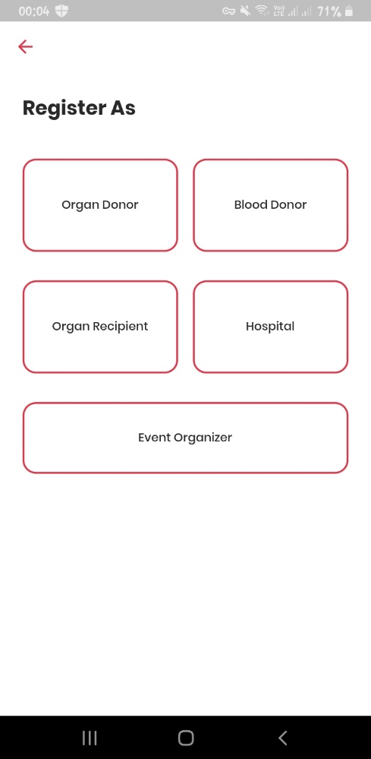

Figure 4. 1 Register step 01

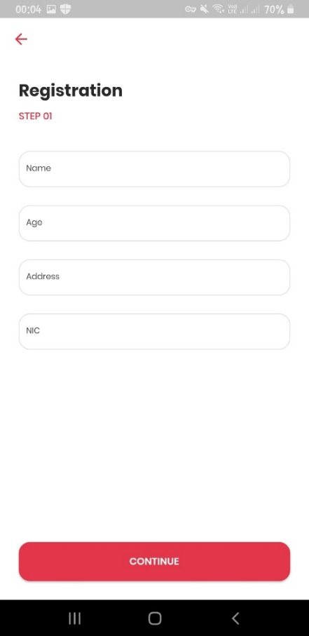

Figure 4. 2 Register step 02

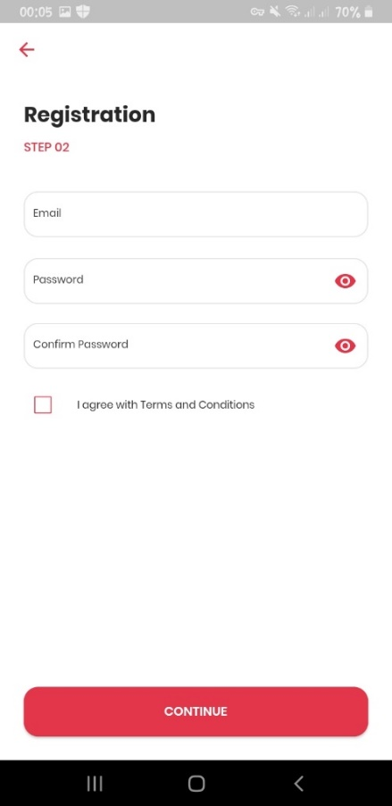

Figure 4. 3 Register step 03

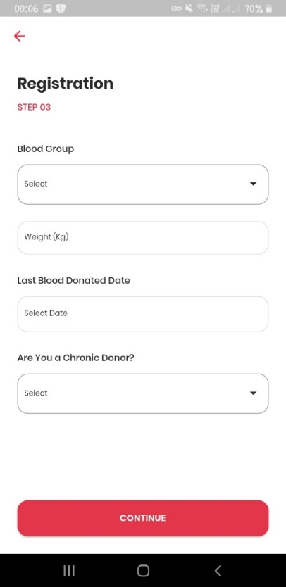

Figure 4. 4 Register step 04

They will be provided an online Individualized Passbook after their account has been setup.

Figure 4. 5 Online Passbook Dashboard

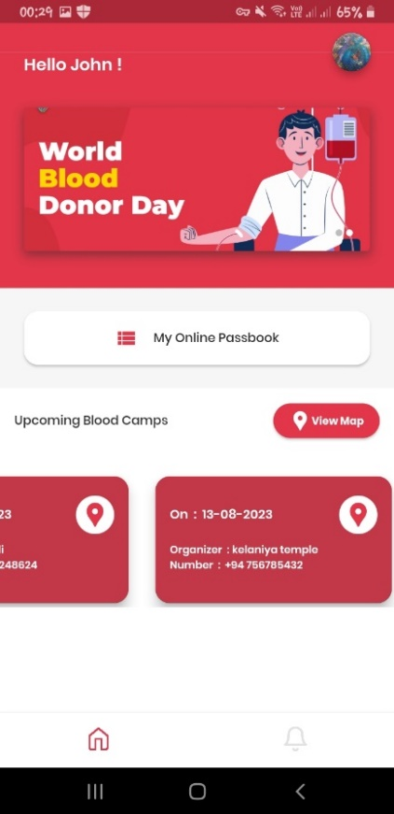

Figure 4. 6 Online Passbook Dashboard

It includes the donor's previous medical records as well as the most recent blood donation report. The contents of this book are available for viewing and editing by the appropriate parties. First, users should authenticate their authentication by using their mobile’s default screen lock type. Figure 4. 7 Screen Lock Type

If that is successful, then an after passbook can be produced in this manner by applying the applicable donor's face detection approach. Figure 4. 7 Face ID Screen

When detection the face reorganization, it is hoped to use one of the biometric detection technologies based primarily on the processing of information about facial features to automatically identify the face. Accurately locate the key feature points on the face in the picture (such as eyes, nose, mouth, etc.), used to determine the face posture and face alignment.

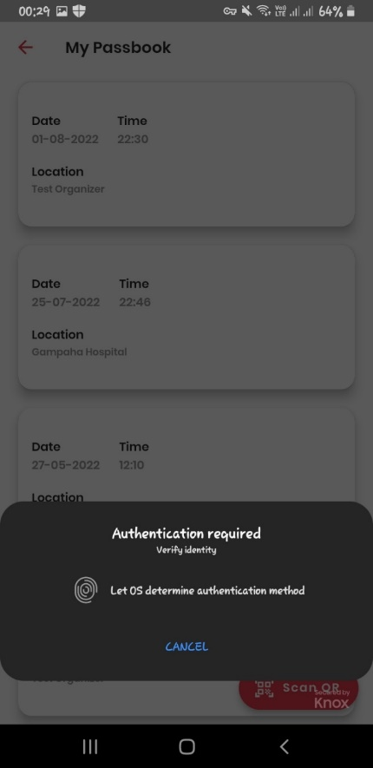

Figure 4. 8 Screen Lock Type

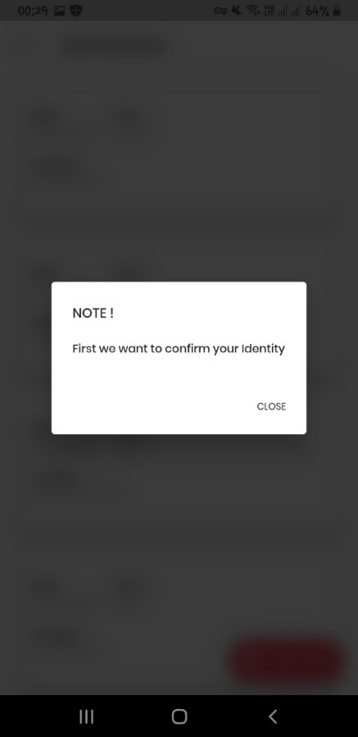

Figure 4. 9 Face ID Screen

Upon identification, the donor's face system automatically identifies and accesses the online passbook. After that, the donor should select the place from two selection of Blood Camp or Hospital. It means donor’s donation place. Figure 4. 10

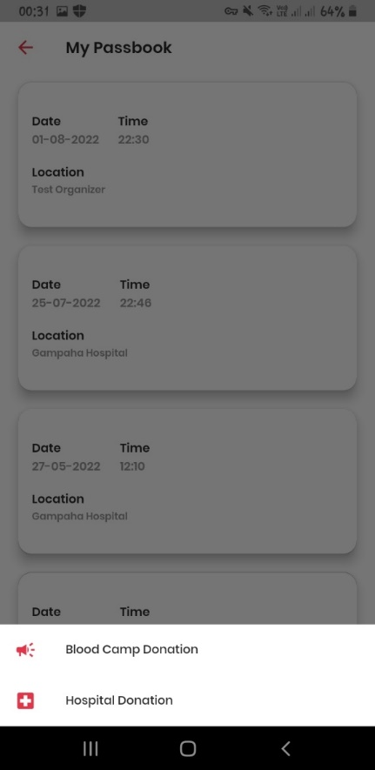

Figure 4. 10 Selection of Camp or Hospital

Then donor can scan the QR code, and the donation records will update automatically. QR belongs to a particular blood camp and hospital that is registered in our application. Figure 4. 11 QR Scanning Figure 4. 12 After the updating donation records

This means that the relevant parties should be able to know the donation history of the donor. When going to donate blood, this book generally needs you to fill out leaflets with the donor's information. Donors shouldn't have to fill out the leaflets again once they have filled them out and submitted them. In addition, each piece of information should be recorded in the passbook.

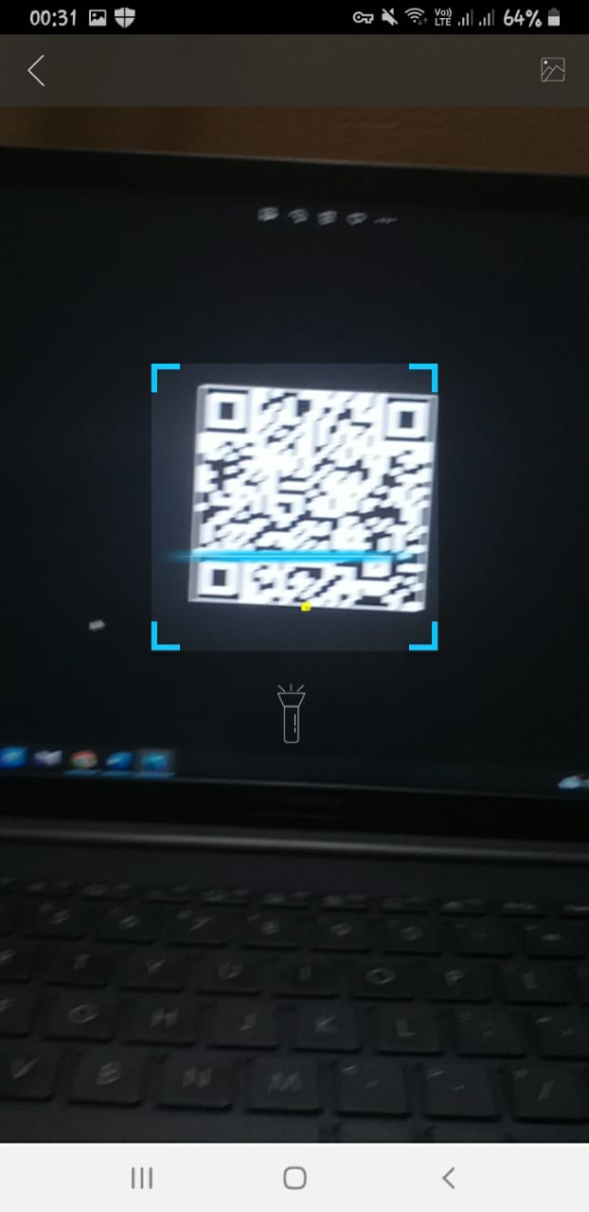

Figure 4. 11 QR Scanning

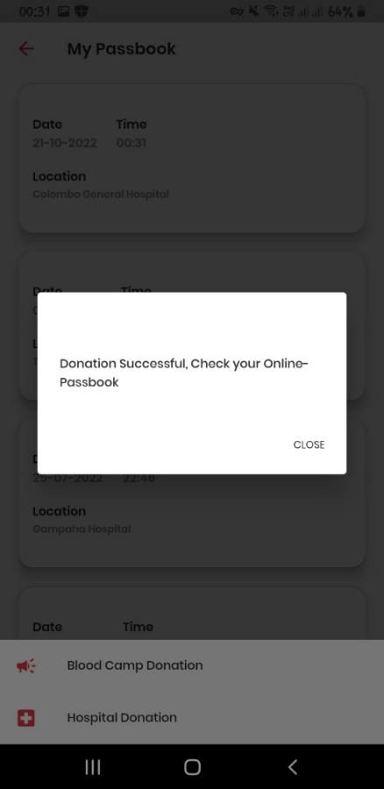

Figure 4. 12 After the updating donation records

The blood bank should use Google Maps to identify donors in specific areas and send notifications. It has been decided to use Google API technology for this purpose. When in blood emergency situation donee search the emergency area, system will filter the donors who in the emergency area by using google map. Then donee filter the relevant blood group and send the notifications to eligible donors. Figure 4. 13 Select the blood group Figure 4. 14 After the sending notification

This is when the information provided at donors’ registration comes in useful. System will automatically exclude the donors who have not complete the 4 months after last blood donation.

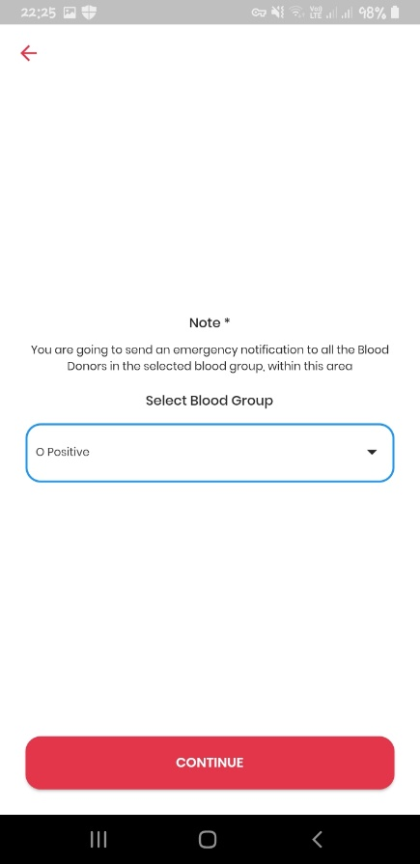

Figure 4. 13 Select the blood group

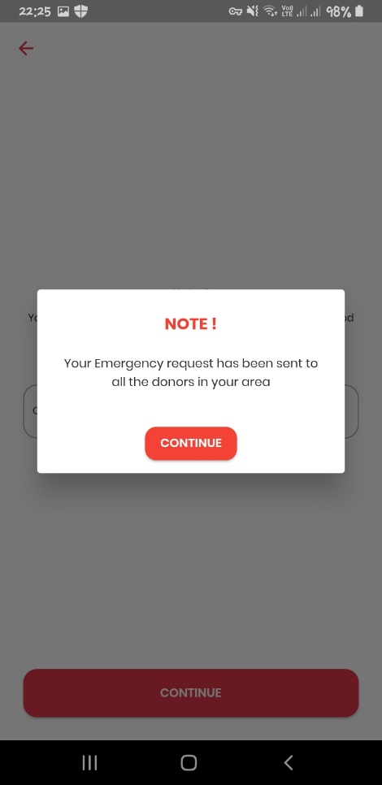

Figure 4. 14 After the sending notification

## **4.2 Commercialization**

Sri Lanka has been identified as a country which has an intermediate prevalence of Thalassemia. Around 3500 patients have been identified in Sri Lanka. Majority of them have thalassemia major. Thalassemia patients, blood donors, organ recipients, and donees in Sri Lanka are the principal target audience for the “Donor me” app. We want to conduct awareness campaigns using social media sites like YouTube, Facebook, Instagram, and Twitter to achieve the core goal of the “Donor me”. Additionally, we are going to conduct awareness campaigns in hospitals and clinics.

Donor me's main advertising platform will be "AdMob. "AdMob is a mobile ad network owned by Google and is the mobile version of Google AdSense. AdMob lets you advertise using formats like text, images, video, or interactive media. And the great thing is you can choose what ad format you want to feature. All ads are custom to present ads related to our app, so we can make more money. You can place ads using automatic artificial intelligence, which means we add one line of code to our app, and ads are automatically generated or we can do manual, which means we pick and place ads where we want them.

By launching “Donor me” as a welfare application, we are planning to conduct an awareness workshop in conjunction with the Ministry of Health and the Ministry of Health in Sri Lanka to inform the doctors and nurses. The primary sources of money for "Donor me" come from government funding provided through special programs like the Ministry of Health.

Local users can download Donor Me after launching the app in the App Store. Basically, this application allows volunteers in the community to donate their tissues and build relationships between the two parties to the process of obtaining those tissues. We suggest that this be used as a free mobile application for government sector, as it does a social service that goes beyond its monetary worth. In the private sector, users are able to utilize the program for free for a three-month trial period. After that, consumers must use one of our monthly or annual packages. Table 4.2 1 Business model for Donor me with pricing rates.

|  |  |
| --- | --- |
| **Package** | **Cost (LKR)** |
| Monthly | 650 |
| Annual | 6500 |

Table 4.2 1 Business model for Donor me with pricing rates

# **5.TESTING & IMPLEMENTATION**

## **5.1 Results**

Due to the wide variety of mobile devices with various screen sizes and resolutions, internal hardware (memory size, processor speed, and button/input differences), various mobile operating systems like Android, Windows, and iOS, and various API levels, testing applications on mobile devices is more difficult than testing web apps on a desktop.

Usability, performance, security, and functional and non-functional testing across various platforms, devices, and browsers are the key elements of a mobile application testing strategy.

Users can drag and drop data from one app to another using the multi-window mode, which is supported by devices running Android 7.0 (API level 24) or higher.

Due to the wide variety of mobile devices with various screen sizes and resolutions, internal hardware (memory size, processor speed, and button/input differences), various mobile operating systems like Android, Windows, and iOS, and various API levels, testing applications on mobile devices is more difficult than testing web apps on a desktop.

Usability, performance, security, and functional and non-functional testing across various platforms, devices, and browsers are the key elements of a mobile application testing strategy.  
Users can drag and drop data from one app to another using the multi-window mode, which is supported by devices running Android 7.0 (API level 24) or higher.

|  |  |  |
| --- | --- | --- |
| **Device** | **Android Version** | **API Level** |
| Samsung Galaxy J2 | 5.1.1 | 22 |
| Samsung Galaxy A2 | 9 | 28 |
| Samsung Galaxy M10 | 9 | 28 |
| Samsung Galaxy A51 | 10 | 29 |

Table 5. 1 Testing Devices

We performed functional and non-functional tests in order to monitor the functionality of the Donor me.

|  |  |
| --- | --- |
| Unit testing | Unit testing is performed separately for “Donor me” sub parts to ensure that all individual components are working properly. |
| Integration testing | “Donor me” individual parts are combined and tested as a group to ensure that functionality is working fine. |
| System testing | Four completed components are integrated and tested as a system to clarify whether outcomes are expected as it is. |
| Regression testing | Done to ensure that existing features working fine with defect fixes. |

Table 5. 2 Functional test types

|  |  |
| --- | --- |
| Usability testing | As the target users are donors and donees usability testing is done to ensure quality and user-friendliness to use by considering fonts, labels, buttons and layout. |
| Portability testing | Done to ensure that application work fine in different operating systems such as android, iOS. |

Table 5. 3 Non-Functional Test Types

**Test Cases:**

Here are a few illustrations of sample test cases used in my component:

|  |  |  |  |  |  |  |  |
| --- | --- | --- | --- | --- | --- | --- | --- |
| **Test Scenario ID** | | Login -1 | | **Test Case ID** | | Login 1A | |
| **Test Case Description** | | Both the email and password fields are empty | | **Test Priority** | | High | |
| **Pre-requisite** | | NA | | **Post-requisite** | | NA | |
| **Test Execution Steps:** | | | | | | | |
| **Step number** | **Action** | | **Inputs** | **Expected result** | **Actual result** | | **Test results** |
| 1 | Launch the app | | - | Login page is displayed | Login page is displayed | | Pass |
| 2 | Click the “LOGIN” button | | - | Login form | Login form | | Pass |
| 3 | Keep both username and password fields empty | | Email: null  Password: null | “Email is missing” and “Password is missing” message displays | “Email is missing” and “Password is missing” message displays | | Pass |

Table 5. 4 Login with empty email and password

|  |  |  |  |  |  |  |  |
| --- | --- | --- | --- | --- | --- | --- | --- |
| **Test Scenario ID** | | Login -2 | | **Test Case ID** | | Login 2A | |
| **Test Case Description** | | Login using valid email and invalid password | | **Test Priority** | | High | |
| **Pre-requisite** | | Should registered user | | **Post-requisite** | | NA | |
| **Test Execution Steps:** | | | | | | | |
| **Step number** | **Action** | | **Inputs** | **Expected result** | **Actual result** | | **Test results** |
| 1 | Launch the app | | - | Login page is displayed | Login page is displayed | | Pass |
| 2 | Click the “LOGIN” button | | - | Login form | Login form | | Pass |
| 3 | Enter valid email and invalid password and click login button | | Email: blooddonor@gmail.com  Password: 123 | “Oops! Incorrect password” message displays | “Oops! Incorrect password” message displays | | Pass |

Table 5. 5 Login with valid email and invalid password

|  |  |  |  |  |  |  |  |
| --- | --- | --- | --- | --- | --- | --- | --- |
| **Test Scenario ID** | | Login -3 | | **Test Case ID** | | Login 3A | |
| **Test Case Description** | | Login using invalid email and valid password | | **Test Priority** | | High | |
| **Pre-requisite** | | Should registered user | | **Post-requisite** | | NA | |
| **Test Execution Steps:** | | | | | | | |
| **Step number** | **Action** | | **Inputs** | **Expected result** | **Actual result** | | **Test results** |
| 1 | Launch the app | | - | Login page is displayed | Login page is displayed | | Pass |
| 2 | Click the “LOGIN” button | | - | Login form | Login form | | Pass |
| 3 | Enter invalid email and valid password and click login button | | Email: blood@gmail.com  Password: 123456 | “Oops! Incorrect email” message displays | “Oops! Incorrect email” message displays | | Pass |

Table 5. 6 Login with invalid email and valid password

|  |  |  |  |  |  |  |  |
| --- | --- | --- | --- | --- | --- | --- | --- |
| **Test Scenario ID** | | Login -4 | | **Test Case ID** | | Login 4A | |
| **Test Case Description** | | Login using valid email and valid password | | **Test Priority** | | High | |
| **Pre-requisite** | | Should registered user | | **Post-requisite** | | NA | |
| **Test Execution Steps:** | | | | | | | |
| **Step number** | **Action** | | **Inputs** | **Expected result** | **Actual result** | | **Test results** |
| 1 | Launch the app | | - | Login page is displayed | Login page is displayed | | Pass |
| 2 | Click the “LOGIN” button | | - | Login form | Login form | | Pass |
| 3 | Enter valid email and valid password and click login button | | Email: blooddonor@gmail.com  Password: 123456 | Successfully redirected to the profile | Successfully redirected to the profile | | Pass |

Table 5. 7 Login with valid email and password

|  |  |  |  |  |  |  |  |
| --- | --- | --- | --- | --- | --- | --- | --- |
| **Test Scenario ID** | | Login -5 | | **Test Case ID** | | Login 5A | |
| **Test Case Description** | | Login using valid email and valid password | | **Test Priority** | | High | |
| **Pre-requisite** | |  | | **Post-requisite** | | NA | |
| **Test Execution Steps:** | | | | | | | |
| **Step number** | **Action** | | **Inputs** | **Expected result** | **Actual result** | | **Test results** |
| 1 | Launch the app | | - | Login page is displayed | Login page is displayed | | Pass |
| 2 | Click the “LOGIN” button | | - | Login form | Login form | | Pass |
| 3 | Enter invalid email and invalid password and click login button | | Email: blooddonor@gmail.  Password: 1234 | “Oops! Looks like bad formatted email address” message displays | “Oops! Looks like bad formatted email address” message displays | | Pass |

Table 5. 8 Login with invalid email and password

|  |  |  |  |  |  |  |  |
| --- | --- | --- | --- | --- | --- | --- | --- |
| **Test Scenario ID** | | Navigate the Passbook -1 | | **Test Case ID** | | Navigate the Passbook 1A | |
| **Test Case Description** | | Navigate the passbook using invalid screen lock type | | **Test Priority** | | High | |
| **Pre-requisite** | |  | | **Post-requisite** | | NA | |
| **Test Execution Steps:** | | | | | | | |
| **Step number** | **Action** | | **Inputs** | **Expected result** | **Actual result** | | **Test results** |
| 1 | Launch the app | | - | Login page is displayed | Login page is displayed | | Pass |
| 2 | Login as blood donor | | Email: [blooddonor@gmail.com](mailto:blooddonor@gmail.com)  Password: 123456 | Redirect to profile | Redirect to profile | | Pass |
| 3 | Click “My Online Passbook” button | |  | Redirect to passbook dashboard | Redirect to passbook dashboard | | Pass |
| 4 | Click “Scan QR” button | |  | Authentication required popup is displayed | Authentication required popup is displayed | | Pass |
| 5 | Give invalid screen lock type | |  | Process is stopped | Process is stopped | | Pass |

Table 5. 9 Navigate the passbook using invalid screen lock type

|  |  |  |  |  |  |  |  |
| --- | --- | --- | --- | --- | --- | --- | --- |
| **Test Scenario ID** | | Navigate the Passbook -2 | | **Test Case ID** | | Navigate the 2A | |
| **Test Case Description** | | Navigate the passbook using valid screen lock type | | **Test Priority** | | High | |
| **Pre-requisite** | |  | | **Post-requisite** | | NA | |
| **Test Execution Steps:** | | | | | | | |
| **Step number** | **Action** | | **Inputs** | **Expected result** | **Actual result** | | **Test results** |
| 1 | Launch the app | | - | Login page is displayed | Login page is displayed | | Pass |
| 2 | Login as blood donor | | Email: [blooddonor@gmail.com](mailto:blooddonor@gmail.com)  Password: 123456 | Redirect to profile | Redirect to profile | | Pass |
| 3 | Click “My Online Passbook” button | |  | Redirect to passbook dashboard | Redirect to passbook dashboard | | Pass |
| 4 | Click “Scan QR” button | |  | Authentication required popup is displayed | Authentication required popup is displayed | | Pass |
| 5 | Give valid screen lock type | |  | Navigate to face ID process | Navigate to face ID process | | Pass |

Table 5. 10 Navigate the passbook using valid screen lock type

|  |  |  |  |  |  |  |  |
| --- | --- | --- | --- | --- | --- | --- | --- |
| **Test Scenario ID** | | Navigate the Passbook -3 | | **Test Case ID** | | Navigate the 3A | |
| **Test Case Description** | | Navigate the passbook using valid face ID | | **Test Priority** | | High | |
| **Pre-requisite** | |  | | **Post-requisite** | | NA | |
| **Test Execution Steps:** | | | | | | | |
| **Step number** | **Action** | | **Inputs** | **Expected result** | **Actual result** | | **Test results** |
| 1 | Launch the app | | - | Login page is displayed | Login page is displayed | | Pass |
| 2 | Login as blood donor | | Email: [blooddonor@gmail.com](mailto:blooddonor@gmail.com)  Password: 123456 | Redirect to profile | Redirect to profile | | Pass |
| 3 | Click “My Online Passbook” button | |  | Redirect to passbook dashboard | Redirect to passbook dashboard | | Pass |
| 4 | Click “Scan QR” button | |  | Authentication required popup is displayed | Authentication required popup is displayed | | Pass |
| 5 | Give valid screen lock type | |  | Navigate to face ID process | Navigate to face ID process | | Pass |
| 6 | Get picture of using front camera | |  | “Blood Donation Camp” or “Hospital” section is displayed bottom of the page | “Blood Donation Camp” or “Hospital” section is displayed bottom of the page | | Pass |

Table 5. 11 Navigate the passbook using valid face ID

|  |  |  |  |  |  |  |  |
| --- | --- | --- | --- | --- | --- | --- | --- |
| **Test Scenario ID** | | Navigate the Passbook -4 | | **Test Case ID** | | Navigate the 4A | |
| **Test Case Description** | | Navigate the passbook using invalid face ID | | **Test Priority** | | High | |
| **Pre-requisite** | |  | | **Post-requisite** | | NA | |
| **Test Execution Steps:** | | | | | | | |
| **Step number** | **Action** | | **Inputs** | **Expected result** | **Actual result** | | **Test results** |
| 1 | Launch the app | | - | Login page is displayed | Login page is displayed | | Pass |
| 2 | Login as blood donor | | Email: [blooddonor@gmail.com](mailto:blooddonor@gmail.com)  Password: 123456 | Redirect to profile | Redirect to profile | | Pass |
| 3 | Click “My Online Passbook” button | |  | Redirect to passbook dashboard | Redirect to passbook dashboard | | Pass |
| 4 | Click “Scan QR” button | |  | Authentication required popup is displayed | Authentication required popup is displayed | | Pass |
| 5 | Give valid screen lock type | |  | Navigate to face ID process | Navigate to face ID process | | Pass |
| 6 | Get unnecessary picture of using front camera | |  | “Blood Donation Camp” or “Hospital” section is not displayed bottom of the page | “Blood Donation Camp” or “Hospital” section is not displayed bottom of the page | | Pass |

Table 5. 12 Navigate the passbook using invalid face ID

|  |  |  |  |  |  |  |  |
| --- | --- | --- | --- | --- | --- | --- | --- |
| **Test Scenario ID** | | Update the online passbook -1 | | **Test Case ID** | | Update the online passbook 1A | |
| **Test Case Description** | | Update the online passbook using correct screen lock type, face ID and QR for blood donation camp | | **Test Priority** | | High | |
| **Pre-requisite** | |  | | **Post-requisite** | | NA | |
| **Test Execution Steps:** | | | | | | | |
| **Step number** | **Action** | | **Inputs** | **Expected result** | **Actual result** | | **Test results** |
| 1 | Launch the app | | - | Login page is displayed | Login page is displayed | | Pass |
| 2 | Login as blood donor | | Email: [blooddonor@gmail.com](mailto:blooddonor@gmail.com)  Password: 123456 | Redirect to profile | Redirect to profile | | Pass |
| 3 | Click “My Online Passbook” button | |  | Redirect to passbook dashboard | Redirect to passbook dashboard | | Pass |
| 4 | Click “Scan QR” button | |  | Authentication required popup is displayed | Authentication required popup is displayed | | Pass |
| 5 | Give valid screen lock type | |  | Navigate to face ID process | Navigate to face ID process | | Pass |
| 6 | Get picture of using front camera | |  | “Blood Donation Camp” or “Hospital” section is displayed bottom of the page | “Blood Donation Camp” or “Hospital” section is displayed bottom of the page | | Pass |
| 7 | Select the “Blood donation camp” or “Hospital” | | Blood Donation Camp | QR scanner is opened | QR scanner is opened | | Pass |
| 8 | Scan the relevant QR code | |  | “Donation Successful. Check Your Online Passbook” message is displayed | “Donation Successful. Check Your Online Passbook” message is displayed | | Pass |

Table 5. 13 Update the online passbook using correct screen lock type, face ID and QR for blood donation camp

|  |  |  |  |  |  |  |  |
| --- | --- | --- | --- | --- | --- | --- | --- |
| **Test Scenario ID** | | Update the online passbook -2 | | **Test Case ID** | | Update the online passbook 2A | |
| **Test Case Description** | | Update the online passbook using correct screen lock type, face ID and QR for Hospital | | **Test Priority** | | High | |
| **Pre-requisite** | |  | | **Post-requisite** | | NA | |
| **Test Execution Steps:** | | | | | | | |
| **Step number** | **Action** | | **Inputs** | **Expected result** | **Actual result** | | **Test results** |
| 1 | Launch the app | | - | Login page is displayed | Login page is displayed | | Pass |
| 2 | Login as blood donor | | Email: [blooddonor@gmail.com](mailto:blooddonor@gmail.com)  Password: 123456 | Redirect to profile | Redirect to profile | | Pass |
| 3 | Click “My Online Passbook” button | |  | Redirect to passbook dashboard | Redirect to passbook dashboard | | Pass |
| 4 | Click “Scan QR” button | |  | Authentication required popup is displayed | Authentication required popup is displayed | | Pass |
| 5 | Give valid screen lock type | |  | Navigate to face ID process | Navigate to face ID process | | Pass |
| 6 | Get picture of using front camera | |  | “Blood Donation Camp” or “Hospital” section is displayed bottom of the page | “Blood Donation Camp” or “Hospital” section is displayed bottom of the page | | Pass |
| 7 | Select the “Blood donation camp” or “Hospital” | | Hospital | QR scanner is opened | QR scanner is opened | | Pass |
| 8 | Scan the relevant QR code | |  | “Donation Successful. Check Your Online Passbook” message is displayed | “Donation Successful. Check Your Online Passbook” message is displayed | | Pass |

Table 5. 14 Update the online passbook using correct screen lock type, face ID and QR for Hospital

|  |  |  |  |  |  |  |  |
| --- | --- | --- | --- | --- | --- | --- | --- |
| **Test Scenario ID** | | Send blood emergency notification - 1 | | **Test Case ID** | | Blood emergency notification 1A | |
| **Test Case Description** | | Send the blood emergency notifications to the donors | | **Test Priority** | | High | |
| **Pre-requisite** | | Should registered donor | | **Post-requisite** | | NA | |
| **Test Execution Steps:** | | | | | | | |
| **Step number** | **Action** | | **Inputs** | **Expected result** | **Actual result** | | **Test results** |
| 1 | Launch the app | | - | Login page is displayed | Login page is displayed | | Pass |
| 2 | Login as a hospital member | | Email: [hospital@gmail.com](mailto:hospital@gmail.com)  Password: 123456 | Redirect to profile | Redirect to profile | | Pass |
| 3 | Click “Emergency Blood Requirements” button | |  | Redirect to Emergency Blood Requirements dashboard | Redirect to Emergency Blood Requirements dashboard | | Pass |
| 4 | Select the relevant blood group | |  | Should select blood group in dropdown | Should select blood group in dropdown | | Pass |
| 5 | Click “Continue”  button | |  | “Your emergency blood request has been sent to all donors in your area” message is displayed | “Your emergency blood request has been sent to all donors in your area” message is displayed | | Pass |

Table 5. 15 Send the blood emergency notifications to the donors

|  |  |  |  |  |  |  |  |
| --- | --- | --- | --- | --- | --- | --- | --- |
| **Test Scenario ID** | | Donors receive blood emergency notifications - 1 | | **Test Case ID** | | Donors receive blood emergency notifications 1A | |
| **Test Case Description** | | Donors receive blood emergency notifications | | **Test Priority** | | High | |
| **Pre-requisite** | | should be a registered donor who has already received an emergency blood message | | **Post-requisite** | | NA | |
| **Test Execution Steps:** | | | | | | | |
| **Step number** | **Action** | | **Inputs** | **Expected result** | **Actual result** | | **Test results** |
| 1 | Click the notification from the notification bar | | - | Notification page is displayed | Notification page is displayed | | Pass |
| 2 | Click “Blood Emergency Request” section | |  | Redirect to Blood Emergency Request page | Redirect to Blood Emergency Request page | | Pass |
| 3 | Click relevant blood request’s google map icon | |  | Redirect to the blood emergency location through google map | Redirect to the blood emergency location through google map | | Pass |

Table 5. 16 Donors receive blood emergency notifications

## **5.2 Research Findings**

The “Donor me” application tested among 30 people. The most significant thing is currently in Sri Lanka there are no any kind of application to manage the communication between the blood bank and the donors in accordance with their requirements. It was the majority opinion that by using this application, a blood donor can connect with a donee in a short time and give them a message that there is a blood emergency and the hospital wants blood. Then donors can go there and transfuse blood. Also, there is an online passbook. So, people can update their blood donation records using this. That is very helpful to donors because of paperwork. There is currently a manual passbook, but it is a very inconvenient and time-consuming process.

## **5.3 Summary of each student’s contribution**

Group Member: Malkanthi.P.L

IT19115108

|  |  |
| --- | --- |
| Component | Task |
| Emergency blood donation Management and manage the online passbook | * Manage the communication between the blood bank and the donors in accordance with their requirements * Send notifications to the registered eligible donors, by using google map * Verification of the passbook through the face ID & screen lock type * Automatically update the donation records in passbook by scanning the QR code * Blood prediction for thalassemia in each hospital |

# **6.CONCLUSION**

They were able to improve communication between donors and donors with the use of the suggested blood and donation management system. The main objective of the research was accomplished along with important prerequisites. Users benefit greatly from the synchronization of cutting-edge mobile technologies with contemporary interfaces. The system compiles all the donor's information and creates an online passbook for the user. The user can select the ideal place and date for their blood camp if they register as the camp organizer. Users can also converse with contributors using chatbots. Finally, hospitals that house blood banks can also obtain forecasts.

Hospitals that have thalassemia centers can find required blood paint counts through monthly blood prediction. That is very important for thalassemia patients, as they need a considerable blood count.

Since there is now no app for this type of issue, creating this kind of donation app is significantly more beneficial for the medical industry.

According to testing done on qualitative data collected through the survey, the "Donor me" application has increased donor satisfaction.

# **REFERENCE**

[1] G. M. Breen and N. J. Zhang, “Introducing Ehealth to nursing homes: Theoretical analysis of improving resident care,” *J. Med. Syst.*, vol. 32, no. 2, pp. 187–192, 2008, doi: 10.1007/s10916-007-9121-9.

[2] L. Sardi, A. Idri, and J. L. Fernández-Alemán, “Gamified mobile blood donation applications,” *Lect. Notes Comput. Sci. (including Subser. Lect. Notes Artif. Intell. Lect. Notes Bioinformatics)*, vol. 10208 LNCS, pp. 165–176, 2017, doi: 10.1007/978-3-319-56148-6_14.

[3] S. N. Diba, “Blood Donation Application with Implementation of Machine Learning,” no. April, 2018.

[4] A. A. Batis and A. Albarrak, “Preferences and features of a blood donation smartphone app: A multicenter mixed-methods study in Riyadh, Saudi Arabia,” *Comput. Methods Programs Biomed. Updat.*, vol. 1, no. February, p. 100005, 2021, doi: 10.1016/j.cmpbup.2021.100005.

[5] S. Ahdan and S. Setiawansyah, “Android-Based Geolocation Technology on a Blood Donation System (BDS) Using the Dijkstra Algorithm,” *IJAIT (International J. Appl. Inf. Technol.*, vol. 5, no. 01, p. 1, 2021, doi: 10.25124/ijait.v5i01.3317.

[6] H. Moghaddasi, F. Asadi, A. Hosseini, and Z. Ebnehoseini, “E-health: A global approach with extensive semantic variation,” *J. Med. Syst.*, vol. 36, no. 5, pp. 3173–3176, 2012, doi: 10.1007/s10916-011-9805-z.

[7] S. Periyanayagi, A. Manikandan, M. Muthukrishnan, and M. Ramakrishnan, “BDoor App-Blood Donation Application using Android Studio,” *J. Phys. Conf. Ser.*, vol. 1917, no. 1, 2021, doi: 10.1088/1742-6596/1917/1/012018.

[8] S. De Silva *et al.*, “Thalassaemia in Sri Lanka: Implications for the future health burden of Asian populations,” *Lancet*, vol. 355, no. 9206, pp. 786–791, 2000, doi: 10.1016/S0140-6736(99)08246-X.

[9] A. Premawardhena *et al.*, “Thalassemia in Sri Lanka: A progress report,” *Hum. Mol. Genet.*, vol. 13, no. REV. ISS. 2, pp. 203–206, 2004, doi: 10.1093/hmg/ddh250.

[10] A. Azarkeivan *et al.*, “Blood transfusion and alloimmunization in patients with thalassemia: Multicenter study,” *Pediatr. Hematol. Oncol.*, vol. 28, no. 6, pp. 479–485, 2011, doi: 10.3109/08880018.2011.568595.

[11] A. R. Cohen, R. Galanello, D. J. Pennell, M. J. Cunningham, and E. Vichinsky, “Thalassemia.”

[12] Borgna-Pignatti C, Rugolotto S, De Stefano P, et al. Survival and disease complications thalassemia major [abstract]. Cooley’s Anemia-Seventh Symposium. 1998;850:227.

[13] Borgna-Pignatti C, Rugolotto S, De Stefano P, et al. Survival and disease complications thalassemia major [abstract]. Cooley’s Anemia-Seventh Symposium. 1998;850:227.

[14] Cunningham MJ, Acklin EA, Neufeld EJ, Cohen R. Complications of thalassemia major North America. Blood. February 26, 2004; e-pub ahead of print. DOI 10.1182/blood-2003-09-3167.

[15] Hider RC, Liu ZD. Emerging understanding of the advantage of small molecules such as hydroxypyridinones in the treatment of iron overload. Curr Med Chem. 2003;10:1051-1064.

# **APPENDICES**

Appendix A: Overall diagram

