**MANAGING BLOOD AND ORGAN DONATION IN SRI LANKA**

2022_311

Final Project Thesis

IT19121734 – R.M.S.Dananjani

Bachelor of Science (Hons) Degree in Information Technology

Department of Information Technology

Sri Lanka Institute of Information Technology

Sri Lanka

January 2022

**MANAGING BLOOD AND ORGAN DONATION IN SRI LANKA**

2022_311

Final Project Thesis

IT19121734 – R.M.S.Dananjani

   Mrs. Uthpala Samarakoon

Supervisor

Bachelor of Science (Hons) Degree in Information Technology

Department of Information Technology

Sri Lanka Institute of Information Technology

Sri Lanka

January 2022

**DECLARATION**

I declare that this is my own work and this proposal does not incorporate without acknowledgement any material previously submitted for a degree or diploma in any other university or Institute of higher learning and to the best of our knowledge and belief it does not contain any material previously published or written by another person.

|  |  |  |
| --- | --- | --- |
| Name | Student ID | Signature |
| R.M.S.Dananjani | IT19121734 |  |

The above student are carrying out research for the undergraduate Dissertation under my supervision.

2022/09/24

…………………………… ……………………………

Signature of the supervisor: Date

Mrs. Uthpala Samarakoon

# **Abstract**

In Sri Lanka there isn’t any application to predict the future blood necessities with the connection between the blood banks and the hospitals. The focus on rural hospital such as base hospitals and divisional hospitals by the blood bank is relatively low. In emergency situations such as the ongoing covid pandemic, these rural hospitals often get crowded, and the hospitals won’t be able to supply the necessary blood to all the patients. However, we are of the view that the efficiency can be further enhanced by introducing a software-based management system for this purpose. Covid-19 may identify issues such as blood shortages and contributions experienced by blood banks during the pandemic period.

This is a mobile blood and organ donation management application that allows those who desire to help others in need to do so by donating blood and organ. It focuses on a system that will enhance blood bank and tissue bank database management, resulting in a stronger interaction between blood and organ donors, banks, receptors. This application also provides an opportunity for social service organizations such as blood donation camping and can be used as a community awareness tool.

*Keywords: Predict* *the future blood, blood shortage, receptors*

# **ACKNOWLEDGEMENT**

I would like to give my heartfelt gratitude to our supervisor Madam Uthpala Samarakoon and our co-supervisor Madam Suriya Kumari for all guidance, support, and motivation. They were very helpful and generous with their valuable time.

As well as I am acknowledging to all my team members and all peoples who have helped me to get the research success.

Thank you.

IT19121734

R.M.S.Dananjani

**Contents**

Abstract iv

ACKNOWLEDGEMENT v

List of Figures vii

List of Tables viii

1. Introduction 1

2. Background and Literature Survey 3

**2.1 Background** 3

**2.2 Literature Survey** 6

3. Research Gap 7

4. Research Problem 8

5.Objective 9

**5.2 Specific Objectives** 9

**5.2.4.1 Collect the datasets** 11

**5.2.4.2 Process the data** 11

**5.2.4.3** **Train the model** 11

**5.2.4.4** **Evaluate and optimize accuracy performance** 12

**API implementation** 12

6.Methodology 12

6.1 command prompt view when integration of mobile application 28

7. Results & Discussion 29

**7.1 Research Findings** 29

6.1.1 command prompt view when integration of mobile application 30

8. Commercialization 32

9. Conclusion 33

References 34

APPENDIX 35

**6.1 Work Breakdown Structure** 35

6.2 Gantt Chart 36

6.3 Mobile application Manifest 36

6.6 Mobile application UI development 38

6.7 Mobile application xml 39

6.9 Firebase Realtime Database 40

# **List of Figures**

Figure 1 Currently working hospitals 4

Figure 2 Emergency situations where you run out of the blood to give patients 4

Figure 3 most needed blood groups type for a year 5

Figure 4 Blood groups types are given the most for a year 5

Figure 5 matplotlib.axes._subplots.AxesSubplot at 0x7f9ed27eb8d0 15

Figure 6 Boxplot for Months since Last Donation 16

Figure 7 High Level Architectural Diagram 17

Figure 8 software development life cycle 18

Figure 9 Flask API Integration 21

Figure 10 Firebase databse 23

Figure 12 command prompt view of app.py runtime 28

Figure 13 Train and Test accuracy 29

Figure 11 Postman request of API endpoint 30

Figure 12 command prompt view of app.py runtime 31

Figure 14 example application 32

Figure 15 Work Break Down structure 35

Figure 16 Grant chart 36

Figure 17 Mobile application manifest 37

Figure 18 Android App UI 38

Figure 19 Android App Main Activity XML file 39

Figure 20 Firestore 40

# **List of Tables**

Table 1 Research gap 8

Table 2 Login with registered user 26

Table 3 Login with invalid username 28

Table 4 Login with invalid password 30

# **Introduction**

The procedure of blood donation is critical for health-care systems. As a result, hospitals' ability to predict donor flow has become important. Managing the supply and demand for blood is central to the health care supply chain, as blood plays an essential role in saving lives [1]. There has been a significant increase in deaths Due to a lack of quick blood donors and the bureaucracy associated with sick people quickly receiving their required blood type. In 73 countries, donation rates are less than 1% (fewer than 10 donations per 1000 people). 70 of these are either developing or transitional countries [2].

The deficiency of future accessibility of blood and lack of prediction. This idea is suggested by a medical officer form his personal perspective. In Sri Lanka there is no technology to predict the amount of blood needs in the future and there is no proper procedure to connect blood bank and the hospitals. The focus on rural hospital such as base hospitals and divisional hospitals by the blood bank is relatively low. In emergency situations such as the ongoing covid pandemic, these rural hospitals often get crowded and the hospitals won’t be able to supply the necessary blood to all the patients. As a solution for this matter, we have done this research to overcome the future obstacles.

The proper accessibility of blood which are needed for base hospitals and divisional hospitals. It is easy to predict the amount of blood needed for the future. As an example, there is a high demand of blood in festive seasons due to accidents. Therefore, the predictability of blood through this system leads to minimize the wastage of blood and to be prepared for the respective time periods. The system is composed of a stored knowledge based and system offers a categorized solution for an emergency.

The fact that blood is not a conventional commodity is one of the intriguing things about it. First, blood is a perishable substance. Blood has a shelf life of approximately 42 days according to the American Red Cross [3] Platelets, red blood cells, and plasma are frequently separated from whole blood; each has different storage needs and a shelf life. For instance, plasma needs to be kept at -25 degrees Celsius, whereas red blood cells need to be kept at 4 degrees Celsius and platelets at 22 degrees. Furthermore, red blood cells may typically be kept for up to 42 days, platelets for up to a year, and plasma for up to 42 days.

Amazingly, only around 5% of the eligible donor population actually donate [4]. This low proportion emphasizes the risk that people face today as the use of blood and blood products is expected to rise year after year. This is perhaps the reason why so many researchers continue work to understand the social and behavioural factors that lead to the decision to donate in the first place. Regular donations from healthy volunteers are the main means of satiating need.

# **Background and Literature Survey**

## **2.1 Background**

Prediction of blood for future use, is an uncommon area among Sri Lankan’s. Hospitals and blood banks are focused on this research. It can be used to reduce blood wastage, and the hospitals would be able to take precautions at emergency situations.

Worldwide, applications have been made to predict the blood in Haemoglobin and predict the blood glucose levels and etc, but no applications have been made in Sri Lanka. The research area I’m conducting has never been looked in to previously.

In this research we mainly focus on base hospitals, divisional hospitals in Western Province Sri Lanka. We have conducted a google survey to come up with an idea of the medical staff on the knowledge about the above-mentioned research area. We shared this survey from directors to minor staff.

From these two Figure 5, Figure 6 we can get an idea that some hospital staff members are not aware about the blood group type are most needed for a year and blood groups type are given the most for a year by the blood bank.

Figure 1 Currently working hospitals

Figure 2 Emergency situations where you run out of the blood to give patients

Figure 3 most needed blood groups type for a year

Figure 4 Blood groups types are given the most for a year

## **2.2 Literature Survey**

This section addresses various research projects that have already been conducted by researchers to provide blood prediction section systems. Blood prediction systems approaches are conducted for blood and organ donation management.

Even if there was research about blood prediction, there was not any to be found under “the connection between blood bank and the hospitals”. In this research, we focused on the base hospitals and the divisional hospitals in Western province Sri Lanka.

We expect from this research to give out blood needed for hospitals and blood banks when they need blood this will affect the blood wastage to keep it minimum, also if there is to be a huge blood request in a short amount of time, this system will assist and the help the situation.

To summarize, several studies have been developed in data mining algorithms that used blood amount predict systems to determine the solution to a particular problem. Only a few studies are devoted to blood predict system. According to the previous studies it was completely clear, blood amount predict system has not yet been develop the connection between hospitals and the blood banks. Such as, the amount of Blood needed for each Hospital by the Blood bank is predicted by the System, in which Times, selected Hospitals need more Blood than Regular months, for A selected Hospital, the most and least wanted Blood Groups are predicted.

# **Research Gap**

To the best of the researcher's knowledge, no research has been done to design blood amount prediction system for a hospitals and blood bank. But there has been some research done to predict the blood in Haemoglobin and predict the blood glucose levels (Techniques such as predicting BG (modelling of a personalized profile), and modelling BG dynamics are central to the development of these diabetes management technologies [5].

The proposed system aims “the amount of Blood needed for each Hospital ​, in which Times, selected Hospitals need more Blood than Regular months, for A selected Hospital, the most and least wanted Blood Groups​”.

|  |  |  |  |  |  |
| --- | --- | --- | --- | --- | --- |
| **Research** | **The amount of Blood needed for each Hospital** | **In which Times, selected Hospitals need more Blood than Regular months.** | **For A selected Hospital, the most and least wanted Blood Groups** | **Get the information about previous blood Availability Records.** | **Who is likely to donate blood again?** |
| Research [1] | No | No | No | Yes | No |
| Research | No | No | No | Yes | No |
| Research [2] | No | No | No | No | No |
| Research [3] | No | No | No | No | Yes |
| Proposed System | Yes | Yes | Yes | Yes | Yes |

Table 1 Research gap

The main purpose of this components is to create a strong connection between blood bank and the hospitals. Also, this component will help to take precautions in blood emergency situations and reduce blood wastage.

The component will calculate the amount of blood needed for a year by collecting data from previous blood amount records. It will also predict how much blood types are needed for a selected hospital in a year and predict the seasons where specific blood types are needed the most.

The blood prediction method has much more features than other currently accessible studies. By the purpose this component provide solution for people who is willing to donate blood.

# **Research Problem**

It is clear from the research conducted in the literature review that there is no research conducted to predict the future blood necessities with the connection between the blood banks and the hospitals. We developed clinical models predictive of short-term clinical outcomes in a broad patient population discharged after hospitalization for HF [6]. In Sri Lanka there is no technology to predict the amount of blood needs in the future and there is no proper procedure to connect blood bank and the hospitals.

The focus on rural hospital such as base hospitals and divisional hospitals by the blood bank is relatively low. In emergency situations such as the ongoing covid pandemic, these rural hospitals often get crowded and the hospitals won’t be able to supply the necessary blood to all the patients. As a solution for this matter, we have done this research to overcome the future obstacles. The need of blood prediction for future use is suggested by a doctor.

According to the survey, many medical staff are not aware about the blood group type are most needed for a year and blood groups type are given the most for a year by the blood bank and many of them do not know how to deal with the problem and they seek specialized expertise. Hence, this research proposes a system for blood prediction. That can assist the user with the amount of Blood needed for each Hospital by the Blood bank is predicted by the System, in which Times, selected Hospitals need more Blood than Regular months, for A selected Hospital, the most and least wanted Blood Groups are predicted.

Only around 5% of the eligible donor population actually donate [4]. This low percentage highlights the risks people face today as blood and blood products are predicted to increase year on year. This may be the reason why so many researchers are attempting to comprehend the social and behavioural factors that contribute to why people donate in the first place.

# **5.Objective**

**5.1 Main Objective**

Design and develop an application to manage blood and organ donations in Sri Lanka. And predict the amount of blood needs in the future and connect blood bank and the hospitals.

## **5.2 Specific Objectives**

System offers a categorized solution for the amount of blood needed for each Hospital by the Blood bank is predicted by the System, in which Times, selected Hospitals need more Blood than Regular months, for A selected Hospital, the most and least wanted Blood Groups are predicted. The system is composed of a stored knowledge-based technique.

This component mainly focuses on the Blood Availability in Base Hospitals and Divisional Hospitals in Western Province. The need of blood prediction for future use is suggested by a doctor. The information was gathered from the Homagama Hospital, Awissawella Hospital, Navagamuwa Hospital etc. in Western Province. Since we don’t take personal details, the hospital allowed us to take their blood availability details.

1. The amount of Blood needed for each Hospital by the Blood bank is predicted by the System.

* To identify the severity of emergency using an indexing technique, count of blood will be counted using indexing technique for the researchers to decide on a control method.

1. In which Times, selected Hospitals need more Blood than Regular months.

* The amount of Blood needed for Hospitals in the seasonal Times is higher than normal times.
* Using previous data records system can predict how much blood is needed for these times and the system will send a notification to user.

1. For A selected Hospital, the most and least wanted Blood Groups are predicted.

* By taking the amount of most used and least used blood groups for a year, system can predict the amount of blood needed for the next year. This will mainly manage blood storage efficiently.

1. To build a model which can identify who is likely to donate blood again.

* Months since last donation
* Total number of donations
* Total blood donated in c.c.
* Months since ﬁrst donation

### **5.2.4.1 Collect the datasets**

Data gathering is the most important component for a recommender system and blood prediction to be implemented correctly. Because a model has to be trained on more data to be used with the highest level of accuracy. The system won't work if the data set selected is not sufficient as expected. For the first challenge, it is necessary to gather a special data set since the model needs to be highly precise in order to interact with the topics needed to fill this area.

### **5.2.4.2 Process the data**

The data must be pre-processed after it has been gathered. Real-world data typically exhibits several defects and is poorly organized when viewed through the eyes of a computer. In real-world data, missing values and inappropriate formats are common. However, we must first clean and prepare the data before we can do anything with it, like create an ML model. Data preparation involves determining if these steps are applicable.

### **Train the model**

While training the Model, the collected data set must be divided into appropriate training and test sets. In my function I used 80% for the training set, 20% for the testing set. Appropriate values must be given to them in order for them to create a good model. We may choose the optimal optimizer and increase the number of training epochs to boost the model's accuracy.

### **Evaluate and optimize accuracy performance**

The models must be tested using fresh data after they have been trained. To make sure the model is prepared to deliver the intended outcomes, it may be reviewed. After evaluation, hyperparameters should be changed and altered if the model isn't performing well. Accuracy and efficiency can both be enhanced by doing this.

### **API implementation**

The API can then use the model to make predictions.

# **6.Methodology**

The proposed System is to predict the amount of blood needs in the future.

* The amount of Blood needed for each Hospital by the Blood bank is predicted by the System.
* In which Times, selected Hospitals need more Blood than Regular months.
* For A selected Hospital, the most and least wanted Blood Groups are predicted
* Send the alert messages to the user
* Predict who is likely to donate blood again,

Blood Amount Predict system offers the several advantages, this will give out blood needed for hospitals and blood banks when they need blood, this will affect the blood wastage to keep it minimum, also if there is to be a huge blood request in a short amount of time, this system will assist and the help the situation.

The blood Amount Predict system is created using the Data mining algorithm. The characteristics and capabilities of the algorithm that data mining incorporates are the reasons for choosing it.

We still haven’t chosen an algorithm for this but, we did refer some algorithms such as K-mean algorithm, Regression algorithms, Segmentation algorithms and etc. The reason for chosen this algorithm is to create a model. First the algorithm analyses the data which we provide, looking for specific types of patterns or trends from the data set we provided. The algorithm iterates through the finding of this research to identify the best parameters for developing the data mining model.

We have compared the performance of various binary classification algorithms not investigated previously on clustered data and non-clustered data to see if we can better predict if a person is going to donate blood or not [4]. For intelligence solutions, data collecting is essential, and it has to be organized. in order to address the problem. By examining previous data, we can spot recurrent trends. Machine learning patterns that support the creation of predictive models Algorithms. The future may then be predicted using these models. adjustments that are very precisely made. The gathering of data can result in the creation of powerful models. The performance and accuracy of the models are influenced by the data that was used to construct them. I gathered a patient blood donation dataset by surfing various websites to build these classification models for blood prediction system.

This Python 3 environment comes with many helpful analytics libraries installed. It is defined by the Kaggle /python docker image: <https://github.com/kaggle/docker-python>. Here I have used for model implemented Logistic Regression, Support Vector Machine, Random Forest, Decision Tree, MLPClassifier. I have Imported library for splitting model into train and test and for data transformation.

**Setting up the Environment in PyCaret**

The function setup*()* transformation pipeline and initializes the pycaret environment to get the data ready for modelling and deployment. setup() must be called before executing any other function in pycaret. A pandas data frame and the name of the target column are required inputs. The optional additional parameters are used to alter the pre-processing pipeline.

When setup() is executed, the data formats for all features will be automatically determined by PyCaret's inference method based on certain characteristics. It should be possible to accurately deduce the data type, however this is not always the case. In order to take this into account, PyCaret shows a table with the features and their inferred data types once setup() is executed.

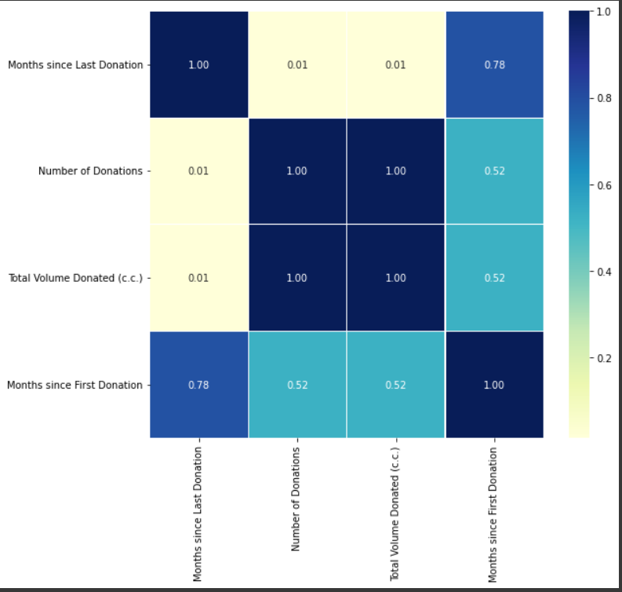

Figure 5 matplotlib.axes._subplots.AxesSubplot at 0x7f9ed27eb8d0

The logarithm transformation, sometimes known as the log transform, is one of the most widely used mathematical transformations in feature engineering. The distribution gets closer to normalcy following transformation, which helps with managing skewed data.

**Boxplot for Months since Last Donation**

Figure 6 Boxplot for Months since Last Donation

**System Architecture**

The system architecture is shown in Figure 8

Figure 7 High Level Architectural Diagram

The selection of an appropriate methodology is essential for the entire development of any software application since it ensures that a reasonable timeframe for each step of the project is created and that requirements are properly defined. This section explains the best development technique for this project.

During the life cycle of a project, agile methodology divides the development process into iterative phases and promotes flexibility, testing, and change. It helps to reduce overall project risk, manage change, and improve customer satisfaction. The project's exploratory approach is followed by iterative development cycles. At the conclusion of each build, a subsystem or function will be built. With each incremental build, new requirements are likely to be discovered and implemented, and the project will become more complex, building on the preceding build's features and eventually contributing to the application's final implementation. Because requirements are split down into smaller pieces that are implemented at the end of each build cycle, organizing the development of the project over multiple build cycles can reduce the risks associated with development to a more manageable level.

Faults are detected early in short, manageable cycles, allowing for efficient testing, and debugging. The Agile Methodology is the ideal development approach for this project.

Figure 8 software development life cycle

**Requirement Gathering and Analysis**

The most effective process to gather data for this project was to use a questionnaire. Responses to surveys will be collected neatly and automatically in Forms, with real-time response information and charts. As a result, reading and analysing data to identify requirements is easy.

**Feasibility study**

* **Schedule feasibility**

The proposed system should be completed within the timeframe allotted, with each step producing consistent results on time. Additionally, meet the deadline for the final output.

* **Economy feasibility**

Even if the proposed system's end result is ideal and produces preferred correct results with no errors or mistakes, it cannot be considered a success if it is expensive.

* **Technical Feasibility (Skills)**

To successfully complete the proposed system, you will need to be skilled in a variety of technologies.

**Implementation**

The implementation includes the construction of the blood predict system. Documented sources are used to gather relevant data. The proposed system will then be coded in the next phase. This is done with the help of a data mining algorithm. The next stage is to create the user interface that will allow users to connect with the system. Java is used to develop the user interface.

To improve accessibility and user friendliness, the final solution incorporates an Android mobile application. The framework will be Flutter, and the database will be Firebase. The aforesaid features will be provided to the user through the mobile application.

**Android Application development**

The final solution includes an Android mobile application to boost accessibility and user friendliness. Java will be used to create the application. It's simpler to implement, keeps costs down, and allows for a faster release.

**API Implementation**

We need to develop a REST API that can interact with any service in order to take use of these models. For this, I used the flask framework. It is scalable to complex techniques. I implemented flask to the algorithms as methods, and flask endpoint integrated with the mobile application. JSON file will be generated every time the function calls with the retrofit API. After the Python script receives the relevant input it requires, processing takes place after the Python script generates output that is directly stored in the Flask server, and when certain specific circumstances need to be handled, when we access the Flask API using the mobile application. The mobile application also has a life cycle, and when that life cycle began, it triggered the retrofit when the answer from the flask API wasn't received in the appropriate amount of time.

When I validated the code, I didn't get a response. Then I start another episode and display relevant text views edit text, fragments when necessity, so the users may engage with another features in the mobile application.

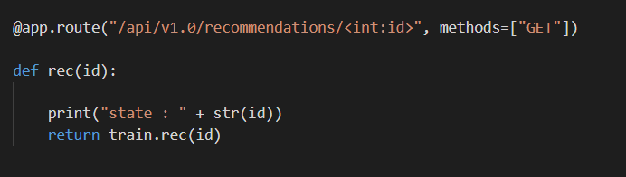

Figure 9 Flask API Integration

The retrofit API and coroutines are used to script each validation procedure. When every activity on the mobile application is tracked on the machine learning model, user interface buttons, text views, and text boxes are allocated to & verified using API methods.

All the platforms are connected using the flask API. The mobile application is directly connected to the Firebase real-time database to retrieve the necessary data by using trained data received from machine learning model, and the model continues predicting the recommended blood amount & demand blood prediction graphs. When the user logs into the system, using data will be sent to the backend and getting all the trained values appropriately.

**Database Handling**

**Firebase console**

For the validation purpose database is important for this system, In order to create a user-based recommendation system, it is necessary to identify individual users. for the user authentication I used firebase authentication. When a user logs in to the system, scripts that handle Firebase authentication, storage, and real-time data base validations send the user's pertinent information to the Flask server.

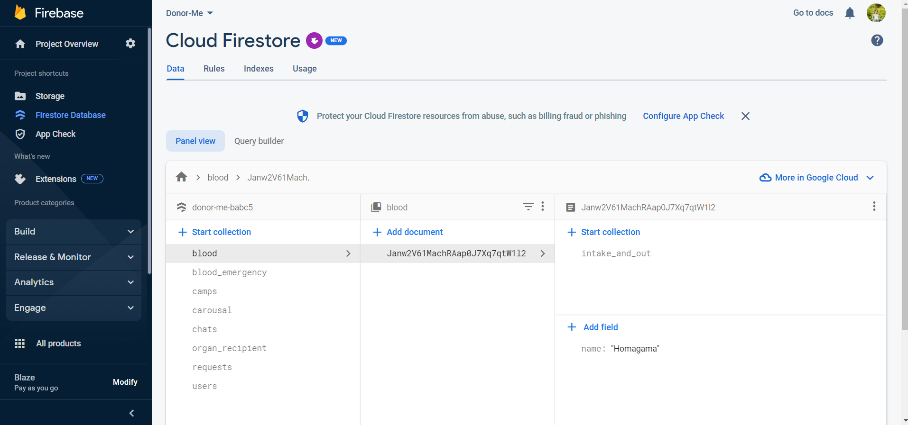

Figure 10 Firebase databse

**Testing and Evaluation**

The system has been thoroughly evaluated and tested. When a proposed system is finished, it should be tested and evaluated to see how well it performs and whether it fits the needs of its users and is applicable in the domain. Then the system is tested and evaluated as the final phase in the process. To determine if the system fulfils its requirements, system tests and user acceptability testing are used.

During this phase, testing and integration are completed. For a good product, this process is valuable. Unit Testing, Integration Testing and System Testing are used to inspect each system module. In this phase, we are going to test techniques for three tests. Unit testing mistakes are often checked by separate modules, whereas

|  |  |  |  |
| --- | --- | --- | --- |
| **Test Case ID** | | Login -1 | |
| **Test Case Description** | | Login using valid email and valid password | | **Test Priority** | | High | |
| **Pre-condition** | | User must be a registered user | | **Post-condition** | | _ | |
| **Test Case Steps:** | | | | | | | |
| **Step number** | **Action** | | **Inputs** | **Expected result** | **Actual result** | | **Test results** |
| 1 | Launch the app | | - | Navigate to the login page | Navigate to the login page | | Pass |
| 2 | Click the “LOGIN” button | | - | Display to enter login credentials | Display to enter login credentials | | Pass |
| 3 | Enter login details | | Email; - [hospital@gmail.com](mailto:hospital@gmail.com)  Password; - xxxxxx | Displays login successful message and navigate to the profle page | Displays login successful message and navigate to the profle page | | Pass |

integration testing checks problems in the integration module. System testing will be used to verify the completed system following unit and integration testing.

Table 2 Login with registered user

|  |  |  |  |
| --- | --- | --- | --- |
| **Test Case ID** | | Login -2 | |
| **Test Case Description** | | Login with invalid username | | **Test Priority** | | High | |
| **Pre-condition** | | User must be a registered user | | **Post-condition** | | _ | |
| **Test Case Steps:** | | | | | | | |
| **Step number** | **Action** | | **Inputs** | **Expected result** | **Actual result** | | **Test results** |
| 1 | Launch the app | | - | Navigate to the login page | Navigate to the login page | | Pass |
| 2 | Click the “LOGIN” button | | - | Display to enter login credentials | Display to enter login credentials | | Pass |
| 3 | Enter login details | | Email; - [hospitalgmail.com](mailto:hospital@gmail.com)  Password; - xxxxxx | Displays the error message which shows “your username is incorrect”. | Displays the error message which shows “your username is incorrect”. | | Pass |

Table 3 Login with invalid username

|  |  |  |  |
| --- | --- | --- | --- |
| **Test Case ID** | | Login -3 | |
| **Test Case Description** | | Login with invalid password | | **Test Priority** | | High | |
| **Pre-condition** | | User must be a registered user | | **Post-condition** | | _ | |
| **Test Case Steps:** | | | | | | | |
| **Step number** | **Action** | | **Inputs** | **Expected result** | **Actual result** | | **Test results** |
| 1 | Launch the app | | - | Navigate to the login page | Navigate to the login page | | Pass |
| 2 | Click the “LOGIN” button | | - | Display to enter login credentials | Display to enter login credentials | | Pass |
| 3 | Enter login details | | Email; - [hospital@gmail.com](mailto:hospital@gmail.com)  Password; - 08567 | Displays the error message which shows “your password is incorrect”. | Displays the error message which shows “your password is incorrect”. | | Pass |

Table 4 Login with invalid username

**Functional Requirements**

* User must be a registered user
* System will send alert Messages to the Hospitals and Blood Bank
* **Unit Testing**

We focus Donor me application’s functions as a single units and test those units independently.

* **Smoke Testing**

Test the Donor me application’s main functionality.

Eg: - Access to the application

Login with set of users

* **Regression Testing**

Re-runs the functions that were originally scripted.Done to make sure that fixed bug features operate properly.

* **System Testing**

Test the entire application (Donor me application) as a single unit. And check whether how the entire system fails to meet its objectives.

* **User Acceptance Testing**

We selected set of end users and give our application (Donor me) to test it and got feedbacks.

**Non-Functional Requirements**

* Availability​
* Security & Privacy​
* Performance​
* Accuracy​
* Usability​

**Software Requirements**

Android Studio

**Hardware Requirements**  
• Processor – intel core i5  
• Android Device

### 6.1 command prompt view when integration of mobile application

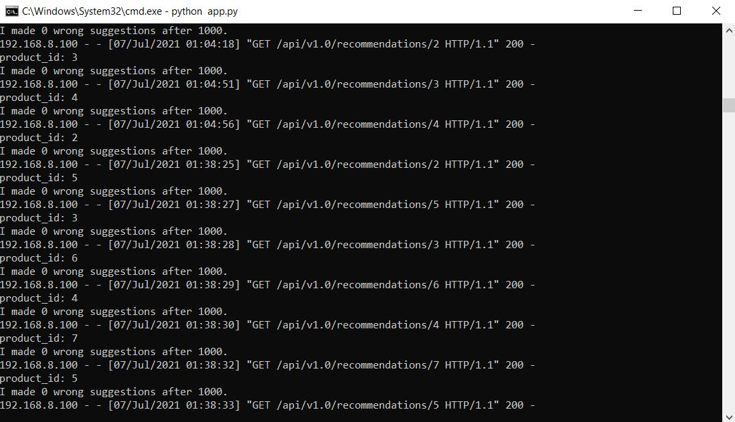

Figure 12 command prompt view of app.py runtime

# **7. Results & Discussion**

The system was tested using ten 12 devices. After examining how each user's activity affected the recommendation system, both previously registered users and new users were successfully used to test the system's fundamental functions.

For each dataset, we choose 70% of user interactions as the training set and the remaining 30% as the testing set.

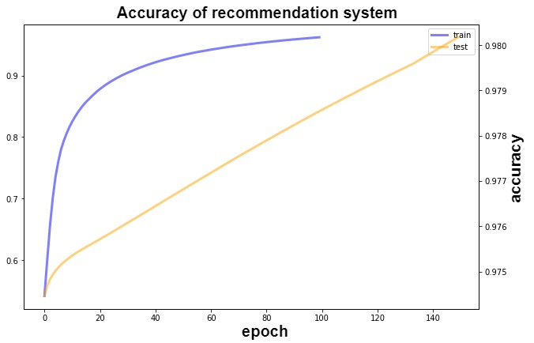

Figure 13 Train and Test accuracy

## **7.1 Research Findings**

Finally, as a team, we were able to develop the system we had envisioned, and the mobile application runs without any problems. The integration of all components with the real-time databases runs well.

The system will recognize users' prior choices when they log in. Additionally, UI receiving output in python scrips via the flask server. And when a different user logs in, the system is sophisticated enough to recognize the user and provide the appropriate recommendations; it also knows whether the user is happy with the recommendations. Additionally, users may watch animated, user-friendly graphs and plots to see future predictions.

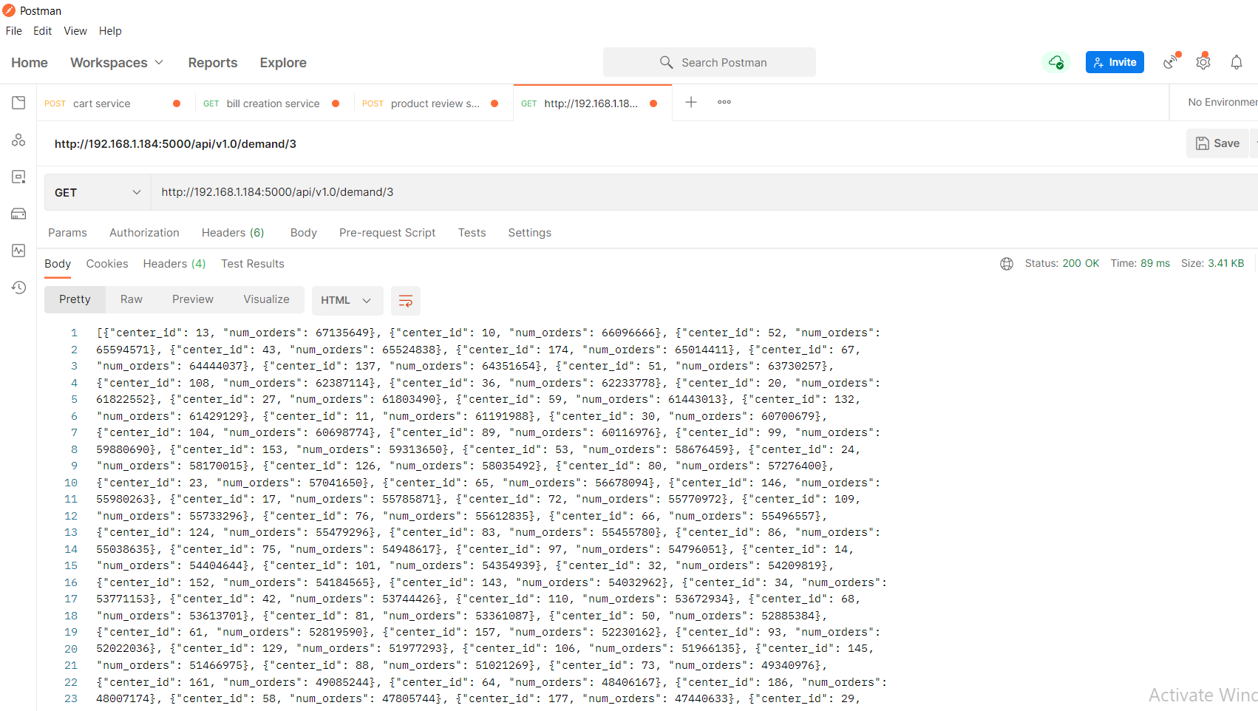

Figure 11 Postman request of API endpoint

### 6.1.1 command prompt view when integration of mobile application



Figure 12 command prompt view of app.py runtime

# **Commercialization**

Following the deployments, the final product must be made available on the market. It is the ultimate goal of every firm and a crucial stage. There are several marketing strategies that may be used to commercialize a new product.

**Our target demographic -** Average medical field like eChannelling and insureme application.

Figure 14 example application

**Social Media –** We will use Facebook and Instagram advertising to determine our target audience.

# **Conclusion**

In this research, we offer the system for performing recommendation tasks, which is based on reinforcement learning.

It is still impossible to create a universal model that yields an accurate prediction in every situation due to the intricacy of Blood Group dynamics. With the expanding availability of self-collected health data, machine learning approaches have recently attracted more interest and gained appeal in diabetes research generally and Blood Group prediction in particular.

Future studies should take into account the fact that no one has evaluated model predicting performance during stress and infection occurrences in a free-living setting. Additionally, there hasn't been much work done on model portability that can account for patient inter- and intra-variability.

But generally speaking, we anticipate that these advancements may encourage the development of next-generation Blood Goop prediction algorithms, which will significantly aid the endeavor to create the long-awaited "artificial pancreas."

# **References**

|  |  |
| --- | --- |
| [1] | C. Salazar-Concha, "Predicting the Intention to Donate Blood among Blood Donors," 10 August August 2021. |
| [2] | W. H. Organization, "Blood safety and donation," [Online]. Available: https://www.who.int/bloodsafety/global_database/GDBSFactSheet%20.pdf. |
| [3] | Darwiche, Prediction of blood transfusion donation, 2010. |
| [4] | Linden, PREDICTING BLOOD DONATIONS USING MACHINE LEARNING TECHNIQUES, 2008. |
| [5] | "Data-driven modeling and prediction of blood glucose dynamics: Machine learning applications in type 1 diabetes," July 2019. |
| [6] | C. M.O'ConnorMDa, "Predictors of mortality after discharge in patients hospitalized with heart failure: An analysis from the Organized Program to Initiate Lifesaving Treatment in Hospitalized Patients with Heart Failure (OPTIMIZE-HF)," October 2008. |

# **APPENDIX**

## **6.1 Work Breakdown Structure**

Figure 15 Work Break Down structure

## 6.2 Gantt Chart

Figure 16 Grant chart

## 6.3 Mobile application Manifest

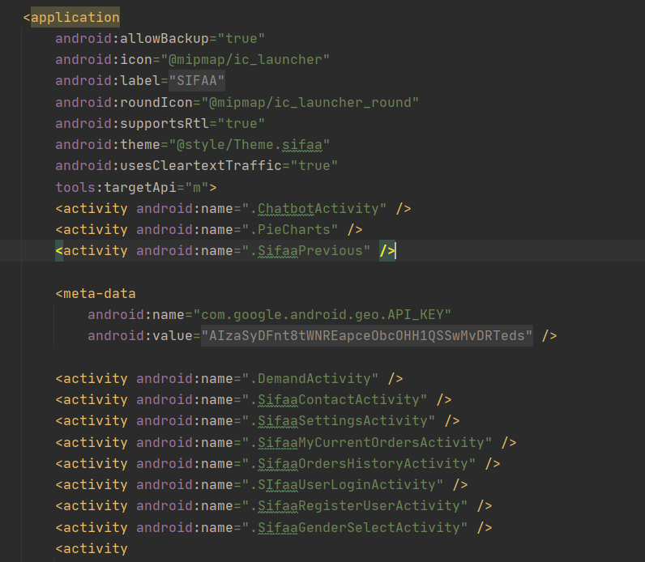

Figure 17 Mobile application manifest

## 6.6 Mobile application UI development

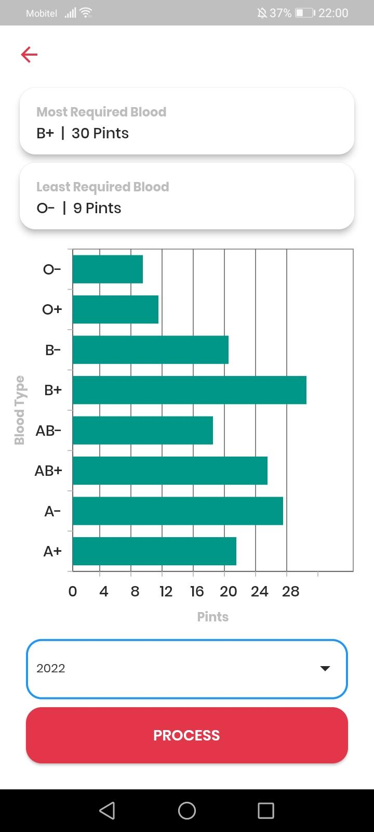

Figure 18 Android App UI

## 6.7 Mobile application xml

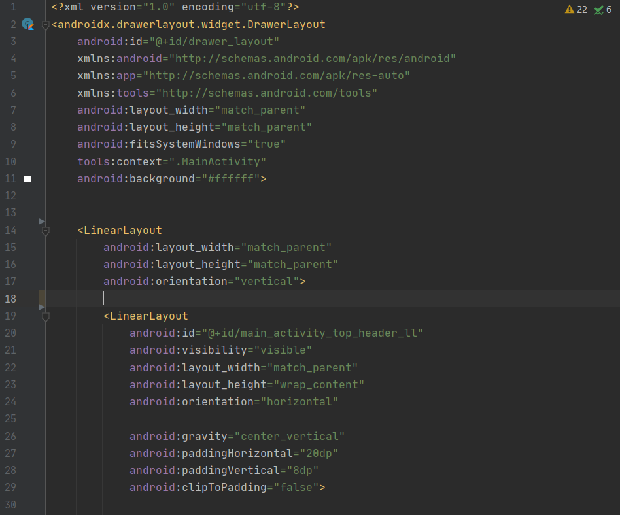

Figure 19 Android App Main Activity XML file

## 6.9 Firebase Realtime Database



Figure 20 Firestore