**Donor Me APPLICATION**

TMP-22-311

Bandara K.U.R.O.D

B.Sc (Hons) Information Technology (SLIIT)

Sri Lanka Institute of Information Technology

Sri Lanka

October 2022

**Creates a successful correspondence between the Organ Donor and the Donee**

TMP-22-311

Oshan Devinda Bandara

B.Sc. (Hons) Degree in Information Technology Specializing in

Information Technology

Department of Information Technology

Sri Lanka

October 2022

# Declaration, copyright statement and the statement of the supervisor

We declare that this is our own work, and this proposal does not incorporate without acknowledgement any material previously submitted for a degree or diploma in any other university or Institute of higher learning and to the best of our knowledge and belief it does not contain any material previously published or written by another person except where the acknowledgement is made in the text.

|  |  |  |
| --- | --- | --- |
| Name | Student ID | Signature |
| **K.U.R.O.D Bandara** | **IT19236438** |  |

The supervisor/s should certify the proposal report with the following declaration.

The above candidates are carrying out research for the undergraduate Dissertation under my supervision.

Name of supervisor: **Ms.**

Name of co-supervisor: **Ms.**

Signature of the supervisor: Date:

Signature of the co-supervisor: Date:

# Abstract

For some patients, organ transplant is their only hope to live on.Organ transplantation is the only treatment for end-stage organ failure. In the world, there are very few populations are Organ Donation Register. This application’s main purpose is to increase the population of Organ Donation.

This application Creates a successful correspondence between the organ donors and the donees**.** Organ donors who register through this application will be added to a queue. When an organ donee needs an organ a confirmation message will be sent to the organ donor who is at the top of the queue. if the donor confirms it, the donor and the donee will be added to a separate chat room and the donor will be removed from the queue, if not, the confirmation message will be sent to the next donor. Through this application, we will link the social media platform to share the post. To share the post, donee should respond to the pop-up message that he agrees to share the details.

Contents

Declaration, copyright statement and the statement of the supervisor iii

Abstract iv

List of figures vii

List of tables viii

1 Introduction 1

1.2 Literature Review 5

1.3 Research Gap 6

1.4 Research Problem 7

2 Research Objectives 8

2.1 Main Objective 8

2.2 Specific Objectives 8

3 System Flow Chart 9

4 System Diagram 10

5 Methodology 11

6 WORK BREAKDOWN STRUCTURE 12

5 Gannt Chart 13

6 Budget 14

6.1 Digital Marketing 15

7 TESTING & IMPLEMENTATION 17

7.1 Unit testing 17

7.2 Integration testing 17

7.3 System Testing 18

7.4 Acceptance Testing 18

7.5 Regression Testing 18

8 Result And Discussion 26

8.1 Discussion 26

8.2 Result 27

9 Conclusion 30

10 Reference List 31

11 Appendix 32

Other Functions in the Application 35

Donor Emergency Blood donation management function 35

Prediction Blood for future usage 36

Blood Camp Organization 37

Firebase Realtime Database 38

Mobile Application Manifest 40

Mobile Application xml 40

Turnitin 42

# List of figures

Figure 1 Summary of responses for what kind of organ do you likes to donate 2

Figure 2 Summary of responses for how would you like to donate organ(s)? 3

Figure 3 would you be willing to donate the organ(s) 3

Figure 4 Do you know a person who likes to donate organ(s) 4

Figure 5 Do you know a person who needs organs 4

Figure 6 System flowchart 9

Figure 7 System Diagram 10

Figure 8 Work Breakdown Structure 12

Figure 9 Facebook icon 15

Figure 10 Twitter Icon 15

Figure 11 Google AdSense 16

Figure 12 Registration Page 19

Figure 13 Registration 21

Figure 14 ChatPage 22

Figure 15 Homepage 22

Figure 16 Notifications 23

Figure 17 requests 24

Figure 18 Dataset Figure 19 Chatbot 27

Figure 20 Notification 28

Figure 21 Real-time Chat System 29

Figure 22 Usecase Diagram 34

Figure 23 Emergency Blood donation 35

Figure 24 Prediction for Blood Usage 36

Figure 25 Blood camp Organization 37

Figure 26 DataBase 38

Figure 27 Manifest 40

Figure 28 XML 41

Figure 29 Turnitin 42

# List of tables

Table 1 Research Gap with Research Paper 6

Table 2 Gannt Chart 13

Table 3 Budget 14

Table 4 Test case 01 19

Table 5 Test case 02 20

Table 6 Test case 03 21

Table 7 Test case 04 23

Table 8 Test case 05 24

Table 9 Test case 06 25

# Introduction

**1.1 Background**

Organ donation can occur When a person willingly agrees to donate an organ. There can be two types of organ donation. one is when he/she is alive, they can donate some organs such as the eye and kidney. And another one after the brain death. As shown in Figure 1.2 many people likes to donate organ after death.Becoming a living organ donor or making the personal but complex decision to donate one’s organs. According to statistics, a single organ donor can save the lives of up to nine additional people.

Organ donation is the selfless act of donating one or more organs (or portions of organs) to be transplanted into the body of someone else. Because of the various concerns surrounding organ donation, most countries have legal safeguards. What is more, living donors are usually able to donate a part of the pancreas, lung, liver, intestine, or kidney. As shown in Figure 1.1 Many people like donate eyes and kidneys.

The World Health Organization (WHO) claims that the majority of transplanted organs originate from living donors around the world. People of any age are usually able to donate their organs as long as they are free of certain medical conditions. Active malignancy, systemic infection, HIV-positive status, sickle cell anemia, or a history of intravenous drug usage, are only a few concerns in an organ donation. A parent or guardian's permission is required for anyone under the age of 18. For organ donation after death, a medical assessment will be done to determine what organs can be donated. Certain conditions, such as having HIV, actively spreading cancer, or severe infection would exclude organ donation.

In Sri Lanka, the major causes of organ shortages are ignorance and lack of awareness. People are under-informed on the advantages of organ donation. Today, social media and a variety of other platforms may be used to promote the benefits of organ donation and how more individuals registering for organ donation can save more lives. There isn’t any significant system to connectOrgan donors with the donees. Therefore, lack of correspondence in between donors and the donees is a major problem in the research . In this app I able to find a solution for this problem. So this application can Create a successful correspondence between the donors and the donees . For this I used a real-time chat system .

By using this Application, users can quickly find an organ donor or organ recipient. So many people use social media to find organ donors or recipients. Although many people see this is not relevant to many people. But Notifications are sent in these applications only to the relevant people. So finding an organ donor or recipient is easier than using social media.

Today’s Mobile applications have become an integral part of our daily lives. Many elements were introduced to the field because of the revolution in mobile computing. The main purpose of this component is to build a successful correspondence between the donors and the donees.First, the organ donors and donees should register for the application. A confirmation message will be sent to a donor and after the donor accepts it the donor and the donee will be added to a separate chatbot. This app has a connection between social media platforms, therefore donees can share details to social media. As shown in Figures 1.3 and 1.4 many people like to donate organs. So, this app will be motivated to donate organs. And when comparing figures 1.4 and 1.5 more people like to donate organs than people who need organs.

The proposed method is to create an android application to create a connection between organ donors and donees. The donors who are all register in this application are stored in a queue . When there is a need of organ, first a confirmation message will be sent to the first donor of the queue. Here all the donors will be stored the order of they registered. If the first donor didn’t respond to it the confirmation message will be send to the second donor of the queue . After a donor responds to it the donor and the donee will be added to a separate chat. And the donor will be remove from that queue.

Figure Summary of responses for what kind of organ do you likes to donate

Figure Summary of responses for how would you like to donate organ(s)?

Figure would you be willing to donate the organ(s)

Figure 1.3- Summary of responses would you like to donate organ(s)?

Figure Do you know a person who likes to donate organ(s)

Figure 1.4- Summary of responses Do you know a person like to donate organ(s)?

Figure Do you know a person who needs organs

Figure 1.5- Summary of responses Do you know a person who needs organ(s)?

### Literature Review

There are various android applications and websites which are international but not for are local. Here are international but not for are local. Here we give you the information on related android applications and researches. Various researches have been done on blood donation .Some of them are help to find organ donors. In Some researches they send OTP( to verify whether the donor ready to donate),track donors(check near organ donor using GPS),Send message by using the application(to let the public to know what the organ donation is), collaborated with Facebook(to share their need for a live donor through social media)

## Research Gap

Some researchers have been done various types of research about organ donation. By referring to those researchers I took below mentioned variables for my research.

• Store Donors in a queue in order of registration​

• Send confirmation message to the donor​

• Chatbot and real-time Message​

• Share the post to social media​

According to the research paper[2], they are developed for Blood Donation by storing the donors in a queue. In this research when a donor accepts the request then a one-time password (OTP) will be sent to the donor to verify. So referring to this research[1] I apply this method for Organ donation and instead of the one-time password (OTP), a confirmation message will be sent to the donor for the verification part.

According to the research paper[1], they have connected their application to the social media platform for sharing the post to find organ donors. I apply this concept to my component. here in addition to this, a popup message will be sent to donee to confirm that the donee likes to do it.

There are no products that would provide suggestions to create a separate chatbot for the donors and the donees. In the Proposed System is designed by using All the variables.

Table Research Gap with Research Paper

|  |  |  |  |  |
| --- | --- | --- | --- | --- |
| Research | Store Donors in a queue | Send confirmation message | Chatbot and real-time message | Share post to social media |
| Research [1] | Yes | No | No | No |
| Research [2] | No | No | No | Yes |
| Research [3] | No | No | No | No |
| Proposed System | Yes | Yes | Yes | Yes |

## Research Problem

In Sri Lanka, the major causes of organ shortages are ignorance and lack of awareness. People are under-informed on the advantages of organ donation. Today, social media and a variety of other platforms may be used to promote the benefits of organ donation and how more individuals registering for organ donation can save more lives. There isn’t any significant system to connectOrgan donors with the donees. Therefore, lack of correspondence in between donors and the donees is a major problem in the research .

Organ donation has become the treatment of choice for many diseases, yet there is still a global scarcity of donor organs. Despite worldwide research-based applications indicating that connects blood donators, but there isn’t any research-based application in Sri Lanka which builds connection between two Organ donators. This research aids to build the interaction between organ donors and the donees.

# Research Objectives

## Main Objective

Organ donation is the selfless act of donating one or more organs (or portions of organs) to be transplanted into the body of someone else. People are under-informed on the advantages of organ donation. Today, social media and a variety of other platforms may be used to promote the benefits of organ donation and how more individuals registering for organ donation can save more lives. There isn’t any significant system to connectOrgan donors with the donees. Therefore, Create a successful correspondence between the donors and the donees is the main objective

.



## Specific Objectives

* **Send confirmation message to the donor** ​

When there is a need of an organ for a donor, A confirmation message will be sent to the donors to verify whether the donor ready to donate .

* **real-time Message**

After a donor accepts to donate the donor and the donee will be added to a separate chat. Here, donee can directly and securely connect with the donor.

* **Create and Share the post on social media**​

This app is connected with the social media .So, donees share post to social media through this application

# 3 System Flow Chart

Figure System flowchart

# 4 System Diagram

Figure System Diagram

# Methodology

The proposed method is to create an android application to create a connection between organ donors and donees. The donors who are all register in this application are stored in a queue . When there is a need of organ, first a confirmation message will be sent to the first donor of the queue. Here all the donors will be stored the order of they registered. If the first donor didn’t respond to it the confirmation message will be send to the second donor of the queue . After a donor responds to it the donor and the donee will be added to a separate chat. And the donor will be remove from that queue.

**System Functionalities**

* The system will create a chatbot
* Create Real-time messaging systyem
* The system will keep record all the donees and donors details to find a correct organ donor for donees.
* Connection between app and the social media to share post

This system has chatbot system for organ donors and organ recipients. Here organ recipients and organ donors can ask questions and the system response for the questions.

# WORK BREAKDOWN STRUCTURE

Figure Work Breakdown Structure

# Gannt Chart

Table Gannt Chart

# Budget

Table Budget

|  |  |  |
| --- | --- | --- |
| Resource Type​ | Amount (LKR)​ | Amount (USD)​ |
| Electricity​ | 8000.00​ | $36.91​ |
| Stationary​ | 4000.00​ | $16.96​ |
| Internet​ | 4000.00​ | $16.96​ |
| Communication​ | 4000.00​  ​ | $16.96​  ​ |
| Software Purchasing​ | 4000.00​  ​ | $16.96​  ​ |
| Total​ | 24000.00​ | $104.75​ |

## Digital Marketing

We use digital marketing to promote our app among people . For that we use ,

* Social media platforms like Facebook, Instagram, and Twitter, among others.
* Taking a look at google AdSense



Figure Facebook icon

Facebook is distinctive in that it enables simultaneous connections and sharing with the people you value. Other websites have tried to include Facebook due of its popularity. This implies that you can log into a number of online companies using your Facebook account.



Figure Twitter Icon

Twitter is a social media site that strives to unite individuals and provide them a platform to communicate with a large audience. Making it a practical substitute for Med Connection's services in terms of digital marketing.



Figure Google AdSense

A tool called Google AdSense enables you to place advertisements on your website. The program is made for website owners who want to include relevant text, video, or graphic ads on their pages and be paid when visitors view or click them.

# 7 TESTING & IMPLEMENTATION

In order to minimize issues, this chapter explains how the system was checked using various testing techniques. It describes each system that is used during the execution phase and how it was put together.

**Testing**

Finding and fixing problems in the developed system is the aim of testing. The testing process is required to create the system, and a tested programming system may be recognized as a validated and approved system. It is a procedure for validation and verification. Unit testing, system testing, and acceptance are all performed on the system. Testing will help determine whether or not the goals can be achieved.

## 7.1 Unit testing

Testing is performed on individual programs, subroutines, processes, and generally every component Unit of a system. It is a technique for synchronizing the many testing parts. Each module should undergo separate unit testing. This does two things: it improves unit performance without causing it to malfunction, and it decreases the price of failure repair. The benefit of this is that if an issue is discovered, it may be Since the testing is carried out separately, the damage is properly corrected. Debugging tasks are made simpler by it. The final phase of the system was eventually combined from a number of smaller programs that made up the initial phase.

## 7.2 Integration testing

Integration Testing involves the integration and comprehensive testing of several components. Integrity testing aims to confirm that the evaluation of two or more components produces a result that satisfies the functional requirement. This is performed following unit testing and before validation testing. In this context, module testing always started at the top of the development structure and worked its way down.

Problems can be found earlier rather than later in the development cycle since testing starts early in the implementation phase. Given how easy it is to test in a development environment, integration is straightforward. End-to-end testing is less effective than integration testing. Isolating failures is trustworthy and easy. Integrity testing also requires the attitudes of both developers and testers.

## 7.3 System Testing

This compares the system as a whole or the developed program to its original objectives. System testing is an effort to determine why a system isn't accomplishing its objectives. It verifies the user needs as well as the system's design and development. System testing accepted the results of integration testing as inputs. It is possible to find errors in interconnected components as well as the complete system. This testing strategy's ultimate goal is to track the system's behavior. System testing is often performed by a testing team that is independent of the implementation team and in charge of guaranteeing the system's quality. There are both functional and nob functional tests.

## 7.4 Acceptance Testing

A system's initial specs are compared to the current needs of the end users during acceptance testing. The customer or end user often takes care of this. The developer will do user testing prior to delivering the solution to the user.

## 7.5 Regression Testing

As part of the process, developers must replace or modify functionality; these modifications may cause unexpected behaviors that might have a big impact. A modification or addition is often tested for regression to make sure none of the existing functionalities have been impacted. Along with finding faults and errors that may have been mistakenly introduced into the existing solution, its objective is to confirm if previously eliminated issues are still there. Regression testing can continue their work using a variety of functional testing methodologies.

**Test Case 01**

|  |  |
| --- | --- |
| Test case – ID | 01 |
| Description | Display Map |
| Input Values | Blood Group  Organ Type  Emergency |
| Test Data | Blood Group – A Positive Organ Type – Kidney Emergency – High |
| Test Procedure | If someone enters emergency as HIGH the map should be displayed |
| Expected Result | Map displayed |
| Actual Result | Map displayed |
| Status | Pass |

Table Test case 01

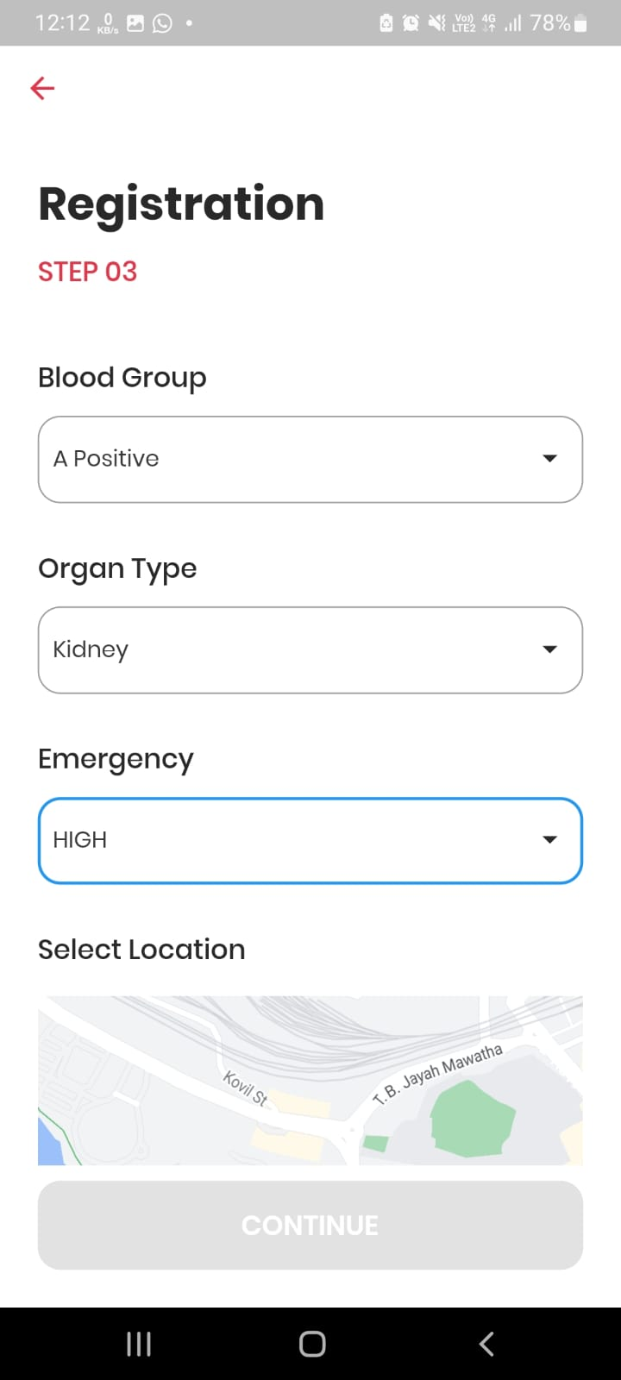

Figure Registration Page

**Test Case 02**

|  |  |
| --- | --- |
| Test case – ID | 02 |
| Description | Display Map and continue button should be enable after select location |
| Input Values | Blood Group  Organ Type  Emergency |
| Test Data | Blood Group – A Positive Organ Type – Kidney Emergency – High |
| Test Procedure | If someone enters emergency as HIGH the map should be displayed an the continue button should be enable |
| Expected Result | Map displayed continue button enable |
| Actual Result | Map displayed continue button enable |
| Status | Pass |

Table Test case 02

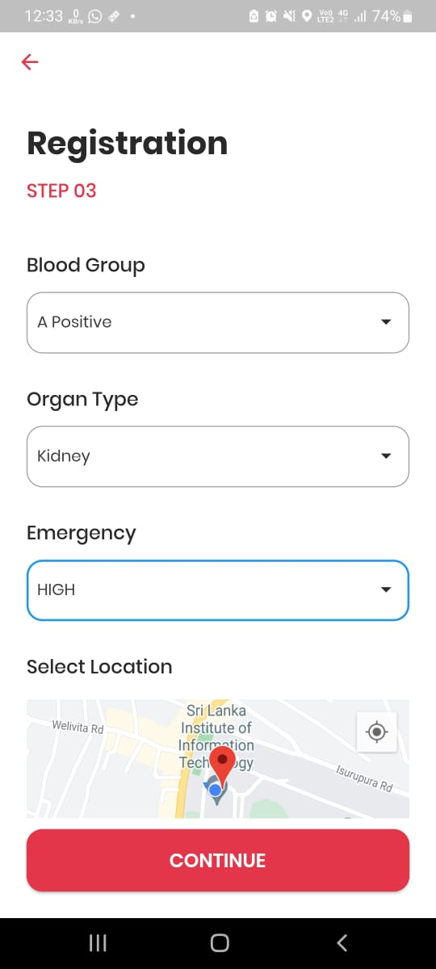

Figure Registration

**Test Case 03**

|  |  |
| --- | --- |
| Test case – ID | 03 |
| Description | The chat icon should display and redirect to chat after click the icon |
| Test Procedure | If a donor accepts a request from recipient ,chat should be enabled for both donor and recipient. |
| Expected Result | Chat icon display in both donor and recipient account |
| Actual Result | Chat icon display in both donor and recipient account |
| Status | Pass |

Table Test case 03

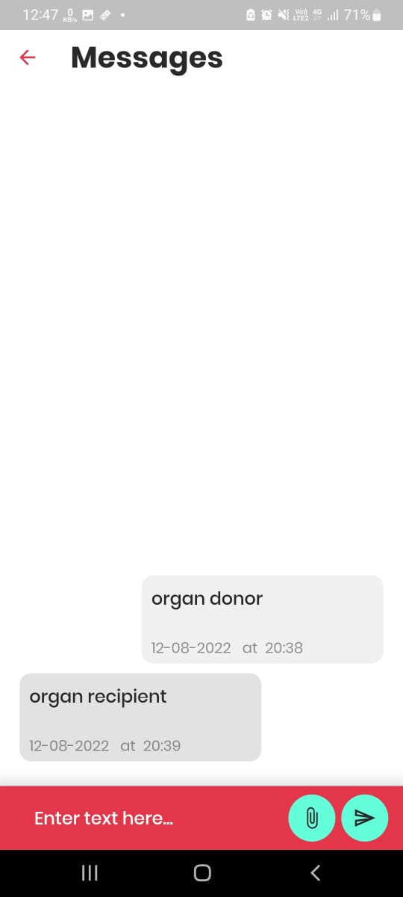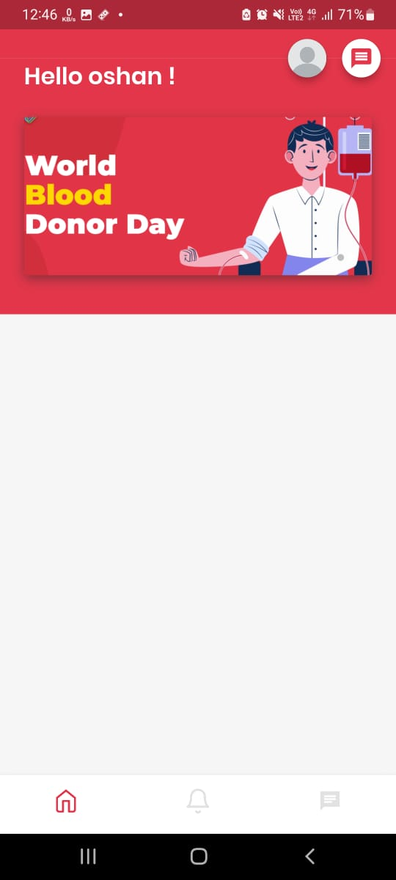

Figure ChatPage

Figure Homepage

**Test Case 04**

|  |  |
| --- | --- |
| Test case – ID | 04 |
| Description | Send notifications to recipients |
| Test Procedure | If a donor registers as an emergency, a notification should be sent to all the registered recipients |
| Expected Result | New donor available notifications should be displayed |
| Actual Result | Received the New donor available notification |
| Status | Pass |

Table Test case 04

Figure Notifications

**Test Case 05**

|  |  |
| --- | --- |
| Test case – ID | 05 |
| Description | Display requests of recipients on the notification page in the donor account. |
| Test Procedure | If a recipient register to the system a request should be displayed on the organ donor notification page. |
| Expected Result | Recipient’s requests Should be seen on the notification page |
| Actual Result | Request can be seen in the notification page |
| Status | Pass |

Table Test case 05

Figure requests

**Test Case 06**

|  |  |
| --- | --- |
| Test case – ID | 06 |
| Description | Display the location icon of emergency organ recipient’s requests |
| Test Procedure | The requests of emergency organ recipients should have a location icon and should display the location of that recipient after click the icon. |
| Expected Result | Should have location icon in the request |
| Actual Result | Can see the location icon in the request |
| Status | Pass |

Table Test case 06

# 8 Result And Discussion

## 8.1 Discussion

In Sri Lanka, the major causes of organ shortages are ignorance and lack of awareness. People are under-informed on the advantages of organ donation. Today, social media and a variety of other platforms may be used to promote the benefits of organ donation and how more individuals registering for organ donation can save more lives. There isn’t any significant system to connectOrgan donors with the donees. Therefore, lack of correspondence in between donors and the donees is a major problem in the research . In this app I able to find a solution for this problem. So this application can Create a successful correspondence between the donors and the donees . For this I used a real-time chat system .

By using this Application, users can quickly find an organ donor or organ recipient. So many people use social media to find organ donors or recipients. Although many people see this is not relevant to many people. But Notifications are sent in these applications only to the relevant people. So finding an organ donor or recipient is easier than using social media.

Various research has been done on blood donation. Some of them help to find organ donors. In Some research, they send OTP( to verify whether the donor is ready to donate), track donors(check near organ donors using GPS), Send messages by using the application(to let the public know what organ donation is), collaborated with Facebook(to share their need for a live donor through social media). After considering all this, I decided to apply a chat system to this.

## 8.2 Result

* ChatBot

Figure 6 shows the image which has taken from the chatbot . Here organ doner and organ recipient can ask questions and the system will answer for the questions . Dialogflow tool use to create the datasets . figure 6 shows the image which has taken from the dataset of the chatbot in dialogflow.

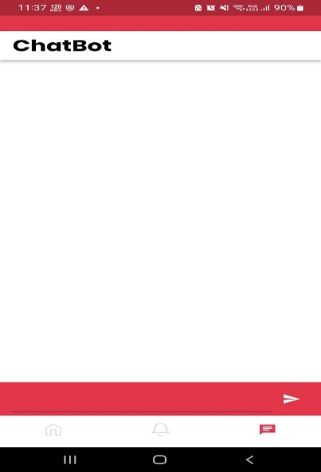

Figure Dataset Figure Chatbot

* Send Notifications

When a new organ recipient register , a notification will be send to relevant organ donors in the system . cloud function is used to implement this.

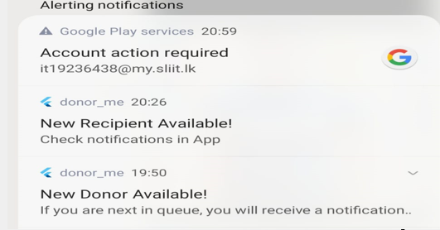

Figure Notification

* Real-Time Chat

Here organ donor and recipient can share detail each other using the chat option. In order to available the chat system organ donor need to accept the requests of recipients. Cloud function technic use for this . Figure 9 shows the real-time messaging system in this app .

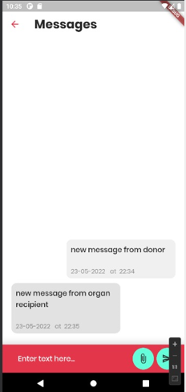

Figure Real-time Chat System

# 9 Conclusion

For those looking for an organ donation option, this application will be ideal. As a free application for the donors it would be brilliant opportunity for the people who like to work as volunteers. From this Application we hope to help for every Sri Lankan people those who have organ related diseases.

It is difficult to obtain information from a government hospital. Our daily lives revolve on time, therefore while we were designing the system, we placed importance to time management as well. If we could help users save time by providing clever, intelligent services, we would do so. I believe that will be one of our greatest successes.

Finally, we can state that this system is capable of delivering the highest quality

# 10 Reference List

[1] “A Smartphone App for Increasing Live Organ Donation” research done by K. Kumar, E. A. King1, A. D. Muzaale, J. M. Konel, K. A. Bramstedt, A. B. Massie, D. L. Segev, and A. M. Cameron​

[2] “Blood donation and life saver-blood donation app” research was done by M.R. Anish Hamlin and​ J. Albert Mayan​

[3] “Organ donation in the United States” research was done by Howard M. Nathan,Suzanne L. Conrad,Philip J. Held,Keith P. McCullough,Richard E. Pietroski,Laura A. Siminoff,Akinlolu O. Ojo​

[4] “Social media and organ donation: Ethically navigating the next frontier” M. L. Henderson,K. A. Clayville,J. S. Fisher,K. K. Kuntz,H. Mysel,T. S. Purnell,R. L. Schaffer,L. A. Sherman,E. P. Willock,E. J. Gordon https://doi.org/10.1111/ajt.14444

[5] “Social Media and Organ Donation: The Facebook Effect” Andrew M. Cameron https://doi.org/10.1080/01947648.2015.1049916

[6] “LIFE SAVER: ANDROID APPLICATION FOR BLOOD DONATION “ Kshipra B. Panaskar1, Akansha N. Nakate2, Siddhi R. Mhatre3, Prof. Sachin Chavan4 https://www.academia.edu/download/69248567/IRJET_V8I4690.pdf

# 11 Appendix

The following questionnaire is based on a survey to get some details on organ donation.

Use Case Diagram

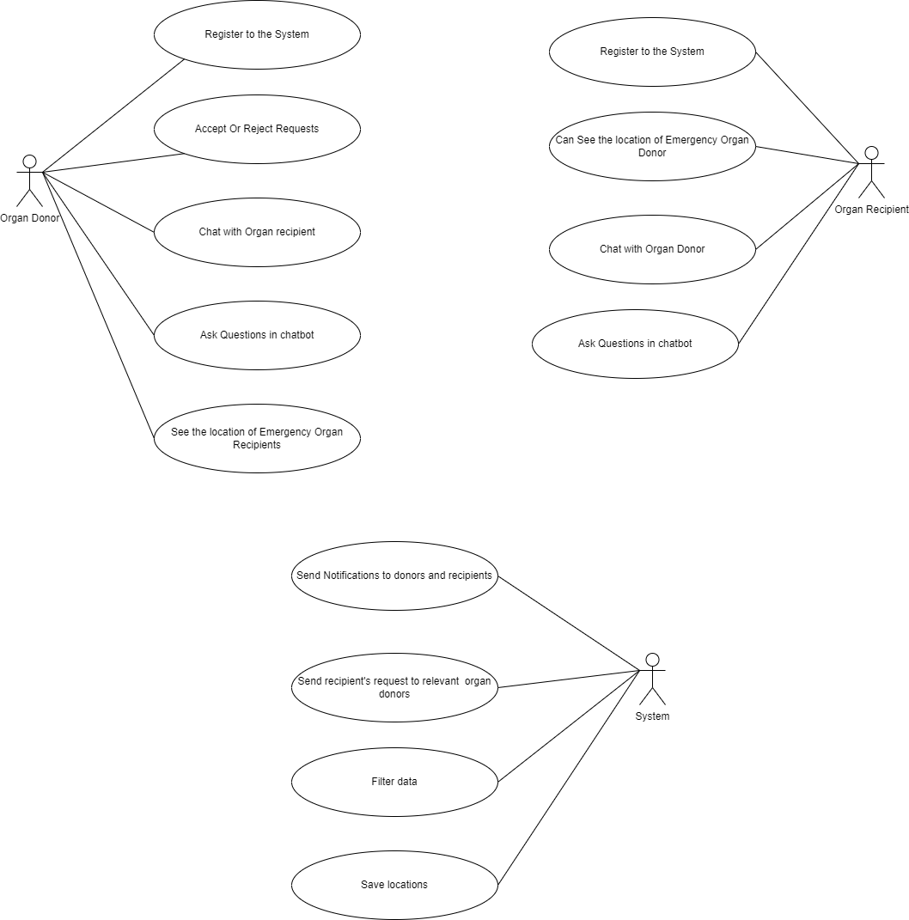

Figure Usecase Diagram

## Other Functions in the Application

Figure Emergency Blood donation

### Prediction Blood for future usage

Figure Prediction for Blood Usage

### Blood Camp Organization

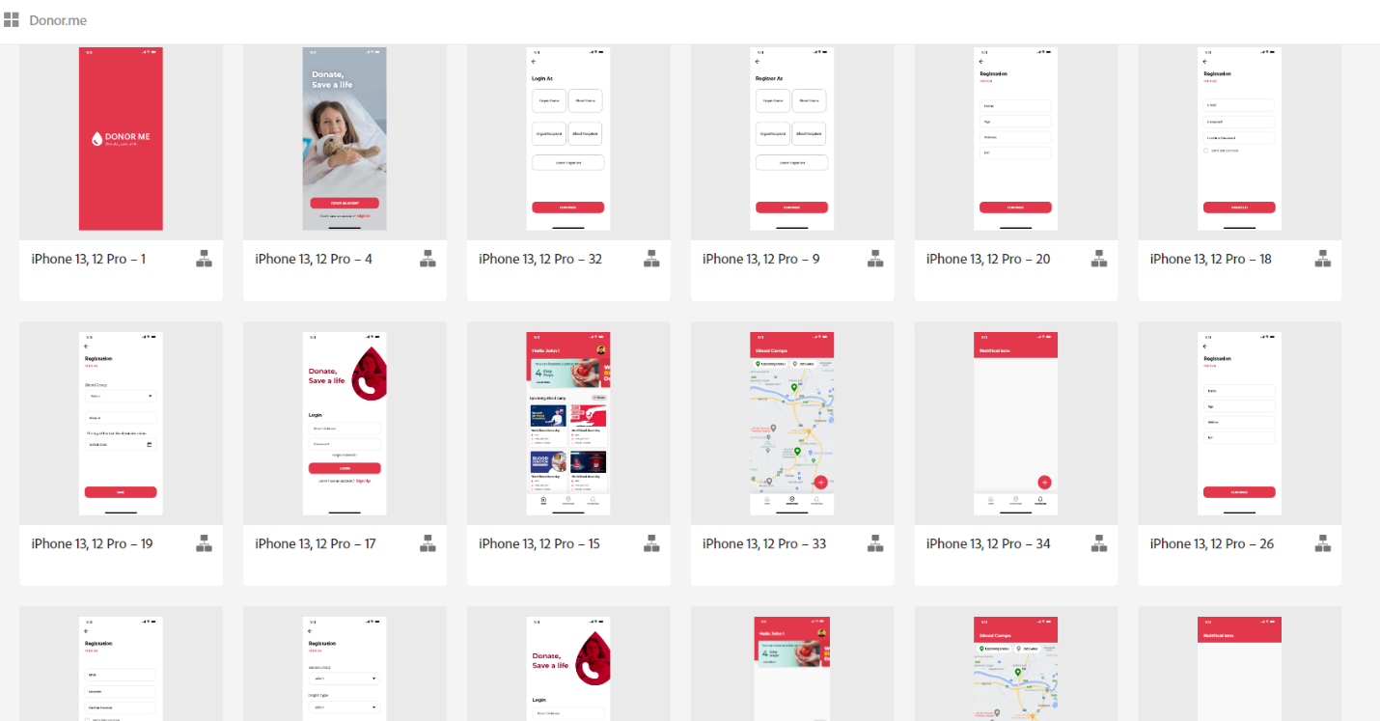

Figure Blood camp Organization

### Firebase Realtime Database

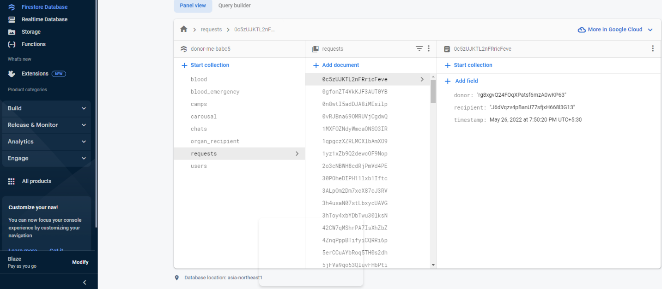

Figure DataBase

### Mobile Application Manifest

Figure Manifest

### Mobile Application xml

Figure XML

### Turnitin



Figure Turnitin