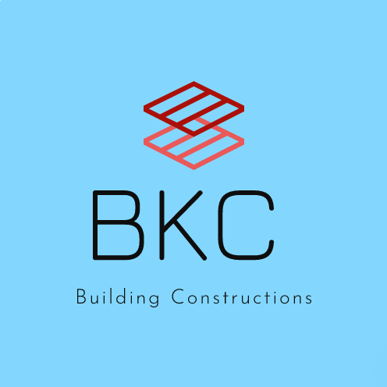

SAMPLE CONSTRUCTION BUDGET

# Expenses Hard Construction Costs (8,000 SF @ $97/SF)

|  |  |  |
| --- | --- | --- |
| Foundation, Framing, Drywall, Flooring, Roofing |  | $581,000 |
| Plumbing, Electrical, Security System |  | $80,000 |
| Fixtures, Furnishings and Equipment |  | $50,000 |
| HVAC |  | $27,000 |
| Landscaping |  | $19,000 |
| Site Work |  | $18,000 |
|  | Sub-total Hard Costs * | $775,000 |

|  |  |  |
| --- | --- | --- |
| **Land Acquisition** |  | $75,000 |
| **Soft Construction Costs**  Architect and Engineers |  | $31,000 |
| Fees |  | $4,000 |
|  | Sub-total Soft Costs ** | $35,000 |

**Contingency \*\*\***

**Total Expenses**

$9,000

$894,000

**Revenues Committed Funds**

Individual Contributions $295,000

"ABC" Foundation $125,000

"DEF" Foundation $85,000

Other Foundations $75,000

Government Grant (please identify grant by title) $75,000

Corporate Donations $55,000

XYZ Corporation (in-kind) $35,000

Other Corporate Donations $25,000

Fundraising Events/Products $14,000

Agency Funds Assigned **** $10,000

# Pending Requests

Bivins Foundation $50,000

XYZ Foundation (pending) $50,000

**Total Revenues**

$894,000

Notes:

* Hard Construction Costs include any costs that cannot be physically moved, in other words site work, renovations or construction work, plumbing, electrical, landscaping, parking lot, demolition, flooring roofing, HVAC, wiring , fire and security alarms, playgrounds, fixtures, appliances, etc. that become a permanent part of the site.

Among other things, the Bivins Foundation looks at the cost per SF of the hard construction costs.

** Soft construction costs include fees, surveys, permits, architect and engineer fees, etc.

*** Contingencies are usually about 10% of construction costs.

**** Funds assigned from your agency's operating budget in support of this project.