Predicting Extreme Rainfall for Agricultural Flood-Risk in Sri Lanka

Machine Learning Assignment

H.R.B.G.M. Bandara
214029P

Contents
1. Problem Definition & Dataset Collection 3
1.1 Problem Description and Relevance 3
1.2 Data Source 3
1.3 Features and Target Variable 4
1.4 Dataset Size 4
1.5 Preprocessing Steps 5
1.6 Ethical Considerations 5
2. Selection of a New Machine Learning Algorithm 5
2.1 Selected Algorithm: XGBoost 5
2.2 Justification for Selection 5
2.3 Differences from Standard Models 6
3. Model Training and Evaluation 6
3.1 Training Procedure 6
3.2 Performance Metrics 6
3.3 Results and Interpretation 7
4. Explainability & Interpretation 8
4.1 Explainability Method 8
4.2 What the Model Learned 8
4.3 Most Influential Features 9
4.4 Alignment with Domain Knowledge 10
5. Critical Discussion 10
5.1 Limitations 10
5.2 Data Quality Issues 10
5.3 Bias and Fairness 11
5.4 Real-World Impact and Ethics 11
Conclusion 11

1. Problem Definition & Dataset Collection

1.1 Problem Description and Relevance

Agriculture is a major factor in the Sri Lankan economy and food security especially of rice, tea, and green vegetable farming. The extreme precipitation causes a lot of flooding, damaged crops, soil erosion, and alterations in the planting and harvesting timetables. Such occurrences not only impact on the livelihood of farmers, but also the stability of food supply in countries. Consequently, to plan agricultural activity and prepare against disasters, early detection of the possible days of extreme rainfall is negatively significant.
The problem that will be tackled within this project is a binary classification one: whether the next day will be rainy with extreme rainfall or not, which is considered to be more than 50 mm. Some future weather conditions and the recent history of precipitation are utilized to make the prediction. The chosen 50 mm threshold is a proxy measure of high risk events of floods caused by rain. Even though this threshold is not an actual measure of flooding, it is a meteorologically significant amount of rainfall that can cause agricultural and hydrological hazards.

1.2 Data Source

Weather data for this study was collected from the Open-Meteo Historical Weather API. The archive endpoint was used to retrieve daily meteorological data for the period from 1 January 2020 to 31 December 2024. The data was requested in the Asia/Colombo timezone, and no API key was required.
Data was collected for three geographically distinct and agriculturally important regions in Sri Lanka: Kandy, Batticaloa, and Anuradhapura. These locations represent different climatic zones and rainfall patterns within the country. A Python script (src/fetch_weather.py) was developed to automate the process of sending HTTP GET requests and compiling the responses into a structured dataset.
The following daily variables were retrieved:
- Maximum temperature at 2 meters (temperature_2m_max)
- Minimum temperature at 2 meters (temperature_2m_min)
- Total daily precipitation (precipitation_sum)

1.3 Features and Target Variable

Feature engineering was performed to enhance the predictive capability of the model. In addition to the raw meteorological variables, several derived features were created to capture temporal rainfall dynamics and soil wetness conditions.
The final feature set consisted of eight variables:
- location_id – Encoded location (0,1,2)
- temperature_2m_max – Daily maximum temperature (°C)
- temperature_2m_min – Daily minimum temperature (°C)
- temperature_mean – Mean of max and min temperature
- precipitation_sum – Daily precipitation (mm)
- precipitation_rolling_3d – Total rainfall over previous 3 days
- precipitation_rolling_7d – Total rainfall over previous 7 days
- dry_days – Consecutive days with precipitation < 1 mm
The calculation of rolling precipitation features was done in each location individually to capture the antecedent rainfall accumulation. The dry-days feature parameter was to simulate the level of soil dryness, which is a determinant of runoff and risk of floods.
The target variable extreme_rain_tomorrow was created by moving the precipitation variable a day in each location. The target was set at 1 when the amount of precipitation on next day was more than 50 mm, and 0 at other times. Such formulation makes the model utilize only the existing and historical data to forecast the future occurrences.

1.4 Dataset Size

The dataset had around 5,400 records after pre-processing and dropping of rows that were influenced by rolling-window initiation and target shifting. The dataset is about a period of five years of daily data on three locations.
A chronological split was used to prevent data leakage and maintain temporal consistency. Training was done at the first 70% followed by validation at the next 15% and test at the final 15%. There was no random shuffling so that in future observations no training in the model was used.

1.5 Preprocessing Steps

Some of the steps were structured to preprocess. Initially, date columns were read and put in a time sequence. Derived features, such as rolling precipitation sums and mean temperature were computed on a location by location basis. Calculation of the dry-days characteristic was done based on a cumulative counting approach whereby the count would be reset when there was a precipitation of more than 1 mm.
The one-day forward shift operation was used to produce the target variable. The rows with missing data due to rolling calculations or shifting were deleted. Location as a categorical variable was coded numerically as location_id. As the algorithm chosen is tree-based, it did not need any feature normalization or scaling.

1.6 Ethical Considerations

The dataset consists entirely of publicly available meteorological data. No personal, demographic, or sensitive information was used in this study. The data was used strictly for academic and research purposes. Therefore, there are no privacy concerns or issues related to individual-level bias.

2. Selection of a New Machine Learning Algorithm

2.1 Selected Algorithm: XGBoost

The selected algorithm for this project is Extreme Gradient Boosting (XGBoost), implemented using the XGBClassifier. This algorithm was chosen because it was not covered in the lecture materials and satisfies the assignment requirement of using a new machine learning algorithm while avoiding deep learning models.

2.2 Justification for Selection

XGBoost is particularly well-suited for structured tabular data. It is an ensemble method based on gradient boosting, where multiple decision trees are trained sequentially to correct the errors of previous trees. This approach enables the model to capture nonlinear relationships and feature interactions without requiring manual feature engineering.
Additionally, XGBoost incorporates regularization mechanisms that reduce overfitting, making it more robust than a single decision tree. It also provides built-in mechanisms for handling imbalanced datasets through the scale_pos_weight parameter, which is important in this study because extreme rainfall events are relatively rare compared to non-extreme days.

2.3 Differences from Standard Models

Unlike logistic regression, which assumes a linear decision boundary, XGBoost can model complex nonlinear relationships between meteorological variables and rainfall events. Compared to a single decision tree, which may suffer from high variance and overfitting, XGBoost aggregates multiple trees to improve generalization. Unlike k-nearest neighbors, which relies on storing all training samples and computing distances during inference, XGBoost learns a compact predictive model that is computationally efficient at prediction time.

3. Model Training and Evaluation

3.1 Training Procedure

The model was trained using the chronological training set. Hyperparameters were selected based on validation performance. The primary hyperparameters included 200 estimators, a maximum tree depth of 5, and a learning rate of 0.05. The scale_pos_weight parameter was calculated as the ratio of negative to positive samples to compensate for class imbalance. The evaluation metric during training was log loss.
Hyperparameters
- n_estimators = 200
- max_depth = 5
- learning_rate = 0.05
- scale_pos_weight = (negatives / positives)
- eval_metric = logloss
- random_state = 42

3.2 Performance Metrics

Because this is a classification problem with imbalanced classes, multiple evaluation metrics were used. Accuracy measures overall correctness but can be misleading in imbalanced settings. Precision and recall provide insight into how well the model identifies extreme rainfall events. The F1-score balances precision and recall. The Receiver Operating Characteristic Area Under the Curve (ROC AUC) measures the model’s ability to rank positive instances higher than negative ones across different thresholds.

3.3 Results and Interpretation

On the test dataset, the model achieved an overall accuracy of approximately 98%. However, this high accuracy is largely influenced by the dominance of non-extreme rainfall days in the dataset. The ROC AUC score was approximately 0.78, indicating moderate discriminatory ability. This suggests that the model can meaningfully differentiate between extreme and non-extreme rainfall days.
Precision, recall, and F1-score for the positive class were relatively low when using the default classification threshold of 0.5. This indicates that the model is conservative in predicting extreme rainfall events. For practical early-warning systems, a lower probability threshold could be selected to increase recall, even at the cost of reduced precision.
The confusion matrix confirms that most predictions fall into the non-extreme category, reflecting class imbalance. The ROC curve demonstrates that performance improves when threshold selection is adjusted.
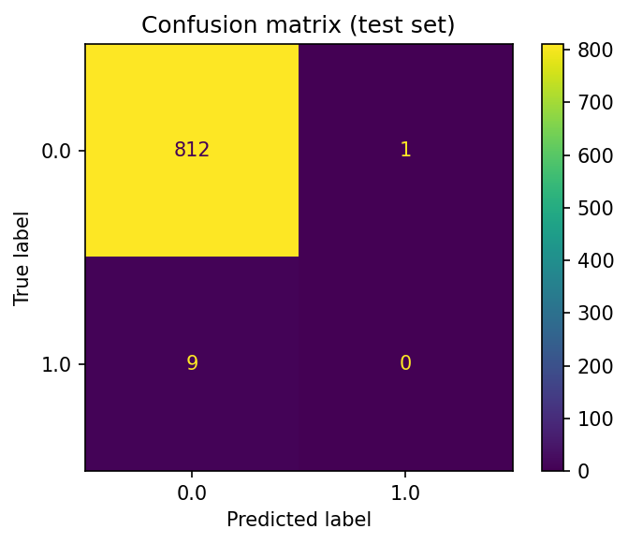
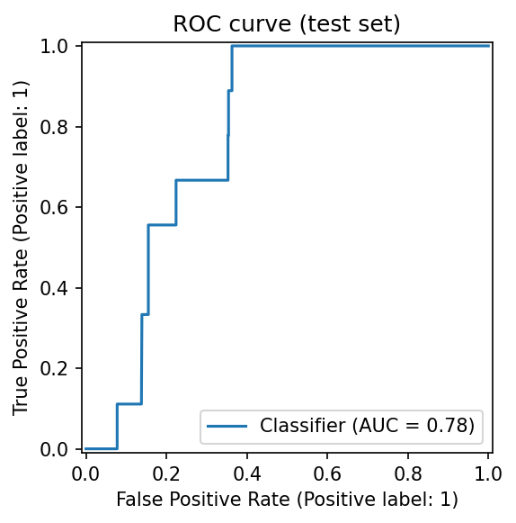

4. Explainability & Interpretation

4.1 Explainability Method

To interpret the trained model, SHAP (SHapley Additive exPlanations) was applied using the TreeExplainer method. SHAP provides additive feature contribution values for each prediction, allowing insight into how individual features influence model output.

4.2 What the Model Learned

The SHAP analysis revealed that recent precipitation variables, particularly the current-day precipitation and seven-day rolling precipitation, were the most influential features. The three-day rolling precipitation and the number of consecutive dry days also contributed significantly to predictions. Location-specific differences were observed, indicating regional climatic effects.
Higher values of recent precipitation increased the predicted probability of extreme rainfall on the following day. Conversely, longer dry periods reduced predicted risk.

4.3 Most Influential Features

Based on SHAP summary plot:
- precipitation_sum
- precipitation_rolling_7d
- precipitation_rolling_3d
- dry_days
- location_id
Higher precipitation values increase predicted extreme rain probability.
More dry days decrease predicted probability.
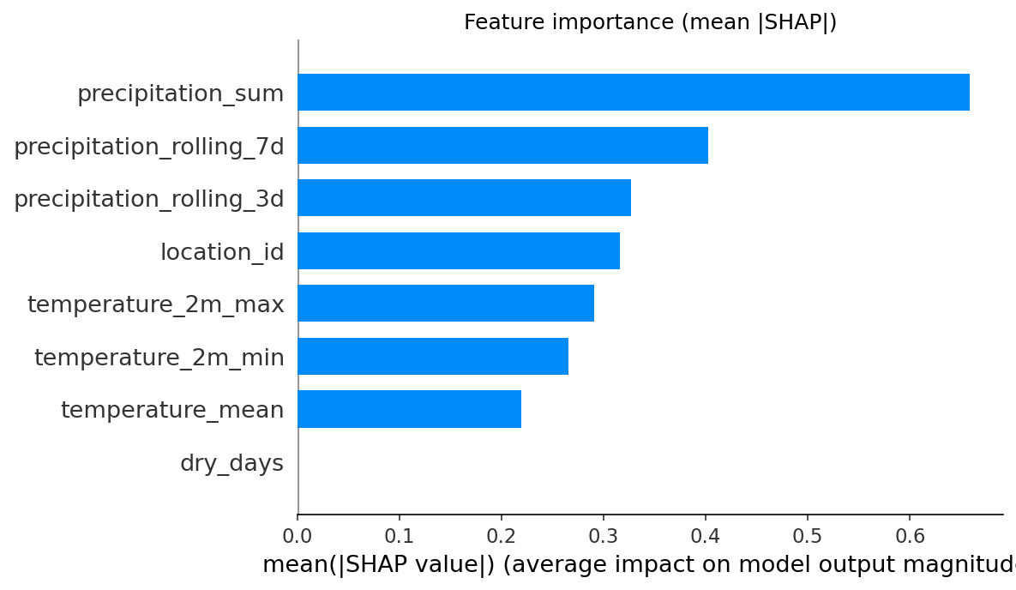
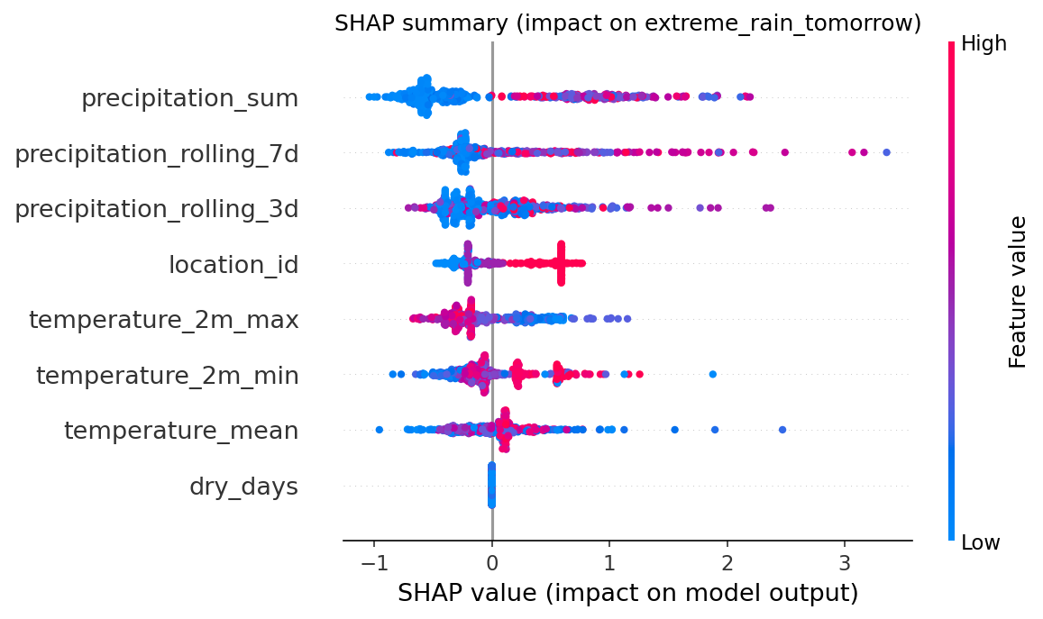

4.4 Alignment with Domain Knowledge

The model’s behavior aligns with established hydrological principles. Flood risk increases when soil is saturated due to prior rainfall, and accumulated precipitation contributes to runoff intensity. Therefore, the prominence of rolling rainfall features in the SHAP analysis is consistent with meteorological understanding.

5. Critical Discussion

5.1 Limitations

This model predicts extreme rainfall events rather than actual flood occurrences or crop damage. The fixed 50 mm threshold may not capture all meaningful risk levels, and different thresholds could produce different results. The study is limited to three locations and a five-year period, which may restrict generalizability to other regions or timeframes.

5.2 Data Quality Issues

The dataset is derived from reanalysis-based weather data rather than direct ground station measurements. Such data may involve spatial smoothing and potential estimation errors. Missing values were removed rather than imputed, which may slightly reduce dataset size but simplifies preprocessing.

5.3 Bias and Fairness

No personal or demographic data was used, eliminating concerns related to individual-level bias. However, geographic representation is limited to three locations, which may introduce regional bias if the model were applied nationally without further data.

5.4 Real-World Impact and Ethics

The model offers several positive impacts, notably by supporting early agricultural planning through its transparent and explainable approach. However, there are risks associated with over-reliance on the system without human verification, and its operational deployment requires thorough validation and calibration to ensure reliability.

Conclusion

This project demonstrated the application of XGBoost for predicting extreme rainfall events in Sri Lanka. The model achieved high overall accuracy and moderate discriminative ability, as reflected by the ROC AUC score. SHAP-based explainability confirmed that the model’s decision-making aligns with meteorological domain knowledge. While the model serves as a useful prototype for agricultural flood-risk early warning, further improvements could include expanding geographic coverage, incorporating additional meteorological variables, and calibrating decision thresholds for operational deployment.

