Who Am I?

**Personal Details**

**Surname : pedhuru Singhege**

**First Name : Buddhika**

**Middle Name :**

**Last Name : Lakshan**

**Birth day : 1995-11-13**

**Nic : 953180898v**

**Contact Info**

**Address : 135/1,Ehala karagahamuna,kadawatha.**

**Home : 0112901462 Mobile : 0755996086**

**Attended Schools**

**Schools : Galahitiyawa Central college,Kadawatha Central college.**

**Java institute Information**

Bsc.(Stud) .

JSAD,OCJP,AJDES,AJDMS

Pcjt 51 Batch.

Concept

What is Software?

This is very easy reloading System. The System Administrator Have a Full responsibility in this Software.

Admin can use All privileges And card Adding;

After User Can came this System User Can Bye reloads.

**Buyer**

**System**

**Admin**

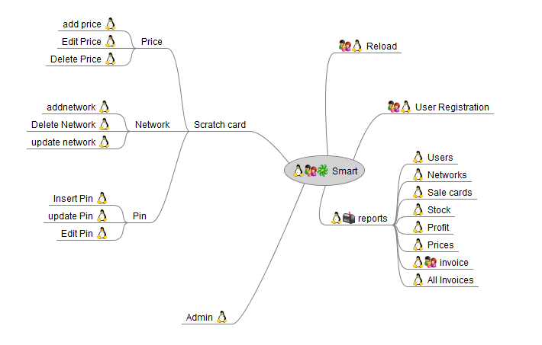Mind Map

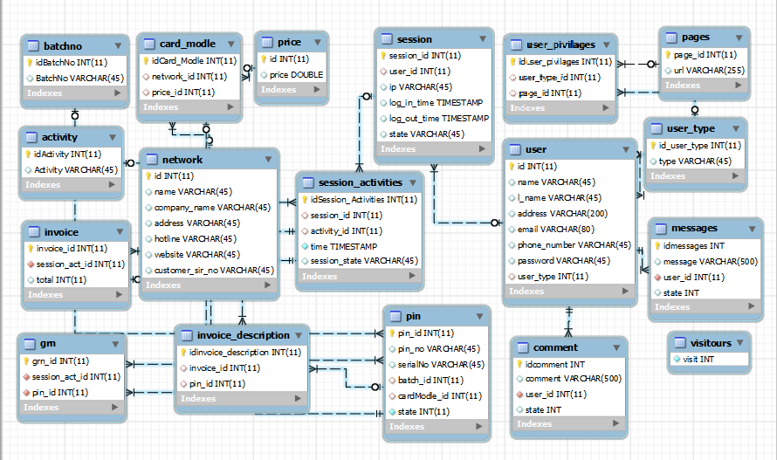ER Diagram

Wireframes

Index page

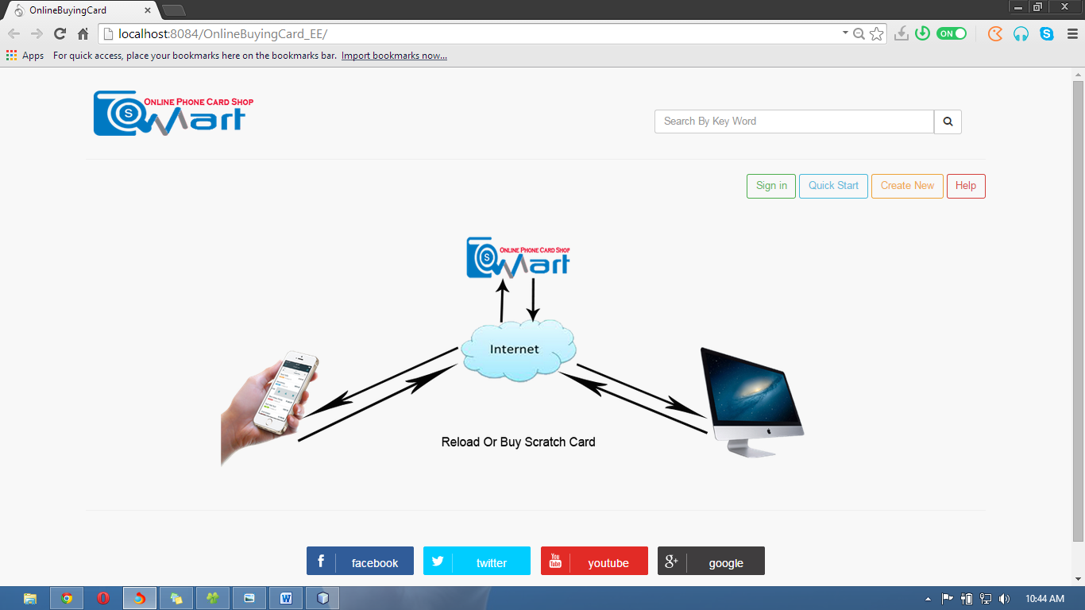

<%--

Document : index

Created on : 12-Dec-2014, 19:24:43

Author : Mr.Buddhika

--%>

<%@page import="java.sql.ResultSet"%>

<%@page import="java.sql.Statement"%>

<%@page contentType="text/html" pageEncoding="UTF-8"%>

<!DOCTYPE html>

<html>

<head>

<meta http-equiv="Content-Type" content="text/html; charset=UTF-8">

<title>OnlineBuyingCard</title>

<link rel="stylesheet" href="css/bootstrap.min.css">

<link rel="stylesheet" href="css/plugins/metisMenu/metisMenu.min.css">

<link rel="stylesheet" href="css/sb-admin-2.css">

<link type="text/css" rel="stylesheet" href="font-awesome-4.1.0/css/font-awesome.min.css">

<script src="js/jquery.js"></script>

<script src="js/bootstrap.min.js"></script>

<script src="js/plugins/metisMenu/metisMenu.min.js"></script>

<script src="js/sb-admin-2.js"></script>

<script src="js/jzone.js"></script>

<%

Statement s=db.Database.Database();

int max=0;

ResultSet rs= s.executeQuery("SELECT max(visit) FROM visitours");

if(rs.next()){

max=rs.getInt(1);

}

max++;

s.executeUpdate("INSERT INTO visitours VALUES('"+max+"')");

%>

</head>

<body >

<br/>

<div style="margin-left: 8%;margin-right: 8%;">

<table border="0">

<tbody>

<tr>

<td> <img src="images/Capture2.png"/></td>

<td style="width: 40%"></td>

<td>

<div class="form-group input-group" style="margin-top: 9%;" align="right">

<input class="form-control" type="text" size="50" placeholder="Search By Key Word"></input>

<span class="input-group-btn">

<button class="btn btn-default" type="button">

<i class="fa fa-search"></i>

</button>

</span>

</div>

</td>

</tr>

</tbody>

</table>

<hr/>

<!------------------------------------------------------------------------------------------------------------------------------------------------------>

<!-- menu wage aka -->

<div align="right">

<button class="btn btn-outline btn-success" onclick="Signin()" type="button">Sign in</button>

<button class="btn btn-outline btn-info" type="button" onclick="ClickQuickStart()">Quick Start</button>

<button class="btn btn-outline btn-warning" onclick="window.location='CreateUser.jsp'" type="button">Create New</button>

<button class="btn btn-outline btn-danger" type="button">Help</button>

</div>

<br/>

<!-- /.row -->

<img src="images/ind.png" />

<hr/>

<%@include file="foot.jsp" %>

</div>

</body>

</html>

Login page

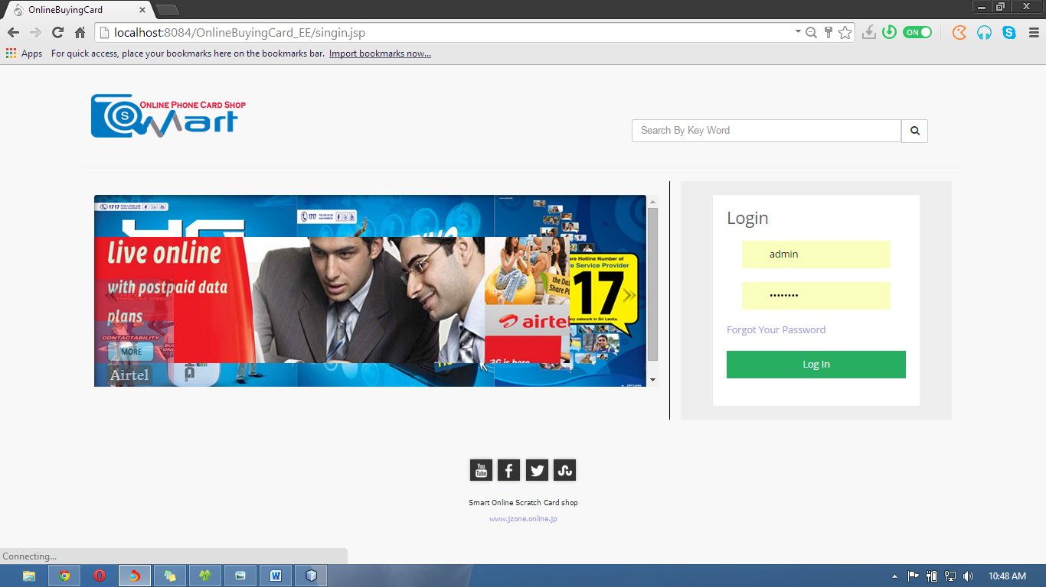

<%--

Document : index

Created on : 12-Dec-2014, 19:24:43

Author : Mr.Buddhika

--%>

<%@page contentType="text/html" pageEncoding="UTF-8"%>

<!DOCTYPE html>

<html>

<head>

<meta http-equiv="Content-Type" content="text/html; charset=UTF-8">

<title>OnlineBuyingCard</title>

<link rel="stylesheet" href="css/bootstrap.min.css">

<link rel="stylesheet" href="css/plugins/metisMenu/metisMenu.min.css">

<link rel="stylesheet" href="css/footer.css">

<link rel="stylesheet" href="css/sb-admin-2.css">

<link type="text/css" rel="stylesheet" href="font-awesome-4.1.0/css/font-awesome.min.css">

<script src="js/jquery.js"></script>

<script src="js/bootstrap.min.js"></script>

<script src="js/plugins/metisMenu/metisMenu.min.js"></script>

<script src="js/sb-admin-2.js"></script>

<script src="js/validation.js"></script>

<script src="js/jzone.js"></script>

</head>

<body >

<br/>

<div style="margin-left: 8%;margin-right: 8%;">

<header>

<table border="0">

<tbody>

<tr>

<td> <img src="images/Capture2.png"/></td>

<td style="width: 40%"></td>

<td>

<div class="form-group input-group" style="margin-top: 9%;" align="right">

<input class="form-control" type="text" size="50"

placeholder="Search By KeyWord"></input>

<span class="input-group-btn">

<button class="btn btn-default" type="button">

<i class="fa fa-search"></i>

</button>

</span>

</div>

</td>

</tr>

</tbody>

</table>

<hr/>

</header>

<!--------------------------------------------------------CONTENT--------------------------------------------------->

<div class="col-lg-8">

<br>

<iframe src="web animation/index.html" style="width:865px;height:279px;max-width:100%;overflow:hidden;border:none;padding:0;margin:0 auto;display:block;" marginheight="0" marginwidth="0"></iframe>

</div>

<div class="col-lg-4" style="border-left: #000 double thin ">

<link href='http://fonts.googleapis.com/css?family=Open+Sans:400,300,700' rel='stylesheet' type='text/css'>

<div class="wrap">

<form action="loginAcsess" method="post">

<h3>Login</h3>

<input type="email" id="inputUserEmail" name="Email" placeholder="Email" data-validate="required,email">

<input type="password" id="inputUserPassword" name="pw" placeholder="Password" data-validate="required,text">

<a href="forgotpassword.jsp">Forgot Your Password</a>

<button type="submit">Log In</button>

</form>

</div>

<!-- /.panel -->

</div>

<br/>

<style>

.wrap {

font-family: "Open Sans", "Helvetica Neue", "Helvetica", sans-sarif;

background: #eee;

padding: 20px;

}

form {

margin: 0 auto;

padding: 20px;

background-color: #fff;

width: 300px;

}

form h3 {

margin: 0;

padding: 0;

color: #555;

}

input,

button {

display: block;

width: 83%;

margin: 20px auto;

border: none;

padding: 10px;

font-size: 14px;

}

button {

background-color: #27ae60;

color: #fff;

width: 100%

}

button:hover {

background-color: #2ecc71;

}

input {

background: #eee;

padding-left: 40px;

}

input[name="username"] {

background: #eee url("http://oi59.tinypic.com/e7mr0z.jpg") no-repeat;

background-position: 10px 50%;

}

input[name="password"] {

background: #eee url("http://oi60.tinypic.com/os92eo.jpg") no-repeat;

background-position: 10px 50%;

}

</style>

</div>

<br/><br/><br/><br/><br/><br/><br/><br/><br/><br/><br/><br/><br/><br/><br/><br/><br/><br/><br/>

<%@include file="footer.jsp" %>

<br/></body></html>

Login error page

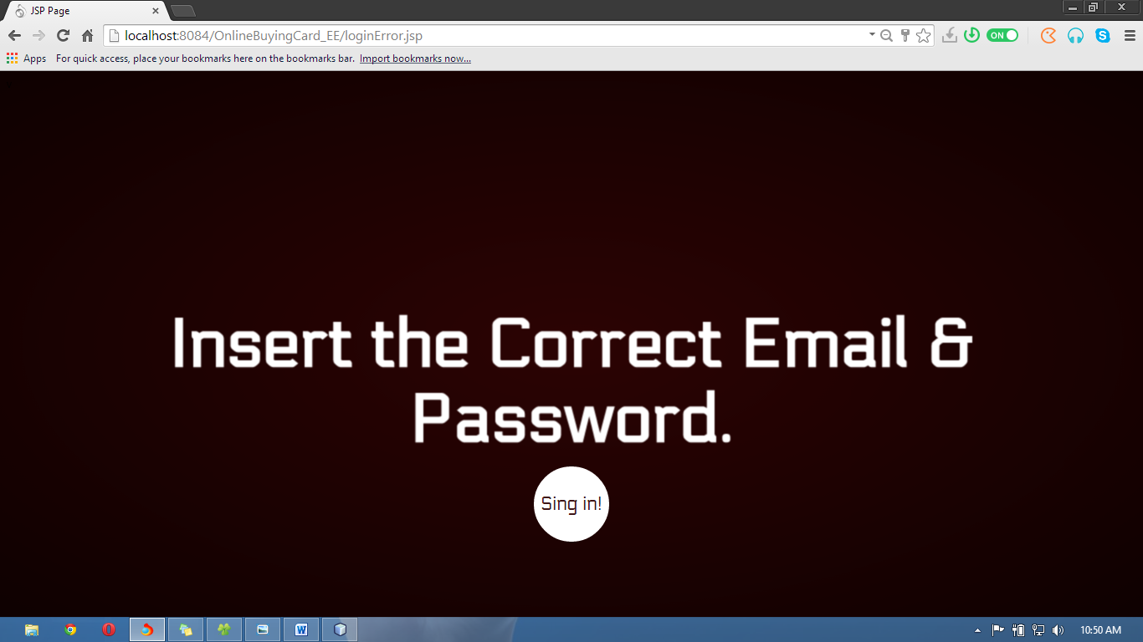

<%--

Document : loginError

Created on : Jan 27, 2015, 11:35:12 PM

Author : Buddhika

--%>

<%@page contentType="text/html" pageEncoding="UTF-8"%>

<!DOCTYPE html>

<html>

<head>

<meta http-equiv="Content-Type" content="text/html; charset=UTF-8">

<title>JSP Page</title>

</head>

<style>

@font-face {

font-family: 'Electrolize';

font-style: normal;

font-weight: 400;

src: local('Electrolize'), local('Electrolize-Regular'), url(http://themes.googleusercontent.com/static/fonts/electrolize/v2/DDy9sgU2U7S4xAwH5thnJ4bN6UDyHWBl620a-IRfuBk.woff) format('woff');

}

body {

background: #310404 url(http://web-sonick.zz.mu/images/sl/red_texture.jpg) repeat top left;

font-family: 'Electrolize';

}

.container{

width: 100%;

position: relative;

overflow:hidden;

}

a {

text-decoration:none;

}

h1.main,p.demos {

-webkit-animation-delay: 18s;

-moz-animation-delay: 18s;

-ms-animation-delay: 18s;

animation-delay: 18s;

}

.sp-container {

position: fixed;

top: 0px;

left: 0px;

width: 100%;

height: 100%;

z-index: 0;

background: -webkit-radial-gradient(rgba(0, 0, 0, 0.1), rgba(0, 0, 0, 0.3) 35%, rgba(0, 0, 0, 0.7));

background: -moz-radial-gradient(rgba(0, 0, 0, 0.1), rgba(0, 0, 0, 0.3) 35%, rgba(0, 0, 0, 0.7));

background: -ms-radial-gradient(rgba(0, 0, 0, 0.1), rgba(0, 0, 0, 0.3) 35%, rgba(0, 0, 0, 0.7));

background: radial-gradient(rgba(0, 0, 0, 0.1), rgba(0, 0, 0, 0.3) 35%, rgba(0, 0, 0, 0.7));

}

.sp-content {

position: absolute;

width: 100%;

height: 100%;

left: 0px;

top: 0px;

z-index: 1000;

}

.sp-container h2 {

position: absolute;

top: 50%;

line-height: 100px;

height: 90px;

margin-top: -50px;

font-size: 90px;

width: 100%;

text-align: center;

color: transparent;

-webkit-animation: blurFadeInOut 3s ease-in backwards;

-moz-animation: blurFadeInOut 3s ease-in backwards;

-ms-animation: blurFadeInOut 3s ease-in backwards;

animation: blurFadeInOut 3s ease-in backwards;

}

.sp-container h2.frame-1 {

-webkit-animation-delay: 0s;

-moz-animation-delay: 0s;

-ms-animation-delay: 0s;

animation-delay: 0s;

}

.sp-container h2.frame-2 {

-webkit-animation-delay: 3s;

-moz-animation-delay: 3s;

-ms-animation-delay: 3s;

animation-delay: 3s;

}

.sp-container h2.frame-3 {

-webkit-animation-delay: 6s;

-moz-animation-delay: 6s;

-ms-animation-delay: 6s;

animation-delay: 6s;

}

.sp-container h2.frame-4 {

font-size: 200px;

-webkit-animation-delay: 9s;

-moz-animation-delay: 9s;

-ms-animation-delay: 9s;

animation-delay: 9s;

}

.sp-container h2.frame-5 {

-webkit-animation: none;

-moz-animation: none;

-ms-animation: none;

animation: none;

color: transparent;

text-shadow: 0px 0px 1px #fff;

}

.sp-container h2.frame-5 span {

-webkit-animation: blurFadeIn 3s ease-in 12s backwards;

-moz-animation: blurFadeIn 1s ease-in 12s backwards;

-ms-animation: blurFadeIn 3s ease-in 12s backwards;

animation: blurFadeIn 3s ease-in 12s backwards;

color: transparent;

text-shadow: 0px 0px 1px #fff;

}

.sp-container h2.frame-5 span:nth-child(2) {

-webkit-animation-delay: 13s;

-moz-animation-delay: 13s;

-ms-animation-delay: 13s;

animation-delay: 13s;

}

.sp-container h2.frame-5 span:nth-child(3) {

-webkit-animation-delay: 14s;

-moz-animation-delay: 14s;

-ms-animation-delay: 14s;

animation-delay: 14s;

}

.sp-globe {

position: absolute;

width: 282px;

height: 273px;

left: 50%;

top: 50%;

margin: -137px 0 0 -141px;

background: transparent url(http://web-sonick.zz.mu/images/sl/globe.png) no-repeat top left;

-webkit-animation: fadeInBack 3.6s linear 14s backwards;

-moz-animation: fadeInBack 3.6s linear 14s backwards;

-ms-animation: fadeInBack 3.6s linear 14s backwards;

animation: fadeInBack 3.6s linear 14s backwards;

-ms-filter: "progid:DXImageTransform.Microsoft.Alpha(Opacity=30)";

filter: alpha(opacity=30);

opacity: 0.3;

-webkit-transform: scale(5);

-moz-transform: scale(5);

-o-transform: scale(5);

-ms-transform: scale(5);

transform: scale(5);

}

.sp-circle-link {

position: absolute;

left: 50%;

bottom: 100px;

margin-left: -50px;

text-align: center;

line-height: 100px;

width: 100px;

height: 100px;

background: #fff;

color: #3f1616;

font-size: 25px;

-webkit-border-radius: 50%;

-moz-border-radius: 50%;

border-radius: 50%;

-webkit-animation: fadeInRotate 1s linear 16s backwards;

-moz-animation: fadeInRotate 1s linear 16s backwards;

-ms-animation: fadeInRotate 1s linear 16s backwards;

animation: fadeInRotate 1s linear 16s backwards;

-webkit-transform: scale(1) rotate(0deg);

-moz-transform: scale(1) rotate(0deg);

-o-transform: scale(1) rotate(0deg);

-ms-transform: scale(1) rotate(0deg);

transform: scale(1) rotate(0deg);

}

.sp-circle-link:hover {

background: #85373b;

color: #fff;

}

/**/

@-webkit-keyframes blurFadeInOut{

0%{

opacity: 0;

text-shadow: 0px 0px 40px #fff;

-webkit-transform: scale(1.3);

}

20%,75%{

opacity: 1;

text-shadow: 0px 0px 1px #fff;

-webkit-transform: scale(1);

}

100%{

opacity: 0;

text-shadow: 0px 0px 50px #fff;

-webkit-transform: scale(0);

}

}

@-webkit-keyframes blurFadeIn{

0%{

opacity: 0;

text-shadow: 0px 0px 40px #fff;

-webkit-transform: scale(1.3);

}

50%{

opacity: 0.5;

text-shadow: 0px 0px 10px #fff;

-webkit-transform: scale(1.1);

}

100%{

opacity: 1;

text-shadow: 0px 0px 1px #fff;

-webkit-transform: scale(1);

}

}

@-webkit-keyframes fadeInBack{

0%{

opacity: 0;

-webkit-transform: scale(0);

}

50%{

opacity: 0.4;

-webkit-transform: scale(2);

}

100%{

opacity: 0.2;

-webkit-transform: scale(5);

}

}

@-webkit-keyframes fadeInRotate{

0%{

opacity: 0;

-webkit-transform: scale(0) rotate(360deg);

}

100%{

opacity: 1;

-webkit-transform: scale(1) rotate(0deg);

}

}

/**/

@-moz-keyframes blurFadeInOut{

0%{

opacity: 0;

text-shadow: 0px 0px 40px #fff;

-moz-transform: scale(1.3);

}

20%,75%{

opacity: 1;

text-shadow: 0px 0px 1px #fff;

-moz-transform: scale(1);

}

100%{

opacity: 0;

text-shadow: 0px 0px 50px #fff;

-moz-transform: scale(0);

}

}

@-moz-keyframes blurFadeIn{

0%{

opacity: 0;

text-shadow: 0px 0px 40px #fff;

-moz-transform: scale(1.3);

}

100%{

opacity: 1;

text-shadow: 0px 0px 1px #fff;

-moz-transform: scale(1);

}

}

@-moz-keyframes fadeInBack{

0%{

opacity: 0;

-moz-transform: scale(0);

}

50%{

opacity: 0.4;

-moz-transform: scale(2);

}

100%{

opacity: 0.2;

-moz-transform: scale(5);

}

}

@-moz-keyframes fadeInRotate{

0%{

opacity: 0;

-moz-transform: scale(0) rotate(360deg);

}

100%{

opacity: 1;

-moz-transform: scale(1) rotate(0deg);

}

}

/**/

@keyframes blurFadeInOut{

0%{

opacity: 0;

text-shadow: 0px 0px 40px #fff;

transform: scale(1.3);

}

20%,75%{

opacity: 1;

text-shadow: 0px 0px 1px #fff;

transform: scale(1);

}

100%{

opacity: 0;

text-shadow: 0px 0px 50px #fff;

transform: scale(0);

}

}

@keyframes blurFadeIn{

0%{

opacity: 0;

text-shadow: 0px 0px 40px #fff;

transform: scale(1.3);

}

50%{

opacity: 0.5;

text-shadow: 0px 0px 10px #fff;

transform: scale(1.1);

}

100%{

opacity: 1;

text-shadow: 0px 0px 1px #fff;

transform: scale(1);

}

}

@keyframes fadeInBack{

0%{

opacity: 0;

transform: scale(0);

}

50%{

opacity: 0.4;

transform: scale(2);

}

100%{

opacity: 0.2;

transform: scale(5);

}

}

@keyframes fadeInRotate{

0%{

opacity: 0;

transform: scale(0) rotate(360deg);

}

100%{

opacity: 1;

transform: scale(1) rotate(0deg);

}

}

</style>

<body>

v

<div class="container">

<div class="header">

<div class="clr"></div>

</div>

<div class="sp-container">

<div class="sp-content">

<div class="sp-globe"></div>

<h2 class="frame-1">Please Wait</h2>

<h2 class="frame-2">You Are enter the error value</h2>

<h2 class="frame-3">You can Try again</h2>

<h2 class="frame-4">Now!</h2>

<h2 class="frame-5"><span>Insert the Correct</span> <span>Email &</span> <span>Password.</span></h2>

<a class="sp-circle-link" href="singin.jsp">Sing in!</a>

</div>

</div>

</div>

<script type="text/javascript" src="/path/to/shared/js/EventHelpers.js">

</script>

<script type="text/javascript" src="/path/to/shared/js/cssQuery-p.js">

</script>

<script type="text/javascript" src="/path/to/shared/js/jcoglan.com/sylvester.js">

</script>

<script type="text/javascript" src="/path/to/shared/js/cssSandpaper.js">

</script>

</body>

</html>

Forgot password page

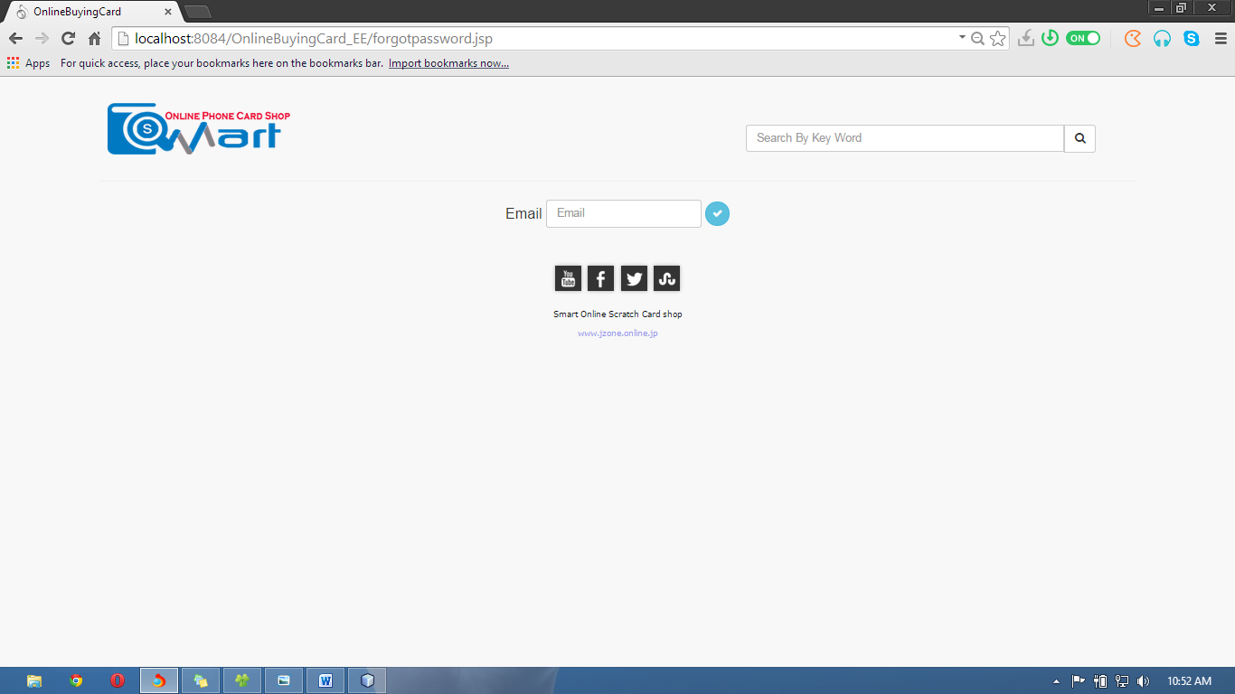

<%--

Document : index

Created on : 12-Dec-2014, 19:24:43

Author : Mr.Buddhika

--%>

<%@page contentType="text/html" pageEncoding="UTF-8"%>

<!DOCTYPE html>

<html>

<head>

<meta http-equiv="Content-Type" content="text/html; charset=UTF-8">

<title>OnlineBuyingCard</title>

<link rel="stylesheet" href="css/bootstrap.min.css">

<link rel="stylesheet" href="css/plugins/metisMenu/metisMenu.min.css">

<link rel="stylesheet" href="css/footer.css">

<link rel="stylesheet" href="css/sb-admin-2.css">

<link type="text/css" rel="stylesheet" href="font-awesome-4.1.0/css/font-awesome.min.css">

<script src="js/jquery.js"></script>

<script src="js/bootstrap.min.js"></script>

<script src="js/plugins/metisMenu/metisMenu.min.js"></script>

<script src="js/sb-admin-2.js"></script>

<script src="js/jzone.js"></script>

<script src="swtallerts/sweet-alert.js"> </script>

<script src="swtallerts/sweet-alert.min.js"> </script>

<link rel="stylesheet" href="swtallerts/sweet-alert.css">

<script src="swtallerts/min.js"></script>

</head>

<body >

<br/>

<div style="margin-left: 8%;margin-right: 8%;">

<header>

<table border="0">

<tbody>

<tr>

<td> <img src="images/Capture2.png"/></td>

<td style="width: 40%"></td>

<td>

<div class="form-group input-group" style="margin-top: 9%;" align="right">

<input class="form-control" type="text" size="50" placeholder="Search By Key Word"></input>

<span class="input-group-btn">

<button class="btn btn-default" type="button">

<i class="fa fa-search"></i>

</button>

</span>

</div>

</td>

</tr>

</tbody>

</table>

<hr/>

</header>

<!--------------------------------------------------------CONTENT--------------------------------------------------------------------------------------->

<div align="center">

<table border="0" >

<tbody>

<form action="FPassword">

<tr>

<td><h4>Email</h4></td>

<td>&nbsp;</td>

<td><input type="text" name="email" id="tmail" value="" class="form-control" placeholder="Email" /></td>

<td> &nbsp;<button type="submit" class="btn btn-info btn-circle"><i class="fa fa-check"></i>

</button></td>

</tr>

</form>

</tbody>

</table>

</div>

<br/><br/>

<!------------------------------------------------------------------------------------------------------------------------------------------------------>

<%@include file="footer.jsp" %>

</div>

</body>

</html>

Homepage

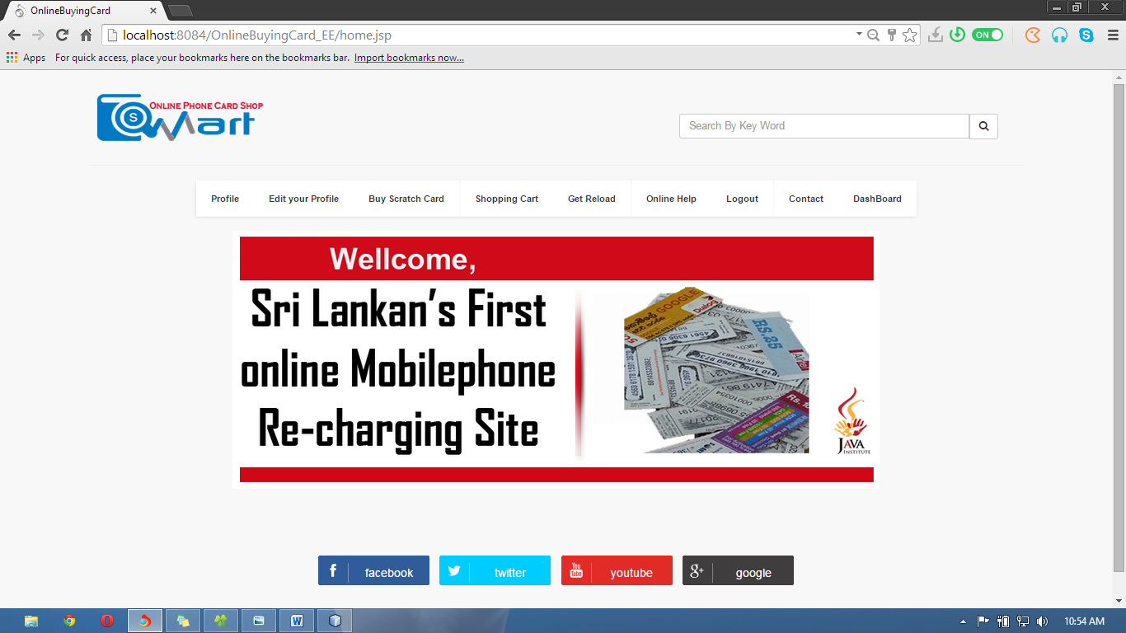

<%--

Document : index

Created on : 12-Dec-2014, 19:24:43

Author : Mr.Buddhika

--%>

<%@page import="java.sql.Statement"%>

<%@page import="java.sql.ResultSet"%>

<%@page contentType="text/html" pageEncoding="UTF-8"%>

<!DOCTYPE html>

<html>

<head>

<meta http-equiv="Content-Type" content="text/html; charset=UTF-8">

<title>OnlineBuyingCard</title>

<link rel="stylesheet" href="css/bootstrap.min.css">

<link rel="stylesheet" href="css/plugins/metisMenu/metisMenu.min.css">

<link rel="stylesheet" href="css/footer.css">

<link rel="stylesheet" href="css/sb-admin-2.css">

<link type="text/css" rel="stylesheet" href="font-awesome-4.1.0/css/font-awesome.min.css">

<script src="js/jquery.js"></script>

<script src="js/bootstrap.min.js"></script>

<script src="js/plugins/metisMenu/metisMenu.min.js"></script>

<link rel="stylesheet" href="css/dashboard.css">

<script src="js/sb-admin-2.js"></script>

<script src="js/jzone.js"></script>

<script src="swtallerts/sweet-alert.js"> </script>

<script src="swtallerts/sweet-alert.min.js"> </script>

<link rel="stylesheet" href="swtallerts/sweet-alert.css">

<script src="swtallerts/min.js"></script>

<%

try {

HttpSession s = request.getSession(true);

int roleid = Integer.parseInt(s.getAttribute("utype").toString());

ResultSet rs = db.Database.Database().executeQuery("SELECT user_type_id FROM user_pivilages WHERE page_id=(SELECT page_id FROM pages WHERE url ='home.jsp')");

boolean isavailable = false;

while (rs.next()) {

if (rs.getInt(1) == roleid) {

// true

isavailable = true;

}

}

if (!isavailable) {

response.sendRedirect("AccessDenied.jsp");

}

} catch (NullPointerException e) {

response.sendRedirect("singin.jsp");

}

%>

</head>

<body >

<br/>

<div style="margin-left: 8%;margin-right: 8%;">

<header>

<table border="0">

<tbody>

<tr>

<td> <img src="images/Capture2.png"/></td>

<td style="width: 40%"></td>

<td>

<div class="form-group input-group" style="margin-top: 9%;" align="right">

<input class="form-control" type="text" size="50" placeholder="Search By Key Word"></input>

<span class="input-group-btn">

<button class="btn btn-default" type="button">

<i class="fa fa-search"></i>

</button>

</span>

</div>

</td>

</tr>

</tbody>

</table>

<hr/>

</header>

<!--------------------------------------------------------CONTENT--------------------------------------------------------------------------------------->

<!--Menu-->

<div align="center">

<ul>

<li onclick="profile()">Profile </li>

<li onclick="editUser()">Edit your Profile</li>

<li onclick="bsc()">Buy Scratch Card</li>

<li onclick="window.location='cart.jsp'">Shopping Cart</li>

<li>Get Reload</li>

<li onclick="window.location='onlineHelp.jsp'">Online Help</li>

<li onclick="window.location='logOut.jsp'" >Logout</li>

<li onclick="window.location='http://about.me/buddhika.lakshan123'">Contact</li>

<li onclick="ClickDashBoard()" >DashBoard</li>

</ul>

</div>

<br/>

<div align="center">

<img src="images/slider.png" />

</div>

<br /><br />

<%@include file="foot.jsp" %>

<!------------------------------------------------------------------------------------------------------------------------------------------------------>

</div>

</body>

</html>

# User Actions

View Profile

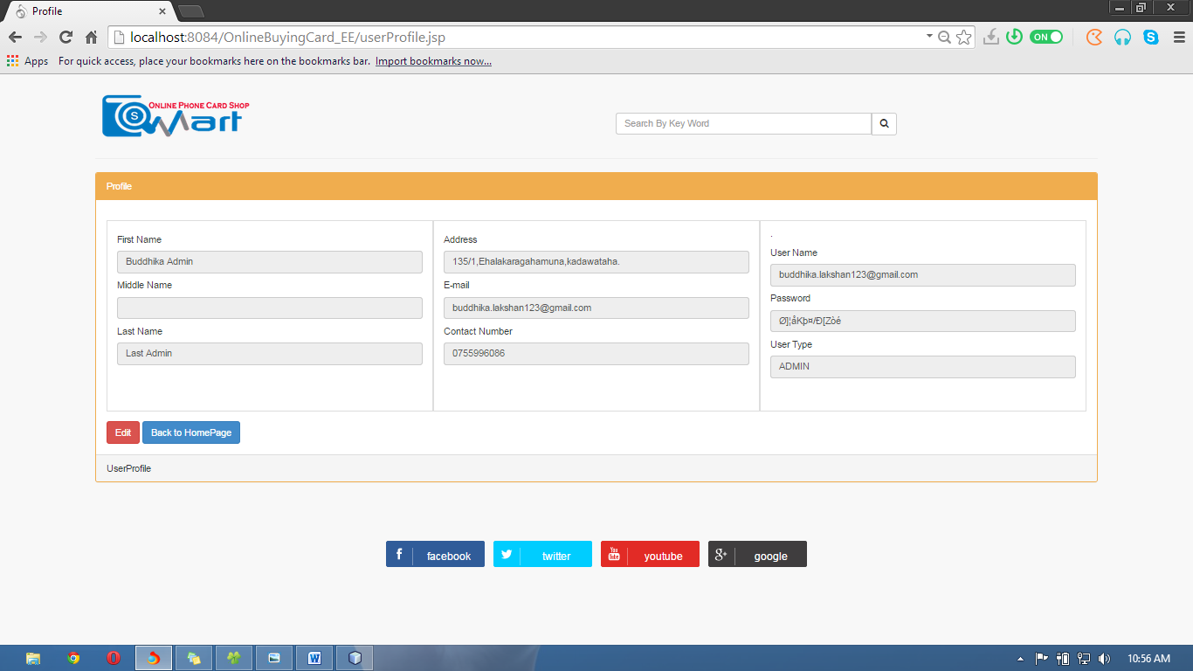

<%--

Document : userProfile

Created on : Jan 3, 2015, 8:19:07 PM

Author : Buddhika

--%>

<%@page import="java.sql.Statement"%>

<%@page import="com.mysql.jdbc.ResultSet"%>

<%@page contentType="text/html" pageEncoding="UTF-8"%>

<!DOCTYPE html>

<html>

<head>

<meta http-equiv="Content-Type" content="text/html; charset=UTF-8">

<title>Profile</title>

<link rel="stylesheet" href="css/bootstrap.min.css">

<link rel="stylesheet" href="css/dashboard.css">

<link rel="stylesheet" href="css/plugins/metisMenu/metisMenu.min.css">

<link rel="stylesheet" href="css/sb-admin-2.css">

<link type="text/css" rel="stylesheet" href="font-awesome-4.1.0/css/font-awesome.min.css">

<script src="js/jquery.js"></script>

<script src="js/bootstrap.min.js"></script>

<script src="js/plugins/metisMenu/metisMenu.min.js"></script>

<script src="js/sb-admin-2.js"></script>

<script src="js/jzone.js"></script>

<%

int uid=0;

try {

HttpSession s = request.getSession(true);

int roleid = Integer.parseInt(s.getAttribute("utype").toString());

int userid = Integer.parseInt(s.getAttribute("userid").toString());

uid=userid;

java.sql.ResultSet rs = db.Database.Database().executeQuery("SELECT user_type_id FROM user_pivilages WHERE page_id=(SELECT page_id FROM pages WHERE url ='profile.jsp')");

boolean isavailable = false;

while (rs.next()) {

if (rs.getInt(1) == roleid) {

isavailable = true;

}

}

if (!isavailable) {

response.sendRedirect("AccessDenied.jsp");

}

} catch (NullPointerException e) {

response.sendRedirect("singin.jsp");

}

Statement s=db.Database.Database();

java.sql.ResultSet rs2= s.executeQuery("SELECT user.name, user.l_name, user.address, user.email, user.phone_number, user.password, user_type.type, user.id FROM user INNER JOIN user_type ON user.user_type = user_type.id_user_type WHERE user.id='"+uid+"'");

if(rs2.next()){

%>

</head>

<body>

<br/>

<div style="margin-left: 8%;margin-right: 8%;">

<table border="0">

<tbody>

<tr>

<td> <img src="images/Capture2.png"/></td>

<td style="width: 40%"></td>

<td>

<div class="form-group input-group" style="margin-top: 9%;" align="right">

<input class="form-control" type="text" size="50" placeholder="Search By Key Word"></input>

<span class="input-group-btn">

<button class="btn btn-default" type="button">

<i class="fa fa-search"></i>

</button>

</span>

</div>

</td>

</tr>

</tbody>

</table>

<hr/>

<!--Form-->

<div class="row" >

<div class="col-lg-12">

<div class="panel panel-yellow">

<div class="panel-heading">

Profile

</div>

<div class="panel-body">

<form action="editUser.jsp" method="Post">

<div class="row show-grid">

<div class="col-md-4">

<h5>First Name</h5><input type="text" readonly="readonly" name="fname" value="<%=rs2.getString(1)%>" class="form-control" />

<h5>Middle Name</h5><input type="text" readonly="readonly" name="mname" value="" class="form-control" />

<h5>Last Name</h5><input type="text" readonly="readonly" name="lname" value="<%=rs2.getString(2)%>" class="form-control" />

<br/><br/><br/>

</div>

<div class="col-md-4">

<h5>Address</h5>

<input type="text" readonly="readonly" name="address" value="<%=rs2.getString(3)%>" class="form-control" />

<h5>E-mail</h5>

<input type="text" readonly="readonly" name="email" value="<%=rs2.getString(4)%>" class="form-control" />

<h5>Contact Number</h5>

<input type="text" readonly="readonly" name="tp" value="<%=rs2.getString(5)%>" class="form-control" />

<br/><br/><br/>

</div>

<div class="col-md-4">.

<h5>User Name</h5>

<input type="text" readonly="readonly" name="un" value="<%=rs2.getString(4)%>" class="form-control" />

<h5>Password</h5>

<input type="text" readonly="readonly" name="pw" value="<%=rs2.getString(6)%>" class="form-control" />

<h5>User Type</h5>

<input type="text" readonly="readonly" name="ut" value="<%=rs2.getString(7)%>" class="form-control" />

<br/> <br/>

</div>

<% }%>

</div>

<input type="submit" class="btn btn-warning btn-danger" value="Edit" />

<button type="button" onclick="ClickQuickStart()" class="btn btn-primary">Back to HomePage</button>

</form>

</div>

<div class="panel-footer">

UserProfile

</div>

</div>

</div></div>

<br/>

<%@include file="foot.jsp" %>

</div> </body></html>

Edit profile

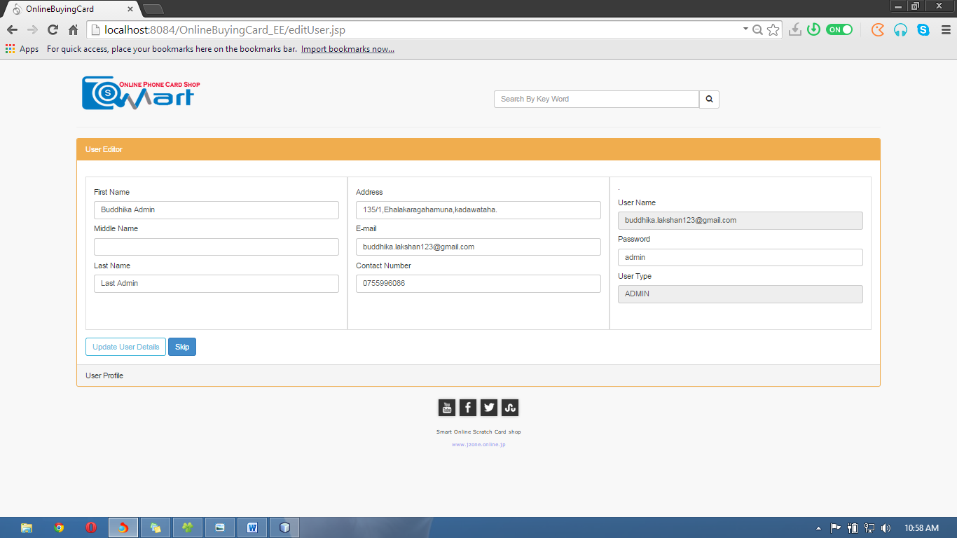

<%--

Document : index

Created on : 12-Dec-2014, 19:24:43

Author : Mr.Buddhika

--%>

<%@page import="java.sql.Statement"%>

<%@page import="java.sql.ResultSet"%>

<%@page contentType="text/html" pageEncoding="UTF-8"%>

<!DOCTYPE html>

<html>

<head>

<meta http-equiv="Content-Type" content="text/html; charset=UTF-8">

<title>OnlineBuyingCard</title>

<link rel="stylesheet" href="css/bootstrap.min.css">

<link rel="stylesheet" href="css/plugins/metisMenu/metisMenu.min.css">

<link rel="stylesheet" href="css/footer.css">

<link rel="stylesheet" href="css/sb-admin-2.css">

<link type="text/css" rel="stylesheet" href="font-awesome-4.1.0/css/font-awesome.min.css">

<script src="js/jquery.js"></script>

<script src="js/bootstrap.min.js"></script>

<script src="js/plugins/metisMenu/metisMenu.min.js"></script>

<script src="js/sb-admin-2.js"></script>

<script src="js/jzone.js"></script>

<script src="js/validation.js"></script>

<%

int uid = 0;

try {

HttpSession s = request.getSession(true);

int roleid = Integer.parseInt(s.getAttribute("utype").toString());

int userid = Integer.parseInt(s.getAttribute("userid").toString());

uid = userid;

ResultSet rs = db.Database.Database().executeQuery("SELECT user_type_id FROM user_pivilages WHERE page_id=(SELECT page_id FROM pages WHERE url ='editUser.jsp')");

boolean isavailable = false;

while (rs.next()) {

if (rs.getInt(1) == roleid) {

isavailable = true;

}

if (!isavailable) {

response.sendRedirect("AccessDenied.jsp");

}

} catch (NullPointerException e) {

response.sendRedirect("singin.jsp");

}

Statement s = db.Database.Database();

String m = null;

ResultSet rs2 = s.executeQuery("SELECT user.name, user.l_name, user.address, user.email, user.phone_number, AES_DECRYPT(password, SHA1(SHA(PASSWORD(MD5('953180898'))))), user_type.type, user.id FROM user INNER JOIN user_type ON user.user_type = user_type.id_user_type WHERE user.id='" + uid + "'");

if (rs2.next()) {

m = rs2.getString(4);

%>

</head>

<body >

<br/>

<div style="margin-left: 8%;margin-right: 8%;">

<header>

<table border="0">

<tbody>

<tr>

<td> <img src="images/Capture2.png"/></td>

<td style="width: 40%"></td>

<td>

<div class="form-group input-group" style="margin-top: 9%;" align="right">

<input class="form-control" type="text" size="50" placeholder="Search By Key Word">

</input>

<span class="input-group-btn">

<button class="btn btn-default" type="button">

<i class="fa fa-search"></i>

</button>

</span>

</div>

</td>

</tr>

</tbody>

</table>

<hr/>

</header>

<!--------------------------------------------------------CONTENT--------------------------------------------------------------------------------------->

<div>

<div class="row" >

<div class="col-lg-12">

<div class="panel panel-yellow">

<div class="panel-heading">

User Editor

</div>

<div class="panel-body">

<form action="editAdmin.jsp" method="POST">

<div class="row show-grid">

<div class="col-md-4">

<h5>First Name</h5><input type="text" name="fname" value="<%=rs2.getString(1)%>" class="form-control" data-validate="required" />

<h5>Middle Name</h5><input type="text" name="mname" value="" class="form-control" />

<h5>Last Name</h5><input type="text" name="lname" value="<%=rs2.getString(2)%>" class="form-control" data-validate="required" />

<br/><br/><br/>

</div>

<div class="col-md-4">

<h5>Address</h5>

<input type="text" name="address" value="<%=rs2.getString(3)%>" class="form-control" data-validate="required" />

<h5>E-mail</h5>

<input type="text" name="email" value="<%=rs2.getString(4)%>" class="form-control" data-validate="required,email" />

<h5>Contact Number</h5>

<input type="text" name="tp" value="<%=rs2.getString(5)%>" class="form-control"data-validate="required,number" />

<br/><br/><br/>

</div>

<div class="col-md-4">.

<h5>User Name</h5>

<input type="text" name="un" readonly="readonly" value="<%=rs2.getString(4)%>" class="form-control" />

<h5>Password</h5>

<input type="text" name="pw" value="<%=rs2.getString(6)%>" class="form-control"data-validate="required" />

<h5>User Type</h5>

<input type="text" readonly="readonly" name="ut" value="<%=rs2.getString(7)%>" class="form-control" />

<br/> <br/> <% }%>

</div>

</div>

<button class="btn btn-outline btn-info" type="submit" >Update User Details</button>

<button type="button" onclick="ClickQuickStart()" class="btn btn-primary">Skip</button>

</form>

</div>

<div class="panel-footer">

User Profile

</div>

</div>

</div></div>

<%@include file="footer.jsp" %>

</div>

</body>

</html>

# Buy a scratch card

View by network

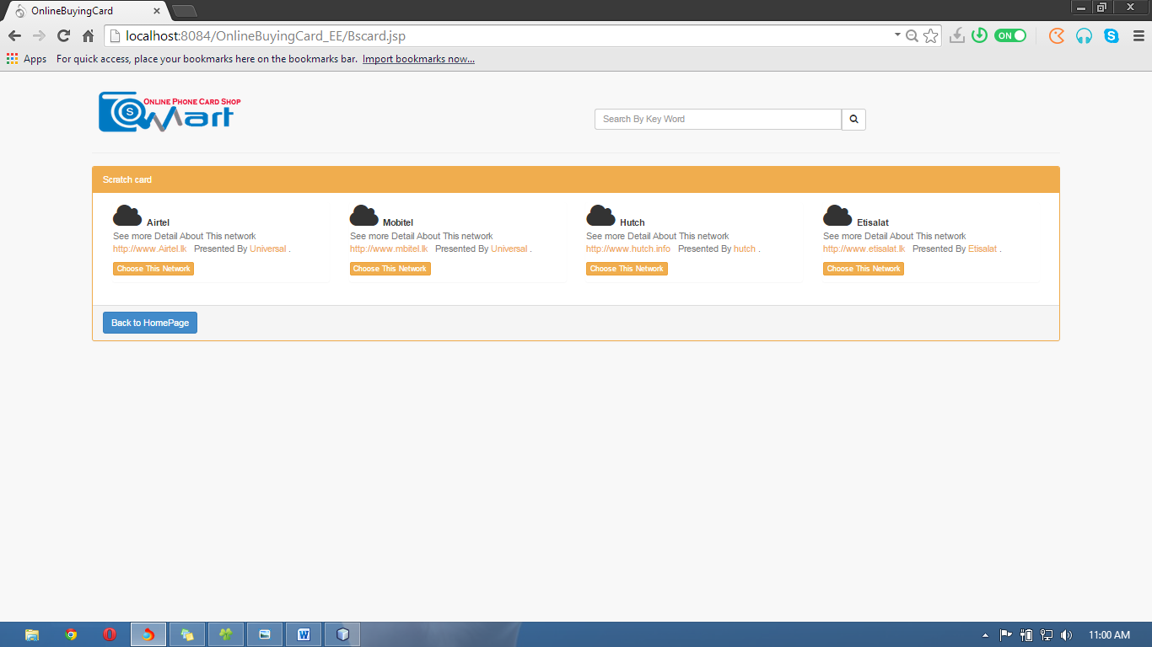

<%--

Document : index

Created on : 12-Dec-2014, 19:24:43

Author : Mr.Buddhika

--%>

<%@page import="java.sql.ResultSet"%>

<%@page contentType="text/html" pageEncoding="UTF-8"%>

<!DOCTYPE html>

<html>

<head>

<meta http-equiv="Content-Type" content="text/html; charset=UTF-8">

<title>OnlineBuyingCard</title>

<link rel="stylesheet" href="css/bootstrap.min.css">

<link rel="stylesheet" href="css/plugins/metisMenu/metisMenu.min.css">

<link rel="stylesheet" href="css/footer.css">

<link rel="stylesheet" href="css/sb-admin-2.css">

<link type="text/css" rel="stylesheet" href="font-awesome-4.1.0/css/font-awesome.min.css">

<script src="js/jquery.js"></script>

<script src="js/bootstrap.min.js"></script>

<script src="js/plugins/metisMenu/metisMenu.min.js"></script>

<link rel="stylesheet" href="css/dashboard.css">

<script src="js/sb-admin-2.js"></script>

<script src="js/jzone.js"></script>

<%

try {

HttpSession s = request.getSession(true);

int roleid = Integer.parseInt(s.getAttribute("utype").toString());

ResultSet rs = db.Database.Database().executeQuery("SELECT user_type_id FROM user_pivilages WHERE page_id=(SELECT page_id FROM pages WHERE url ='Bscard.jsp')");

boolean isavailable = false;

while (rs.next()) {

if (rs.getInt(1) == roleid) {

// true

isavailable = true;

}

}

if (!isavailable) {

response.sendRedirect("AccessDenied.jsp");

}

} catch (NullPointerException e) {

response.sendRedirect("singin.jsp");

}

%>

</head>

<body >

<br/>

<div style="margin-left: 8%;margin-right: 8%;">

<header>

<table border="0">

<tbody>

<tr>

<td> <img src="images/Capture2.png"/></td>

<td style="width: 40%"></td>

<td>

<div class="form-group input-group" style="margin-top: 9%;" align="right">

<input class="form-control" type="text" size="50" placeholder="Search By Key Word"></input>

<span class="input-group-btn">

<button class="btn btn-default" type="button">

<i class="fa fa-search"></i>

</button>

</span>

</div> </td> </tr> </tbody> </table> <hr/> </header>

<!--------------------------------------------------------CONTENT--------------------------------------------------------------------------------------->

<div class="row" >

<div class="col-lg-12">

<div class="panel panel-yellow">

<div class="panel-heading">

Scratch card

</div>

<div class="panel-body">

<%

ResultSet rs = db.Database.Database().executeQuery("SELECT network.id, network.name, network.website, network.customer_sir_no, network.company_name FROM network");

while (rs.next()) {

%>

<!------------------------------------------------------------------------------------------------------------------------------------------------------>

<div class="col-md-3 col-sm-12 col-xs-12">

<div class="panel back-dash">

<i class="fa fa-cloud fa-3x"></i><strong> &nbsp;<%= rs.getString(2)%></strong>

<p class="text-muted"> See more Detail About This network &nbsp;<a href="#" class="alert-link"> <%= rs.getString(3)%></a> &nbsp; Presented By

<a href="#" class="alert-link"><%= rs.getString(5)%></a> .<div>

<input type="hidden" name="htInput" id="kk" value="<%= rs.getString(1)%>" />

<button class="btn btn-warning btn-xs" onclick="chooseNetwork(<%= rs.getString(1)%>)">Choose This Network</button></div> </p>

</div>

</div><% }%>

</div>

<div class="panel-footer">

<button type="button" onclick="ClickQuickStart()" class="btn btn-primary">Back to HomePage</button>

</div>

</div></div>

</div>

</div> </body>/html>

After Select Network view existing card models and qty

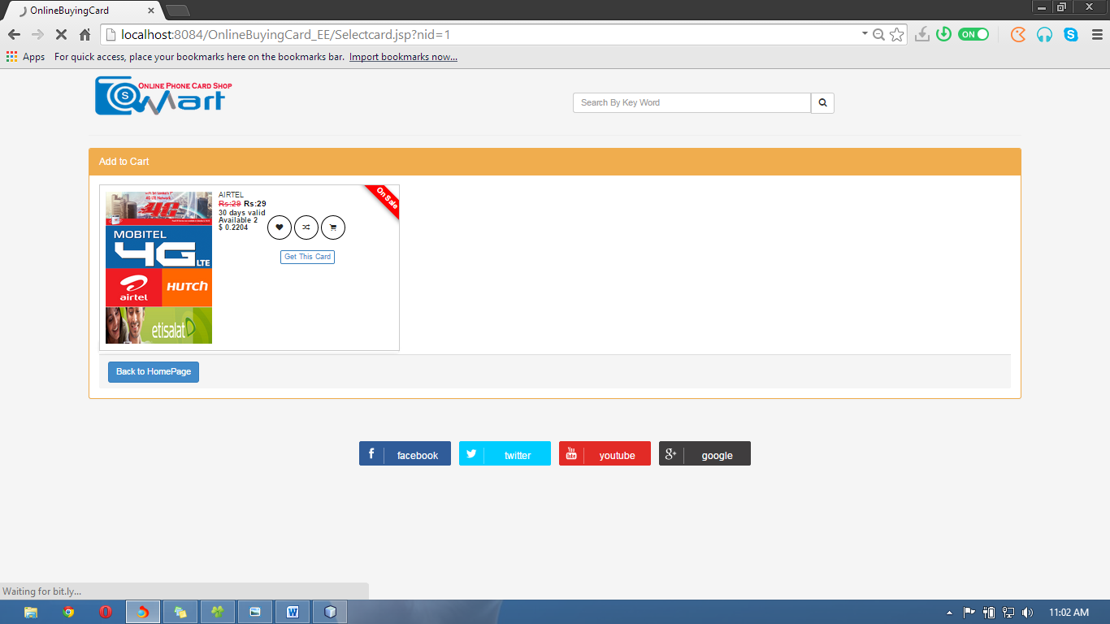

<%--

Document : Selectcard

Created on : Jan 4, 2015, 10:34:27 AM

Author : Buddhika

--%>

<%@page import="java.sql.ResultSet"%>

<%@page contentType="text/html" pageEncoding="UTF-8"%>

<!DOCTYPE html>

<html>

<head>

<meta http-equiv="Content-Type" content="text/html; charset=UTF-8">

<title>OnlineBuyingCard</title>

<link rel="stylesheet" href="css/bootstrap.min.css">

<link rel="stylesheet" href="css/plugins/metisMenu/metisMenu.min.css">

<link rel="stylesheet" href="css/footer.css">

<link rel="stylesheet" href="css/viewplan.css">

<link rel="stylesheet" href="css/sb-admin-2.css">

<link type="text/css" rel="stylesheet" href="font-awesome-4.1.0/css/font-awesome.min.css">

<script src="js/jquery.js"></script>

<script src="js/bootstrap.min.js"></script>

<script src="js/plugins/metisMenu/metisMenu.min.js"></script>

<link rel="stylesheet" href="css/dashboard.css">

<script src="js/sb-admin-2.js"></script>

<script src="js/jzone.js"></script>

<script src="Cart/cart.js"></script>

<link rel="stylesheet" href="Cart/cart.css">

<%

String networkId = request.getParameter("nid");

try {

HttpSession s = request.getSession(true);

int roleid = Integer.parseInt(s.getAttribute("utype").toString());

ResultSet rs = db.Database.Database().executeQuery("SELECT user_type_id FROM user_pivilages WHERE page_id=(SELECT page_id FROM pages WHERE url ='Selectcard.jsp')");

boolean isavailable = false;

while (rs.next()) {

if (rs.getInt(1) == roleid) {

// true

isavailable = true;

}

}

if (!isavailable) {

response.sendRedirect("AccessDenied.jsp");

}

} catch (NullPointerException e) {

response.sendRedirect("singin.jsp");

}

%>

</head>

<body>

<div style="margin-left: 8%;margin-right: 8%;">

<header>

<table border="0">

<tbody>

<tr>

<td> <img src="images/Capture2.png"/></td>

<td style="width: 40%"></td>

<td>

<div class="form-group input-group" style="margin-top: 9%;" align="right">

<input class="form-control" type="text" size="50" placeholder="Search By Key Word"></input>

<span class="input-group-btn">

<button class="btn btn-default" type="button">

<i class="fa fa-search"></i>

</button>

</span>

</div>

</td>

</tr>

</tbody>

</table>

<hr/>

</header>

<!---- content-->

<div class="row" >

<div class="col-lg-12">

<div class="panel panel-yellow">

<div class="panel-heading">

Add to Cart </div>

<div class="panel-body">

<div class="product_grid">

<%

ResultSet rs = db.Database.Database().executeQuery("SELECT price.price, network.name, COUNT(pin.cardModle_id) AS Qty FROM card_modle INNER JOIN network ON card_modle.network_id = network.id INNER JOIN price ON card_modle.price_id = price.id INNER JOIN pin ON pin.cardModle_id = card_modle.idCard_Modle WHERE network.id = '" + networkId + "' AND pin.state='1' GROUP BY price.price, card_modle.idCard_Modle, card_modle.network_id, card_modle.price_id, network.id, network.name, price.id");

while (rs.next()) {

%>

<ul class="product_list list">

<li class="product_item">

<div class="product_sale">

<p>On Sale</p>

</div>

<div class="product_image">

<a href="#"><img src="images/net.png" alt=""></a>

<div class="product_buttons">

<button class="product_heart"><i class="fa fa-heart"></i></button>

<button class="product_compare"><i class="fa fa-random"></i></button>

<button class="add_to_cart"><i class="fa fa-shopping-cart"></i></button>

<div class="quick_view">

<a href="#"><h6>Quick View</h6></a>

</div>

</div>

</div>

<div class="product_values">

<div class="product_title">

<h5><%= rs.getString(2)%></h5>

</div>

<div class="product_price">

<a href="#"><span class="price_old">Rs:<%= rs.getString(1)%></span> <span class="price_new">Rs:<%= rs.getString(1)%></span></a>

<span class="product_rating"></span>

</div>

<div class="product_desc">

<p class="truncate">30 days valid <br/>Available <%= rs.getString(3)%> <br/> <label><b>$ <%= 0.0076*Double.parseDouble(rs.getString(1)) %></b></label> </p>

</div>

<div class="product_buttons">

<button class="product_heart"><i class="fa fa-heart"></i></button>

<button class="product_compare"><i class="fa fa-random"></i></button>

<button class="add_to_cart" onclick="CreateCookey()"><i class="fa fa-shopping-cart"></i></button>

<br/><br/>

<div align="center">

<a href="create_cookei.jsp?network=<%= rs.getString(2)%>&price=<%= rs.getString(1)%> "class="btn btn-outline btn-primary btn-xs">Get This Card</a>

</div>

</div>

</div>

</li>

<% }%>

</div>

<div class="panel-footer">

<button type="button" onclick="ClickQuickStart()" class="btn btn-primary">Back to HomePage</button>

</div>

</div></div>

</div>

</div>

<%@include file="foot.jsp" %>

</div> </body></html>

Cart

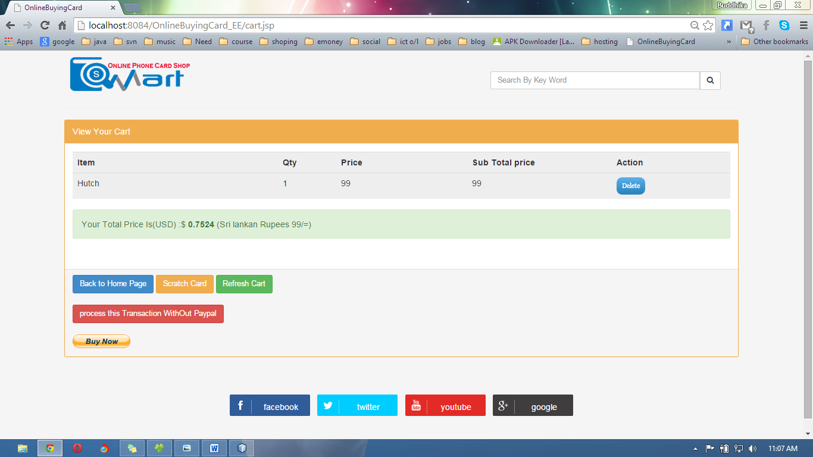

<%--

Document : cart

Created on : Jan 13, 2015, 7:16:03 PM

Author : Buddhika

--%>

<%@page import="java.sql.ResultSet"%>

<%@page contentType="text/html" pageEncoding="UTF-8"%>

<!DOCTYPE html>

<html>

<head>

<meta http-equiv="Content-Type" content="text/html; charset=UTF-8">

<title>OnlineBuyingCard</title>

<link rel="stylesheet" href="css/bootstrap.min.css">

<link rel="stylesheet" href="css/plugins/metisMenu/metisMenu.min.css">

<link rel="stylesheet" href="css/footer.css">

<link rel="stylesheet" href="css/viewplan.css">

<link rel="stylesheet" href="css/sb-admin-2.css">

<link type="text/css" rel="stylesheet" href="font-awesome-4.1.0/css/font-awesome.min.css">

<script src="js/jquery.js"></script>

<script src="js/bootstrap.min.js"></script>

<script src="js/plugins/metisMenu/metisMenu.min.js"></script>

<link rel="stylesheet" href="css/dashboard.css">

<script src="js/sb-admin-2.js"></script>

<script src="js/jzone.js"></script>

<script src="Cart/cart.js"></script>

<link rel="stylesheet" href="Cart/cart.css">

<%

try {

HttpSession s = request.getSession(true);

int roleid = Integer.parseInt(s.getAttribute("utype").toString());

ResultSet rs = db.Database.Database().executeQuery("SELECT user_type_id FROM user_pivilages WHERE page_id=(SELECT page_id FROM pages WHERE url ='Cart.jsp')");

boolean isavailable = false;

while (rs.next()) {

if (rs.getInt(1) == roleid) {

// true

isavailable = true;

}

}

if (!isavailable) {

response.sendRedirect("AccessDenied.jsp");

}

} catch (NullPointerException e) {

response.sendRedirect("singin.jsp");

}

%>

</head>

<body>

<div style="margin-left: 8%;margin-right: 8%;">

<header>

<table border="0">

<tbody>

<tr>

<td> <img src="images/Capture2.png"/></td>

<td style="width: 40%"></td>

<td>

<div class="form-group input-group" style="margin-top: 9%;" align="right">

<input class="form-control" type="text" size="50" placeholder="Search By Key Word"></input>

<span class="input-group-btn">

<button class="btn btn-default" type="button">

<i class="fa fa-search"></i>

</button>

</span>

</div>

</td>

</tr>

</tbody>

</table>

<hr/>

</header>

<div class="row" >

<div class="col-lg-12">

<div class="panel panel-yellow">

<div class="panel-heading">

View Your Cart

</div>

<div class="panel-body">

<div align="center" style="background-color: #eeeeee;">

<table border="0" id="table" class="table" >

<script>

function deleterow()

{

document.getElementById("table").deleteRow(1);

}

</script>

<thead>

<tr>

<th width="175">Item</th>

<th width="50">Qty</th>

<th width="112">Price</th>

<th width="123">Sub Total price</th>

<th width="100">Action</th>

</tr>

</thead>

<tbody>

<%

String item;

int qty;

int price = 0;

int totalprice = 0;

%>

<%

Cookie[] cookies = request.getCookies();

if (cookies != null) {

for (Cookie ck : cookies) {

if ("sl_pincode_save_cart".equals(ck.getName())) {

String ckarray[] = ck.getValue().split("_");

for (int i = 0; i < ckarray.length; i++) {

%>

<tr>

<%

String modlearray[] = ckarray[i].split(",");

for (int j = 0; j < modlearray.length; j++) {

if (modlearray[j].split("=")[0].equals("network")) {

%>

<td><%= modlearray[j].split("=")[1].toString()%></td>

<td>1</td>

<%

// network = modlearray[j].split("=")[1].toString();

} else if (modlearray[j].split("=")[0].equals("price")) {

%>

<td><%= Integer.parseInt(modlearray[j].split("=")[1])%></td>

<td name="total_cell_price">

<%

int pprice = Integer.parseInt(modlearray[j].split("=")[1]) * 1;

totalprice = totalprice + pprice;

%>

<%= pprice%>

</td>

<td>

<form action="fuu.jsp" >

<input type="hidden" name="hidden" value="<%=ckarray[i]%>" />

<input type="submit" value="Delete" class="btn1" />

</form>

<style>

.btn1 {

background: #5bb1eb;

background-image: -webkit-linear-gradient(top, #5bb1eb, #2980b9);

background-image: -moz-linear-gradient(top, #5bb1eb, #2980b9);

background-image: -ms-linear-gradient(top, #5bb1eb, #2980b9);

background-image: -o-linear-gradient(top, #5bb1eb, #2980b9);

background-image: linear-gradient(to bottom, #5bb1eb, #2980b9);

-webkit-border-radius: 10;

-moz-border-radius: 10;

border-radius: 10px;

font-family: Georgia;

color: #ffffff;

font-size: 12px;

padding: 8px 10px 8px 10px;

border: solid #1f628d 0px;

text-decoration: none;

}

.btn1:hover {

background: #4a69e6;

background-image: -webkit-linear-gradient(top, #4a69e6, #2ab5e8);

background-image: -moz-linear-gradient(top, #4a69e6, #2ab5e8);

background-image: -ms-linear-gradient(top, #4a69e6, #2ab5e8);

background-image: -o-linear-gradient(top, #4a69e6, #2ab5e8);

background-image: linear-gradient(to bottom, #4a69e6, #2ab5e8);

text-decoration: none;

}

</style>

</td>

<%

// price = Integer.parseInt(modlearray[j].split("=")[1]);

}

}

%>

</tr>

<%

}

}

}

}

%>

</tbody>

</table>

</div>

<div class="alert alert-success">

Your Total Price Is(USD) :$ <b><%= 0.0076 * totalprice%></b> (Sri lankan Rupees <%= totalprice%>/=)

</div>

<table border="0" align="center">

<tbody>

<tr>

<!-- <td> <a href="cotinue_shoping.jsp?p_tot=<%= totalprice%>" class="">Continue Shoping</a></td>-->

</tr>

</tbody>

</table>

<br/>

</div>

<%

String k = totalprice + "";

session.setAttribute("totalPriceOneCart", k);

%>

<div class="panel-footer">

<button type="button" onclick="ClickQuickStart()" class="btn btn-primary">Back to Home Page</button>

<button type="button" onclick="window.location='Bscard.jsp'" class="btn btn-warning">Scratch Card</button>

<button type="button" onclick="window.location='cart.jsp'" class="btn btn-success">Refresh Cart</button>

<br/><br/>

<form action="CartNext.jsp" method="post">

<input type="hidden" name="hidtot" value="<%= totalprice%>" />

<input type="submit" value="process this Transaction WithOut Paypal" class="btn btn-danger" />

</form>

<br/>

<form onload="payPalRedirect();" name="_xclick" action="https://www.paypal.com/cgi-bin/webscr" method="post">

<input type="hidden" name="cmd" value="_xclick">

<input type="hidden" name="business" value="srilankaecode@gmail.com">

<input type="hidden" name="currency_code" value="USD">

<input type="hidden" value="http://localhost:8084/OnlineBuyingCard_EE/CartNext.jsp" name="return">

<input type="hidden" name="item_name" value="You are Redy to Buying To RechargeCard In Smart App.">

<input type="hidden" name="amount" id="amount" value="<%= 0.0076*totalprice %>">

<input type="image" src="http://www.paypalobjects.com/en_US/i/btn/btn_buynow_LG.gif" border="0" name="submit" alt="Make payments with PayPal - it's fast, free and secure!">

</form>

</div>

</div></div>

</div>

<%@include file="foot.jsp" %>

</div>

</body>

</html>

## After transaction

#### Invoice

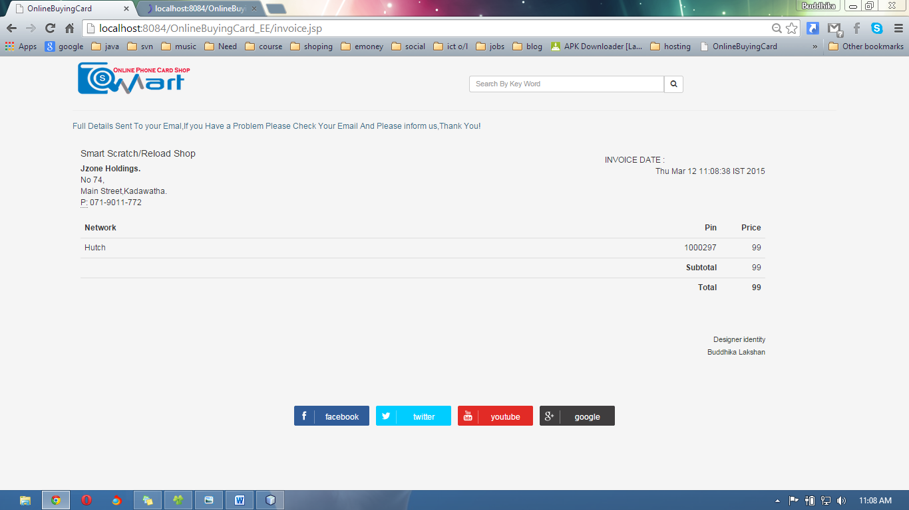

<%--

Document : Selectcard

Created on : Jan 4, 2015, 10:34:27 AM

Author : Buddhika

--%>

<%@page import="java.util.Date"%>

<%@page import="java.text.SimpleDateFormat"%>

<%@page import="java.sql.Statement"%>

<%@page import="java.sql.ResultSet"%>

<%@page contentType="text/html" pageEncoding="UTF-8"%>

<!DOCTYPE html>

<html>

<head>

<meta http-equiv="Content-Type" content="text/html; charset=UTF-8">

<title>OnlineBuyingCard</title>

<link rel="stylesheet" href="css/bootstrap.min.css">

<link rel="stylesheet" href="css/plugins/metisMenu/metisMenu.min.css">

<link rel="stylesheet" href="css/footer.css">

<link rel="stylesheet" href="css/viewplan.css">

<link rel="stylesheet" href="css/sb-admin-2.css">

<link type="text/css" rel="stylesheet" href="font-awesome-4.1.0/css/font-awesome.min.css">

<script src="js/jquery.js"></script>

<script src="js/bootstrap.min.js"></script>

<script src="js/plugins/metisMenu/metisMenu.min.js"></script>

<link rel="stylesheet" href="css/dashboard.css">

<link rel="stylesheet" href="css/invoice.css.css">

<script src="js/sb-admin-2.js"></script>

<script src="js/jzone.js"></script>

<script src="Cart/cart.js"></script>

<link rel="stylesheet" href="Cart/cart.css">

<%

String networkId = request.getParameter("nid");

try {

HttpSession s = request.getSession(true);

int roleid = Integer.parseInt(s.getAttribute("utype").toString());

ResultSet rs = db.Database.Database().executeQuery("SELECT user_type_id FROM user_pivilages WHERE page_id=(SELECT page_id FROM pages WHERE url ='Selectcard.jsp')");

boolean isavailable = false;

while (rs.next()) {

if (rs.getInt(1) == roleid) {

// true

isavailable = true;

}

}

if (!isavailable) {

response.sendRedirect("AccessDenied.jsp");

}

} catch (NullPointerException e) {

response.sendRedirect("singin.jsp");

}

%>

</head>

<body>

<div style="margin-left: 8%;margin-right: 8%;">

<header>

<table border="0">

<tbody>

<tr>

<td> <img src="images/Capture2.png"/></td>

<td style="width: 40%"></td>

<td>

<div class="form-group input-group" style="margin-top: 9%;" align="right">

<input class="form-control" type="text" size="50" placeholder="Search By Key Word"></input>

<span class="input-group-btn">

<button class="btn btn-default" type="button">

<i class="fa fa-search"></i>

</button>

</span>

</div>

</td>

</tr>

</tbody>

</table>

<hr/>

</header>

<span class="text-info">Full Details Sent To your Emal,If you Have a Problem Please Check Your Email And Please inform us,Thank You!</span>

<!---- content-->

<div class="col-md-11">

<div class="grid simple">

<div class="grid-body no-border invoice-body"> <br>

<div class="row">

<div class="col-md-9">

<h4 class="semi-bold">Smart Scratch/Reload Shop</h4>

<address>

<strong>Jzone Holdings.</strong><br>

No 74,<br>

Main Street,Kadawatha.<br>

<abbr title="Phone">P:</abbr> 071-9011-772

</address>

</div>

<div class="col-md-3"> <br>

<div>

<div class="pull-left"> INVOICE DATE : </div>

<div class="pull-right"> <%= new Date() %></div>

<div class="clearfix"></div>

</div>

<br>

</div>

</div>

<table class="table">

<thead>

<tr>

<th class="text-left">Network</th>

<th style="width:140px" class="text-right">Pin</th>

<th style="width:90px" class="text-right">Price</th>

</tr>

</thead>

<tbody>

<%

int p=0;

int db_real_pin = 0;

// String pin = request.getParameter("953180898");

String pin=session.getAttribute("953180898").toString();

String pinz[] = pin.split("_");

Statement st= db.Database.Database();

Statement st1=db.Database.Database();

// out.write(session.getAttribute("invoiceID").toString());

for (int i = 0; i < pinz.length; i++) {

System.out.println();

ResultSet rs= st.executeQuery(" SELECT n.`name`,AES_DECRYPT(p.pin_no, SHA1(SHA(PASSWORD(MD5('953180898'))))),q.price FROM network n,pin p,price q WHERE p.pin_id='"+ pinz[i].split("_")[0].toString()+"' AND q.id=(SELECT price_id FROM card_modle WHERE `idCard_Modle`=(SELECT `cardModle_id` FROM pin WHERE pin_no=(SELECT pin_no FROM pin WHERE pin_id ='"+ pinz[i].split("_")[0].toString()+"'))) AND n.id=(SELECT network_id FROM card_modle WHERE `idCard_Modle`=(SELECT `cardModle_id` FROM pin WHERE pin_no=(SELECT pin_no FROM pin WHERE pin_id ='"+ pinz[i].split("_")[0].toString()+"')))");

while(rs.next()){

// out.write(rs.getString(1));

// out.write("--------");

// out.write(rs.getString(2));

// out.write("------");

// out.write(rs.getString(3));

// out.write("--------");

p=p+Integer.parseInt(rs.getString(3));

%>

<tr>

<td><%= rs.getString(1) %></td>

<td class="text-right"><%= rs.getString(2) %></td>

<td class="text-right"><%= rs.getString(3) %></td>

</tr>

<% } } %>

<tr>

<td></td>

<td class="text-right"><strong>Subtotal</strong></td>

<td class="text-right"><%= p %></td>

</tr>

<tr>

<td></td>

<td class="text-right no-border"><div class=""><strong>Total</strong></div></td>

<td class="text-right"><strong><%= p %></strong></td>

</tr>

</tbody>

</table>

<br>

<br>

<h5 class="text-right text-black">Designer identity</h5>

<h5 class="text-right semi-bold text-black">Buddhika Lakshan</h5>

<br>

<br>

</div>

</div>

</div>

<br/> <br/> <br/> <br/> <br/> <br/> <br/> <br/> <br/> <br/> <br/> <br/> <br/> <br/> <br/> <br/> <br/> <br/> <br/> <br/> <br/> <br/> <br/>

<%@include file="foot.jsp" %>

</div>

</body>

<script type="text/javascript">

window.open("ip.jsp",'_blank');

</script>

</html>

#### Report Invoice

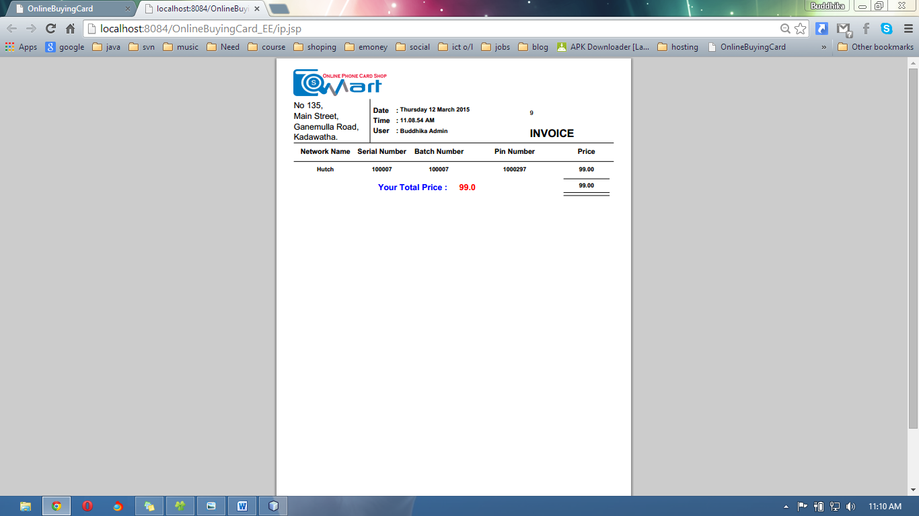

#### Online Help

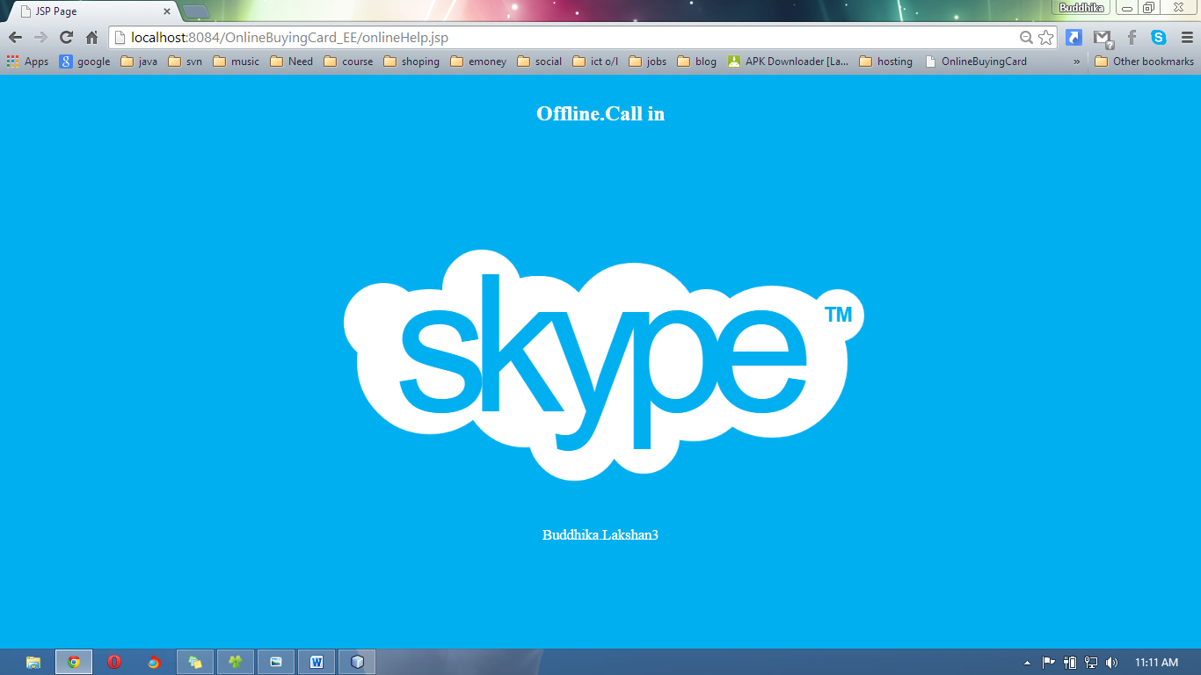

<%--

Document : onlineHelp

Created on : Jan 25, 2015, 10:55:19 PM

Author : Buddhika

--%>

<%@page contentType="text/html" pageEncoding="UTF-8"%>

<link type="text/css" rel="stylesheet" href="onlineHelp/onlinehelp.css">

<!DOCTYPE html>

<html>

<head>

<meta http-equiv="Content-Type" content="text/html; charset=UTF-8">

<title>JSP Page</title>

</head>

<body>

<div id="skype">

<div class="circle circle-1"></div>

<div class="circle circle-2"></div>

<div class="circle circle-3"></div>

<div class="circle circle-4"></div>

<div class="circle circle-5"></div>

<div class="circle circle-6"></div>

<div class="circle circle-7"></div>

<div class="circle circle-8"></div>

<div class="circle circle-9"></div>

<div class="circle circle-10"></div>

<div class="circle circle-11"></div>

<div class="circle circle-12"></div>

<div class="circle circle-13"></div>

<div class="circle circle-14"></div>

<h1>skype</h1>

<h2>TM</h2>

<div align="center" > <label style="font-size: 22px;color: #ffffff;">Buddhika.Lakshan3</label> </div>

</div>

<br/>

<div align="center" > <h1 style="color: #ffffff">Offline.Call in</h1></div>

</div>

</body>

</html>

# Admin Actions

DashBoard

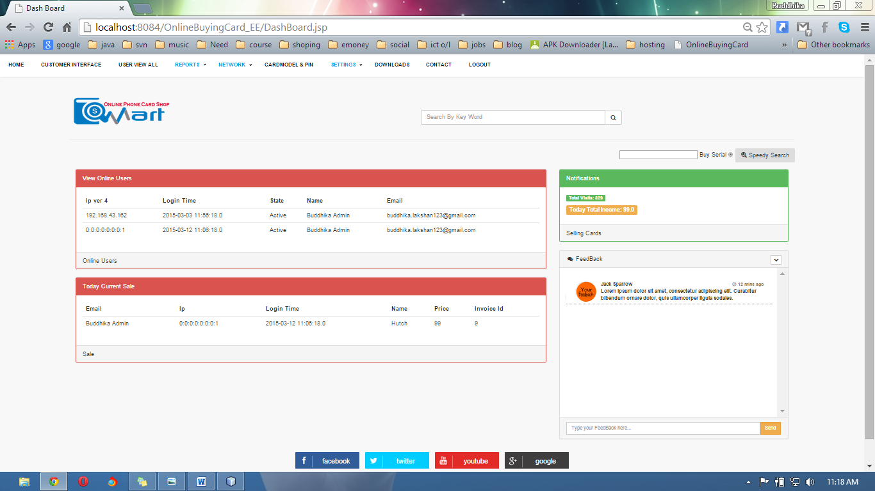

<%--

Document : index

Created on : 12-Dec-2014, 19:24:43

Author : Mr.Buddhika

--%>

<%@page import="java.sql.ResultSet"%>

<%@page import="java.sql.Statement"%>

<%@page contentType="text/html" pageEncoding="UTF-8"%>

<!DOCTYPE html>

<html>

<head>

<meta http-equiv="Content-Type" content="text/html; charset=UTF-8">

<title>OnlineBuyingCard</title>

<link rel="stylesheet" href="css/bootstrap.min.css">

<link rel="stylesheet" href="css/plugins/metisMenu/metisMenu.min.css">

<link rel="stylesheet" href="css/footer.css">

<link rel="stylesheet" href="css/sb-admin-2.css">

<link type="text/css" rel="stylesheet" href="font-awesome-4.1.0/css/font-awesome.min.css">

<script src="js/jquery.js"></script>

<script src="js/bootstrap.min.js"></script>

<script src="js/plugins/metisMenu/metisMenu.min.js"></script>

<script src="js/sb-admin-2.js"></script>

<script src="js/jzone.js"></script>

<script src="swtallerts/sweet-alert.js"> </script>

<script src="swtallerts/sweet-alert.min.js"> </script>

<link rel="stylesheet" href="swtallerts/sweet-alert.css">

<script src="swtallerts/min.js"></script>

</head>

<body >

<br/>

<div style="margin-left: 8%;margin-right: 8%;">

<header>

<table border="0">

<tbody>

<tr>

<td> <img src="images/Capture2.png"/></td>

<td style="width: 40%"></td>

<td>

<div class="form-group input-group" style="margin-top: 9%;" align="right">

<input class="form-control" type="text" size="50" placeholder="Search By Key Word"></input>

<span class="input-group-btn">

<button class="btn btn-default" type="button">

<i class="fa fa-search"></i>

</button>

</span>

</div>

</td>

</tr>

</tbody>

</table>

<hr/>

</header>

<!--------------------------------------------------------CONTENT--------------------------------------------------------------------------------------->

<div>

<div class="col-lg-12">

<div class="col-lg-8"><img src="images/admin_icon.png"/></div>

<div class="col-lg-4">

<p>

This app for admin use Only.if you are admin ple use this app.then you can manage your site esially.

You Can download Use this Link <&nbsp; <a href="">Download Smart App</a>>

<br/> <br/>

<img src="images/se.PNG" style="width: 100%" />

<br/>

<div align="center"><a href="SEAPP/SmartSeAPP.rar" class="buttonDownload">Download</a>

<input type="button" value="Dashboard" onclick="window.location='DashBoard.jsp'"class="btn btn-default" />

</div>

<style>

.buttonDownload {

display: inline-block;

position: relative;

padding: 10px 25px;

background-color: #4CC713;

color: white;

font-family: sans-serif;

text-decoration: none;

font-size: 0.9em;

text-align: center;

text-indent: 15px;

}

.buttonDownload:hover {

background-color: #333;

color: white;

}

.buttonDownload:before, .buttonDownload:after {

content: ' ';

display: block;

position: absolute;

left: 15px;

top: 52%;

}

/* Download box shape */

.buttonDownload:before {

width: 10px;

height: 2px;

border-style: solid;

border-width: 0 2px 2px;

}

/* Download arrow shape */

.buttonDownload:after {

width: 0;

height: 0;

margin-left: 3px;

margin-top: -7px;

border-style: solid;

border-width: 4px 4px 0 4px;

border-color: transparent;

border-top-color: inherit;

animation: downloadArrow 2s linear infinite;

animation-play-state: paused;

}

.buttonDownload:hover:before {

border-color: #4CC713;

}

.buttonDownload:hover:after {

border-top-color: #4CC713;

animation-play-state: running;

}

/* keyframes for the download icon anim */

@keyframes downloadArrow {

/* 0% and 0.001% keyframes used as a hackish way of having the button frozen on a nice looking frame by default */

0% {

margin-top: -7px;

opacity: 1;

}

0.001% {

margin-top: -15px;

opacity: 0;

}

50% {

opacity: 1;

}

100% {

margin-top: 0;

opacity: 0;

}

}

</style>

</p></div>

</div>

<br /><br />

<br /><br />

<br /><br />

<br /><br /> <br />

<br /> <br />

<br /> <br /><br />

<br /><

br /><br />

<br /> <br /><br />

<br /><br />

<footer>

[%@include file="foot.jsp" %](mailto:%25@include%20%20%20file=%22foot.jsp%22%20%25)

</footer>

</div>

<!------------------------------------------------------------------------------------------------------------------------------------------------------>

</div>

</body>

</html>

Network Add

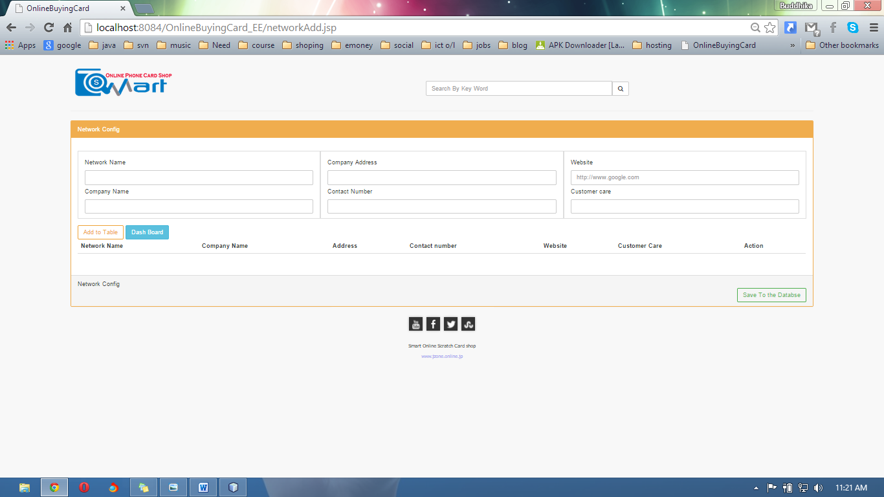

<%--

Document : index

Created on : 12-Dec-2014, 19:24:43

Author : Mr.Buddhika

--%>

<%@page import="com.mysql.jdbc.ResultSet"%>

<%@page contentType="text/html" pageEncoding="UTF-8"%>

<!DOCTYPE html>

<html>

<head>

<meta http-equiv="Content-Type" content="text/html; charset=UTF-8">

<title>OnlineBuyingCard</title>

<link rel="stylesheet" href="css/bootstrap.min.css">

<link rel="stylesheet" href="css/plugins/metisMenu/metisMenu.min.css">

<link rel="stylesheet" href="css/footer.css">

<link rel="stylesheet" href="css/sb-admin-2.css">

<link type="text/css" rel="stylesheet" href="font-awesome-4.1.0/css/font-awesome.min.css">

<script src="js/jquery.js"></script>

<script src="js/bootstrap.min.js"></script>

<script src="js/plugins/metisMenu/metisMenu.min.js"></script>

<script src="js/sb-admin-2.js"></script>

<script src="js/jzone.js"></script>

<script src="js/validation.js"></script>

<script src="swtallerts/sweet-alert.js"> </script>

<script src="swtallerts/sweet-alert.min.js"> </script>

<link rel="stylesheet" href="swtallerts/sweet-alert.css">

<script src="swtallerts/min.js"></script>

<%

try {

HttpSession s = request.getSession(true);

int roleid = Integer.parseInt(s.getAttribute("utype").toString());

java.sql.ResultSet rs = db.Database.Database().executeQuery("SELECT user_type_id FROM user_pivilages WHERE page_id=(SELECT page_id FROM pages WHERE url ='networkAdd.jsp')");

boolean isavailable = false;

while (rs.next()) {

if (rs.getInt(1) == roleid) {

// true

isavailable = true;

}

}

if (!isavailable) {

response.sendRedirect("AccessDenied.jsp");

}

} catch (NullPointerException e) {

response.sendRedirect("singin.jsp");

}

%>

</head>

<body >

<br/>

<div style="margin-left: 8%;margin-right: 8%;">

<header>

<table border="0">

<tbody>

<tr>

<td> <img src="images/Capture2.png"/></td>

<td style="width: 40%"></td>

<td>

<div class="form-group input-group" style="margin-top: 9%;" align="right">

<input class="form-control" type="text" size="50" placeholder="Search By Key Word"></input>

<span class="input-group-btn">

<button class="btn btn-default" type="button">

<i class="fa fa-search"></i>

</button>

</span>

</div>

</td>

</tr>

</tbody>

</table>

<hr/>

</header>

<!--------------------------------------------------------CONTENT--------------------------------------------------------------------------------------->

<div class="row" class="panel-heading">

<div class="col-lg-12">

<div class="panel panel-yellow">

<div class="panel-heading">

Network Config

</div>

<div class="panel-body">

<div class="row show-grid">

<form>

<div class="col-md-4">

<h5>Network Name</h5>

<input type="text" name="networkname" id="netname" value="" class="form-control" data-validate="required" />

<h5>Company Name</h5>

<input type="text" name="companyname" id="cname" value="" class="form-control" data-validate="required" />

</div>

<div class="col-md-4">

<h5>Company Address</h5>

<input type="text" name="address"id="address" value="" class="form-control" data-validate="required" />

<h5>Contact Number</h5>

<input type="number" name="hotline" id="contact" value="" class="form-control" data-validate="required,number" />

</div>

<div class="col-md-4">

<h5>Website</h5>

<input type="text" name="web" id="web" placeholder="http://www.google.com" value="" class="form-control" data-validate="required,url" />

<h5>Customer care</h5>

<input type="number" name="customercare" id="ccare" value="" class="form-control" data-validate="required,number" />

</div>

</form>

</div>

<button type="button" class="btn btn-outline btn-warning" onclick="addRow()">Add to Table</button>

<button type="button" onclick="ClickDashBoard()" class="btn btn-info">Dash Board</button>

<table class="table" id="myTableData">

<thead>

<tr>

<th>Network Name</th>

<th>Company Name</th>

<th>Address</th>

<th>Contact number</th>

<th>Website</th>

<th>Customer Care</th>

<th>Action</th>

</tr>

</thead>

<tbody>

<tr>

<td></td>

<td></td>

<td></td>

<td></td>

<td></td>

<td></td>

<td></td>

</tr>

</tbody>

</table>

</div>

<!-- /.table-responsive -->

<div class="panel-footer">

Network Config

<div align="right">

<input type="submit" class="btn btn-outline btn-success" value="Save To the Databse" onclick="saveNetworkAdd()" />

</div>

</div>

</div>

</div></div>

<!------------------------------------------------------------------------------------------------------------------------------------------------------>

<%@include file="footer.jsp" %>

</div>

</body>

</html>

Network View All

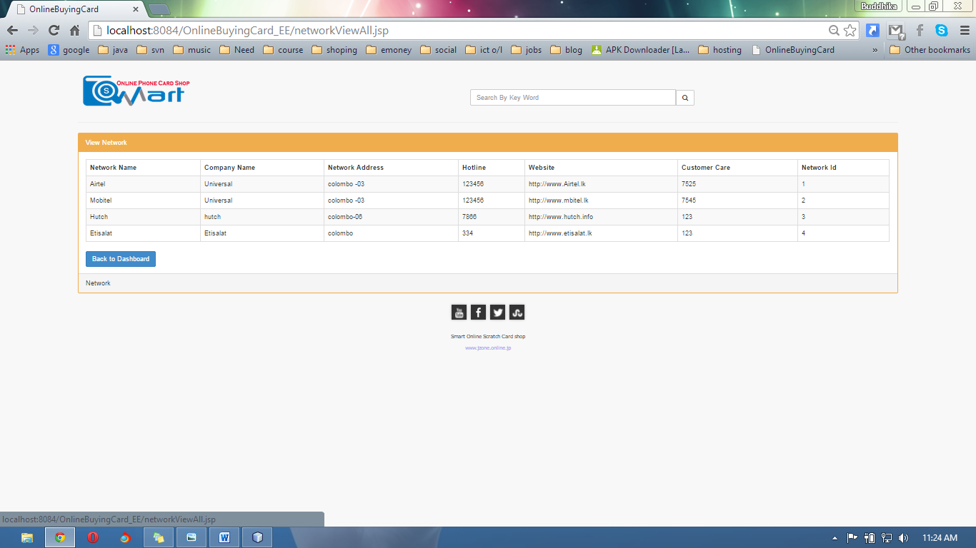

<%--

Document : index

Created on : 12-Dec-2014, 19:24:43

Author : Mr.Buddhika

--%>

<%@page import="java.sql.ResultSet"%>

<%@page import="java.sql.Statement"%>

<%@page contentType="text/html" pageEncoding="UTF-8"%>

<!DOCTYPE html>

<html>

<head>

<meta http-equiv="Content-Type" content="text/html; charset=UTF-8">

<title>OnlineBuyingCard</title>

<link rel="stylesheet" href="css/bootstrap.min.css">

<link rel="stylesheet" href="css/plugins/metisMenu/metisMenu.min.css">

<link rel="stylesheet" href="css/footer.css">

<link rel="stylesheet" href="css/sb-admin-2.css">

<link type="text/css" rel="stylesheet" href="font-awesome-4.1.0/css/font-awesome.min.css">

<script src="js/jquery.js"></script>

<script src="js/bootstrap.min.js"></script>

<script src="js/plugins/metisMenu/metisMenu.min.js"></script>

<script src="js/sb-admin-2.js"></script>

<script src="js/jzone.js"></script>

<%

try {

HttpSession s = request.getSession(true);

int roleid = Integer.parseInt(s.getAttribute("utype").toString());

java.sql.ResultSet rs = db.Database.Database().executeQuery("SELECT user_type_id FROM user_pivilages WHERE page_id=(SELECT page_id FROM pages WHERE url ='networkViewAll.jsp')");

boolean isavailable = false;

while (rs.next()) {

if (rs.getInt(1) == roleid) {

// true

isavailable = true;

}

}

if (!isavailable) {

response.sendRedirect("AccessDenied.jsp");

}

} catch (NullPointerException e) {

response.sendRedirect("singin.jsp");

}

%>

</head>

<body >

<br/>

<div style="margin-left: 8%;margin-right: 8%;">

<header>

<table border="0">

<tbody>

<tr>

<td> <img src="images/Capture2.png"/></td>

<td style="width: 40%"></td>

<td>

<div class="form-group input-group" style="margin-top: 9%;" align="right">

<input class="form-control" type="text" size="50" placeholder="Search By Key Word"></input>

<span class="input-group-btn">

<button class="btn btn-default" type="button">

<i class="fa fa-search"></i>

</button>

</span>

</div>

</td>

</tr>

</tbody>

</table>

<hr/>

</header>

<!--------------------------------------------------------CONTENT--------------------------------------------------------------------------------------->

<div class="row" >

<div class="col-lg-12">

<div class="panel panel-yellow">

<div class="panel-heading">

View Network

</div>

<div class="panel-body">

<table border="0" class="table table-striped table-bordered table-hover">

<thead>

<tr>

<th>Network Name</th>

<th>Company Name</th>

<th>Network Address</th>

<th>Hotline</th>

<th>Website</th>

<th>Customer Care</th>

<th>Network Id</th>

</tr>

</thead>

<tbody>

<%

Statement s=db.Database.Database();

ResultSet rs=s.executeQuery("SELECT network.name, network.id, network.company_name, network.address, network.hotline, network.website, network.customer_sir_no FROM network");

while(rs.next()){

%>

<tr>

<td><%= rs.getString(1) %></td>

<td><%= rs.getString(3) %></td>

<td><%= rs.getString(4) %></td>

<td><%= rs.getString(5) %></td>

<td><%= rs.getString(6) %></td>

<td><%= rs.getString(7) %></td>

<td><%= rs.getString(2) %></td>

<%

}

%>

</tr>

</tbody>

</table>

<button type="button" onclick="ClickDashBoard()" class="btn btn-primary">Back to Dashboard</button>

</div>

<div class="panel-footer">

Network

</div>

</div>

</div></div>

<!------------------------------------------------------------------------------------------------------------------------------------------------------>

<%@include file="footer.jsp" %>

</div>

</body>

</html>

Add Card Model

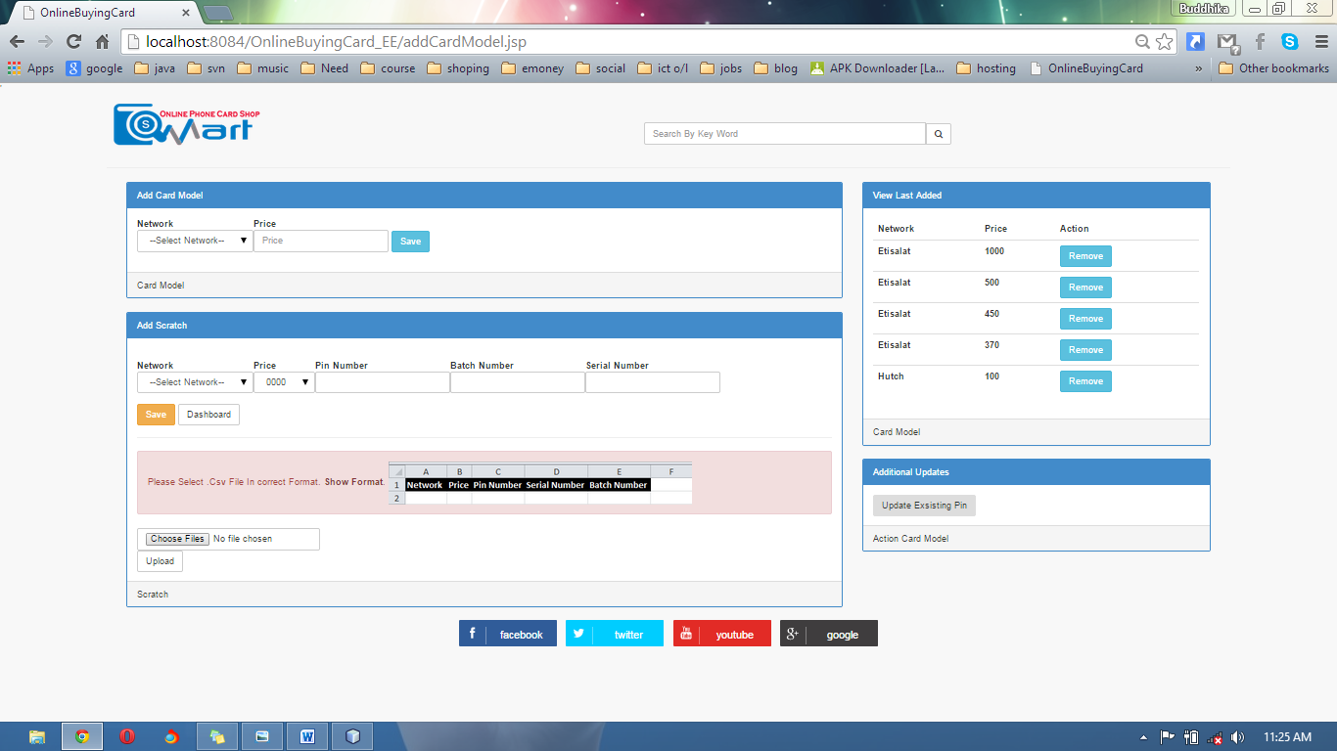

<%--

Document : index

Created on : 12-Dec-2014, 19:24:43

Author : Mr.Buddhika

--%>

<%@page import="java.sql.ResultSet"%>

<%@page import="java.sql.Statement"%>

<%@page contentType="text/html" pageEncoding="UTF-8"%>

<!DOCTYPE html>

<html>

<head>

<meta http-equiv="Content-Type" content="text/html; charset=UTF-8">

<title>OnlineBuyingCard</title>

<link rel="stylesheet" href="css/bootstrap.min.css">

<link rel="stylesheet" href="css/plugins/metisMenu/metisMenu.min.css">

<link rel="stylesheet" href="css/footer.css">

<link rel="stylesheet" href="css/sb-admin-2.css">

<link type="text/css" rel="stylesheet" href="font-awesome-4.1.0/css/font-awesome.min.css">

<script src="js/jquery.js"></script>

<script src="js/bootstrap.min.js"></script>

<script src="js/plugins/metisMenu/metisMenu.min.js"></script>

<script src="js/sb-admin-2.js"></script>

<script src="js/jzone.js"></script>

<script src="swtallerts/sweet-alert.js"> </script>

<script src="swtallerts/sweet-alert.min.js"> </script>

<link rel="stylesheet" href="swtallerts/sweet-alert.css">

<script src="swtallerts/min.js"></script>

<!--popuo-->

'<script src="bootstrap-modal.js"></script>

<script src="bootstrap-modalmanager.js"></script>

<link rel="stylesheet" href="bootstrap-modal.css">

<script src="js/SaveScCard.js"></script>

<%

try {

HttpSession s = request.getSession(true);

int roleid = Integer.parseInt(s.getAttribute("utype").toString());

ResultSet rs = db.Database.Database().executeQuery("SELECT user_type_id FROM user_pivilages WHERE page_id=(SELECT page_id FROM pages WHERE url ='Addtocard.jsp')");

boolean isavailable = false;

while (rs.next()) {

if (rs.getInt(1) == roleid) {

// true

isavailable = true;

}

}

if (!isavailable) {

response.sendRedirect("AccessDenied.jsp");

}

} catch (NullPointerException e) {

response.sendRedirect("singin.jsp");

}

%>

</head>

<body >

<br/>

<div style="margin-left: 8%;margin-right: 8%;">

<header>

<table border="0">

<tbody>

<tr>

<td> <img src="images/Capture2.png"/></td>

<td style="width: 40%"></td>

<td>

<div class="form-group input-group" style="margin-top: 9%;" align="right">

<input class="form-control" type="text" size="50" placeholder="Search By Key Word"></input>

<span class="input-group-btn">

<button class="btn btn-default" type="button">

<i class="fa fa-search"></i>

</button>

</span>

</div>

</td>

</tr>

</tbody>

</table>

<hr/>

</header>

<!--------------------------------------------------------CONTENT--------------------------------------------------------------------------------------->

<div class="col-lg-12">

<div class="col-lg-8">

<div class="panel panel-primary">

<div class="panel-heading">

Add Card Model

</div>

<div class="panel-body">

<table border="0">

<thead>

<th>Network</th>

<th>Price</th>

</thead>

<tbody>

<tr>

<form method="post" action="SaveCardModel">

<td><div class="form-group">

<select name="Networkaaa" id="nit" class="form-control">

<option>--Select Network--</option>

<%

String q = "SELECT network.`name`,network.id FROM network";

ResultSet rs1 = db.Database.Database().executeQuery(q);

while (rs1.next()) {

%>

<option id="<%= rs1.getString(1)%>"><%= rs1.getString(1)%></option>

<% }%>

</select>

</div></td>

<td><div class="form-group">

<script>

function m(){

var s=document.getElementById("nit").value;

if(s=='--Select Network--'){

swal("Please Select The Network :)", "error");

}

}

</script>

<input type="text" name="Priceqqq" required="" value="" onchange="m()" onclick="m()" class="form-control" placeholder="Price" />

</div>

</td>

<td>

<div class="form-group">

<label></label>

<input type="submit" value="Save" class="btn btn-info" />

</div>

</form>

</td>

</tr>

</tbody>

</table>

</div>

<div class="panel-footer">

Card Model

</div>

</div>

<div class="panel panel-primary">

<div class="panel-heading">

Add Scratch

</div>

<div class="panel-body">

<table border="0">

<thead>

<tr>

<th>Network</th>

<th>Price</th>

<th>Pin Number</th>

<th>Batch Number</th>

<th>Serial Number</th>

</tr>

</thead>

<tbody>

<tr><form action="SaveScartchCard" method="POST">

<td><div class="form-group">

<select name="scnetwork" id="cmmnet" onchange="loadPrice()" class="form-control">

<option>--Select Network--</option>

<%

String q1 = "SELECT network.`name`,network.id FROM network";

ResultSet e2 = db.Database.Database().executeQuery(q1);

while (e2.next()) {

%>

<option id="<%= e2.getString(1)%>"><%= e2.getString(1)%></option>

<% }%>

</select>

</div></td>

<td><div class="form-group">

<select name="scPrice" id="xprice" class="form-control">

<option>0000</option>

</select>

</div></td>

<br/>

<td>

<div class="form-group">

<input type="number" required="" name="scPin" value="" class="form-control" />

</div>

</td>

<td><div class="form-group">

<input type="number" required="" name="scbatch" value="" class="form-control" />

</div></td>

<td>

<div class="form-group">

<input type="number" required="" name="scserial" value="" class="form-control" />

</div>

</td>

</tr>

</tbody>

</table>

<input type="submit" value="Save" class="btn btn-warning" />

</form>

<input type="button" value="Dashboard" onclick="window.location='DashBoard.jsp'"class="btn btn-default" />

<hr/>

<div class="alert alert-danger">

Please Select .Csv File In correct Format.

<a href="#" class="alert-link">Show Format</a>.

<img src="images/fr.PNG"/>

</div>

<form method="post" enctype="multipart/form-data" action="fileUpload">

<input class="btn btn-default" type="file" id="trackfile" name="trackfile" multiple="multiple" size="50">

<button class="btn btn-default" type="submit">Upload</button>

</form>

</div>

<div class="panel-footer">

Scratch

</div>

</div>

</div>

<div class="col-lg-4">

<div class="panel panel-primary">

<div class="panel-heading">

View Last Added

</div>

<div class="panel-body">

<table border="0" class="table">

<thead>

<tr>

<th>Network</th>

<th>Price</th>

<th>Action</th>

</tr>

</thead>

<tbody>

<%

ResultSet rs = db.Database.Database().executeQuery("SELECT card_modle.idCard_Modle, network.`name`, price.price FROM card_modle INNER JOIN price ON price.id = card_modle.price_id INNER JOIN network ON network.id = card_modle.network_id ORDER BY network.id DESC LIMIT 5 ");

while (rs.next()) {

%>

<form action="deletePriceModel" method="POST">

<tr>

<input type="hidden" name="cid" value="<%= rs.getString(1)%>" />

<td><label><%= rs.getString(2)%></label></td>

<td><label><%= rs.getString(3)%></label></td>

<td><button class="btn btn-mini btn-info" type="submit" >Remove<i class="icon-edit bigger-120"></i>

</button></td>

</tr>

</form>

<% }%>

</tbody>

</table>

</div>

<div class="panel-footer">

Card Model

</div>

</div>

</div>

<div class="col-lg-4">

<div class="panel panel-primary">

<div class="panel-heading">

Additional Updates

</div>

<div class="panel-body">

<input class="btn bigger-120" onclick="window.location='updateExsistingPin.jsp'" type="button" value="Update Exsisting Pin" />

</div>

<div class="panel-footer">

Action Card Model

</div>

</div>

</div>

</div>

<!------------------------------------------------------------------------------------------------------------------------------------------------------>

</div>

<br /><br /> <br /><br /><br /><br /> <br /><br /><br /><br /> <br /><br /> <br /><br />

<br /><br /> <br /><br /> <br /><br /> <br /><br />

<%@include file="foot.jsp" %>

</body>

</html>

Calculating Profit

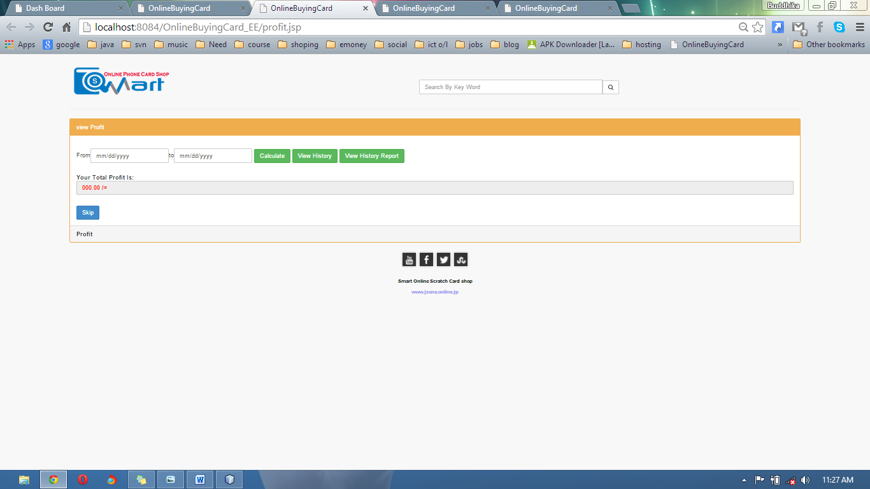

<%--

Document : index

Created on : 12-Dec-2014, 19:24:43

Author : Mr.Buddhika

--%>

<%@page import="com.mysql.jdbc.ResultSet"%>

<%@page contentType="text/html" pageEncoding="UTF-8"%>

<!DOCTYPE html>

<html>

<head>

<meta http-equiv="Content-Type" content="text/html; charset=UTF-8">

<title>OnlineBuyingCard</title>

<link rel="stylesheet" href="css/bootstrap.min.css">

<link rel="stylesheet" href="css/plugins/metisMenu/metisMenu.min.css">

<link rel="stylesheet" href="css/footer.css">

<link rel="stylesheet" href="css/sb-admin-2.css">

<link type="text/css" rel="stylesheet" href="font-awesome-4.1.0/css/font-awesome.min.css">

<script src="js/jquery.js"></script>

<script src="js/bootstrap.min.js"></script>

<script src="js/plugins/metisMenu/metisMenu.min.js"></script>

<script src="js/sb-admin-2.js"></script>

<script src="js/jzone.js"></script>

<script src="swtallerts/sweet-alert.js"> </script>

<script src="swtallerts/sweet-alert.min.js"> </script>

<link rel="stylesheet" href="swtallerts/sweet-alert.css">

<script src="swtallerts/min.js"></script>

<%

try {

HttpSession s = request.getSession(true);

int roleid = Integer.parseInt(s.getAttribute("utype").toString());

java.sql.ResultSet rs = db.Database.Database().executeQuery("SELECT user_type_id FROM user_pivilages WHERE page_id=(SELECT page_id FROM pages WHERE url ='profit.jsp')");

boolean isavailable = false;

while (rs.next()) {

if (rs.getInt(1) == roleid) {

// true

isavailable = true;

}

}

if (!isavailable) {

response.sendRedirect("AccessDenied.jsp");

}

} catch (NullPointerException e) {

response.sendRedirect("singin.jsp");

}

%>

</head>

<body >

<br/>

<div style="margin-left: 8%;margin-right: 8%;">

<header>

<table border="0">

<tbody>

<tr>

<td> <img src="images/Capture2.png"/></td>

<td style="width: 40%"></td>

<td>

<div class="form-group input-group" style="margin-top: 9%;" align="right">

<input class="form-control" type="text" size="50" placeholder="Search By Key Word"></input>

<span class="input-group-btn">

<button class="btn btn-default" type="button">

<i class="fa fa-search"></i>

</button>

</span>

</div>

</td>

</tr>

</tbody>

</table>

<hr/>

</header>

<!--------------------------------------------------------CONTENT--------------------------------------------------------------------------------------->

<div class="row" >

<div class="col-lg-12">

<div class="panel panel-yellow">

<div class="panel-heading">

view Profit

</div>

<div class="panel-body">

<div class="row show-grid">

<table border="0">

<tbody> <form action="ProfitHistoryView.jsp">

<tr>

<td>From</td>

<td><input type="date" id="datepicker1" name="dp1" value=""class="form-control" placeholder="From" /></td>

<td>to</td>

<td><input type="date" id="datepicker2" name="dp2" value=""class="form-control" placeholder="to" /></td>

<td>&nbsp;</td>

<td><input type="button" onclick="getTotalProfit()" value="Calculate" class="btn btn-success" /></td>

<td>&nbsp;</td>

<td><input type="submit" value="View History" class="btn btn-success" /></td>

<td>&nbsp;</td>

<td><input type="button" onclick="printProfit()" value="View History Report" class="btn btn-success" /></td>

</tr>

</form>

</tbody>

</table>

<br/>

<lable><h5><b>Your Total Profit Is:<input type="text" name="ttt" id="ttt" readonly="" value="000.00 /=" style="color: red" class="form-control" value="" /></h5></lable>

</div>

<button type="button" onclick="ClickQuickStart()" class="btn btn-primary">Skip</button>

</div>

<div class="panel-footer">

Profit

</div>

</div>

</div></div>

<!------------------------------------------------------------------------------------------------------------------------------------------------------>

<%@include file="footer.jsp" %>

</div>

</body>

</html>

Downloads

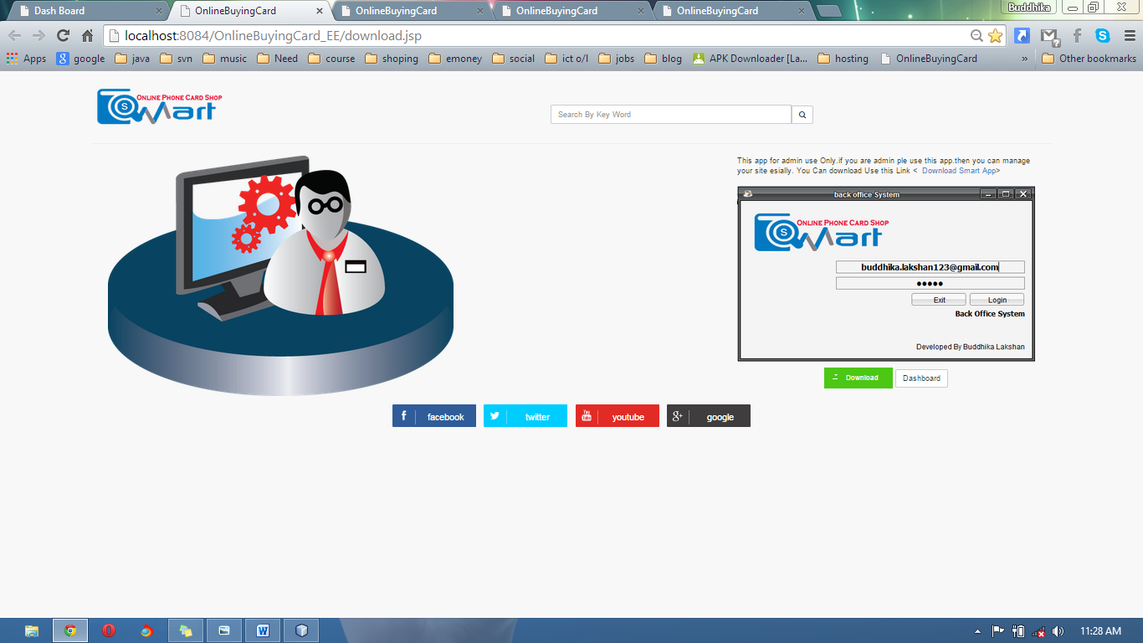

<%--

Document : index

Created on : 12-Dec-2014, 19:24:43

Author : Mr.Buddhika

--%>

<%@page import="java.sql.ResultSet"%>

<%@page import="java.sql.Statement"%>

<%@page contentType="text/html" pageEncoding="UTF-8"%>

<!DOCTYPE html>

<html>

<head>

<meta http-equiv="Content-Type" content="text/html; charset=UTF-8">

<title>OnlineBuyingCard</title>

<link rel="stylesheet" href="css/bootstrap.min.css">

<link rel="stylesheet" href="css/plugins/metisMenu/metisMenu.min.css">

<link rel="stylesheet" href="css/footer.css">

<link rel="stylesheet" href="css/sb-admin-2.css">

<link type="text/css" rel="stylesheet" href="font-awesome-4.1.0/css/font-awesome.min.css">

<script src="js/jquery.js"></script>

<script src="js/bootstrap.min.js"></script>

<script src="js/plugins/metisMenu/metisMenu.min.js"></script>

<script src="js/sb-admin-2.js"></script>

<script src="js/jzone.js"></script>

<script src="swtallerts/sweet-alert.js"> </script>

<script src="swtallerts/sweet-alert.min.js"> </script>

<link rel="stylesheet" href="swtallerts/sweet-alert.css">

<script src="swtallerts/min.js"></script>

</head>

<body >

<br/>

<div style="margin-left: 8%;margin-right: 8%;">

<header>

<table border="0">

<tbody>

<tr>

<td> <img src="images/Capture2.png"/></td>

<td style="width: 40%"></td>

<td>

<div class="form-group input-group" style="margin-top: 9%;" align="right">

<input class="form-control" type="text" size="50" placeholder="Search By Key Word"></input>

<span class="input-group-btn">

<button class="btn btn-default" type="button">

<i class="fa fa-search"></i>

</button>

</span>

</div>

</td>

</tr>

</tbody>

</table>

<hr/>

</header>

<div>

<div class="col-lg-12">

<div class="col-lg-8"><img src="images/admin_icon.png"/></div>

<div class="col-lg-4">

<p>

This app for admin use Only.if you are admin ple use this app.then you can manage your site esially.

You Can download Use this Link <&nbsp; <a href="">Download Smart App</a>>

<br/> <br/>

<img src="images/se.PNG" style="width: 100%" />

<br/>

<div align="center"><a href="SEAPP/SmartSeAPP.rar" class="buttonDownload">Download</a>

<input type="button" value="Dashboard" onclick="window.location='DashBoard.jsp'"class="btn btn-default" />

</div>

<style>

.buttonDownload {

display: inline-block;

position: relative;

padding: 10px 25px;

background-color: #4CC713;

color: white;

font-family: sans-serif;

text-decoration: none;

font-size: 0.9em;

text-align: center;

text-indent: 15px;

}

.buttonDownload:hover {

background-color: #333;

color: white;

}

.buttonDownload:before, .buttonDownload:after {

content: ' ';

display: block;

position: absolute;

left: 15px;

top: 52%;

}

/* Download box shape */

.buttonDownload:before {

width: 10px;

height: 2px;

border-style: solid;

border-width: 0 2px 2px;

}

/* Download arrow shape */

.buttonDownload:after {

width: 0;

height: 0;

margin-left: 3px;

margin-top: -7px;

border-style: solid;

border-width: 4px 4px 0 4px;

border-color: transparent;

border-top-color: inherit;

animation: downloadArrow 2s linear infinite;

animation-play-state: paused;

}

.buttonDownload:hover:before {

border-color: #4CC713;

}

.buttonDownload:hover:after {

border-top-color: #4CC713;

animation-play-state: running;

}

/* keyframes for the download icon anim */

@keyframes downloadArrow {

/* 0% and 0.001% keyframes used as a hackish way of having the button frozen on a nice looking frame by default */

0% {

margin-top: -7px;

opacity: 1;

}

0.001% {

margin-top: -15px;

opacity: 0;

}

50% {

opacity: 1;

}

100% {

margin-top: 0;

opacity: 0;

}

}

</style>

</p></div>

</div>

<br /><br />

<br /><br /> <br /><br /> <br /><br /> <br /><br /> <br /><br /> <br /><br /> <br /><br /><br /><br /> <br /><br /> <br /><br />

<footer><%@include file="foot.jsp" %></footer>

</div>

<!------------------------------------------------------------------------------------------------------------------------------------------------------>

</div>

</body>

</html>

View All Sessions

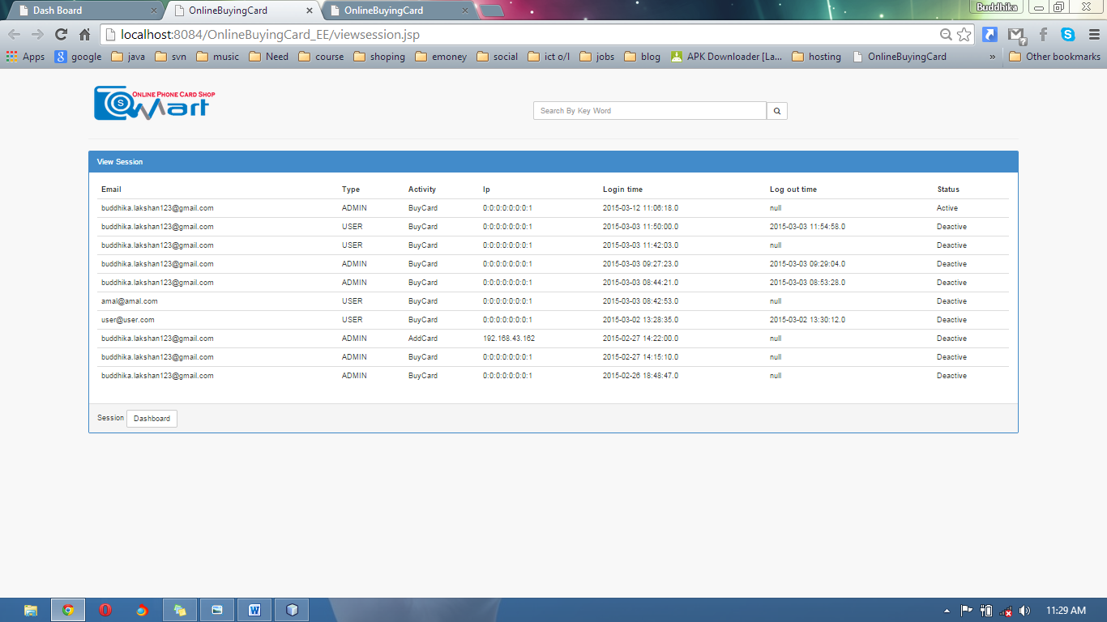

<%--

Document : index

Created on : 12-Dec-2014, 19:24:43

Author : Mr.Buddhika

--%>

<%@page import="java.sql.ResultSet"%>

<%@page import="java.sql.Statement"%>

<%@page contentType="text/html" pageEncoding="UTF-8"%>

<!DOCTYPE html>

<html>

<head>

<meta http-equiv="Content-Type" content="text/html; charset=UTF-8">

<title>OnlineBuyingCard</title>

<link rel="stylesheet" href="css/bootstrap.min.css">

<link rel="stylesheet" href="css/plugins/metisMenu/metisMenu.min.css">

<link rel="stylesheet" href="css/footer.css">

<link rel="stylesheet" href="css/sb-admin-2.css">

<link type="text/css" rel="stylesheet" href="font-awesome-4.1.0/css/font-awesome.min.css">

<script src="js/jquery.js"></script>

<script src="js/bootstrap.min.js"></script>

<script src="js/plugins/metisMenu/metisMenu.min.js"></script>

<script src="js/sb-admin-2.js"></script>

<script src="js/jzone.js"></script>

<script src="swtallerts/sweet-alert.js"> </script>

<script src="swtallerts/sweet-alert.min.js"> </script>

<link rel="stylesheet" href="swtallerts/sweet-alert.css">

<script src="swtallerts/min.js"></script>

<%

try {

HttpSession s = request.getSession(true);

int roleid = Integer.parseInt(s.getAttribute("utype").toString());

ResultSet rs = db.Database.Database().executeQuery("SELECT user_type_id FROM user_pivilages WHERE page_id=(SELECT page_id FROM pages WHERE url ='viewsession.jsp')");

boolean isavailable = false;

while (rs.next()) {

if (rs.getInt(1) == roleid) {

// true

isavailable = true;

}

}

if (!isavailable) {

response.sendRedirect("AccessDenied.jsp");

}

} catch (NullPointerException e) {

response.sendRedirect("singin.jsp");

}

%>

</head>

<body >

<br/>

<div style="margin-left: 8%;margin-right: 8%;">

<header>

<table border="0">

<tbody>

<tr>

<td> <img src="images/Capture2.png"/></td>

<td style="width: 40%"></td>

<td>

<div class="form-group input-group" style="margin-top: 9%;" align="right">

<input class="form-control" type="text" size="50" placeholder="Search By Key Word"></input>

<span class="input-group-btn">

<button class="btn btn-default" type="button">

<i class="fa fa-search"></i>

</button>

</span>

</div>

</td>

</tr>

</tbody>

</table>

<hr/>

</header>

<!--------------------------------------------------------CONTENT--------------------------------------------------------------------------------------->

<div class="panel panel-primary">

<div class="panel-heading">

View Session

</div>

<div class="panel-body">

<table border="0" class="table">

<thead>

<tr>

<th>Email</th>

<th>Type</th>

<th>Activity</th>

<th>Ip</th>

<th>Login time</th>

<th>Log out time</th>

<th>Status</th>

</tr>

</thead>

<tbody>

<%

ResultSet rs=db.Database.Database().executeQuery("SELECT `user`.email, user_type.type, activity.Activity, `session`.ip, `session`.log_in_time, `session`.log_out_time, `session`.state FROM `session` INNER JOIN session_activities ON `session`.session_id = session_activities.session_id INNER JOIN `user` ON `session`.user_id = `user`.id INNER JOIN user_type ON `user`.user_type = user_type.id_user_type INNER JOIN activity ON activity.idActivity = session_activities.activity_id GROUP BY `session`.log_in_time ORDER BY session_activities.session_id DESC");

while(rs.next()){

%>

<tr>

<td><%= rs.getString(1) %></td>

<td><%= rs.getString(2) %></td>

<td><%= rs.getString(3) %></td>

<td><%= rs.getString(4) %></td>

<td><%= rs.getString(5) %></td>

<td><%= rs.getString(6) %></td>

<td><%= rs.getString(7) %></td>

</tr>

<% } %>

</tbody>

</table>

</div>

<div class="panel-footer">

Session

<input type="button" value="Dashboard" onclick="window.location='DashBoard.jsp'"class="btn btn-default" />

</div>

</div>

<!------------------------------------------------------------------------------------------------------------------------------------------------------>

</div>

</body>

</html>

Implementation

1. Those days I’m planning to marketing this Application.
2. Try to host my own server

Quotation

Jzone solutions ,

135/1 Ehalajkaragahamuna,

Kadawatha.

Highway Communication,

No 32,

kandy road,

Kadawatha.

Mr.Salutha Samarathunga

Dear Sir,

**Quotation For Online Shopping Cart in Smart online Reload Shop**

|  |  |
| --- | --- |
| Include System Categories | **Amount** |
| Smart Online Shopping Cart Reload System | 87,500.00/= |
|  |  |
| Total Investment | 87,500.00/= |

Please note that we provide FREE SEVICE for First year And After one year we charge 15% service charge from your company. There is another option for you are not satisfied to pay 15% we can give a special offer for you to pay every visit RS.6000.00/= from your company.

1. Payment Method
   1. 50% Advance Payment From The Total Investment.
   2. 25% After blue print sign off.
   3. 25% After finalizing.
2. Payment Method
   1. 40% Advance Payment From The Total Investment.
   2. 30% After blue print sign off.
   3. 30% After finalizing.

Thank You,

Yours Faithfully,

Jzone (pvt) ltd.

---------------------------------------------

Business Analysis

Buddhika lakshan