Pan Asia EZY Meet — Business Requirements Document
Oct 30, 2026 · @Buddhi Sandeepa

1. Summary
EZY Meet adds appointment banking to the Pan Asia EZY app. Customers book a branch visit or a video call in four taps, and branch staff manage the bookings in a branch portal. Every visit arrives with its purpose known, so staff can prepare, serve on time and use the conversation to offer the next right product. Phase 2 connects EZY Meet to EZY Apply, the digital onboarding portal, through Video KYC.
Item | Detail
Product | Pan Asia EZY Meet ("Your Branch. Your Time.")
Channels | EZY mobile app (customers) · Branch portal (staff)
Version | 1.0 draft for review
Prototype app | buddhirc5.github.io/ezymeet
Branch portal | buddhirc5.github.io/ezymeet/admin (not linked from the app)
Source | EZY Meet concept deck (Oct 2026), EZY app screens, a review of a peer bank's appointment catalogue

2. Problem
Most branch visits today are unplanned, so customers cannot predict their wait and branches cannot plan staff for the demand coming in.
Today | With EZY Meet
Unplanned visits and uncertain queue times | Book by service, branch, date and time in the EZY app
Customers don't know which nearby branch is less busy | See open slots, estimated service time (TAT) and expected wait
Branches can't see incoming demand | Branch portal shows every booking for the next 7 days
Missed relationship and sales moments | Staff know the customer and the purpose before they arrive
Simple requests still need a visit | Video calls for advisory and verifiable requests, including Video KYC

3. Objectives and success measures
EZY Meet serves six goals, each tracked by one measure from booking and portal data. Numeric targets are still to be agreed with the business (see open questions).
Objective | Measure | How it is measured
Increase planned footfall across 88 branches | Booked visits per branch per week | Bookings with status Served
Turn every visit into a relationship conversation | Follow-up leads per 100 visits; products per customer 90 days after a visit | Leads recorded in the portal; core banking product count
Make it easy to open new accounts and facilities | Accounts and facilities opened from appointments | Account-opening and credit bookings that end in a new account or facility
Boost EZY app engagement and digital adoption | Monthly customers using EZY Meet | Unique customers who book
Better customer experience | Wait time for booked customers | Check-in to service start, from the portal
Better branch utilisation and planning | Slot fill rate and no-show rate | Booked ÷ offered slots; No-show ÷ booked

4. Scope
Release 1 covers booking in the EZY app, video calls, and the branch portal. Anything the EZY app already does on its own is out of scope, so customers are never sent to a branch for it.
In scope
- EZY Meet entry on the EZY home screen: a widget and a tile.
- Branch-visit booking with smart branch recommendation, for 41 services.
- Video-call booking and instant "talk to an advisor now" for advisory services.
- Confirmation with QR code and reference, Priority Service, calendar and directions.
- My Appointments: view, reschedule, cancel.
- Branch portal: today's queue, check-in, schedule, video desk, slots and capacity, and follow-up leads after each visit.
Out of scope
- Services the EZY app already handles: savings and FD opening, FD upliftment, investment planner, cashback loan, cheque book request, stop cheque, LKR fund transfers, standing orders.
- Walk-in queue tokens for customers without a booking (existing branch queue system).
- Head-office analytics dashboards (later release).
Phase 2 — Video KYC with EZY Apply
- Video KYC is delivered with EZY Apply, the bank's digital onboarding portal, not as a stand-alone EZY Meet service.
- An EZY Apply applicant who reaches the identity step books a Video KYC slot, or joins a live advisor, using the EZY Meet slot engine and video desk.
- If Video KYC cannot be completed, the applicant books a branch visit through EZY Meet with the application reference attached.
- Once the account is opened, the new customer is invited to the EZY app, where EZY Meet is ready for their next visit.
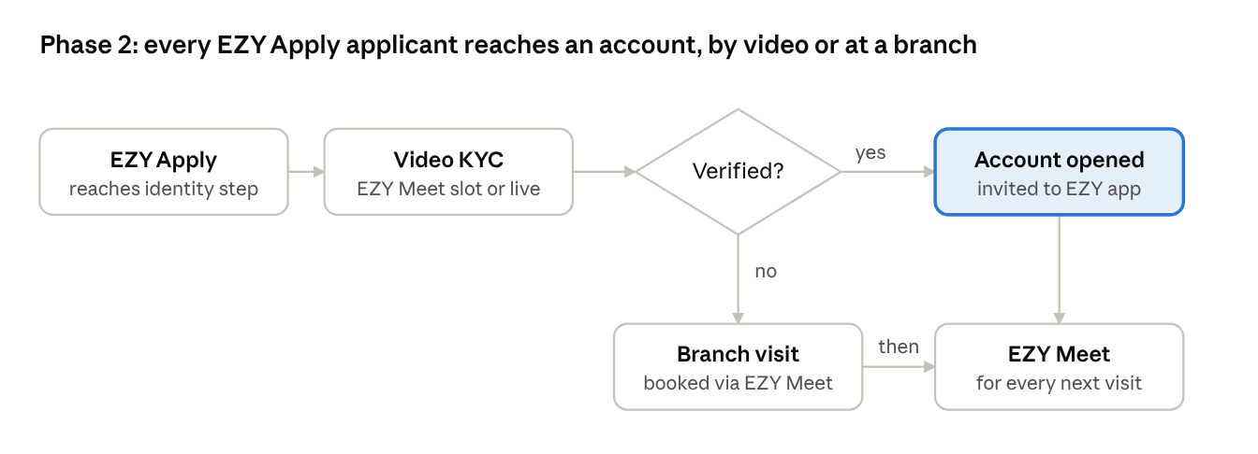
Phase 2 flow · EZY Apply to account, by video or at a branch
A failed Video KYC never ends the application: the applicant is booked into a branch, and every new account lands in the EZY app with EZY Meet ready.

5. Stakeholders and user roles
Role | Uses | Needs
Customer | EZY app | Book in few taps, short wait, know what to bring
Branch officer | Branch portal | See who is coming, check them in, move them through
Branch manager | Branch portal | Set EZY Meet counters, block slots, watch no-shows
Virtual advisor | Video desk | Join scheduled calls, answer the live queue, verify KYC
Digital banking (product owner) | Both | Adoption, service catalogue, recommendation rules
Branch operations | Both | Branch hours, capacity rules, service-to-channel policy
Compliance and risk | Video KYC, data | Consent for follow-up, record keeping; Phase 2 Video KYC under CBSL KYC/CDD rules
IT and security | Both | Integrations, access control, availability

6. Customer journey
A logged-in customer books a branch visit in four taps: EZY Meet, service, recommended slot, Confirm. The deck's nine steps are merged so the customer never chooses what the app can suggest.
- Open EZY Meet from the home widget or the services grid (tap 1).
- Pick the service. Each one shows its estimated service time; tapping moves on straight away (tap 2).
- Take the recommended branch and slot. The app suggests the best nearby branch by earliest slot, expected wait and distance (tap 3). "Choose another time" or another branch is optional.
- Confirm in a sheet that lists the documents to bring (tap 4).
- Confirmation shows a QR code and reference, Priority Service, Add to Calendar and Get Directions.
- Visit: the branch scans the QR code, checks the customer in and serves them at their time.
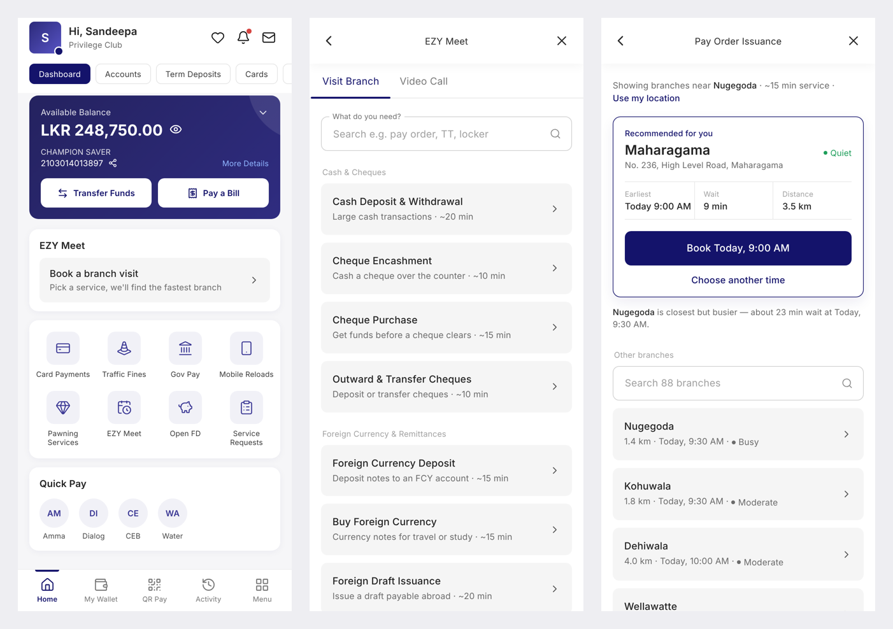
Home with the EZY Meet widget · service list · smart recommendation
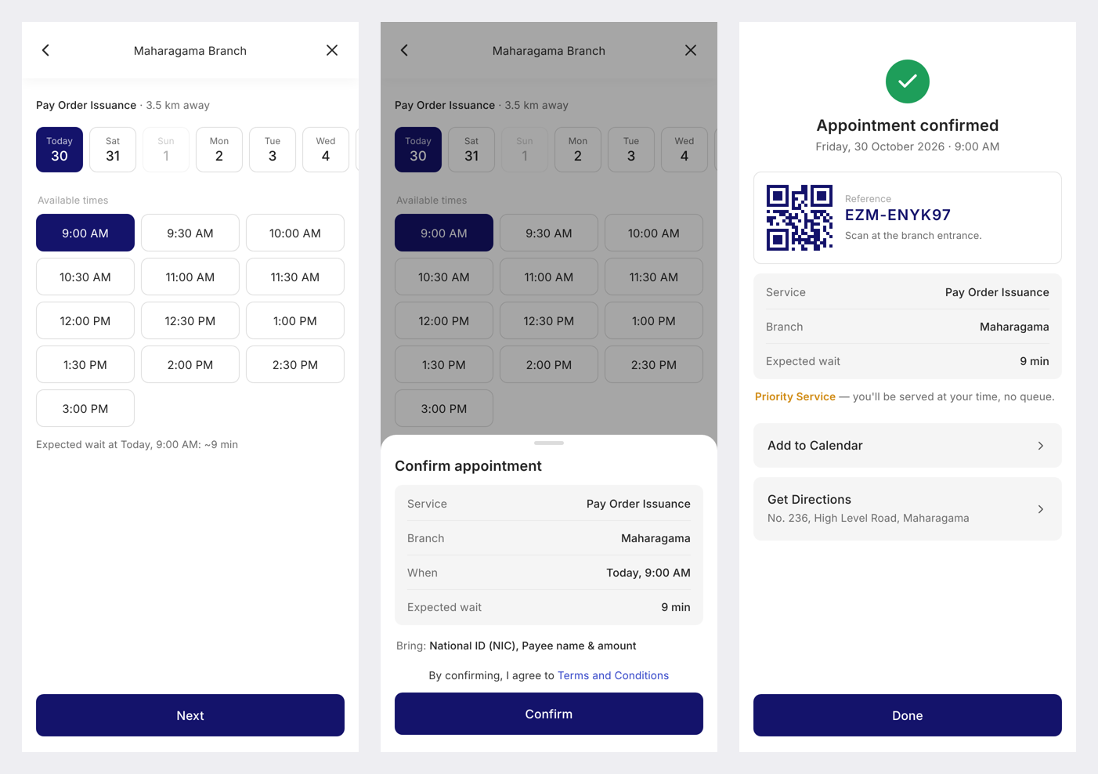
Optional time picker · confirm sheet · confirmation with QR code
Managing a booking. The home widget shows the next appointment. Tapping it opens My Appointments; tapping a booking opens its QR code, directions, reschedule, calendar and cancel.
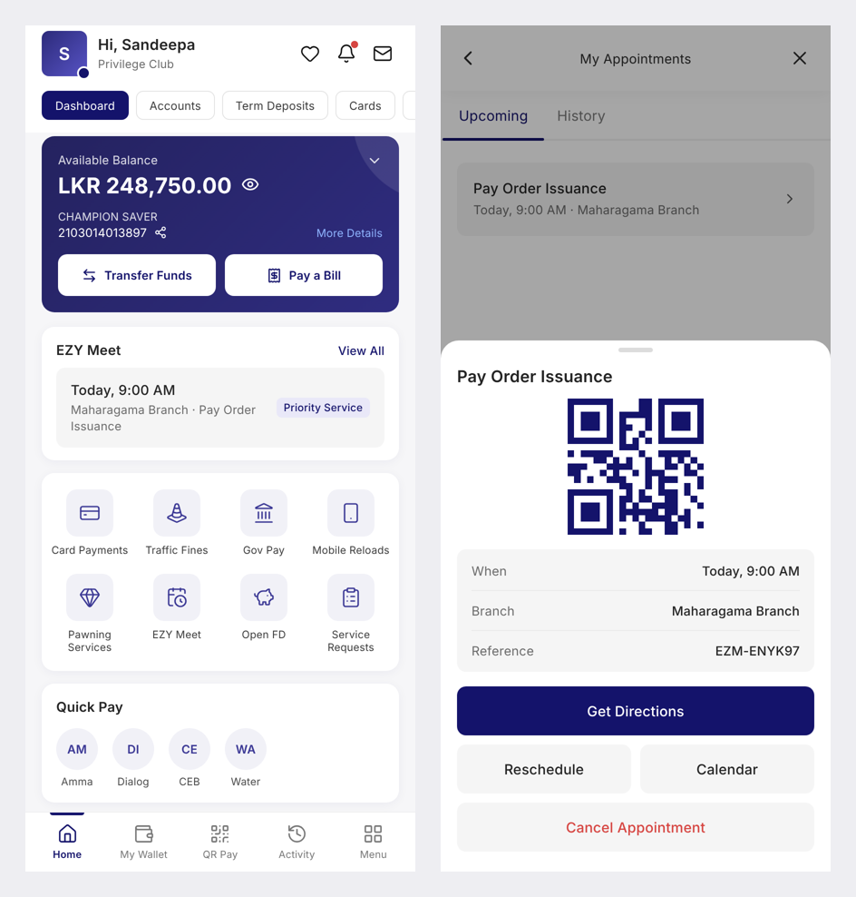
Video calls. The Video Call tab offers "talk to an advisor now" and every service that can be done by video. A video booking is date, time and Confirm. The prototype also shows the Phase 2 Video KYC booking with document upload, which will be reached from EZY Apply.
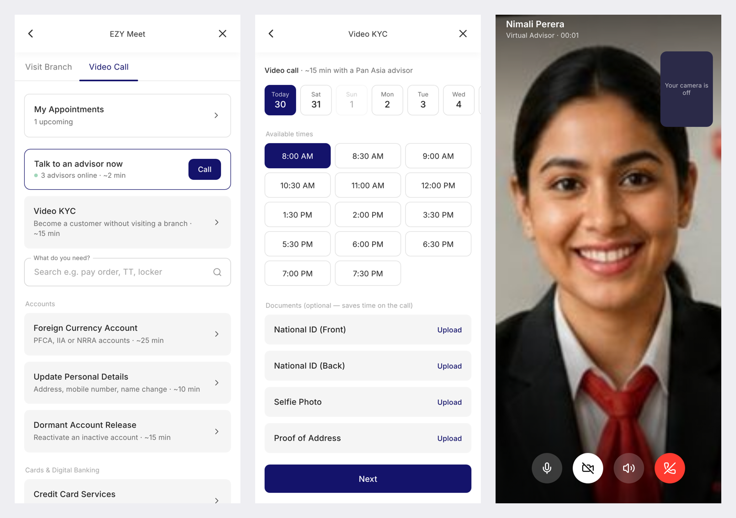
Video Call tab · Video KYC booking (Phase 2, via EZY Apply) · video call

7. Service catalogue
Each service is offered on the channel that suits it. Branch only: it needs cash, original documents, a wet signature, or a card or locker in person. Branch or video: advisory work, or requests the bank can verify on a video call. TAT is the estimated service time shown to customers.
Category | Service | Channel | TAT (min)
Cash & Cheques | Cash deposit & withdrawal | Branch | 20
Cash & Cheques | Cheque encashment | Branch | 10
Cash & Cheques | Cheque purchase | Branch | 15
Cash & Cheques | Outward & transfer cheques | Branch | 10
Foreign Currency & Remittances | Foreign currency deposit | Branch | 15
Foreign Currency & Remittances | Buy foreign currency | Branch | 15
Foreign Currency & Remittances | Foreign draft issuance | Branch | 20
Foreign Currency & Remittances | Foreign draft collection | Branch | 15
Foreign Currency & Remittances | Telegraphic transfer (TT) | Branch | 25
Foreign Currency & Remittances | Foreign currency fund transfer | Branch | 20
Foreign Currency & Remittances | RTGS transfer | Branch | 15
Pay Orders & Letters | Pay order issuance | Branch | 15
Pay Orders & Letters | Pay order cancellation | Branch | 15
Pay Orders & Letters | Gift vouchers | Branch | 10
Pay Orders & Letters | Balance confirmation letter | Branch | 15
Pay Orders & Letters | Certified bank statement | Branch | 15
Accounts | Current account opening | Branch | 30
Accounts | Minor savings account | Branch | 20
Accounts | Foreign currency account (PFCA / IIA / NRRA) | Branch or video | 25
Accounts | Update personal details | Branch or video | 10
Accounts | Dormant account release | Branch or video | 15
Accounts | Signature change | Branch | 15
Accounts | Nominations | Branch | 15
Accounts | Account freeze & lien | Branch | 20
Accounts | Account closure | Branch | 15
Accounts | Safe deposit locker | Branch | 20
Accounts | Video KYC | Video — Phase 2, via EZY Apply | 15
Cards & Digital Banking | Debit card issuance | Branch | 15
Cards & Digital Banking | Credit card services | Branch or video | 15
Cards & Digital Banking | EZY app & online banking activation | Branch or video | 10
Cards & Digital Banking | Fund recall & bill payment reversal | Branch or video | 15
Loans & Credit | Personal & housing loans | Branch or video | 40
Loans & Credit | Leasing | Branch or video | 30
Loans & Credit | Pawning | Branch | 20
Loans & Credit | Overdraft against deposits | Branch | 25
Loans & Credit | Cash margin facility | Branch | 25
Loans & Credit | Collect credit documents | Branch | 10
Investments | Treasury bills, bonds & REPO | Branch or video | 20
Business & Trade | Trade finance | Branch or video | 45
Business & Trade | Business banking & SME loans | Branch or video | 40
Meet Our Team | Relationship manager | Branch or video | 30
Meet Our Team | Branch manager | Branch | 30
Not offered: savings and FD opening, FD upliftment, investment planner, cashback loan, cheque book request, stop cheque, LKR transfers and standing orders, which the EZY app already does on its own.

8. Functional requirements — customer app
Priority: Must = needed for launch, Should = launch if possible, Could = later.
ID | Requirement | Priority
FR-01 | Show an EZY Meet widget on the home dashboard and an EZY Meet tile in the services grid. | Must
FR-02 | The widget shows the next upcoming appointment; with none, one row opens booking. | Must
FR-03 | EZY Meet has two tabs, Visit Branch and Video Call, and a link to My Appointments when bookings exist. | Must
FR-04 | List services by category with name, one-line description and estimated service time; support search by name or description. | Must
FR-05 | Tapping a service goes straight to the next step, with no Continue button. | Must
FR-06 | Use the device location, with consent, to rank branches; without it, use the customer's home branch. | Must
FR-07 | Show one recommended branch with its earliest slot, expected wait, distance and crowd level, and a one-tap "Book <slot>" button. | Must
FR-08 | Tell the customer when the nearest branch is busier than the recommendation. | Should
FR-09 | List other nearby branches with distance, next slot and crowd level; search all 88 branches. | Must
FR-10 | Show 7 days of dates and only the free 30-minute slots, earliest preselected; closed days disabled. | Must
FR-11 | When another nearby branch is at least one hour sooner, offer a one-tap switch. | Should
FR-12 | Confirm in a sheet showing service, branch or mode, time, expected wait or duration, documents to bring, and the terms. | Must
FR-13 | On confirmation, show a QR code and reference, Priority Service note, Add to Calendar (.ics) and Get Directions. Send SMS and push. | Must
FR-14 | My Appointments lists upcoming and past bookings; each opens its QR code, reschedule, calendar, directions and cancel. | Must
FR-15 | Reschedule keeps the same reference; cancel releases the slot at once. | Must
FR-16 | Video Call tab: "talk to an advisor now" with live availability, and scheduling for every video-capable service. | Must
FR-17 | Identity-based video requests (personal details, dormant release, EZY activation) accept optional uploads: NIC front and back, selfie, proof of address. | Should
FR-18 | Join a scheduled call from the app at the booked time over a secure video room. | Must
FR-19 | Remind the customer 30 minutes before (push), and the day before for branch visits (SMS). | Should
FR-20 | Limit each customer to a set number of open bookings, to stop slot hoarding. | Should
FR-21 | After a visit, ask for a one-tap rating and offer "Talk to us about another product", which books a follow-up with the relationship manager. | Should
FR-22 | A customer can book for a family member's need, such as a minor savings account or a joint account, with the family member's details captured at booking. | Should
FR-23 | Phase 2: EZY Apply applicants book Video KYC or a branch visit through the EZY Meet slot engine, with the application reference attached. | Could

9. Branch portal
Branch staff run EZY Meet from a web portal at /admin, signed in with their staff ID and branch. Each customer moves along with one click per step: Check in, Start, Complete. The customer app has no link to the portal.
Today. The day's counts, the appointment list filtered by All, Waiting or Done, and the selected customer's service, reference and documents to bring.
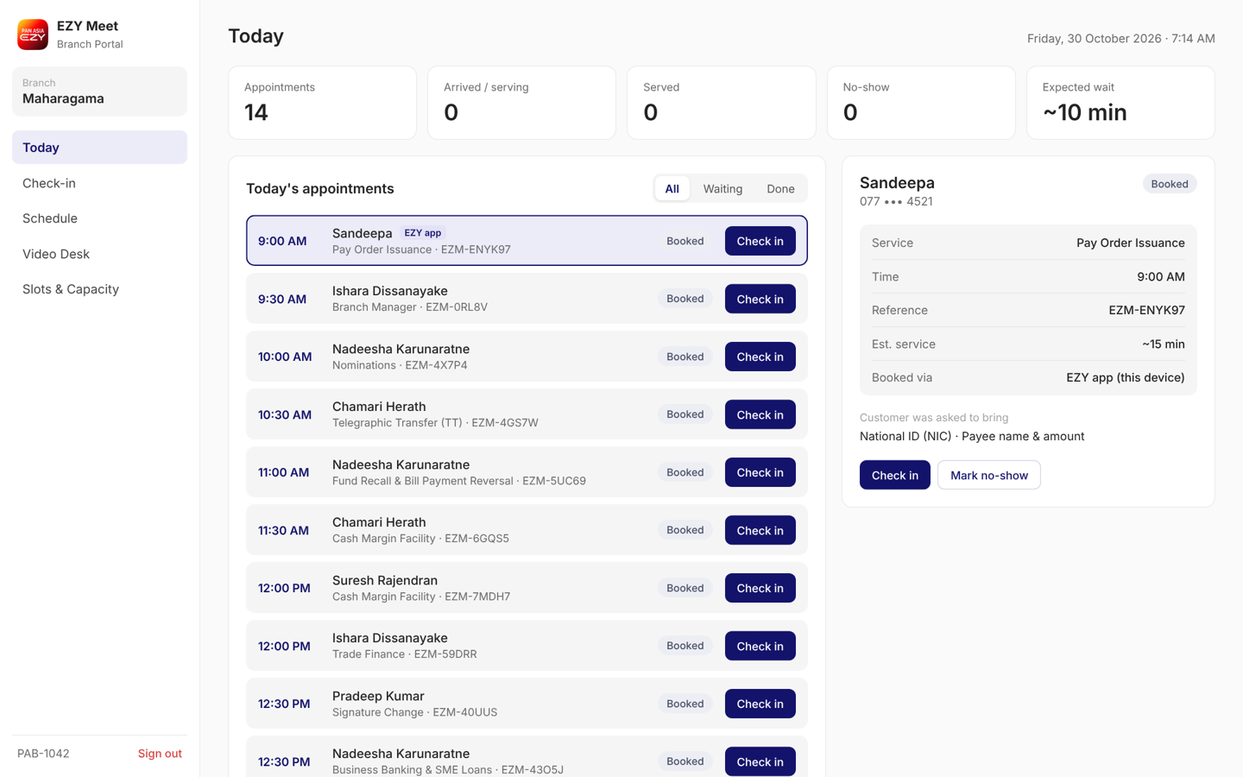
Check-in. Staff scan the customer's QR code with the device camera or type the reference. One button checks the customer in and issues a priority token.
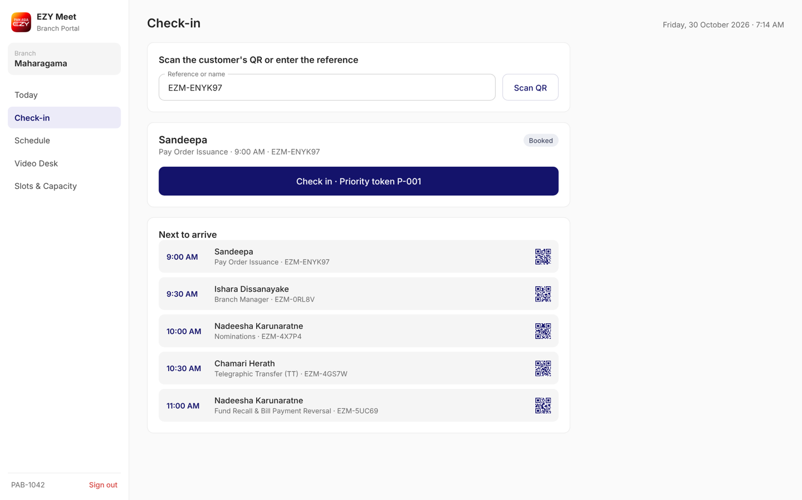
Schedule. A 7-day by 30-minute view; darker cells hold more bookings, blocked slots are hatched. Clicking a cell lists its customers.
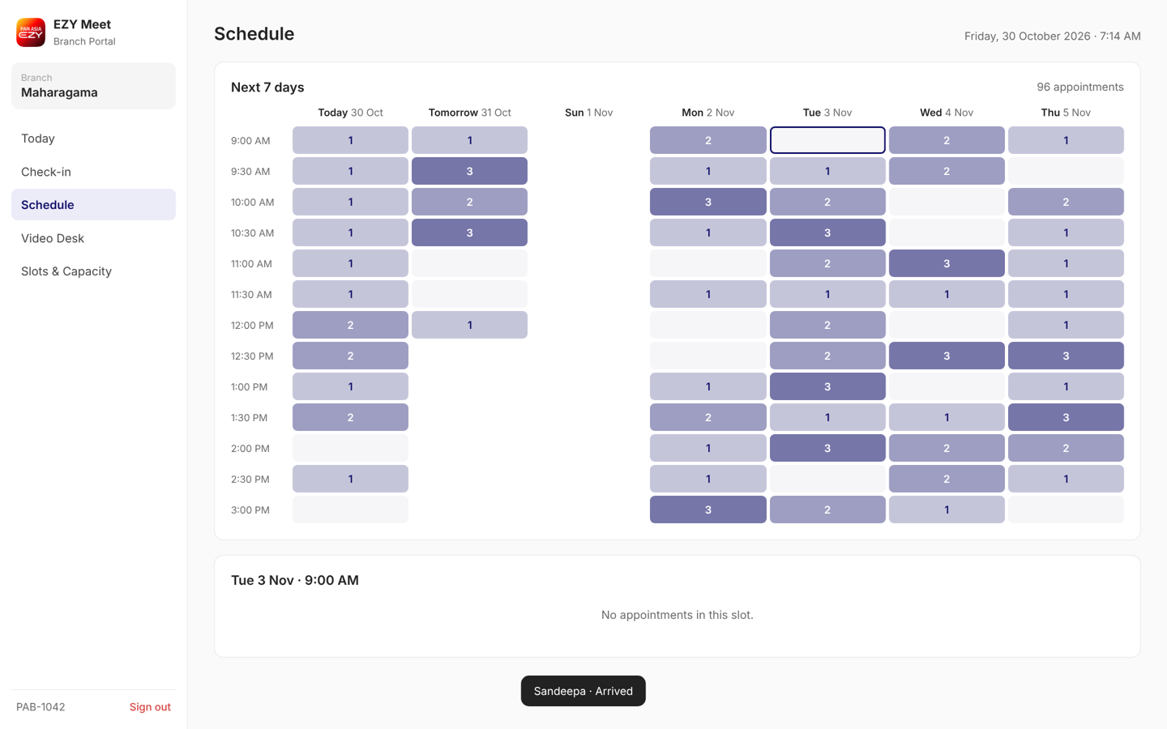
Video desk. Scheduled video calls and the live queue from "talk to an advisor now". In Phase 2, Video KYC sessions from EZY Apply arrive on this desk.
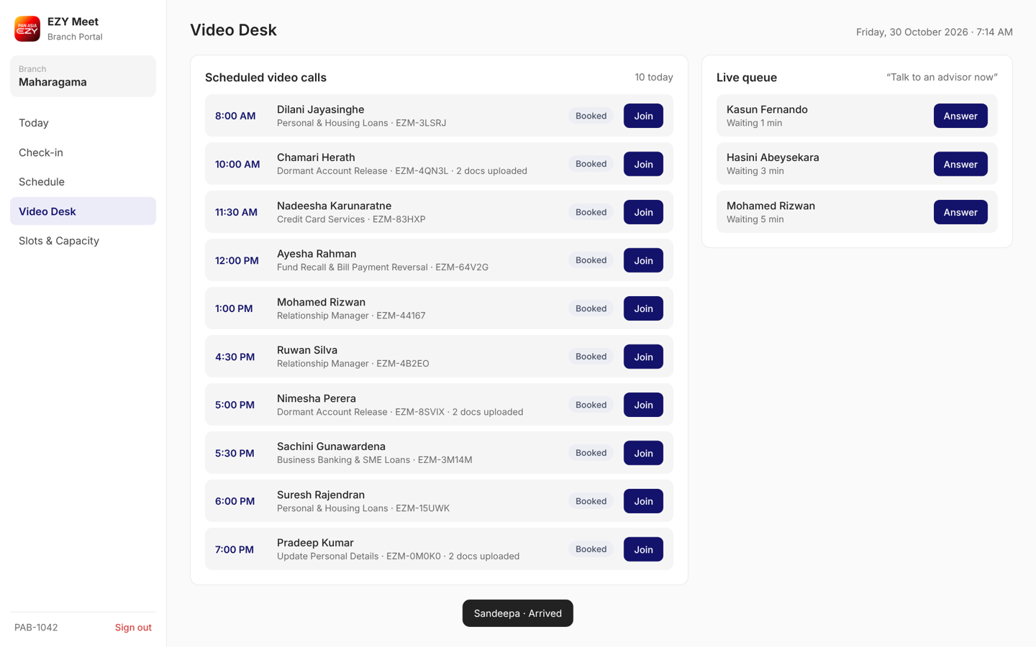
Slots and capacity. The manager sets the number of EZY Meet counters and blocks slots; a blocked slot disappears from the app at once.
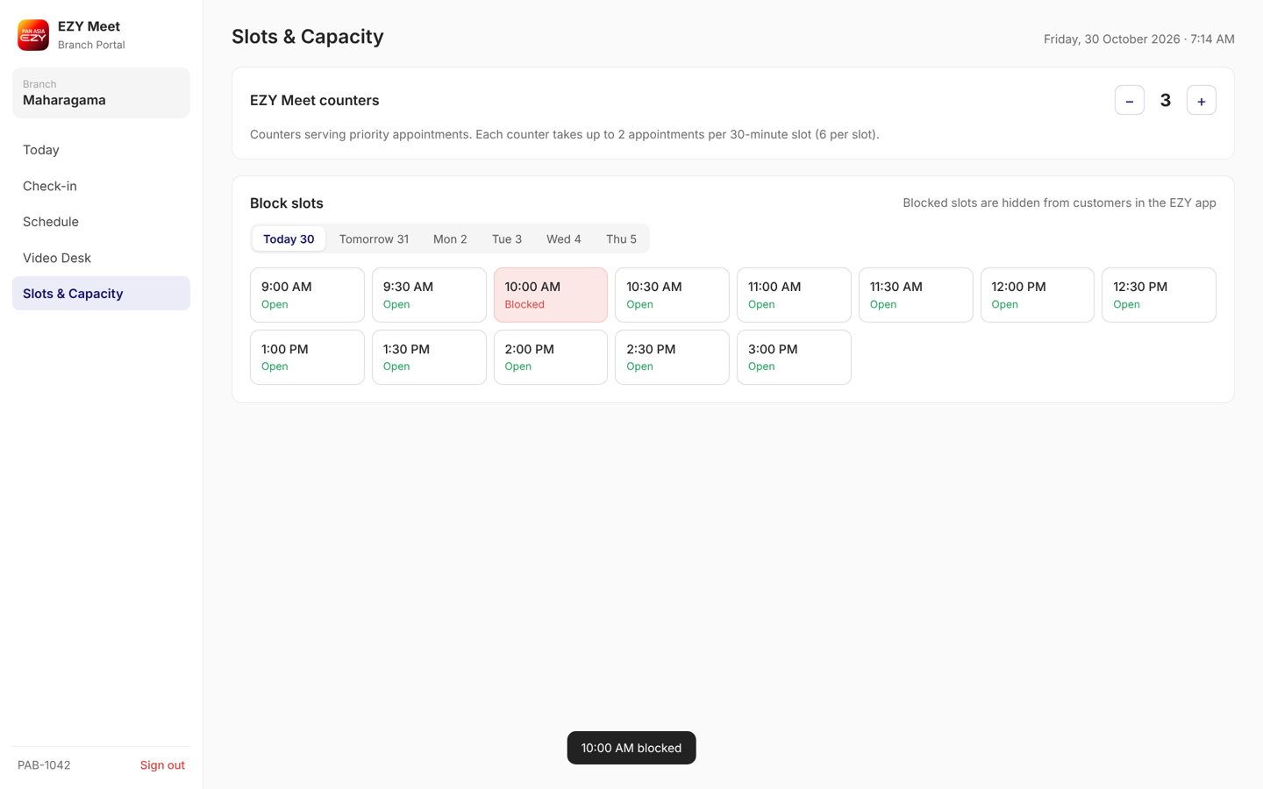
ID | Requirement | Priority
BP-01 | Staff sign in with bank credentials (SSO); each user sees only their branch. Video advisors see the video desk. | Must
BP-02 | Today view: counts of appointments, arrived or serving, served, no-show, and expected wait. | Must
BP-03 | Status flow Booked → Arrived → Serving → Served, plus No-show and Cancelled; one action button per state. | Must
BP-04 | Customer detail: name, masked mobile, service, time, reference, documents to bring, booking channel. | Must
BP-05 | Customer detail also shows a relationship snapshot: products held and a suggested next product, so staff can prepare before the customer arrives. | Should
BP-06 | Check-in by QR scan or reference; issue a priority token and send it to the branch queue system. | Must
BP-07 | On Complete, staff can record products the customer showed interest in; each becomes a follow-up lead for the relationship manager or sales team. | Must
BP-08 | Schedule view for the next 7 days with booking counts per slot and drill-down. | Must
BP-09 | Set EZY Meet counters per branch; slot capacity follows counters. | Must
BP-10 | Block and reopen slots (holidays, staff shortage); booked customers in a blocked slot are told and offered a new time. | Must
BP-11 | Video desk: join scheduled calls, see uploaded documents, answer the live queue. | Must
BP-12 | Mark no-shows automatically 30 minutes after the slot if not checked in. | Should
BP-13 | Every status change, lead and slot change is logged with staff ID and time. | Must
BP-14 | Daily and weekly reports per branch: bookings, no-shows, wait time, top services, leads and accounts opened from visits. | Could
BP-15 | Phase 2: Video KYC sessions from EZY Apply appear on the video desk with the application and its documents. | Could

10. Business rules
The recommendation picks the nearby branch with the best mix of soonest slot, shortest distance and shortest expected wait. The weights are set by Digital Banking and can change without an app release.
Smart recommendation
- Candidates are branches within 15 km; if fewer than 3, the 5 nearest.
- Score = 1.2 × hours until the earliest free slot + 2.5 × distance in km + 0.6 × expected wait in minutes. Lowest score wins. (Prototype weights.)
- Expected wait comes from the branch's current load and the slot's bookings.
- Crowd level shown to customers: Quiet, Moderate or Busy.
Slots and capacity
- Branch slots are 30 minutes: Monday to Friday 9:00 AM to 3:30 PM, Saturday 9:00 AM to 12:30 PM, closed Sunday and bank holidays.
- Video slots are 30 minutes, Monday to Saturday 8:00 AM to 8:00 PM.
- Capacity per slot = EZY Meet counters × 2. A full or blocked slot is not shown.
- Booking opens 7 days ahead and closes 30 minutes before the slot.
- Priority service: a checked-in customer is served at the booked time ahead of walk-ins.
- A customer not checked in 30 minutes after the slot is a no-show and the slot is released.
Follow-up after a visit
- A lead recorded at Complete names the product, the customer and the branch; it is assigned to the customer's relationship manager, or the branch sales officer if none.
- The customer is contacted only with their consent, captured at booking or after the visit.
Video KYC (Phase 2, with EZY Apply)
- Entry is from EZY Apply at its identity step, not from the EZY Meet service list.
- Documents captured in EZY Apply are passed to the advisor; nothing is uploaded twice.
- The advisor matches the live face to the NIC and selfie, and the session is recorded for audit, per CBSL KYC/CDD rules.
- On success, EZY Apply opens the account and invites the customer to the EZY app.
- If verification fails, the applicant is offered a branch visit through EZY Meet with the application reference attached.

11. Non-functional requirements
The figures below are proposed starting values for IT and Risk to confirm.
Area | Requirement
Security | Booking needs an authenticated EZY session. Portal uses bank SSO with role-based access per branch. All traffic over TLS 1.2+.
Privacy | Portal shows masked mobile numbers. KYC documents are stored encrypted, kept per the bank's retention policy, and visible only to the assigned advisor.
Compliance | Phase 2 Video KYC follows CBSL KYC/CDD directions, with customer consent and session recording.
Performance | Service list and recommendation load within 2 seconds on 4G. Booking confirms within 3 seconds.
Concurrency | A slot can never be overbooked: capacity is checked at confirm time, not when the list loads.
Availability | 99.5% monthly for booking; the branch can still serve customers from the reference if the portal is down.
Audit | Every booking, change, check-in and slot block is logged with who and when.
Accessibility | Customer screens meet WCAG 2.1 AA: text size, contrast, screen-reader labels.
Devices | Built for current iOS and Android EZY app versions; portal runs in current Chrome and Edge on branch PCs and tablets.
Language | English at launch; Sinhala and Tamil as in the EZY app.

12. Integrations, data and notifications
EZY Meet needs seven integrations at launch and one more in Phase 2; only the booking service is new.
System | Used for | Phase
EZY app (mobile) | Customer screens, session, location consent, push | 1
EZY Meet booking service (new) | Services, slots, capacity, bookings, recommendation | 1
Core banking / CIF | Customer name, home branch, products held, KYC status | 1
Branch master data | 88 branches: address, location, hours, holidays | 1
Branch queue system | Priority token on check-in | 1
CRM / sales pipeline | Follow-up leads recorded after visits | 1
Video platform | Secure rooms and recording for video calls | 1
SMS and push gateway | Confirmation, reminders, changes and cancellations | 1
EZY Apply (digital onboarding) | Hand applicants to Video KYC or a branch visit, with documents and application reference | 2
Booking record: reference, customer ID, service, channel (branch or video), branch, date and time, status, uploaded documents, created and changed by, timestamps.
Notifications
Event | Channel
Booked or rescheduled | Push + SMS with reference
Day before (branch visit) | SMS
30 minutes before | Push
Cancelled by customer or by branch | Push + SMS
Slot blocked by branch | Push + SMS with a new-time link

13. Assumptions, risks and open questions
Assumptions
- Customers book while logged in to the EZY app; walk-ins without a booking continue as today.
- Each branch can staff at least one EZY Meet counter during opening hours.
- A central virtual advisory team handles video calls for all branches.
- Relationship managers and branch sales officers follow up leads recorded in the portal.
- EZY Apply can hand an applicant, their documents and the application reference to EZY Meet in Phase 2.
Risks
Risk | Mitigation
No-shows waste priority slots | Reminders, easy cancel, auto no-show release, booking limit per customer
Walk-in customers feel bumped | Cap EZY Meet counters per branch; explain priority service in branch
Recommendation sends too many people to one quiet branch | Expected wait rises with bookings, so the score rebalances
Phase 2 Video KYC rejected by audit | Agree the process with Compliance before launch
Open questions
- ☐ Numeric targets for each success measure in section 3.
- ☐ Which branches pilot first, and for how long?
- ☐ Final service-to-channel list and TATs, signed off by Branch Operations.
- ☐ Booking limit per customer and cut-off before a slot.
- ☐ Which video platform, and where recordings are kept?
- ☐ Does the queue system accept priority tokens from EZY Meet?
- ☐ Which CRM receives follow-up leads, and who owns them?
- ☐ Phase 2: how EZY Apply hands over applicants and documents (API or shared service), and its target date.
Prototype
- Customer app: buddhirc5.github.io/ezymeet (sized for iPhone 15 Pro Max)
- Branch portal: buddhirc5.github.io/ezymeet/admin
- The prototype uses demo data. Bookings made in the app show in the portal when both are opened in the same browser.

