Gerrymandering in the Laboratory: Extended Abstract

Sunah An, Michael Anderson, and Cary Deck

5/6/2021

## Motivation

Configuring voting districts is an integral aspect of many U.S. political competitions. If a district includes relatively more members of one political party, then an opposing political party may choose not to campaign there and instead direct their efforts toward more competitive districts. In other words, a political party considers the composition of voting districts when choosing where and how to campaign, and possesses the ability to alter the likelihood of their party’s candidate winning, which is gerrymandering. This paper reports experiments that examine decisions in a best of three districts competition where independent Tullock contests determine the outcome of undecided voters in each district. We consider different districting maps of partisan and undecided voters and compare participant decisions to theoretical predictions. We also examine if participants engage in gerrymandering by allowing subjects to determine how district maps are drawn.

## Model

In our experiment we employ a two-player Tullock multi-contest with one prize where each player is denoted by $i$ and $j$. Both players know the value of the winning prize of $v$. Players simultaneously expend their efforts $v≥e_{i}≥0$ or $v≥e_{j}≥0$. The probability of player $i$ winning a single contest is calculated by $\frac{e_{i}}{e_{i}+e_{j}}$ using a Tullock contest success function (CSF). The expected payoff of each player in the competition is a function of the effort expended by each player and the combined effort of two players. Efforts are priced linearly at a single lab dollar for simplicity. $Eπ_{i}=p_{i}v−e_{i}=\frac{e_{i}}{e_{i}+e_{j}}v−e_{i}$.

## Design

Using the Zurich Toolbox for Ready-made Economic Experiments (Fischbacher, 2007), or Ztree, and The TIDE Lab at The University of Alabama, we developed a setting in which subjects compete against one another across five differently configured maps for a prize of 80 lab dollars, or 20 USD. To avoid experimenter demand effects we use normative language an phrase the competition as an internal sales competition. Each round subjects are randomly matched with an opponent; one subject is Player A and the other is Player B. Subjects complete a series of training exercises in order to ensure they understand how their efforts, or bids, relate to their potential payoffs and how it is they win any given zone, district, or map. A map consists of three districts that are defined by their color: dark gray, light gray, and white.

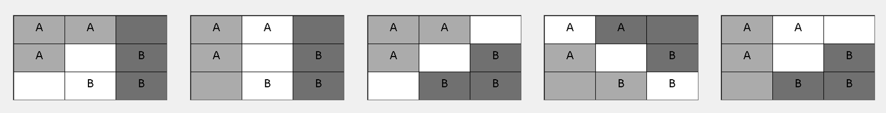

Maps 1 through 5 in order from left to right.

Each district contains three zones. The training exercises walk through these different concepts, testing subjects on their understanding of each and providing them an opportunity to practice, but without giving away the maps on which subjects will actually compete. Player A and Player B both have three guaranteed zones in any given map. The configurations are best seen in Figure .

For maps 1 and 5 the configuration of these pre-determined zones provides an advantage to Player B and Player A respectively. Any zone that is not pre-determined can be thought of as being open. Individual zones are the multi-contests where a subject wins an open zone (no preexisting letters) with probability $\frac{e_{mi}}{e_{mi}+e_{mj}}$ where $e_{mi}$ is the effort/bid chosen by player $i$ in map $m∈\{1,2,3,4,5\}$. To win a district a subject must win 2/3 of the zones in that district and to win a map a subject must win 2/3 the districts of that map. Subjects are paid for the outcome of a randomly chosen round. It is worth noting that total bids for any given map may not exceed 80 lab dollars, the contest prize. For each round in Stage 1 (the first 10 potentially paid rounds) a map is chosen at random and the outcome of that map determines the subjects’ potential payoff for that round. This ensures subjects have proper incentive to make thoughtful decisions for each map. For the next three rounds (Stage 2) subjects are also asked for their map preference. In other words, subjects identify on which map they would like to compete, enabling us to identify whether participants gerrymander when given the opportunity. In Stage 2 a map is chosen at random from the map selections of paired subjects in order to maintain incentive for thoughtful decisions on every map, not just the one chosen by the relevant subject. For the final round (Stage 3) subjects are told that their player type, A or B, is not yet determined, but that they must pick which map they would like to compete on nonetheless. After subjects make their map choice they are assigned to either Player A or Player B and must choose efforts with this knowledge. The stage then proceeds as Stage 2. For each Stage, after map selections and bids are made the results of the contest for each map are displayed with the randomly chosen map highlighted to showcase which map could determine the subjects’ earnings. The information shown to subjects includes their bids for every district in every map, their opponent’s bids in every district in every map, their probability of winning any given district, their probability of wining the map, and their payoff for each map.

## Theory

The use of five separate maps is important to our theoretical calculations. For each map a subject’s probability of winning is tied directly to their bids and the bids of their opponent. The functional form of these probabilities, as functions of each player’s bid, differ depending on which map configuration is considered. Using these probabilites we construct a simple expected payoff maximization problem for each map and calculate the optimal bidding strategies as functions of value $v$. The optimal total bidding strategies for maps 1, 2, 3, 4, and 5 are $\frac{1}{4}v$, $\frac{1}{4}v$, $\frac{3}{8}v$, $\frac{3}{8}v$, and $\frac{1}{4}v$ respectively. The design of maps 1, 2, 3, and 5 are such that only the White district actually effects the probability a player wins the contest. In map 4, however, all three districts are competitive and so the $\frac{3}{8}v$ optimal bid is actually $\frac{1}{8}v$ per district. Another feature of our design are the advantaged maps, maps 1 and 5, but interestingly the optimal bids are not player dependent for these maps. Maps 2, 3, and 4 are symmetric. Map selection is also a theoretical question, though a relatively simple one. Assuming a subject is only interested in winning the contest then they should pick the map that provides them the greatest chance of winning. That is, during Stage 2 Player A should choose map 5 and Player B should choose map 1. We make no theoretical claims regarding map selection in Stage 3 as this requires further assumptions on subject behavior.

## Results

#### Map behavior

For starters, behavior for each map is in line with expectations in terms of *where* subjects should focus their efforts. That is, subjects rarely bid in noncompetitive districts. A few subjects start off biding in noncompetitive districts, but quickly update and change their strategy after the first couple of rounds. A handful of subjects bid in noncompetitive districts for the majority of rounds suggesting they did not fully understand the impact of such a strategy on their chances of winning the contest. For the most part, even if subjects bid in noncompetitive districts, those bids were far less than their bids in the competitive White district. In map 4, where every district is competitive, we observe similar distributions of bids across each district with 72% of subjects bidding in all three districts and 17% bidding in only two. Overbidding is evident across all maps, which is somewhat expected given the literature surrounding similar contests. For average bidding behavior in each district of each map see Figure .

#### Map selection

Using the mode of map selection over the three rounds of Stage 2, subjects overwhelming choose the map that provides them with an advantage. In other words, we find evidence that gerrymandering occurs in our laboratory setting. Using the modal map selection for each subject in Stage 2, out of 64 observations 44 subjects chose the gerrymandered map. This equates to 68.75% of the sample (If we do not use the modal measure this percentage drops modestly to 65.63%). Map selection in Stage 3, which is a one-shot choice in the final round, identifies maps 3 and 4 as the relatively preferred maps when a subject does not know their player type in advance. Specifically, 14%, 12%, 34%, 23%, and 14% of the sample choose maps 1 through 5 respectively. These percentages sum to 98% due to a singular subject excusing themselves from the map selection part of the final round in order to use the restroom.

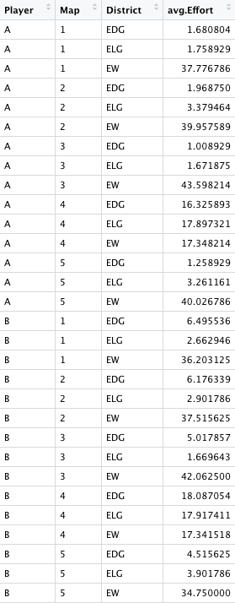

Average bids by role in each district for each map.