Reference
How competition does affects businesses: Competition impacts business. Research, Data & Technology - Blogs. (2023, March 20). https://www.eminenture.com/blog/competition-affects-businesses/


Conclusion
A company's operations are significantly impacted by competition, which drives innovation, efficiency, and customer-centricity. Businesses can succeed in a cutthroat market by differentiating themselves, embracing product innovation, optimizing operational performance, and producing noteworthy client stories. Companies may stay ahead of the competition, draw in customers, and find long-term contentment by adapting to their demands. To compete in a constantly changing market, organizations must review and improve their processes regularly.

Introduction
Competition in the business landscape is extreme, with organizations vying for market share, customer loyalty, and profitability. This competitive environment significantly influences how companies manage their operations. From market differentiation to product innovation and operational efficiency, competition drives companies to continually improve and excel in various aspects of their operations.

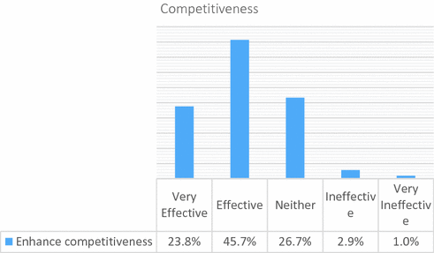
The Impact of Competition on the Company’s Operation

Operational Efficiency
To thrive in a competitive environment, companies optimize operations for cost reduction and productivity enhancement. Operations teams streamline processes, improve supply chain management, and adopt advanced technologies to achieve efficiency and maintain profitability.

Customer Experience
Exceptional customer experiences are crucial in a competitive landscape. Operations teams ensure smooth interactions, efficient logistics, timely delivery, effective customer service, and personalized experiences. By prioritizing customer satisfaction, companies gain a competitive advantage.

Product Innovation
Competition drives continuous product improvement. Operations teams efficiently implement innovation processes, including R&D, prototyping, and production. They collaborate with other departments to bring new offerings to market promptly.
Market Differentiation
In a competitive marketplace, companies must differentiate themselves to stand out. Specific functions, cost considerations, and customer assessments that distinguish the organization are widened by operations groups. They are knowledgeable of how to make an aggressive gain by using branding, layout, and pleasure.

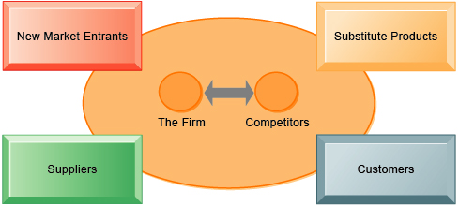
Overview
Competition plays a critical role in shaping a business enterprise's operations. Corporations must constantly adapt and enhance their operations in a competitive market to take advantage of it. This text explores the impact of competition on an organization's operations, highlighting key regions where competition drives alternatives and innovation.


The Impact of Competition on the Company’s Operation

