State of Tariffs: November 17, 2025
Summary
The Budget Lab (TBL) estimates the effects of all US tariffs and foreign retaliation implemented in 2025 through November 17, including the effects of recent exemptions for certain agricultural products. This report looks at two scenarios: one where these tariff policies remain in effect in perpetuity, and another where the IEEPA tariffs are invalidated and refunded after the Supreme Court decision and are not replaced under other authorities.
Current Tariff Rate: Consumers face an overall average effective tariff rate of 16.8%, the highest since 1935. After consumption shifts, the average tariff rate will be 14.4%. (If IEEPA tariffs are invalidated, the pre-substitution rate would be 9.3%.)
Overall Price Level & Distributional Effects: TBL assumes the Federal Reserve “looks through” the tariffs and allows prices to rise such that the tax burden is felt through prices rather than nominal incomes. The price level rises by 1.2% in the short run, representing a loss of $1,700 for the average household and $9,00 for households at the bottom of the income distribution. (Without IEEPA, the price level impact would instead be 0.6%.)
Commodity Prices: The 2025 tariffs fall most heavily on apparel, products with high metal content like electrical equipment and computers, and motor vehicles. (If IEEPA tariffs are invalidated, the burden on apparel and related products would largely be relieved.)
Real GDP Effects: Tariffs slow US real GDP growth by 0.5 pp in 2025 and 0.4pp 2026. In the long run, the US economy is persistently 0.3% smaller, the equivalent of $90 billion annually in 2024$. (If IEEPA tariffs are invalidated, the long-run hit to output is instead 0.1%.)
Labor Market Effects: The unemployment rate rises 0.3 percentage points by the end of 2025 and 0.6 percentage points by the end of 2026. Payroll employment is about 460,000 lower by the end of 2025. (If IEEPA tariffs are struck down and collections are refunded, the 2026 hit to employment would be about half as large.)
Long-Run Sectoral GDP & Employment Effects: In the long run, tariffs present a trade-off. US manufacturing output expands by 2.9%, but these gains are more than crowded out by other sectors: construction output contracts by 4.1% and agriculture declines by 1.4%. (These relative patterns are similar with or without IEEPA tariffs.)
Fiscal Effects: All tariffs to date in 2025 raise about $2.7 trillion over 2026-35, though slower economic growth reduces revenues and brings the net dynamic revenue to $2.3 trillion. (Invalidating IEEPA would cut these revenue streams by about half.)

Changes Since the Last Report
TBL has incorporated the following changes since the October 30 report:
New Policy. Since the last update, the Trump administration announced several changes to tariff policy:
- The list of products exempt from the “reciprocal” IEEPA tariff regime was expanded, with a specific focus on agricultural imports like beef, coffee, and fruit. The full list of exemptions can be found here. This report reflects this change.
- The administration announced a new deal with Switzerland cutting the reciprocal IEEPA rate from 39% to 15%. This report reflects this change.
- The administration announced new deals with Argentina, Guatemala, El Salvador and Ecuador, though the lists of products that will receive favorable tariff treatment under these deals have not yet been announced. This report does not reflect this change due to insufficient detail. TBL will update when additional details become available.
Refinements to Effective Tax Rate Calculations. Since the last update, TBL has updated its methodology for calculating effective tariff rates (ETRs) by making two changes:
- The model now incorporates product-level import data at the ten-digit Harmonized Tariff Schedule (HTS) code level (up from six digits prior) in its parameterization of Section 232 tariffs. IEEPA exemptions are also now specified at the ten-digit code level of precision (rather than broad GTAP sector code as before). All else equal, this change slightly decreases TBL’s estimated pre-substitution ETR. The code for these calculations can be found at this public repository.
- Our reported post-substitution ETR now reflects two margins of behavioral adjustment: substitution away from higher-tariff to lower-tariff countries, and within-country substitution away from higher-tariff products to lower-tariff products. Prior TBL post-substitution ETR estimates only reflected the first of those two margins. This change does not affect TBL’s revenue or macroeconomic estimates, which have always reflected both margins.

Current Tariff Policy as of November 17

Broad Tariffs under IEEPA Authority
Region | “Reciprocal” Tariff | “Fentanyl” Tariff
Canada | 0% reciprocal (exempt) | 0% on USMCA-duty-free; 10% energy/potash; 35% other non-USMCA; USMCA goods duty-free
Mexico | 0% reciprocal (exempt) | 0% on USMCA-duty-free; 10% potash; 25% other non-USMCA; USMCA goods duty-free
China | 10% reciprocal baseline; higher China rate delayed | 10%; stacks regardless of other tariffs
European Union | Formula reciprocal rate, typically 0–15% | None
United Kingdom | 10% reciprocal | None
Trade-deal partners (Japan, Korea, Vietnam, etc.) | Reciprocal rates mostly in 15–25% range | None
Other | Mostly 10% reciprocal; some countries 15–40% | None
Product-Specific Tariffs under Section 232 Authority
Sector / Product | Current Tariff Rate
Steel | 50%; 25% UK; USMCA goods duty-free
Aluminum | 50%; 25% UK; USMCA goods duty-free
Copper | 50% on semi-finished/derivative copper; USMCA goods duty-free
Automobiles | 25% headline; often 0–15% for EU/Japan via formula; USMCA goods duty-free
Auto parts | 25% most; 10% for some UK parts; 0–15% EU/Japan formula; USMCA import adjustment can reduce rates
Medium/heavy trucks & buses | 25% on trucks/parts; 10% buses; some USMCA relief
Lumber / wood products | 10% softwood; 25–30% upholstered furniture; 25–50% cabinets/vanities; USMCA goods duty-free

Results
This report presents two scenarios for tariff policy:
- Baseline. In this scenario, tariff policies as of November 30 remain in effect in perpetuity (“Baseline”). This scenario is the focus of the report.
- IEEPA Invalidation. In this scenario, IEEPA tariffs are invalidated by the Supreme Court and refunded to importers. Tariffs under other legal authorities are unaffected, and the lost revenues from IEEPA tariffs are not replaced by new tariffs under other authorities. Detailed estimates for this scenario can be found in the data download file.
The table below summarizes TBL's estimated effects under both scenarios.
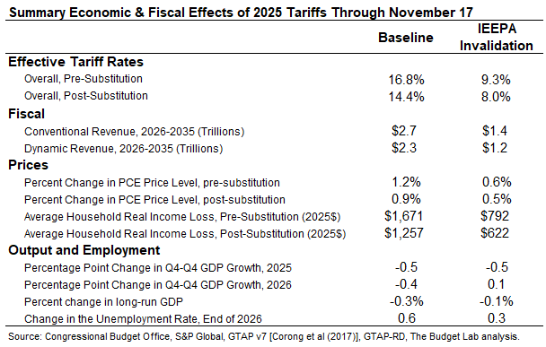

Average effective tariff rate
The distinction between pre-substitution metrics (before consumers and businesses shift purchases in response to the tariffs) and post-substitution (after they shift) is a crucial one. One metric where the difference is meaningful is the average effective tariff rate.
Measured pre-substitution—assuming there are no shifts in the import shares of different countries and products—current tariff policy represents the equivalent of a 14.4 percentage point increase in the US average effective tariff rate. That calculation assumes that, for example, the share of imports from China remains at 13%, where it was in 2024. A pre-substitution approach is a good measure of welfare, since it reflects the full cost faced by consumers before they start making difficult spending choices. This increase would bring the overall US average effective tariff rate to 16.8%, the highest since 1935.
The effective tariff rate implied by policy has fluctuated substantially this year, starting at 2.4% in early January and peaking at about 28% in the wake of the April 9 and 13 announcements.
Post-substitution—after imports shift in response to the tariffs—the 2025 tariffs generate a 11.9 percentage point increase in the US average effective tariff rate, which brings the overall US effective tariff rate to 14.4%, the highest since 1939. The timing of the transition from “pre” to “post” substitution is highly uncertain. Some shifts are likely to happen quickly—within days or weeks—while others may take longer.

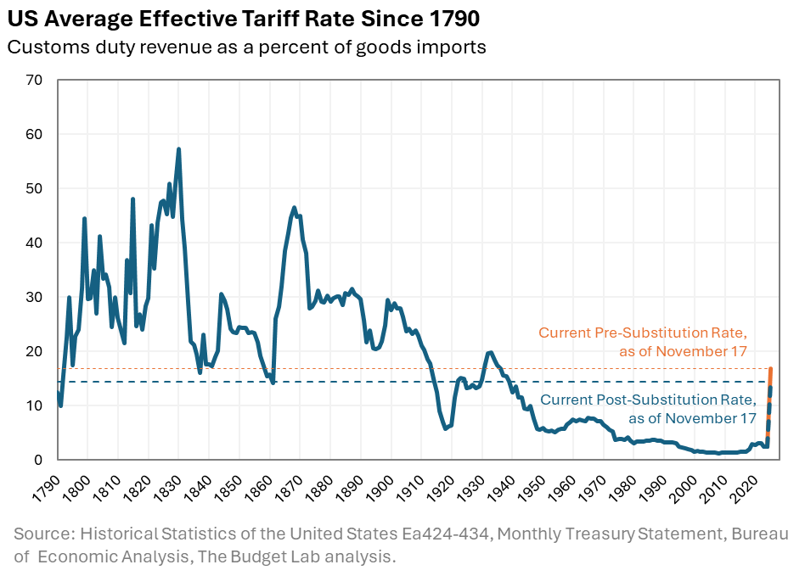
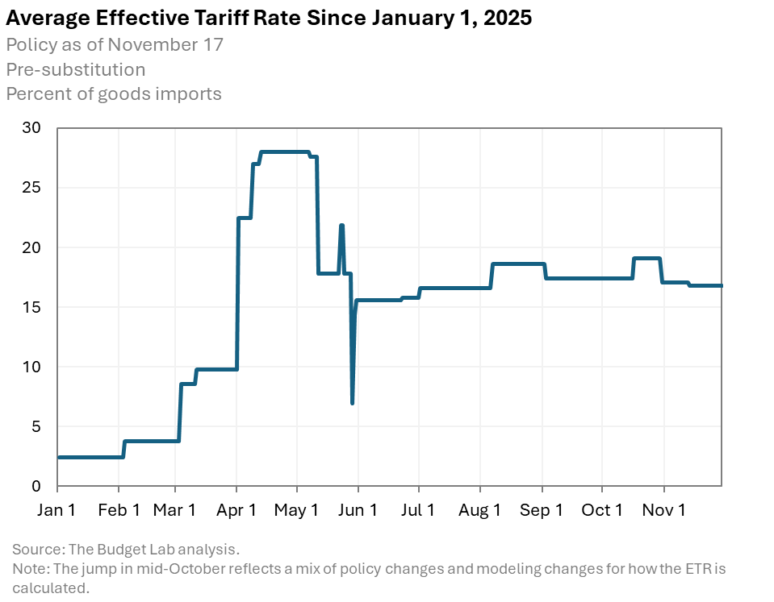

Average aggregate price impact
The 2025 tariffs imply an increase in consumer prices of 1.2% in the short run, assuming full passthrough of tariffs to consumers. (For the purpose of this calculation, TBL assumes the real income adjustment imposed by tariffs comes through prices rather than nominal incomes.) This is a pre-substitution number that captures consumer welfare effects. It is the equivalent of a short-run income loss of about $1,700 per household on average in 2025 dollars. The post-substitution price increase settles at 0.9%, a $1,300 loss per household.

US real GDP & labor market effects
All 2025 US tariffs plus foreign retaliation lower real GDP growth by about 0.5 percentage points in 2025 and 0.4 percentage points in 2026. The unemployment rate ends 2025 0.3 percentage points higher and 2026 0.6 percentage points higher, and payroll employment is 490,000 lower by the end of 2025. The level of real GDP remains persistently 0.3% smaller in the long run (the equivalent of about $90 billion 2024$ annually) while exports are 16% lower.
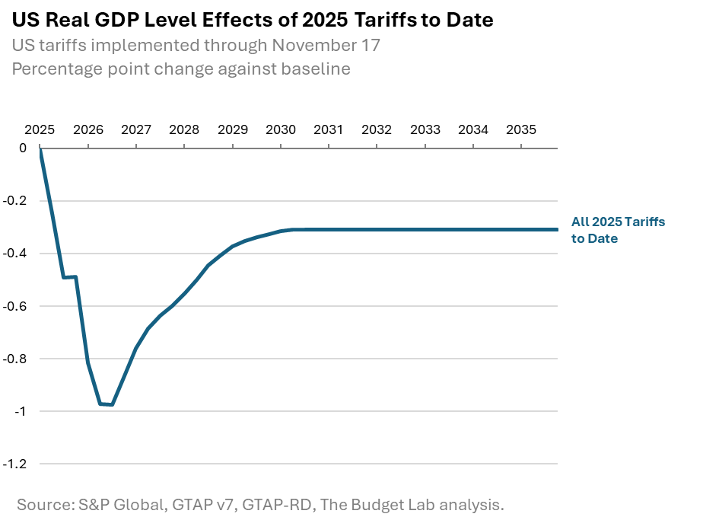

Long-run US sectoral output & employment effects
Tariffs shrink the overall size of the US economy in the long-run by 0.3%, but beneath aggregate GDP they also drive reallocation across US sectors. Long-run output in the manufacturing sector expands by about 3%, within which nonadvanced durable manufacturing seeing the largest gains and advanced manufacturing seeing a slight decline. This expansion of the overall manufacturing sector, however, more than crowds out the rest of the economy: construction contracts by about 4%, agriculture by more than 1%, and mining & extraction by more than 2%.

Global long-run real GDP effects
Long-run global GDP is about 0.1% lower due to the tariff policy. China’s and Canada’s economies are each a bit more than 0.2% smaller—about two thirds of the economic hit to the US. The UK, EU, and Mexico all see small gains in the long run.

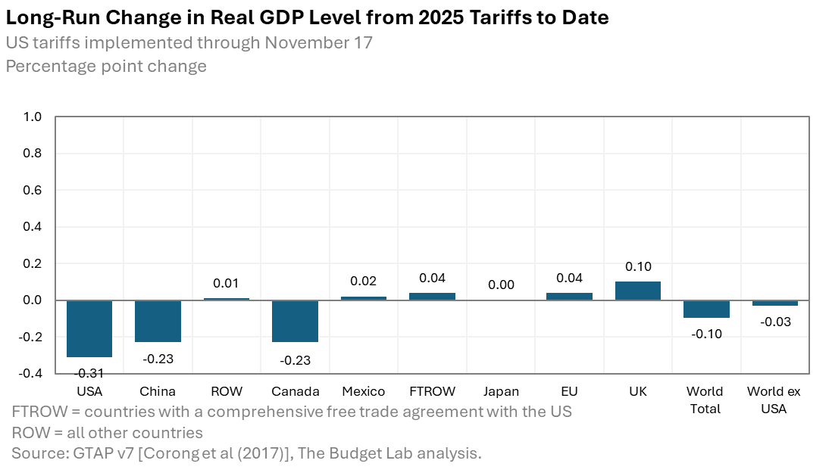

Fiscal impact

The 2025 tariffs to date, were they to remain in place, would raise more than $2.7 trillion over ten years, conventionally scored. Given the negative output effects of the tariffs, these new revenues will be partially offset by reductions in tax revenue as a result of lower growth. Based on Congressional Budget Office rules-of-thumb, TBL estimates that these effects would total almost $400 billion over the decade.

Distributional impact
One way to measure the distributional burden of tariffs is to look at the relationship between consumption, which gets more expensive under tariffs, and income for a given year. Under this view, tariffs are a regressive tax because lower-income households spend a larger fraction of their income than higher-income households do on average.
TBL finds that the burden, expressed as a share of post-tax-and-transfer income, on the first decile is more than three times that of the top decile (2.4% versus 0.8%). The average annual cost to households in the first and top decile are to about $900 and $3,900 respectively in 2024$. The median cost is about $1,400 per household.
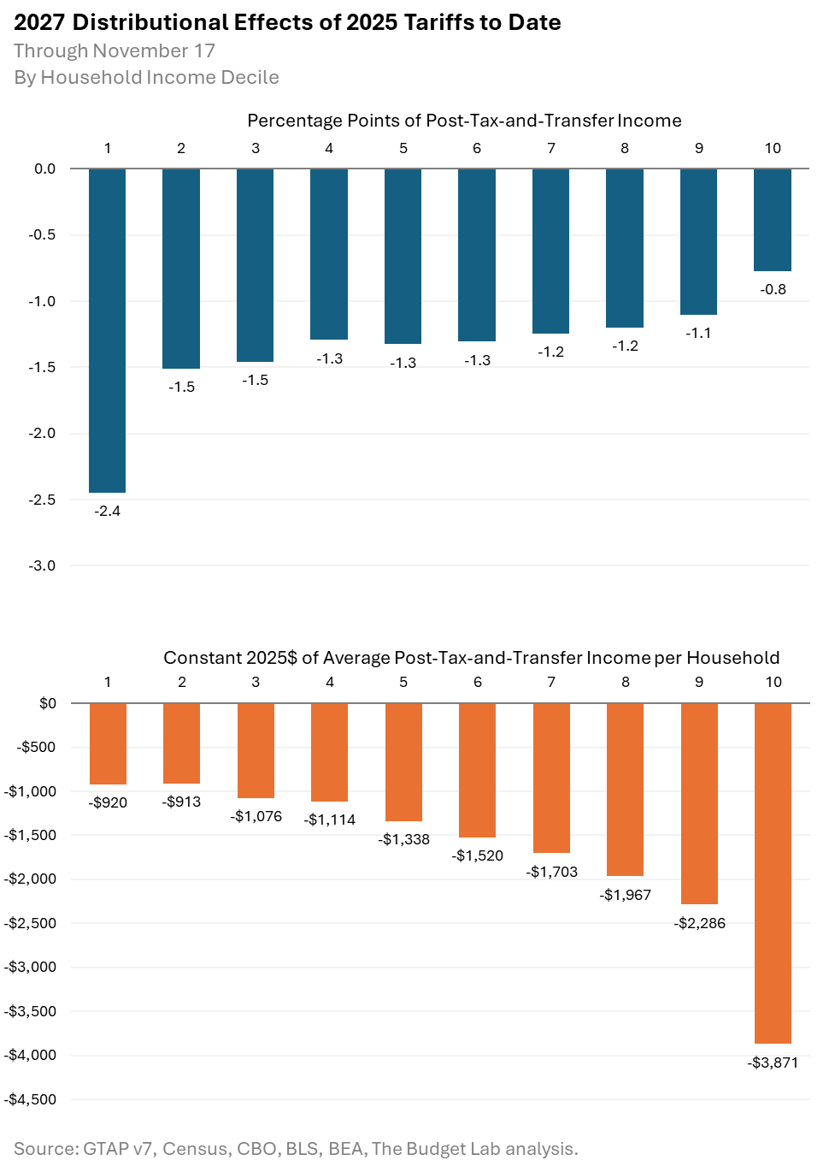

Commodity price effects
The charts below show how the 1.3% price level increase from the 2025 tariffs to date would look across individual commodities in the short-run (pre-substitution), as well as the 1.1% long-run price increase (post-substitution). Some high level takeaways:
- Consumers face particularly high increases in leather and clothing in the short run: prices increase by more than 20% for leather products (shoes and hand bags) and general apparel, and by 14% for textiles. After substitution and global supply shifts in the long run, prices remain 7%, 7%, and 4% higher, respectively.
- Metal imports are a central target of recent tariffs. Beyond raw materials which face direct price impacts, affected consumer products include electoral equipment and consumer electronics (17-18% short-run price effect, 5-6% long-run price effect).
- Food prices rise 1.2% in the short run and stay 1% higher in the long run.
- Motor vehicle prices rise by 13% in the short run and by 5% in the long run, the equivalent of an additional roughly $6,500 and $2,500 respectively to the price of an average new car in 2025.
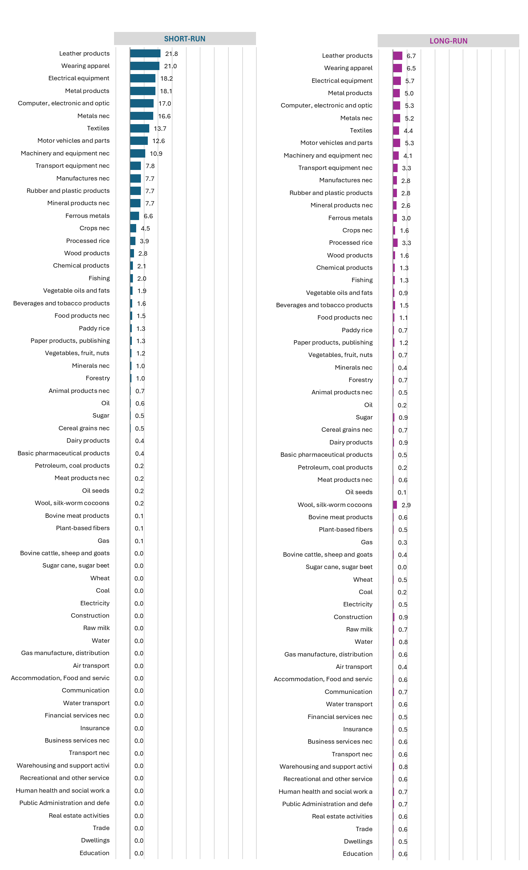

TBL assumes throughout its tariff analysis that the transition to longer-run GTAP equilibria occurs after three years.
TBL defines “income” as CBO-concept post-tax-and-transfer income. “Short-run” refers to the effect over the next couple of years; TBL proxies for this definition by using CBO projections of the distribution of income in 2027, expressed in 2025 dollars.
TBL employs a “relaxed conventional” assumption for the retaliation scenario, whereby foreign income is permitted to fall but US income remains fixed.

