Actual verses Effective ETRs

- Introduction
  - Tariff regime
  - High statutory tariff rates, lower observed rates.
  - What could explain the difference?
    - Real economic response (trade flows change)
    - Implementation / avoidance responses (trade flows don’t change)
  - Why is this important?
    - Impacts passthrough
    - Impacts ….
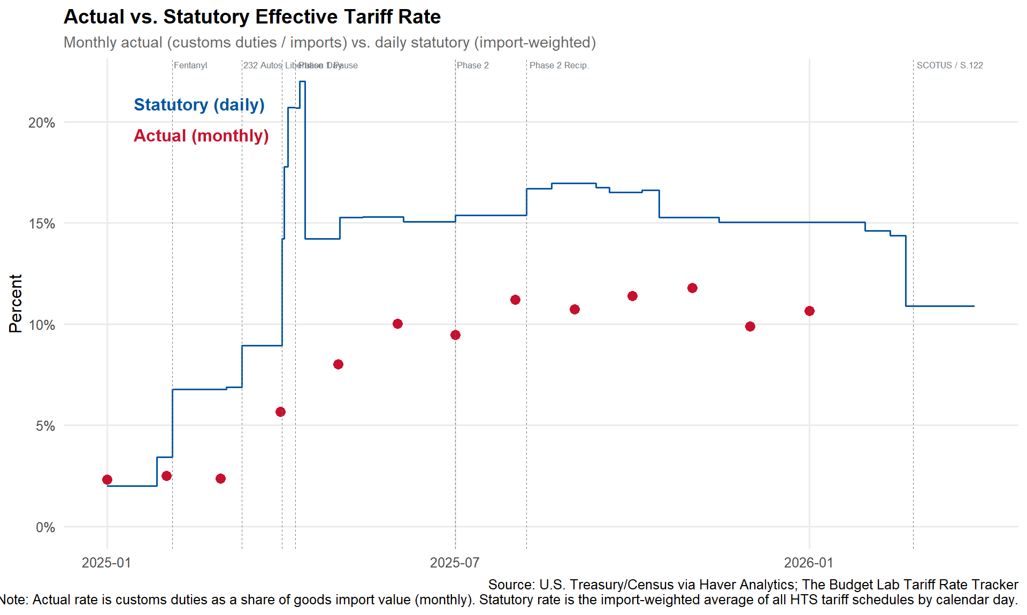

- Defining the gap
  - Define statutory ETR
    - Statutory rates weighted by 2024 weights
    - Differentiate from TBL headline #
      - TBL includes some behavioral responses (USMCA) but excludes others.
      - For this exercise, we begin with holding fixed 2024 trade weights AND all other factors
    - Describe daily rate tracker tool
  - Define actual ETR
    - US treasury data on actual imports and custom duties revenue
    - Only observable at the aggregate monthly level.
  - We can observe monthly import data at a more granular level (product, country, etc…) but not duties collected
- Literature review
  - Azzimonti (Richmond Fed, August 2025)
  - Cui et al. (2026)
  - Gopinath and Neiman (2026) (NBER)
  - Fajgelbaum and Khandelwal (2026) (Brookings)
- Understanding economic response
  - Within-country
  - Across country
  - Stockpiling
- Understanding non-economic response
  - Legal / Avoidance
    - USMCA
    - Auto (rebate)
    - Transfer pricing
    - Other exceptions
    - Lags can we rule out

  - Evasion
    - Model HTS code shifting from neighboring tariffed HTS codes to non-tariffed HTS codes.
      - Use post implementation revisions to find
      - Stories / newspapers

NOTES

What you can get from the public Census data (via USA Trade Online or the Census API) is monthly imports by HTS code and country, broken into customs value, dutiable value, and calculated duties collected. So in principle you can construct an effective tariff rate at the country-by-product-by-month level by dividing duties collected by customs value.
The wrinkle is that what Census reports as "calculated duty" is the duty assessed at the time of entry, not necessarily what's ultimately collected after protests, refunds, drawback claims, FTZ adjustments, exclusions granted retroactively, and so on. There's a gap between assessed and collected, and that gap itself is informative for your decomposition — it's another channel of legal avoidance.
The actual cash collections data sits with CBP and Treasury. The Monthly Treasury Statement reports total customs duties collected, but that's just one top-line number, not broken out by country or product. CBP has more granular collections data internally but doesn't publish it at the country-by-HTS level as far as I know.

