Tracking the Economic Effects of Tariffs
The Budget Lab at Yale
February 19, 2026

Key Takeaways
- Tariff revenue: The 2025 tariffs have raised an estimated $194.8 billion in inflation-adjusted customs revenue above the 2022–2024 average as of January 20261, with the effective tariff rate reaching 9.9% in December 2025.
- Pass-through to consumer prices: Imported PCE core goods and durable goods prices have risen 1.0% and 1.3% respectively during 2025 through November, both well above prior-year comparisons. Implied passthrough of tariffs to imported consumer goods prices ranges from roughly 31–63% for core goods and 42–96% for durables, depending on methodology (see Tables 1a–1b).
- Employment: There is no definitive indication of a significant aggregate labor market effect so far, though tariff-exposed industries show some signs of weakness relative to pre-2025 trend.

Introduction
In response to new tariff announcements, The Budget Lab (TBL) regularly estimates fiscal and macroeconomic effects resulting from policy; TBL published its latest report on January 19th, and we aim to update these projections as we refine our methodology and as policies change. These analyses rely on projections from well-respected economic and trade models, including the MA/US macroeconometric model (currently maintained by S&P Global) for short-run analysis and the Global Trade Analysis Project (GTAP) model for medium/long-run analysis.
One year after the initial wave of new tariffs, this report updates a September 2025 assessment of how actual economic indicators have responded to tariff changes. This provides a check on the assumptions made by economic models, as well as a real-time assessment of how tariffs are impacting the US economy. Most of these indicators are updated monthly, and going forward this report will be released on that same schedule. In particular, we consider the impact of tariffs on economic data on revenues, prices, trade, and labor markets. Critically, these are not causal estimates of the effect of tariffs on the economy, but rather constitute a descriptive attempt to explore how the economy is changing with tariffs. There are a number of other economic changes happening concurrently, including but not limited to the growth of generative AI and the passage of the One Big Beautiful Bill Act, which we do not control for in the series presented below. This report was updated using data as of Thursday, February 19th, 2026.
Overall, there is evidence, consistent with economic theory, that tariffs have raised both additional revenue ($194.8 Billion above the 2022–2024 average) and led to higher prices (Personal Consumption Expenditure (PCE) core goods up 1.5% during 2025 through November). There is less clear evidence about the impacts of tariffs on the wider economy: for example, employment in tariff-exposed industries is not appreciably lower or higher than what would have been expected prior to 2025. Importantly, these statistics are representations of the current economy, and it is difficult to disentangle what changed due to tariffs versus the many other economic changes over the past year. It is still early and the effects of tariffs may evolve and change over time as consumers, businesses, and policymakers respond.

Revenues & Effective Tariff Rates
Tariffs are a tax on imports, therefore higher tariffs will increase revenues if their effect on imports is not sufficiently prohibitive. Before the 2025 tariff announcements, the average effective US tariff rate was 2.7% (2022–2024 average), raising $7.6 billion a month in net customs duty revenues. The new 2025 tariffs have raised roughly $194.8 billion in revenues so far (after accounting for the 2022–2024 average), with $174.7 billion collected over the course of 2025 and about $20.1 billion of that new tariff revenue posted in January 2026 alone.
In our modeling of the general revenue effects of tariffs, we at TBL estimate that tariffs will raise $246 billion in annual revenue for fiscal year (FY) 2026 (conventionally), which is lower than the annualized revenue we would expect if monthly tariff revenue remained at its current level (2-month average of December and January projected forward) for the rest of the fiscal year ($334 billion). However, our simulated revenue accounts for decreases in other revenue sources, like federal payroll and corporate income taxes, following the methodology of the U.S. Congressional Budget Office. Adjusting for that gives us a simulated annual revenue of $319 billion, notably closer to the annualized tariff revenue level suggested by the customs data.
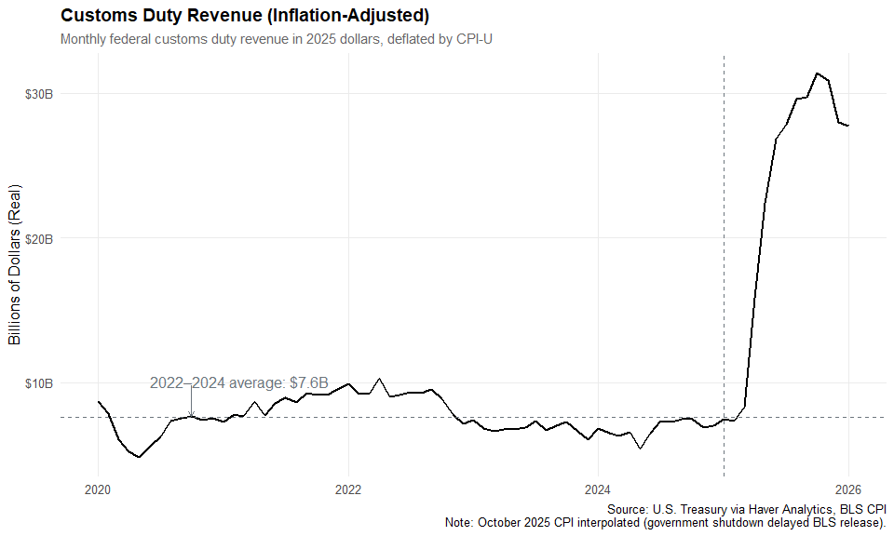
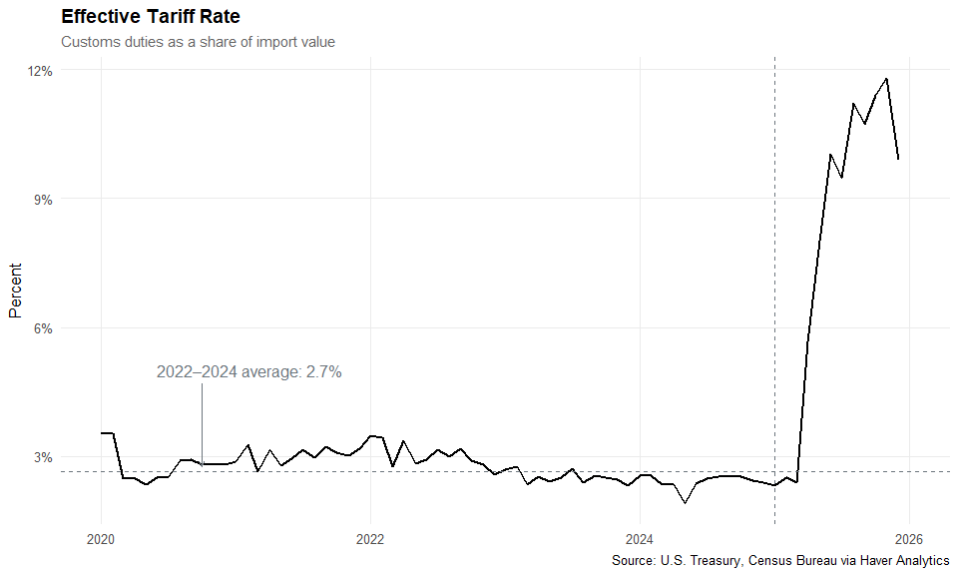

Prices and Consumer Passthrough
One of the most debated questions around tariffs is to what extent they are leading to higher consumer prices. Tariffs are taxes that otherwise add to the cost of imported goods. Different groups can bear this cost, or incidence: foreign producers (in the form of accepting lower prices on their exports), American importers and businesses (in the form of lower profit margins), and American consumers (in the form of lower real after-tax incomes). Moreover, tariffs reduce productivity and thereby real U.S. income (even when including tariff revenue) by reducing the efficiency of resource allocation across countries and increasing the marginal cost of investment. After-tax real incomes in turn can fall either from a rise in realized prices, holding nominal income constant, or a fall in nominal income.

Overall Goods Prices
One possible indication that tariffs are raising consumer goods prices is that goods prices have increased since the beginning of the year, both in absolute terms and against reasonable estimates of pre-2025 trend. We estimate the pre-2025 trend using a local projection method with recession and pandemic controls. See the accompanying Methodology document for full details. We find similar differences when the trend is calculated using a simple log-linear approach. During 2025 through November, PCE core goods prices (goods excluding volatile food & energy components) rose 1.5%, versus 0.2% over the same 11-month period starting in 2023. The difference is even starker with PCE durable goods prices, which rose 1.6%, versus -1.8% over the same period starting in 2023. Core goods and durable goods were 2.5% and 3.1% above TBL’s estimate of pre-2025 trend in November.
Versions of Figures 3 and 4 using the log-linear trend approach are included in the Appendix.
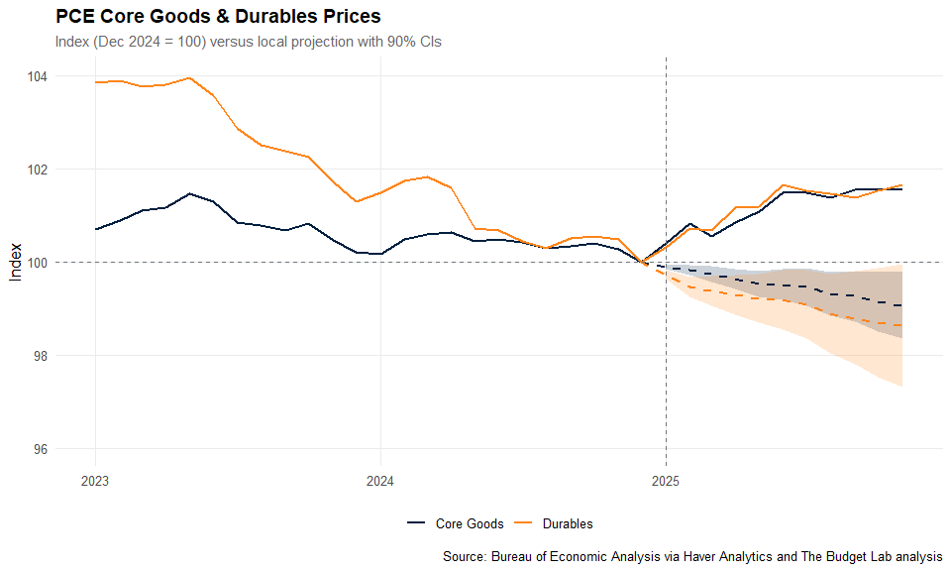
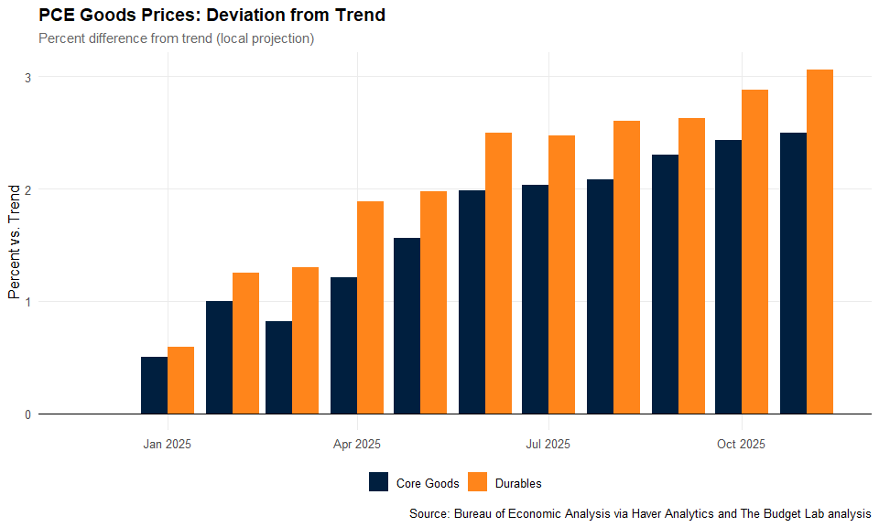

Imported PCE Goods Prices
When we construct a price index that reweights standard PCE component price indices by their import content—weighting categories like electronics, motor vehicles, and apparel more heavily, and domestic-heavy categories less—the deviation remains, though it is less extreme for core goods. This Imported PCE Goods Price Index measures price changes in the goods most exposed to imports and therefore tariffs. As of November, the imported core goods index is 2.1% above trend and the imported durables index is 2.9% above trend, compared to 2.5% and 3.1% for the standard PCE indices. See the accompanying Methodology document for details on index construction.
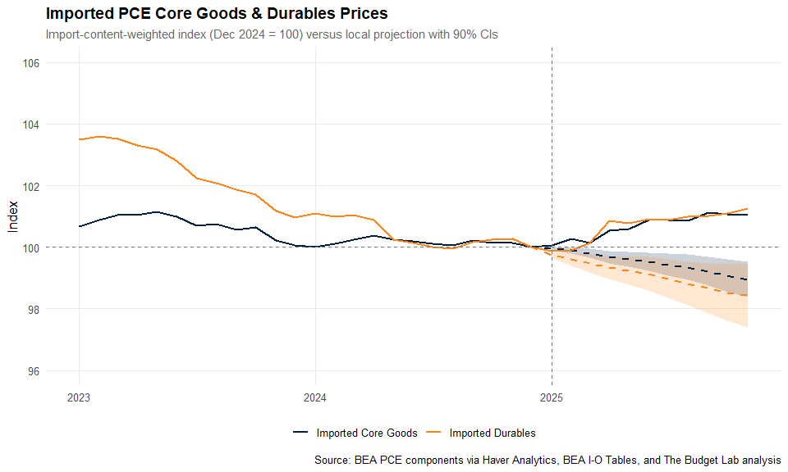
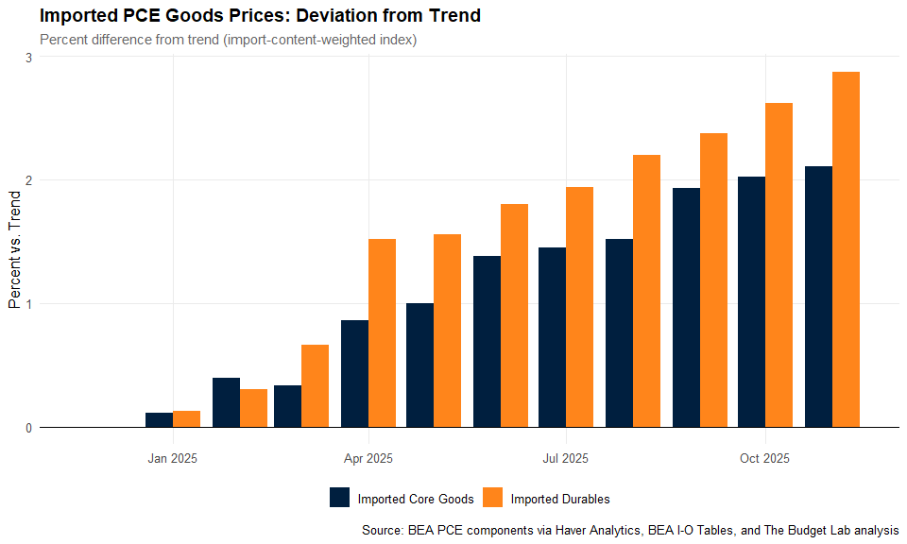

Implied Consumer Passthrough
In its modeling, TBL assumes that passthrough of tariffs to consumer prices will ultimately reach 100%. This is partially an assumption of convenience but it is also rooted in studies of the 2018 tariffs, such as Flaaen, Hortacsu & Tintelnot (2020) and USITC (2023). However, both of these studies primarily focus on much narrower tariff increases, rather than the broader and more aggressive increases over the last year. The 2025 tariffs also come after a period of inflation, which may have changed how price-sensitive consumers are. In this context, comparing the rise in overall goods prices against what we would mechanically expect given the rise in tariffs, we can estimate an implied “spot” passthrough of actual tariffs to consumer prices as of November 2025.
In November 2025 (the month of the latest detailed Census trade data), the statutory fully-phased-in average tariff policy rate was 16.8%, but as mentioned earlier, there are several reasons why it takes time for tariff policy to fully flow through into realized revenues. We therefore use as our basis the actual average effective tariff rate, which was 11.8% that month. But this rate, calculated based on all revenues and imports, includes products and content that will not be ultimately purchased by consumers, such as business investment and exports. TBL therefore calculated average tariff rates on imported consumer goods. For imported core PCE goods, the average import-weighted effective tariff rate was 13.1% in the most recent month, up from a 2022–2024 average of roughly 2.7% (the 2025 annual average was 8.7%). For just imported PCE durables, the most-recent-month rate was 13.3%, up from roughly 2.7% (2025 annual average: 9.0%). Given these shifts and the import share of PCE (total import content—including indirect imports through the supply chain—is 32.3% of core goods spending; see accompanying Methodology document), we would expect full passthrough price effects from the actual tariff increases in 2025 so far to add 3.4 and 3.0 percentage points through November 2025 for core goods and durables prices, respectively.
We estimate the rise in imported core good and durable prices in three ways. The first, and our preferred approach, uses the trend estimates reported in Figure 5 as the counterfactual level of prices but-for tariffs. The second approach uses data from 2023-2024 to project forward pre-2025 prices. The third approach moves away from relying on estimating trends, and rather assumes that prices would have remained at their December 2024 level. It therefore uses the change in prices during 2025 through November. We think that this approach underestimates true price increases from the tariffs by ignoring counterfactuals, but provides an easy lower-bound estimate.
The results of each are shown below, with one table for June 2025 and one for the most recent month of data, November 2025. Tables 1a and 1b use these category-specific tariff rates rather than the economy-wide effective rate, since the tariff burden varies across consumer goods categories. Passthrough tables using overall PCE prices (as opposed to the imported goods) are available in the Appendix.
Using our preferred LP trend method, the implied passthrough of tariffs to imported core goods prices through November 2025 is 63%, and the implied passthrough to imported durables prices is 96%. The larger durable passthrough rate is due both to a lower import share and a more aggressive pre-2025 downward trend in prices. The simpler log-linear trend yields very similar passthrough estimates of 46% for core goods and 106% for durables. The most conservative method—raw price changes during 2025 through November with no trend adjustment—gives 31% and 42% for core goods and durables, respectively. All in all, the story is fairly consistent for imported core goods, with somewhere between 31% and 63% passthrough of tariffs. The story is more mixed for durable goods, due primarily to the uncertainty around the counterfactual level of prices but for tariffs. At the June 2025 mark, the LP passthrough estimates were 51% for core goods and 72% for durables. The estimates of passthrough of imported core goods has remained relatively constant over time, but implied passthrough of durable goods has now reached over 100 percent, versus 37%–78% in June 2025. These estimates of passthrough are larger than those found by other researchers, but not unreasonably so. For example, Cavallo, Llamas, and Vazquez (2026) estimate that the passthrough to retail prices was 24 percent in October 2025.
Table 1a. Implied Passthrough -- Imported PCE Core and Durable Goods Prices (June 2025). Passthrough calculation components, estimated price change, and estimated passthrough rates.
 | Inputs |  |  | Price Changes |  |  | Implied Passthrough
Category | Import Share | Tariff Increase | Expected Effect | 2025 Change | vs LP Trend | vs Log-Linear | 2025 Change | vs LP Trend | vs Log-Linear
Imported Core Goods | 32.3% | 8.4 pp | 2.7% | 0.9% | 1.4% | 1.2% | 33% | 51% | 43%
Imported Durables | 28.3% | 8.9 pp | 2.5% | 0.9% | 1.8% | 2.0% | 37% | 72% | 78%
Table 1b. Implied Passthrough -- Imported PCE Core and Durable Goods Prices (November 2025). Passthrough calculation components, estimated price change, and estimated passthrough rates.
 | Inputs |  |  | Price Changes |  |  | Implied Passthrough
Category | Import Share | Tariff Increase | Expected Effect | 2025 Change | vs LP Trend | vs Log-Linear | 2025 Change | vs LP Trend | vs Log-Linear
Imported Core Goods | 32.3% | 10.4 pp | 3.4% | 1.0% | 2.1% | 1.5% | 31% | 63% | 46%
Imported Durables | 28.3% | 10.6 pp | 3.0% | 1.3% | 2.9% | 3.2% | 42% | 96% | 106%
Notes:
- LP (Local Projection): Price deviation from trend estimated using local projections with recession/pandemic controls (1996–2024 estimation period). See accompanying Methodology document.
- Log-Linear: Price deviation from simple log-linear trend fit to 2023–2024 data.
- Simple: Raw price change during 2025 through November with no trend adjustment.
- Tariff rates are category-specific effective rates from USITC trade data: core goods 13.1%, durables 13.3% (vs 2.7% baseline). Economy-wide effective rate as of November 2025: 9.9%.

Import Prices
As noted above, there are other groups beyond US consumers that might bear the burden of tariffs. For some of these groups (e.g. firms and their shareholders) it is difficult to observe these effects directly. However, we can observe import prices: if foreign producers are willing to accept lower prices on their imports, the incidence of tariffs could fall, at least in part, on them. Below, we plot non-petroleum import prices, and find no evidence of a reduction in prices as a response to tariffs. This is a noisy series, so a response is possible: potentially import prices would have continued on their 2024 trajectory. But there is no clear evidence of a reduction in these prices.
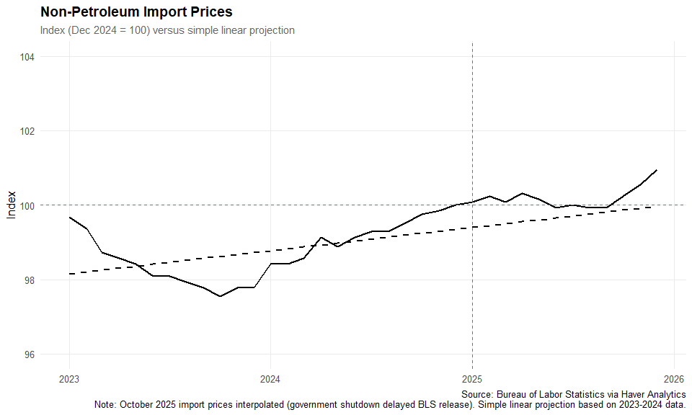
Note: October 2025 non-petroleum import price data were not published by BLS due to the government shutdown. The October value is interpolated as the average of September and November 2025.

The Labor Market
Tariffs have the capacity to impact the labor market via different channels that operate over different time frames. Over the short run, prior to substantial effects on consumer or firm behavior, employment might not respond substantially to tariffs. However, over the medium-to-long term, the net effect of tariffs on employment depends on their overall effect on demand, the responses of the Federal Reserve to keep the economy at full-employment, and any positive (e.g. manufacturing) or negative (e.g. construction) sectoral effects that could emerge.
So far, there is no definitive indication of any effect of tariffs on the aggregate job market. Total nonfarm employment as of January 2026 changed by +0.4M jobs relative to the level of employment one year earlier. This is lower than that same statistic from one year prior (+1.2M).
However, the overall labor market might not be as affected as certain industries that are more exposed to tariffs. We therefore construct indices of tariff-sensitive employment, which measure employment weighted by industry-level tariff exposure.
For industry \(j\), commodity \(c\), and month \(t\):
\begin{equation}
I_t = \sum_j E_{j,t} \times w_j, \quad w_j = \sum_c \tau_c \times R_{c,j} \times s_c
\end{equation}
Where \(E_{j,t}\) is employment, \(\tau_c\) is the tariff rate, \(R_{c,j}\) is the total requirement of commodity \(c\) per dollar of industry \(j\)’s output (from the BEA Leontief inverse), and \(s_c\) is the direct import share. This Leontief-adjusted weighting captures tariff cost pressure at every tier of the supply chain. The index is calculated using the most recent month’s tariff rates. We calculate two versions of this index, one for all non-farm covered employment, and one for manufacturing.
Looking at the overall index, there is some evidence of weakening employment during 2025: the index changed by -0.5% during 2025 through January, which is 0.8% less than the pre-2025 trend would have predicted, and 0.4% less than the growth rate in 2024 over the same period. When we just look at tariff-sensitive manufacturing employment, the manufacturing index changed by -0.8%, versus the trend’s -0.6% predicted change. In other words, there are some indications of weakness in tariff-exposed employment overall, but not in the manufacturing sector. It is worth noting, however, that both of these comparisons are illustrative only, and more rigorous work is necessary to determine the short-term effects of tariffs on employment.
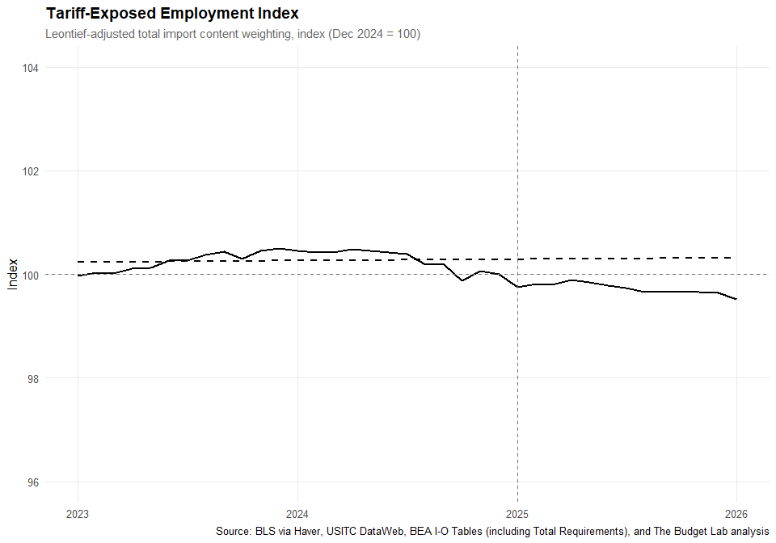
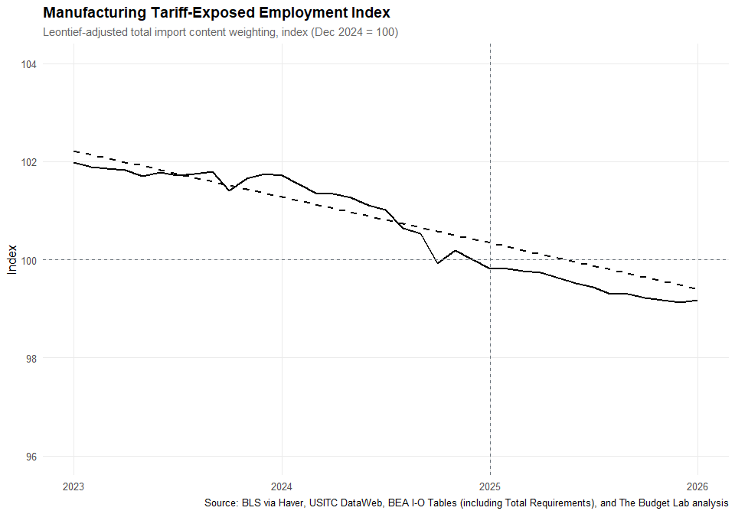

Industrial Output
Building on the analysis of tariff-sensitive manufacturing employment above, we also consider the evolution of industrial production in this same sector. The manufacturing industrial production index is constructed by the Federal Reserve Board and measures real output of manufacturing industries. We plot the index from 2021 onward, and find that during 2025 through January, the index has changed by +0.6%, though it is worth noting it is possible this is due to mean-reversion rather than to any tariff-related effect. In this case, the 2-year pre-trend plotted below may not be the appropriate counterfactual.
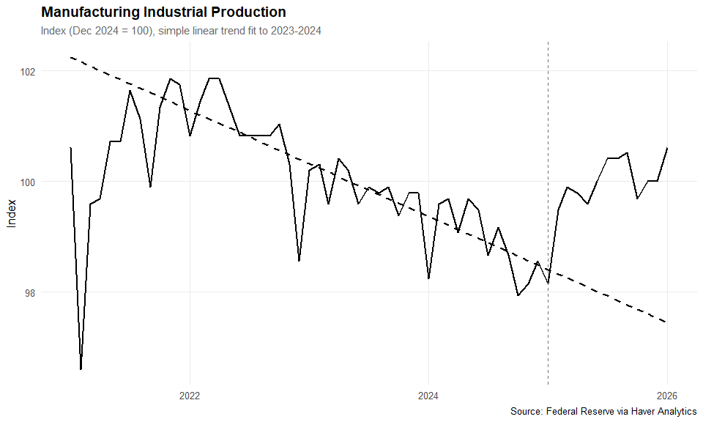

The Strength of the US Dollar
A conventional assumption in economics is that tariffs, when faced with incomplete retaliation from other countries, will cause either an appreciation in the levying country’s currency and/or a depreciation in the currencies of the other countries. This is because the relative demand for the levying country’s currency rises as their consumers and businesses buy fewer imports. The Budget Lab’s tariff modeling has assumed that currency adjustments offset roughly one-third of the cost of US tariffs to US consumers & businesses without foreign retaliation.
The reality, however, has been different so far. As of January 2026, the US dollar is 6.3% weaker than its December 2024 average. There’s also been inconsistent depreciation among the targets of US tariffs. China’s yuan is 0.0% weaker than its December 2024 average, while Canada’s dollar is 0.5% stronger over the same period. Mexico’s peso is 11.6% stronger than December 2024, though this is not out of the range of pre-2025 variation, making it difficult to establish any causal claim.
These currency movements will affect the price of imports for consumers. While stronger currencies make imported goods cheaper for residents, weaker currencies have the opposite effect, making imports more expensive. A weakening US dollar exacerbates the price impact of tariffs by making all imports more expensive in dollar terms.
It is unclear what explains these currency movements. As a first order effect, US tariffs may indeed be putting upward pressure on the US dollar but other factors, like a deteriorating economic outlook, shifting views on the credibility of US institutions, the role of the US dollar in the global economy, and expectations of lower interest rates, are likely exerting downward pressure. The real trade-weighted dollar also entered 2025 roughly 20.3% stronger than its long-run average level (2000–2024), so mean reversion may also be a factor in dollar movement.
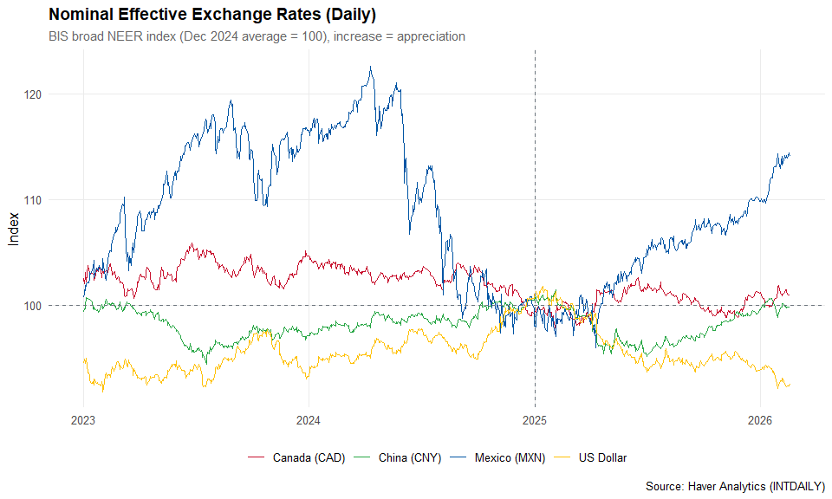

Imports & Exports
A country’s trade deficit, or the amount their imports from other countries exceeds their exports to those countries, can be impacted by tariffs if the higher prices of non-domestic goods induces a shift in purchasing by consumers and businesses. However, if the currency of the levying country appreciates as a result of tariffs, this will drive down the relative price of imports, meaning that any sort of persistent reduction in the trade deficit due to tariffs is unlikely in the long run. We are still in the early days of any such transition, and, as noted above, the changes in the value of the dollar might be driven by other factors, meaning that the expected offsetting effects of a (relatively) stronger dollar might not materialize. It is therefore difficult to evaluate the medium-to-long-term effects of tariffs on the trade deficit.
There are, however, some notable dynamics in the short-term reaction of imports over the last year. First, real imports grew 17.8% over the pre-2025 trend between December 2024 and March 2025, equal to $50.4 billion in real 2025 dollars, as consumers and businesses sought to make purchases ahead of tariffs taking effect. Starting in April, imports declined, and as of December 2025 imports have been on average -6.2% below the pre-2025 trend. Real exports fell more modestly (in absolute terms) than imports, and are 2.1% below trend as of December 2025.
Cumulatively, as of December 2025, cumulative imports are still up by $2.3 billion (real 2025 USD) from November 2024 relative to trend. This has implications for the discussion of stockpiling: this very rough measure of imports implies the ability of firms to rely on pre-tariff stocks of goods will degrade shortly.
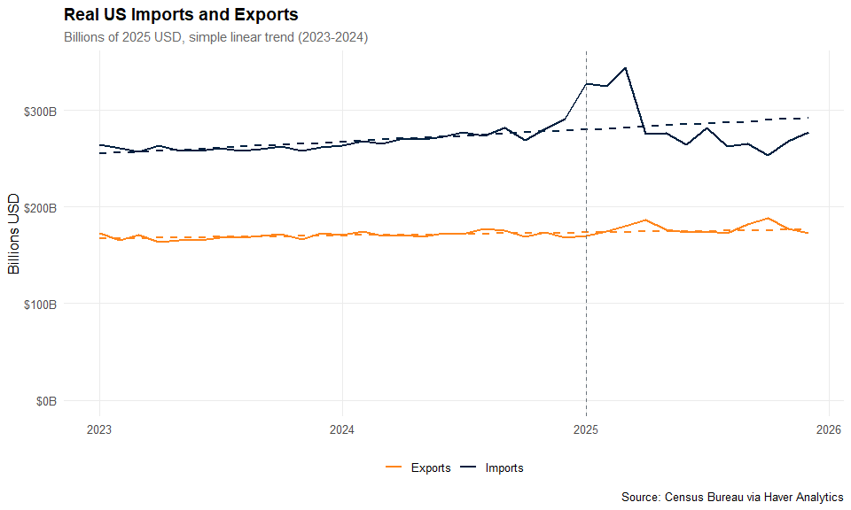
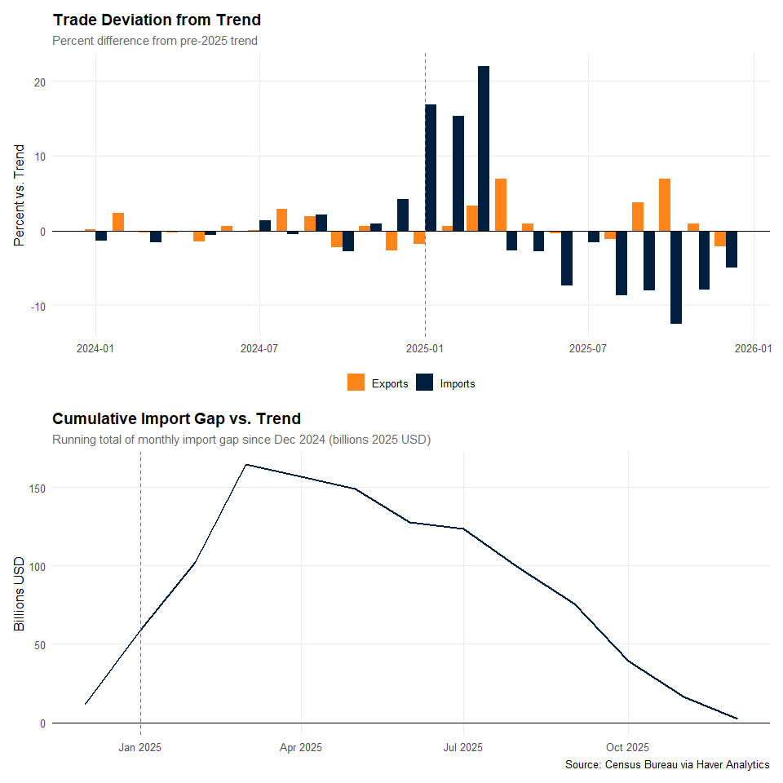

Data Sources
All data in this report is pulled directly from Haver Analytics databases:
- USECON: U.S. Economic data
- USNA: National Accounts (PCE price indices)
- USTRADE: Trade data by country
- USINT: International trade
- LABOR: Employment by industry

Appendix
Table A1. Implied Consumer Passthrough -- All PCE Goods (June 2025). Economy-wide effective tariff rate: 10.0%.
 | Inputs |  |  | Price Changes |  |  | Implied Passthrough
Category | Import Share | Tariff Increase | Expected Effect | 2025 Change | vs LP Trend | vs Log-Linear | 2025 Change | vs LP Trend | vs Log-Linear
Core Goods | 32.3% | 7.4 pp | 2.4% | 1.5% | 2.0% | 1.7% | 62% | 83% | 73%
Durables | 28.3% | 7.4 pp | 2.1% | 1.7% | 2.5% | 2.7% | 79% | 119% | 132%
Table A2. Implied Consumer Passthrough -- All PCE Goods (November 2025). Economy-wide effective tariff rate.
 | Inputs |  |  | Price Changes |  |  | Implied Passthrough
Category | Import Share | Tariff Increase | Expected Effect | 2025 Change | vs LP Trend | vs Log-Linear | 2025 Change | vs LP Trend | vs Log-Linear
Core Goods | 32.3% | 7.2 pp | 2.3% | 1.5% | 2.5% | 2.0% | 66% | 107% | 85%
Durables | 28.3% | 7.2 pp | 2.0% | 1.6% | 3.1% | 3.7% | 81% | 150% | 179%
Note: Tables A1–A2 use overall PCE price indices (domestic + imported) rather than the import-weighted index used in the main text Tables 1a–1b.
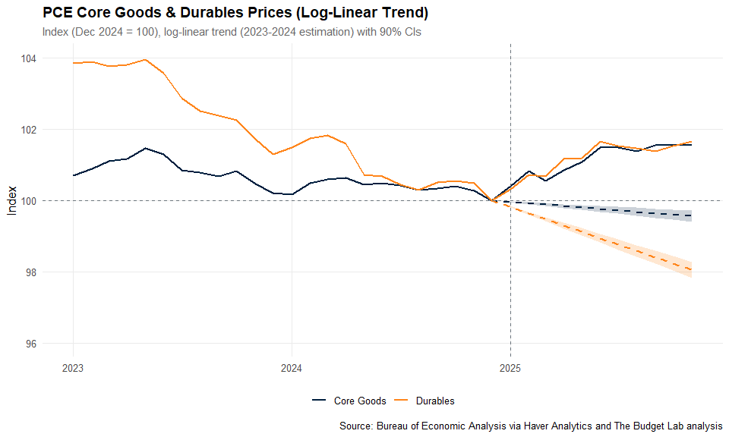
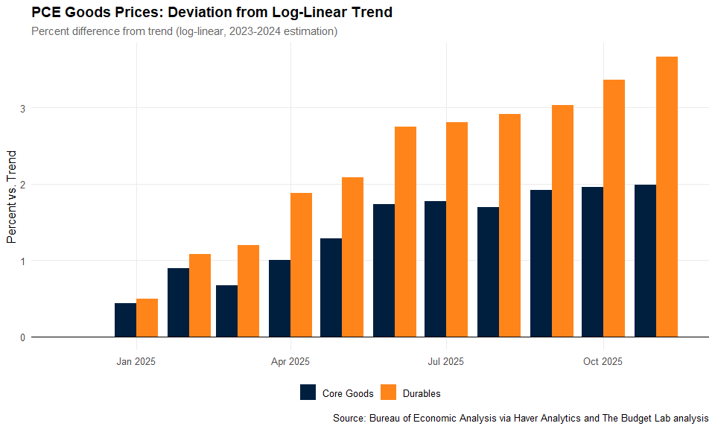

Export Data to Excel
The raw data underlying all figures and tables has been exported to: tariff_impacts_results_20260219.xlsx
This Excel file contains 21 sheets:
- Data TOC: Table of contents with hyperlinks to each data sheet
- Fig1-Fig13: Raw data for each figure (indexed values, trends, confidence intervals)
- Tables: Passthrough calculations and employment index summaries

Report generated on 2026-02-19 09:45:23.043074 using R R version 4.5.2 (2025-10-31 ucrt)

