Coursework

**By FInlay Nugent**

**12Bn**

Contents

**Analysis**

The problem 3

Computational Solution 3

Stakeholders 3

Analysis of existing solutions 3

Data Collection 8

Data Analysis 9

Success Criteria, Limitations, and Hardware Requirements 15

Choice of language 16

Analysis

# The problem

Hong Ni, my client, has enjoyed playing first-person competitive shooters since before he can remember. However, he has recently come across a problem. Due to recent technological advancements, the latest first-person shooters have become increasingly more difficult to play on his hardware. He also desires a game where there is a certain level of skill required, and a tiered game design, which would allow the player to truly test their capabilities in a fun yet interesting first-person shooter environment.

The game must have the following: a realistic and satisfying weapon mechanics system, an interesting not massively hardware-intensive graphics layout, and fluid movement systems.

# Computational Solution

Typically, we have only ever seen first-person shooters on computers, or consoles. Therefore, we can see that a computational solution is the best, if not the only one.

The simulation of accurate physics, in terms of movement of the player and the bullets/projectiles, will be efficiently executed with computational methods, especially with “Physic Materials” built into Unity. Doing these computations in any other way would be excessively time consuming. Movement of various game objects, including the player, enemy AI, bosses, and other sprites/objects will be done with other in-built methods in the unity editor.

Keeping track of simple things, such as a score of points that you achieve, will be made very easy to with variables in the code, which can also be easily altered at any time.

There will be several different maps that the player can choose from to play in, and the use of the tools Progrids and Protools, creating entertaining environments will be quick, and painless.

# Stakeholders

There are many stakeholders in this project. Hong Ni will benefit greatly from this project, as his hardware cannot run other, more graphically intensive games that are available.

Besides Mr. Ni, there are several other people who are interested in this project. For instance, several of my friends have been looking for something similar on the market, yet there seems to be a lack of simple first-person shooters. Lots of my friends do enjoy some shooters on the market, however for many they are just simply too much money. This project will be totally open-source and free of charge, so anyone can play it.

# Analysis of existing solutions

This genre of video games has a panoply of already existing solutions, many of which have been massively successful in sales. In order to fully understand the best course of action to produce a viable alternative solution, many other solutions need to be analysed. It is essential that the parts of what makes other shooter games good are used in good taste, and all negative parts be avoided or solved in this project to make a successful product.

**Solution 1: Call of Duty: Modern Warfare**

The first solution that came to mind was the ever-famous series: Call of duty[1]. This has been, for many, the first shooter that they have played, so there must be several aspects of the game design which allow the game to be easily accessible, and fun to play.

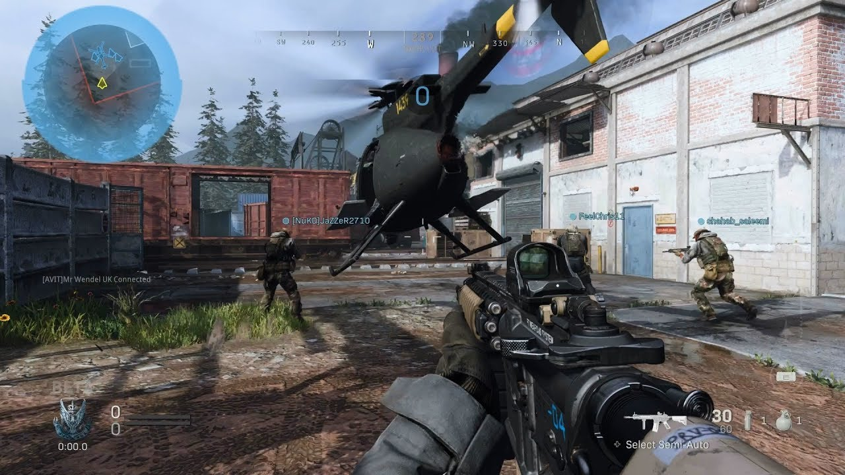

Courtesy of: “No commentary gaming” <https://www.youtube.com/channel/UCrdI6AcVLxLC7ZFJr19dlDA>

This game has a clear and simple layout, the UI elements are quite minimalist, and the overall scene is small, and not too grand. The pace of the game is quite fast, which allows the user to be entertained. The ability for the user to choose the level of detail the scenery and the weapons are in is absolutely to this game’s advantage; the hardware requirements for this game are not massive, and even relatively old systems can run this game reliably. To quote[2]:

*“The minimum requirements are as follows:*

* *OS: Windows 7 64-bit (SP1) or Windows 10 64-bit*
* *Processor: Intel Core i3-4340 or AMD FX-6300*
* *Memory: 8GB*
* *Graphics Card: Nvidia GeForce GTX 670/Nvidia GeForce GTX 1650 or AMD Radeon HD 7950 - DirectX 12.0 compatible system*
* *Storage: 175GB”*

As we can see, the OS that is needed is not a restrictive factor for the user: windows 7 and windows 10 are two of the most widely used operating systems in the world. As for the processor, graphics card, and storage, these are not particularly restrictive either. This will be a very important factor in the design of this project, so the ability to run on relatively old hardware is very important.

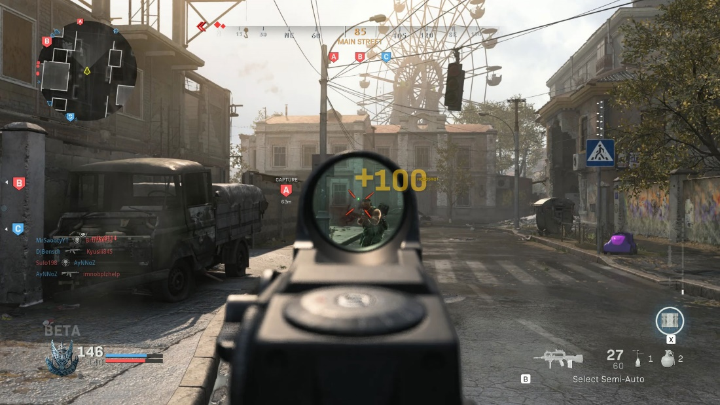

Courtesy of: “gamesradar” <https://www.gamesradar.com/call-of-duty-modern-warfare-multiplayer-review/>

In terms of the computational approach, this game is using variables to store a sort of score system, denoted by the +100 on the screen. This will be something that will be replicated in this project, as it can be very rewarding to the player, when playing the game.

This can further be built on by adding leaderboards or upgrades, which Call of Duty also has. The ability to achieve upgrades in this project will also be available, which will hopefully give the user a feeling of progressing, which is often what people enjoy most in shooter games. The use of post-processing effects in this game are used to great effect: they really add a lot to the environment, and make it feel less sterile. Unity has several in-built post-processing effects that will be used to make this project feel more realistic, and potentially make it more pleasing to the eye.

Many mechanical aspects in this game are inspiring, the smooth movement, the fluid animations, the satisfying weapon mechanics. All of these will be seen in this project, all of which will hopefully add up to an enjoyable game.

There are a couple of issues with call of duty, however. Many people seem to not appreciate the sounds of the guns, calling them “tinny” or “boring”. I hope to remedy this in my project with the use of high-fidelity sounds, which hopefully will make the weapons seem more impactful. It is also important to note that this game is as AAA title and has had the work of many hundreds of people over more than a year put into it. So, the variety in the weapons and the multitude of maps will not be seen to such an extent in this project.

**Solution 2: Murder Miners**

Murder Miners[3] is another solution. It is a multiplayer shooter, which primarily focuses on interesting gameplay mechanics and a variety of skill-based weapons. What this solution has over Call of Duty is that it is made by a relatively small company, so the final product will be more similar to this project. The look and feel of the game are quite unique, and while it doesn’t have the final AAA title polish like Call of Duty, it does have a characteristically simplistic design.

The landscapes are quite blocky, which means that they are quite easy to develop. This is one aspect I wish to implement in my game, as it will make world-building drastically simpler, while still being relatively visually pleasing.

Courtesy of: “Jforce Games” <https://jforcegames.com/>

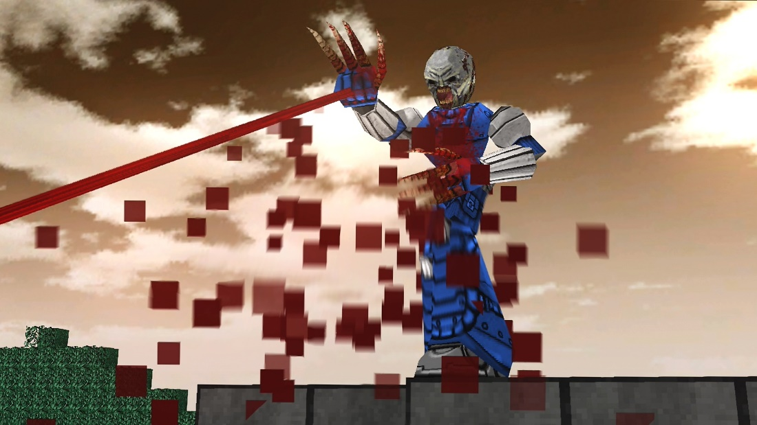The pace of the game, like many shooters, is quite fast. This will tie in very well with the fluid animations and smooth movement to make a game that is fun to play. A good movement system is vital to creating a good shooter game.

In terms of graphics, the game seems quite basic. This is because the game design team is not massive, so they did not have a lot of time to create extremely high-detail graphics. However, even though they may seem a little bit dated, the graphics do serve the game well.

Also, there is a large selection of maps in the game. In this project there will be several maps to choose from as well, as the ability to select a map to play on adds a lot of interest into the game, instead of the game becoming very repetitive in the same environment. However, the actual themes of the maps in Murder Miners can be quite varied, some being large city-landscapes, and others being alien planets. In this project, however, I intend on making all the maps to a similar sort of theme, which will make the game seem consistent.

The creators of this game, however, used their own in-house game engine to create this game. While this means that they had a greater ability to customize their game to make it as unique and interesting as possible, creating an entire game engine is very time-consuming, and will not be done for this project due to time constraints. The abilities of Unity are vast, and certainly contain everything that would be needed to make this project.

In terms of system requirements, this game is quite unique. Due to the lack of extremely detailed graphics and lightweight game engine, the requirements are very relaxed. From the Steam link previously referenced, it says:

*“The minimum requirements are as follows:*

* *OS: Windows*
* *Network: Broadband Internet connection*
* *Memory: 1 GB RAM*
* *Graphics Card: ATI Radeon X1300-X1950, nVidia Geforce 6 et 7*
* *Storage: 250MB required”*

These requirements are very low, and as the game came out in July 2014, even low performance machines from 6 years ago would still contend quite well with this game. This basically means if the computer has a graphics card it will be able to run this game. For this project, it is essential that even low performance systems can run it. With the use of simple level design and the not extremely high-quality graphics that this game has, it is likely the project will run very well.

**Solution 3: Hotdogs, Horseshoes and Hand grenades (VR)**

H3VR[4] is a game that is supposed to model guns as accurately as possible. Every single bullet, magazine, and attachment are faithful to their real-life counterparts to an extremely high degree of accuracy. This game has been my main inspiration to create a first-person shooter, as I have played this game for a long time.

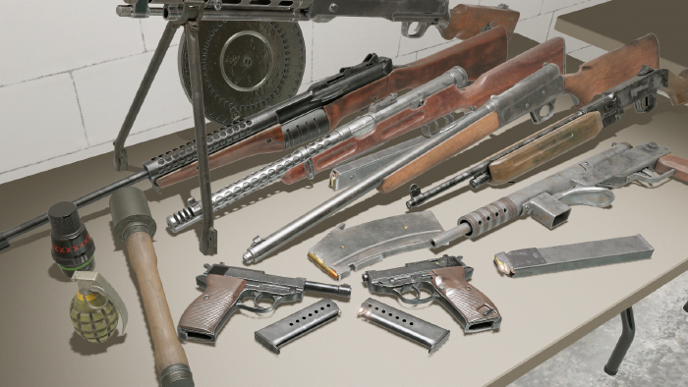The one difference between H3VR and this project is the fact that H3VR is in VR. I am not intending to build this project in VR, as VR development is difficult and requires the user to have an expensive headset. On top of that, in order to use a VR headset effectively, you need a relatively high-end machine. I am taking massive inspiration from the game in this project, as I have gotten many hours of enjoyment out of it, although I won’t be using VR in the project.

In terms of the core game features, this game seems to do everything right. The movement is very fluid, the weapons mechanics are basically a recreation of real life, and the graphics are quite satisfying. However, most of the game's mechanics are built for VR, and the fact of the matter is that those mechanics would likely not port well over into normal, flat screen games. So instead of completely copying everything about the game, the only inspirations will be the weapon mechanics and the overall design and layout of the game.

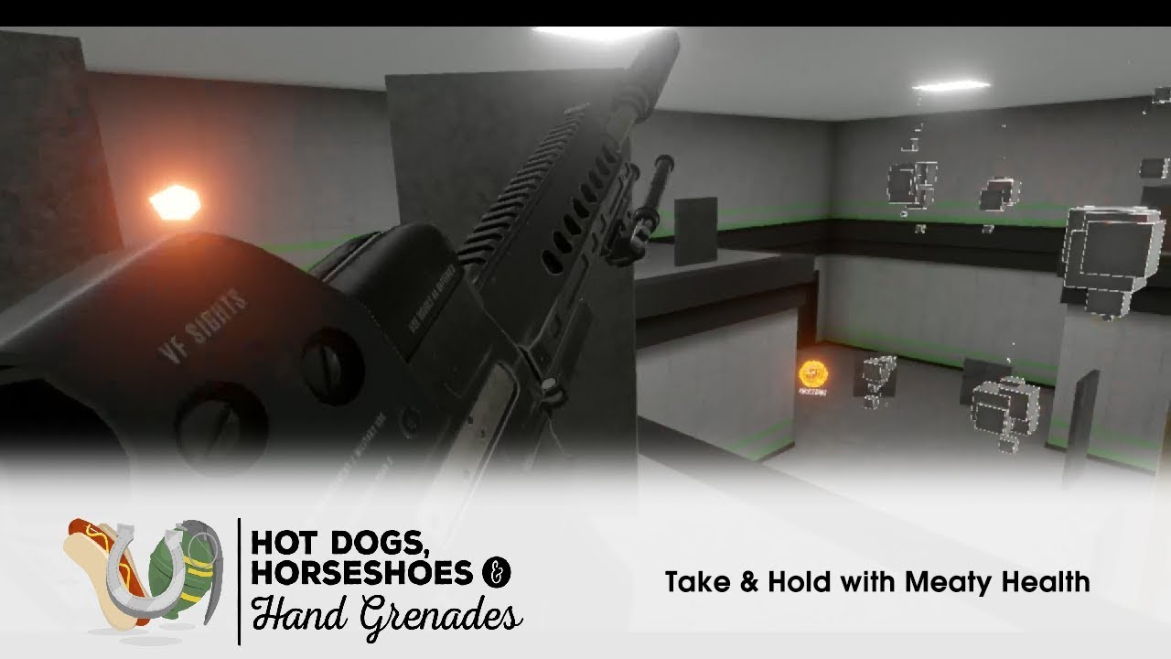

As shown in this picture, the style of the graphics is quite simple, like Murder Miners. I think for a small game developer, the best course of action is to use simple graphics like these.

H3VR was created in Unity as well, so it really showcases that such a solution can be executed to a high degree with the game engine.

Also, the detail to which the guns are actually modelled in this game is not going to be feasible in this project, due to the complexity and the fact that VR allows for a greater level of control/manipulation of handheld objects than a mouse and keyboard. Therefore, the weapon mechanics that we will see in the project will be quite simplified.

# Data Collection

In order to create the best solution possible with the given amount of time, it is important that I find out exactly what needs to be in the solution. There will 2 methods that I will use to collect the data that I need:

**Questionnaire**

This is going to be a small set of important questions based on what the solution will contain and what the stakeholders want from the solution. I will use an online resource to create a questionnaire that is easy to distribute to people, which will allow for a greater sample size, and then hopefully a better picture for what needs to be done for the solution. A common problem with questionnaires is that the fixed answers can be misleading, or not allow the user to give their whole opinion on the matter. To combat this, I will allow for a small box where the people doing the questionnaires can put any further comments they may wish to make.

I will be mainly intending to send this questionnaire to people whom I know as interested in the final project, who may want to play the game, or who are interested in games in general. Once I have received an adequate amount of responses, I will analyse the data, and determine what the majority of the respondents want.

**Interview with the client**

Of course, the main client has the opinion that matters the most in this situation. So therefore, I will take further measures than just a questionnaire to make sure he gets what he wants. This interview will comprise of me asking specific questions based on ideas that might be needed in the game, as well as some insight from the client on what his specific demands are.

This will be beneficial over the questionnaire because it will let me see exactly what the client wants, and then I can give that opinion a bit more weighting over what is going to happen with the project. Due to it being more personal as well, I think I will be able to extract more information about what he wants for the game than with a questionnaire.

# Data Analysis

**Questionnaire Introduction**

I used Microsoft’s Forms to create an online questionnaire that was easy to distribute among people. It was very easy to setup and use, and I managed to create several different questions that are relevant to the project. I tried to only use questions that would benefit the final product and give a better picture of what the stakeholders want from the project.

*Here is the setup of the questionnaire:*

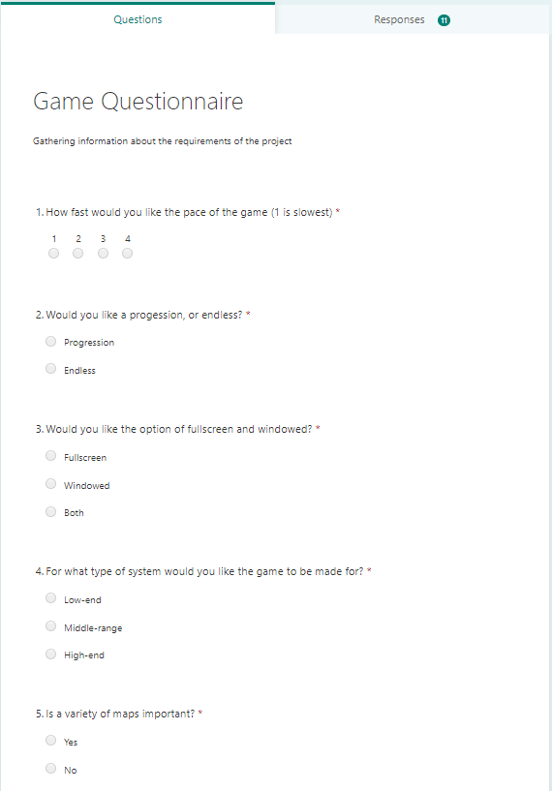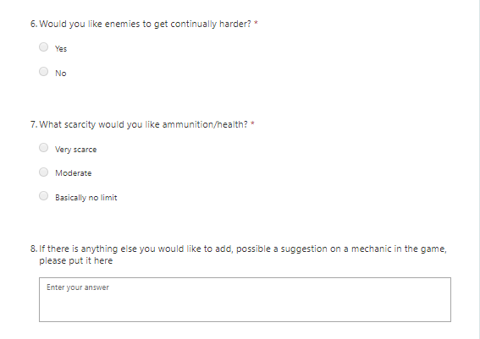

*Here are the results of the questionnaire:*

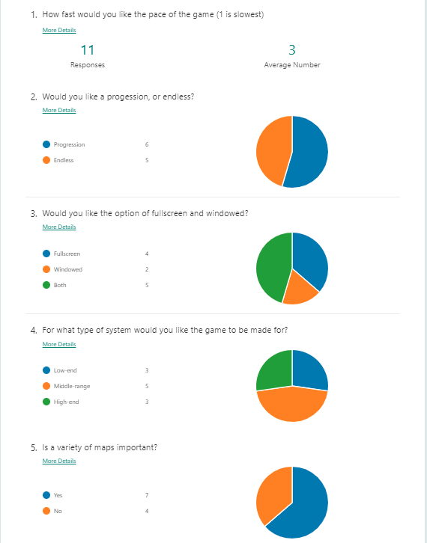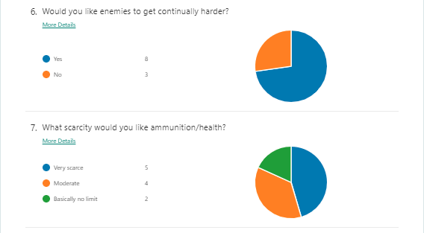

*Note: While there were several responses to the last question, none of them were particularly constructive or contained any useful ideas to be added into the game*

**Questionnaire Analysis**

Although there was some disagreement about some of the questions in the population, there do seem to be many trends in the data.

**Question 1**

The general result of this is question shows that people want the game to be relatively fast, but not extremely fast. I think this is more in line with a game like H3VR, which is relatively fast paced, but is not also excessively fast.

**Question 2**

For this question, there is nearly a 50-50 split between whether the game should have a system of progression, which I find quite strange. For me, a game needs some level of progression to be able to be interesting. As we will see later, the main client Mr. Ni agrees with me in that respect.

**Question 3**

This question was about the user’s preference for a windowed and full screen option. While many voted for just full screen, a lot also voted for the option for both. As this is not particularly difficult to implement with the Unity engine, I have decided that it is best just to add the option anyway.

**Question 4**

When asked about how intensive they want the game to be, many people went for the mid to low range. This means that there is a considerable amount of people who would like an accessible solution to this problem, and therefore a simpler graphics/physics system in the game will be appreciated. While performance is key, quite a few people have mid-high range computers, so this does give us leeway in the amount of effects / other performance intensive aspects in the game.

**Question 5**

The answer to this question was also quite split. Many people would like some variety, while others aren’t massively worried about the types of maps there are available. I think that this means a few maps of similar style, as aforementioned, is the best course of action.

**Question 6**

The result for this question is clear: people want the challenge of the game to increase as it goes on.

**Question 7**

This question has shown that people want scarcity of things to be a factor in the game, rather than it being an infinite slaughter. This project will need fine tuning to make sure that the level of scarcity is bearable, and it needs to be certain that even if you completely run out of ammunition, there is still the ability to fight the enemies (possibly with a melee weapon).

**Summary**

So, in summary, I believe this questionnaire has revealed many things:

1.The game needs to be relatively fast

2. Some system of progression

3. Windowed and full screen options

4. The game should perform well for a low to medium performance computer

5. A few well engineered maps

6. Enemies get harder over time

7. Quite scarce resources

**Interview Introduction**

The purpose of the interview with the main client is to identify which parts of the game are more important than others. With the help of having a real time conversation with Mr. Ni, I will be able to identify which parts of the solution are required and which are optional. Below is a copy of the conversation I had with Mr. Ni:

|  |  |
| --- | --- |
|  | Started: 19:41 24th March 2020 |
| Me | Hello Hong! I was wondering if you could answer a few questions about the first-person shooter game that I am creating |
| Mr. Ni | Sure, what would you like to ask? |
| Me | I would just like to get to know more about what you want from the game. In terms of the questionnaire that I got you to do, can you remind me of what you answered for the questions? |
| Mr. Ni | ...[Reflected in the questionnaire summary] |
| Me | Ok, that’s good. So, in terms of the difficulty, how hard do you want the game to be? |
| Mr. Ni | I’m not sure… I would like a game that I can relax while playing, but at the same time I occasionally want a challenge when I play games. |
| Me | How about a system where you can change the difficulty of the game? |
| Mr. Ni | Yeah that would be good. I would like it to be quite a large area of difficulties, where the easiest is very easy, and the hardest is very hard [sic]. |
| Me | Sure. Also, I remember you telling me a while ago that your graphics card broke, would you like the game to be accommodating to that? |
| Mr. Ni | A few months ago my computer randomly started to crash out completely when playing intensive games. This was really frustrating, but it was also really annoying how the games weren’t running as well as they used to. So after this happened a few times, and after looking into the system specs and doing diagnostics, I came to the conclusion that my graphics card exploded. I’ve recently also become destitute as well, so I most likely won’t be able to buy another good graphics card for a while. |
| Me | Do you have another graphics card to use in the meantime? |
| Mr. Ni | Yeah, but it’s just a GTX 650, which is basically unusable with a lot of the games I used to play. So for me it’s pretty important that the game can be ran on really old hardware. |
| Me | In terms of the performance of the game, I think when using the Unity engine, making sure that the physics and graphics aren’t extremely demanding will be quite easy. I will make sure that it will run on your computer. |
| Mr. Ni | That would be great! |
| Me | I assume you have a little bit of space left on your hard drive though? |
| Mr. Ni | Oh yeah, as long as its not over 300 GB I will be able to keep it on my computer. |
| Me | It won’t be too large, most likely under 500 MB, so you should be fine. |
| Mr. Ni | Ok that’s fine, but what about RAM? Do you think the game will need a lot of a RAM? I’ve only got like 8 GB. |
| Me | Don’t worry about RAM, this project will be quite lightweight, so you probably won’t need any more than 2 GB to play it. |
| Mr. Ni | Nice. |
| Me | You also said that you would like some sort of progression, would you elaborate on what type of progression you would like to see? |
| Mr. Ni | Well, for me, I don’t need a huge amount of progression. As long as I can roughly tell the game is actually progression, it’s fine. I guess for ways of showing it, maybe add some different weapons. As you go along the game you can unlock these new weapons, which are a lot better than previous ones, and maybe at the end one really interesting weapon, like a laser gun or a rocket launcher or something! |
| Me | Ok, I appreciate your passion. Well I think that’s most of what I wanted to ask you really. Is there anything else you want to tell me before the end of the interview? |
| Mr. Ni | No not really. Thank you for making this game for me, I haven’t been able to play any first person shooters for months since my graphics card blew up. |
| Me | No problem, talk to you soon. |
| Mr. Ni | Bye! |
|  |  |

**Interview Analysis**

The interview didn’t add a massive amount to the list of things that need to be added, although it did add some extra bits of information that may be helpful, these include:

1. A way of changing the difficulty
2. Preferably quite small in terms of file size
3. A concrete progression system, with new guns being given to the player as they progress. Also, an ‘endgame’ sort of weapon like a laser gun/rocket gun right at the end of the game.

# Success Criteria, Limitations, and Hardware Requirements

**Criteria**

*Essential:*

1. *A progression in terms of difficulty*
2. *Small File sizes*
3. *Some sort of progression to better and better weapons*
4. *Simple graphics design*
5. *Interesting and fun weapon characteristics*
6. *A few good maps of similar design*
7. *The ability to change the difficulty on the enemies*
8. *Feeling of scarcity in resources*
9. *Ability to choose full screen/windowed*

*Desirable:*

1. *Ability to save the game*
2. *Items around the world to pick up and use*
3. *Ability to play at any resolution*

**System Requirements**

* OS: Windows (Unity currently only supports windows)
* Graphics card: GTX 650 or equivalent (To render graphics)
* Storage: Roughly 500 MB (To store game)
* Memory: At least 2 GB of RAM (To run game)
* CPU: Any i3 or i5 or equivalent

**Software Requirements**

There are no software requirements.

**Limitations**

There will likely be no multiplayer as multiplayer will be difficult to integrate into the game in the given amount of time, and multiplayer slightly defeats the purpose of the game as a simple shooter.

# Choice of language

**C# And Unity**

I have chosen Unity as the game engine of choice for my project. There are several reasons why I have chosen unity over other similar game engines. One of the main reasons is that I have a bit of experience with unity as a program, as I have spent quite a while getting to know the components of it. Also, Unity allows you to create detailed, 3D play spaces which may not be possible with other engines that mainly deal with 2D spaces.

In terms of language, I had few options. C sharp is a great language, however, it is by far the most widely used language with Unity, as most of the scripts you will make with be in the language. Also, I have had quite a bit of prior knowledge of the language, and often use it for other projects.

1. <https://www.callofduty.com/modernwarfare>
2. <https://www.techspot.com/news/82281-call-duty-modern-warfare-system-requirements-revealed.html>
3. <https://store.steampowered.com/app/274900/Murder_Miners/>
4. <https://store.steampowered.com/app/450540/Hot_Dogs_Horseshoes__Hand_Grenades/>