5. Human Approval Points

5.1 Human-Approval Swimlane Overview
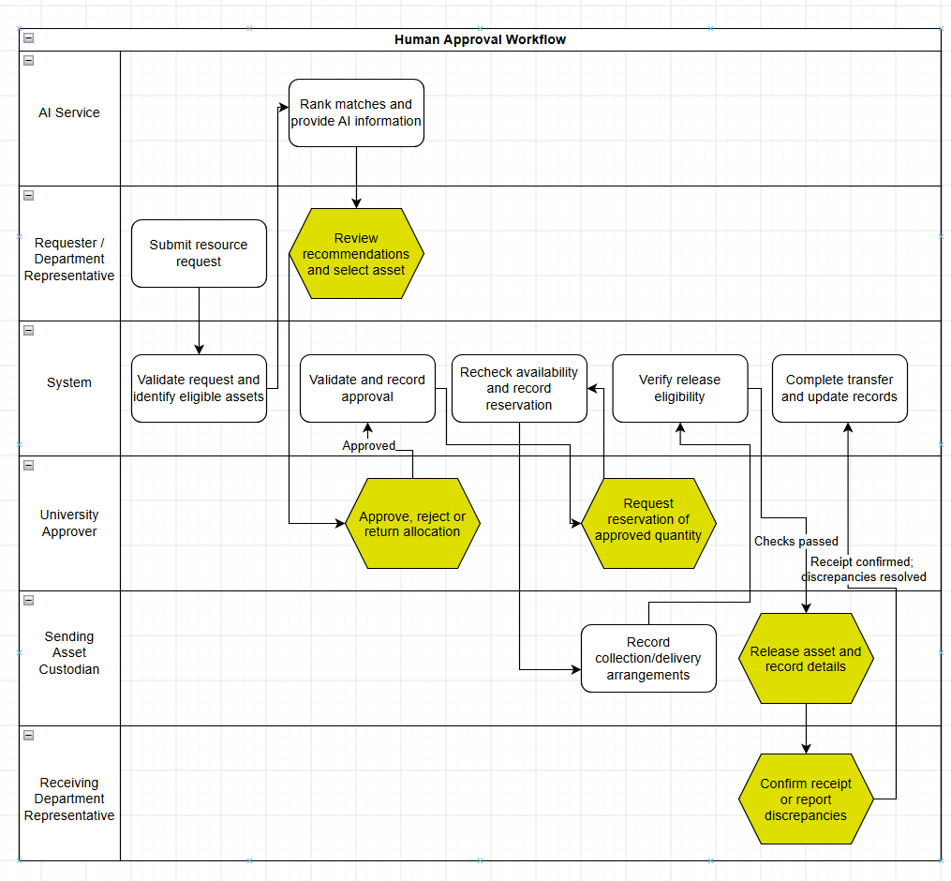
Figure 5.1: Human Approval Workflow

This stage allows the AI to provide a score, reason, and confidence level. Where AI is not available or appropriate, the user can perform a manual search and select relevant assets. Approval is still required.
Approval ensures you cannot approve yourself and prevents inappropriate/ineligible allocations. Reservations will only allow you to reserve the correct amount of approved items; they also have a time limit. Safety/Inspection restrictions and duplicate releases are prevented.
Receipt will record how much you received, what condition it was in, and where it went. The item will be in a Registered/Unpublished status or Unavailable status depending on any restrictions.
The flow shows the successful route through the process; any request that is rejected or returned will not go through. Any yellow hexagons are points where a person will need to review/approve.

5.2 Human Approval and Review Points

This is achieved by distinguishing between suggestions provided by AI, human approval, and logging of the execution of the action. AI can recommend classification, matches, actions, or summary reports, but the authorized person will still be accountable for reviewing them. The system validates the permissions and workflow prerequisites before accepting the decision.

Each logged decision will indicate the user who made the decision, time and date of the decision, and the associated record. Any AI decision will identify the output and the model/service used.

Decision point | Responsible role | Information presented | Reason for human control | Recorded outcome
Review an AI classification | Asset Custodian | Asset details, suggested category/tags, explanation and confidence or missing-information warning | Incorrect classification can affect search and matching | Accepted, corrected or rejected suggestion; confirmed values and override reason where applicable
Review a recommended match | Requester or authorized Department Representative | Requested specifications, available quantity, asset condition, match score, explanation and uncertainty | The requester must judge whether the proposed asset meets the intended need | Selected or rejected recommendation and any override reason; selection does not constitute approval
Approve, reject or return a request | University Approver | Request, proposed allocation, quantity, availability, condition, safety restrictions and any AI explanation | Allocation and transfer require authorized approval; users cannot approve their own requests | Decision, reason, approver and timestamp
Reserve an approved allocation | University Approver | Approved request, selected asset, eligible quantity and reservation expiry | The allocation must follow approval and avoid conflicting reservations | Linked reservation, reserved quantity and expiry; remaining eligible units stay available
Release an asset | Sending Asset Custodian | Valid approval, allocated quantity, handover arrangements, condition and safety/inspection information | Authorization alone does not prove that physical release occurred | Released asset and quantity, releasing user and release date/time
Confirm receipt | Receiving Department Representative | Transfer record, delivered quantity, condition and destination | Ownership and custody changes require confirmation of delivery | Receipt details and discrepancies; completion only after discrepancies are resolved
Authorize a controlled repair or life-cycle action | University Approver within delegated authority | Asset condition, inspection/history, proposed action, available cost information and any AI recommendation | Repair, refurbishment, donation, recycling, retirement and disposal can have financial or irreversible consequences | Approval or rejection and reason; staff record actual execution separately
Clear an asset for return to use | Authorized inspection staff and Asset Custodian | Inspection findings, maintenance outcome, resulting condition and remaining restrictions | Repair completion does not automatically establish that an asset is safe and available | Authorized condition assessment followed by the Custodian’s availability confirmation
Confirm an assistant-prepared request | Requester or authorized Department Representative | Complete draft request, including specifications, quantity, purpose and required date | AI may misunderstand the user’s intended request | User confirmation followed by permission/field validation and standard submission
Review an AI-generated report summary | Authorized report reviewer | Draft summary, underlying calculated report, reporting period, sources and assumptions | Generated statements must agree with verified records before official use | Accepted, edited or rejected summary and the reviewed version

6. Security, Data Storage and Recovery

6.1 Authentication and Access Boundaries
Users will need to authenticate to gain access to any secure functionality. The server will verify users role, department and if the user has permission to access the requested record. This is done regardless of whether a user wants access directly to an endpoint or has modified the record ID. When a user logs out their session will be invalidated.
The interface will interact with the application server. The application server controls access to the database and external AI calls. The AI services will only have access to the correct fields required to complete their task and cannot directly authorise requests or make changes to business records. Authorisation and handing over are outlined in section 5.
Related requirements: FR-01–FR-03; NFR-SE01–NFR-SE03 and NFR-SE10.

6.2 Role-Based Permissions
Permissions are denied unless explicitly granted. A user holding multiple roles still cannot approve their own request.

Role | Permitted access and actions | Main restriction
Requester | Search published assets; submit, track and update their own requests where the status permits. | Cannot publish assets or approve requests.
Department Representative | Manage authorized departmental records and requests; confirm receipt for their department when designated. | Cannot authorize their own request or an unapproved transfer.
Asset Custodian | Register and update assigned assets; publish eligible surplus assets; arrange and record approved releases; record authorized inspections. | Cannot approve requests or release assets without valid approval.
University Approver / Business Administrator | Review requests; approve, reject or return them; reserve approved quantities; authorize controlled lifecycle actions within delegated authority. | Cannot self-approve or act outside delegated authority.
Procurement Officer | View authorized procurement information and record or verify assigned purchasing information. | Cannot approve transfers without a separately assigned approval role.
Finance Officer | View authorized financial records; record or verify assigned costs and review financial reports. | Cannot change unrelated asset or approval records.
Maintenance Staff | Record assigned inspections, repairs, progress, costs and resulting condition. | Maintenance completion does not independently authorize publication or transfer.
Sustainability Officer | Review sustainability reports and verify authorized calculation inputs and assumptions. | Cannot authorize transfers or disposal without a separately assigned approval role.
System Administrator | Manage accounts, approved role assignments, configuration, technical logs and recovery operations. | Technical administration does not automatically grant business approval authority.
AI Service | Produce recommendations and summaries using approved inputs. | Cannot approve, reserve, release, confirm receipt or independently modify business records.

Procurement and Finance are separated to fit the list of roles for the project. They are grouped together under Procurement and Finance Officer in the SRS. The University Approver reflects the business authority. This role is different from the System Administrator.

Related Requirements: Sec 2 of SRS, FR-01 to FR-06, BR-08.

6.3 Audit Records

All major changes will be logged within the system. This includes changes to assets, requests, reservations, approvals, transfers and permissions. Within the log it will show:
- Responsible user or service identifier.
- Action and affected record identifier.
- Timestamp.
- Previous and new values or status, where applicable.
- Decision or correction reason, where required.

If the decision was made using AI then the output, model/version, related records and if they were accepted, edited or rejected by the user will be logged. If there has been an override then the reason will be shown.

Only authorised staff can view audit trails. Application users cannot make any changes/deletions. Passwords, tokens and API keys are not stored.

Related Requirements: FR-34, FR-48, FR-52. NFR-SE06, NFR-AI08.

6.4 Data Storage & Security

The database stores all related data relating to users, departments, assets, requests, reservations, approvals and transfers. It also stores historical and reporting data. Any related changes will be processed using transactions to ensure that if something goes wrong during the process then the transfer/reservation will not be partially completed. Quantity and reservation changes are done atomically to avoid double allocations.

Passwords are stored as salted hashes. All network activity is done over HTTPS. Secrets are not stored in the source code or on GitHub. The server will check that mandatory fields, types and allowed values are correct before making any changes. Demo data will be used.

External AI requests will only have a set list of fields that can be sent. Search and reporting functionality will still be available if the AI services are down.

Related requirements: NFR-SE04–NFR-SE10; NFR-Q04–NFR-Q05; NFR-AI10.

6.5 Backup and Recovery

The following is the proposed prototype backup design:

Item | Design
Backup contents | Database records, audit history and any stored supporting documents.
Frequency | Daily during active development and before database migrations.
Location | An access-restricted team backup folder separate from the running application, with encryption at rest. Secrets are stored separately.
Responsibility | The System Administrator role controls backup and restoration.
Recovery procedure | Restore the latest valid backup into a separate environment, verify it, then resume application use.
Restore test | Restore a backup and verify login, record counts, linked asset/request/transfer records, statuses and audit history. Record the result.

A failed save rolls back the affected transaction. Backup restoration is used for wider data loss or corruption; it does not replace transaction handling.
Related requirements: NFR-Q05 and NFR-SE06–NFR-SE07.

7.4 Transfer Approval
This screen allows the University Approver to review a proposed allocation, record a decision and reserve the approved quantity after approval.
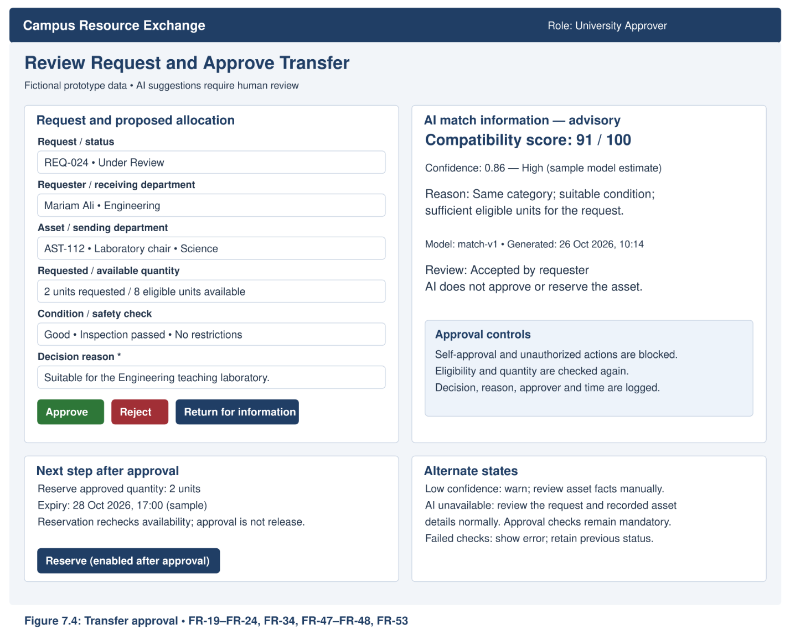
Figure 7.4: Transfer Approval

7.5 Maintenance Tracking
This screen allows Maintenance Staff to record repair progress and costs, while keeping repair completion separate from inspection and custodian-confirmed return to availability.
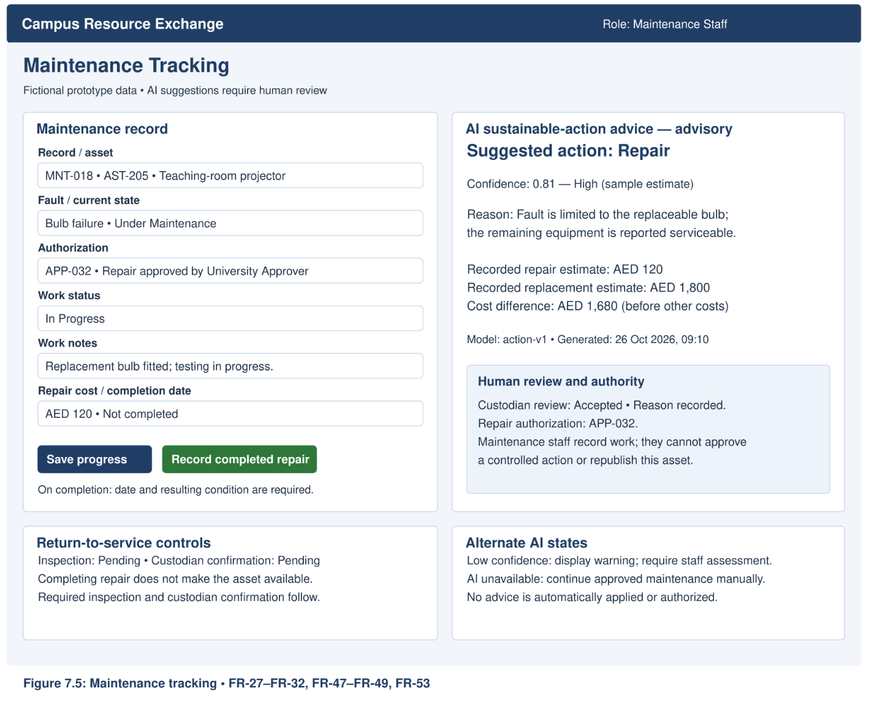
Figure 7.5: Maintenance Tracking Screen Mockup

7.6 Sustainability Dashboard
This screen presents calculated sustainability measures, their methods and sources, and an AI-generated interpretation for human review; calculated results remain available when AI is unavailable.
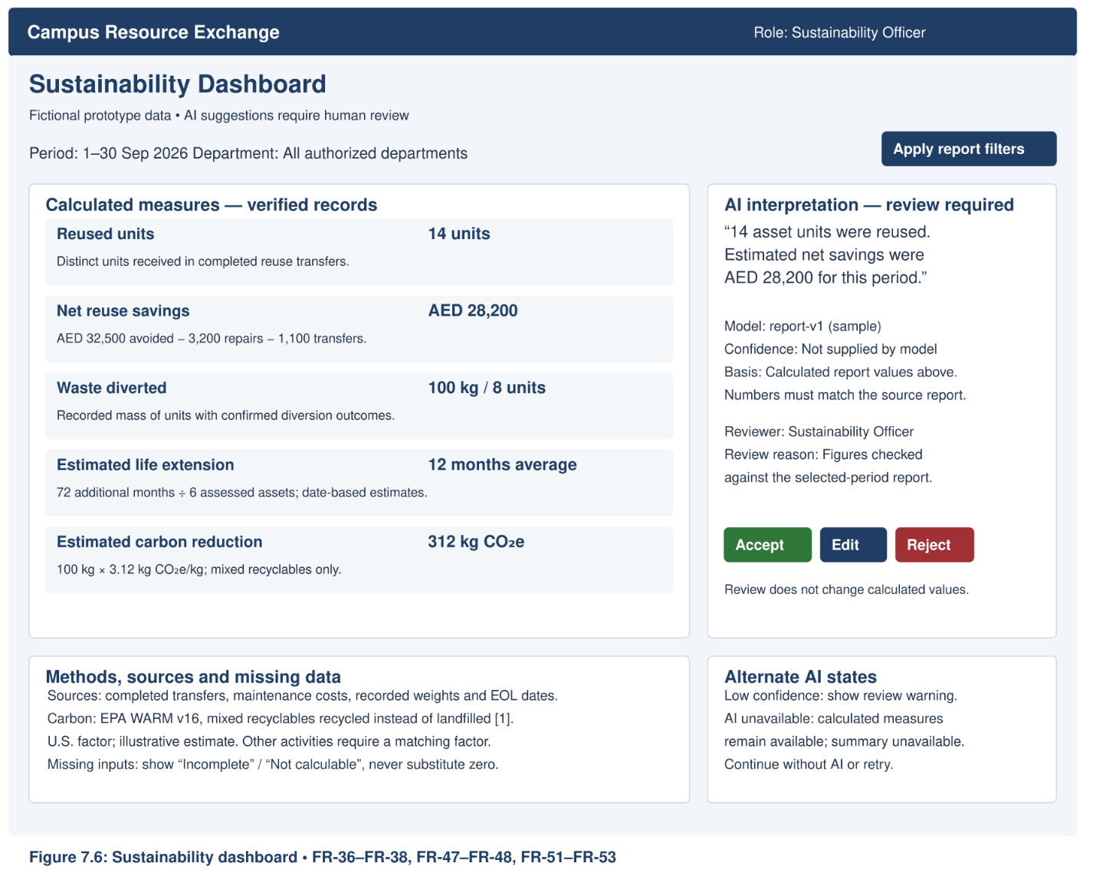
Figure 7.6: Sustainability Dashboard Screen Mockup

The eight user-interface mockups follow consistent design principles to support usability, accessibility, and human control. The screens use fictional prototype data and display AI-related information and fallback options where applicable. Table 7.1 summarizes the shared design rules applied across the mockups.

Table 7.1:
Shared User-Interface Mockup Design Rules
Rule | How It Is Applied
Consistent Layout | Screens use a consistent header, navigation menu, content layout, and visible user-role information.
Human Control | Authorized users can review, confirm, accept, edit, or reject relevant actions and AI suggestions. AI does not automatically approve or execute consequential actions.
AI Transparency | AI-assisted screens display relevant suggestions, explanations, confidence information, and model/version details where applicable.
AI Failure Handling | When AI is unavailable, users receive a clear message and can continue using the relevant manual functions or standard reports.
Accessibility | Screens use labelled fields, readable text, sufficient contrast, keyboard-accessible controls, and text labels alongside status colours or icons.
Sample Data | All displayed records and calculated examples are fictional prototype data, not actual university results.

8.3.3 Approval and Transfer Sequence Diagram
This sequence begins after a request has been submitted with a proposed asset allocation. It shows approval, reservation, release and receipt confirmation, including failed checks and receipt discrepancies. Cancellation and reservation-expiry rules are described in Section 8.5.
Related requirements: FR-19–FR-26, FR-33 and FR-34.
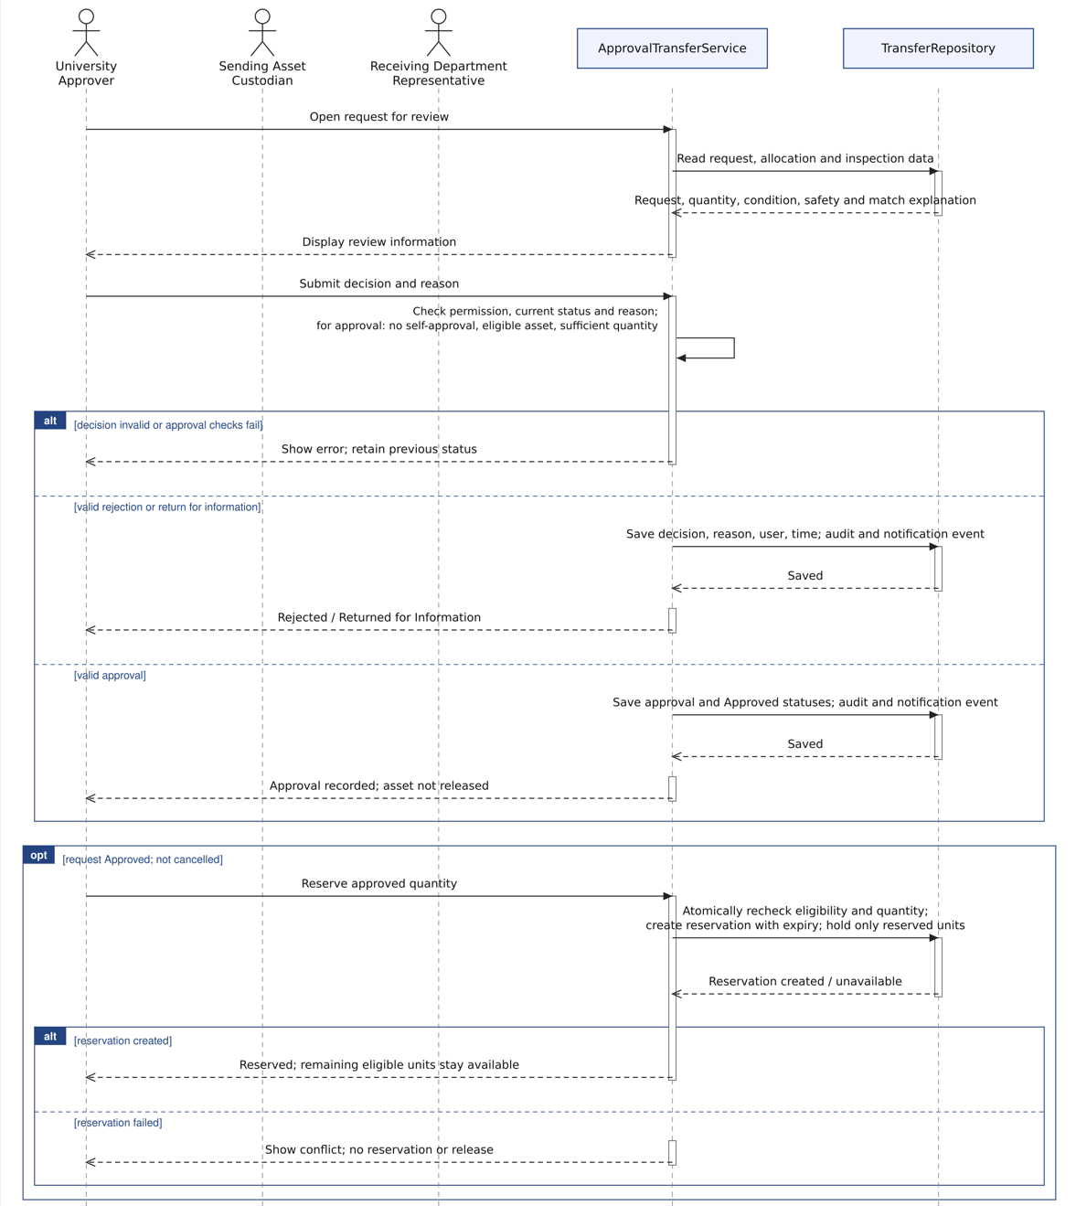
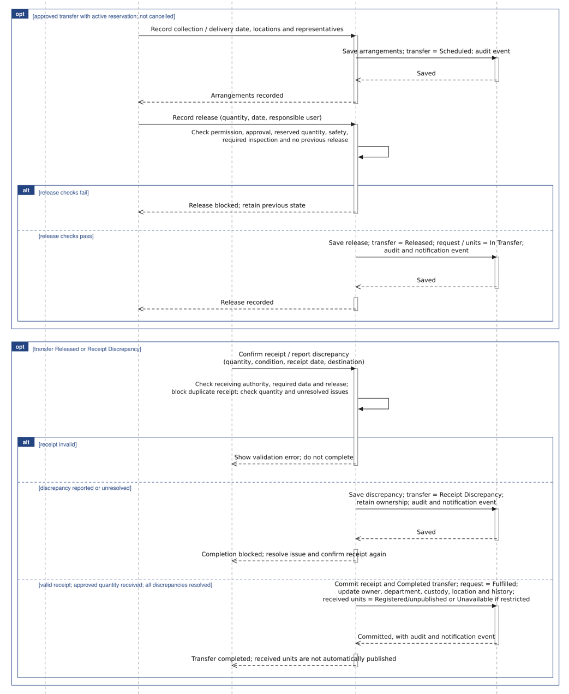
Figure 8.3.3
Submit Requests,Approvals, and Transfers

Precondition: a submitted request has a proposed asset allocation and user is authenticated.
Repository writes are transactional: a failed write rolls back, reports an error and retains the last valid state.
Solid arrows: calls, dashed arrows = replies. Service checks apply on every protected action. AI cannot authorize transfers

8.4 Activity Workflow

The exchange process starts by submitting a request. Eligible matches will appear for review or an alternative search can be done manually if AI is not available. The University Approver will review the proposed allocation and approve, decline or ask for more information. Once approved, the request can be reserved and the system will verify that items are still available.

The Asset Custodian (sending) will record the transfer details. They will release the asset once it has been approved, the quantity has been confirmed and safety checks passed. The Department Representative (receiving) will confirm they have received the item or report any discrepancies. Once they have received a valid confirmation and resolved any discrepancies the ownership, custodian, department, location and history can be updated. If the item is restricted then the units will remain unpublished/unavailable. See Sections 5.1 and 8.3.3 for examples of responsibilities and interactions during the exchange process. The rules around the lifecycle of the asset are described in Section 8.5.

8.5 Life-Cycle (State) Descriptions

8.5.1 Asset Lifecycle
An asset begins as Draft and becomes Registered when its record is saved with a unique identifier. Registered assets remain unpublished until an authorized user publishes them as Available.
Approved requests may reserve eligible asset quantities. Only the reserved units are held; any remaining eligible units remain available. Release moves the allocated units to In Transfer. After confirmed receipt, the receiving units become Registered/unpublished, or Unavailable if restrictions apply. Receipt does not automatically publish them for another exchange.
Assets requiring assessment or repair enter Under Inspection or Under Maintenance. Return to availability requires an acceptable condition, any required safety inspection and custodian confirmation. Assets that cannot be repaired become Unrepairable. Retirement, donation, recycling and disposal require authorized approval, and their records remain available for history and auditing.
The permitted asset transitions follow Phase 3 SRS Section 3.3. Invalid transitions are rejected without changing the record.

8.5.2 Request Lifecycle

The request life-cycle is shown below. Once a request has been prepared and submitted, it will go into review. If a request is returned then amendments need to be made and then the request re-submitted. When a request times out of reserved it will go back to approved so that availability can be re-checked. Any discrepancies in receipt will leave the request in Transfer until they have been resolved.

A request can only be cancelled in the stages indicated in the diagram above. This will also cancel any associated reservation. Requests which have been rejected cannot be reopened and a new request will need to be created.
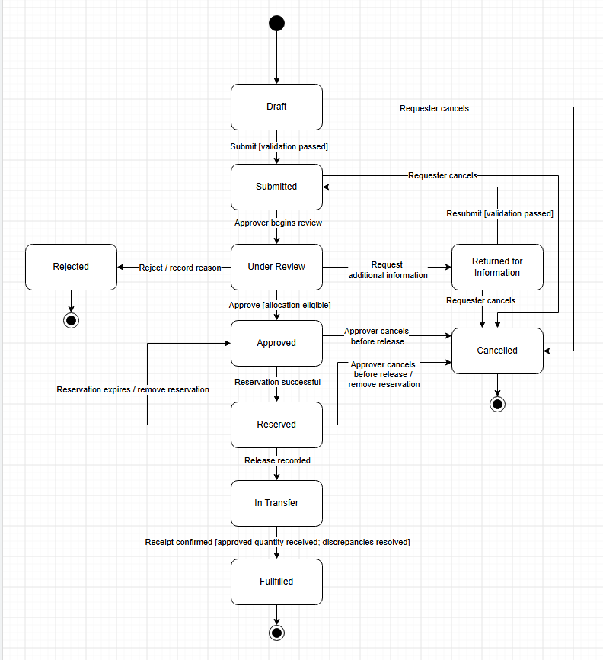
Figure 8.5.2: Request State Diagram

8.5.3 Approval Lifecycle

Below is a state diagram showing what happens when a request is approved, denied or asked for more info after being submitted. If a request is resubmitted it goes back into the review queue.

Only an authorised University Approver can approve/deny. You will not be allowed to approve yourself. In order to approve you must have an appropriate asset with enough stock available. Once approved/denied the reason for your decision, name of the approver and date/time of approval will be recorded. This does not mean that the asset has been booked, issued or received, just that the decision has been made to allow the allocation to go through.

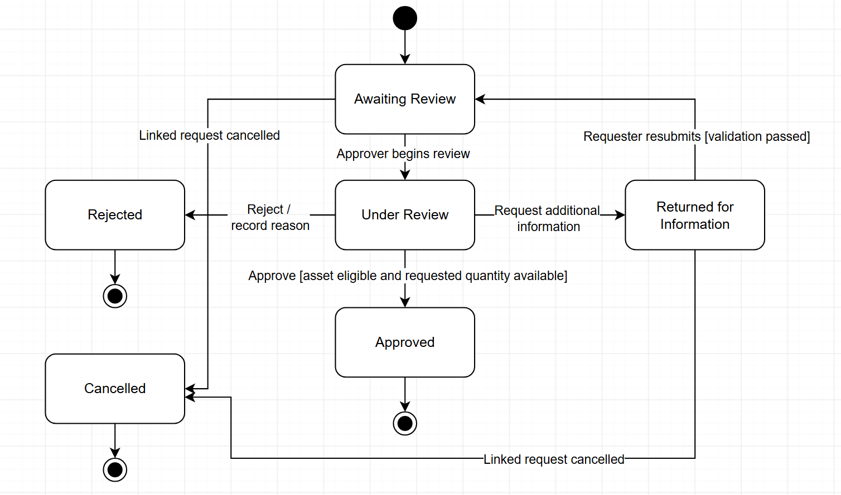
Figure 8.5.3: Approval State Diagram

8.5.4 Transfer Lifecycle
The following shows the state diagram of the transfer process. Once approved, the sending custodian will note any arrangements and release. The receiving Department Representative will confirm receipt or report discrepancies. The University Approver may cancel an approved or scheduled transfer before release, but once released any issues will follow the same process as confirmation and discrepancies.
Once complete (confirmed receipt, discrepancies resolved), the system will update the ownership, department, custody, location and asset history. Any assets received will be unpublished or restricted (as per section 8.5.1).
Related requirements: Phase 3 SRS Sections 3.2–3.5; FR-20–FR-26, FR-29, FR-32 and FR-34.
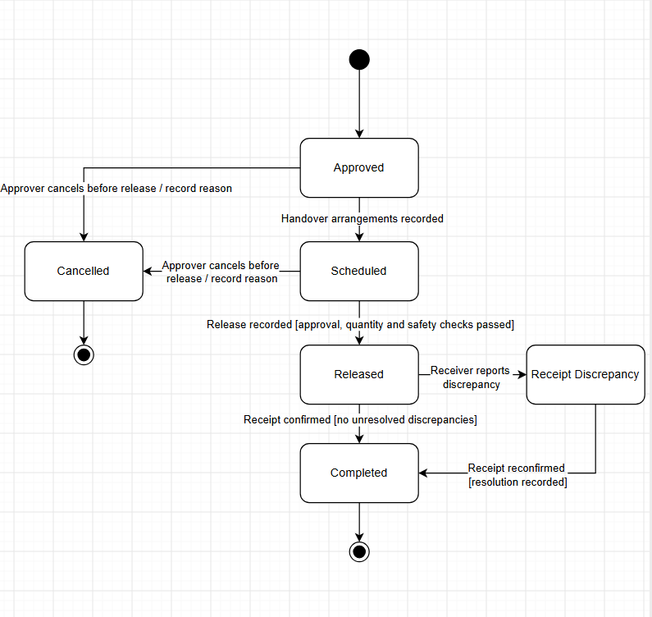
Figure 8.5.4: Transfer State Diagram

8.12 Sustainability Calculations
Financial and sustainability figures are calculated based on the data captured. The AI may summarise the figures but will not calculate them. Each figure will include the unit of measurement, inputs, source, calculation method and assumptions.

Table 8.12:
Sustainability Calculations

Measure | Calculation and counting rule | Unit
Reused assets | Count the number of unique asset units that were successfully reused via a completed transfer. Excludes incomplete, cancelled and unresolved transfers. | Asset units
Repaired assets | Count the number of unique asset units that have had a completed maintenance log showing they were repaired. | Asset units
Assets returned to service | Count the number of unique asset units that were repaired or refurbished and had an acceptable inspection result and were confirmed by the custodian to be back in service. Completed repairs are not enough.  Asset Units | Asset units
Waste diversion | Count the number of unique asset units that had an outcome logged to divert it from being disposed of. Sum up the total weight of these items. Excludes normal disposal. Not all transfers will be waste diversion. | Asset units; kg
Estimated asset-life extension | Revised expected end-of-life date after reuse, repair or refurbishment minus the previously recorded expected end-of-life date. Convert the difference to months using days ÷ 30.44. Report per asset. | Months
Avoided purchase costs | Sum documented replacement unit costs × quantities for completed reuse events confirmed to replace a planned purchase. | AED
Net reuse savings | Avoided purchase costs − associated repair costs − associated transfer costs. | AED
Estimated carbon reduction | Eligible material weight × an avoided-emission factor matching the material and activity. | kg CO₂e
Reuse rate | (Number of unique asset units successfully reused through completed transfers during the reporting period ÷ Total number of eligible asset units made available for reuse during the same period) × 100. Exclude cancelled or incomplete transfers from the numerator. | %

Reuse rate is calculated for a defined reporting period using the number of eligible asset units made available for reuse as the denominator. If the denominator is zero or unavailable, the reuse rate is reported as “Not calculable” rather than 0%.

Carbon and factor source

Estimated carbon reduction (Kg CO2e) = Material weight (Kg) x Relevant avoided emissions factor (Kg CO2e/Kg)
According to the U.S. Environmental Protection Agency (EPA), the Waste Reduction Model (WARM), Version 16, estimates an avoided emission of 2.83 metric tons CO₂e per US short ton of mixed recyclables recycled instead of landfilled [1]. Converting this factor to kilograms gives approximately 3.12 kg CO₂e per kg of mixed recyclables.
Illustrative calculation:
Estimated carbon reduction = Material weight × Avoided-emission factor
= 100 kg × 3.12 kg CO₂e/kg
≈ 312 kg CO₂e avoided
This example applies only to mixed recyclables recycled instead of landfilled. It does not automatically apply to reuse, repair, or other materials. The system must use an appropriate documented factor for each material and activity. If no suitable factor is available, the result is marked "Not calculable." This is an illustrative estimate, not a measured university result.
Calculation controls
- Count each asset unit only once within the same count-based measure and reporting period.
- Keep links to the contributing transfer, maintenance or lifecycle records.
- Identify missing inputs and mark affected results “Incomplete” or “Not calculable”; do not substitute zero.
- Record the source and version of emission factors, and label carbon and life-extension results as estimates.
- Ensure AI-generated summaries reproduce the calculated report values.
Related requirements: FR-36–FR-38, FR-51 and NFR-AI09.

9. Use of Artificial Intelligence
Throughout Phases 4 and 5, the team used ChatGPT (OpenAI) as an aid in producing the Architecture and Detailed Design Document. The team were responsible for making the plans, decisions and requirements for the system. The AI was primarily used to help produce the report structure, organise the topics and paragraphs and improve the explanations. Some diagrams were also produced by the AI.
All content produced using the AI was checked by the team to ensure it fit with the requirements, project description and lecture slides from Phase 3. Any necessary changes were made and the team were fully responsible for any decisions made, diagrams, documentation and any work they submitted.

