**Sign in and sign up activities**

At the first use of the application Signing screens are displayed to the user, these two activities are designed. For current users with already existing accounts sign in screen is used to get the users in the application on the other hand a new user can use the sign-up screen to fill the required personal information and get registered so the app functions can be accessible. a UML class diagram is shown in figure (x).

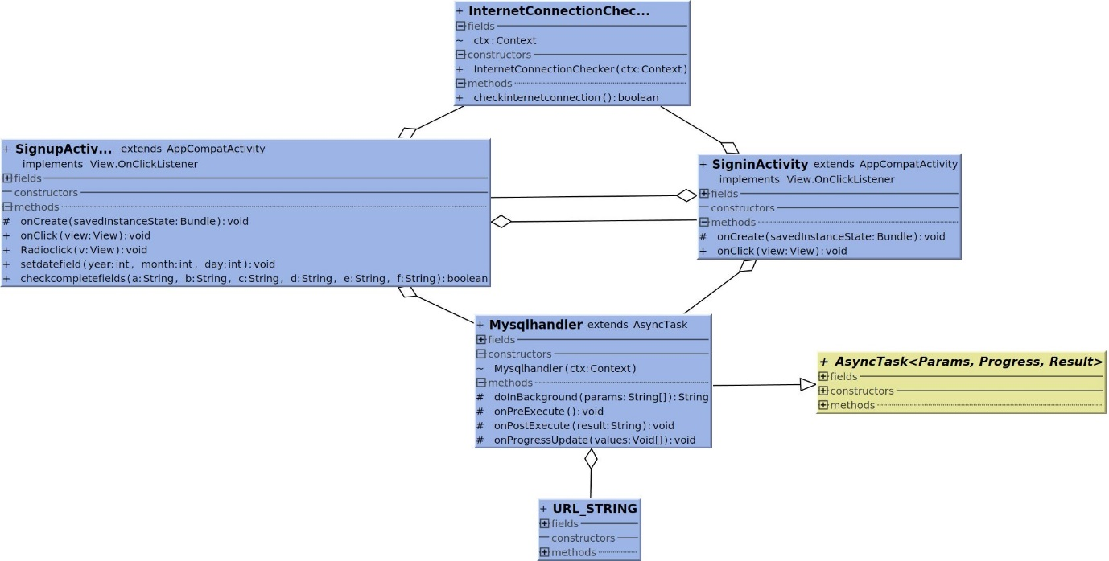

Figure(x): Figure (x): Class diagram for Sign in and sign up.

InternetConnectionChecker is a class that checks if the mobile phone is connected to the internet or not, because the signing in or up process requires an internet connection to be completed, a warning message appears if the user trays to sign in or up but there is no connection as shown in figure x+1

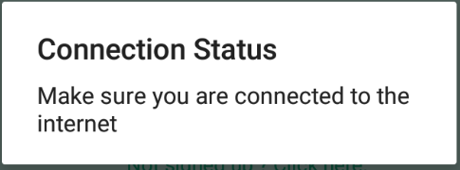

URL_STRING is a class used by all the other classes that do any network operation, the class is responsible for providing the correct URL for each operation, so it can be used to establish the connection then send and receive the needed data.

Mysqlhandler class is a subclass that inherits AsyncTask to create a thread model that run networks operations, in this case the method doInBackground identify the type of operation if it’s signing in or signing up then establishes a connection with the webserver to send the data to complete the operation and receive a response. The onPostExecute method handles the response in the case of existing users confirms the user name and password are correct and the operation was successful and if something went wrong such as the user name was incorrect or the password doesn’t match the user name, in the case of new users confirms if the registration process completed or there is a problem with the user name such as a user already exists with the entered user name or any other issue.

After asserting the completion of the process, the user can precede to the app. But before that happens the user information are stored on the app to avoid repeating this process every time the app is used.

The layout of the sign in and sign up screens very simple to keep the process quick the layouts are shown in figures x+2 and x+3.

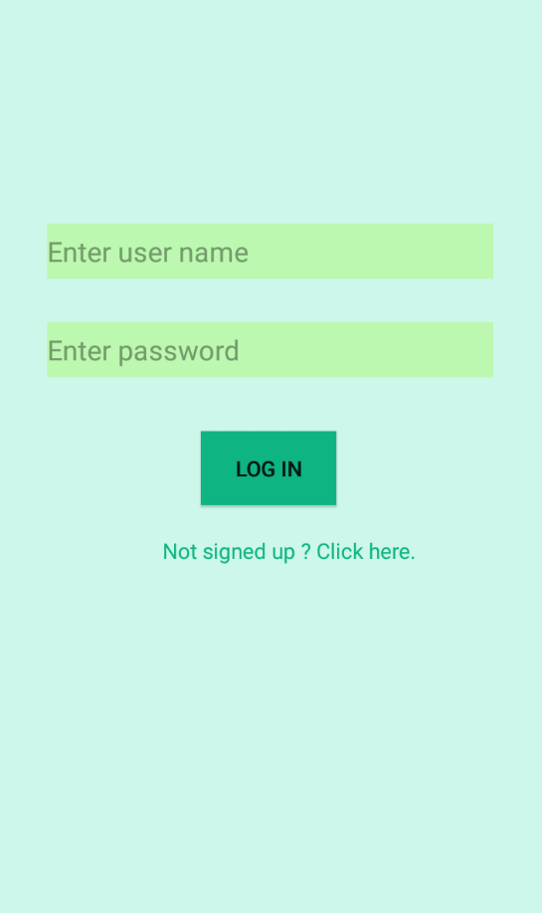 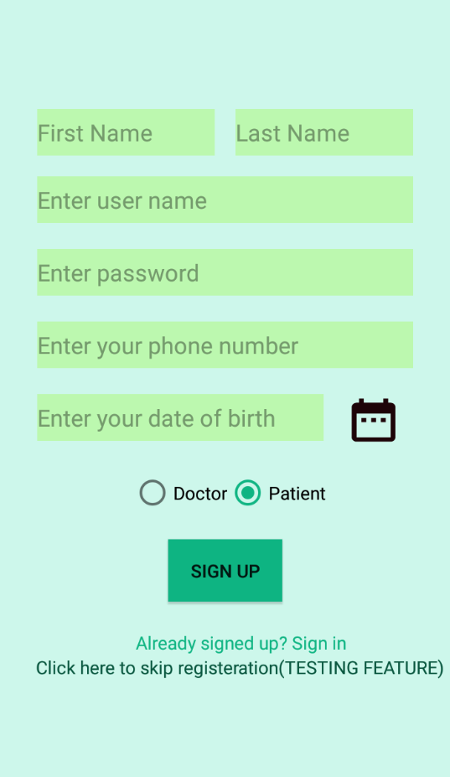

Figure x+2: GUI for sign in screen Figure x+3: GUI for sign up screen

The user is required to fill all the fields with his first name, last name, unique user name, password, phone number and birth date before clicking the log in or sign up buttons, if not an error appears on the missing or wrong field to help the user find out the issue as shown figure x+4. Switching between the two screens can be done by clicking the text.

To make it easy for the user to choose his birth date in the correct format when the calendar icon is touched a calendar is presented to the user to choose the date as shown in figure x+4.

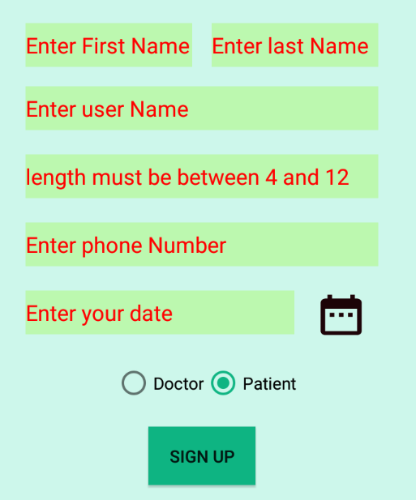 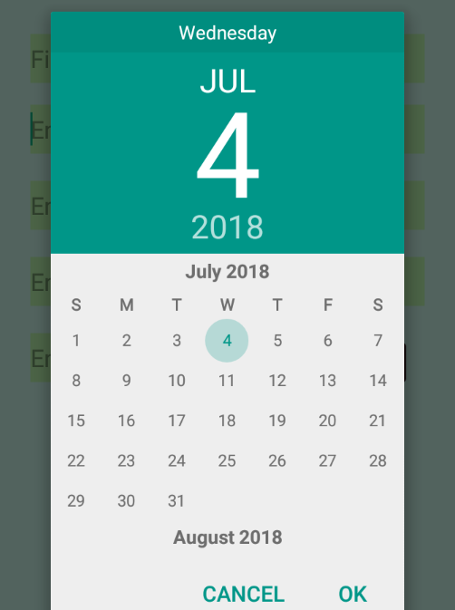

Figure x+3: Error messages. Figure x+4: birth date calendar.