**1. Patient Information Fragment**

Patient information is the default fragment that appears to the user when opening the application, it’s also the first item in the navigation drawer menu. This fragment is designed to show the patient own personal information and allow him to upload a personal photo as a profile picture it also displays the doctors associated with the patient case information including names and phone numbers and allow the patient to call the doctor directly. a UML class diagram is shown in figure (x).

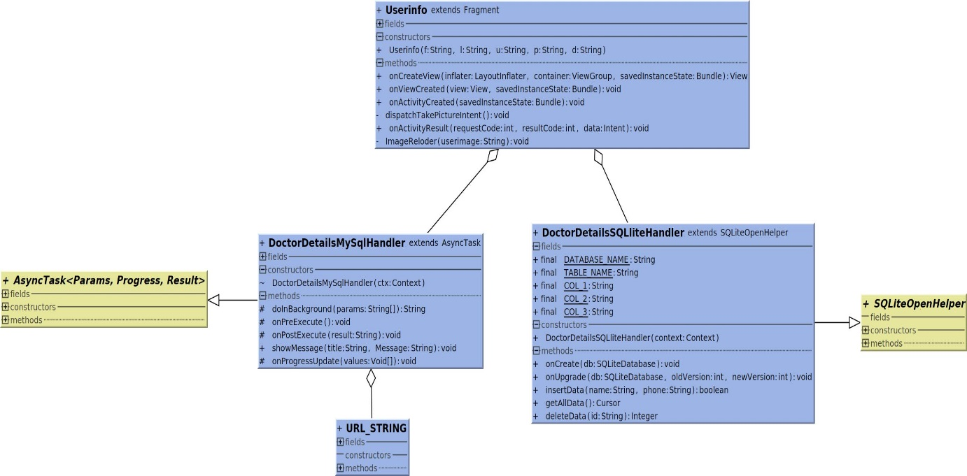

Figure (x): Class diagram for Patient information.

The DoctorDetailsSQLiteHandler class extends the super class SQLiteOpenHelper it’s designed to create a table in the phone offline database to contain information about the doctors associated with the patient. it has the implementation of the methods which are used to operate the database, by inserting, updating, deleting or retrieving data from the Doctor_Table which is described in table y.

Table y: Doctor_Table

|  |
| --- |
| Doctor_Table |

|  |  |
| --- | --- |
| ID | IINTEGER PRIMARY KEY AUTOINCREMENT |
| NAME | TEXT |
| PHONE | TEXT |

DoctorDetailsMysqlHandler class is a subclass that inherits AsyncTask to create a thread model that run networks operations in this case the method doInBackground establishes a connection with the webserver to send the user unique name and receive information about the user doctors in the response. The onPostExecute method handles the response and insert the data to the Doctor_Table. To avoid unnecessarily connections each time the fragment is used this operation only runs if the Doctor_Table is empty or an update on the patient information takes place.

The user info fragment is responsible for handling the two classes mentioned above. it also sets the GUI layout and manages all the click listeners, touch events and gestures on the screen. The layout of the fragment is shown in figure(x+1). The layout contains image view to display the user personal photo, a button to allow the user to set and change the photo. There are two sections to display all the information one for the patient and one for the doctor with a button to call the doctor if needed.

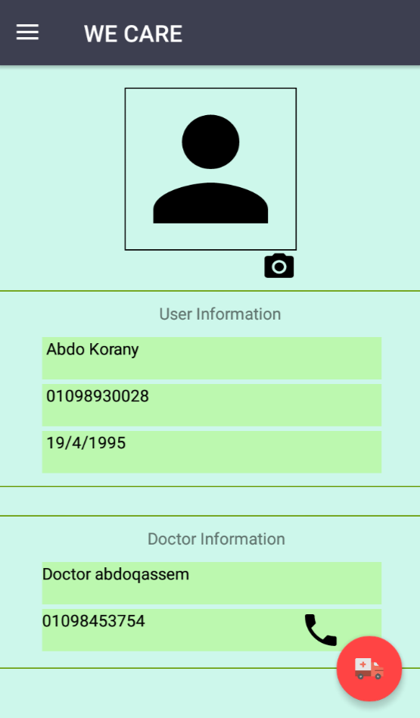

Figure (x+1): GUI for patient information tab

To explain what this fragment does a diagram is shown in figure (x+2) to summarize the use of the patient information fragment.

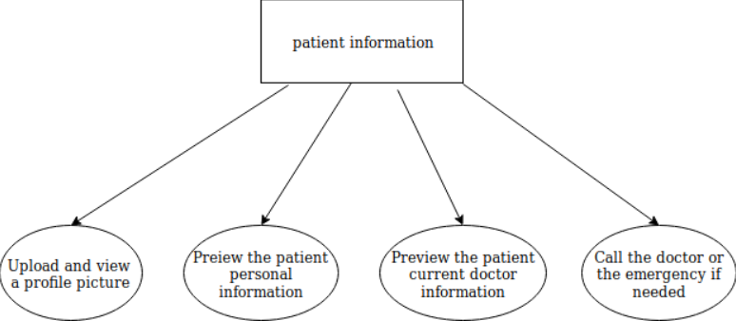

Figure(x+2): Patient information use diagram