[RateRight] Site Plan

[Ashton Scott]

WDD 130

Overview

Purpose
[To create a user-friendly website that gives a summary of recent movies and rates movies to allow others to know good movies that are coming out]

Audience
[Movie lovers who are looking for a new great movie to watch]

Branding

Website Logo
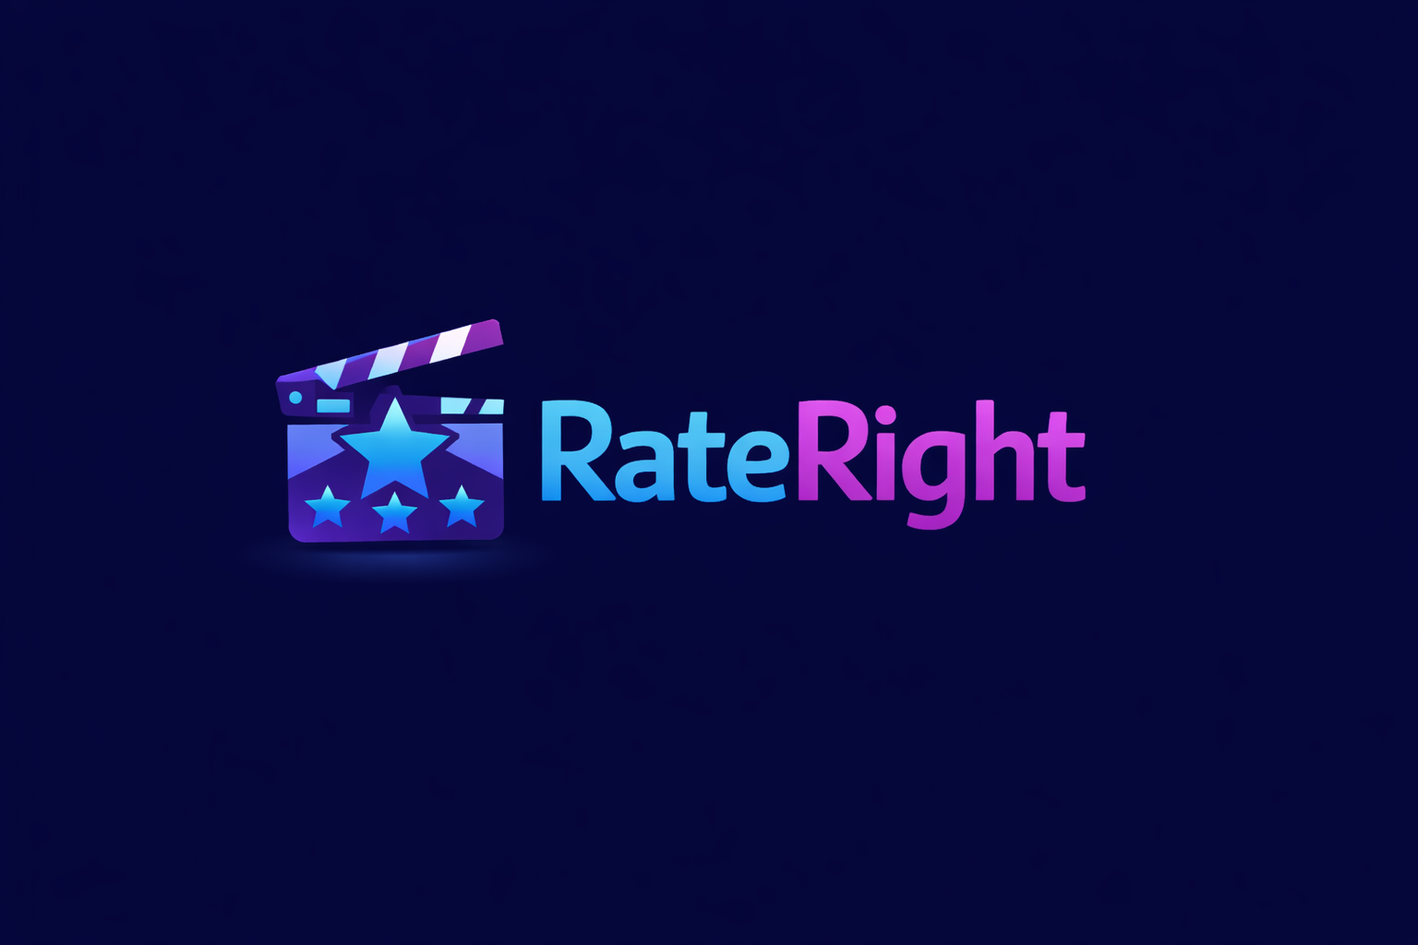


Style Guide

Color Palette
Primary | Secondary | Accent 1 | Accent 2
#232323 | #1C0C4F | #C238EB | #00C8F8

Typography

Heading Font: [Montserrat]

Paragraph Font: [Helvetica]

Navigation
Home Top Rated Review

Content

[put all content for the pages here, including written text and images]

Find your next watch
﻿Midnight Signal
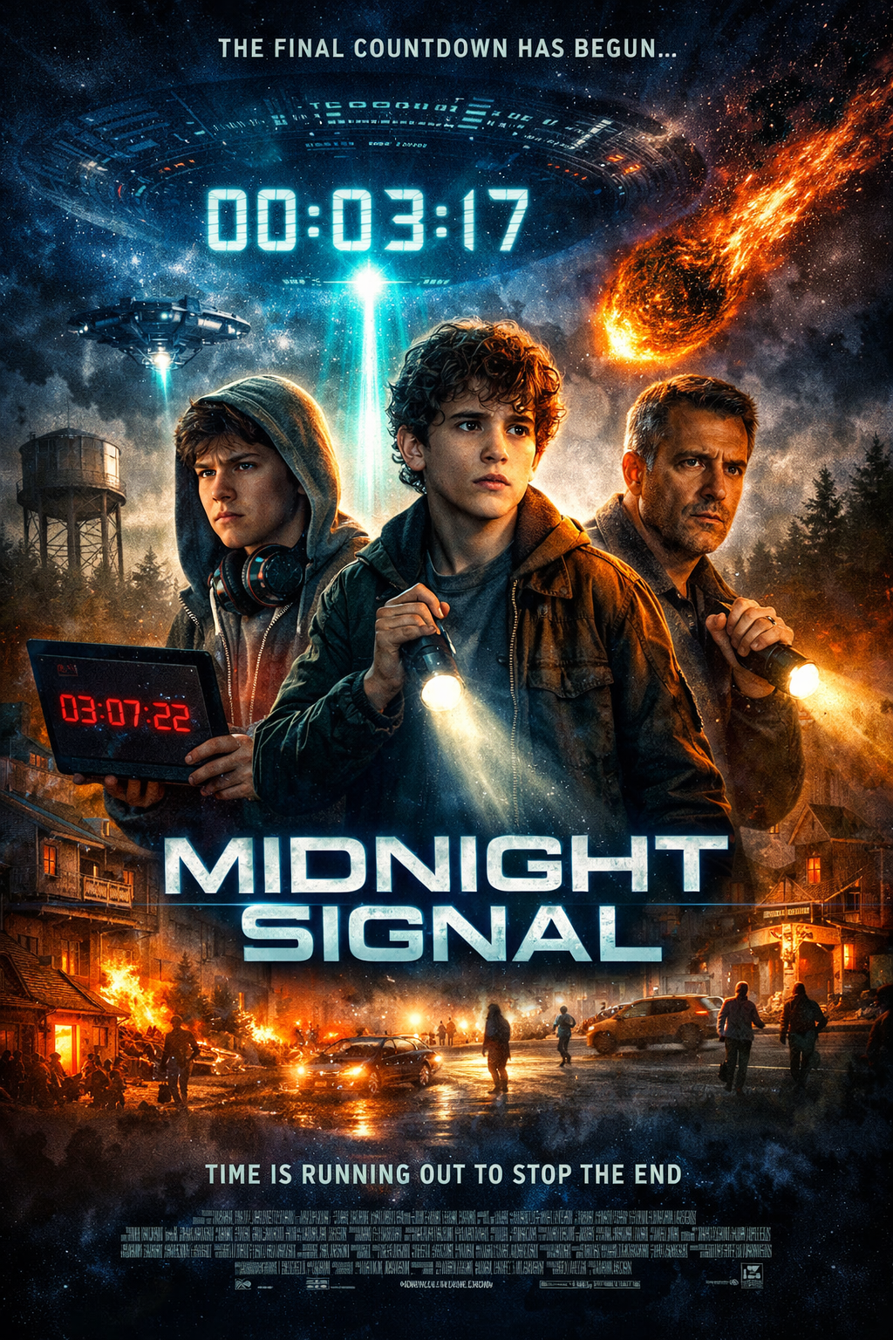
Sci-Fi / Thriller | PG-13
When a teenage coder intercepts a mysterious signal from space, he realizes it’s actually a countdown. As strange events unfold in his town, he teams up with his best friend and a skeptical teacher to uncover the truth. With time running out and no one else believing them, they must race to stop a cosmic disaster before it’s too late.

Midnight Signal is a suspenseful sci-fi thriller with a strong hook—a teenage coder discovering a mysterious countdown from space. The story builds tension quickly while highlighting friendship and courage. Though it follows some familiar tropes, the fast pace and high stakes keep it engaging and fun to watch. See more...

Shadow Run
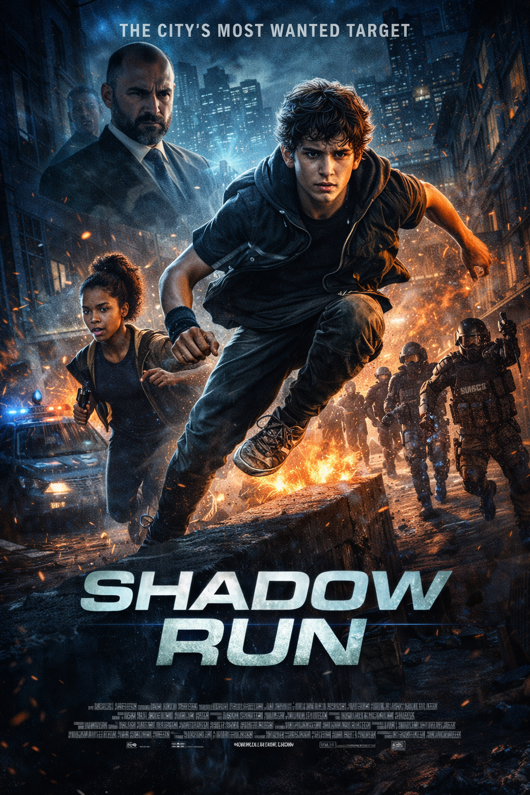
Action / Adventure | PG-13
After witnessing a powerful crime boss’s secret deal, a teenage parkour runner becomes the city’s most wanted target. With only his speed, instincts, and a small group of loyal friends, he must outrun both criminals and corrupt authorities to expose the truth. As the chase tightens and trust becomes fragile, he learns that survival isn’t just about running—it’s about standing up for what’s right.

Shadow Run is a high-energy action thriller that keeps the adrenaline pumping from start to finish. The parkour-driven chase scenes add excitement and creativity, while the story of loyalty and courage gives the film heart. Though the plot feels familiar at times, the fast pace and strong themes of trust and standing up for what’s right make it an... See more...

Echoes of Tomorrow
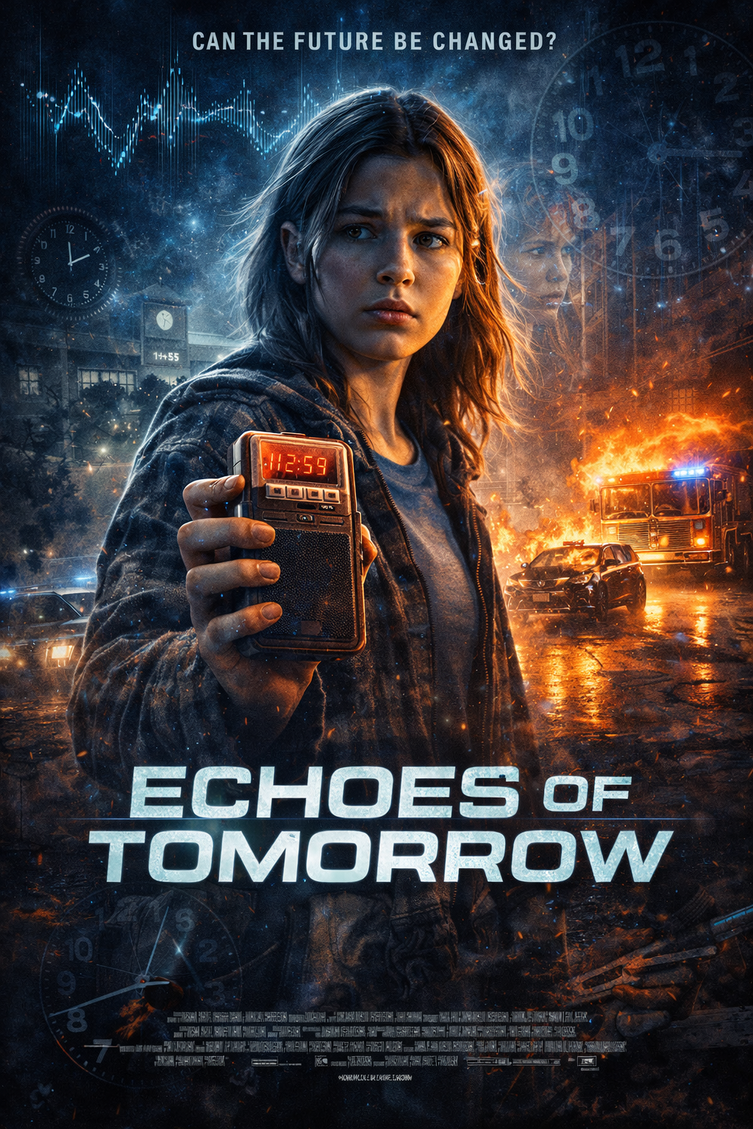
Drama / Mystery | PG

After discovering an old voice recorder in her attic, a high school senior begins hearing messages that seem to predict events before they happen. At first, the recordings help her avoid small mistakes—but soon they warn of something much bigger. As she searches for who left the messages and why, she must decide whether changing the future is worth the cost.

Echoes of Tomorrow is a thoughtful mystery that blends emotional drama with a touch of the supernatural. The voice recorder concept creates steady suspense, drawing viewers into the question of fate versus choice. While the pacing is more reflective than action-packed, the story’s focus on consequences and courage makes it engaging and meaningful. See more...

The Last Horizon
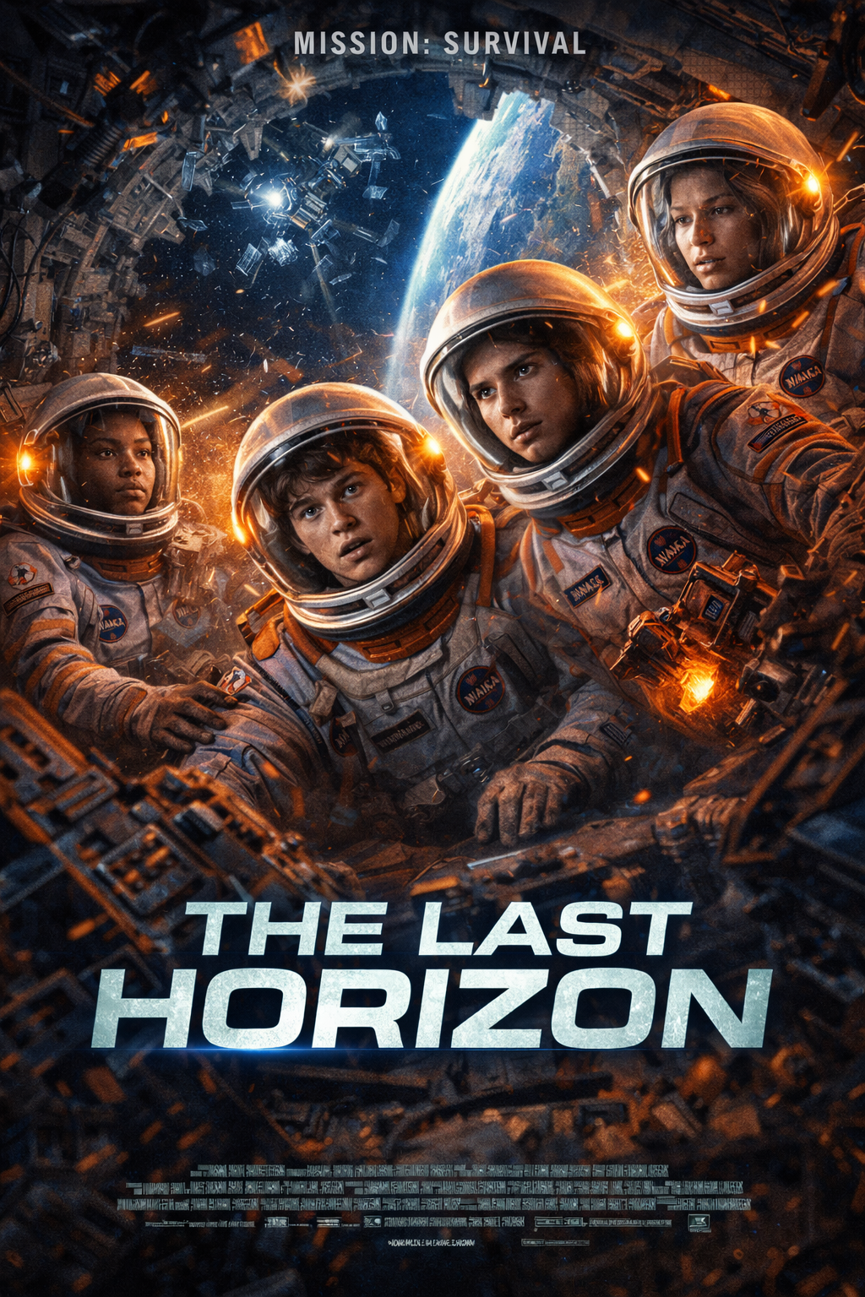
Adventure / Sci-Fi | PG-13
When a group of student astronauts win a chance to test a new experimental spacecraft, their routine training mission turns into a fight for survival after a systems failure sends them off course. With limited oxygen and no immediate rescue in sight, they must rely on teamwork and quick thinking to find a way home. As hope fades and tensions rise, they discover that courage isn’t about fearlessness—it’s about pushing forward when everything feels lost.

The Last Horizon is a gripping space adventure that combines intense survival drama with strong themes of teamwork and resilience. The high-stakes situation keeps the tension steady, while the emotional struggles between the student astronauts add depth to the story. Though the premise feels familiar, the inspiring message about courage under pressure... See more...

Rate a movie

Write Your Review



@RightRate

Wireframes

Home
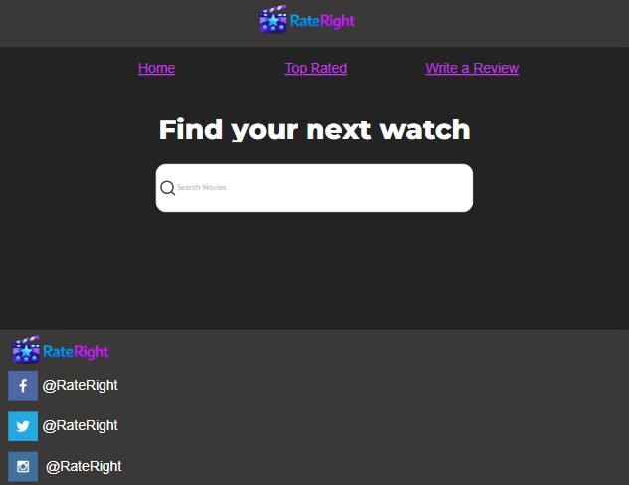

Top Rated
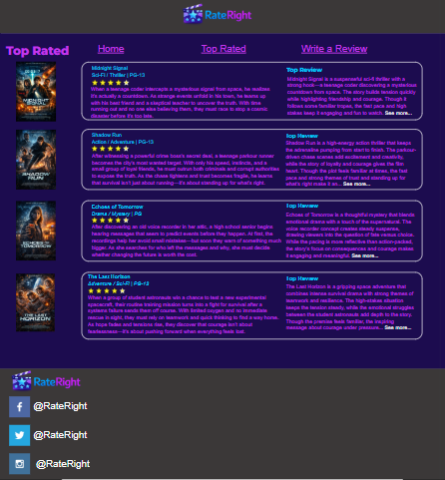

Write a Review
