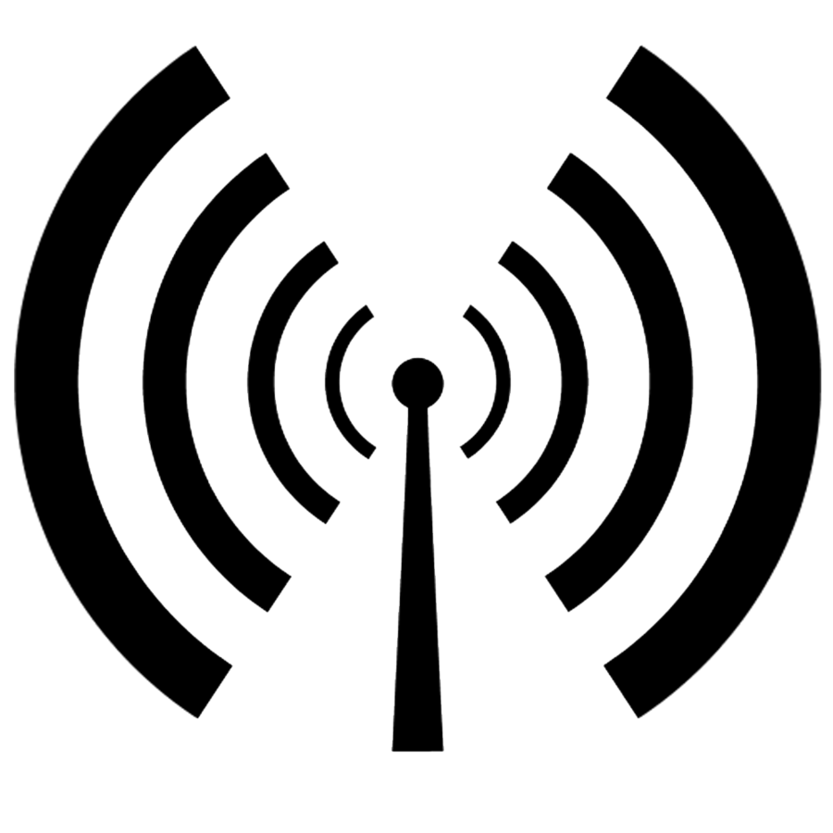

Free Wifi Here

SSID: Buffalomesh.net

http://thisnode

