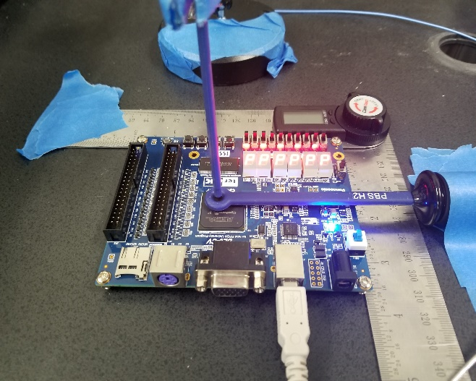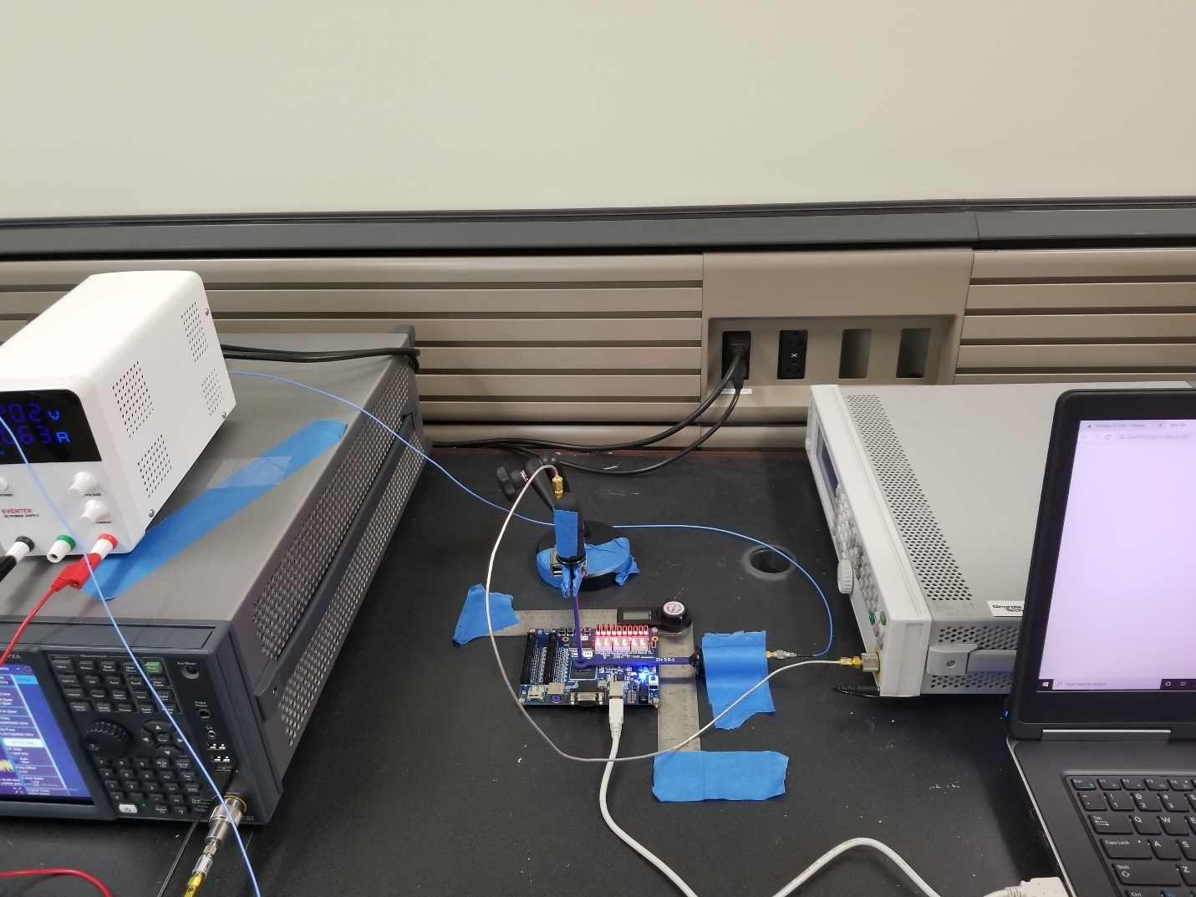

Positioner

FPGA

Receiver probe

Function Generator

Transmitter probe

Spectrum Analyzer

Controlling laptop