A Matter of Size: What Underpinned the Demise of the Largest Rodents that Ever Lived?
Lucas Buffan¹*, Myriam Boivin$​^{2,3}$*, Alicia Álvarez$​^{2,3}$, Fabien L. Condamine¹, Laurent Marivaux¹
¹ Institut des Sciences de l’Évolution de Montpellier, Université de Montpellier, CNRS, IRD, Place Eugène Bataillon, 34095 Montpellier cedex 5, France.
² Laboratorio de Paleontología de Vertebrados, Instituto de Ecorregiones Andinas (INECOA), CONICET – Universidad Nacional de Jujuy, Avenida Bolivia 1661, 4600 San Salvador de Jujuy, Jujuy, Argentina.
³ Instituto de Geología y Minería (IdGyM), Universidad Nacional de Jujuy, Avenida Bolivia 1661, 4600 San Salvador de Jujuy, Jujuy, Argentina
* corresponding authors: lucas.l.buffan@gmail.com, mboivin@idgym.unju.edu.ar

Abstract
Understanding the causes behind diversity declines is a central aim of macroevolutionary research. Exemplifying this are the Chinchilloidea (chinchillas, vizcachas, and relatives) only encompass a few species distributed across South America. However, the fossil record attests that this clade was much more diverse in the past, and notably accounted for some of the largest rodents that ever existed, until six times as heavy as the heaviest living rodent (capybara). Despite several hypotheses, the tempo of chinchilloid diversification remains poorly elucidated, and the causes behind their decline have never been properly quantified. Here, we combine expert-revised fossil occurrences, molecular phylogenies, and the most comprehensive body mass and crown height reconstructions available for Chinchilloidea. Using Bayesian birth–death models and neural networks, we investigate the clade’s macroevolutionary dynamics and their likely traits and environmental correlates. Our findings revealed that the demise of Chinchilloidea resulted from a shift in extinction regime during the Late Miocene. This increase in extinction rate was selective against large-sized, extratropical taxa, and was likely mediated by the Andean uplift and sea-level changes. This suggests that the tectonically- and eustatically-controlled Late Miocene collapse of large wetlands contributed to selectively shaping the decline of Chinchilloidea. We emphasise the coupled dynamics between chinchilloid diversity and body size disparity, illustrating the scale-dependence of the relationship between taxonomic diversity and morphological disparity. Our results illustrate how the complex interplay between traits and environmental factors shape the macroevolutionary fate of the clades.
Keywords: Body Mass; Diversity-Disparity coupling; Environment-dependent Diversification; Extinction Selectivity; Trait-dependent Diversification
Running heads: Buffan et al. – Macroevolution of Chinchilloidea: a matter of size

Introduction
How taxonomic diversity and morphological disparity vary and covary through evolutionary timescales has long puzzled macroevolutionary researchers (Jablonski 2017). Evolution towards gigantism has been repeatedly documented in the fossil record of a wide array of animal clades (e.g., Sander et al. 2011; Bianucci et al. 2023), raising the two-sided question of what drove the emergence and the frequent demise of these remarkable phenotypes (e.g., Boessenecker et al. 2019; Pimiento et al. 2019; Chiarenza et al. 2020; Boscaini et al. 2025). Two classes of factors are usually invoked to explain the long-term dynamics of taxonomic diversity. On one side, in its modern interpretation, the classical ‘Red Queen’ hypothesis (Van Valen 1973) posits that evolutionary changes primarily result from biotic interactions (Barnosky 2001). On the other hand, a wealth of hypotheses summarised under the ‘Court Jester’ model rather emphasise the role of abiotic factors as the primary drivers of evolutionary changes (Barnosky 2001). Deciphering how these factors shape speciation and extinction dynamics as well as the evolution of phenotypes is a central aim of macroevolutionary research (Benton 2009), and may in turn provide answers to the evolutionary questions raised by gigantism.
In the present-day, South America harbours a myriad of examples of gigantism in the animal realm. These are well exemplified by the Anaconda, the largest living snake (Eunectes murinus, Murphy and Henderson 1997), Morpho butterflies (e.g., Blandin and Morris 2007) or the Arapaima (Arapaima gigas). During most of the Cenozoic (i.e., last 66 million years ago, Ma), this continent was isolated from the others, inevitably promoting a vast array of endemic radiations (Simpson 1980). Among the most emblematic are the impressively disparate New World hystricognath rodents (Hystricognathi: Caviomorpha), accounting for ca. 10% of the global extant rodent diversity (Upham et al. 2026). As it happens, the astonishing disparity within Caviomorpha is greatly exemplified by their body size range, going far beyond what is usually found in the Rodentia, from 50 g (Tympanoctomys kirchnerorum Teta, 2014) to 50 kg (Hydrochoerus hydrochaeris Linnaeus, 1766, the largest living rodent) (Patton et al. 2015). In fact, hystricognaths, and particularly caviomorphs, evolved the largest body sizes found in the Rodentia clade. Interestingly, evolution towards large (i.e., body mass above 10 kg) to giant (i.e., above 100 kg) body sizes occurred iteratively and independently in an almost coordinated way among distinct caviomorph lineages (e.g., Vucetich et al. 2015; Álvarez et al. 2017), a trend particularly well illustrated within the Chinchilloidea.
Nowadays, Chinchilloidea includes eight small-to-moderate-sized species with high-crowned, ever-growing (euhypsodont) cheek teeth, distributed among four genera – Chinchilla Bennett, 1829, Lagidium Meyen, 1933 and Lagostomus Brookes, 1828, forming the family Chinchillidae, and Dinomys Peters, 1873, the only living representative of the Dinomyidae (Fig. 1). Extant chinchilloids are found in a diverse range of habitats. Meanwhile Chinchilla and Lagidium are distributed in the Andean cordillera, Lagostomus inhabits lowlands from Paraguay, Bolivia and Argentina, and Dinomys is found within West-Amazonian montane forests (Patton et al. 2015). The fossil record of Chinchilloidea, encompassing continental South America and Caribbean Islands (see Supplementary text) extends back to the latest Eocene (Antoine et al. 2021) and comprises more than 100 described species with variable degrees of crown height (Candela 2005), and including many of the largest rodents ever recorded. In continental South America, fossils of giant chinchilloids were assigned to $†$Neoepiblemidae (e.g., $†$Phoberomys Kraglievitch, 1926) and Dinomyidae (e.g., $†$Isostylomys Kraglievich, 1926 and $†$Josephoartigasia, Mones 2007, the latter being the largest rodent ever recorded) (e.g., Sánchez-Villagra et al. 2003; Rinderknecht and Blanco 2008; Rasia et al. 2024). All these giant taxa, together with the rest of the Chinchilloidea, flourished until the Late Miocene and further vanished, leaving the modest extant diversity of the group (achieving no more than some 15 kg for Dinomys branickii, the largest extant chinchilloid, an order of magnitude below its giant ancestors) as a relic of a formerly speciose superfamily (Vucetich et al. 2015). Most of these extinct large-to-giant taxa, and could either forage in or near water or be semi-aquatic (e.g., Sánchez-Villagra et al. 2003; Rinderknecht and Blanco 2008; Candela et al. 2013; Kerber et al. 2022), a lifestyle that totally disappeared in the extant representatives of the superfamily.
Several hypotheses have been proposed to explain chinchilloid palaeodiversity dynamics and exceptional phenotypical evolution, though mostly emphasising high latitudes. Some authors argued that the environmentally-driven emergence of new niches, either promoted by the late Neogene climatic cooling and aridification (Vucetich et al. 2015) or the Late Miocene hydrographic changes (Candela et al. 2013), favoured the remarkable size-increase pattern found in this rodent clade (Álvarez et al. 2017). Also, the spectacular sizes achieved by the ‘Giant Hutias’ – particularly $†$Amblyrhiza – have often been proposed to result from the ‘island rule’ (e.g., Biknevicius et al. 1993; McFarlane et al. 1998), though the validity of this macroecological pattern has been under debate (e.g., Meiri et al. 2007). However, our understanding of the evolutionary dynamics of Chinchilloidea, and particularly of their drastic evolutionary decline, remains fragmentary. Previous studies relying on a phylogenetic framework illustrated that the dynamics of caviomorph palaeodiversity and body mass evolution were decoupled (Álvarez et al. 2017; Carrillo et al. 2026). Nevertheless, many extinct chinchilloid taxa lack DNA or sufficient morphological material to be adequately placed in a phylogenetic framework, leading to their exclusion from subsequent macroevolutionary analyses relying on phylogenies. Thus, there is much to gain by relaxing phylogenetic assumptions and fully taking advantage of the rich fossil record of the group to reconstruct its macroevolutionary history. In addition, major palaeoenvironmental upheavals have shaped South America since the late Eocene, including the Andean orogeny, marine introgressions, river network reorganization, and the onset of the South American Dry Diagonal. In parallel, numerous methods for studying diversification dynamics have been developed over the last decade (e.g., Hauffe et al. 2024; Morlon et al. 2024 and literature therein). Yet, the macroevolutionary dynamics of Chinchilloidea have never been investigated within a trait- and environment-dependent diversification framework.
Here, we investigate the evolutionary history of Chinchilloidea and assess some of its trait and environmental correlates. To do so, we compiled and revised 708 chinchilloid fossil occurrences from online databases and the literature, and used divergence times leading to extant species absent from the fossil record extracted from a dated phylogeny to build the most exhaustive temporal occurrence database ever produced for this group, encompassing 62 genera and 124 species. In parallel, we collected cranio-dental traits and measurements to (1) carry out body mass estimations based on recently-published sets of predictive equations, and (2) determine cheek teeth crown height categories based on hypsodonty indices. We further analysed chinchilloid palaeodiversity and diversification dynamics throughout their entire evolutionary history using state-of-the-art preservation-aware methodological frameworks, and sought for their likely environmental drivers, allowing rate variations across time, body size and crown height categories. We hypothesise that (i) climate – in particular temperature – evolution since the Middle Miocene impacted the diversification history of Chinchilloidea; (ii) continent-scale changes in habitat connectivity, either mediated by hydrographic (i.e., sea level) or tectonic (i.e., Andean elevation) factors had repercussions on the macroevolutionary fate of Chinchilloidea; and (iii) the magnitude of the changes in speciation and/or extinction rates were heterogeneous across body size and crown height categories.
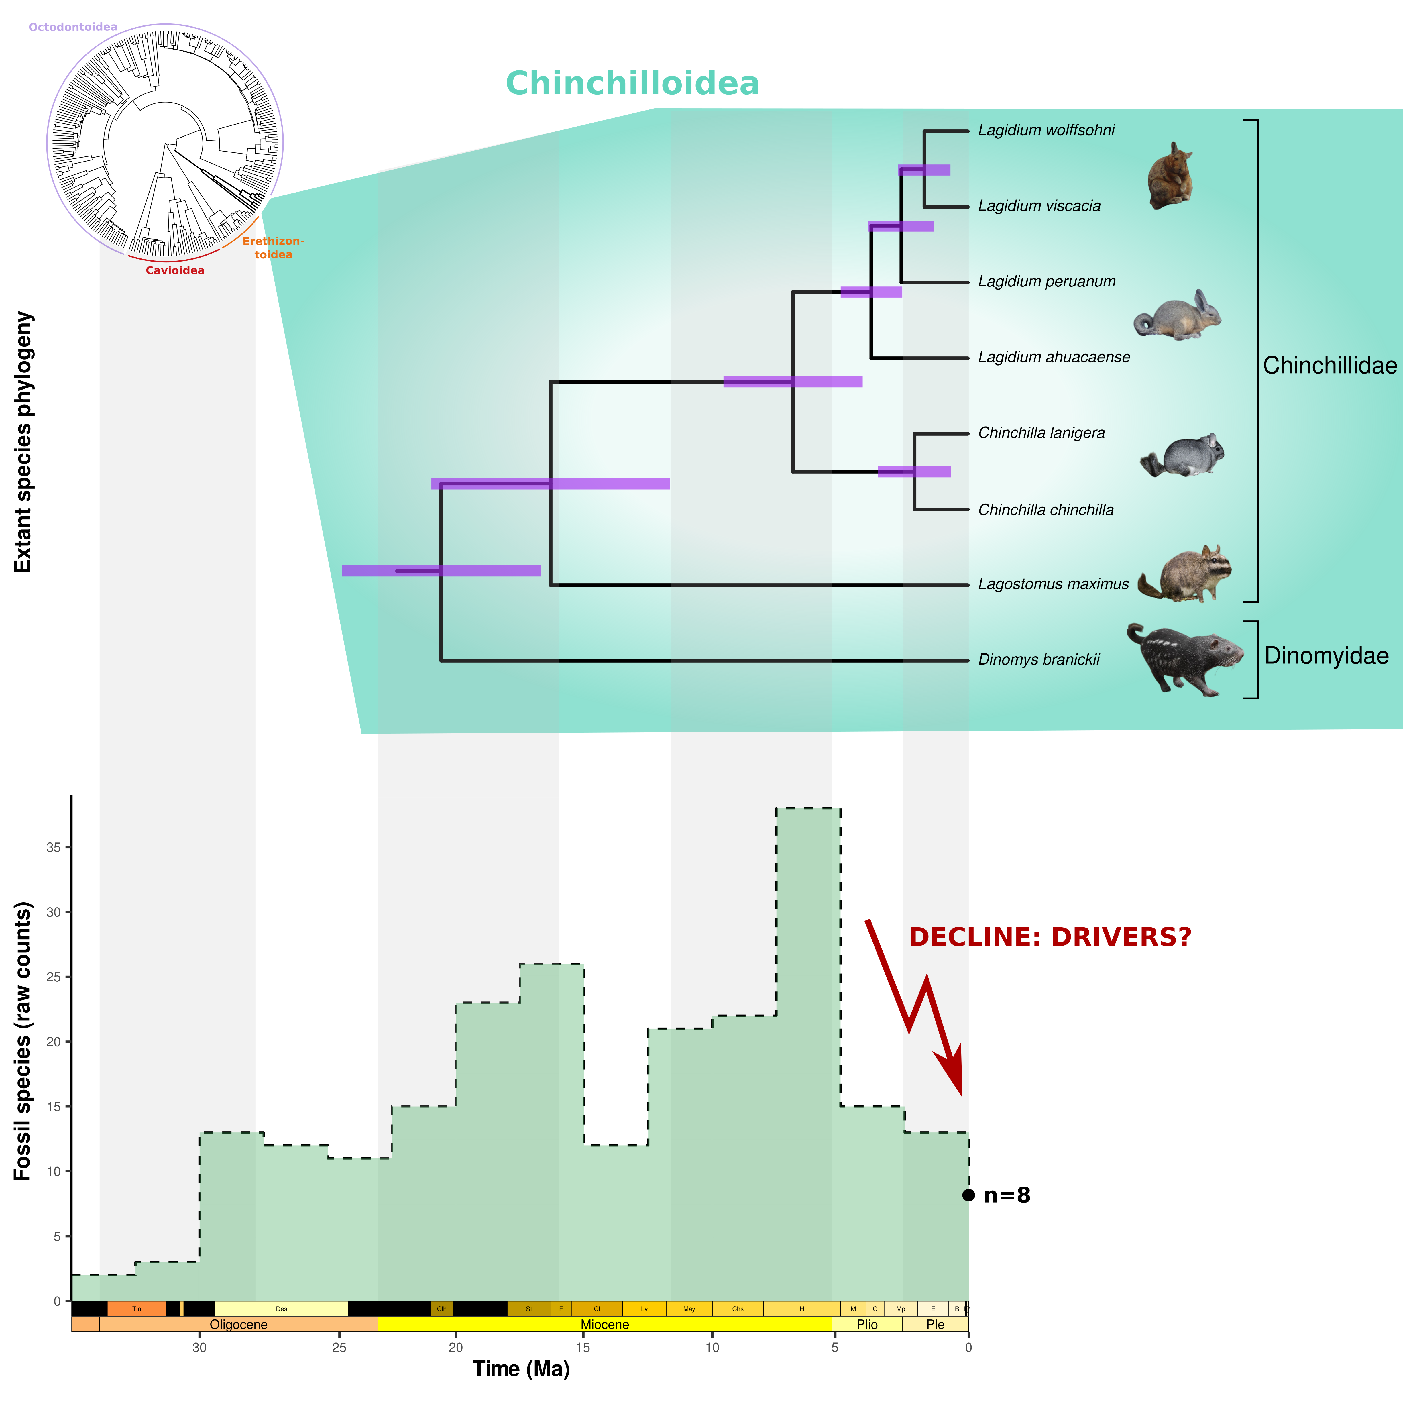
Figure 1: A glimpse into the evolutionary history of Chinchilloidea : combined perspectives from a dated phylogeny and the fossil record. On the top left corner, we represented the extant caviomorph tree of life, encompassing four superfamilies: Octodontoidea, Cavioidea, Erethizontoidea and Chinchilloidea. At present, Chinchilloidea encompass eight species, represented on their dated sub-tree along with a few silhouettes (credits in Tab. S3). Purple bars represent node age 95% Confidence Interval. On the bottom part of the figure, we plotted the raw chinchilloid species count across 5-Myr time bins from the fossil occurrence dataset that we built de novo ($n=124$ species). In the Late Miocene, up to 37 chinchilloid species were co-existing in a 5-Myr frame, contrasting with the extant diversity of the group. This paper seeks to understand the causes of this striking diversity decline.

Materials and Methods

Temporal occurrence database
We downloaded genus- and species-level fossil occurrences of Chinchilloidea from The Paleobiology Database (https://paleobiodb.org). Each entry was then checked and, if necessary, updated by us (taxonomic name, fossiliferous locality and geologic formation, age range). We provided the most precise age range on the basis of the data available in the literature, firstly searching limits for the fossiliferous level(s), then increasing to the member, formation or locality level in case the first did not exist. We updated some ages previously published given recent chronostratigraphic (International Chronostratigraphic Chart 2024/12; Cohen et al. (2025)) and geomagnetic (Ogg 2020) scales. The South American Land Mammal Age (SALMA) limits are based on Dunn et al. (2013), Brandoni et al. (2016), Fernicola et al. (2019), Cuitiño et al. (2021) and Muñoz et al. (2023). This compilation was further complemented by an extensive literature review conducted up to April 2026, which enabled the removal of duplicates, the incorporation of missing published data (e.g., Arnal et al. 2026) and to account for the most up-to-date taxonomic revisions (e.g., Rasia 2026). We excluded occurrences with open nomenclature names (cf., aff., ?) from downstream analyses. Additional details on our data cleaning procedure may be found in Supplementary materials.
We obtained a dated caviomorph phylogeny from VertLife (http://vertlife.org/phylosubsets). This tree was extracted from the 95% Highest Posterior Density (HPD) of 10,000 trees, including 5,911 mammalian species (Mammals birth–death node-dated completed trees; see Upham et al. (2019)). Relying on this phylogeny, we developed a simple approach to incorporate extant species lacking fossil record (i.e., Chinchilla chinchilla, Chinchilla lanigera, Lagidium ahuacaense, Lagidium viscacia, Lagidium peruanum, Lagidium wolffsohni, and Dinomys branickii; see Supplementary text) in our database (Fig. 2). Combining information from the fossil record and molecular phylogenies for macroevolutionary inference was already done for groups where a large proportion of the extant diversity is absent from the fossil record, like sharks (e.g., Brée et al. 2022; Marion et al. 2025) or ants (Jouault et al. 2024). These studies typically considered the divergence times leading to extant species (hereafter termed $T_{d,i}$ for a given species $i$) as a proxy of extant species origination times ($T_{s,i}$). They carried out their macroevolutionary inference out of a dataset combining the origination and extinction ages of species from the fossil record estimated with PyRate (Silvestro et al. 2014) and samples of extant species’ $T_{d,i}$ across different trees (to account for age uncertainty) – extant species’s extinction times were by definition set to zero. Here, we propose to treat $T_{d,i}$ as a lower bound of $T_{s,i}$. Our approach therefore involves sampling virtual occurrences of each extant species $i$ within [$0,T_{d,i}$], and incorporating these virtual occurrences into the previously-introduced fossil occurrence database. Assuming sampling probability to decrease as we get closer to $T_{d,i}$ (Liow et al. 2010), we therefore randomly drew $n$ occurrences of the species $i$ from a truncated exponential distribution ($​^{tr}ϵ$) of rate $γ$ determined so that an arbitrary proportion $α$ of the non-truncated distribution lies within [$0,T_{d,i}$] (Fig. 2). This leads to
$$γ=\frac{−ln\left(1−α\right)}{T_{d,i}}$$
In practice, we sampled $n=10$ values $T_{d,i}^{⋆}$ from the 95% HPD of $T_{d,i}$ (Tab. S2). Since we did not have direct access to the distribution in itself but rather to its lower and upper bounds (respectively $T_{d,i}^{2.5\%}$ and $T_{d,i}^{97.5\%}$), we approximated it to a normal distribution of mean $μ=\frac{T_{d,i}^{97.5\%}+T_{d,i}^{2.5\%}}{2}$ and variance $σ^{3}=\frac{T_{d,i}^{97.5\%}−μ}{1.96}$. Then, for each of the 10 $T_{d,i}^{⋆}$ values, we sampled the minimum and maximum ages of a virtual occurrence from $​^{tr}ϵ\left(γ\right)$ by setting $α=0.95$, except for Dinomys branickii. Indeed, given that the divergence time of D. branickii with the rest of the extant representatives of the clade ($T_{d,branickii}$) is too ancient to be reasonably considered as an approximation of the time when the species originated (95% HPD = $\left[16.5,24.8\right]$ Ma, according to the tree distribution obtained from VertLife), we set $α=0.999$ (Fig. S3). By doing so, we made it almost impossible to sample an occurrence maximum age close to $T_{d,branickii}$.
This resulted in one species-level database (536 occurrences, 124 species, including 56 only represented by a single occurrence, thereafter referred to as singletons) and one genus-level database (769 occurrences, 61 genera, including 13 singletons), spanning the entire lifespan of the clade (from the latest Eocene to present), spread across South America and the Caribbean Islands (Fig. S1).
Diversification rates obtained from the analysis of the resulting ‘hybrid’ temporal occurrence dataset (incorporating fossil occurrences and extant occurrences sampled following the approach described above) were compared to diversification rates obtained from a dataset in which extant taxa lacking fossil record were assigned a single occurrence of modern age (i.e., min_age = max_age = 0 Ma) (Fig. S1).
To assess potential heterogeneities in diversification rates across latitude, occurrences were binned into three spatial domains on the basis of their sampling location: Tropical, Extratropical and Caribbean. The tropical/extratropical affinity of a given locality was set as done by Buffan et al. (2025). Due to the substantially fragmented nature of the Caribbean fossil record, the latter domain – only encompassing five species, $†$Borikenomys praecursor, $†$Amblyrhiza inundata, $†$Elasmodontomys obliquus, $†$Clidomys osborni and $†$Quemisia gravis – was very structured in time, only covering the Quaternary, with the notable exception of a single late early Oligocene taxon ($†$B. praecursor). Analyses with and without these taxa were thus conducted.
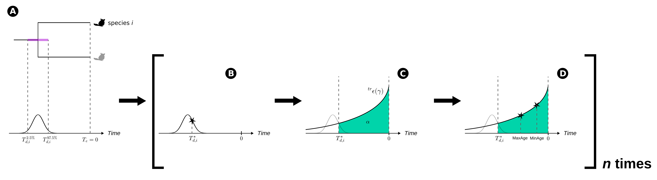
Figure 2: Visual representation of the occurrence sampling scheme that we implemented for extant species lacking fossil record. We approximated the posterior distribution of the divergence times leading to a given extant species $i$ (denoted $T_{d,i}$) with a gaussian of mean and variance determined by the lower and upper boundaries of the empirical 95% HPD of $T_{d,i}$ (resp. $T_{d,i}^{2.5\%}$ and $T_{d,i}^{97.5\%}$) (a). Then, we randomly drew a value $T_{d,i}^{⋆}$ from this distribution, serving as a lower boundary for the species’ origination time (b). We then drew simulated occurrence’s minimum and maximum ages (resp. ‘MinAge’ and ‘MaxAge’) from a truncated exponential distribution ($​^{tr}ϵ$) of rate $γ$ determined so that a proportion $α$ of the non-truncated distribution lies between $0$ and $T_{d,i}^{⋆}$ (c–d). Steps b–d were repeated $n$ times, so we finally ended up with $n$ simulated occurrences per extant species lacking fossil record. In practise, we set $n=10$ and $α=0.95$, except for Dinomys branickii, for which we set $α=0.999$. Chinchilla chinchilla silhouette is from Phylopic, see Tab. S3 for additional information.

Trait data collection
On the basis of body mass reconstructions carried out from cranial and dental proxies detailed in Boivin et al. (2024), complemented with a literature review, species were classified in six body size categories: XS (< 0.5kg), S (0.5–1kg), M (1–10kg), L (10–100kg), XL (100–200kg) and XXL (> 200kg).
We scored cheek teeth tooth growth types mainly based on the hypsodonty index (HI), which corresponds to the ratio between the crown height of an unworn tooth and its anteroposterior length or labiolingual width (Van Valen 1960; Janis 1988). We considered four categories: brachydont (HI < 0.9, rooted), mesodont (0.9 < HI < 1.1, rooted), protohypsodont (HI > 1.1, rooted), and euhypsodont (HI > 1.1, unrooted; Mones (1982); Pérez (2010)). The category scoring was derived from literature sources, observations and unpublished measurements made by the authors (Fig. S7).
In the end, body mass and HI estimates were obtained for nearly all species represented in our dataset (resp. 97% and 98%). Thus, this work presents the most exhaustive trait compilation so far assembled for the Chinchilloidea.

Palaeodiversity and diversification inferences from the fossil record
Our occurrence database was first analysed using PyRate 3.1.3 (Silvestro et al. 2014, 2019). Species’ origination and extinction times (altogether forming the palaeodiversity) and the underlying diversification process (i.e., origination and extinction rates) were jointly estimated in a Bayesian framework accounting for preservation heterogeneity, and approximated through reversible-jump Markov Chain Monte Carlo (rjMCMC). We ran the rjMCMC algorithm for 10 million iterations, sampling every 10,000 iteration. In parallel, the same database was analysed using the birth–death model with Constrained Shifts (BDCS) (Silvestro et al. 2015b). As its name indicates, this model allows diversification rates to vary across a user-defined set of bins (here, the same as those used for BDNN rate-through-time inference, see the corresponding section), thus limiting the potential impact of data incompleteness on the estimation of rate shifts across time.
In either case, we used a time-dependent preservation process, in which preservation rate could vary between geological stages (Fig. S4). We also allowed preservation rates to vary between lineages according to a Gamma model. These analyses were replicated 20 times after randomly sampling fossil ages between each occurrence’s upper and lower age boundaries. MCMC runs that achieved convergence, i.e., with Effective Sample Size (ESS) over 200 ($n=20$; Fig. S5) were further combined. Several sensitivity analyses were conducted to assess the impact of (1) our new phylogeny-based sampling scheme for extant species lacking fossil record (Fig. 2 and Fig. S4), (2) removing singletons (Fig. S8–S9), and (3) incorporating recently-published taxonomic revision of a hyperdiverse dinomyid fauna located in Northeast Argentina (Ituzaingó formation; Rasia (2026), Fig. S12) on the reconstructed diversification pattern. We also carried out analyses at the genus level (Fig. S10–S11). Parameter convergence was monitored using the pymc v5.9.2 python library, and we considered parameters achieved convergence following the same criterion as before ($ESS>200$).
To obtain an alternative perspective on the temporal patterns of chinchilloid diversity accounting for the incompleteness of the fossil record differently (i.e., without explicitly modelling it), we used the recently-developed fossil-based palaeodiversity reconstruction framework implemented in DeepDive 1.0.28 (Cooper et al. 2024). DeepDive uses a biodiversity simulator based on a spatially-explicit birth–death process to simulate diversity trajectories of virtual clades. It further applies several filters (acting as fossilisation and sampling processes in a spatially-constrained manner) to ‘degrade’ simulated diversities and in turn simulate the fossil record. Simulation parameters (e.g., sample size, number of regions, etc.) can be user-tuned so that simulated scenarios reflect more any empirical case study. Then, a deep-learning model relying on recursive neural networks is trained to predict palaeodiversity from a set of features directly extracted from the simulated fossil record (e.g., number of singletons, range-through diversity, …) given the complete simulated diversity as a ground truth (supervised learning), within a user-defined set of time bins. Once the model achieves a satisfying training level (quantified with a loss function, see Tab. S1), the same features are extracted from the empirical set of fossil occurrences and fed into the trained neural network to get an estimate of palaeodiversity through time. Consequently, DeepDive complements the inference of diversity through time made by PyRate, as it represents a means to overcome the complete lineage sampling assumption made by PyRate, one of the biggest limitations of the latter framework.
In practice, we ran DeepDive from configuration files produced with the R package DeepDiveR 1.0 (Cooper et al. 2025). Below, we provide an overview of our motivations behind some parameter values. Exhaustive details of the values we set for each parameter are available in the configuration files (see Supplementary Data).
Simulation. We generated 150,000 training and 1,000 test sets. For each simulated dataset, the number of starting lineages was set between 30 and 150, and we chose to set the number of regions where our taxa occurred to three, reflecting our empirical trichotomy between tropical, extratropical, and Caribbean regions. We set the number of extant taxa in the simulations – as well as in the predictions – to 8, reflecting the number of extant chinchilloid species (Patton et al. 2015; Burgin et al. 2025).
Model training. Following Cooper et al. (2024), we tested models with variable numbers of bidirectional ‘Long Short-Term Memory’ (LSTM) layers, including (or not) additional fully-connected ‘dense’ layers, and selected the best architectures based on the mean squared error (MSE) between simulated (i.e., ‘true’) and predicted diversity of each set of fossil occurrences of our training set (Evaluation loss). Two architectures performed equally (Evaluation loss = 0.377, Tab. S1): one comprised two LSTM layers (64 and 32 nodes) coupled with two dense layers (64 and 32 nodes) (Fig. S18), the other three LSTM layers (128, 64, and 32 nodes) coupled with two dense layers (64 and 32 nodes) (Fig. S19). Consequently, we selected the least complex architecture (i.e., the one with two LSTM layers).
Empirical predictions. We made 100 replicates of age assignment for occurrences in our fossil database.

Drivers behind macroevolutionary patterns
Since insular and continental taxa are not subject to the same evolutionary constraints, we excluded the five Caribbean taxa ($†$Amblyrhiza inundata, $†$Borikenomys praecursor, $†$Clidomys osborni, $†$Elasmodontomys obliquus, $†$Quemisia gravis) from our environment-dependent diversification analyses. In particular, this avoided to test spurious relationships, for instance, the effect of the Andean uplift on the diversification of Caribbean taxa.

Environmental variable selection
To investigate the likely environmental correlates underlying our reconstructed patterns, we incorporated two regional and one global abiotic variables in our workflow (Fig. S23). First, as illustrated by many studies, the Andean uplift has often been identified as a key driver for the build-up of South American ecosystems from the Neogene to the present (e.g., Hoorn et al. 1995; Antonelli et al. 2009; Hoorn et al. 2010; Tarquini et al. 2022; Vallejos-Garrido et al. 2023; Solórzano et al. 2024). Thus, we incorporated the multi-proxy reconstruction of the pace of the Andean uplift produced by Boschman and Condamine (2022) (Fig. S23 a) – averaged across the entire continent. Another abiotic factor frequently retrieved as significantly influencing diversification in a wide array of clades is temperature (e.g., Condamine et al. 2018; 2019a; Flannery-Sutherland et al. 2022; Weppe et al. 2023). So far, studies testing the effect of palaeotemperature on clade diversification have often used global proxy-derived temperature reconstructions (e.g., from Westerhold et al. 2020). The main limitation of this approach is that it poorly reflects regional climatic idiosyncrasies. We therefore relied on the regional South American average temperature reconstructions recently produced by Tardif et al. (2025) (Fig. S23 b). Also, South American biomes have been highly influenced by hydrographic reorganisations, tightly related to the Andean orogeny, but also to eustatism (Hoorn et al. 2022; Guayasamin et al. 2024). We therefore incorporated the sea level reconstructions of Miller et al. (2020) in our analyses (Fig. S23 c). Last, diversity-dependent effects have been illustrated many times as important drivers for changes in macroevolutionary rates (e.g., Etienne et al. 2012; Condamine et al. 2019a, 2020) in a wide range of clades. Therefore, we allowed for diversity dependence in our environment-dependent diversification (EDD) analyses.

Multivariate birth–death (MBD) analyses
At first, we carried out EDD analyses using the Multivariate birth–death (MBD) model implemented in PyRate (Lehtonen et al. 2017). Given species-specific origination and extinction times inferred by PyRate (see previous part), the MBD model estimates de novo origination and extinction rates (resp. $λ$ and $μ$) using a birth–death process where $λ$ and $μ$ are functions of environmental variables. Given a set of environmental correlates of size $n$ (in our case, $n=4$), the model assumes either a linear or an exponential dependency between $λ$ (or $μ$) and the environment correlates – here, we only tested for exponential dependencies. Therefore, to a given rate, $n$ correlation parameters – one per environment variable – are estimated (resp. $G_{λ,i}$ or $G_{μ,i}$), plus a baseline rate. As recommended by Lehtonen et al. (2017), given our low number of predictors, each $G_{λ,i}$ and $G_{μ,i}$ was assigned a Gamma prior. An MCMC algorithm approximating the posterior distribution of each model parameter was run across 10 million generations with a sampling frequency of 10,000, and parameter convergence was monitored using pymc.
Prior to their incorporation as correlates in the MBD model, environmental variables were manually scaled. In addition, we ensured to match them all to the same time scale (last 36 Ma with a 0.5 My time step). Not doing the latter step significantly increased computing time, and the resulting model had lower support than the model incorporating predictors matched to the same time scale. Model support was assessed by approximating 2$×$log Bayes Factor (BF) as two times the difference in harmonic means of the sampled log likelihood across MCMC iterations (after removing burn-in) of the two models (i.e., with and without matching predictors’ time scale), as done by Lehtonen et al. (2017). The resulting metric was compared to the thresholds set by Kass and Raftery (1995), and turned out to provide strong support in favour of the model incorporating predictors matched to the same time scales ($2log\left(BF\right)=7.24>6$; Supplementary Data).

Birth–Death Neural Networks (BDNN) analyses
We consolidated our EDD analyses by using the Birth–Death Neural Networks (BDNN) model (Hauffe et al. 2024). BDNN uses PyRate’s framework to estimate preservation-aware times of origination and extinction for each taxon of the occurrence database. Given these times, it further extends the birth–death process used in PyRate to model origination and extinction rate dynamics by allowing rates to vary not only across time, but also across lineages. One of the key advances of BDNN is that it uses an unsupervised neural network to estimate these rates as a function of a user-provided set of external predictors, such as environmental covariates or biological traits. It therefore does not assume any predefined dependency between diversification rates and the variables tested – contrary to the linear vs. exponential dichotomy usually offered by model-based EDD. Consequently, these dependencies can be complex, going beyond linearity. The estimated rates are then directly incorporated in the likelihood function of the birth–death process implemented in PyRate. Noteworthy, BDNN provides the ability to test for the combined effect (i.e., interaction) of multiple variables, and further ranks the predictors according to their respective contribution to the modelled macroevolutionary pattern by using explainable AI metrics (for additional details, see Hauffe et al. 2024).
All model parameters were estimated using an MCMC that ran for 50 million generations, sampling every 50,000. As in our PyRate analyses, we used a time-dependent preservation process allowing preservation rate shift between geological stages, and between lineages according to a Gamma model. We constrained the time effects of the BDNN to vary between the following set of bins: latest Eocene–Oligocene (35–23.04 Ma), Early Miocene (23.04–15.97 Ma), Middle Miocene (15.97–11.63 Ma), Late Miocene (11.63–6 Ma), latest Miocene–Pliocene (6–2.58 Ma) and Quaternary (<2.58 Ma). The choice of these bins was informed by prior knowledge on rate variation provided by our PyRate analyses (particularly in the latest Miocene–Pliocene), and allowed us to cope with the paucity of our fossil record, particularly in the Early Miocene. Predictors (i.e., environmental covariates and categorical traits) were scaled prior to their incorporation in the model. All the BDNN results presented thereafter were obtained with the default network architecture (2 layers with 16 and 8 nodes). As BDNN cannot handle missing data, we imputed trait values of taxa for which either body mass and/or crown height category could not be determined. The species that had missing body size and/or crown height category are: $†$Agnomys formosus, $†$Eusigmomys friasensis, $†$Perimys pueraster and $†$Perimys oemulus. For a given species, the imputation procedure consisted of sampling a trait value at random. Since the taxa in question were all nested within clades not having contemporaneous species with small body sizes (XS and S) (Fig. 4) or low crown heights (brachydont and mesodont) (Fig. S7), we only allowed missing taxa to have moderate-to-large body sizes (M, L or XL) with high-crowned (un)rooted cheek teeth (protohypsodont or euhypsodont). Random trait drawings were independent between species. Due to the stochasticity of this procedure, we replicated it 10 times. Hence, the results presented thereafter for BDNN were obtained from a consensus of the independent analyses of these 10 imputed datasets, each set of analysis itself replicated 10 times after re-sampling fossil ages within the range of the occurrences.

Age-Dependent Extinction (ADE) model
To investigate the potential effect of species age on their extinction probabilities, we used the Age-Dependent Extinction (ADE) model (Hagen et al. 2018). This model uses a Weibull distribution to model the relationship between species age and their probability to go extinct. The shape parameter ($ϕ$) of the distribution informs about the direction of such a relationship, with $ϕ<1$ indicating decreasing extinction probability decreases with species age, $ϕ>1$ increasing extinction probability with species age, and $ϕ=1$ no relationship between species age and extinction probability. We fitted the ADE model to our fossil occurrence database, approximating the posterior distribution of the model parameters with an MCMC that ran across 40 million MCMC generations, sampling every 40,000. Parameter convergence was assessed using pymc, and we considered parameters achieved convergence if their ESS was above 200.

Results

The waxing-and-waning palaeodiversity and body size evolution of chinchilloid rodents
Either relying on a Bayesian preservation-aware framework (PyRate) or supervised neural networks (DeepDive), macroevolutionary modelling of the fossil record show that Chinchilloidea originated ca. 35 Ma (Fig. S5 c). Then, the clade diversity increased, peaked during the Late Miocene and abruptly declined from ca. 6 Ma (i.e., latest Miocene, Fig. 3 a–b). At their maximum, median sampled and corrected diversities exhibit a three-fold difference between each other, peaking at 22 and 62 species, respectively. Four additional – though more attenuated – peaks of palaeodiversity may be reported from the sampled diversity curve (PyRate): one during the late Oligocene (Deseadan SALMA), two during the Early Miocene (Colhuehuapian and Santacrucian SALMAs) and one during the late Middle Miocene (Laventan SALMA) (Fig. 3 a). These peaks are barely recovered from the corrected diversity curve (Fig. 3 b). The overall pattern of sampled palaeodiversity was conserved when conducting genus-level analyses (Fig. S10 c) or when excluding singletons from the species-level dataset (Fig. S8 c), though we may report that the amplitude of changes in palaeodiversity was attenuated in either case when compared to the analysis of the complete species-level dataset.
This diversity pattern consistently matched the temporal dynamics of body size across the history of the clade made from the body mass estimations that we obtained for nearly all species (97%) represented in the occurrence dataset (Fig. 3 c, Dataset S3). Indeed, median chinchilloid body size was slightly above 100 g at the beginning of the evolutionary history of the clade (latest Eocene–earliest Oligocene), peaked around 35 [1.90, 233] kg in the Late Miocene and further decreased until the present to around 1.9 [0.45, 12.6] kg. Overlaying body mass estimates with species-specific origination and extinction times reconstructed with PyRate highlights a coordinated temporal trend towards body mass increase among several chinchilloid lineages until the latest Miocene (Fig. 4). Small-bodied species (< 1 kg) are mostly restricted to Palaeogene–Early Miocene forms (i.e., ‘stem’ or Superfamilia incertae sedis; see Supplementary text), with the notable exception of Early Miocene chinchillids ($†$Peruchinchilla prima, $†$Pliolagostomus notatus and $†$Pl. obliquidens) and neoepiblemids ($†$Perimys dissimilis, $†$P. erutus and $†$P. pacificus), and the two extant Chinchilla species. From the early Middle to the latest Miocene, a gradual increase in body mass is reported, mostly within the two families $†$Neoepiblemidae and Dinomyidae, with the first giant taxa (> 100 kg; Phoberomys pattersoni) originating ca. 10 Ma (early Late Miocene). Then, in continental South America, most of this flourishing large-sized diversity disappeared at ca. 6 Ma (latest Miocene), and only persisted the lineages related to the extant moderate-sized representatives of the group. In the Caribbean Islands, Quaternary deposits yielded remains of large-sized taxa (grouped into the likely non-monophyletic family $†$?Heptaxodontidae), that went extinct very recently, thus well after the previously reported latest Miocene decline.
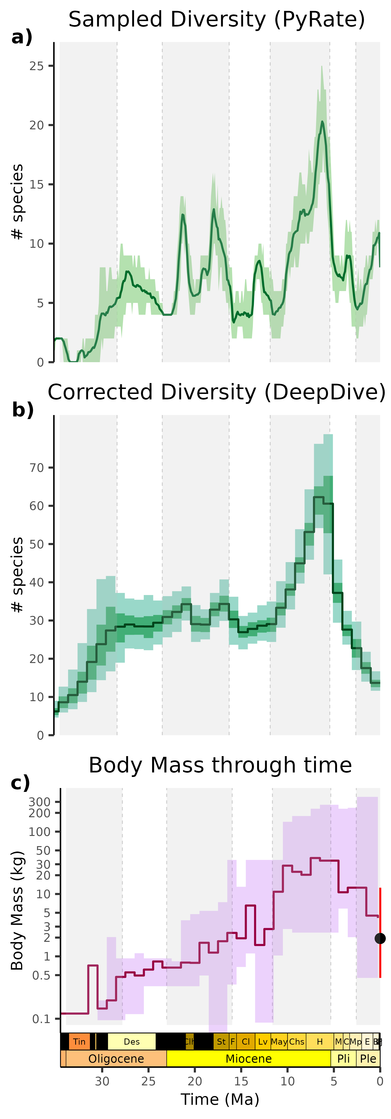
Figure 3: The joint temporal trends in diversity and clade-wise body size evolution of Chinchilloidea. Occurrence-based diversity reconstructions were either produced in a bayesian preservation-aware framework jointly assessing the times of speciation and extinction of each species (Fig. 4) from the temporal occurrence database (PyRate) (i.e., sampled diversity, a), or using a simulation-based deep-learning framework incorporating a wide variety of biases to reconstruct the temporal variations of the ‘true’ (i.e., corrected) diversity in 1-Myr time bins (DeepDive) (b). Body mass through time reconstructions (c, log scale) were produced after binning our body mass estimates of each species in 1-Myr time bins. The body mass of a taxon was included within a given bin if its reconstructed lifespan overlapped with it. The black dot at the right of the plot shows the median body mass of the extant chinchilloids, and the red line shows its range. In all cases, full lines represent median estimates. In (a), the ribbon shows the 95% HPD interval of the diversity estimate across MCMC iterations. In (b), the lighter and darker ribbons respectively encompass 95% and 50% of the per-bin diversity distribution across the 100 DeepDive prediction replicates. In (c), the ribbon depicts the total range of values.
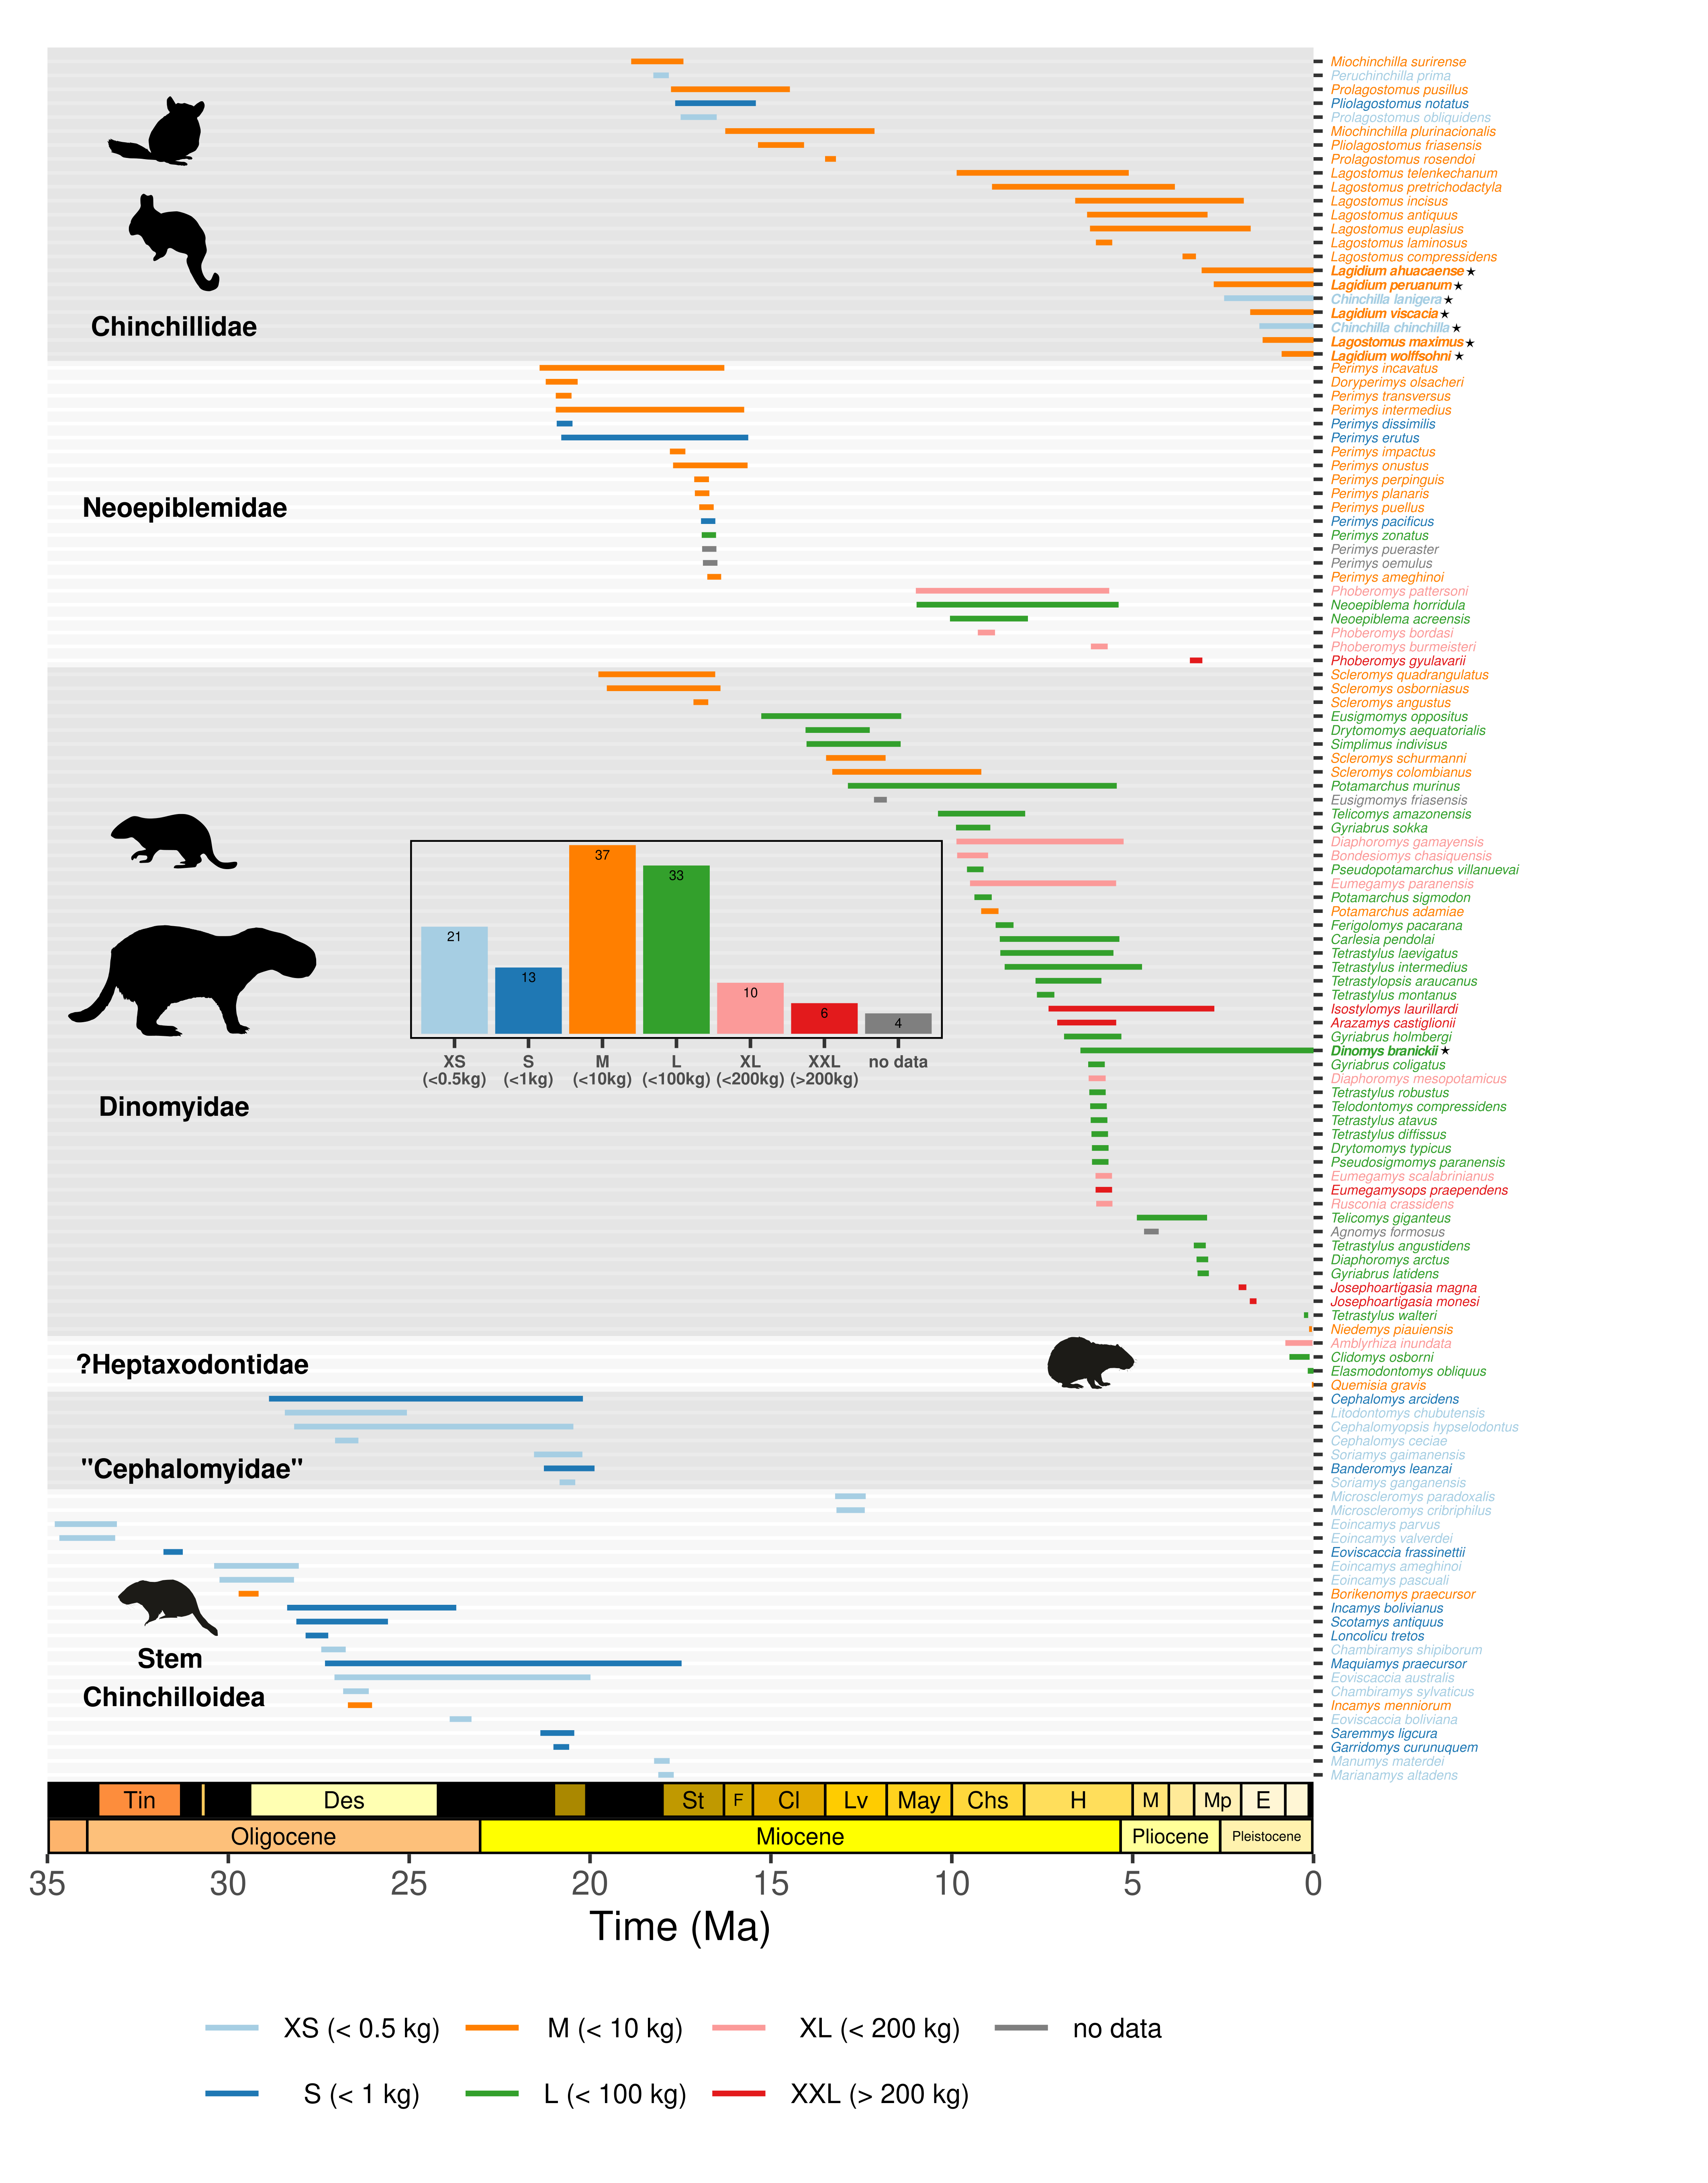
Figure 4: Bayesian reconstruction of the longevities of the 124 chinchilloid species considered in our dataset. Each segment depicts the longevity of a given species, that is, the interval between species’ speciation and extinction times averaged across PyRate runs that achieved convergence. Segments and taxonomic names were coloured according to the body mass category to which species were assigned. The histogram at the centre of the plot shows the number of species within each body mass class. The 8 extant species names are highlighted in bold with a star at the end. Except for Lagostomus maximus, these taxa had almost no fossil record. Consequently, their age of origination was estimated with the method presented in Fig. 2. The first four silhouettes (from top to bottom) are from Phylopic (credits available in Tab. S3). The last two silhouettes (†Elasmodontomys obliquus and †Borikenomys praecursor) were designed by L.M. for a previous work (Marivaux et al. 2020).

Diversification dynamics of Chinchilloidea: a cautionary tale on extant sampling scheme and taxonomy
Our findings revealed that the aforementioned changes in palaeodiversity were due to changes in extinction, not speciation rate during the evolutionary history of the clade.
Indeed, the analyses we conducted using PyRate (rjMCMC algorithm and BDCS model) suggest that the speciation rate of Chinchilloidea has not experienced any significant shift during their evolutionary history (Fig. 5 a,c; Fig. S6 a). In fact, the RJMCMC model appears to detect two marginally significant changes in speciation rate (one in the early Late Oligocene and one in the Early Miocene) (Fig. S6 a). However, when paying attention to the lineage persistence through time, it appears that these most likely arose from the irregularities of the fossil record (Fig. 4). The absence of speciation rate shift aligns with the output of the MBD model, in which speciation rate estimated with exponential correlations with environmental variables also remained constant across the evolutionary history of the group (Fig. 5 g), and was not found significantly associated with any of the variables (Fig. S20). The results obtained with the BDNN model also corroborate this observation. Indeed, when plotted against time, BDNN-inferred marginal speciation rate remained overall stable across the study period (Fig. 5 e, Fig. S16-S17). Also, the coefficients of rate variation across the ten imputation replicates, not differing from expectations under a constant-rate birth–death model (0.23 vs. 0.23, Table S4), suggest an absence of significant speciation rate variation across lineages.
On the other hand, we found compelling evidence for extinction rate variation, both across time (Fig. 5 b,d,f,h) and lineages (Fig. 6 and Tab. S5). A single significant extinction rate shift was captured by the rjMCMC model ca. 6 Ma (Fig. 5 b, Fig. S5 b), coinciding with the onset of the diversity decline described in the previous section (Fig. 3). The significance of this shift was nevertheless altered as we updated our temporal occurrence dataset accounting for a very recent taxonomic revision among the Late Miocene rodent fauna of the Ituzaingó Formation (Entre Ríos Province, Northeast Argentina, Fig. S12) (Rasia 2026). This single-shift extinction pattern persisted at the genus level, but with a 2–3 million-year delay towards the present, instead occurring in the late Pliocene (ca. 3 Ma; Fig. S10-S11). This shift was also detected by the BDCS, BDNN and the MBD models, these three models capturing a possible additional increase in extinction rate during the Middle Miocene (labelled ‘?’ on Fig. 5 d, f, h). Removing singletons from our diversification analyses totally eroded the pattern that we described (Figures S7-S8).
Following our phylogenetically-informed occurrence sampling for the seven extant species lacking fossil record (see Methods), the resulting origination ages of the focal species subsequently estimated with PyRate were slightly younger than divergence ages from the phylogeny (Fig. S3) – except for D. branickii, for which the difference was way more pronounced, as we tailored our sampling scheme to (see Methods). This sampling scheme (leading to the ‘newly-combined’ dataset) had minor effects on downstream reconstructions of palaeodiversity when compared to inferences carried out from datasets either exclusively encompassing fossil occurrences (‘fossil-only’) or in which extant taxa were incorporated by means of a single occurrence of modern age (i.e., min_age = max_age = 0 Ma, ‘biased sampling’) (Fig. S2 g–i). The only noticeable change was the inflation of diversity in the last few million years, sharp in the ‘biased sampling’ case, smooth in the ‘newly-combined’ case, absent in the ‘fossil-only’ case. However, reconstructed diversification rates through time were highly sensitive to the extant sampling scheme. Indeed, as described before, analyses of the ‘newly-combined’ dataset retrieved no significant change in speciation rate, whereas a shift was detected ca. 2.5 Ma with the alternative datasets, either significant (‘fossil-only’ dataset) or strongly-supported (‘biased sampling’ dataset) (Fig. S2 a–c). Also noteworthy, the magnitude of the Late Miocene increase in chinchilloid extinction rate was three times higher in the analysis of the two alternative datasets (Fig. S2 d–f).
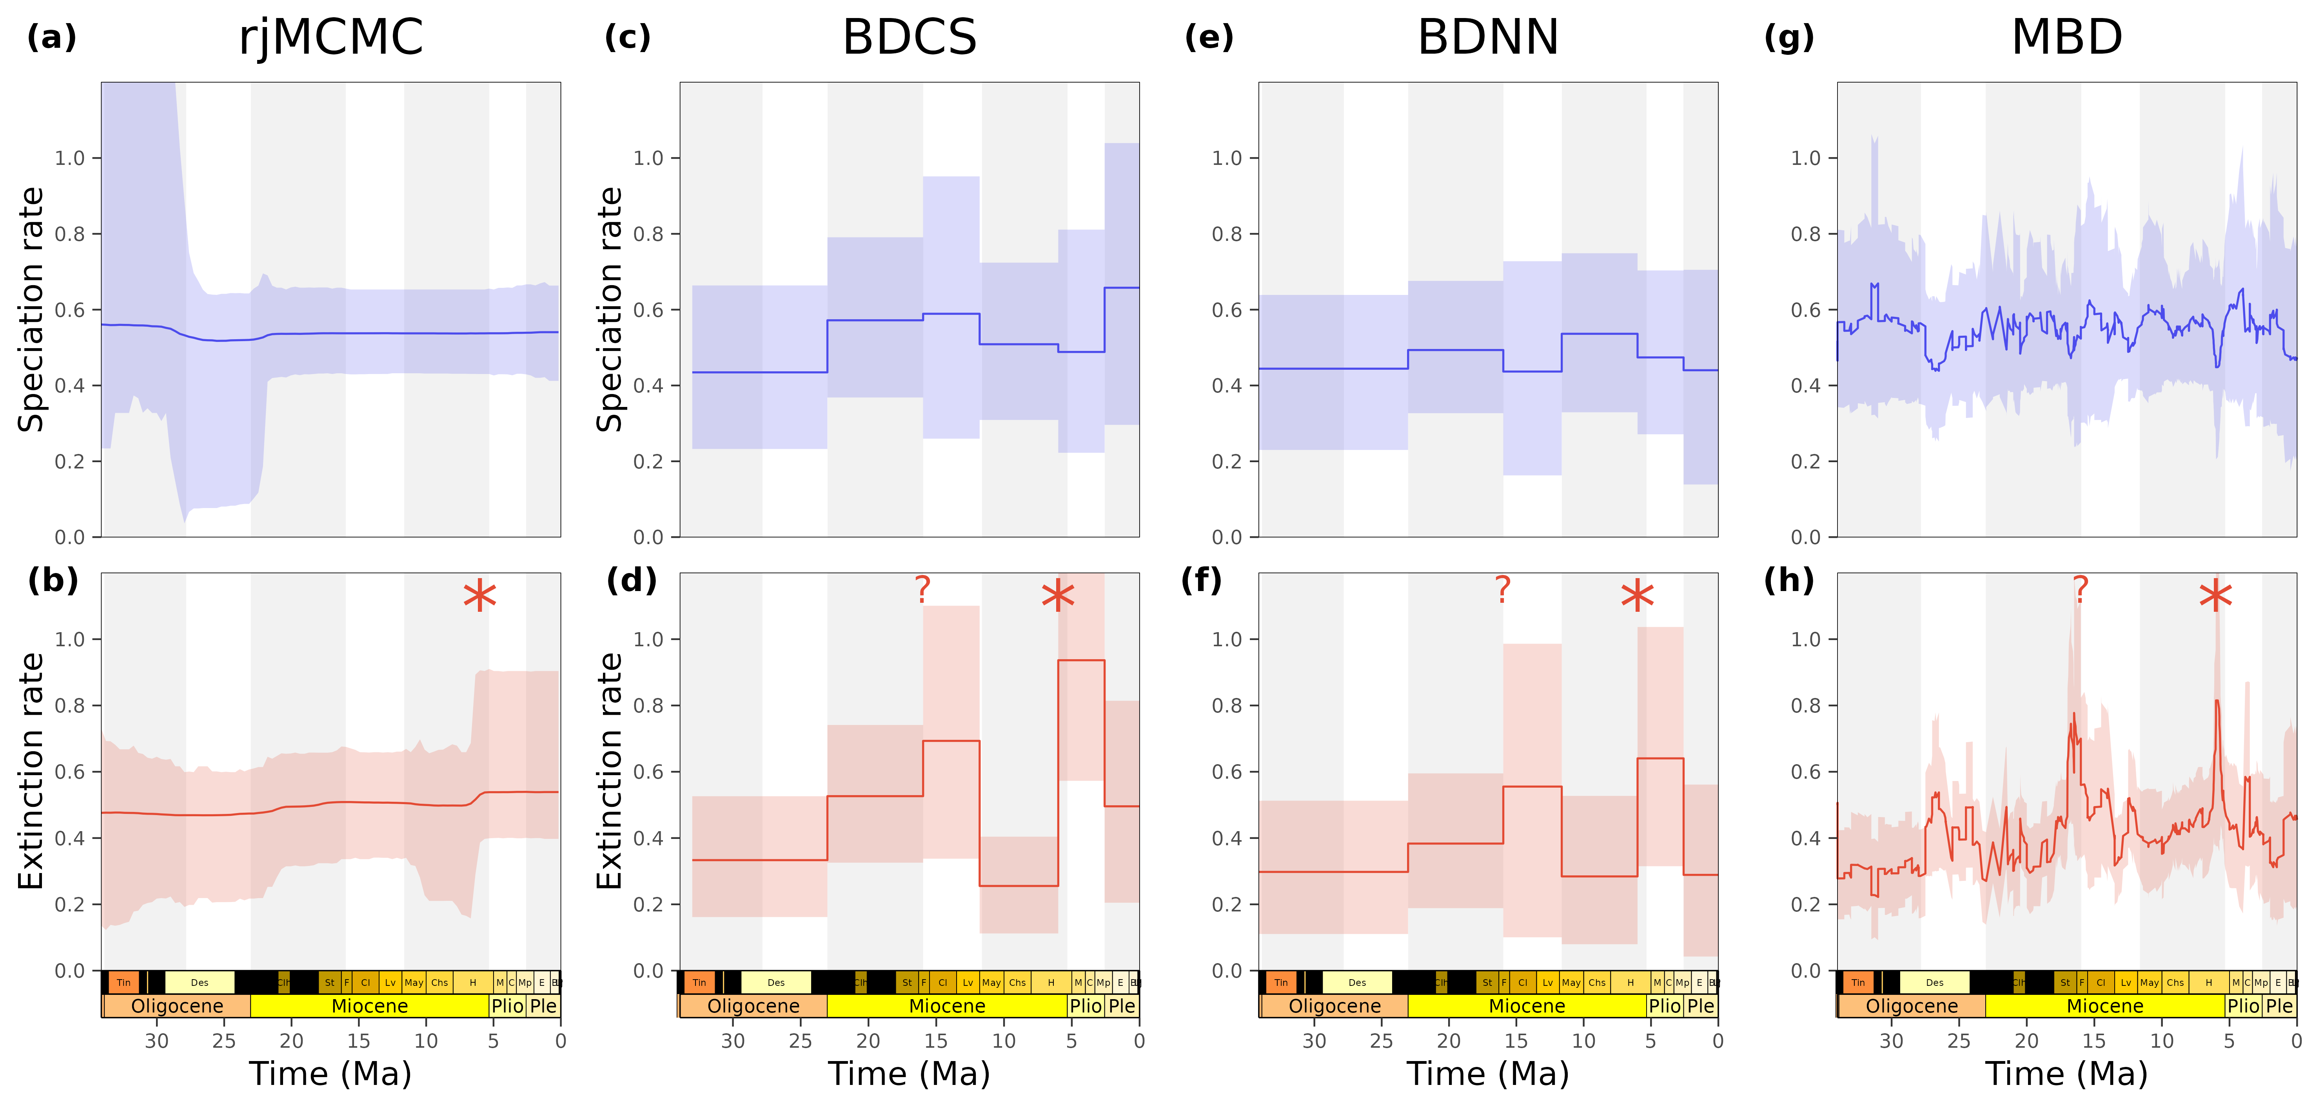
Figure 5: Comparative chinchilloid speciation and extinction rates reconstructed using four Bayesian fossil-based birth–death models. Speciation and extinction rates are respectively depicted in blue and red. (a–b) show the rates estimated by PyRate, using the rjMCMC algorithm (Silvestro et al. 2019). The star indicates a significant rate shift (see Fig. S6). (c–d) show the rates estimated with the Birth–Death model with Constrained Shifts (BDCS) (Silvestro et al. 2015b). (e–f) show the marginal rates estimated with BDNN. These were obtained after imputing missing values for taxa with missing trait estimate. As this procedure was repeated 10 times randomly (see Methods), the rates presented here come from a replicate chosen arbitrarily (replicate 8), but marginal rates through time did not differ across replicates (Fig. S16–S17). Last, (g–h) show the rates through time estimated by the MBD model as linear combinations of environmental variables.

Heterogeneous extinction selectivity across body size classes and latitude, likely enhanced by the Andean uplift and sea-level changes, shaped the decline of Chinchilloidea
Our BDNN analyses revealed that the three best predictors of extinction rate variations across lineages are the (1) Andean uplift, (2) body mass and (3) latitude (Tab. S6). We document a non-linear relationship between extinction rate and the Andean uplift. Lineages from intervals where average Andean elevation was relatively low (900–1400 m) are indeed associated with nearly stable extinction rates. On the contrary, we report a positive relationship between the Andean elevation and extinction rate of lineages from intervals of higher average elevation (> 1500 m; Fig. 6 c). Tropical and extratropical species respectively show a similar response to increasing uplift, altough more pronounced for the second ones (Fig. S24). This overall pattern of uplift-dependent extinction was also conserved across body size classes, except for the smallest taxa (XS; Fig. S25). Furthermore, we evidenced that larger-bodied species had higher extinction rates than smaller-bodied species, with up to a 1.84-fold difference in average values (Fig. 6 a, Tab. S7). The independent rjMCMC analyses that we conducted for each body size class confirmed the higher susceptibility of large-sized taxa to go extinct (Fig. S14 b). These analyses also indicate that the aforementioned Late Miocene increase in chinchilloid extinction rate was mainly driven by these large body-size classes (Fig. S15). Note that chinchilloid assemblages at ca. 6 Ma were mostly composed of large taxa (Fig. 3 c and Fig. 4). Last, on average, tropical species were found to have 1.5-times lower extinction rates than extra-tropical species (Fig. 6 b, Tab. S8). This difference in extinction rate between tropical and extratropical taxa was particularly pronounced in moderate-to-giant classes (i.e., M, L, XL; Fig. S26). We might precise that, in our BDNN analyses, time was always ranked as the least important predictor (Tab. S6), suggesting our environmental and trait variables effectively captured signals of rate variation.
Also, depending on the imputation replicate, hypsodonty was sometimes ranked at the third position among the most important extinction rate predictors (Tab. S6). Our findings indeed highlight differential extinction sensitivities within high-crowned taxa. The extinction rate was indeed on average 1.56 times higher for protohypsodont (rooted) than for euhypsodont (unrooted) species (Tab. S9, Fig. S27). Given their very restricted number of species, it is hard to reliably interpret extinction rate estimations for the two other crown height categories (i.e., brachydont and mesodont, Fig. S7).
The best predictor for inter-lineage extinction rate variations in the Chinchilloidea drastically differs from the factors identified by the MBD model as most influencing extinction rate variations across time. Indeed, our MBD analyses revealed that the only factor significantly associated to the temporal variations of extinction rate is sea-level changes (Fig. 6 d, Tab. S10). This factor was always ranked as the second-to-least important predictor by BDNN (Tab. S6). On the contrary, our MBD analyses failed at relating the pace of chinchilloid extinction to the Andean uplift, which is yet suggested by our BDNN analyses.
Last, our findings revealed a sustained age-dependent extinction pattern over chinchilloid evolutionary history, in which extinction rate decreases with increasing species age (Weibull shape $Φ<1$), both before and after the extinction rate shift that we detected ca. 6 Ma (Fig. S13, Tab. S12).
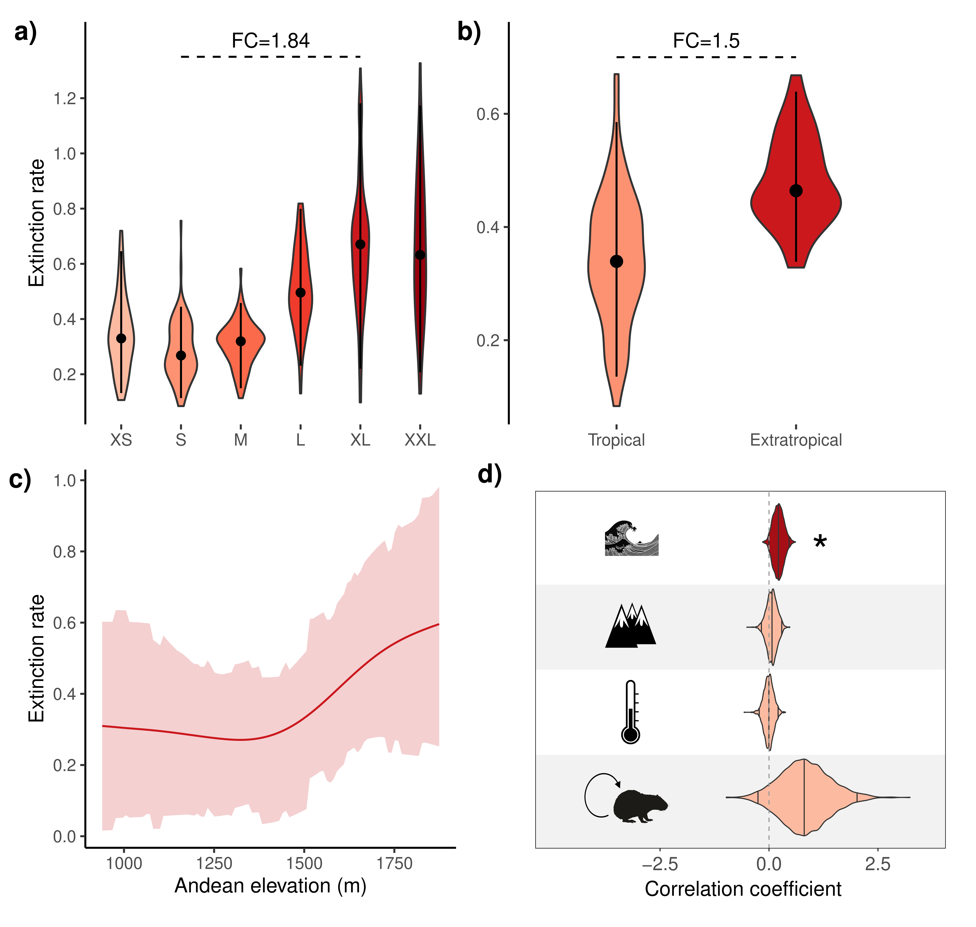
Figure 6: Trait and environmental drivers of chinchilloid extinction rate variations across lineages and time. Plots (a–c) depict the effects of the three best predictors of extinction rate variations across lineages according to the BDNN model (Tab. S6). These include body mass (a), latitude (i.e., tropical vs. extratropical) (b) and the Andean uplift (c). ‘FC’ means ‘Fold Change’. These findings are shown along with the outcome of the MBD analyses, showing the posterior distributions of correlation coefficients between the temporal variations of extinction rate and four biotic and abiotic variables (d). These four variables (from top to bottom) are: sea level changes (Miller et al. 2020), Andean uplift (Boschman and Condamine 2022), regional temperature (Tardif et al. 2025) and self-diversity (i.e., diversity of the group). Significant correlations, i.e., of which the 95% HPD interval does not significantly overlap with zero, are shown in dark red, and non-significant correlations are shown in light red. Vertical bars show the median correlation coefficient and the boundaries of the associated 95% HPD. Note that Caribbean taxa were excluded from all the analyses presented in this figure.

Discussion

The coupled dynamics of chinchilloid diversity and body size disparity
Our findings highlight the coordinated dynamics of body mass evolution and species richness in Chinchilloidea. From the late Eocene–early Oligocene to the Late Miocene, chinchilloids experienced a steady increase in median body size and body size range (Fig. 3 c). Such an increase may illustrate a long-recognised tendency for lineages to increase in body size over evolutionary time, known as Cope’s rule (Cope 1896). A similarly-increasing pattern is suggested by our estimations of diversity through time until the latest Miocene (Fig. 3 a–b). The largest body mass range – together with the largest clade-wise median body mass – were concomitantly achieved when the clade diversity peaked, in the Late Miocene (Fig. 3). Species diversity and body mass disparity then subsequently declined (Fig. 3). This coupled diversity-disparity pattern aligns with seminal macroevolutionary theories, having long postulated the existence of a positive relationship between the dynamics of clade diversity/diversification and morphological evolution. These notably include the adaptive radiation theory (Simpson 1953), the concept of punctuated equilibria (Gould and Eldredge 1977) or the ‘versatility’ hypothesis (Vermeij 1973a, 1973b). A positive relationship between diversity and disparity was supported by empirical case studies on several vertebrate clades (Rabosky et al. 2013; e.g., Hughes et al. 2013; Croft et al. 2018; Cooney and Thomas 2021). However, evidence from a diverse array of study models, including therapsids (Ruta et al. 2013), muroid rodents (Rowe et al. 2011; Alhajeri et al. 2016; Maestri et al. 2017; Missagia et al. 2023) or equids (Cantalapiedra et al. 2017) challenged such a relationship, illustrating a decoupling between species diversity and morphological disparity. In that respect, though with a more restricted taxonomic sampling (and associated trait reconstructions, see Limitations & Perspectives), a recent study analysed the patterns of diversity and morphological (body size and cranio-dental) evolution of Chinchilloidea and their sister group, Octodontoidea (Carrillo et al. 2026). They evidenced a striking pairwise decoupling between the dynamics of disparity and diversity of the two clades, with chinchilloids always maintaining a larger morphological (and particularly body size) disparity with a lower species diversity than octodontoids. We propose that, beyond contradiction, our study illustrates the scale-dependence of the disparity-diversity relationship. Over their evolutionary history, chinchilloids were unquestionably more morphologically diverse but less species-diverse than their sister clade, the octodontoids, thereby suggesting an inter-clade decoupling between diversity and disparity. However, at the intra-clade scale, chinchilloid species diversity and body size disparity were undoubtedly correlated. The dependence of the diversity-disparity relationship to the phylogenetic scale was already illustrated by Cooney and Thomas (2021), finding that the positive relationship between rates of diversification and morphological evolution preferentially arose from large phylogenetic scales. Also noteworthy, a recent study applying phylogenetic comparative methods to the Hystricomorpha clade (including the caviomorph radiation) highlighted a similar scale-dependence (Flores Gasparetto et al. 2026). They indeed evidenced an overall decoupling between that the temporal dynamics of the rates of diversification and morphological evolution at the scale of the entire clade, but coupled dynamics for particular subclades, such as Ctenomyidae.

Drivers of an evolutionary decline
Our findings revealed that chinchilloid evolutionary history was best summarised by a birth–death model with constant speciation and time-variable extinction (Fig. 5; Fig. S6). The absence of temporal variation in speciation rate suggests that the ‘Ent wives’ model of clade demise due to a decrease in speciation/origination rate (Quental and Marshall 2013) fails to explain the macroevolutionary dynamics of chinchilloids, though such a model was found to accurately reflect the decline of several clades (e.g., Condamine et al. 2019a; Condamine et al. 2019b). However, recent findings reaffirmed the importance of species-level extinction over speciation in shaping clade diversity trajectories (Quintero et al. 2025).
The extinction rate increase that we evidenced ca. 6 Ma (latest Miocene) did not apply uniformly to all species of the clade. Rather, extinction rates were higher for larger-bodied and extratropical taxa (Fig. 6 a–b; Fig. S14 b, S15, S26). Size-selective extinction throughout chinchilloid evolution accounts for the 32 kg decline in median body size observed from the Late Miocene to the present (Fig. 3 c). Extinction has traditionally been viewed as a limitation to morphological innovation (e.g., Foote 1993), though recent findings suggested that it can also act as a creative engine depending on the zones of the morphospace where it operates (Balseiro et al. 2025; Esteve 2025). In the case of Chinchilloidea, our results suggest that extinction eroded large-sized regions of the body mass distribution, in turn echoing the long-recognised tendency for large taxa to have higher extinction rates (Raup 1986; Liow et al. 2008). Regarding the latitudinal selectivity of extinction, our findings provided support to the historical ‘Tropical stability’ hypothesis, postulating that the environmental stability offered by tropical regions would buffer tropical taxa against extinction (Wallace 1878). Such a hypothesis received substantial support in the recent literature (e.g., Meseguer and Condamine 2020; Quintero et al. 2023; Buffan et al. 2025). Importantly, our findings also stress the absence of latitudinal decoupling of the factors affecting the dynamics of chinchilloid diversification (Fig. S24 and S26), contrary to what has long been postulated (e.g., Carrillo et al. 2026).
Our BDNN analyses indicate that the pace of the Andean uplift was always identified as the best predictor of extinction rate variations across chinchilloid lineages, with higher elevations associated to higher extinction rates (Fig. 6 c; Fig. S24, S26; Tab. S6). The uplift of the Andes, by generating new niches and re-distributing climatic advections at the continent scale, had major repercussions on South American palaeoenvironments (e.g., Hoorn et al. 2010) and was frequently illustrated as a major driver behind the diversification of a wide range of South American groups (e.g., Lagomarsino et al. 2016; Boschman and Condamine 2022; Vallejos-Garrido et al. 2023; Hoorn et al. 2023). The common paradigm considers the Andean uplift as a positive driver behind diversification, explaining the exceptional diversity of regions such as Western Amazonia, offering an altitudinal gradient (e.g., Upham et al. 2013; Antonelli et al. 2018). However, quantitative analyses of the fossil record of several clades evidenced that the Andean uplift may also promote extinction (e.g., Solórzano et al. 2024; Buffan et al. 2025), which is what our results suggest for the Chinchilloidea.
Given the positive association between the temporal trends of chinchilloid extinction rate and eustatic variations that we retrieved in our MBD analyses (Fig. 6 d), the effect of the Andes on the extinction rate variations across lineages can be interpreted under the lens of continent-wise hydrographic pattern remodelling – it should nevertheless be mentioned that sea level was among the least important predictors for extinction rate variations across lineages in our BDNN analyses (Tab. S6). Several geological and palaeontological studies indeed evidenced that many Late Miocene chinchilloids – and particularly large forms – probably inhabited water-related environments, either foraging in or near water or being semi-aquatic (see Carrillo et al. 2026 and literature therein). Hence, one may expect their macroevolutionary dynamics to be tightly related to the hydrographic history of South America. During most of the Miocene, what is now Western Amazonia was flooded by a vast wetland known as the Pebas Mega-Wetland System (PMWS), recognised to have greatly favoured lineage diversification in tropical South America (e.g., Marivaux et al. 2016; Antoine et al. 2017; Hoorn et al. 2022). Similarly, a marine transgression known as the ‘Paranense sea’ flooded a vast portion of southern South America during the Middle–Late Miocene (Hernández et al. 2005). The environmental heterogeneity that emerged following the final regressive stages of the Paranense sea, during the Late Miocene, has been proposed to have favoured dinomyid diversification in the Mesopotamian region (northeastern Argentina) (Nasif et al. 2013; Candela et al. 2013). Our results fail to quantitatively support a positive imprint of these continent-scale transgressions in chinchilloid diversification. That being said, the Late Miocene demise of the PMWS, a by-product of tectonic (Andean) and eustatic factors (e.g., Hoorn et al. 2022), massively impacted low-latitude ecosystems from South America (e.g., Salas-Gismondi et al. 2015; Jaramillo et al. 2017). Our findings that the Andean elevation, together with sea-level changes, synergetically shaped the decline of Chinchilloidea may therefore be interpreted as a result from the Late Miocene disappearance of the past South American wetlands (Hernández et al. 2005).
We also evidenced heterogeneous extinction rates across hypsodonty classes, with euhypsodont (high-crowned ever-growing cheek teeth) species having attenuated extinction rates (Fig. S27). This result aligns with the common paradigm that continuously-growing cheek teeth, offering a sustainable protection against demanding food items (e.g., abrasive elements), provide more dietary flexibility to taxa that acquired this innovation (Candela et al. 2013). High-crowned cheek teeth emerged early in the evolution of Chinchilloidea. Basal species of the early Oligocene genera $†$Eoincamys and $†$Eoviscaccia were already classified as protohypsodont, meanwhile euhypsodont cheek teeth emerged in the late Oligocene (Deseadan SALMA) and became conspicuous in the Early Miocene (Fig. S7). On the contrary, few chinchilloid taxa have been described with low-crowned cheek teeth (i.e., brachydont and mesodont, Fig. S7). Also noteworthy, by offering the possibility to quantitatively enhance (demanding) food intake, increasing cheek teeth crown heights have been related to the tendency to evolve large body sizes among †Neoepiblemidae and Dinomyidae (Candela et al. 2013). In South America, high-crowned cheek teeth have been acquired several times independently among various lineages of native ungulates (Croft et al. 2020) and caviomorph rodents (e.g., Vucetich et al. 2015; Boivin et al. 2019). A growing body of evidence increasingly suggests that hypsodonty, at least in South American mammals, is not directly associated with grass consumption, as has historically been proposed (e.g., Stebbins 1981; MacFadden 2000), particularly for Chinchillidae, supported by the presence of other craniomandibular innovation associated to grass-eating among the basalmost representatives of this family (Álvarez et al. 2020). Rather, several authors proposed this innovation had to do with the ingestion of exogenous abrasive materials present in the diet, such as grit or volcanic dust (e.g., Billet et al. 2009; Jardine et al. 2012; Selkin et al. 2015; Armella and Croft 2026). Our findings do not permit concluding on the drivers that underlay a better success for euhypsodont chinchilloids. However, by showing that euhypsodont taxa were less prone to extinction, they add another piece of evidence suggesting that this morpho-functional innovation had an adaptive value at macroevolutionary scales for this clade of rodents.
Our analyses failed to provide support for an effect of diversity dependence and temperature change on the diversification dynamics of Chinchilloidea, both across time (Fig. 6 d) and lineages (Tab. S6). Yet, several studies proposed that climate cooling and aridification from the Late Miocene onwards affected diversification dynamics and evolution of large sizes in the Caviomorpha (e.g., Vucetich et al. 2015; Álvarez et al. 2017). On the other hand, despite the wide recognition of the importance of (self-)diversity-dependent effects in the macroevolutionary fate of the clades (e.g., Etienne et al. 2012), recent advances in macroevolutionary modelling have challenged the importance of diversity dependence as a primary driver of diversification rates (Condamine et al. 2019a; Quintero et al. 2025).
The ecologically-selective demise of chinchilloids somewhat mirrors that of sloths (Xenarthra: Folivora), which also experienced a massive decline in both species diversity and body mass disparity over their evolutionary history (Boscaini et al. 2025). This decline, occurring ca. 4 million years ahead that of Chinchilloidea (in the mid-Pleistocene), was characterised by the extinction of all species with terrestrial or semi-arboreal [and aquatic; e.g., Valenzuela-Toro et al. (2025)] lifestyles. The two distantly-related sloth lineages that persisted until the present are small-sized and share an arboreal lifestyle. In the case of Chinchilloidea, large-sized semi-aquatic taxa all went extinct, and the extant small-to-moderate-sized representatives of the group are either found in the Andean Cordillera (six species) or in the plains of Western Amazonia and Argentina (two species).

Limitations and perspectives
Over this work, we proposed a conceptual improvement of the pipeline for putting together data from the fossil record and dated molecular phylogenies of extant taxa for diversification inference introduced by Brée et al. (2022). This pipeline was initially designed for clades for which a large proportion of the extant diversity is missing from the fossil record, and paved insightful avenues to overcome long-formulated concerns around estimating extinction rates from extant timetrees (e.g., Rabosky 2010) meanwhile taking advantage of the invaluable information encapsulated in the fossil record. Our improvement relied on the fact that we no longer considered divergence times leading to extant species (and their 95% HPD) directly as species’ ages of origination ($T_{s}$), as done by Brée et al. (2022), but rather as upper bounds for $T_{s}$. This approach can unfortunately not be validated with simulations and has some part of arbitrary. Nevertheless, since node ages of phylogenies are expected to be older than actual species divergence ages (Arbogast et al. 2002), we argue that, at least conceptually, our approach is relevant. Our analyses evidenced that reconstructions of chinchilloid diversification dynamics were highly impacted by the extant sampling scheme (Fig. S2). In particular, incorporating extant taxa using our new sampling scheme totally eroded any temporal shift in speciation rate, and significantly reduced the magnitude of the Late Miocene shift in extinction rate (Fig. S2). This must be due to the fact that the number of species concerned by this sampling procedure (seven) was actually very close to the number of fossil taxa recorded in the last 5 million years, and thus, that any change in occurrence age would have significant repercussions on the estimation of diversification rates over this time frame. We therefore encourage to take advantage of different sources of data to reconstruct macroevolutionary patterns and to perform sensitivity analyses to evaluate the robustness of the reconstructions to the input data and methodologies.
In addition to the effect of this extant sampling procedure, our findings confirmed the great sensitivity of occurrence-based diversification inference to the input dataset, already evidenced by several studies (Moharrek et al. 2022; e.g., Flannery-Sutherland et al. 2022; Jouault et al. 2022). As expected, incorporating the taxonomic revisions of Rasia (2026) on the hyperdiverse dinomyid fauna from the Late Miocene (Ituzaingó Fm.) of Mesopotamia (Argentina), formerly encompassing many synonymies, significantly eroded the magnitude of the Late Miocene change in extinction regime (Fig. S12). Recently, worries have been expressed about the importance of conducting thorough taxonomic revisions before carrying out occurrence-based analyses of clade diversification relying on online databases (Guinot et al. 2026). Despite the invaluable character of such databases (see https://palaeoverse.org/external) for the whole field of quantitative palaeobiology, the occurrences that they contain are prone to several types of errors (e.g., incorrect or non-updated age assignment, taxonomic issues). Our study primarily relies on data from ‘The Paleobiology Database’, subsequently carefully revised and completed by us (see Methods, Supplementary text and Supplementary Data). A recent work conducted similar reconstructions of the temporal trends in chinchilloid diversity from fossil occurrence data, though their taxonomic sampling was less exhaustive than ours (330 occurrences for 97 species, whereas our species-level fossil occurrence database prior incorporation of extant taxa lacking fossil evidence comprised 466 occurrences for 117 species, see Supplementary Data) (Carrillo et al. 2026). Marked differences in the persistence of some species in the fossil record may be reported between our dataset and theirs (Fig. S22). Overall, these may be summarised in that species tend to persist longer in their database, though this trend is not statistically significant (Fig. S21). This is due to the fact that they preferentially binned occurrences in the corresponding geological stages whereas we intended to use more refined published ages of the corresponding localities/formations when available. In addition, we spotted that 12 of their species had taxonomic issues or were assigned to an incorrect bibliographic reference, making them intractable (Supplementary Data). Despite these contrasts, the outcome of our DeepDive diversity-through-time analyses (Fig. 3 b) did not substantially differ from their reconstruction, both in trends and amplitude. The only noticeable difference is that they estimated higher species diversities throughout the Oligocene–Early Miocene interval compared to us. In light of all these elements and in the continuity of Guinot et al. (2026), we recall the importance of the input data – at the foundation of any empirical study, beyond fancy methodological frameworks – when carrying out macroevolutionary inferences. Despite significant improvements towards common practices in computer-aided occurrence data cleaning (e.g., Jones et al. 2025), taxonomic expertise remains, in our view, essential and non-substitutable when conducting quantitative analyses of the fossil record (but see Gardiner et al. 2026 for some discussion regarding how taxonomic subjectivity may bias the cleaning process).
Also, we uncovered a sustained ADE pattern over the evolutionary history of Chinchilloidea, in which extinction probability decreases with increasing species age (Fig. S13). This ADE pattern conforms to many empirical findings (e.g., Finnegan et al. 2008; Condamine et al. 2019b; Saulsbury et al. 2024; Kocáková et al. 2025), though the opposite trend was also sometimes evidenced (e.g., Condamine et al. 2021; Guinot and Condamine 2023). The idea that older species would be associated to larger geographic range size, in turn buffering against extinction risk has often been considered as an explanation behind this frequent ADE pattern (e.g., McKinney 1997; Condamine et al. 2019b), but has also raised some criticism (Finnegan et al. 2008). Here, it cannot be excluded that this ADE pattern emerged as an artifact, as many of our short-living species are only known from a single occurrence (i.e., singletons), which may narrow their lifespans (Fig. 4).
An additional limitation to this study is the absence of integrative phylogenetic reconstruction for our focal clade. To date, existing phylogenies incorporating the largest number of extinct members of Chinchilloidea have respectively accounted for 18 (Kerber et al. 2020; Busker et al. 2020), 25 (Marivaux et al. 2020) and 41 (Rasia et al. 2021) taxa, thus only a fraction of the 124 species recognised and used over this work. Future directions towards a better understanding of the macroevolutionary dynamics of Chinchilloidea would greatly benefit from the information provided by a phylogeny of increased completeness (work in progress). Information regarding phylogenetic relatedness between taxa has proven relevant in occurrence-based analyses of proboscid diversification dynamics using BDNN (Hauffe et al. 2024). In our case, it cannot be excluded that the trait-diversification relationships that we uncovered are an artefact of phylogenetic inertia (Felsenstein 1985). In addition, phylogeny-based estimates of chinchilloid rate of body size and cranio-dental evolution were already produced by Carrillo et al. (2026), but these findings were limited by the low completeness of the phylogeny that they used (Boivin et al. 2019). A better-resolved phylogeny would thus be of high value to better elucidate the joint dynamics of chinchilloid diversification and body mass evolution. Moreover, State-dependent Speciation and Extinction models (reviewed in Morlon et al. 2024) fitted to such a phylogeny could provide a valuable framework to validate the extinction selectivity that we raised over this work, with larger extratropical species having greater extinction rates (Fig. 6 a–b and Fig. S26). Last, recent development in phylogenetic comparative methods may provide precious insights into the likely abiotic (Clavel and Morlon 2017; Troyer et al. 2022) or biotic (Drury et al. 2016) factors that shaped the dynamics of chinchilloid morphological evolution.
Beyond our findings, many questions around the evolutionary history of Chinchilloidea persist. Some relate to the drivers behind the spectacular and coordinated increase in body size that many caviomorph lineages independently underwent in the Miocene. Whether this unique trajectory stems from intrinsic developmental capacities among hystricognathous rodents, ecological opportunity or a combination of both remains an open question (Vucetich et al. 2015). Given the additional energetic requirements that such large sizes would imply (Damuth 1993), further research would be needed to shed some light on the eco-trophical correlates behind the fascinating emergence of these extreme phenotypes in the framework of rodents, such as microwear texture analysis (e.g., Robinet et al. 2020, 2026b, 2026a).
Last, given that the time frame of the demise of Chinchilloidea could match the onset of the Great American Biotic Interchange (Marshall et al. 1982; Webb 1985), one can also wonder whether such a demise can be related to the arrival of North American migrants, either competing for similar food resources (e.g., herbivores) or preying on them (e.g., carnivorans). Consequently, future research could quantitatively test whether chinchilloid diversification dynamics were affected by the diversity of some North American migrant clades. Seminal macroevolutionary studies highlighted that biotic interactions were among the primary drivers behind the diversification dynamics of a wide range of clades, such as North American canids (Silvestro et al. 2015a), mackerel sharks (Condamine et al. 2019b), gymnosperms (Condamine et al. 2020), antilocaprids (Nascimento and Pires 2025) or ants (Jouault et al. 2026), thus giving some support to the idea that biotic interactions influence clade diversification, known as the ‘Red Queen’ hypothesis (Van Valen 1973; Barnosky 2001).

Concluding remarks
Here, using the South American rodent clade Chinchilloidea as a case study, we provide an illustration of how traits and abiotic factors synergised to shape an evolutionary decline. Applying a multi-approach framework involving Bayesian birth–death models and neural networks to an unprecedented dataset, we show that, over their evolutionary history, the dynamics of chinchilloid diversity and body size disparity were coupled, portraying how the phylogenetic scale impacts the diversity/disparity relationship. The demise of Chinchilloidea resulted from a Late Miocene change in extinction regime, selective against large-sized and extratropical taxa. The increase in extinction rate was likely mediated by the Andean uplift and sea-level changes, possibly pointing towards an implication of the Late Miocene tectonically- and eustatically-controlled collapse of South American large wetlands. Our analyses also failed to retrieve an imprint of long-term temperature dynamics in the macroevolutionary trends of Chinchilloidea, challenging previous hypotheses. We also pinpoint the sensitivity of occurrence-based approaches to reconstruct clade diversification dynamics to the input data, emphasising the importance of cleaning as well as combining several sources of data (i.e., the fossil record and phylogenies of extant taxa) to address macroevolutionary issues.

Acknowledgements
We are grateful to Torsten Hauffe (University of Fribourg), Rebecca B. Cooper (Naturhistorisk Museum Oslo), Bethany J. Allen (Postdam University) and Gildas Merceron (University of Poitiers) for their helpful methodological advice. We also thank Guillaume Guinot (University of Montpellier) for useful feedbacks and recommendations. L.B. was funded by a grant offered by the École Normale Supérieure de Lyon. This work received support from the French Agence Nationale de la Recherche (ANR) in the framework of the GAARAnti program (ANR-17-CE31-0009); the LabEx CEBA (ANR-10-LABX-25-01), through the EMERGENCE project; and the ANPCyT FONCYT PICT-2021-I-INVI-00045.

References
Alhajeri B.H., Schenk J.J., Steppan S.J. 2016. Ecomorphological diversification following continental colonization in muroid rodents (Rodentia: Muroidea). Biological Journal of the Linnean Society. 117:463–481.
Álvarez A., Arévalo R.L.M., Verzi D.H. 2017. Diversification patterns and size evolution in caviomorph rodents. Biological Journal of the Linnean Society. 121:907–922.
Álvarez A., Ercoli M.D., Verzi D.H. 2020. Integration and diversity of the caviomorph mandible (rodentia: Hystricomorpha): Assessing the evolutionary history through fossils and ancestral shape reconstructions. Zoological Journal of the Linnean Society. 188:276–301.
Antoine P.-O., Salas-Gismondi R., Pujos F., Ganerød M., Marivaux L. 2017. Western Amazonia as a Hotspot of Mammalian Biodiversity Throughout the Cenozoic. Journal of Mammalian Evolution. 24:5–17.
Antoine P.-O., Yans J., Castillo A.A., Stutz N., Abello M.A., Adnet S., Custódio M.A., Benites-Palomino A., Billet G., Boivin M., Herrera F., Jaramillo C., Mártinez C., Moreno F., Navarrete R.E., Negri F.R., Parra F., Pujos F., Rage J.-C., Ribeiro A.M., Robinet C., Roddaz M., Tejada-Lara J.V., Varas-Malca R., Ventura Santos R., Salas-Gismondi R., Marivaux L. 2021. Biotic community and landscape changes around the EoceneOligocene transition at Shapaja, Peruvian Amazonia: Regional or global drivers? Global and Planetary Change. 202:103512.
Antonelli A., Kissling W.D., Flantua S.G.A., Bermúdez M.A., Mulch A., Muellner-Riehl A.N., Kreft H., Linder H.P., Badgley C., Fjeldså J., Fritz S.A., Rahbek C., Herman F., Hooghiemstra H., Hoorn C. 2018. Geological and climatic influences on mountain biodiversity. Nature Geoscience. 11:718–725.
Antonelli A., Nylander J.A.A., Persson C., Sanmartín I. 2009. Tracing the impact of the Andean uplift on Neotropical plant evolution. Proceedings of the National Academy of Sciences. 106:9749–9754.
Arbogast B.S., Edwards S.V., Wakeley J., Beerli P., Slowinski J.B. 2002. Estimating Divergence Times from Molecular Data on Phylogenetic and Population Genetic Timescales. Annual Review of Ecology, Evolution, and Systematics. 33:707–740.
Armella M.A., Croft D.A. 2026. Pass on the grass? The unexpected “last supper” of hypselodont Pachyrukhinae (Notoungulata, Mammalia) from the late Neogene of northwestern Argentina. Palaeogeography, Palaeoclimatology, Palaeoecology. 687:113585.
Arnal M., Kay R.F., Valdivia L.A., Salenbien W., Morse P.E., Borths M.R., Williams B.A., Riddle C., Martínez J.-N., Gonzales L.A. 2026. New Early Miocene hystricognath rodents (Caviomorpha) from the Madre de Dios River in the southeastern Peruvian Amazon. Papers in Palaeontology. 12:e70064.
Balseiro D., Serra F., Bignon A. 2025. Extinction drives both expansion and contraction of morphological disparity in trilobites. Proceedings B.
Barnosky A.D. 2001. Distinguishing the effects of the Red Queen and Court Jester on Miocene mammal evolution in the northern Rocky mountains. Journal of Vertebrate Paleontology. 21:172–185.
Benton M.J. 2009. The Red Queen and the Court Jester: Species Diversity and the Role of Biotic and Abiotic Factors Through Time. Science. 323:728–732.
Bianucci G., Lambert O., Urbina M., Merella M., Collareta A., Bennion R., Salas-Gismondi R., Benites-Palomino A., Post K., Muizon C. de, Bosio G., Di Celma C., Malinverno E., Pierantoni P.P., Villa I.M., Amson E. 2023. A heavyweight early whale pushes the boundaries of vertebrate morphology. Nature. 620:824–829.
Biknevicius A.R., Macfarlane D.A., MacPhee R.D.E. 1993. Body size in Amblyrhiza inundata (Rodentia: Caviomorpha), an extinct megafaunal rodent from the Anguilla Bank, West Indies: Estimates and implications. American Museum Novitates.:1–25.
Billet G., Blondel C., Muizon C. de. 2009. Dental microwear analysis of notoungulates (Mammalia) from Salla (Late Oligocene, Bolivia) and discussion on their precocious hypsodonty. Palaeogeography, Palaeoclimatology, Palaeoecology. 274:114–124.
Blandin P., Morris B. 2007. The systematics of the genus *morpho*, fabricius, 1807:(lepidoptera nymphalidae, morphinae). Hillside Books.
Boessenecker R.W., Ehret D.J., Long D.J., Churchill M., Martin E., Boessenecker S.J. 2019. The Early Pliocene extinction of the mega-toothed shark Otodus megalodon: a view from the eastern North Pacific. PeerJ. 7:e6088.
Boivin M., Álvarez A., Ercoli M.D., Moyano S.R., Salgado-Ahumada J.S., Tejerina A.M.O., Cassini G.H. 2024. Body mass estimation from cheek tooth measurements in extinct caviomorphs (Ctenohystrica, Hystricognathi): the importance of predictor, reference sample and method. Journal of Mammalian Evolution. 31:43.
Boivin M., Marivaux L., Antoine P.-O. 2019. L’apport du registre paléogène d’Amazonie sur la diversification initiale des Caviomorpha (Hystricognathi, Rodentia): Implications phylogénétiques, macroévolutives et paléobiogéographiques. Geodiversitas. 41:143–245.
Boscaini A., Casali D.M., Toledo N., Cantalapiedra J.L., Bargo M.S., De Iuliis G., Gaudin T.J., Langer M.C., Narducci R., Pujos F., Soto E.M., Vizcaíno S.F., Soto I.M. 2025. The emergence and demise of giant sloths. Science. 388:864–868.
Boschman L.M., Condamine F.L. 2022. Mountain radiations are not only rapid and recent: Ancient diversification of South American frog and lizard families related to Paleogene Andean orogeny and Cenozoic climate variations. Global and Planetary Change. 208:103704.
Brandoni D., Ruiz L.G., Tejedor M.F., Martin G., Fleagle J.G. 2016. Megatherioidea (Mammalia, Xenarthra, Tardigrada) from the Pinturas Formation (Early Miocene), Santa Cruz Province (Argentina) and their chronological implications. PalZ. 90:619–628.
Brée B., Condamine F.L., Guinot G. 2022. Combining palaeontological and neontological data shows a delayed diversification burst of carcharhiniform sharks likely mediated by environmental change. Scientific Reports. 12:21906.
Buffan L., Condamine F.L., Stutz N.S., Pujos F., Antoine P.-O., Marivaux L. 2025. The fate of South America’s endemic mammalian fauna in response to the most dramatic Cenozoic climate disruption. Proceedings of the National Academy of Sciences. 122:e2419520122.
Burgin C.J., Zijlstra J.S., Becker M.A., Handika H., Alston J.M., Widness J., Liphardt S., Huckaby D.G., Upham N.S. 2025. How many mammal species are there now? Updates and trends in taxonomic, nomenclatural, and geographic knowledge.
Busker F., Dozo M.T., Soto I.M. 2020. New remains of Cephalomys arcidens (Rodentia, Caviomorpha) and a redefinition of the enigmatic Cephalomyidae. Journal of Systematic Palaeontology. 18:1589–1629.
Candela A.M. 2005. Los roedores del Mesopotamiense (Mioceno tardío, Formación Ituzaingó) de la provincia de Entre Ríos (Argentina). Temas de la Biodiversidad del Litoral fluvial argentino II.:37–48.
Candela A.M., Cassini G.H., Nasif N.L. 2013. Fractal dimension and cheek teeth crown complexity in the giant rodent Eumegamys paranensis. Lethaia. 46:369–377.
Cantalapiedra J.L., Prado J.L., Hernández Fernández M., Alberdi M.T. 2017. Decoupled ecomorphological evolution and diversification in Neogene-Quaternary horses. Science. 355:627–630.
Carrillo J.D., Torres Jimenez M.F., Urrea-Barreto F.J., Pino K., Cooper R.B., Antonelli A., Bacon C.D., Faurby S., Silvestro D. 2026. Decoupled diversity and disparity after faunistic turnover in caviomorph rodents. Proceedings of the Royal Society B: Biological Sciences. 293:20252586.
Chiarenza A.A., Farnsworth A., Mannion P.D., Lunt D.J., Valdes P.J., Morgan J.V., Allison P.A. 2020. Asteroid impact, not volcanism, caused the end-Cretaceous dinosaur extinction. Proceedings of the National Academy of Sciences. 117:17084–17093.
Clavel J., Morlon H. 2017. Accelerated body size evolution during cold climatic periods in the Cenozoic. Proceedings of the National Academy of Sciences. 114:4183–4188.
Cohen K., Harper D., Gibbard P., Car N. 2025. The ICS international chronostratigraphic chart this decade. Episodes Journal of International Geoscience. 48:105–115.
Condamine F.L., Guinot G., Benton M.J., Currie P.J. 2021. Dinosaur biodiversity declined well before the asteroid impact, influenced by ecological and environmental pressures. Nature Communications. 12:3833.
Condamine F.L., Rolland J., Höhna S., Sperling F.A.H., Sanmartín I. 2018. Testing the Role of the Red Queen and Court Jester as Drivers of the Macroevolution of Apollo Butterflies. Systematic Biology. 67:940–964.
Condamine F.L., Rolland J., Morlon H. 2019a. Assessing the causes of diversification slowdowns: temperature-dependent and diversity-dependent models receive equivalent support. Ecology Letters. 22:1900–1912.
Condamine F.L., Romieu J., Guinot G. 2019b. Climate cooling and clade competition likely drove the decline of lamniform sharks. Proc. Nat. Acad. Sc. U.S.A. 116.
Condamine F.L., Silvestro D., Koppelhus E.B., Antonelli A. 2020. The rise of angiosperms pushed conifers to decline during global cooling. Proceedings of the National Academy of Sciences. 117:28867–28875.
Cooney C.R., Thomas G.H. 2021. Heterogeneous relationships between rates of speciation and body size evolution across vertebrate clades. Nature Ecology & Evolution. 5:101–110.
Cooper R.B., Allen B.J., Silvestro D. 2025. DeepDiveRA software for deep learning estimation of palaeodiversity from fossil occurrences. Methods in Ecology and Evolution. 16:1923–1934.
Cooper R.B., Flannery-Sutherland J.T., Silvestro D. 2024. DeepDive: estimating global biodiversity patterns through time using deep learning. Nature Communications. 15:4199.
Cope E.D. 1896. The primary factors of organic evolution. The Open Court Publishing Company.
Croft D.A., Engelman R.K., Dolgushina T., Wesley G. 2018. Diversity and disparity of sparassodonts (metatheria) reveal non-analogue nature of ancient south american mammalian carnivore guilds. Proceedings of the Royal Society B: Biological Sciences. 285:20172012.
Croft D.A., Gelfo J.N., López G.M. 2020. Splendid Innovation: The Extinct South American Native Ungulates. Annual Review of Earth and Planetary Sciences. 48:259–290.
Cuitiño J.I., Sol Raigemborn M., Susana Bargo M., Vizcaíno S.F., Muñoz N.A., Kohn M.J., Kay R.F. 2021. Insights on the controls on floodplain-dominated fluvial successions: A perspective from the EarlyMiddle Miocene Santa Cruz Formation in Río Chalía (Patagonia, Argentina). Journal of the Geological Society. 178:jgs2020–188.
Damuth J. 1993. Cope’s rule, the island rule and the scaling of mammalian population density. Nature. 365:748–750.
Drury J., Clavel J., Manceau M., Morlon H. 2016. Estimating the Effect of Competition on Trait Evolution Using Maximum Likelihood Inference. Systematic Biology. 65:700–710.
Dunn R.E., Madden R.H., Kohn M.J., Schmitz M.D., Strömberg C.A.E., Carlini A.A., Ré G.H., Crowley J. 2013. A new chronology for middle Eocene−early Miocene South American Land Mammal Ages. GSA Bulletin. 125:539–555.
Esteve J. 2025. When extinction expands morphospace: Lessons from trilobites. Proceedings of the Royal Society B: Biological Sciences. 292:20252245.
Etienne R.S., Haegeman B., Stadler T., Aze T., Pearson P.N., Purvis A., Phillimore A.B. 2012. Diversity-dependence brings molecular phylogenies closer to agreement with the fossil record. Proceedings of the Royal Society B: Biological Sciences. 279:1300–1309.
Felsenstein J. 1985. Phylogenies and the Comparative Method. The American Naturalist. 125:1–15.
Fernicola J.C., Vizcaíno S.F., Bargo M.S., Kay R.F., Cuitiño J.I. 2019. Analysis of the EarlyMiddle Miocene mammal associations at the río Santa Cruz (Patagonia, Argentina). Publicación Electrónica de la Asociación Paleontológica Argentina. 19.
Finnegan S., Payne J.L., Wang S.C. 2008. The Red Queen Revisited: Reevaluating the Age Selectivity of Phanerozoic Marine Genus Extinctions. Paleobiology. 34:318–341.
Flannery-Sutherland J.T., Silvestro D., Benton M.J. 2022. Global diversity dynamics in the fossil record are regionally heterogeneous. Nature Communications. 13:2751.
Flores Gasparetto L., Upham N.S., Patterson B.D., de Freitas T.R.O., Maestri R. 2026. Diversity and disparity are decoupled in the most ecomorphologically diverse rodent radiation. Evolution.:qpag124.
Foote M. 1993. Discordance and concordance between morphological and taxonomic diversity. Paleobiology. 19:185–204.
Gardiner A., Mathes G.H., Cooper R., Kocáková K., Villafaña J.A., Silvestro D., Pimiento C. 2026. Robust evidence for modest diversity loss across the K/Pg in neoselachians: Response to Guinot et al.
Gould S.J., Eldredge N. 1977. Punctuated equilibria: the tempo and mode of evolution reconsidered. Paleobiology. 3:115–151.
Guayasamin J.M., Ribas C.C., Carnaval A.C., Carrillo J.D., Hoorn C., Lohmann L.G., Riff D., Ulloa Ulloa C., Albert J.S. 2024. Evolution of Amazonian biodiversity: A review. Acta Amazonica. 54:e54bc21360.
Guinot G., Adnet S., Cuny G., Feichtinger I., Shimada K., Siversson M., Underwood C.J., Vullo R., Ward D.J., Condamine F.L. 2026. Fossil-based analyses of clades’ diversification patterns require taxonomic expertise and appropriate methodology.
Guinot G., Condamine F.L. 2023. Global impact and selectivity of the Cretaceous-Paleogene mass extinction among sharks, skates, and rays. Science. 379:802–806.
Hagen O., Andermann T., Quental T.B., Antonelli A., Silvestro D. 2018. Estimating Age-Dependent Extinction: Contrasting Evidence from Fossils and Phylogenies. Systematic Biology. 67:458–474.
Hauffe T., Cantalapiedra J.L., Silvestro D. 2024. Trait-mediated speciation and human-driven extinctions in proboscideans revealed by unsupervised bayesian neural networks. Science Advances. 10:eadl2643.
Hernández R.M., Jordan T.E., Dalenz Farjat A., Echavarría L., Idleman B.D., Reynolds J.H. 2005. Age, distribution, tectonics, and eustatic controls of the Paranense and Caribbean marine transgressions in southern Bolivia and Argentina. Journal of South American Earth Sciences. 19:495–512.
Hoorn C., Boschman L.M., Kukla T., Sciumbata M., Val P. 2022. The Miocene wetland of western Amazonia and its role in Neotropical biogeography. Botanical Journal of the Linnean Society. 199:25–35.
Hoorn C., Guerrero J., Sarmiento G.A., Lorente M.A. 1995. Andean tectonics as a cause for changing drainage patterns in Miocene northern South America. Geology. 23:237.
Hoorn C., Lohmann L.G., Boschman L.M., Condamine F.L. 2023. Neogene History of the Amazonian Flora: A Perspective Based on Geological, Palynological, and Molecular Phylogenetic Data. Annual Review of Earth and Planetary Sciences. 51:419–446.
Hoorn C., Wesselingh F.P., Steege H. ter, Bermudez M.A., Mora A., Sevink J., Sanmartín I., Sanchez-Meseguer A., Anderson C.L., Figueiredo J.P., Jaramillo C., Riff D., Negri F.R., Hooghiemstra H., Lundberg J., Stadler T., Särkinen T., Antonelli A. 2010. Amazonia Through Time: Andean Uplift, Climate Change, Landscape Evolution, and Biodiversity. Science. 330:927–931.
Hughes M., Gerber S., Wills M.A. 2013. Clades reach highest morphological disparity early in their evolution. Proceedings of the National Academy of Sciences. 110:13875–13879.
Jablonski D. 2017. Approaches to Macroevolution: 2. Sorting of Variation, Some Overarching Issues, and General Conclusions. Evolutionary Biology. 44:451–475.
Janis C.M. 1988. An estimation of tooth volume and hypsodonty indices in ungulate mammals, and the correlation of these factors with dietary preferences. Mémoires du Moséum d’Histoire Naturelle de Paris.:367–387.
Jaramillo C., Romero I., D’Apolito C., Bayona G., Duarte E., Louwye S., Escobar J., Luque J., Carrillo-Briceño J.D., Zapata V., Mora A., Schouten S., Zavada M., Harrington G., Ortiz J., Wesselingh F.P. 2017. Miocene flooding events of western Amazonia. Science Advances. 3:e1601693.
Jardine P.E., Janis C.M., Sahney S., Benton M.J. 2012. Grit not grass: Concordant patterns of early origin of hypsodonty in Great Plains ungulates and Glires. Palaeogeography, Palaeoclimatology, Palaeoecology. 365-366:1–10.
Jones L.A., Dean C.D., Allen B.J., Drage H.B., Flannery-Sutherland J.T., Gearty W., Chiarenza A.A., Dillon E.M., Farina B.M., Godoy P.L. 2025. Ten simple rules to follow when cleaning occurrence data in palaeobiology. Palaeontology. 68:e70028.
Jouault C., Condamine F.L., Legendre F., Perrichot V. 2024. The Angiosperm Terrestrial Revolution buffered ants against extinction. Proc. Nat. Acad. Sc. U.S.A. 121:e2317795121.
Jouault C., Nel A., Legendre F., Condamine F.L. 2022. Estimating the Drivers of Diversification of Stoneflies Through Time and the Limits of Their Fossil Record. Insect Systematics and Diversity. 6:4.
Jouault C., Swain A., Sosiak C. 2026. Diversity-dependent effects probably influenced the diversification of species-rich crown ant subfamilies during the Cenozoic. R Soc Open Sci. 13:252318.
Kass R.E., Raftery A.E. 1995. Bayes Factors. Journal of the American Statistical Association. 90:773–795.
Kerber L., Candela A.M., Ferreira J.D., Pretto F.A., Bubadué J., Negri F.R. 2022. Postcranial Morphology of the Extinct Rodent Neoepiblema (Rodentia: Chinchilloidea): Insights Into the Paleobiology of Neoepiblemids. Journal of Mammalian Evolution. 29:207–235.
Kerber L., Mayer E.L., Gomes A.C., Nasif N. 2020. On the morphological, taxonomic, and phylogenetic status of South American Quaternary dinomyid rodents (Rodentia: Dinomyidae). PalZ. 94:167–178.
Kocáková K., Silvestro D., Mathes G.H., Villafaña J.A., Pimiento C. 2025. Global extinction events and persistent age-dependency in sharks and rays over the past 145 million years. Proceedings of the Royal Society B: Biological Sciences. 292:20252272.
Lagomarsino L.P., Condamine F.L., Antonelli A., Mulch A., Davis C.C. 2016. The abiotic and biotic drivers of rapid diversification in Andean bellflowers (Campanulaceae). New Phytologist. 210:1430–1442.
Lehtonen S., Silvestro D., Karger D.N., Scotese C., Tuomisto H., Kessler M., Peña C., Wahlberg N., Antonelli A. 2017. Environmentally driven extinction and opportunistic origination explain fern diversification patterns. Scientific Reports. 7:4831.
Liow L.H., Fortelius M., Bingham E., Lintulaakso K., Mannila H., Flynn L., Stenseth N.Chr. 2008. Higher origination and extinction rates in larger mammals. Proceedings of the National Academy of Sciences. 105:6097–6102.
Liow L.H., Quental T.B., Marshall C.R. 2010. When Can Decreasing Diversification Rates Be Detected with Molecular Phylogenies and the Fossil Record? Systematic Biology. 59:646–659.
MacFadden B.J. 2000. Cenozoic Mammalian Herbivores From the Americas: Reconstructing Ancient Diets and Terrestrial Communities. Annual Review of Ecology and Systematics. 31:33–59.
Maestri R., Monteiro L.R., Fornel R., Upham N.S., Patterson B.D., Freitas T.R.O. de. 2017. The ecology of a continental evolutionary radiation: Is the radiation of sigmodontine rodents adaptive? Evolution. 71:610–632.
Marion A.F.P., Condamine F.L., Guinot G. 2025. Bioluminescence and repeated deep-sea colonization shaped the diversification and body size evolution of squaliform sharks. Proceedings of the Royal Society B: Biological Sciences. 292:20242932.
Marivaux L., Adnet S., Altamirano-Sierra A.J., Pujos F., Ramdarshan A., Salas-Gismondi R., Tejada-Lara J.V., Antoine P.-O. 2016. Dental remains of cebid platyrrhines from the earliest late Miocene of Western Amazonia, Peru: Macroevolutionary implications on the extant capuchin and marmoset lineages. American Journal of Physical Anthropology. 161:478–493.
Marivaux L., Vélez-Juarbe J., Merzeraud G., Pujos F., Viñola López L.W., Boivin M., Santos-Mercado H., Cruz E.J., Grajales A., Padilla J., Vélez-Rosado K.I., Philippon M., Léticée J.-L., Münch P., Antoine P.-O. 2020. Early Oligocene chinchilloid caviomorphs from Puerto Rico and the initial rodent colonization of the West Indies. Proceedings of the Royal Society B: Biological Sciences. 287:20192806.
Marshall L.G., Webb S.D., Sepkoski J.J., Raup D.M. 1982. Mammalian Evolution and the Great American Interchange. Science. 215:1351–1357.
McFarlane D.A., MacPhee R.D.E., Ford D.C. 1998. Body Size Variability and a Sangamonian Extinction Model for Amblyrhiza,a West Indian Megafaunal Rodent. Quaternary Research. 50:80–89.
McKinney M.L. 1997. Extinction Vulnerability and Selectivity: Combining Ecological and Paleontological Views. Annual Review of Ecology, Evolution, and Systematics. 28:495–516.
Meiri S., Cooper N., Purvis A. 2007. The island rule: Made to be broken? Proceedings of the Royal Society B: Biological Sciences. 275:141–148.
Meseguer A.S., Condamine F.L. 2020. Ancient tropical extinctions at high latitudes contributed to the latitudinal diversity gradient. Evolution. 74:1966–1987.
Miller K.G., Browning J.V., Schmelz W.J., Kopp R.E., Mountain G.S., Wright J.D. 2020. Cenozoic sea-level and cryospheric evolution from deep-sea geochemical and continental margin records. Science Advances. 6:eaaz1346.
Missagia R.V., Casali D.M., Patterson B.D., Perini F.A. 2023. Decoupled Patterns of Diversity and Disparity Characterize an Ecologically Specialized Lineage of Neotropical Cricetids. Evolutionary Biology. 50:181–196.
Moharrek F., Taylor P.D., Silvestro D., Jenkins H.L., Gordon D.P., Waeschenbach A. 2022. Diversification dynamics of cheilostome bryozoans based on a Bayesian analysis of the fossil record. Palaeontology. 65:e12586.
Mones A. 1982. An equivocal nomenclature: What means hypsodonty? Paläontologische Zeitschrift. 56:107–111.
Morlon H., Andréoletti J., Barido-Sottani J., Lambert S., Perez-Lamarque B., Quintero I., Senderov V., Veron P. 2024. Phylogenetic Insights into Diversification. Annual Review of Ecology, Evolution, and Systematics.
Muñoz C.O.R., Bonini R., Hemming S., Cenizo M., Pardiñas U.F.J., Prevosti F.J. 2023. Advances in the understanding of Neogene mammalian fauna in the pampean region (Central Argentina) through revising “biozone” hypotheses based on new dates and biochronological analyses. Ameghiniana. 60:465–491.
Murphy J.C., Henderson R.W. 1997. Tales of giant snakes: A historical natural history of anacondas and pythons. Krieger Publishing Company USA.
Nascimento J.C.S., Pires M.M. 2025. Open ecosystems expansion, competition and predation shaped the evolution of Antilocapridae. Evolution.:qpaf091.
Nasif N.L., Candela A.M., Rasia L., Jaén M.C.M. 2013. Actualización del conocimiento de los roedores del Mioceno tardío de la Mesopotamia argentina: aspectos sistemáticos, evolutivos y paleobiogeográficos. p. 147–163.
Ogg J.G. 2020. Geomagnetic Polarity Time Scale. In: Gradstein F.M., Ogg J.G., Schmitz M.D., Ogg G.M., editors. Geologic time scale 2020. Elsevier. p. 159–192.
Patton J.L., Pardiñas U.F.J., D’Elía G. 2015. Mammals of South America, Volume 2: Rodents. Chicago, IL: University of Chicago Press.
Pérez M.E. 2010. A new rodent (Cavioidea, Hystricognathi) from the middle Miocene of Patagonia, mandibular homologies, and the origin of the crown group Cavioidea sensu stricto. Journal of Vertebrate Paleontology. 30:1848–1859.
Pimiento C., Cantalapiedra J.L., Shimada K., Field D.J., Smaers J.B. 2019. Evolutionary pathways toward gigantism in sharks and rays. Evolution. 73:588–599.
Quental T.B., Marshall C.R. 2013. How the Red Queen Drives Terrestrial Mammals to Extinction. Science. 341:290–292.
Quintero I., Andréoletti J., Silvestro D., Morlon H. 2025. Loss of macroevolutionary species fitness explains the rise and fall of clades. Nat Ecol Evol.:1–12.
Quintero I., Landis M.J., Jetz W., Morlon H. 2023. The build-up of the present-day tropical diversity of tetrapods. Proceedings of the National Academy of Sciences. 120:e2220672120.
Rabosky D.L. 2010. Extinction rates should not be estimated from molecular phylogenies. Evolution. 64:1816–1824.
Rabosky D.L., Santini F., Eastman J., Smith S.A., Sidlauskas B., Chang J., Alfaro M.E. 2013. Rates of speciation and morphological evolution are correlated across the largest vertebrate radiation. Nature Communications. 4:1958.
Rasia L.L. 2026. Reassessing the hyperdiverse dinomyid (Rodentia, Caviomorpha) assemblage from the Late Miocene Ituzaingó Formation (Entre Ríos province, Argentina). Ameghiniana.
Rasia L.L., Candela A.M., Cañón C. 2021. Comprehensive total evidence phylogeny of chinchillids (Rodentia, Caviomorpha): Cheek teeth anatomy and evolution. Journal of Anatomy. 239:405–423.
Rasia L.L., Montalvo C.I., Sostillo R., Kerber L., Tomassini R.L. 2024. Dinomyid (Rodentia, Caviomorpha) diversity from the Late Miocene (Chasicoan Stage/Age) Cerro Azul Formation at the classical Arroyo Chasicó locality (Argentina). Historical Biology. 37:1902–1914.
Raup D.M. 1986. Biological Extinction in Earth History. Science. 231:1528–1533.
Rinderknecht A., Blanco R.E. 2008. The largest fossil rodent. Proceedings of the Royal Society B: Biological Sciences. 275:923–928.
Robinet C., Boivin M., Merceron G., Candela A.M., Salas-Gismondi R., Antoine P.-O., Marivaux L. 2026a. Palaeodiet reconstruction of Palaeogene rodents from the Shapaja Section (Tarapoto, Peru) with dental microwear textures. Palaeogeography, Palaeoclimatology, Palaeoecology. 694:113767.
Robinet C., Merceron G., Candela A.M., Marivaux L. 2020. Dental microwear texture analysis and diet in caviomorphs (Rodentia) from the Serra do Mar Atlantic forest (Brazil). Journal of Mammalogy. 101:386–402.
Robinet C., Merceron G., Candela A.M., Marivaux L. 2026b. Del diente a la dieta: Un nuevo modelo de interpretación del microdesgaste dentario en roedores caviomorfos actuales para inferencias paleoecológicas. Boletim Informativo da Sociedade Brasileira de Paleontologia. 40:49–115.
Rowe K.C., Aplin K.P., Baverstock P.R., Moritz C. 2011. Recent and Rapid Speciation with Limited Morphological Disparity in the Genus Rattus. Systematic Biology. 60:188–203.
Ruta M., Angielczyk K.D., Fröbisch J., Benton M.J. 2013. Decoupling of morphological disparity and taxic diversity during the adaptive radiation of anomodont therapsids. Proceedings of the Royal Society B: Biological Sciences. 280:20131071.
Salas-Gismondi R., Flynn J.J., Baby P., Tejada-Lara J.V., Wesselingh F.P., Antoine P.-O. 2015. A Miocene hyperdiverse crocodylian community reveals peculiar trophic dynamics in proto-Amazonian mega-wetlands. Proceedings of the Royal Society B: Biological Sciences. 282:20142490.
Sánchez-Villagra M.R., Aguilera O., Horovitz I. 2003. The Anatomy of the World’s Largest Extinct Rodent. Science. 301:1708–1710.
Sander P.M., Christian A., Clauss M., Fechner R., Gee C.T., Griebeler E.-M., Gunga H.-C., Hummel J., Mallison H., Perry S.F., Preuschoft H., Rauhut O.W.M., Remes K., Tütken T., Wings O., Witzel U. 2011. Biology of the sauropod dinosaurs: the evolution of gigantism. Biological Reviews. 86:117–155.
Saulsbury J.G., Parins-Fukuchi C.T., Wilson C.J., Reitan T., Liow L.H. 2024. Age-dependent extinction and the neutral theory of biodiversity. Proceedings of the National Academy of Sciences. 121:e2307629121.
Selkin P.A., Strömberg C.A.E., Dunn R., Kohn M.J., Carlini A.A., Davies-Vollum K.S., Madden R.H. 2015. Climate, dust, and fire across the Eocene-Oligocene transition, Patagonia. Geology. 43:567–570.
Silvestro D., Antonelli A., Salamin N., Quental T.B. 2015a. The role of clade competition in the diversification of North American canids. Proceedings of the National Academy of Sciences. 112:8684–8689.
Silvestro D., Cascales-Miñana B., Bacon C.D., Antonelli A. 2015b. Revisiting the origin and diversification of vascular plants through a comprehensive Bayesian analysis of the fossil record. New Phytologist. 207:425–436.
Silvestro D., Salamin N., Antonelli A., Meyer X. 2019. Improved estimation of macroevolutionary rates from fossil data using a Bayesian framework. Paleobiology. 45:546–570.
Silvestro D., Salamin N., Schnitzler J. 2014. PyRate: a new program to estimate speciation and extinction rates from incomplete fossil data. Methods in Ecology and Evolution. 5:1126–1131.
Simpson G.G. 1953. The Major Features of Evolution.
Simpson G.G. 1980. Splendid isolation : The Curious History of South American Mammals.
Solórzano A., Núñez-Flores M., Rodríguez-Serrano E. 2024. The rise and fall of notoungulates: How Andean uplift, available land area, competition, and depredation driven its diversification dynamics. Gondwana Research.:116–132.
Stebbins G.L. 1981. Coevolution of Grasses and Herbivores. Annals of the Missouri Botanical Garden. 68:75–86.
Tardif D., Condamine F.L., Streiff S.J.R., Sepulchre P., Couvreur T.L.P. 2025. Generating Spatialised and Seasonal Deep-Time Palaeoclimatic Information: Integration Into an Environmental-Dependent Diversification Model. Global Ecology and Biogeography. 34:e70024.
Tarquini S.D., Ladevèze S., Prevosti F.J. 2022. The multicausal twilight of South American native mammalian predators (Metatheria, Sparassodonta). Scientific Reports. 12:1224.
Troyer E.M., Betancur-R R., Hughes L.C., Westneat M., Carnevale G., White W.T., Pogonoski J.J., Tyler J.C., Baldwin C.C., Ortí G., Brinkworth A., Clavel J., Arcila D. 2022. The impact of paleoclimatic changes on body size evolution in marine fishes. Proceedings of the National Academy of Sciences. 119:e2122486119.
Upham N., Burgin C., Widness J., Liphardt S., Parker C., Becker M., Rochon I., Huckaby D., Zijlstra J. 2026. Mammal Diversity Database v2.4.
Upham N.S., Esselstyn J.A., Jetz W. 2019. Inferring the mammal tree: Species-level sets of phylogenies for questions in ecology, evolution, and conservation. PLOS Biology. 17:e3000494.
Upham N.S., Ojala-Barbour R., Brito M J., Velazco P.M., Patterson B.D. 2013. Transitions between Andean and Amazonian centers of endemism in the radiation of some arboreal rodents. BMC Evolutionary Biology. 13:191.
Valenzuela-Toro A.M., Pyenson N.D., Velez-Juarbe J., Suárez M.E. 2025. Aquatic sloths (Thalassocnus) from the Miocene of Chile and the evolution of marine mammal herbivory in the Pacific Ocean. PeerJ. 13:e19897.
Vallejos-Garrido P., Pino K., Espinoza-Aravena N., Pari A., Inostroza-Michael O., Toledo-Muñoz M., Castillo-Ravanal B., Romero-Alarcón V., Hernández C.E., Palma R.E., Rodríguez-Serrano E. 2023. The importance of the Andes in the evolutionary radiation of Sigmodontinae (Rodentia, Cricetidae), the most diverse group of mammals in the Neotropics. Scientific Reports. 13:2207.
Van Valen L. 1960. A functional index of hypsodonty. Evolution. 14:531–532.
Van Valen L. 1973. A new evolutionary law. Evolutionary Theory.:1–30.
Vermeij G.J. 1973a. Biological Versatility and Earth History. Proceedings of the National Academy of Sciences. 70:1936–1938.
Vermeij G.J. 1973b. Adaptation, Versatility, and Evolution. Systematic Zoology. 22:466–477.
Vucetich M.G., Arnal M., Deschamps C.M., Pérez M.E. 2015. A brief history of caviomorph rodents as told by the fossil record. In: Vassalo A.I., Antenucci D., editors. Biology of caviomorph rodents: Diversity and evolution. Buenos Aires, Argentina: Sociedad Argentina para el Estudio de los Mammíferos (SAREM). p. 11–62.
Wallace A.R. 1878. Tropical Nature, and Other Essays. Macmillan; Company.
Webb S.D. 1985. Late Cenozoic Mammal Dispersals between the Americas. In: Stehli F.G., Webb S.D., editors. The great american biotic interchange.
Weppe R., Condamine F.L., Guinot G., Maugoust J., Orliac M.J. 2023. Drivers of the artiodactyl turnover in insular western Europe at the EoceneOligocene Transition. Proceedings of the National Academy of Sciences. 120:e2309945120.
Westerhold T., Marwan N., Drury A.J., Liebrand D., Agnini C., Anagnostou E., Barnet J.S.K., Bohaty S.M., De Vleeschouwer D., Florindo F., Frederichs T., Hodell D.A., Holbourn A.E., Kroon D., Lauretano V., Littler K., Lourens L.J., Lyle M., Pälike H., Röhl U., Tian J., Wilkens R.H., Wilson P.A., Zachos J.C. 2020. An astronomically dated record of Earth’s climate and its predictability over the last 66 million years. Science. 369:1383–1387.

