

Lucas Buffan August 20, 2026
Institut des Sciences de l’Évolution de Montpellier

Dear editorial board members of Ecology Letters,

We have received your decision letter concerning our manuscript (number 4175150), entitled “Palaeoclimate alone fails to explain the asymmetry of the Great American Biotic Interchange”. Since the Handling Editor accepted our revised manuscript without requesting any change, the version of our manuscript that you will find alongside this new submission is exactly similar to the former version. In addition, after a careful check, we confirm that the links between our manuscript and its associated code (GitHub) and data (Figshare) are effective. We hope they will meet the expectations imposed by Ecology Letters.

If we can answer any further questions, or be of any assistance to you whatsoever, please feel free to contact me.
Thank you for considering our study.
Yours sincerely,

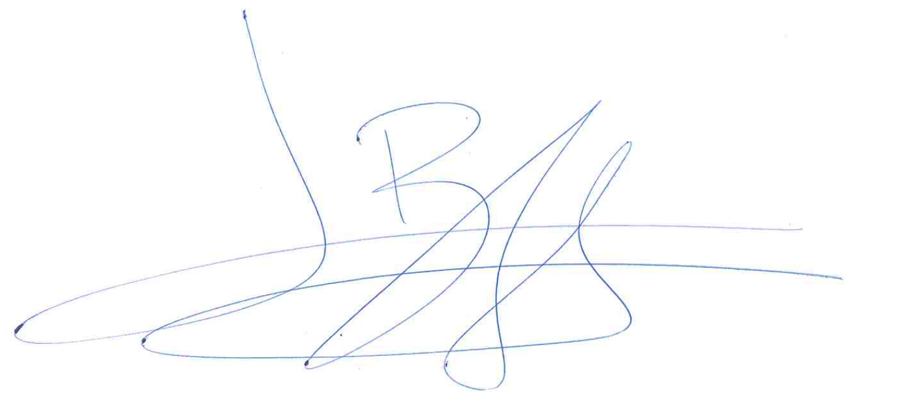
Lucas Buffan, on behalf of my co-authors

