

Lucas Buffan May 29, 2026
Institut des Sciences de l’Évolution de Montpellier

Dear editorial board members of Ecology Letters,

We have received your decision letter concerning our manuscript (number 4175150), entitled “Palaeoclimate alone fails to explain the asymmetry of the Great American Biotic Interchange”. You may find enclosed a revised version of our manuscript, which was modified following the very constructive comments and suggestions made by the handling editor. We hope that the changes that we made to our manuscript will fit your expectations.
Below are the comments (italicised pink), to which we respond with a normal font.

*******

Handling editor’s comment:

Although one of the reviewers considers the authors should have made a stronger effort to revise the framing of the introduction, both acknowledged that the manuscript has improved, that the analyses are original and appropriate and that the results are interesting. I also consider the authors made an effort to address my recommendations by performing a new set of analyses. However, after carefully reading the revised version, I still identified a few minor issues that should be addressed before proceeding further.
I was surprised by the result of the additional analysis that indicated that "fixed-niche simulations originating in South America always yielded to a greater exchange intensity than evolving-niche simulations starting in North America". Also, those results were barely mentioned in the discussion. I would guess that there are certain parameter combinations that would reverse the pattern. Identifying those limits would be valuable because it would allow the authors to discuss how strong the asymmetry in niche conservatism would need to be for the exchange asymmetry to arise solely as a response to climate. I recommend that the authors check those results carefully and discuss them in greater detail.

Thank you for this comment. We actually shared your surprise regarding this result suggesting that, even with 10-fold wider temperature niches, simulated lineages from North America with evolving niches fail to colonise the South as good as their southern counterparts with fixed (or evolving) niche. We agree with you that the discussion would greatly benefit from some words about how strong the difference in niche breadth would need to be between northern and southern lineages to replicate the empirical GABI pattern. As we explained in our previous reply letter, we did not explore additional ranges of ω_{T} as we think that going beyond a 10-fold difference would not be biologically realistic. Nevertheless, we agree that there should be a threshold Δ_{ω}* above which the pattern would be reverted. Our findings suggest that Δ_{ω}* > 10, which, in our opinion, is already very informative. It indeed means that the niche conservatism imbalance between northern and southern lineages would need to be very (even unrealistically, given what we just mentioned) strong so that the empirical asymmetry of the GABI emerges as a sole response to climate. Having a numeric estimate of Δ_{ω}* would, in our view, not bring more information than that. However, it would require substantial new computational effort, followed by a separate analysis and interpretation of the resulting outcomes. Given these elements, we prefer not to run any additional analysis. Instead, to address this point, we expanded the first paragraph of the discussion (limited by the word limit imposed by the journal). We hope that these new elements will address the very relevant concern raised. We thank you again for this feedback.

I also have a few minor suggestions regarding the text:
Pg 6, Ln. 16. edit suggestion: the long-term outcome of these intercontinental faunal exchanges was highly asymmetric
That sounds better now, thank you.

Pg 6, Ln. 29. delete "consideration of"
Corrected, thank you.

Pg 6, Ln. 30. adapted to open habitats or open-vegetation habitats
Corrected, thanks.

Pg 13, Ln. 4 this term “colonised diversity” sounds odd. I suggest replacing it throughout the text.
It is true that this expression may be oddly interpreted. We therefore changed it to ‘Richness on the Colonised Continent’ (abbreviated RCC in the rest of the manuscript). Thank you for pointing this.

Pg 16, Ln. 10-13. this sentence is too long and hard to follow
We understand this remark, and decided to remove the explanatory statement that made the sentence too dense.

Pg 17, Ln. 8-10. this sentence is too long and hard to follow
We intended to make this sentence shorter and more to-the-point. We hope that this will match your expectations.

Figure 1 mentions savannas and desert as a single category. I think it is unlikely that there were actual deserts across most of the represented region. Consider replacing it with open-habitat vegetation or any other combination of habitat types that are more likely to have been more prevalent across the highlighted region given palaeoecological reconstructions.
We agree that amalgamating open habitats to deserts and savannas only is quite unlikely in that case, although it was directly inspired by Webb (1991)’s seminal representation. Accordingly, we changed to “Open landscape (savanna woodland, grassland, desert)” (see modified figure).

Reviewer 1 Comments to the Author:

The manuscript has improved substantially. My points were addressed and I think the manuscript is ready for publication. It will be a novel and fresh addition to the GABI literature

We are delighted to read your feedback. Thank you very much for your highly constructive comments.

Reviewer 2 Comments to the Author:

I was reviewer 3. Most of the queries from me or the other reviewers have been adequately addressed. However, the overall framing of the story is still deeply problematic. Since the authors seem unwilling to reframe the study in a more justifiable way, I suppose I either have to accept or reject the current version. I lean towards rejection, but I could also see a justification for acceptance instead and will let it be up to the editor to decide. There are no technical errors in the manuscript, and the call depends on how important one values the introduction/ overall framing of a paper.
We apologise if our reply to your previous comment regarding the framing of our study did not convince you. We maintain that this work should be seen as a first attempt to use eco-evolutionary models to untangle the forces behind the asymmetry of the GABI, and should pave the way towards more accurate modelling of this fascinating biogeographic imbalance. We thank you for taking some time to review our study.
*******

If we can answer any further questions, or be of any assistance to you whatsoever, please feel free to contact us.
Thank you for considering our revised manuscript.
Yours sincerely,

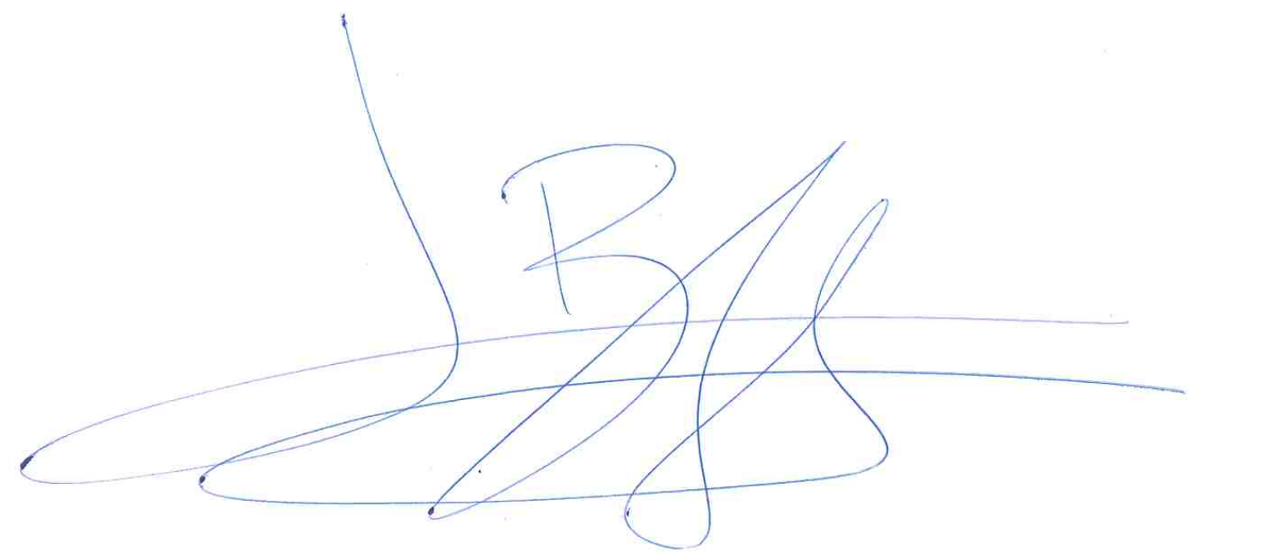
Lucas Buffan, on behalf of my co-authors

