

Dr. Lucas Buffan October 14, 2026
Institut des Sciences de l’Évolution de Montpellier

Dear editorial board members of Ecology Letters,

We have received your decision letter concerning our manuscript (number 4175150), entitled “Palaeoclimate alone fails to explain the asymmetry of the Great American Biotic Interchange”. We thank the data editor for reviewing our code and associated data. The requested changes, i.e., (1) adding a reference to the online archive where the palaeoclimate layers used over this study were downloaded from in a README and (2) archiving our GitHub on a stable repository providing a DOI, have been implemented.

If we can answer any further questions, or be of any assistance to you whatsoever, please feel free to contact me.
Thank you for considering our study.
Yours sincerely,

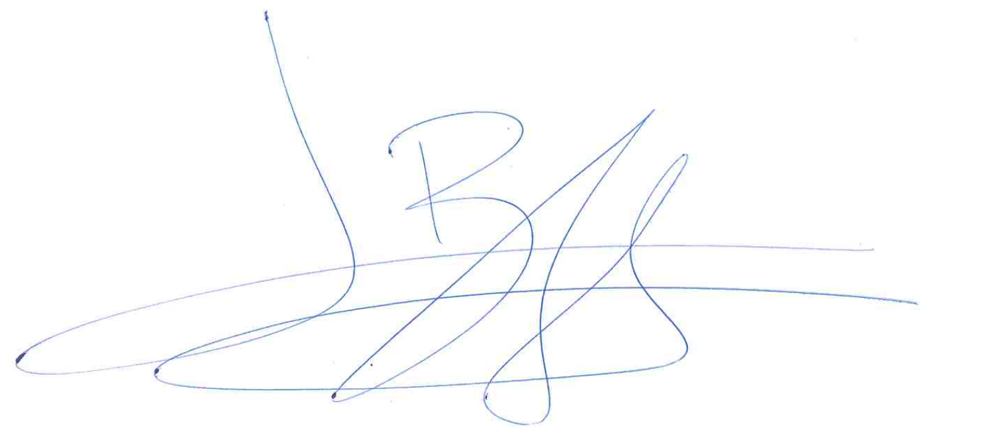
Dr. Lucas Buffan, on behalf of my co-authors

