Palaeoclimate alone fails to explain the asymmetry of the Great American Biotic Interchange
Lucas Buffan¹*, Fabien L. Condamine¹, Philip B. Holden², Sara Varela³
¹ Institut des Sciences de l’Evolution de Montpellier, Université de Montpellier, CNRS, IRD, Place Eugène Bataillon, 34095 Montpellier cedex 5, France
² Environment, Earth and Ecosystem Sciences, The Open University, Walton Hall, Milton Keynes, MK7 6AA, UK
³ Centro de Investigación Mariña, Departamento de Ecoloxía e Bioloxía Animal, Universidade de Vigo, Campus Lagoas-Marcosende, 36310 Vigo, Spain
* Corresponding author: lucas.l.buffan@gmail.com

Statement of authorship
S.V. and L.B. designed the project. P.B.H. gave inputs on palaeoclimate data usage. L.B. ran the simulations, performed the analyses, produced the figures and wrote the manuscript with inputs from all co-authors.

Data availability statement
R scripts for generating, analysing and visualising the data are available at https://github.com/Buffan3369/GABI-gen3sis.git. Simulation landscapes and config files are available at https://doi.org/10.6084/m9.figshare.31160704.

Keywords
Biotic Interchange; Eco-evolutionary simulations; Macroecology; Palaeoclimate

Additional data
- running title : Palaeoclimate and the Great American Interchange
- article type: Letter
- abstract word count: 150
- main text word count: 4980
- number of references: 57
- number of figures: 4

Abstract
Asymmetric colonisation patterns often arise from large-scale biotic exchanges involving two source areas. In the Pliocene, the closure of the isthmus of Panama facilitated the admixture between North and South American faunas, an event termed Great American Biotic Interchange (GABI). The ecological mechanisms underlying the asymmetry of the GABI, incontestably in favour of North American lineages, remain debated. Here, coupling a mechanistic eco-evolutionary simulator with palaeoclimatic reconstructions, we test fundamental hypotheses relating this biogeographic imbalance to palaeoclimate dynamics. When climate is the only constraint to species’ dispersal, our simulations yield more South-to-North than North-to-South dispersal events, mostly within the tropical biome. Also, our models fail to explain the migrant diversity desequilibrium between the two continents, as well as temperate specialists’ over-representation in the fossil record of successfully-exchanged taxa. Hence, we argue that spatio-temporal palaeoclimate dynamics alone cannot explain the asymmetry of the GABI, suggesting additional factors fashioned this macroecological enigma.

Introduction
The Great American Biotic Interchange (GABI) refers to the large-scale biotic exchange that occurred between the Americas and intensified after the closure of the isthmus of Panama (Marshall et al. 1982; Stehli & Webb 1985; Webb 1976). Though the exact timing of the appearance of such a landbridge is not entirely resolved (Bourke et al. 2025; Jaramillo 2018; Montes et al. 2015; O’Dea et al. 2016), palaeontological evidence and molecular phylogenies both agree with a late Miocene onset of (non-volant) biotic exchange between the Americas (Carrillo et al. 2015; Tedford et al. 2004; Verzi et al. 2008), with effective exchange pulses occurring during the Plio-Pleistocene (Bacon et al. 2015, 2016; Marshall et al. 1982; Woodburne 2010). Among land mammals, a puzzling feature of the GABI is that it impacted the North and South continental faunas very differently. Although evidence from the fossil record indicates that the early phases of the GABI were marked by reciprocal land mammal exchanges between the Americas (Marshall et al. 1982; Webb 1976; Woodburne 2010), during the Pleistocene, the ability of migrant lineages to maintain and diversify in the newly-colonised continent became greater in South America (Woodburne 2010). Many native South American lineages concomitantly declined, some of which even going totally extinct (Boscaini et al. 2025; Carrillo et al. 2020; Cione et al. 2015; Croft et al. 2020; Webb 1991). Hence, the long-term outcome of this intercontinental faunal exchange was asymmetric.
Although this macroecological imbalance is unquestionable, no clear consensus regarding the drivers underlying this asymmetry has yet been established. On the one hand, biotic interactions involving migrant and native species have often been proposed to explain such an asymmetry. These would include competition (Domingo et al. 2020; Simpson 1980; Webb 1976) or predation of predator-naive preys (Faurby & Svenning 2016; Fernández-Monescillo et al. 2025; Marshall & Cifelli 1990; Webb 1976). However, their contribution to the asymmetry of the GABI has been increasingly called into question (e.g., Freitas-Oliveira et al. 2024a; Marsà et al. 2025; Prevosti et al. 2013; Tarquini et al. 2022; Vrba 1992). On the other hand, several studies proposed that the asymmetry of the GABI emerged from palaeoclimate dynamics (e.g., Bacon et al. 2016; Freitas-Oliveira et al. 2024b; 2025; Marshall & Cifelli 1990; Vrba 1992; Webb 1991). The prevailing views consist of relating pulses of transcontinental mammal exchanges with Pleistocene climatic oscillations, promoting the transition from tropical rainforest to savannah-like environments in Central America as climate cooled down (Figure 1). Based on the migrant fossil record across both sides of the isthmus of Panama, Webb (1991) proposed that this climate-driven landscape opening would have facilitated the dispersal of taxa adapted to open habitats. As those were assumed to be more numerous in North than in South America – the former continent offering more high-latitude temperate-to-cold environments than the latter –, a larger number of North American taxa would be predicted to disperse to the South than the other way around (Figure 1 A). The resulting exchanges would have been periodically interrupted by intervals of warming, promoting the reverse transition to rainforest in the isthmian region, with rainforests acting as a barrier for species dispersal (tropical ‘holding pen’ hypothesis) (Woodburne 2010). In addition, Vrba (1992) proposed the contraction of tropical habitats towards the equator promoted by the aforementioned periodical climatic cooling to have mechanically attracted taxa suited to tropical environments southwards (Figure 1 B). However, studies supporting these views have only been descriptive, tackling the issue from a pattern-oriented perspective driven by fossil data but, to our knowledge, never from a process-oriented perspective.
Recent improvements in process-explicit modelling have marked a turning point in the study of biodiversity (Pilowsky et al. 2022). By combining a landscape including palaeoenvironmental variables and a set of eco-evolutionary rules according to which virtual species are simulated, mechanistic eco-evolutionary models offer the unique opportunity to causally explore how biodiversity patterns arise and are maintained through evolutionary times (Hagen 2023). Recently, this class of models has provided unprecedented insights into the underlying forces behind widely-recognised biodiversity patterns, such as the latitudinal biodiversity gradient (Hagen et al. 2021a; Lorcery et al. 2025), the diversity desequilibrium between tropical rainforests across the globe (Hagen et al. 2021b), the build-up of the unique biodiversity along the Wallace line (Skeels et al. 2023b) and many others (e.g., Boschman et al. 2023; Liu et al. 2024; Skeels et al. 2023a).
Here, we test Webb and Vrba’s hypotheses on the role of palaeoclimate dynamics in the asymmetry of the GABI (Figure 1) using a spatially-explicit mechanistic biodiversity simulator coupled with palaeoclimate reconstructions across the last 5 million years. Our simulations tracked the diversification of a clade originating either in North or South America. The ability of a virtual species to survive at a given place was only mediated by climatic factors. We hypothesise that (i) simulations starting from a North American ancestor would be more successful at reaching the other continent than the other way around, (ii) successful simulations starting from a North American ancestor would result in a more diverse and spatially spread radiation in the newly-colonised continent, (iii) niche evolvability and (iv) initial biome would significantly impact exchange frequencies, with higher values obtained for adaptive-niche simulations, or fixed-niche simulations with temperate or arid rather than tropical affinity.

Material and Methods
Beforehand, it has to be noticed that, across the entire study, ‘North America’ actually refers to the current North and Central American continents. The delimitation between North and South America was arbitrarily set as a straight line connecting two points located along the eastern and western coasts of present Panama ($82.882°$ W, $7.138°$ N and $81.369°$ W and $9.008°$ N) (see Figure S1).

Palaeoclimate data
We used the spatio-temporal terrestrial palaeoclimate series from the PALEO-PGEM emulator (Holden et al. 2019) of the PLASIM-GENIE intermediate-complexity atmosphere-ocean general circulation model (Holden et al. 2016). This reconstruction covers the last 5 Million years (My) downscaled to a 1 $×$ 1 ° spatial resolution (Barreto et al. 2023). For the scope of this work, we used two bioclimatic variables: mean annual temperature (MAT, BIO1) and mean annual precipitation (MAP, BIO12). To avoid an intractably-high number of simulation time steps, we reduced the temporal resolution of the climate simulations from a 1000-years to a 10,000-years time step by sampling corresponding time slices. This procedure did not alter the overall climatic trends. In particular, Pleistocene climatic oscillations clearly remained after downscaling (Figure S12).
In order to discriminate simulations based on the biome where the initial species originates, we reclassified monthly palaeoclimate layers for the starting time ($t=5$ My ago) according to Köppen-Geiger broad climate types (Beck et al. 2018; Galván et al. 2023). This classification divides the world into five broad climatic regions: Polar, Cold, Temperate, Arid and Tropical, following the criteria proposed by Köppen (1900).

Simulation model and modelling schemes
We performed spatially-explicit simulations of biodiversity using gen3sis v1.5.11 (Hagen et al. 2021a). Simulations, moving forward-in-time with a 10ky time step, tracked the radiation of a clade arising from a single ancestral population, either originating in North or in South America, throughout the last 5 My. In gen3sis, virtual species are modelled with individual populations evolving independently, following a set of four rules: dispersal, speciation, environmental filtering and trait evolution. All simulation scenarios that we implemented only differed on the last rule (trait evolution), the first three being common to all models.
We elaborated a gridded landscape from the time-series of the two palaeoclimatic layers. Within this landscape, populations making up virtual species inhabited a set of connected cells. At each time step, inter-cell dispersal could occur with an intensity sampled in a Weibull distribution (repeated independently for each species-cell combination). As done by Skeels et al. (2023a); (2023b), the cost of moving from a cell to another was made twice harder if the target cell was not habitable (i.e., ocean or sea). If, by chance, two populations become disconnected, they accumulate divergence as long as they remain disconnected, at a rate ruled by a divergence factor, here set to $0.05$ (Table S1). Once passed a divergence threshold, speciation would occur – note that, consequently, the only mode of speciation allowed by gen3sis is allopatry.
As our goal was to evaluate the extent to which palaeoclimate change may have shaped the unequal success of North American taxa establishing southwards compared to South American taxa establishing northwards, local climate was set as the only constraint for a population to survive in a given cell. Each species was therefore assigned a two-dimensional climatic niche, one axis corresponding to temperature suitability and the other to precipitation suitability. The abundance of a species along an environmental gradient was determined by two parameters – that we also call traits – : a population- and species-specific optimum (resp. $P_{k,l}$ and $T_{k,l}$ for the precipitation and temperature optima of the population $k$ of the species $l$) and a breadth (or tolerance) (resp. $ω_{P}$ and $ω_{T}$; within a simulation, all populations and species had the same breadths). A population could survive in a given cell only if the difference between its optima and local climate (both temperature and precipitation) was less than its tolerance. Therefore, given a site $i$ with local precipitation and temperature at time $t$ being $P_{i}\left(t\right)$ and $T_{i}\left(t\right)$, this translates in
$$\left\{\begin{matrix}|P_{i}\left(t\right)−P_{k,l}|<ω_{P} \\ |T_{i}\left(t\right)−T_{k,l}|<ω_{T}\end{matrix}\right.$$
We implemented various simulation scenarios (also called modelling schemes) where we modulated the ability of species to cope with climate change. In the adaptive niche model ($M1$), climatic optima ($P_{k,l}$ and $T_{k,l}$) were able to evolve in the direction of local climate change. To isolate the effect of a single environmental covariate on the resulting simulated biodiversity pattern, alternative versions of this model consisted of either removing the temperature ($M2$) or the precipitation ($M3$) constraint on species ecology. Besides, we also implemented a fixed niche model ($M0$), where niche optima could not evolve and were therefore held constant (to their initial value) across all simulations. 500-member simulation ensembles were performed for each simulation scenario, and for both North and South America as ancestral area. For details about initialisation of a simulation and parameter values, please refer to Supplementary text.
Importantly, simulations generated under the fixed niche model ($M0$) originating in the tropical biome of either continent allowed to assess fundamental hypotheses related to the concept of tropical niche conservatism (Wiens & Donoghue 2004). This concept has often been invoked to explain the high diversity of tropical compared to temperate regions. In the framework of the Americas, Smith et al. (2012) evidenced that the extant vertebrate biodiversity across the Americas resulted from an asymmetric niche conservatism. They indeed showed that taxa of North American origin were a significant compound of the high Neotropical biodiversity, whereas taxa with a southern ascent were little represented in temperate North America, therefore arguing that South American taxa exhibit an higher niche conservatism (in favour of tropical areas) than North American taxa. Thus, our modelling schemes also provide the ability to test whether palaeoclimate is a sufficient driver behind this observed niche conservatism asymmetry across the Americas.
Throughout the study period, a vast proportion the South American landmass was dominated by relatively stable tropical climatic conditions whereas the overall North American climate was dominated by temporal fluctuations (Figure S1). Consequently, we expect that lineages generated under fixed-niche simulations ($M0$, high conservatism) originating in South America to be less intensively exchanged than those generated under evolving-niche simulations starting in North America ($M1−3$, attenuated conservatism). Such an imbalance would be in line with the empirical pattern of exchange asymmetry that took place during the GABI.
Last, it is important to notice that, since the palaeoclimate reconstructions that we used ignored tectonic plate motion – a reasonable assumption for a 5-My time frame – continental position in our landscapes was held constant across simulations. Therefore, in that framework, changes in connectivity between North and South America could only arise from climate.

Quantification and statistical analyses
At every time step, for each run of each simulation, we used a function released by Skeels et al. (2023b) to save presence-absence matrices. Given a time $t$, such matrices stored on their columns the presence of each simulated species that have existed from the onset of the simulation to $t$ within each cell of the landscape (rows of the matrix) as a binary variable – $1$: the species inhabits that cell, $0$: it does not.
Given a batch of simulations, after discarding those that crashed – i.e., that led to no living representative – we quantified four metrics reflecting the occurrence, magnitude and efficiency of an eventual transcontinental exchange based on the presence-absence matrix of the last time step of each successful run (hereafter called $t_{end}$). First, we assessed the exchange success, a binary variable set to one if at least one pixel of the area to colonise (hereafter called $A_{col}$, e.g., South America if the simulation started in North America) recorded a presence. Then, we recorded the biome in which the initial ancestor occurs (i.e., Tropical, Arid, Temperate, Cold, Polar) as well as the distance of this initial ancestor to a point arbitrarily located on the zone of the isthmus of Panama, ($−84°$lon, $10°$lat). Last, in the case of a successful exchange, we quantified the number of virtual taxa recorded in $A_{col}$ at $t_{end}$ – referred to as Richness on the Colonised Continent, RCC – and the proportion of $A_{col}$ actually colonised at $t_{end}$ as the ratio between the number of cells occupied by the colonisers and the total number of available cells (i.e., surface of $A_{col}$).

Results

South-to-North dispersal events are made easier by climate
Our results suggest that the proportion of simulations successfully reaching the other continent is always higher – by approximately a factor of two – when starting from South America than from North America (Figure 2). This imbalance holds whether we allow species climatic niche to evolve following the direction of local climatic change ($44±6\%$ vs. $87±3\%$, model $M1$) or not ($29±6\%$ vs. $59±5\%$, $M0$), although we can notice that overall transcontinental exchange frequencies are lower in the latter case. When allowing climatic niches to evolve, amputation of either their temperature ($47±7\%$ vs. $88±3\%$, $M2$) or precipitation ($38±4\%$ vs. $89±3\%$, $M3$) compounds did not alter the pattern. We emphasise the fact that, contrary to our expectations, fixed-niche simulations originating in South America always yielded to a greater exchange intensity than fixed- or evolving-niche simulations starting in North America. The simulated imbalance persisted after standardising initial distances to the isthmus of Panama for simulated species originating in North America to those of simulated species from South America, except for simulations generated under the fixed-niche model ($50±6\%$ vs. $59±5\%$) (Figure S4). Last, we stress that the simulated pattern was also robust to thermal breadth expansion for lineages originating in North America, up to 10 times broader than for simulations originating in South America (Figure S14 A).
Out of the 500 runs carried out for each initial landmass-modelling scenario combination, the proportion of simulations leading to no living representative (=crash) was on average three times higher for simulations starting from North America, except for model $M3$, recording almost no crash (Table S2). This difference, although attenuated, persisted after the spatial standardisation procedure, but fully disappeared when we increased the thermal breadth of simulations originating in North America (Figure S14 B).

Successful establishment on the newly-colonised continent
Irrespective of the initial continent, our findings highlight that successful simulations generated under models allowing species climatic niches to evolve ($M1−M3$) colonised a larger area on the newly-colonised continent than those generated under the $M0$ model – where climatic niche evolution was not allowed (Figure 3 A). Furthermore, species of North American origin that successfully made it to South America generally colonised a greater area than those of South American origin reaching North America (Figure 3 A). This pattern is particularly striking for simulations generated under the $M0$ model ($36.5±3.5\%$ vs. $11.7±0.4\%$), and holds for all but the $M3$ model – relaxing the precipitation constraint on species’ niche –, the latter suggesting an opposite trend ($69.9±3.3\%$ vs. $79.4±3.9\%$). However, due to the difference in size (i.e., number of pixels) between the two continents (Figure S1), the actual colonised area was greater when simulations generated under the $M1−3$ models started from South than North America, but remained larger when simulations were generated under $M0$ started from North America (Figure S11).
Besides, contrary to the proportion of colonised area for a given ancestral continent, RCC does not vary significantly across our four models. However, a significant decrease is evident in simulations starting from North America generated under the $M3$ model (Figure 3 B). Moreover, ancestral continent does not seem to affect mean RCC values in the case of the $M1$ ($212±61$ vs. $170±25$ species respectively retrieved in the newly-colonised continent after starting from North or South America) and $M2$ ($161±48$ vs. $171±27$ species) models. It does however have an effect for simulations generated under $M0$, with higher average values obtained for simulations starting from North America ($247±85$ vs. $79±20$ species).
In addition, successful simulations starting from North America generally started from an ancestor located closer to the isthmus of Panama than those starting from South America (Figure 3 C), again except for simulation generated under $M3$. Also, we can highlight a general trend that ancestral species originated closer to the isthmus in the case of successful simulations compared to unsuccessful ones (Figure S7-8). Interestingly enough, the results obtained for this metric, just like those obtained for the other two, hold for simulations generated after standardising the initial distances to the isthmus of North American virtual species with those starting from South America (Figure S4).

Biome selectivity of the simulated faunal exchanges
Due to the unequal area occupied by each biome between the two continents, the number of simulations starting within each biome was largely uneven across biome classes and continents (Figure 4 B). The majority of North American ancestral species originated in the cold biome ($57\%$), whereas the tropical biome recorded the largest proportion of ancestral species originating in South America ($58\%$). Standardising initial distances to the isthmus of Panama for simulations originating in North America increased the proportion of simulations originating under low latitudes, to the detriment of those originating in high latitude, less represented in South America (Figure 4 A and Figure S5). Consequently, this increased the representativity of the tropical (from $5\%$ to $10\%$) and arid (from $16\%$ to $26\%$) biomes in the starting ranges of simulations originating in North America, and decreased the proportion of simulations originating in the cold (from $57\%$ to $40\%$) and polar (from $4\%$ to $2\%$) biomes (Figure S10).
Despite this initial imbalance, when simulations were generated under the $M0$ model, our results suggest similar exchange intensity patterns between simulations starting from North and South America (Figure 4 C, first row). Fixed-niche simulations with tropical affinity (i.e., originating in the tropical biome and evolving under $M0$) were largely more frequently exchanged than fixed-niche simulations tied to another biome, with on average $90\left[77,100\right]\%$ successful exchanges southwards (i.e., from simulations originating in North America) and $66±5\%$ northwards (i.e., from simulations originating in South America). Such proportions were significantly reduced when originating in the arid ($26±6\%$ southwards, $18±9\%$ northwards) and temperate biomes ($26±10\%$ southwards, $29±8\%$ northwards). Almost no fixed-niche simulation originating in the cold or polar biome, no matter where it started, resulted in a successful inter-continental exchange. The exact same pattern is obtained for southwards dispersal events occurring after standardising initial distances to the isthmus of Panama (Figure S9, $M0$).
Regarding simulations generated under the adaptive-niche models ($M1−3$), those starting from North America maintained the same pattern of exchange intensities as simulations generated under $M0$. The proportion of exchange success was higher among those originating in the tropical biome ($89\left[75,100\right]\%$ for $M1$), followed by those originating in the temperate ($40±10\%$, $M1$) and arid ($34±11\%$, $M1$) biomes. Also, almost no adaptive-niche simulation originating in the cold or polar biomes made it to South America (Figure 4 C $M1−2$). Note that removing the precipitation constraint on species climatic niche (i.e., model $M3$) attenuated this imbalance (Figure 4 C $M3$). These results hold after standardising initial distances to the isthmus of Panama of simulations starting from North America to those starting from South America (Figure S9, $M1−3$). Conversely, the adaptive-niche disparity in proportion of successful exchanges across biomes was largely attenuated when simulations started in South America. In that case, successful exchanges appear almost equally-likely, regardless of the biome where simulations originate (Figure 4 C $M1−3$).

Discussion

An inverse asymmetry of exchange driven by climate
Throughout this work, we investigated the role of palaeoclimate in the asymmetry of the GABI through the use of eco-evolutionary simulations. Probably one of our most striking findings is that, under climatic constraints alone, simulated South American lineages dispersed to the North with a significantly greater intensity than the other way around (Figure 2). This therefore clearly contrasts with the long-recognised imbalanced success of North American mammal taxa compared to South Americans in the aftermath of the GABI (Simpson 1980). The supplemental analyses that we conducted, increasing northern lineage’s thermal niche breadth up to 10 times that of southern lineages, failed to invert this unexpected simulated pattern of continent-dependent colonisation asymmetry (Figure S14 A). Thus, reproducing the asymmetry of the GABI as a sole consequence of climate would require a very important (typically above a factor 10) niche breadth disequilibrium between northern and southern lineages, which is very unlikely to have emerged in the nature.
Seminal works primarily interpreted the empirically-derived asymmetry of the GABI under the lens of a continent-wide extension of MacArthur & Wilson’s equilibrium theory (MacArthur & Wilson 1967). The latter theory establishes that, on evolutionary timescales, diversity within a given area should tend towards an equilibrium value proportional to the size of this area. Therefore, its continent-wide extension predicts the equilibrium diversity of North America to be larger than that of South America, given the differences in size between the two continents ($24$ vs. $18×{10}^{6}$ km²). Following this framework, Marshall et al. (1982) argued that the continent offering the largest pool of taxa – which, according to this prediction, would be North America – would in turn have resulted in the larger number of species exchanged in the end. It might be noticed that species pool imbalance between two source areas has been identified as a key driver in the faunal exchange asymmetry that contributed to the build-up of the unique biodiversity along the Wallace line (Skeels et al. 2023b). Nonetheless, following such a reasoning, the probability for a given taxon to cross the Panamanian landbridge is assumed to be independent from the side of the isthmus where it came from, which, interestingly, is not supported by our findings (Figure 2). In addition, this theory does not align with the actual imbalance in extant mammal species-level diversity between the Americas, being way larger in South than in North America (Raven et al. 2020).
Although the inverse asymmetry in climate-driven exchange across both sides of the Isthmus suggested by our findings goes in contradiction with the mammal fossil record (e.g., Marshall et al. 1982), it actually echoes inter-American exchange patterns suggested by other groups of vertebrates. For instance, the extant South American amphibian fauna is almost entirely endemic (Lomolino et al. 2006). By contrast, the North American frog fauna is composed of four families of southern origin, and only three of northern origin (Lomolino et al. 2006). Just like herpetofauna, tropical North American ichtyofauna has long been recognised as mainly composed of groups that originated in South America and further dispersed to the North, although most likely multiple dispersal events occurred, some of which pre-dating the closure of the isthmus (e.g., Chakrabarty & Albert 2011; Lomolino et al. 2006; Smith et al. 2012). It should however be noted that, due to the requirement for connected freshwater networks, the magnitude of the faunal admixture among freshwater fishes has been greatly limited compared to land groups. Next, despite the higher dispersal abilities of birds, phylogenetic evidence has shown a significant influence of the closure of the Panamanian Seaway in the rates of exchange between both continent’s avifaunas (Smith & Klicka 2010; Weir et al. 2009). In particular, these studies suggested that transcontinental exchanges occurred symmetrically among clades inhabiting tropical regions, but interestingly, just like land mammals, diversification of extra-tropical groups to tropical regions and further dispersal to the other landmass was strongly asymmetrical in favour of North American groups (Smith et al. 2012; Smith & Klicka 2010). That being said, notable exceptions of South American bird groups that successfully diversified in North America (including within temperate regions) exist, such as crown hummingbirds (e.g., Wallace 1878). However, the lack of fossil record for all the aforementioned groups may hamper the understanding of the processes behind their biogeographic history. Last, the Central American flora has been characterised as a mixture of lineages of North and South American origins, but phylogenetic evidence has suggested that the arrival of taxa from South America largely predated the established timeline of the GABI (e.g., Cody et al. 2010). Nevertheless, the orchid flora of the Chocó region, bridging the north-western coast of South America and southern Panama, was found to be primarily made up with Andean − thus, South American − lineages that radiated locally not earlier than 5 million years ago (Pérez-Escobar et al. 2019).

Revisiting climatic paradigms of the Great American Biotic Interchange
One of the predictions of Vrba’s resource-use hypothesis, formulated within the framework of her Habitat Theory and applied to the GABI, is that species with tropical affinity would have been naturally attracted towards the equator following the contraction of the tropical belt in the aftermath of the global cooling occurring at the Plio-Pleistocene boundary (Figure 1 B; Figure S1, from ca. 3 Ma). This would have actively promoted the establishment of North American tropical-suited taxa in South America (Vrba 1992). Here, our virtual experiments partially corroborate these historical predictions. Indeed, fixed-niche simulations with tropical affinity of North American origin were found to have a high prevalence of crossing the isthmus (Figure 4 C, model $M0$). However, the frequency of successful exchange obtained for fixed-niche tropical-suited simulations starting in South America was found to be almost equally-high, largely exceeding that of fixed-niche simulations tied to another biome and originating in the same continent (Figure 4 C, model $M0$). This goes against Vrba’s seminal hypothesis, instead predicting that fewer mammals – only biome generalists or those suited to open habitats – from South America would be expected to roam the other way around in case of tropical contraction towards the equator. This finding could reflect an attenuated magnitude of the climatic fragmentation of the Panamanian region when compared to historical biome reconstructions (e.g., Webb 1991), with the persistence of a tropical corridor in turn promoting the exchange of tropical specialists between both landmasses.
On average, one simulated radiation of open biome – i.e., arid or temperate – specialists out of four resulted in a successful exchange, irrespective of its ancestral continent (Figure 4 C, model $M0$). This proportion is significantly lower than that obtained for tropical specialists. Yet, it has long been acknowledged that the migrant fossil record across both sides of the isthmus was essentially composed of taxa showing affinity with open biomes (e.g., Vrba 1992). Among the most emblematic, we find for instance equids or camelids on the South American side, and ground sloths, toxodontids or glyptodontids on the North American side. The co-occurrence of distinct taxa in temporally well-delimited fossil assemblages led palaeontologists to postulate that the GABI was in fact a succession of exchange pulses punctuated by phases of interruption, further related to the climate-driven oscillations between savannah and rainforest in Central America during the Pleistocene (Webb 1991). Under such an assumption, the majority of exchanged taxa would therefore have ecologies suited to open habitats, and would have preferentially dispersed during Pleistocene glaciations (Bacon et al. 2016; Woodburne 2010) (Figure 1 A). As mentioned by Weir et al. (2009), the American mammal fossil record is highly biased, with few occurrences coming from low-latitude tropical regions, which is particularly striking in South America (e.g., Ugarte et al. 2025). Furthermore, evidence from extant mammal taxa suggest a strong tropical niche conservatism, that is, the trend according to which newly-originated tropical taxa would remain inhabiting under tropical climates (Smith et al. 2012; Wiens & Donoghue 2004). Thus, the fossil-derived number of mammal exchanges must have been greatly underestimated, with little fossil evidence of interchange constrained to the tropical biome, as stressed by Carrillo et al. (2020). Could South-to-North migrants’ tropical niche conservatism challenge the classical migration imbalance paradigm in favour of North American taxa dispersing southwards?
Our findings revealed that radiations following a colonisation of South America were more spatially spread than those arising from a northwards dispersal, except for simulations generated under the $M3$ model (Figure 3 A). The spatial spread of a migrant radiation was measured by the proportion of cells occupied within the newly-colonised continent relative to the size of the latter. When focusing on the absolute number of cells colonised – therefore without controlling for the area, in terms of number of cells, of the newly-colonised continent – such a finding only holds for successful simulations generated under $M0$ (Figure S11). This mirrors the fact that simulated tropical specialists from South America were more intensively exchanged than other simulated biome specialists (Figure 4 C, S6). The imposed tropical niche conservatism therefore constrained them to remain in tropical regions of North America, that are less represented in tropical North America than in South America (Figure 4 A). This adds some evidence supporting the fact that climate would have permitted South-to-North tropical exchanges to take place, but might have been obscured by a subsequent taphonomic bias in the fossil record, as suggested by studies relying on dated phylogenies (Bacon et al. 2015; Carrillo et al. 2020). Hence, our study calls for thinking about the distinction between the ability to disperse towards, and ability to maintain within the newly-colonised area. Those two distinct processes may have been ruled by different factors.
For additional remarks, limitations and perspectives, see Supplementary text.
In summary, our findings do not support the hypotheses exclusively relating the asymmetry of the GABI to palaeoclimate dynamics. Rather, our virtual experiments suggest that palaeoclimate would not have prevented reciprocal exchanges between the faunas of the two continents, especially within tropical areas. This stresses that the tropics did not act as a barrier as previously stated. Given the scarcity of fossil material in the tropical areas of the Americas, hypotheses relating the asymmetry of the GABI to palaeoclimate dynamics could have been affected by taphonomic bias, as they largely rely on the land mammal fossil record. This ultimately suggests that, although endemic land mammals from South America were virtually able to reach the other landmass, other unconsidered factors must have prevented their establishment on the other continent, in turn shaping the widely-recognised asymmetry of this textbook example of biotic interchange.

Acknowledgements
We are grateful to the Editor and the three anonymous referees who carefully reviewed our study, providing thoughtful comments that greatly improved the quality of the present work. We also thank Adrián Castro Insua for his useful guidelines and recommendations at the onset of the project, as well as Céline Devaux, Pierre-Olivier Antoine and Fabrice Lihoreau for their useful feedbacks at different stages of the project. L.B. was funded by a grant offered by the École Normale Supérieure de Lyon. P.B.H. was supported by the Leverhulme Trust Research Project Grant RPG-2024-076 (‘SABER’). This work received support from the European Research Council under the European Union’s Horizon 2020 research and innovation program (grant agreement 947921) as part of the MAPAS project, and benefited from an “Investissements d’Avenir” program managed by the Agence Nationale de la Recherche (CEBA, ref. ANR-10-LABX-25-01).

Figures
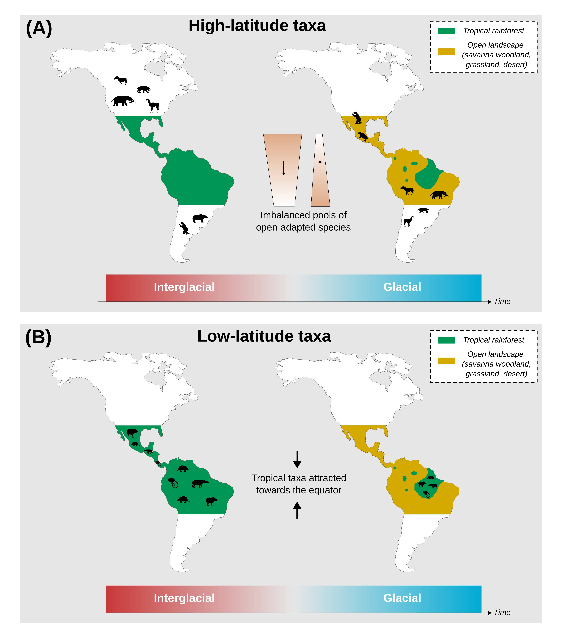
Figure 1: The two nonmutually-exclusive hypotheses relating the asymmetry of the GABI to the Pleistocene climatic oscillations, formulated in the framework of land mammals. Both involve biome transition from close tropical rainforest (green) during interglacial periods − warm and humid − to open savannah/desert (dark yellow) during glacial maxima − cold and dry − in the isthmian region. The first one (A), formulated by Webb (1991) views the asymmetry of the GABI as the result from the fact that North America had a higher pool of open-adapted taxa than South America. The opening of the isthmian region acted as an ecological filter favouring the dispersal of these open-adapted taxa to the detriment of the others. Hence, given the imbalance in open-adapted pool size between the two continents, more species would have been expected to disperse to the South than the other way around. The second one (B), formulated by Vrba (1992), proposes that the contraction of the tropical biome towards the equator triggered by the interglacial-glacial transition would have mechanically attracted tropical specialists southwards, irrespective of their continent of origin. Silhouettes are from phylopic, credits are available in Table S3. Note that the purpose of this figure is to illustrate our working hypotheses. Thus, we do not pretend these maps to accurately reflect inter-American biome dynamics between glacial and interglacial periods. A more accurate picture of these dynamics is available on Figure S13.
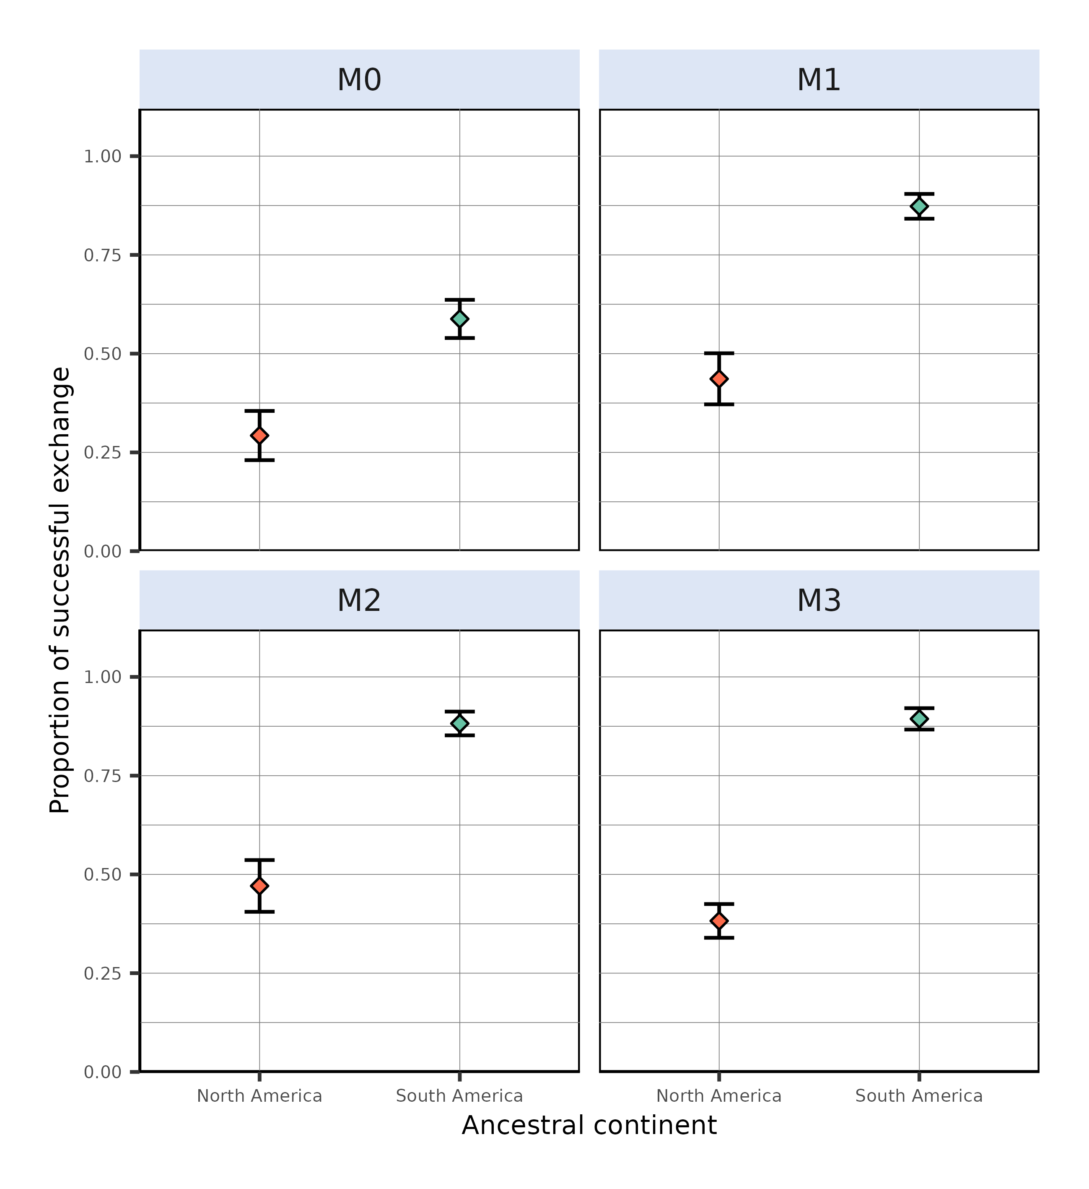
Figure 2: Proportion of simulations leading to a successful exchange to the other continent, computed as the ratio, given an initial continent and a modelling scenario, between the number of simulations leading to a transcontinental exchange and the total number of simulations resulting in at least one living species at the final state. From left to right are depicted the outcome of the fixed-niche model ($M0$, species climatic niche does not change through time), adaptive-niche model ($M1$, species climatic niche evolves following local changes in temperature and precipitations) and alternative versions of $M1$ where species ecological niche is only determined by precipitation ($M2$) or temperature ($M3$). Each individual plot shows the outcome of simulations starting in North (red) and South (cyan) America. Dots represent mean proportion estimates and error bars show their associated Binomial-derived 95% confidence interval.
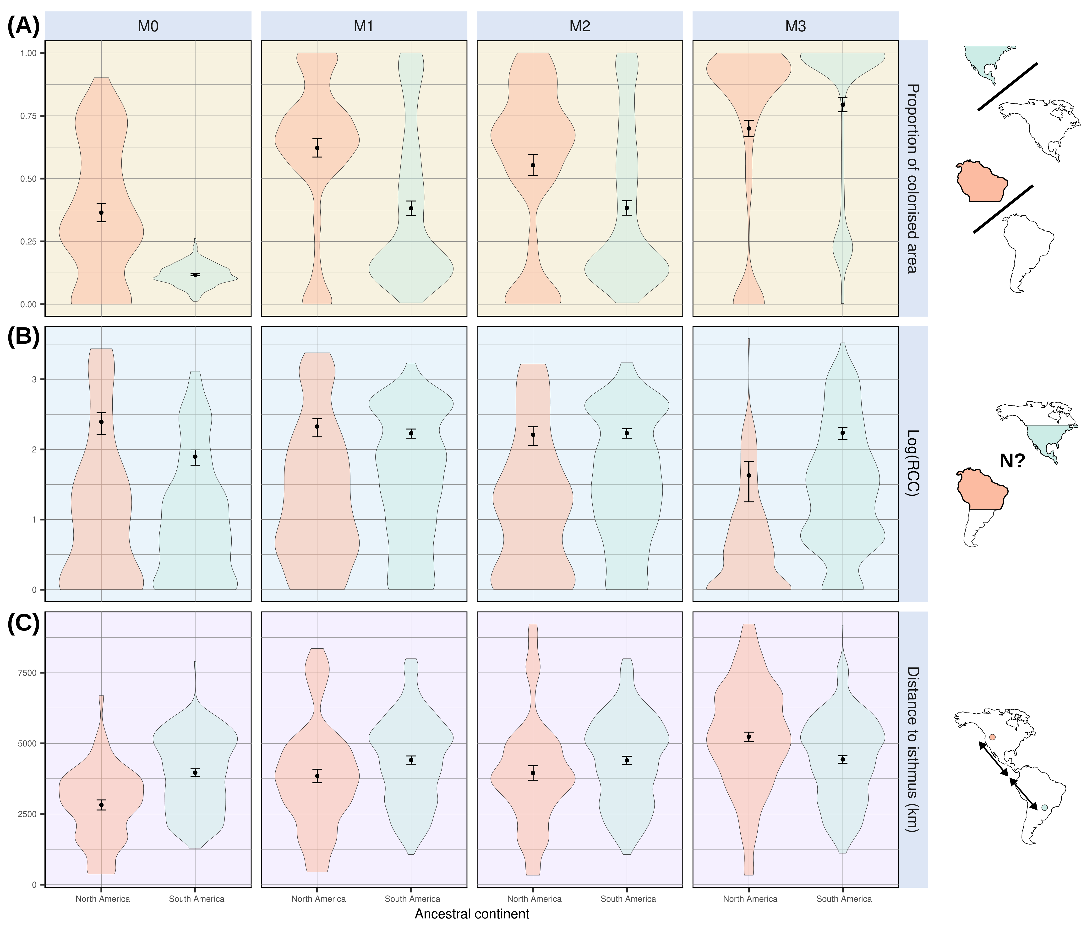
Figure 3: A few metrics summarising climate-mediated interchange given our four modelling schemes. These metrics were assessed for successful simulations only, i.e., simulations that resulted in a transcontinental faunal exchange. (A) Proportion of continent’s newly-colonised area, quantified as the ratio between the number of pixels recording a presence in the landmass to colonise and the total number of pixels offered by this landmass. (B) Richness on the Colonised Continent (RCC), expressed as the natural logarithm of the number of lineages within the colonised area. (C) Distance between simulation starting pixel and the isthmus of Panama. Mean estimates and their associated Student-derived 95% confidence intervals are displayed over their distribution.
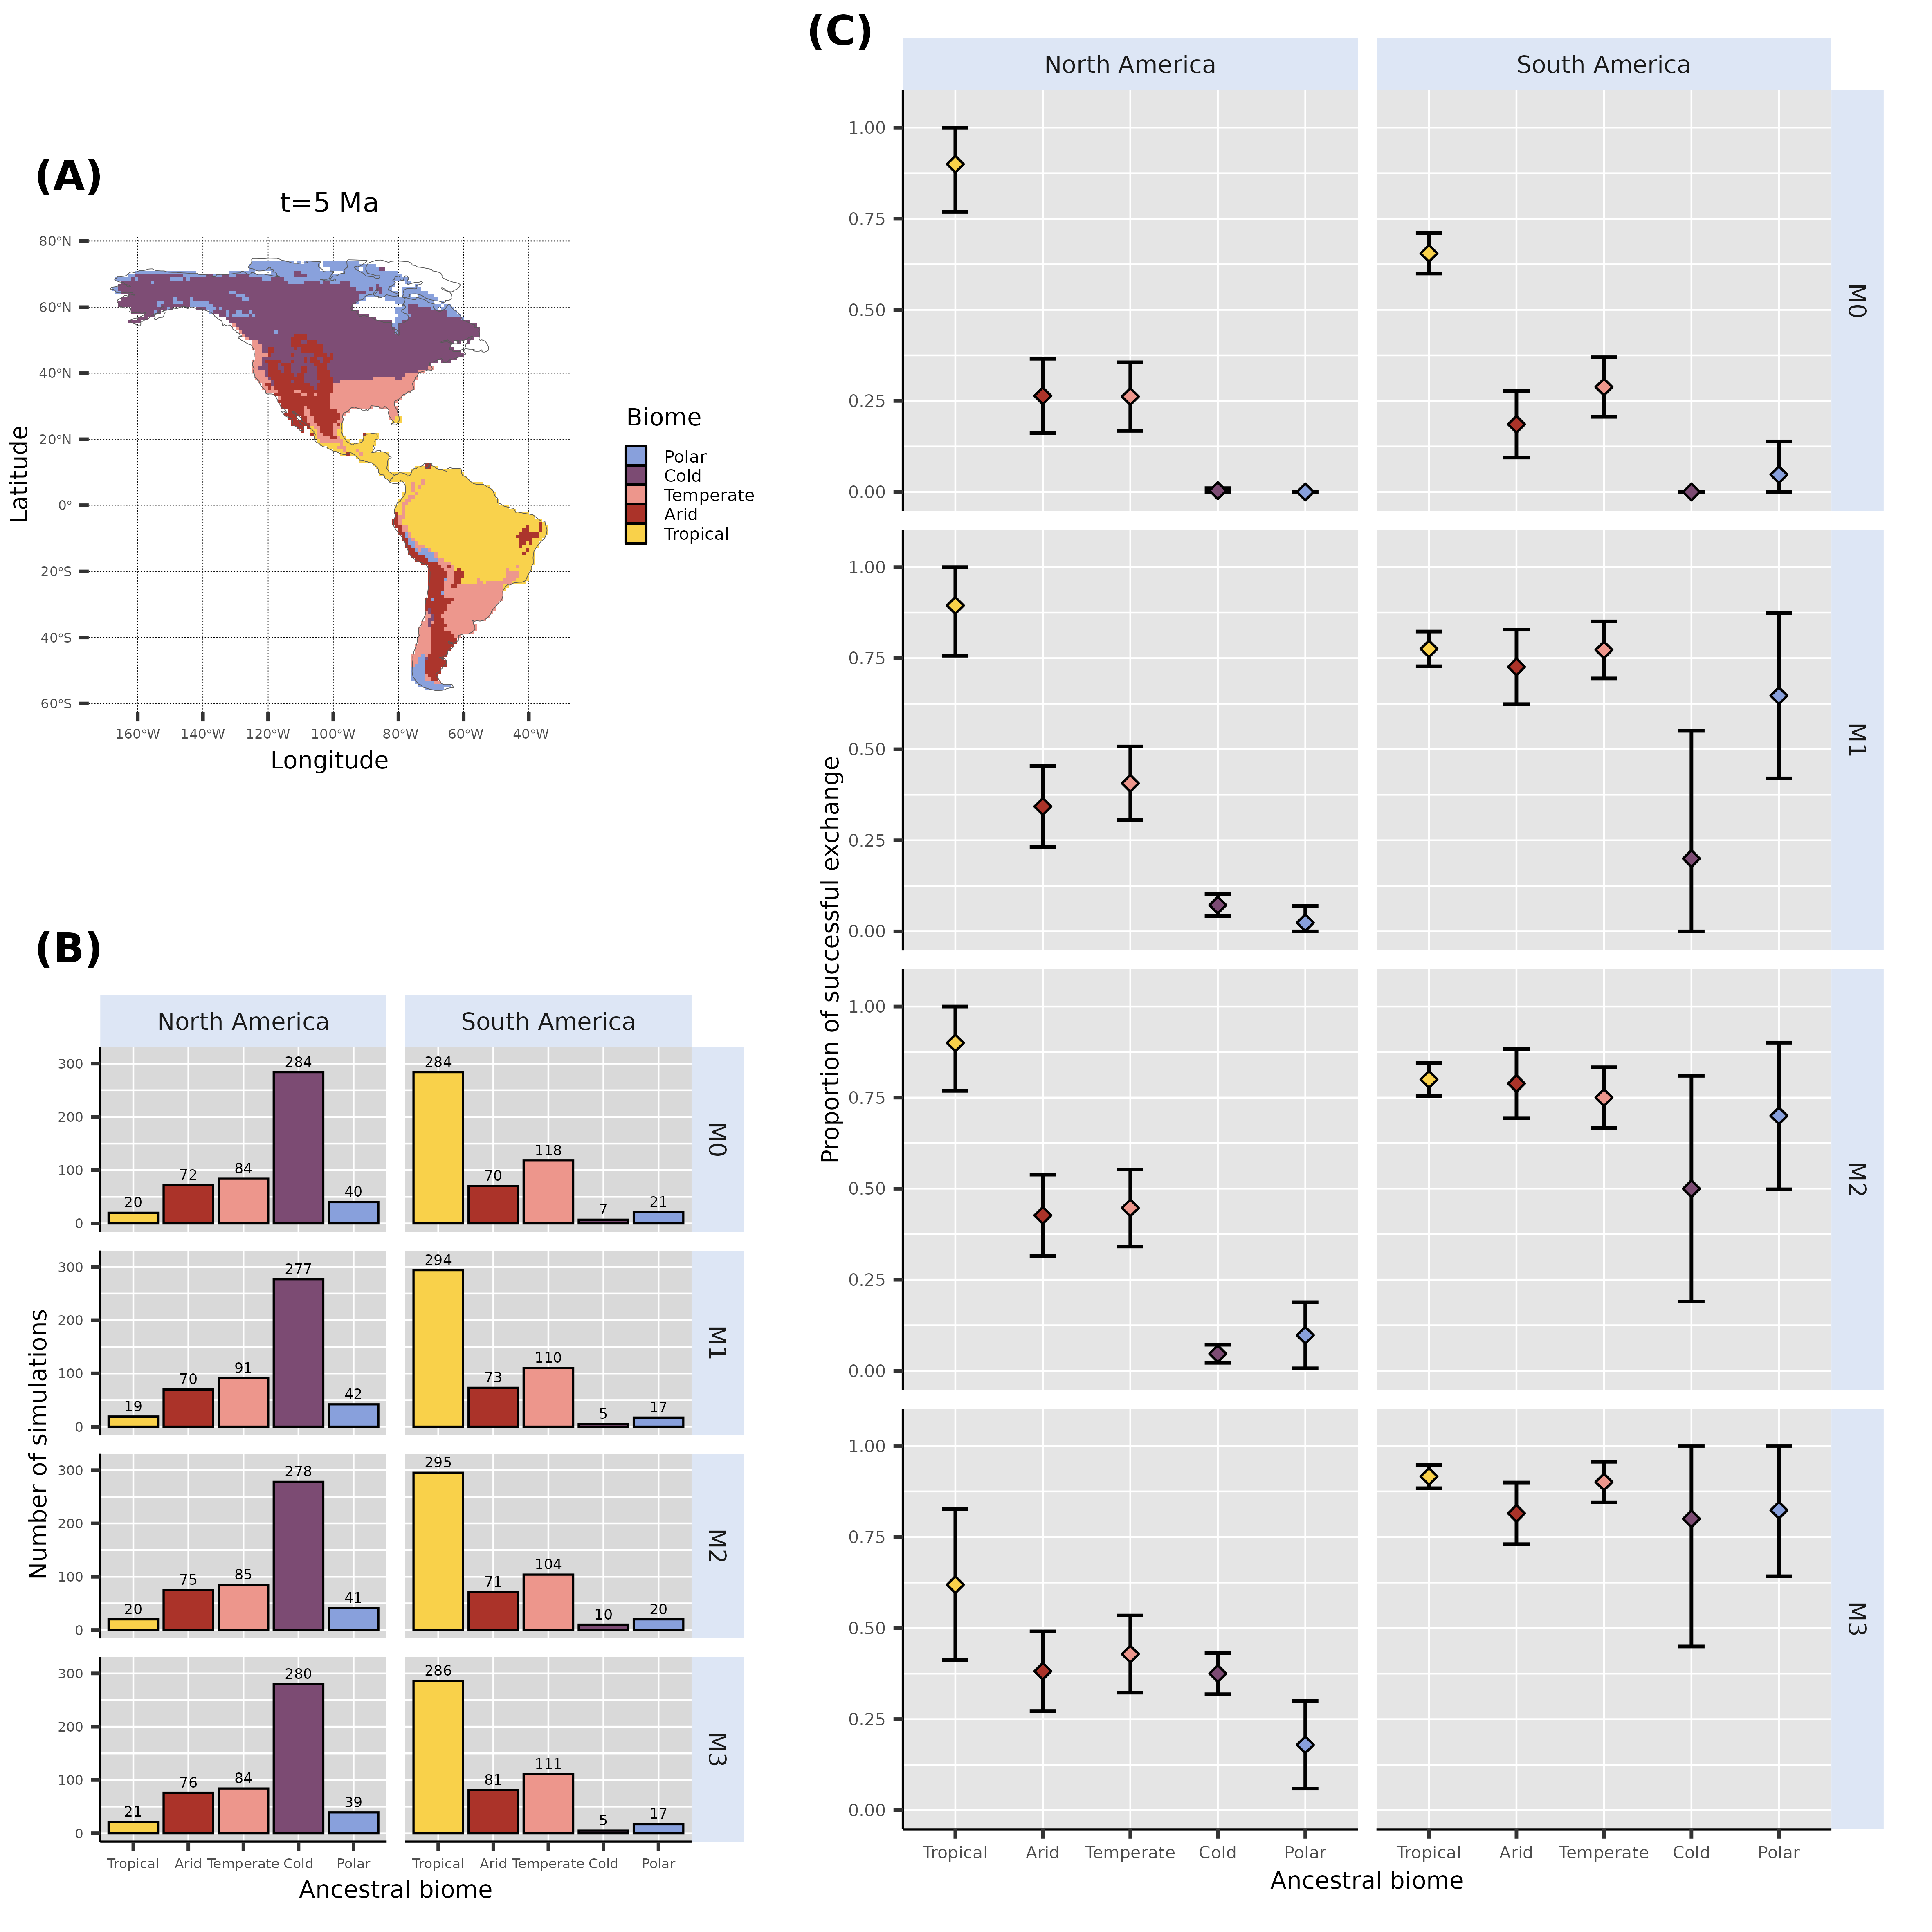
Figure 4: Initial biome where each ancestral species leading to successful simulations is recorded at the time of the onset of the simulations (5 Ma). (A) Global main climate zones based on Köppen-Geiger biome classification at $t=5$ Ma. (B) Biome where the ancestral species of each of the 500 simulations originated, for each continent and each scenario. We removed simulations starting from a cell that could not be assigned a biome from our counts, hence the reason why some are not exactly summing to 500. (C) Proportion of successful simulations based on the biome where ancestral species originates, for each modelled scenario-ancestral continent combination. This proportion is expressed as the ratio between the number of successful simulations and the total number of simulations starting from a given biome. Coloured dots and error bars respectively show proportion estimates and their associated Binomial-derived 95% confidence intervals.

References
Bacon, C.D., Molnar, P., Antonelli, A., Crawford, A.J., Montes, C. & Vallejo-Pareja, M.C. (2016). Quaternary glaciation and the Great American Biotic Interchange. Geology, 44, 375–378.
Bacon, C.D., Silvestro, D., Jaramillo, C., Smith, B.T., Chakrabarty, P. & Antonelli, A. (2015). Biological evidence supports an early and complex emergence of the Isthmus of Panama. Proceedings of the National Academy of Sciences, 112, 6110–6115.
Barreto, E., Holden, P.B., Edwards, N.R. & Rangel, T.F. (2023). PALEO-PGEM-Series: A spatial time series of the global climate over the last 5 million years (Plio-Pleistocene). Global Ecology and Biogeography, 32, 1034–1045.
Beck, H.E., Zimmermann, N.E., McVicar, T.R., Vergopolan, N., Berg, A. & Wood, E.F. (2018). Present and future Köppen-Geiger climate classification maps at 1-km resolution. Scientific Data, 5, 180214.
Boscaini, A., Casali, D.M., Toledo, N., Cantalapiedra, J.L., Bargo, M.S., De Iuliis, G., et al. (2025). The emergence and demise of giant sloths. Science, 388, 864–868.
Boschman, L.M., Carraro, L., Cassemiro, F.A.S., Vries, J. de, Altermatt, F., Hagen, O., et al. (2023). Freshwater fish diversity in the western Amazon basin shaped by Andean uplift since the Late Cretaceous. Nature Ecology & Evolution, 7, 2037–2044.
Bourke, J.R., Link, F., Long, M.D. & Wright, J. (2025). Evidence for Caribbean Plate Subduction Beneath the Isthmus of Panama and Implications for Subduction Initiation and the Closure of the Central American Isthmus During the Miocene. Geochemistry, Geophysics, Geosystems, 26, e2025GC012288.
Carrillo, J.D., Faurby, S., Silvestro, D., Zizka, A., Jaramillo, C., Bacon, C.D., et al. (2020). Disproportionate extinction of South American mammals drove the asymmetry of the Great American Biotic Interchange. Proceedings of the National Academy of Sciences, 117, 26281–26287.
Carrillo, J.D., Forasiepi, A., Jaramillo, C. & Sánchez-Villagra, M.R. (2015). Neotropical mammal diversity and the Great American Biotic Interchange: Spatial and temporal variation in South America’s fossil record. Frontiers in Genetics, 5.
Chakrabarty, P. & Albert, J.S. (2011). Not So Fast: A New Take on the Great American Biotic Interchange. In: (ed. Albert, J.). University of California Press, p. 0.
Cione, A.L., Gasparini, G.M., Soibelzon, E., Soibelzon, L.H. & Tonni, E.P. (2015). The Great American Biotic Interchange: A South American Perspective. SpringerBriefs in Earth System Sciences. Springer Netherlands, Dordrecht.
Cody, S., Richardson, J.E., Rull, V., Ellis, C. & Pennington, R.T. (2010). The Great American Biotic Interchange revisited. Ecography, 33, 326–332.
Croft, D.A., Gelfo, J.N. & López, G.M. (2020). Splendid Innovation: The Extinct South American Native Ungulates. Annual Review of Earth and Planetary Sciences, 48, 259–290.
Domingo, L., Tomassini, R.L., Montalvo, C.I., Sanz-Pérez, D. & Alberdi, M.T. (2020). The Great American Biotic Interchange revisited: a new perspective from the stable isotope record of Argentine Pampas fossil mammals. Scientific Reports, 10, 1608.
Faurby, S. & Svenning, J.-C. (2016). The asymmetry in the Great American Biotic Interchange in mammals is consistent with differential susceptibility to mammalian predation. Global Ecology and Biogeography, 25, 1443–1453.
Fernández-Monescillo, M., Romero-Lebrón, E., Pesquero, M.D., Haro, A., Rodríguez, P.E., Krapovickas, J., et al. (2025). Middle Pleistocene revelations: unravelling taphonomic processes in mammals including Mesotherium cristatum (Mesotheriidae, Notoungulata), Corralito Site, Córdoba Province, Argentina. Palaeontology, 68, e70012.
Freitas-Oliveira, R., Lima-Ribeiro, M.S., Mendoza-Rodriguez, V.H. & Terribile, L.C. (2025). Reviewing the Great American Biotic Interchange: Climate change as a trigger for biodiversity dispersal. Proceedings of the Royal Society B: Biological Sciences, 292, 20251745.
Freitas-Oliveira, R., Lima-Ribeiro, M.S. & Terribile, L.C. (2024b). No evidence for niche competition in the extinction of the South American saber-tooth species. npj Biodiversity, 3, 1–5.
Freitas-Oliveira, R., Lima-Ribeiro, M.S. & Terribile, L.C. (2024a). No evidence for niche competition in the extinction of the South American saber-tooth species. npj biodiversity, 3, 1–5.
Galván, S., Gamboa, S. & Varela, S. (2023). Köppen Geiger climatic classification for R users.
Hagen, O. (2023). Coupling eco-evolutionary mechanisms with deep-time environmental dynamics to understand biodiversity patterns. Ecography, 2023, e06132.
Hagen, O., Flück, B., Fopp, F., Cabral, J.S., Hartig, F., Pontarp, M., et al. (2021a). gen3sis: A general engine for eco-evolutionary simulations of the processes that shape Earth’s biodiversity. PLOS Biology, 19, e3001340.
Hagen, O., Skeels, A., Onstein, R.E., Jetz, W. & Pellissier, L. (2021b). Earth history events shaped the evolution of uneven biodiversity across tropical moist forests. Proceedings of the National Academy of Sciences, 118, e2026347118.
Holden, P.B., Edwards, N.R., Fraedrich, K., Kirk, E., Lunkeit, F. & Zhu, X. (2016). PLASIM−GENIE v1.0: A new intermediate complexity AOGCM. Geoscientific Model Development, 9, 3347–3361.
Holden, P.B., Edwards, N.R., Rangel, T.F., Pereira, E.B., Tran, G.T. & Wilkinson, R.D. (2019). PALEO-PGEM v1.0: A statistical emulator of PliocenePleistocene climate. Geoscientific Model Development, 12, 5137–5155.
Jaramillo, C.A. (2018). Evolution of the Isthmus of Panama: Biological, Paleoceanographic and Paleoclimatological Implications. John Wiley & Sons.
Köppen, W. (1900). Versuch einer Klassifikation der Klimate, vorzugsweise nach ihren Beziehungen zur Pflanzenwelt. Geographische Zeitschrift, 6, 593–611.
Liu, Y., Wang, Y., Willett, S.D., Zimmermann, N.E. & Pellissier, L. (2024). Escarpment evolution drives the diversification of the Madagascar flora. Science, 383, 653–658.
Lomolino, M.V., Riddle, B.R. & Brown, J.H. (2006). The Geography of Divesification - The Great American Biotic Interchange. Sinauer Associates Inc., US, pp. 406–413.
Lorcery, M., Husson, L., Salles, T., Lavergne, S., Hagen, O. & Skeels, A. (2025). Deep time evolution of the Latitudinal Diversity Gradient: Insights from mechanistic models. PLOS ONE, 20, e0332766.
MacArthur, R.H. & Wilson, E.O. (1967). The Theory of Island Biogeography. Princeton University Press. Princeton, New Jersey.
Marsà, J.A.G., Agnolín, F.L., Angst, D. & Buffetaut, E. (2025). Paleohistological Analysis of “Terror Birds” (Phorusrhacidae, Brontornithidae): Paleobiological Inferences. Diversity, 17, 153.
Marshall, L.G. & Cifelli, R.L. (1990). Analysis of changing diversity patterns in Cenozoic land mammal age faunas, South America. Palaeovertebrata, 19, 169–210.
Marshall, L.G., Webb, S.D., Sepkoski, J.J. & Raup, D.M. (1982). Mammalian Evolution and the Great American Interchange. Science, 215, 1351–1357.
Montes, C., Cardona, A., Jaramillo, C., Pardo, A., Silva, J.C., Valencia, V., et al. (2015). Middle Miocene closure of the Central American Seaway. Science, 348, 226–229.
O’Dea, A., Lessios, H.A., Coates, A.G., Eytan, R.I., Restrepo-Moreno, S.A., Cione, A.L., et al. (2016). Formation of the Isthmus of Panama. Science Advances, 2, e1600883.
Pérez-Escobar, O.A., Lucas, E., Jaramillo, C., Monro, A., Morris, S.K., Bogarín, D., et al. (2019). The Origin and Diversification of the Hyperdiverse Flora in the Chocó Biogeographic Region. Frontiers in Plant Science, 10.
Pilowsky, J.A., Colwell, R.K., Rahbek, C. & Fordham, D.A. (2022). Process-explicit models reveal the structure and dynamics of biodiversity patterns. Science Advances, 8, eabj2271.
Prevosti, F.J., Forasiepi, A. & Zimicz, N. (2013). The Evolution of the Cenozoic Terrestrial Mammalian Predator Guild in South America: Competition or Replacement? Journal of Mammalian Evolution, 20, 3–21.
Raven, P.H., Gereau, R.E., Phillipson, P.B., Chatelain, C., Jenkins, C.N. & Ulloa Ulloa, C. (2020). The distribution of biodiversity richness in the tropics. Science Advances, 6, eabc6228.
Simpson, G.G. (1980). Splendid isolation : The Curious History of South American Mammals. Yale University Press, New Haven.
Skeels, A., Bach, W., Hagen, O., Jetz, W. & Pellissier, L. (2023a). Temperature-Dependent Evolutionary Speed Shapes the Evolution of Biodiversity Patterns Across Tetrapod Radiations. Systematic Biology, 72, 341–356.
Skeels, A., Boschman, L.M., McFadden, I.R., Joyce, E.M., Hagen, O., Jiménez Robles, O., et al. (2023b). Paleoenvironments shaped the exchange of terrestrial vertebrates across Wallace’s Line. Science, 381, 86–92.
Smith, B.T., Bryson Jr., R.W., Houston, D.D. & Klicka, J. (2012). An asymmetry in niche conservatism contributes to the latitudinal species diversity gradient in New World vertebrates. Ecology Letters, 15, 1318–1325.
Smith, B.T. & Klicka, J. (2010). The profound influence of the Late Pliocene Panamanian uplift on the exchange, diversification, and distribution of New World birds. Ecography, 33, 333–342.
Stehli, F.G. & Webb, S.D. (Eds.). (1985). The Great American Biotic Interchange. Topics in geobiology. Plenum Press. Springer US, Boston, MA.
Tarquini, S.D., Ladevèze, S. & Prevosti, F.J. (2022). The multicausal twilight of South American native mammalian predators (Metatheria, Sparassodonta). Scientific Reports, 12, 1224.
Tedford, R.H., Albright, L.B., Barnosky, A.D., Ferrusquia-Villafranca, I., Hunt, R.M., Storer, J.E., et al. (2004). 6. Mammalian Biochronology of the Arikareean Through Hemphillian Interval (Late Oligocene Through Early Pliocene Epochs). In: (ed. Woodburne, M.O.). Columbia University Press, pp. 169–231.
Ugarte, P.D. de S., Nascimento, J.C.S. & Pires, M.M. (2025). Spatiotemporal variability in the South American mammalian fossil record and its impact on macroevolutionary inference. Frontiers in Mammal Science, 3.
Verzi, D.H., Montalvo, C.I. & Deschamps, C.M. (2008). Biostratigraphy and biochronology of the Late Miocene of central Argentina: Evidence from rodents and taphonomy. Geobios, Taphonomy, the understanding of fossilization processes in paleontology and archeology, 41, 145–155.
Vrba, E.S. (1992). Mammals as a Key to Evolutionary Theory. Journal of Mammalogy, 73, 1–28.
Wallace, A.R. (1878). Tropical Nature, and Other Essays. Macmillan; Company.
Webb, S.D. (1976). Mammalian Faunal Dynamics of the Great American Interchange. Paleobiology, 2, 220–234.
Webb, S.D. (1991). Ecogeography and the Great American Interchange. Paleobiology, 17, 266–280.
Weir, J.T., Bermingham, E. & Schluter, D. (2009). The Great American Biotic Interchange in birds. Proceedings of the National Academy of Sciences, 106, 21737–21742.
Wiens, J.J. & Donoghue, M.J. (2004). Historical biogeography, ecology and species richness. Trends in Ecology & Evolution, 19, 639–644.
Woodburne, M.O. (2010). The Great American Biotic Interchange: Dispersals, Tectonics, Climate, Sea Level and Holding Pens. Journal of Mammalian Evolution, 17, 245–264.

