

Lucas Buffan May 29, 2026
Institut des Sciences de l’Évolution de Montpellier

Dear editorial board members of Ecology Letters,

We have received your decision letter concerning our manuscript (number 4175150), entitled “Palaeoclimate alone fails to explain the asymmetry of the Great American Biotic Interchange”. We would like to thank you for considering our work, as well as for giving us the opportunity to revise it before a new submission. You may find enclosed a revised version of our manuscript and its Supplementary materials, which were modified following the comments and suggestions made by the reviewers.
Overall, the points raised by the Editor and the three referees were extremely relevant, and we believe they greatly improved our study. Noteworthy, as recommended by the Editor, we carried out additional batches of virtual experiment, allowing North American lineages to have broader thermal tolerance (i.e., increasing the range of the thermal breadth parameter associated to simulations starting in North America, ω_{T}). These supplemental sensitivity analyses strengthened our findings. In addition, we invited Dr. Philip B. Holden, the lead author of the palaeoclimate dataset that we use, to collaborate, in order to strengthen our reply to Reviewer 2’s (highly relevant) worry about the dependency of our results to the palaeoclimatic reconstruction used. Dr. Holden was thus added as a co-author of the study.
We hope that the changes that we made to our manuscript will fit your expectations, as well as those of the three referees who kindly accepted to review our work. We wanted to stress that the substantial changes that our manuscript received after accounting for the issues raised over this review resulted in a 400-word inflation above the 5000-word limit set by Ecology Letters. Consequently, we had to move some paragraphs of the Methods section to supplementary materials. We hope that this will not alter the good understanding of this manuscript.
Below are the comments made by the Editor and the three referees (italicised pink), to which we respond with a normal font.

*******

Editor’s comments:

The manuscript has been reviewed by three reviewers, and their recommendations diverged. While all reviewers agreed that the manuscript is original and of high quality, praising the authors for using this modeling approach to address specific hypotheses, one reviewer raised concerns about the robustness of the results to the choice of climate models, the definition of boundaries between North and South America, and the delimitation of biomes. Another reviewer criticized the way the study is contextualized, contesting the claim that a climate-based hypothesis for the GABI asymmetry is widely accepted. During my own reading, I also identified some additional issues that could be addressed to make the main message clearer.
Thank you for this contextualisation.

Lineages with different origins are often compared under the same simulated scenarios (M0 to M3). Given these scenarios, one might expect the best fit to the observed patterns to arise from a model in which lineages originating in the South exhibit higher niche conservatism (M0), whereas those originating in the North show greater niche evolvability. Emphasizing the comparisons across models between lineages from different regions in the text and figures would help to demonstrate that, even in scenarios where southern lineages exhibit higher niche conservatism, the asymmetry does not emerge.
Given the empirical GABI pattern, one could indeed expect to retrieve smaller exchange intensities from fixed-niche simulations (M0) originating in South America than from evolving-niche (M1) ones originating in North America. We agree that it would both improve the comprehension of the manuscript and strengthen our overall message to clearly state these assumptions while introducing our modelling schemes, and refer to them in the results section by explicitly emphasising relevant inter-model comparisons. Accordingly, we intended to implement these changes in the revised version of the manuscript. Thank you very much for this thoughtful remark.

In addition, the evolution of climatic niches is governed by a small number of parameters that are assumed to have the same range for lineages originating in North and South America. It would be interesting to explore the limits of these parameter ranges, for example, by expanding the range of sigma or the niche breadth for northern lineages under models M1–M3, to assess which parameter combinations might reproduce the observed pattern. This would help determine how asymmetric niche conservatism versus evolvability would need to be, and whether such asymmetry is biologically realistic, to account for the GABI pattern.
Thank you for this comment. We agree that testing for different niche breadths (ω_{T} or ω_{P}, resp. for temperature and precipitation) or evolvability (σ_{e}) ranges between simulations starting from North and South America could provide highly interesting results. Indeed, since North America’s climate is more variable across time than South America’s (as depicted on continent-averaged plots shown in Figure S1), the assumption that North American lineages would either have broader climatic tolerance, or could adapt faster to changing climatic conditions is highly relevant, and worth testing.
In the framework of our virtual experiments, we can expect that, irrespective of the model used to generate simulations (i.e., allowing or not climatic niche to evolve), expanding ω of simulations originating in North America would increase the proportion of successful southwards exchange across the 500 replicates. The same assumption can be made on the basis of larger σ_{e} ranges for simulations starting in North America compared to those from South America. In addition, since climatic (and particularly temperature) temporal variability is more pronounced in North than in South America (see Figure S1), we can also expect that increasing ω_{T} range for simulations starting in North America would decrease the proportion of simulations crashing (i.e., where the ancestral species goes extinct after a tiny number of iterations). Indeed, the proportion of simulations crashing was always 3-4 times higher when simulations started in North America than in South America (Table S2). Leveraging thermal constraints on species’ ecology (i.e., model M3) yielded almost no crash in the end (Table S2), suggesting that most crashing simulations were due to species’ incapacity to cope with temperature change occurring within their home range.
We decided to focus on thermal niche breadth, and carried out additional experiments starting from North America, where we expanded the range of North American lineage’s thermal breadth (ω_{T}) from [0.01, 0.1] to [0.01, 0.6] and [0.01, 1]. We think that going beyond a 10-fold niche breadth difference between simulations originating in North vs. South America is not biologically realistic. We further compared the proportion of successful exchanges obtained with this experimental design to the one derived from our initial pipeline, starting from either continent, allowing (or not) climatic niche to evolve (M0 and M1).
These sensitivity analyses revealed that the inverse asymmetry in proportion of successful exchange that we characterised in our manuscript is robust to the aforementioned increase in thermal niche breadth for North American lineages (Supporting Figure 1A). Indeed, irrespective of the model under which simulations were generated (i.e., M0 or M1), the proportion of successful North-to-South exchanges does not vary significantly when virtual species’ thermal breadth is broadened by up to a factor 10 (Supporting Figure 1A). Also, in line with our expectations, increasing North American lineage thermal breadth drastically decreased (by a factor three) the proportion of simulation that crashed (Supporting Figure 1B). This explains the fact that, although the actual number of simulations leading to successful North-to-South exchange increased when we allowed North American lineages to have broader temperature tolerance, such an increase is also counterbalanced by the overall increase in the number of simulations leading to no exchange, and thus, that the overall proportion of successful exchange does not change when we allow North American lineages to have broader thermal niches.
We ensure to make the config files associated to this new set of analyses entirely available along with the rest of our data, on the same FigShare repository: https://doi.org/10.6084/m9.figshare.31160704
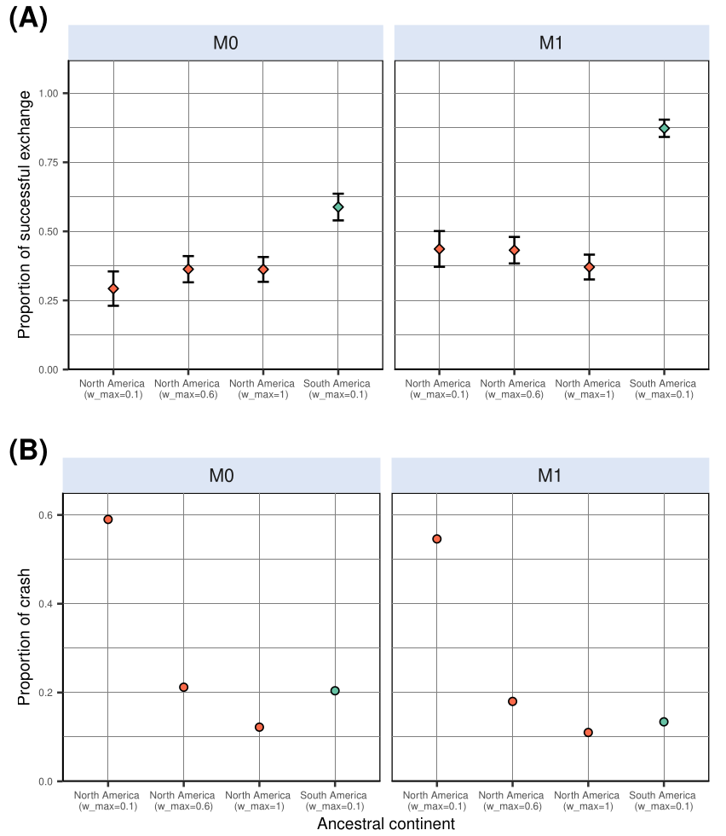
Supporting Figure 1. Comparative proportion of simulations resulting in successful inter-continental exchange (A) and of simulations that crashed (i.e., leading to no living representative at the end of the simulation) (B). Simulations were generated in a landscape based on the PALEO-PGEM series. `w_max` indicates the upper bound of the thermal breadth parameter (ω_{T}) associated with the corresponding batch of simulations.

Considering the reviewers’ comments and my own evaluation, I believe the manuscript would benefit from additional analyses and some revision before it can be considered for publication.

Reviewer #1:

The manuscript tests a clear set of macroecological hypotheses about the drivers of asymmetry in the Great American Biotic Interchange (GABI), using a well-designed modelling framework to evaluate whether spatio-temporal palaeoclimate dynamics can account for the observed pattern. The analyses are carefully executed, the study is well framed in the literature, and the results support the conclusion that climate alone is unlikely to explain the asymmetry, pointing to additional mechanisms that merit future work. Overall, the work is sound, clearly written, and well documented, and in my view, ready for publication. I enjoyed reading the manuscript. The methods are clear, and the modelling approach is well matched to the questions.
Thank you very much for this positive introduction. We are extremely delighted to read that you enjoyed our study.

Nevertheless, I would have liked a bit more discussion of limitations and future work in the main text (not only in supplementary material). For example: what would be the next modelling step? Which alternative hypotheses could explain the observed GABI asymmetry, beyond the “climate alone” expectation explored here? Are there mechanisms that would predict the opposite pattern to the natural tendency emerging from the climate-only simulations?
The reason why we moved the Limitations & Perspectives section to Supplementary Materials is that we were running out of characters in the main text and had to take a decision on how to reduce manuscript length to match the 5000-word limit imposed by Ecology Letters. We share your disappointment, and would have preferred to place it in the main text as well.
We agree that the perspectives that you raise could add interesting layers of discussion to the main text. However, we are afraid that the aforementioned manuscript length constraint prevents ourselves from doing so. That being said, in the third paragraph of the Limitations & Perspectives section − that we regretfully had to move to Supplementary Materials −, we intended to emphasise the (non-abiotic) factors that might have shaped the asymmetry of the GABI, and propose an avenue for further modelling studies. Also, in the main text, we intend to provide biologically-informed perspectives for the inverse asymmetry derived from our simulations, with examples of groups that, contrary to mammals, did not exhibit the classical patterns of higher success at colonising the other continent for Northern taxa. Although we are aware that it is a bit frustrating to constrain ourselves to such a tiny number of arguments in this section, we think that some of the points that you raised are intended to be covered. Hopefully this can be further expanded in follow-up studies!

Finally, the authors did an excellent job sharing the configs, landscapes, and code, and the literature coverage is strong.
Thank you!

One minor request: could the authors also provide the resistance values used or even better the resistance function when create_gen3sis_input function is run? (e.g., the value assigned to ocean / NA), ideally in the main text or a clearly referenced table?
That’s a good point. Our choice of cost function was not innovative since a re-used the cost function designed for earlier studies (see screenshot below), making it twice as hard to disperse to a non-habitable (water) than to a habitable (land) cell (Skeels et al. 2023a, b). This function implied that we made the assumption that the cost of moving from a cell to another does not change across the simulation, and is not tied to any landscape change. This is indeed a strong assumption, and we agree that it should be mentioned in the Methods section of the main text. We therefore added it.

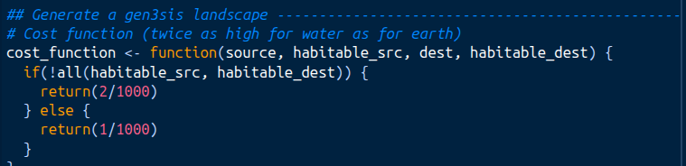

Minor comments
Line 36. Add alone, since you can not exclude paleoclimate dynamics from the equation in case of other interacting mechanisms. Hence, we argue that spatio-temporal palaeoclimate dynamics ***ALONE*** cannot explain the asymmetry of the GABI, suggesting additional factors fashioned this macroecological enigma.
Agreed, thank you.
Line 88. Liu et al. (2024) did not use process-explicit modelling for the biological component; that part was correlative. The process-based component was applied to landscape evolution only.
That’s correct. We cited it because it is recent and is not a gen3sis case study (contrary to the other ones cited alongside), but indeed it would have made more sense to cite a paper using another MEEM rather than a process-explicit model of landscape evolution. We removed the citation.

Lines 102–105. Nice job keeping the continent names consistent and clearly defined.
Thanks!

M0 and M1 labels. Consider renaming M1 and M0. The labels “generalist” and “specialist” may not reflect the adaptation mechanisms you tested. They can also be read as referring mainly to niche breadth. More neutral labels (e.g., “adaptive niche model” vs. “fixed niche model” or something related with niche breath – see next comments) may better match the design.
This is totally accurate. It actually makes more sense to read the generalist vs. specialist dichotomy through the lens of niche breadth − a parameter that was held constant across simulations − rather than through the evolvability of the optimum parameter. We did not consider it, so thank you for stressing this. We modified the manuscript accordingly, adapting the phrasing when necessary.

Consider introducing tropical niche conservatism earlier (rather than first at ~line 357). It is a key concept that connects directly to your M1/M0 framing and overall study design.
You are right that tropical niche conservatism is quite a central concept that would deserve to be mentioned before the discussion. Consequently, we introduced it after the Methods section paragraph introducing our modelling schemes. Thank you for the suggestion.

Reviewer #2:

The analysis wants to test if paleoclimate alone can explain the mammal South America (SA)-North America (NA) asymmetry, e.g., extant mammal faunas have more NA lineages in both SA and NA. This pattern was formed following the connection of SA and NA in an event known as GABI (the Great American Biotic Interchange). Three distinct and well-thought hypotheses are to be tested (i) a NA ancestor would be more successful at reaching the other continent than viceversa, (ii) a NA ancestor migration would result in a more diverse and spatially spread radiation in the newly-colonised continent, and (iii) successful interchange would be more frequently achieved among biome generalists, extratropical specialists rather than tropical specialists.
The analysis uses a paleoclimatic model (PALEO-PGEM) and an eco-evolution simulator (gen3sis). The modeling exercise is well done, following a logical pathway reaching the conclusion that paleoclimate alone cannot explain the asymmetry and actually, the opposite pattern would have been expected (more migrations from SA to NA). This is a very interesting result that will open a new venue for research on GABI, one of the largest biogeographic experiments of the Cenozoic. The manuscript is well written, and the illustrations are appropriate; it would be a good fit for the journal.
Thank you very much for these opening words. We are happy to read that you overall appreciated our work.
However, I see major problems:

1. Modeling climate is a difficult task. Consequently, Global Circulation Models have major prediction discrepancies for predicting future and past climates, especially precipitation in both the tropical band and in the center of large continents. The study used the PALEO-PGEM model, but there are many others (e.g.,bcc-csm1-1,CNRM-CM5, COSMOS-ASO, GISS-E2-R_p150, GISS-E2-R_p151, IPSL-CM5A-LR, FGOALS-g2, MIROC-ESM, MPI-ESM-P_p1, MRI-CGCM3, CCSM4, CSIRO-Mk3-6-0, CSIRO-Mk3L-1-2). Some of them predict that Panama was a savanna during the LGM, while others indicate that there was a rainforest. How dependent are the results on the chosen climatic model? That is a question that must be quantified for this study to be helpful. I think the study needs to select another climate model that predicts contrasting differences with PALEO-PGEM model, to assess if the pattern found in the study holds, or it is highly dependent on the climatic model.
Thank you for this very thoughtful comment. Our simulations are indeed exclusively tied to the assumptions and the outputs of a single GCM, PLASIM-GENIE (Holden et al. 2016), statistically emulated across the last 5 Myrs with a 1000-year interval by the PALEO-PGEM emulator (Holden et al. 2019), leading to the PALEO-PGEM series (Barreto et al. 2023). As you stress, many different GCMs exist, differing in their assumptions, the data they rely on and, in turn, in their predictions. For that reason, testing the sensitivity of our results to the palaeoclimate reconstruction used would be highly relevant and, to our knowledge, has never been done in eco-evolutionary studies using gen3sis.
One constraint arises as, despite the existence of a vast number of GCMs, most of them have a limited number of scenarios (mainly LGM, mid-Holocene and Present). Yet, our eco-evolutionary simulation framework requires palaeoclimate layers temporally interpolated between each others with a narrow resolution (10 ky-interval) throughout the last 5 million years. Such a resolution is typically available for the PLASIM-GENIE model (via the PALEO-PGEM series), but not for many other GCMs often used in macroecology, including those you listed, making it impossible for us to use the outputs of these GCMs in our pipeline.
To our knowledge, PALEO-PGEM-Series is the only palaeoclimate dataset that has both sub-orbital temporal resolution and extends back to 5 Ma, as needed for our study. One alternative dataset that comes close to our needs is the 3 Ma transient coupled simulation with CESM1.2 (Yun et al. 2023), made tractable by splicing together 42 simulations that were run in parallel. Unfortunately, this does not encompass the Pliocene and would thus only allow to test for biotic exchange occurring during the Quaternary, narrowing the scope of our work. In contrast, the Oscillayers dataset (Gamisch 2019) does extend back to 5.4 Ma, but the approach of pattern scaling LGM anomalies does not represent orbital variability − the dominant driver of climate variability at 10 ka. Furthermore, it unrealistically assumes that Pliocene warming has the same spatial pattern as LGM cooling. Similar concerns were expressed by (Brown et al. 2020). Although Oscillayers superficially meets our requirements in terms of spatio-temporal coverage and resolution, this dataset is not fit for our purpose, and in our view should not be used in the Pliocene for any application. Consequently, at time of writing, the sensitivity of our pipeline to the palaeoclimate reconstruction used cannot be evaluated, which represents a strong limitation to our work.
We incorporated these elements in an additional paragraph of our Limitations and Perspectives section.

2. Figure 1 shows Central America and western Amazonia/SA to be savanna/desert, while only a small pocket is rainforest in eastern Amazonia. I wonder where this biome interpretation came from. I downloaded the Paleo-Pgem dataset from the Barreto article and plotted precipitation for the LGM and the pattern seems quite different to the biomes presented in figure 1 (see attached figure). I searched into the supplementary material, the actual MAT and MAP maps for each time slice that were used, but I could not find them. It would be useful if a few time layers are shown (e.g., today, the LGM, the last Interglacial, 1 My ago, 2.6 My, 3 and 5 My).
Figure 1 directly draws on the palaeoenvironmental interpretations made by Webb (1991), that were most likely extrapolated for artistic/visual purpose (see below a screenshot of the figure in question, along with its caption). The purpose of Figure 1 was more to set the scene and present the hypotheses that are being tested in the manuscript rather than to provide an accurate picture of landscape change throughout the study period. Raw first-order maps approximating biome temporal dynamics with illustrative purpose can be found in the literature. A good example is Figure 1 of Meseguer & Condamine (2020), depicting the evolution of the extent of the tropical belt through the Cenozoic to show how it may have influenced the establishment of the Latitudinal Diversity Gradient. To avoid further confusion, we extended Figure 1’s caption to clarify that these maps do not pretend to depict the most accurate picture of biome dynamics in the Americas between glacial and interglacial phases, and that their purpose is purely illustrative.
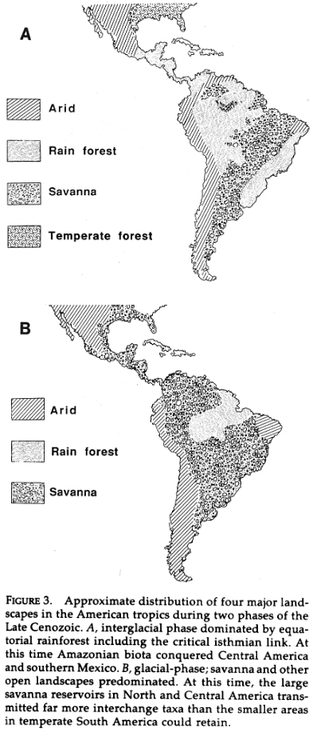
In addition, we did not make the palaeoclimatic layers that we used available along with our publication to avoid useless data storage, since − as indicated in the Methods section − these were directly downloaded from the supplementary materials of Barreto et al. (2023) without any subsequent change (the files in question were called `bio1_mean.txt` and `bio12_mean.txt`, stored in the `biovars_mean.zip` folder), as you did to produce your figure. Biome classification relied on the monthly average temperature and precipitation available in the `monthly_mean.zip` folder. That being said, we agree that inserting some palaeoclimate variable snapshots at precise time steps could help better visualise and apprehend the data our entire study relied on − i.e., the palaoeclimate layers. Consequently, we inserted a panel in supplementary materials, depicting Bio1 and Bio12 at precise snapshots back in time, along with the corresponding biome reconstructions (see figure below). This panel clearly contrasts with the caricatural fragmentation that we drew on Figure 1. During glacial maxima (e.g., LGM), the fragmentation of the closed tropical biomes (tropical rainforest ans monsoon) is way less pronounced than on our representation, but we believe that leaving Figure 1 as it is should not be a problem as long as we clearly state that its aim is purely illustrative (which we intended to do by accounting for your comment). Last, it should also be noted that palaeoclimate reconstructions at the beginning of the 1990s, when the climate-driven asymmetry hypotheses were formulated, were not as advanced as what they are now, explaining potential mismatches between 1990s reconstructions and those that we obtained.

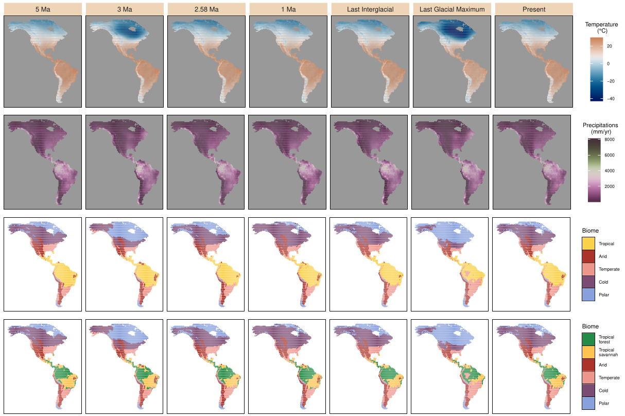
Snapshots of the two bioclimatic variables used in this study (Annual Temperature and precipitations, respectively called Bio1 and Bio12 in the climate model) from PALEO-PGEM (Holden et al. 2019), together with the corresponding biome reconstructions that we carried out following Galván et al. (2023) (using broad climate classes), at key time steps. In the biome reconstruction that we carried out for the bottom row, the "Tropical" class was subdivided into "Tropical forest", incorporating closed Rainforest and Moist forest (Monsoon), and "Tropical savannah", associated with a more open landscape. Last Interglacial corresponds to t=120ka and Last Glacial Maximum to t=21ka.
3. How were the main five biomes determined? (the climatic boundaries that were chosen for each biome must be explicit).
In the Palaeoclimate data section, we explained that: “we reclassified monthly palaeoclimate layers for our starting time ( My ago) according to Köppen-Geiger broad climate types (Beck et al. 2018; Galván et al. 2023). This classification divides the world into five broad climatic regions: Polar, Cold, Temperate, Arid and Tropical, following the criteria proposed by Köppen (1900)”.

4. I could not find a single mammal taxon anywhere in the metadata. There should be a list with the name of the taxa, time of origination, time of extinction, site of origination (lat, long), biome of origen, and additional biomes where it occurred along its history. Very hard to assess the results if none of the raw data is shown.
Sorry for the confusion, but this work exclusively relied on simulated data, not on true mammal taxa. Apart from the palaeoclimate estimates, our pipeline did not incorporate any empirical datum. Our aim was to assess the extent to which a simple simulation framework relying on palaeoclimate could capture a sufficient amount of complexity to explain the asymmetry behind the GABI. As the simulations failed to reproduce the asymmetry, we did not intend to match the simulated diversity pattern with actual data (either of fossil or extant taxa).

Furthermore, it would be useful if some lineages are discussed. For example, I have always puzzled over the horses, camels, and rhinoceros found in the lower Miocene tropical rainforests of Panama. All three lineages would be classified as occupying open biomes, and yet they inhabited the rainforest of Panama for millions of years. Perhaps, they reached newly-formed forest still lacking South American mammals, thus being able to establish even though they moved into a new biome
Since our study is entirely simulation-based, assigning empirically-relevant biological groups to virtual lineages to enhance such a discussion may not be straightforward. That being said, the point that you raise is very interesting. Indeed, as you indicate, particularly in the case of land mammals, some Late Miocene faunal assemblages from Central America (e.g., Gracias Fm in Honduras and El Salvador) were almost exclusively composed of genera also found in temperate North America. These include, among others, rhinocerotids (Teleoceras), equiids (Hipparion, Pliohippus), camelids (Procamelus, Protolabis), bovids (Bison) or gomphotheriids (Rhynchotherium, Cuvieronius) (Webb & Perrigo 1984) (note that almost none of the aforementioned taxa made it to South America). Despite uncertain palaeoenvironmental context for some localities, it cannot be excluded that these assemblages deposited in a tropical forested environment, which contrasts with the conspicuousness of the taxa in question in clearly-established temperate assemblages of North America. Also noteworthy, these assemblages had a poor level of endemism, meaning that most of the taxa that they revealed were also found elsewhere (e.g., temperate North America).
The presence of these taxa in these (likely) tropical forest assemblages may be interpreted under the lens of the enhanced facility for North American non-tropical groups to colonise tropical areas, as evidenced by Smith et al. (2012), who characterised an asymmetric niche conservatism between North and South American land vertebrate families. Following their result, in the framework of the Americas, colonising tropical areas for non-tropical taxa would be easier than the other way around.
Due to space limitation, we could not expand ourselves as much as we would have liked to in this respect, but we believe that this aspect is already approached in the Discussion paragraph in which we analyse our findings under the prism of tropical niche conservatism.

5. The NA vs SA delimitation was set in western Panama. That is a strange boundary that does not correspond to the geological boundary between the Caribbean plate (Panama microplate) and the South American plate. The actual geological boundary between CA and SA is along the Uramite suture in the western cordillera of Colombia (e.g., Montes et al 2015, Science)
As indicated in the main text, the delimitation between North and South America was placed at random somewhere in Panama. As you raise, this choice does not reflect the geology of the continents, instead placing such a separation along the Urumita suture. Our choice reflected some assumptions of connectivity between the landmasses prior to the onset of our simulations (5 Ma). Indeed, placing the delimitation along the Urumita suture would suggest that the closure of the Central American Seaway (CAS), in the middle Miocene (Montes et al. 2015), would have marked the full closure of the isthmus of Panama. Despite the fact that the closure of the CAS most likely interrupted deep-water circulation between the Caribbean sea and the Pacific ocean, there are compelling evidence suggesting that shallow water flow persisted through Panama at least until the Pliocene (Jaramillo 2018; O’Dea et al. 2016 and literature therein). We assume this water flow persistence following the closure of the CAS to have acted as a barrier against most terrestrial exchanges between the continents (though some exceptions exist, see Woodburne 2010). Thus, at the beginning of our simulations (i.e., virtually following the closure of the isthmus), it is relevant to consider that South American lineages could reach a piece of Panama. That being said, moving the inter-continental delimitation a few cells southwards should not impact the overall simulations’ outcome.

6. It is possible that the Andes acted as a conduit for temperate taxa to cross tropical latitudes in both directions. However, a grid of 1 degree would fail to capture the granularity of the Andes climates, and probably the MAT would be lower than the actual values (the Andes grid would contain areas from the lowlands, increasing the MAT for the grid). Perhaps a grid approach is not appropriate for the Andes, and it would be better to use actual shapes that follow the Andes contour lines (e.g., 500-2000m, 2000-3800m,>3800), which would move down during glacial times. Same occur with the shallow bays all along Central America, as all became land during glacial times. That would increase land area by 45% in Panama alone.
Considering that the Andes acted as a corridor for temperate North American taxa to disperse southwards is full of sense. It could explain the successful colonisation of taxa such as camelids in South America − though the fossil record suggests that, in the Pleistocene, camelids could also be found in the plains, as attested by the Eastern Brazil occurrences of Palaeolama. One could also think about the astonishingly diverse radiation of sigmodontine rodents, in which the Andes were shown to have played a key role (Vallejos-Garrido et al. 2023).
As you notice, part of the palaeotopographic information is reflected by the palaeoclimate layers. Although a significant amount of local altitude microclimate information (likely important for the dispersal of several taxa) is probably lost due to the usage of a 1x1° grid, we believe that our approach does not erase all the mountain signal, and that it would be hard to gain more accuracy in that respect.
Next, regarding the changes in the extent of coastlines in shallow bays (e.g., Panama) between glacial maxima and interglacials, your remark is totally relevant. Indeed, this must have significantly changed the amount available area, particularly in the zone of connection between the North and South American landmasses. However, we think that such variations lie within the boundaries of our PALEO-PGEM-derived landscape (not changing across simulations, which is indeed a limitation that we intend briefly mention in the Limitations and Perspectives section), as depicted on the plot below.

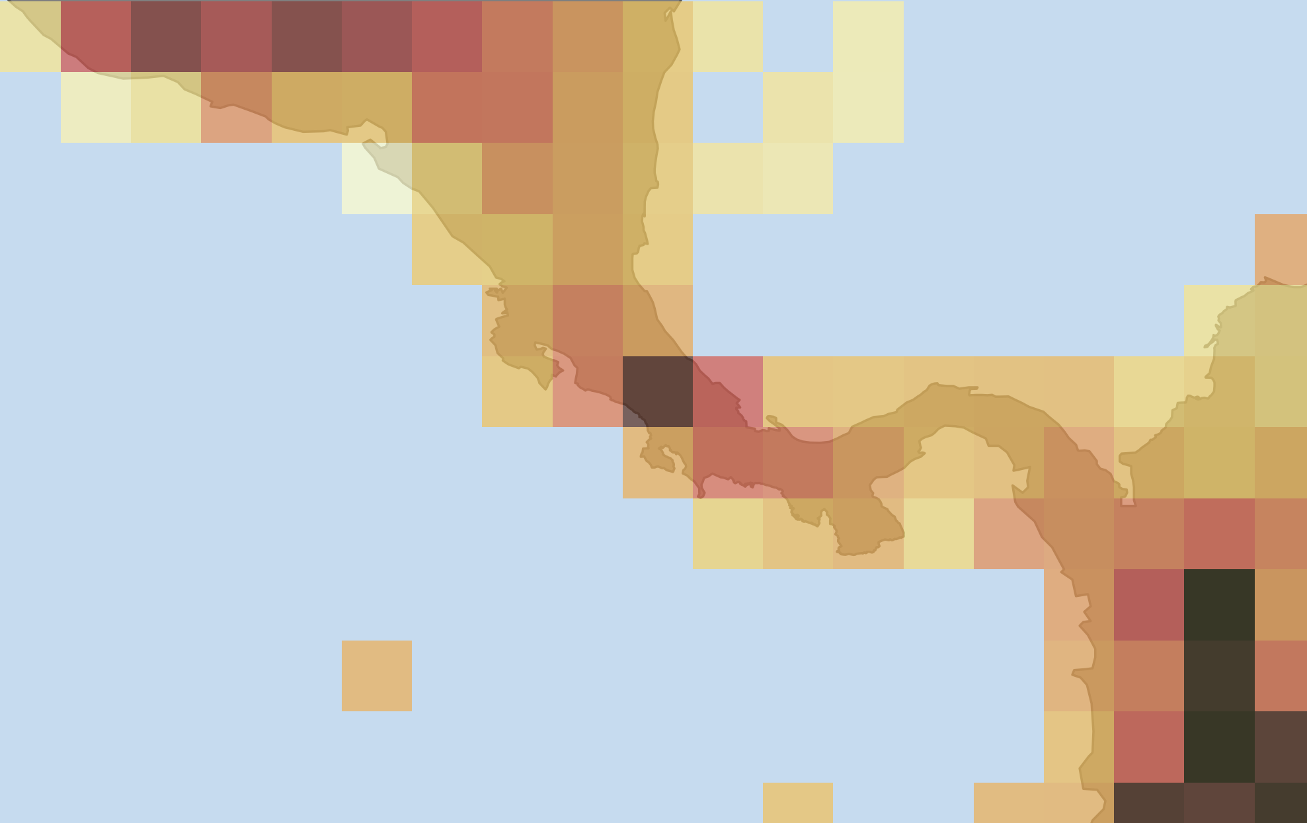
Spatial extent of PALEO-PGEM for Central America. Each pixel is a 1x1° cell, filled with an annual temperature (the value range is not important here, all what we wanted to show is that PALEO-PGEM’s grid cells span a large area in Panama). Note that the isolated pixels, representing islands, were excluded from our actual simualtion landscape.
This is a good piece of work that is worth publishing. However, it requires running an additional experiment (at least one more GCM) and providing the taxa that were used in the analysis.
Thank you for these very useful comments. We believe that they greatly improved the study.

Reviewer #3:

I am not sure what is the right recommendation for the manuscript but I lean towards a major revision.
The main issue lies in the overall framing. The manuscript claims that it is the common expectation that GABI can be explained by climate alone and that it therefore is a surprise that they cannot do it. That seems to be a very one-sided reading. There are ample studies arguing that the climate model is not the most likely. Some are cited but dismissed without good reasoning. Another very cool one is still in preprint only but very central in this regard (https://www.biorxiv.org/) If the paper was rewritten it would be interesting to show with simulations as these that a model lacking good theoretical basis also fails with simulations. Climate is still a commonly claimed driver and such a paper would clearly be publishable and I can easily see myself citing it, but I am not sure if such a paper would be strong enough for a journal like ecology letters? In its current form I cannot recommend publication anywhere. In a rewritten form I would recommend publication somewhere which may or may not be this journal. In addition to this major issue there are a few minor things I will address below on a line by line basis
We apologise if our manuscript gave the impression to be built upon the fact that climate-driven asymmetry of the GABI was “the common expectation”. We acknowledge that alternative hypotheses have been proposed − that, as you noticed, we intend to report in the second paragraph of the introduction −, and that constraining the complexity of such a major biogeographic event to climatic changes is probably inaccurate. That being said, the hypotheses invoking palaeoclimate as the only driver behind such an asymmetry have been formulated for decades (Vrba 1992; Webb 1991), have maintained in the field since then (Bacon et al. 2016; Woodburne 2010), and were supported by recent findings (Freitas-Oliveira et al. 2024a, 2025 and literature therein). They stood out as an alternative to the long-standing view that the asymmetry of the GABI was the result from biotic interactions (Simpson 1950), either competition or predation, that were contrastingly supported in the recent literature, championed by some studies (Domingo et al. 2020; Faurby & Svenning 2016; Pino et al. 2025) but invalidated by others (Freitas-Oliveira et al. 2024b; Pino et al. 2022; Prevosti et al. 2024; Tarquini et al. 2022). Consequently, we do not share the view that the abiotic-only hypotheses are “lacking good theoretical basis”, and still think that such hypotheses are worth testing.
We never meant to “dismiss without good reasoning” the wealth of hypotheses relating the asymmetry of the GABI to non-climatic factors. Given the complexity of the studied pattern and the immense variability that a simulation framework like gen3sis is likely to generate, we instead think that testing alternative hypotheses would deserve to be the topic of an entire study in itself (or even several ones), and that going beyond testing the abiotic-only hypotheses would have been infeasible in a single paper − especially in a relatively short format, as the one imposed by Ecology Letters.
As a result, we argue that our study should be more seen as a first attempt to model the GABI with eco-evolutionary simulations, testing long-standing hypotheses, and that can be used as a building-block for improved processed-based modelling of the GABI, rather than an attempt to build the “most likely” model of the GABI. From a broader perspective, the idea that climate change impacts the temporal dynamics of life on Earth is deeply rooted in the fields of biogeography and palaeontology (Erwin 2009; Malanoski et al. 2024; Nogués-Bravo et al. 2018), adding some relevance to testing hypotheses relating biodiversity and climate dynamics, which is what is intended in this study.

Lines 109-112.
I think that some argument or SI results is needed for why the change in window does not change the amount of climatic oscillation in the Pleistocene. If the timewindow gets too big , the interglacials may disappear. I do not think this should be a major problem for 10,000 years but I think some argumentation and/or SI plot is needed .
That’s a good point, thank you. We added the plot attached below to the Supplementary Materials. You may see that, as you expected, upscaling temperature reconstructions from a 1000-year to a 10,000-year interval had little effect on the trend of the variable across the Pleistocene; we still recover the oscillations. We mentioned it in the main text.
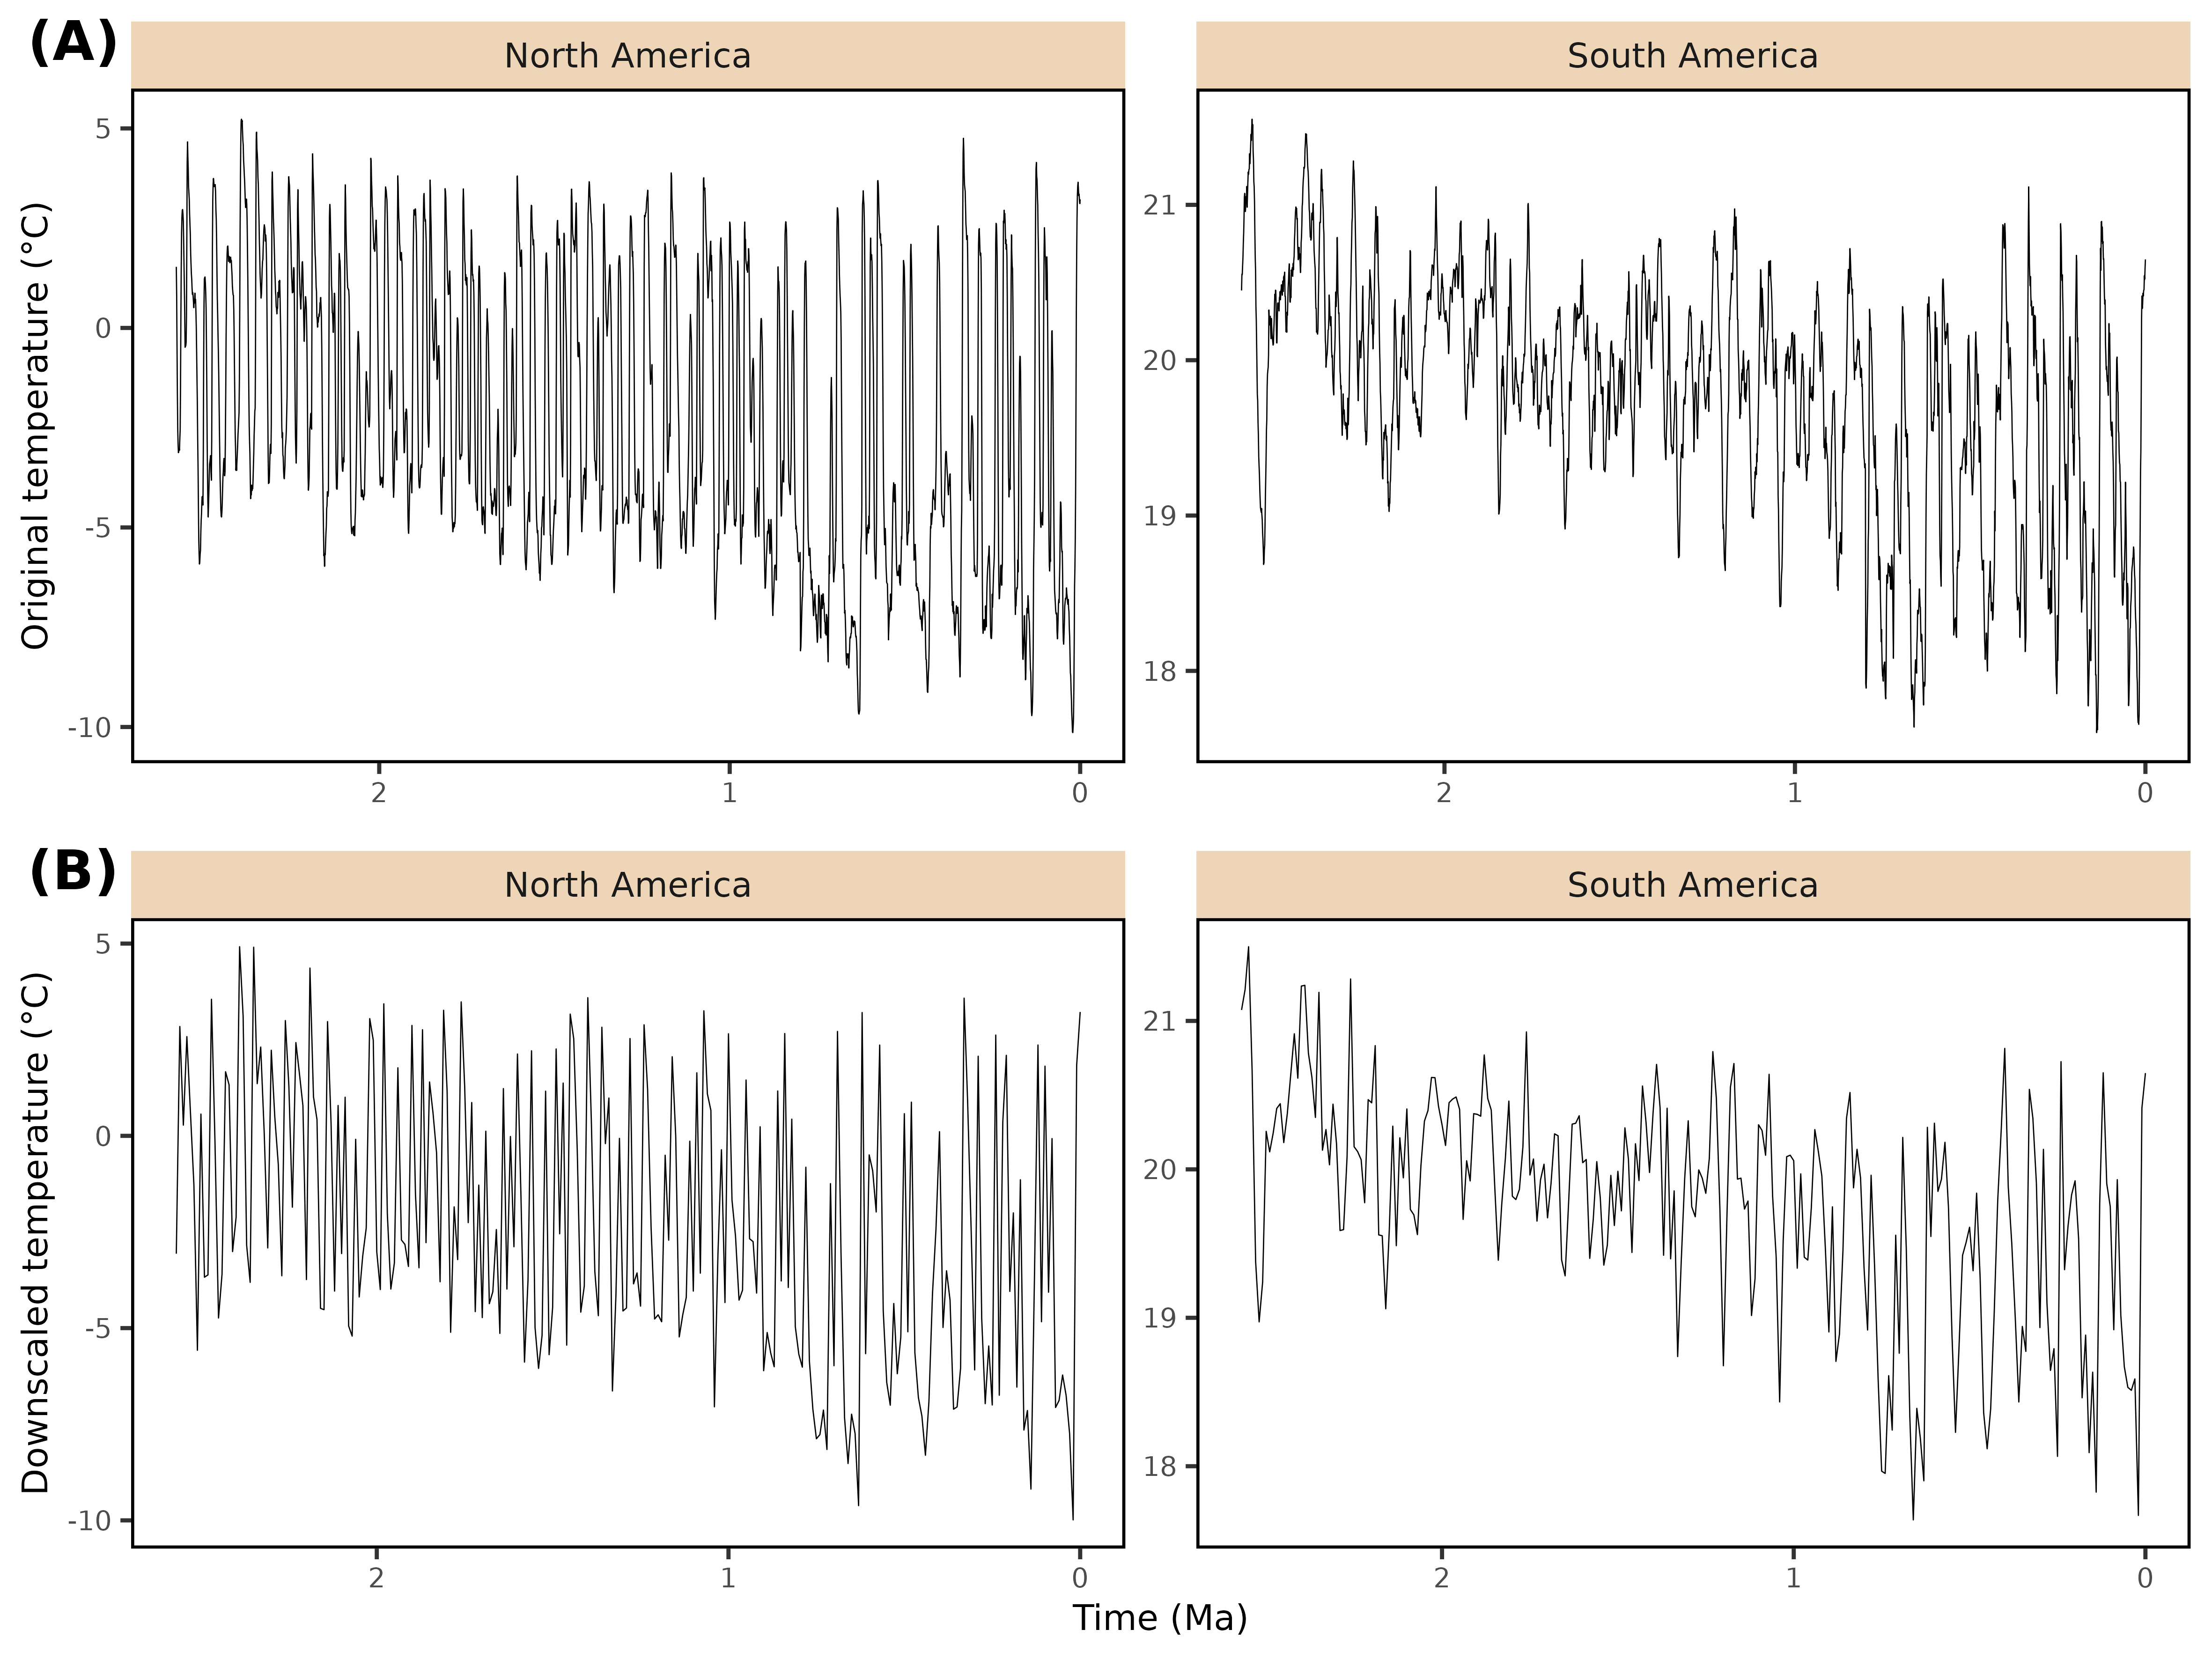
Effect of climatic variable downscaling. Continent-averaged temperature estimates were produced for both North and South America, with the original time step of the climate emulator (1 ky, A) or after downscaling to a 10 ky time step (B).
Figure 3.
Somewhat confusing explanation in the legend and the pictures did not really help me either. I think the figure or legend should be remade.
Thank you for pointing this out. We modified Figure 3’s caption to make it more understandable.
Lines 315-317.
I think that a few words may be needed on the claim that hummingbirds are a South American group. Based on current species this would clearly be the claim but ancestral area reconstruction is known to be very poor without incorporating fossils, see e.g. https://doi.org/10.1098/rspb. and the oldest fossils of humming birds are European. It seems highly plausible that hummingbirds died out in North America long before the GABI and that it makes sense to consider it South American in this context but with the very scarce fossil record of birds and the geography of the few known fossils in the family I think caution is needed in word choice.
Thank you for this thoughtful remark. Your point is highly relevant; the European fossil hummingbirds of Oligocene age suggest that the deep historical biogeography of the group is clearly not exclusively tied to South America. These fossils are regarded as stem Trochilidae (Mayr 2004), and phylogenetic evidence have suggested that the crown group would have radiated in the Miocene of South America, and that all the extant hummingbird lineages that colonised North America (e.g., bee, coquette) descent from a South American lineage (McGuire et al. 2014), although we share your concern about carrying out historical biogeographic reconstructions ignoring the (or in the absence of) fossil record. A similar mismatch between the distribution of the crown radiation and fossil occurrences of stem representatives has been described among other purely Neotropical extant radiations, such as Tyrannida (Harvey et al. 2020; Riamon et al. 2020). Consequently, we modified our sentence “such as hummingbirds” → “such as crown hummingbirds”.

Line 346-348.
It is hard to reliably say anything for sure about habitat preference for extinct groups especially given fossilization biases but at least for proboscids it seems odd to me to call them an open area group. Living elephants do perfectly find in forested habitats after all.
This is correct. After checking the literature (e.g., Asevedo et al. 2012; Sánchez et al. 2004), the trophic preferences of the two proboscid genera that made it to South America (especially Notiomastodon) could clearly match a forested environment. We removed the mention of the group in the sentence. Thanks for the suggestion.

*******

If we can answer any further questions, or be of any assistance to you whatsoever, please feel free to contact us.
Thank you for considering our revised manuscript.
Yours sincerely,


Lucas Buffan, on behalf of my co-authors

Literature cited

Asevedo, L., Winck, G.R., Mothé, D. & Avilla, L.S. (2012). Ancient diet of the Pleistocene gomphothere Notiomastodon platensis (Mammalia, Proboscidea, Gomphotheriidae) from lowland mid-latitudes of South America: Stereomicrowear and tooth calculus analyses combined. Quat. Int., Mammoths and Their Relatives 1: Biotopes, Evolution and Human Impact V International Conference, Le Puy-en-Velay, 2010, 255, 42–52.
Bacon, C.D., Molnar, P., Antonelli, A., Crawford, A.J., Montes, C. & Vallejo-Pareja, M.C. (2016). Quaternary glaciation and the Great American Biotic Interchange. Geology, 44, 375–378.
Barreto, E., Holden, P.B., Edwards, N.R. & Rangel, T.F. (2023). PALEO-PGEM-Series: A spatial time series of the global climate over the last 5 million years (Plio-Pleistocene). Glob. Ecol. Biogeogr., 32, 1034–1045.
Beck, H.E., Zimmermann, N.E., McVicar, T.R., Vergopolan, N., Berg, A. & Wood, E.F. (2018). Present and future Köppen-Geiger climate classification maps at 1-km resolution. Sci. Data, 5, 180214.
Brown, J.L., Hill, D.J. & Haywood, A.M. (2020). A critical evaluation of the Oscillayers methods and datasets. Glob. Ecol. Biogeogr., 29, 1435–1442.
Domingo, L., Tomassini, R.L., Montalvo, C.I., Sanz-Pérez, D. & Alberdi, M.T. (2020). The Great American Biotic Interchange revisited: a new perspective from the stable isotope record of Argentine Pampas fossil mammals. Sci. Rep., 10, 1608.
Erwin, D.H. (2009). Climate as a Driver of Evolutionary Change. Curr. Biol., 19, R575–R583.
Faurby, S. & Svenning, J.-C. (2016). The asymmetry in the Great American Biotic Interchange in mammals is consistent with differential susceptibility to mammalian predation. Glob. Ecol. Biogeogr., 25, 1443–1453.
Freitas-Oliveira, R., Lima-Ribeiro, M., Faleiro, F.V., Jardim, L. & Terribile, L.C. (2024a). Temperature changes affected mammal dispersal during the Great American Biotic Interchange. J. Mamm. Evol., 31, 20.
Freitas-Oliveira, R., Lima-Ribeiro, M.S., Mendoza-Rodriguez, V.H. & Terribile, L.C. (2025). Reviewing the Great American Biotic Interchange: climate change as a trigger for biodiversity dispersal. Proc. R. Soc. B Biol. Sci., 292, 20251745.
Freitas-Oliveira, R., Lima-Ribeiro, M.S. & Terribile, L.C. (2024b). No evidence for niche competition in the extinction of the South American saber-tooth species. Npj Biodivers., 3, 1–5.
Galván, S., Gamboa, S. & Varela, S. (2023). Köppen Geiger climatic classification for R users.
Gamisch, A. (2019). Oscillayers: A dataset for the study of climatic oscillations over Plio-Pleistocene time-scales at high spatial-temporal resolution. Glob. Ecol. Biogeogr., 28, 1552–1560.
Harvey, M.G., Bravo, G.A., Claramunt, S., Cuervo, A.M., Derryberry, G.E., Battilana, J., et al. (2020). The evolution of a tropical biodiversity hotspot. Science, 370, 1343–1348.
Holden, P.B., Edwards, N.R., Fraedrich, K., Kirk, E., Lunkeit, F. & Zhu, X. (2016). PLASIM–GENIE v1.0: a new intermediate complexity AOGCM. Geosci. Model Dev., 9, 3347–3361.
Holden, P.B., Edwards, N.R., Rangel, T.F., Pereira, E.B., Tran, G.T. & Wilkinson, R.D. (2019). PALEO-PGEM v1.0: a statistical emulator of Pliocene–Pleistocene climate. Geosci. Model Dev., 12, 5137–5155.
Jaramillo, C.A. (2018). Evolution of the Isthmus of Panama: Biological, Paleoceanographic and Paleoclimatological Implications. In: Mountains, Climate and Biodiversity. John Wiley & Sons.
Köppen, W. (1900). Versuch einer Klassifikation der Klimate, vorzugsweise nach ihren Beziehungen zur Pflanzenwelt. Geogr. Z., 6, 593–611.
Malanoski, C.M., Farnsworth, A., Lunt, D.J., Valdes, P.J. & Saupe, E.E. (2024). Climate change is an important predictor of extinction risk on macroevolutionary timescales. Science, 383, 1130–1134.
Mayr, G. (2004). Old World Fossil Record of Modern-Type Hummingbirds. Science, 304, 861–864.
McGuire, J.A., Witt, C.C., Remsen, J.V., Corl, A., Rabosky, D.L., Altshuler, D.L., et al. (2014). Molecular Phylogenetics and the Diversification of Hummingbirds. Curr. Biol., 24, 910–916.
Meseguer, A.S. & Condamine, F.L. (2020). Ancient tropical extinctions at high latitudes contributed to the latitudinal diversity gradient. Evolution, 74, 1966–1987.
Montes, C., Cardona, A., Jaramillo, C., Pardo, A., Silva, J.C., Valencia, V., et al. (2015). Middle Miocene closure of the Central American Seaway. Science, 348, 226–229.
Nogués-Bravo, D., Rodríguez-Sánchez, F., Orsini, L., de Boer, E., Jansson, R., Morlon, H., et al. (2018). Cracking the Code of Biodiversity Responses to Past Climate Change. Trends Ecol. Evol., 33, 765–776.
O’Dea, A., Lessios, H.A., Coates, A.G., Eytan, R.I., Restrepo-Moreno, S.A., Cione, A.L., et al. (2016). Formation of the Isthmus of Panama. Sci. Adv., 2, e1600883.
Pino, K., Rodriguez-Serrano, E., Carrillo, J.D., Cooper, R.B. & Silvestro, D. (2025). Splendid isolation with migration: Diversity dynamics of South American mammals.
Pino, K., Vallejos-Garrido, P., Espinoza-Aravena, N., Cooper, R.B., Silvestro, D., Hernández, C.E., et al. (2022). Regional landscape change triggered by Andean uplift: The extinction of Sparassodonta (Mammalia, Metatheria) in South America. Glob. Planet. Change, 210, 103758.
Prevosti, F.J., Suarez, C., Forasiepi, A.M., Tarquini, S. & Chemisquy, A. (2024). Another Twist Decoding the Patterns of Evolution of the South American Extinct Mammalian Predators (Sparassodonta, Metatheria). Ameghiniana, 61, 257–278.
Riamon, S., Tourment, N. & Louchart, A. (2020). The earliest Tyrannida (Aves, Passeriformes), from the Oligocene of France. Sci. Rep., 10, 9776.
Sánchez, B., Prado, J.L. & Alberdi, M.T. (2004). Feeding ecology, dispersal, and extinction of South American Pleistocene gomphotheres (Gomphotheriidae, Proboscidea). Paleobiology, 30, 146–161.
Simpson, G.G. (1950). History of the Fauna of Latin America. Am. Sci., 38, 361–389.
Skeels, A., Bach, W., Hagen, O., Jetz, W. & Pellissier, L. (2023a). Temperature-Dependent Evolutionary Speed Shapes the Evolution of Biodiversity Patterns Across Tetrapod Radiations. Syst. Biol., 72, 341–356.
Skeels, A., Boschman, L.M., McFadden, I.R., Joyce, E.M., Hagen, O., Jiménez Robles, O., et al. (2023b). Paleoenvironments shaped the exchange of terrestrial vertebrates across Wallace’s Line. Science, 381, 86–92.
Smith, B.T., Bryson Jr., R.W., Houston, D.D. & Klicka, J. (2012). An asymmetry in niche conservatism contributes to the latitudinal species diversity gradient in New World vertebrates. Ecol. Lett., 15, 1318–1325.
Tarquini, S.D., Ladevèze, S. & Prevosti, F.J. (2022). The multicausal twilight of South American native mammalian predators (Metatheria, Sparassodonta). Sci. Rep., 12, 1224.
Vallejos-Garrido, P., Pino, K., Espinoza-Aravena, N., Pari, A., Inostroza-Michael, O., Toledo-Muñoz, M., et al. (2023). The importance of the Andes in the evolutionary radiation of Sigmodontinae (Rodentia, Cricetidae), the most diverse group of mammals in the Neotropics. Sci. Rep., 13, 2207.
Vrba, E.S. (1992). Mammals as a Key to Evolutionary Theory. J. Mammal., 73, 1–28.
Webb, S.D. (1991). Ecogeography and the Great American Interchange. Paleobiology, 17, 266–280.
Webb, S.D. & Perrigo, S.C. (1984). Late Cenozoic Vertebrates from Honduras and El Salvador. J. Vertebr. Paleontol., 4, 237–254.
Woodburne, M.O. (2010). The Great American Biotic Interchange: Dispersals, Tectonics, Climate, Sea Level and Holding Pens. J. Mamm. Evol., 17, 245–264.
Yun, K.-S., Timmermann, A., Lee, S.-S., Willeit, M., Ganopolski, A. & Jadhav, J. (2023). A transient coupled general circulation model (CGCM) simulation of the past 3 million years. Clim. Past, 19, 1951–1974.

