Main Manuscript for

The fate of South America's endemic mammalian fauna in response to the most dramatic Cenozoic climate disruption

Lucas Buffan^{1,*}, Fabien L. Condamine¹, Narla S. Stutz¹, François Pujos², Pierre-Olivier Antoine¹, Laurent Marivaux¹

¹ Institut des Sciences de l’Evolution de Montpellier, Université de Montpellier, CNRS, IRD, Place Eugène Bataillon, 34095 Montpellier cedex 5, France
² IANIGLA, CCT–CONICET–Mendoza, Avenida Ruiz Leal s/n, Parque General San Martín, 5500 Mendoza, Argentina
* Lucas Buffan
Email: Lucas.Buffan@umontpellier.fr

ORCID: Lucas Buffan (0000-0002-2353-1432), Fabien L. Condamine (0000-0003-1673-9910), Narla S. Stutz (0000-0002-1937-3902), François Pujos (0000-0002-6267-3927) Pierre-Olivier Antoine (0000-0001-9122-1818), Laurent Marivaux (0000-0002-2882-0874)

Author contributions: L.M., P.O.A. and F.L.C. designed the project; L.B. compiled the fossil occurrences data with clade-specific checking and cleaning of P.O.A., L.M., N.S.S. and F.P.; L.B. performed the analyses with advice from F.L.C. and wrote the paper with input from all co-authors throughout.

Competing Interests Statement: The authors declare having no competing interest.

Classification: Biological Sciences, Evolution

Keywords: Biological crisis; Eocene-Oligocene transition; Diversification dynamics; Multivariate analyses; Bayesian inference

This PDF file includes:
Main text
Figures 1 to 4
Table 1
Abstract (<250 words)
Around 34 million years ago (Ma), the Eocene-Oligocene transition (EOT) marked the most dramatic global climatic cooling of the Cenozoic. On a planetary scale, paleontological evidence suggests that this transition was associated with major faunal turnovers, now regarded as a mass extinction crisis. In South America, there is no consensus on the response of the endemic mammals to this transition. Here, using a vetted fossil dataset and cutting-edge Bayesian inferences, we analyzed the dynamics of South American mammal (SAM) diversification and their possible drivers across latitude (tropical vs. extratropical), taxonomic groups, and trophic guilds throughout the Eocene−Oligocene (ca. 56−23 Ma). Our results did not evidence any mass extinction among SAMs at the EOT. Instead, they experienced a gradual and long-term diversity decline from the middle Eocene to the early Oligocene, followed by a sudden waxing-and-waning diversity associated with a large taxonomic – but not ecological – turnover. Tropical and extratropical lineages have had very distinct macroevolutionary histories. No effective change in the pace at which tropical lineages diversify was found, thus favoring the tropical stability hypothesis proposed by Wallace. Diversity-dependent effects, temperature, and Andean uplift are recovered as probable drivers of SAM diversification across the period but not the abundance of open landscapes, thereby rejecting the common hypothesis linking Oligocene faunal changes to grassland expansion. Our findings illustrate the uniqueness of the deep-time interplay between endemic SAMs and their physical environment in a context of climatic hinge, highlighting the need to consider regional idiosyncrasies for understanding the co-evolution of life and climate.

Significance statement (<120 words)
Understanding what drove the emergence and demise of lineages during biodiversity crises could provide key insights at the time of the sixth mass extinction. Here, using an unprecedented fossil database, we explored how South American mammals (SAM) responded to the most dramatic Cenozoic climate cooling episode, the Eocene-Oligocene transition (ca. 34 Ma). We find that SAM experienced a gradual and long-standing diversity decline strongly related to late Eocene climate cooling, followed by a major taxonomic turnover in the Oligocene, driven by diversity-dependent factors and Andean uplift, but not grassland expansion. SAM were therefore more subject to long-term diversity changes rather than abrupt ones, contrary to what would be expected in a mass extinction scenario.
Introduction
Today, South America is home to a unique mammalian fauna, hosting one of the most species-rich regions of the world, Amazonia (1). Although the extant mammalian taxonomic diversity in the continent is highly diverse, it is a poor reflection of what can be drawn from the fossil record. In fact, throughout most of the Cenozoic (i.e., the last 66 million years), South America was isolated from other landmasses (2). In this insular context, terrestrial mammal lineages that inhabited this huge landmass experienced unique radiations (3–7). According to Simpson (8), South American mammal (SAM) communities through the Cenozoic are well summarized by three successive ‘faunal strata’. The first one, stretching from the early Paleocene (66 million years ago, Ma) to the late Eocene (ca. 37 Ma), is characterized by the early establishment and radiation of endemic lineages, mostly xenarthrans, metatherians and native ungulates. Then, from the early Oligocene (ca. 33 Ma) until the Late Miocene-Early Pliocene (ca. 5 Ma), key morphological innovations appeared among native lineages, leading to a so-called ‘faunal modernization’ (9). In the meantime, rodents and primates, African lineages that most likely reached South America in the middle-late Eocene (10–12), diversified locally (4, 6). At the latest Miocene/Pliocene, this endemic fauna was massively disrupted. The closure of the Panama isthmus (13) paved the way for major faunal exchanges between North and South America, described as the ‘Great American Biotic Interchange’ (14), and immigrant taxa from North America (e.g., carnivores, perissodactyls, artiodactyls, or proboscideans) appeared in the South American fossil record. In the few subsequent millions of years, many endemic South American lineages declined, yet went totally extinct (e.g., litopterns, notoungulates, sparassodonts, glyptodonts, ground sloths).
Close to the limit between Simpson’s first and second faunal strata, ca. 33.9 Ma, the Eocene-Oligocene transition (EOT) marked the most dramatic Cenozoic climatic change episode worldwide (15). At that time, simultaneously, global climate massively cooled down (16), ocean level dropped (17), and the whole Antarctic continent turned into a giant ice sheet (18). The prevailing mechanism proposed to explain these major environmental changes is the onset of the Antarctic circumpolar current (19). Concomitantly, a major biotic turnover among mammals, known as the ‘Grande Coupure’, occurred in Europe (20). This event, punctuated by the arrival of immigrant taxa from Asia, saw the demise of many endemic European lineages (21–23). Although European-oriented case studies dominate the literature about the topic, similar disruptions among mammalian faunas occurred at the same time in other regions of the world, such as Asia (24–26), North America (27, 28), Africa (29) or to some extent Madagascar (30). Recently, Hoyal Cuthill et al. (31) even came to rank this geological boundary as the second most important extinction event throughout the history of life.
In central and southern South America, substantial changes have been documented in metatherians (32, 33) and native ungulates (9) near the EOT. As an echo to the ‘Grande Coupure’, Goin et al. (33) even introduced the term ‘Bisagra Patagónica’ (Patagonian Hinge) to characterize the changes among metatherian communities in Patagonia possibly related to the EOT. General morphological trends have been highlighted in ‘modernized’ notoungulate faunas, with a net increase in body mass and cheek teeth’s crown height (34). The latter changes, by analogy with the evolutionary fate of extant groups, suggested the emergence of the grazing feeding mode, and was postulated to result from the expansion of grasslands, promoted by post-EOT climate cooling and aridification (35, 36). In northern South America, changes in marsupial and rodent communities around the EOT have also been suggested despite the paucity of known Paleogene low-latitude fossil localities to date (37).
Despite general agreement that a faunal remodeling occurred in SAM communities near the EOT, the evolutionary tempo and mode remain unknown. At macroevolutionary scales, as we would expect in a mass extinction scenario, it is unclear whether this faunal renewal was characterized by extinction of Eocene lineages followed by diversification of the surviving ones (e.g., 38), or whether lineages gradually transitioned until they became ‘modernized’. A crucial question underlying these conflicting macroevolutionary hypotheses is whether or not extinction occurred in the tropics, and at what level. Indeed, it has long been postulated that the climatic stability of tropics would make tropical lineages less vulnerable to extinction than extratropical lineages (39). Also, the ecological selectivity and the likely drivers of this apparent faunal transition have remained underexplored. For instance, there is so far no consensus regarding the role of temperature (40, 41) or grassland expansion (42) in shaping the macroevolutionary fate of SAMs. Finally, there is a lack of integrative frameworks at the continental scale, with most case studies at the local scale, mostly in southern South America. Nevertheless, the Paleogene mammal fossil record in South America is spatially and temporally uneven. Spatial gaps cover large areas, such as most of Amazonia, and important time intervals remain unsampled (SI Appendix, Fig. S1 and S3). Accordingly, it has been historically challenging to address questions regarding the history of SAMs at the continental scale.
Here, we aim to fill these gaps by examining the available fossil record of SAMs. We assembled a genus-level fossil dataset consisting of 3,378 occurrences (distributed in 1,115 species, 536 genera, 96 families, and 18 orders) spanning from the late Paleocene to the Early Miocene. Relying on a fossil-based Bayesian birth-death framework accounting for variable preservation rates through time and across taxa (43), we estimated the tempo and modes of the mammalian diversification dynamics in South America throughout the Eocene–Oligocene interval (ca. 56–23 Ma). We then disentangled the underlying taxonomic, functional, and geographic (tropical vs. extratropical) bases of the inferred continent-scale patterns of diversity and diversification among SAM faunas. We finally quantified the most likely biotic and abiotic drivers explaining their diversification dynamics.
Results and Discussion
No mass extinction: South American mammal diversity gradually declined well before the EOT
We analyzed the fossil database (Tab S1) both at the genus and species levels using the process-based Bayesian framework of diversification accounting for varying preservation implemented in PyRate (44). Our results highlight that the overall mammal diversity gradually declined from the end of the early Eocene–shortly after the Early Eocene Climate Optimum (EECO, 45)–to the end of the early Oligocene (decline by respectively 34% and 52% in the number of genera and species between 48 and 32 Ma), and then further increased in the late Oligocene (Fig. 1D and SI Appendix, Fig. S8-11). No massive loss of lineages appears to us at the EOT. This diversity trajectory results from a significant decrease in origination rate during the early Eocene (Fig. 1B and SI Appendix, Fig. S8-11). Additionally, we recover a joint significant increase in the pace of origination and extinction (i.e., increased turnover) during the late Eocene, with the extinction rate always being higher than the origination rate (slightly negative net diversification rate; Fig. 1B-C and SI Appendix, S8-11). Similar diversification patterns are recovered when analyzing the dataset at the genus or species level (SI Appendix, Fig. S8-11), after removing singletons (SI Appendix, Fig. S12-13) or disabling several occurrences of the same lineage that co-occur temporally and geographically (SI Appendix, Fig. S14-15). Moreover, general trends in diversity and diversification dynamics are conserved when working with occurrences assigned to South American Land Mammal Ages (SALMAs; SI Appendix, Fig. S9 and S11) instead of sub-epochs (see Methods; SI Appendix, Fig. S1-2 and Extended Material and Methods), or when considering attempts to derive early Oligocene ages to east Amazonian occurrences originally assigned to an Eocene age (SI Appendix, Fig. S32).
Recently, an analysis of the global Phanerozoic fossil record classified the EOT as the second most intense mass extinction episode (31). Despite its unexpectedly high ranking compared to other clearly-identified biodiversity crises, drastic extinctions at the EOT are supported by analyses of the European (20) and Asian (24) mammal fossil record. Applying a methodological framework similar to ours, Weppe et al. (23) recovered a strong extinction signal among endemic Western European artiodactyls at the EOT, with the loss of 62% of genera and 75% of species in only 1 My. Other studies working on mass extinctions illustrated similarly high levels of lineage loss for various study models, for instance in insects at the Permian/Triassic boundary (82% genus loss) (46) or in elasmobranchs – sharks, skates and rays – at the Cretaceous/Paleogene boundary (44.94% genus and 62.6% species loss) (38). Here, given the relatively small amount of lineages lost at the Eocene-Oligocene boundary (19% genera, 25% species), our results are not consistent with a mass extinction event among SAMs at the EOT. Instead, we highlight a long-term decline in SAM diversity, from the middle Eocene onward, contrasting with the expected short temporality of a mass extinction crisis. To our knowledge, our work is the first to provide quantitative support for such a pattern. These differences between South America and other continents could come from the tropical nature of a significant part of the landmass. Stemming from the cornerstone hypothesis of Wallace linking the striking similarities between tropical biomes from all-over the world to the uniformity of tropical climate across space and (shallow) time (39), tropical climate stability would act as a buffer for tropical lineages against extinction. Also, the isolated condition of the landmass has been proposed as a probable cause explaining the singularity of SAM near-EOT macroevolutionary fate, as it greatly limited the possibilities for immigration events. Yet, immigrations were hypothesized to have played a key role in EOT-related extinctions in other parts of the world (3, but see 22).

Ubiquitous taxonomic – but not ecological – turnover among the main mammalian groups across the study period
Our analyses of the overall SAM diversification dynamics failed at characterizing any mass extinction event at the time of the EOT, but recovered a late-Eocene increase in mammal turnover (joint increase in origination and extinction rates), followed by an Oligocene waxing-and-waning diversity (Fig. 1B and D). As a result, Eocene and Oligocene SAMs appear taxonomically dissimilar. Indeed, the proportion of shared genera between each fauna, represented by the Jaccard’s similarity index, is below 20% for four out of the five main groups we studied (Fig. 1A and SI Appendix, Fig. S38). The corrected genus longevity estimates corroborate results already established in the literature about mammal taxonomic replacement near the EOT, but also highlight previously undescribed patterns (Fig. 1A and SI Appendix, Fig. S18-21).
For notoungulates, the most taxon-rich order of our dataset (encompassing a third of our total occurrences; SI Appendix, Tab. S1), our inferences corroborate a long-recognized family-level turnover at the order scale between the late Eocene and the early Oligocene (9), with the synchronous extinction and origination of three (Archaeopithecidae, Notostylopidae, and Oldfieldthomasiidae) and four (Homalodontheriidae, Hegetotheriidae, Mesotheriidae, and Toxodontidae) families, respectively (SI Appendix, Fig. S19-20). All these newly-arising families, in addition to two surviving ones (Archaeohyracidae and Interatheriidae), convergently evolved larger body sizes and higher teeth crown height (hypsodonty) than their basal counterparts, mostly during the Oligocene (though the first records of a hypsodont notoungulate lineage dates back to the middle Eocene, 20 Million years before its first record outside South America) (34, 35). As notoungulates likely represented a huge proportion of herbivorous lineages, these innovations likely implied changes in the architecture of the primary feeder guild between the Eocene and the Oligocene ecosystems at continent scale.
Considering the other native ungulate orders (i.e., Litopterna, Astrapotheria and Pyrotheria), apart from the late Eocene extinction of Trigonostylopidae (Astrapotheria), evidence for higher-level taxonomic changes near the EOT is less obvious (SI Appendix, Fig. S23). However, there seems to be a strong intra-family taxonomic renewal among most litopterns (i.e., Proterotheriidae, Macraucheniidae, and Adianthidae) and astrapotheriids (Astrapotheria) between the Eocene and Oligocene. These groups have been affected by a diversity decline from the late Eocene to the early Oligocene (SI Appendix, Fig. S16D-F and S17D-F). Given that, just like notoungulates, these groups likely had herbivorous diets, the highlighted changes also surely affected the architecture of the ecosystems between the Eocene and the Oligocene.
In the case of metatherians (SI Appendix, Fig. S18), our results are in line with previous findings about their taxonomic renewal near the EOT (3). On one hand, entire superfamilies or sub-orders like Bonapartherioidea or Polydolopiformes (both subclades of the order Polydolopimorphia according to Goin et al. (3)) went extinct during the early Oligocene, meanwhile others, like Argyrolagoidea (also a subclade of Polydolopimorphia according to Goin et al. (3)), Paleotenthoidea (order Paucituberculata) and Hathliacynidae (order Sparassodonta) originated and/or diversified. We may precise that the super-family Palaeotenthoidea appeared in the middle-late Eocene with the two stem genera Sasawatu and Perulestes, but the Palaeotenthidae and Abderitidae families appeared and diversified from the early Oligocene onward. On the other hand, intra-clade taxonomic replacement occured among Borhyaenoidea (Sparassodonta) and Microbiotheria. As mentioned before, Goin et al. (33) established that the most dramatic turnover among metatherian faunas occurred near the EOT (the ‘Bisagra Patagónica’). Our corrected genus age reconstructions clearly bring qualitative support to such a macroevolutionary fate. However, when estimating metatherian diversification dynamics, no significant rate shift was found, and the overall number of genera through time remained stable (SI Appendix, Fig. S17M-O). Quantitatively, our diversification analyses supported a constant turnover rate across the Eocene-Oligocene interval, which is likely a consequence of the low representation of metatherian in our dataset (219 occurrences, 54 genera).
As for cingulates, representing the majority of our xenarthran occurrences, we highlight a slowdown in Dasypodinae diversity, and the origin of Euphractinae in the middle-late Eocene (SI Appendix, Fig. S21), in agreement with Ciancio et al. (47). Just like for metatherians, our diversification reconstructions provided support for a constant-rate diversification throughout the period of interest, with a stable number of genera (SI Appendix, Fig. S16I-L and 17I-L).
Regarding caviomorph rodents, the oldest representatives of the clade are found to originate in the middle Eocene (Fig. 1A and SI Appendix, Fig. S22). Then, the group diversified at a constant rate until it reached a mid-Oligocene peak in extinction rate (SI Appendix, Fig. S16G-I and S17G-I), and no main taxonomic replacement near the EOT is to be noticed.
To track the evolution of ecological composition between the Eocene and Oligocene SAM, we summarized trophic paleocommunities by four dental ecomorphotype-derived categories: herbivorous, carnivorous, insectivorous and omnivorous. We used the origination and extinction ages estimated by PyRate to assess the number of genera through time within each ecological category and further computed the relative proportion of each trophic category at the geological sub-epoch level (SI Appendix, Fig. S1 and Extended Materials and Methods). Our findings illustrate that the structure of trophic paleocommunities remained stable throughout the entire time interval (Fig. 2). We report a slight trend toward an increase in the relative proportion of herbivorous lineages in assemblages of decreasing age, at the expanse of omnivorous and insectivorous. In addition, ecological dissimilarity increases with the age difference between two assemblages, but remains low (below 25%), especially between the late Eocene and early Oligocene assemblages, when it equals 6.1% (Fig. 2).
Our results provide support for a taxonomic renewal between Eocene and Oligocene SAM faunas, with few changes in the architecture of ecosystems, thereby suggesting intra-guild renewal. Interestingly, the onset of this faunal turnover temporally matches the timing of ‘the most fundamental biotic division in the Cenozoic’ in the marine realm, that is, between the middle and the late Eocene (48).

Latitudinal heterogeneity in diversification histories
Since the late break-up of the Gondwana supercontinent ~130 Ma, the South American landmass has offered a duality between tropical and non-tropical habitats (2). This duality is particularly interesting as it allows for testing a long-standing question in macroevolution as to whether diversification processes occurred the same way inside and outside the tropics (39). Based on a time series of paleoclimate zone maps (49, 50), we assigned each of our occurrences a tropical or extratropical affinity (SI Appendix, Fig. S3), and analyzed genus-level diversification dynamics within each biome separately. Our findings revealed that extratropical genera exhibited diversity and diversification patterns extremely similar to those obtained from the complete dataset across the Eocene–Oligocene interval (Fig. 3D-F and SI Appendix, Fig. S8-11). Their diversity gradually declined from the middle Eocene to early Oligocene, with a late Eocene turnover increase (Fig. 3D-F). This proximity between extratropical and continent-wide patterns was expected, given that extratropical taxa constitute the majority of genera present in our dataset (85.8%, Tab. 1). Nevertheless, results are different when constraining our analyses to tropical genera (Fig. 3A-C). No significant change was found in the tropical origination rate, and one significant negative shift was found for the tropical extinction rate in the late Oligocene (but see later for an interpretation of this extinction peak) (Fig. 3A and S24). Their inferred diversity curve exhibits an opposite trend to the one obtained from extratropical genera. Tropical genera diversity increased exponentially during the Eocene and reached a plateau in the early Oligocene (Fig. 3C). In the late Oligocene, our reconstructions tend to suggest that tropical mammals experienced a diversity decline associated to the aforementioned increase in extinction rate. We propose this apparent decline to result from the scarcity of low-latitude formations of Oligocene age, given that there are almost no tropical Deseadan (~29.4-24.2 Ma) mammal remains unearthed to date (though see 51), therefore more reflecting a sampling artifact rather than a true tropical SAM extinction in the late Oligocene. Consequently, after discarding this likely artefactual extinction peak, our results suggest that tropical lineages experienced no change in diversification rates, providing support for Wallace’s theory of tropical stability (39). Also, when considering attempts to derive early Oligocene ages to east-Amazonian occurrences originally assigned to an Eocene age (52), the overall tropical diversity pattern remains unchanged. Indeed, the previously highlighted Eocene increase in diversity lasts a few more million years within the Early Oligocene, until the onset of the ‘decline’ – that we propose to be artefactual (SI Appendix, Fig. S33).
Our results suggest that highly distinct evolutionary regimes shaped tropical and extratropical mammal assemblages in South America. However, there is no clear evidence supporting commonly-assumed macroevolutionary hypotheses regarding how tropics shaped diversification processes (Fig. 3 and SI Appendix, Fig. S25-S29). Two macroevolutionary scenarios are usually invoked to explain the differences in diversity between tropical and extratropical biomes (53). On one side, tropical lineages would have higher origination rates due to the higher diversity of habitats offered by the tropics (‘cradle’ hypothesis). On the other, tropical climate stability would make tropical lineages less prone to extinction (‘museum’ hypothesis) (53, but see 54). Here, tropical lineages appear to have a higher origination and a lower extinction rate than their extratropical counterparts in the middle Eocene. This would typically be in line with Rolland et al. (55), who estimated temporal trends of speciation and extinction rates across latitudes using the mammal tree of life, and found that tropical mammals had a higher speciation and a lower extinction rate than their extratropical counterparts throughout the Cenozoic. More recently, an emphasis was put on higher-latitude tropical extinctions to explain the build-up of present-day tetrapod diversity (50, 56). In alternative scenarios, varying dispersal rates can explain differences between tropical and extratropical diversity (57). There is a consensus that tropical-to-extratropical transitions are prevalent, supporting the so-called ‘out-of-the-tropics’ hypothesis (50), although extratropical-to-tropical transitions have been suggested (56).

Drivers behind the Eocene-Oligocene macroevolutionary dynamics of SAM
After exploring the dynamics of SAM diversity and diversification, we investigated their underlying drivers, addressing: what drove SAM diversity to decline in the 52-33.9 Ma interval? What caused their late Eocene increase in turnover? How do we explain such levels of taxonomic dissimilarity between Eocene and Oligocene SAM?
Our Multivariate Birth-Death (MBD) analyses indicate that the dissimilar Eocene and Oligocene faunas were ruled by different drivers (Fig. 4). Overall, diversity-dependent effects largely impacted SAM diversification history throughout our study period, but these processes shaped both faunas differently. We recovered strong negative correlations of Eocene (post-EECO, 52-33.9 Ma) origination rate (correlation parameter G_{𝝀} = -3.24, shrinkage weight [w_{𝜆}] = 0.89) and Oligocene extinction rate (G_{µ} = -2.43, w_{µ} = 0.83) with self-diversity (Fig. 4, SI Appendix, Tab. S3-6). This suggests that Eocene mammal origination decreased when their diversity increased, which can be interpreted as a carrying capacity effect, that can occur at macroevolutionary scales (58). The other diversity-dependent correlation indicates that the Oligocene mammal extinction rate decreased when their diversity increased. In the framework of the marked taxonomic turnover highlighted by our analyses, this effect might have arisen from facilitating interactions between recently-originated taxa (see forthcoming paragraph), but it could also be indirectly related to enhanced ecosystems productivity or niche partitioning events, which cannot be captured by the MBD analyses.

We further investigated the effect of genus age on its extinction probability. No effect of taxon age could be retrieved from the analysis of the ‘early’ dataset (56-39 Ma, i.e., before the increase in extinction rate at 39 Ma, SI Appendix, Fig. S10 and S41), but we found evidence for a significant Age-Dependent Extinction (ADE) in the ‘late’ dataset (39-23.03 Ma), with an increasing probability of extinction with decreasing genus age (SI Appendix, Fig. S41 and Tab. S9). In the framework of a faunal renewal, we could have expected the opposite relationship, where older lineages would be more likely to go extinct than recently-originated ones. One possible explanation could come from the concomitant increase in origination rate that we discussed previously (Fig. 1B and SI Appendix, Fig. S10A). The latter would counterbalance the higher prevalence of these newly-originated genera to become extinct, in turn leading to a progressive faunal turnover, as older lineages naturally go extinct. A similar negative relationship between taxon age and extinction probability has been frequently illustrated, for several study models and taxonomic scales (59–63). Factors proposed to explain this ADE pattern at the genus level often include genus range size, species richness and sampling bias (60). Here, fossil sampling bias is less likely to affect our results as PyRate already accounts for it. The current spatial (SI Appendix, Fig. S3) and taxonomic (SI Appendix, Fig. S30) incompleteness of our data do not allow us to reliably test either of the two remaining factors.
The MBD analyses also provided support for a positive correlation between global temperature and Eocene mammal origination rate (G_{𝝀} = 0.24, w_{𝜆} = 0.82). This explains the previously-described gradual decline in SAM diversity in the mid-late Eocene, qualitatively matching with the post-EECO overall decline in temperature (Fig. 1D and 4B). It is now clearly established that temperature change directly impacts biodiversity, at every timescales (64–66), and temperature was already identified as a key driver influencing the diversification of an endemic European artiodactyl family at the EOT (67). This said, based on isotope analyses of Patagonian ungulate enamel or on paleobotanical data, it has been proposed that the South American climate, at least in the Southern part of the continent, remained merely stable across the Eocene−Oligocene interval (40, 41, 68). However, as illustrated by Antoine et al. (37), we assume that the spatial scale (i.e., continental vs. global) does not affect the trends and directionality of temperature changes through time, but rather their amplitude. Hence, in the framework of our MBD analyses, the use of a global estimate of paleotemperature is still relevant, as we are more interested in trends than having actual paleotemperature values. Also, to date, no regional paleotemperature reconstruction for the South American continent has been produced with the same resolution as the global estimate used in this study (16).
We obtained a weak but significant positive correlation between the Oligocene mammal extinction rate and the Andean uplift (G_{µ} = 0.02, w_{µ} = 0.87) (Fig. 4, SI Appendix, Tab. S3-6). Mountain-building processes are known to greatly influence species diversity (69), and previous studies illustrated the key importance of the Andes in shaping diversity patterns of a wide range of South-American organisms, even in the early stages of the build-up of the chain (70–72). In a context of active margin, the Andean orogeny has been associated with volcanic activity, which, in conjunction to subsequent forest fires, resulted in a massive dust emission. This dust emission has been postulated to promote grazer-like herbivore origination and diversification, in particular at the EOT and thereafter (41, 73). Due to the high proportion of herbivores in our dataset (Tab. 1 and Fig. 2), we could have expected Andean uplift to be either positively related to SAM origination, negatively related to SAM extinction, or both. Here, our results suggest that Andean uplift promoted extinction among SAM faunas, thus not providing support for any of the previously-stated hypotheses. Instead, they lead us to hypothesize that the building of the Andes, possibly by reshaping the landscapes, re-organizing climate advections, triggering volcanism or any other factor, was an obstacle, rather than a facilitator, for Oligocene mammal diversification.
Interestingly, none of our proxies for land opening, i.e., phytolith-derived floral composition – proxy for grassland spreading, or habitat openness (42) – and relative Leaf Area Index (rLAI) – proxy for forest density (74) – was found to be correlated with any diversification rate, even when constraining our analyses to notoungulate taxa (Fig. S35). The convergent evolution of high-crowned cheek teeth and larger body sizes among several notoungulate families near the EOT, suggesting the emergence of the grazing feeding mode, has long been regarded as evidence for the expansion of grasslands in response to climate cooling and aridification (35). However, subsequent studies highlighted that grasslands did not spread that much during the mid-Eocene to Oligocene of Patagonia, meanwhile hypsodont taxa evolved and diversified (42), and more generally, that South American paleobiome composition remained stable throughout that period (68). In addition, trait-based correlation analyses failed at recovering any temporal relation between the evolution of hypsodonty and the abundance of open habitats (34). Here, our results for the entire dataset are pointing in the same direction, thereby suggesting that mammal diversification was not influenced by the proportion of open habitats in South America. As mentioned earlier, this could be a direct consequence of the apparent biome stability of the continent at that time, and could probably represent one additional feature making the macroevolutionary behavior of SAMs near the EOT so unique compared to other regions of the world.
When carrying out the MBD analyses without partitioning Eocene and Oligocene faunas, we still found strong negative correlations of origination (G_{𝝀} = -2.16, w_{𝜆} = 0.90) and extinction (G_{µ} = -2.18, w_{µ} = 0.81) rates with self-diversity, and a weak positive correlation of extinction rate with the Andean uplift (G_{µ} = 0.003, w_{µ} = 0.70) (SI Appendix, Fig. S34, Tab. S3-6). However, we no longer retrieved any correlation of origination rate with temperature, highlighting the prominent and exclusive role of temperature in shaping Eocene mammal diversity.

Limits and perspectives
One of the main limitations of our work comes from the fact that many of the taxa we are dealing with (e.g., notoungulates, sparassodonts, glyptodons, ground sloths, etc.) have no modern representatives. This raises a major issue for the inferences about their precise ecology as we do not have any proper reference to lean on. For instance, many studies – including the present work – failed at relating grassland spreading with the apparition of high-crowned and/or ever-growing cheek teeth, whereas it is known to be the case in the history of iconic extant groups, such as horses (35).
Next, as previously mentioned, our data was particularly subject to spatial heterogeneity. There is a sampling gap in Amazonia (SI Appendix, Fig. S3), yet known to be the cradle for most Neotropical groups, ranging from angiosperms to vertebrates (75). The still poorly-known record of fossil mammals from this region surely hides part of the picture of the continent-scale mammal diversification, and even more considering the spatial heterogeneity of diversity dynamics (76, 77). We tested the robustness of our interpretations regarding this spatial heterogeneity by carrying out sensitivity analyses to evaluate the extent to which it affected our results, by subsampling our occurrence data to unique taxa-locality combinations, leading to no major difference with the trends we derived from our complete dataset (SI Appendix, Fig. S14 and S33).
Temporal and taxonomic completeness were also sources of limitations. As for temporal biases, we saw that gaps remain in the South American Land Mammal Age scale, illustrating the temporal sparsity of the SAM fossil record (SI Appendix, Fig. S1). This adds some degree of uncertainty to our taxon age estimations. To intend to cope with this issue, we assigned each of our occurrences with the boundaries of the sub-epoch they most overlapped with (SI Appendix, Fig. S2). In fact, such an age smoothing did not lead to any major difference in our diversification analyses, further illustrating PyRate’s ability to deal with data incompleteness. Furthermore, our work also led us to appreciate the unequal representation of some lineages compared to others, with around 36% of our genera and 54% of our species only represented by a single occurrence in our dataset (i.e., singletons) (SI Appendix, Tab. S1). As a result, our average preservation rates per lineages were low (SI Appendix, Fig. S30-31), below the values that we usually observe in recent studies (23, 78). This said, removing singletons did not seem to have any major effect on the inferred diversification patterns (SI Appendix, Fig. S12-13 and S32). Overall, despite our sensitivity tests, our dataset undersamples South America's past mammalian diversity, and no statistical framework may fully recover the entire picture of its underlying macroevolutionary processes.
Here, we provide the first integrative study of the macroevolutionary fate of the extinct mammals from South America across the Eocene-Oligocene interval using the fossil record. Interestingly, our results challenge the occurrence of a landmass-scale mass extinction of mammals at the EOT (31), contrary to what has been suggested for other regions of the world (e.g. 23). Rather, we showed that the SAMs underwent a temperature- and diversity-dependent gradual diversity decline during the Eocene, followed by an Oligocene waxing-and-waning likely associated with the build-up of the Andes and other diversity-dependent effects. Remarkably, we found that lineages inhabiting tropical and extratropical areas had very different macroevolutionary histories, supporting Wallace’s theory of tropical stability (39). Enhanced knowledge of the past of SAMs will provide key insights into the origin and dynamics of one of the world’s most species-rich regions, a central and historic topic in the field of macroevolution.
Material and Methods
Additional methodological details are provided in the SI Appendix.

Fossil data compilation and analytical framework. We downloaded and cleaned all genus-level South American terrestrial mammal occurrences from The Paleobiology Database (https://paleobiodb.org/) spanning the late Paleocene to the early Miocene (60-16 Ma) (3,384 occurrences; SI Appendix, Extended Materials and Methods and Tab. S1). Cleaning consisted of a manual revision of the taxonomic name (e.g., synonymies, missing open nomenclature elements, typos) and time range of each occurrence (SI Appendix, Fig. S4 and Manual Cleaning Details). Using paleocoordinate reconstructions (79, 80) and paleobiome maps (49), we assigned each occurrence a tropical or extratropical affinity, and collapsed their associated dental ecomorphotype-derived trophic classes into four categories: carnivorous, herbivorous, omnivorous and insectivorous (Tab. 1).
We analyzed our database using PyRate v.3 (81), and approximated the posterior distribution of the origination and extinction times (T_{s} and T_{e}, respectively) of each genus and the rate of the preservation process using the RJMCMC algorithm. We then used these T_{s} and T_{e} to estimate the underlying diversification process (origination and extinction rates) with the Birth-Death model with Constrained Shifts (BDCS) (82) (SI Appendix, Extended Materials and Methods).
We ran the RJMCMC model for 50 million generations and sampled every 50,000, with a time-dependent preservation process allowing for rate shift between geological stages (SI Appendix, Fig. S5-6 and Extended Materials and Methods). We allowed for a gamma-distributed preservation heterogeneity across lineages. We ran the BDCS model for 10 million generations, sampled every 10,000, and allowed diversification (i.e., origination and extinction) rates to vary between each geological sub-Epochs (SI Appendix, Fig. S1). Diversification analyses were replicated 20 times after randomly drawing fossil ages between their upper and lower age boundaries, and posterior estimates across all replicates that achieved convergence (n=11, SI Appendix Fig. S40) were combined. To test the robustness of our macroevolutionary inference, we conducted sensitivity analyses by either removing singletons or subsampling our fossil database to unique locality-lineage combinations (SI Appendix, Extended Materials and Methods). We assessed the convergence of each parameter with the pymc 5.9.2 python library (83). We considered parameters achieved convergence if their Effective Sample Size (ESS) was above 200.

Age-dependent Extinction (ADE) model. We assessed the effect of taxon age on its extinction probability by fitting the ADE model to our genus-level occurrence data (59). We ran the model for 100 million generations and sampled every 50,000, with preservation rates varying between geological stages and across lineages according to a Gamma model. We focused on the shape (𝜙) of the Weibull distribution, knowing that 𝜙 < 1 indicates a decreasing extinction probability with increasing taxon age and 𝜙 > 1 indicates an increasing extinction probability with increasing taxon age (no effect if 𝜙 = 1). 𝜙 was considered as significantly different from one if one was excluded from a significant proportion of its posterior distribution. We performed 20 independent ADE analyses of randomized datasets before and after the increase in turnover to assess the age selectivity of this taxonomic renewal (SI Appendix, Fig. S8-11, S41 and Extended Materials and Methods). We monitored parameter convergence with the pymc 5.9.2 python library, and parameters were considered convergent if their ESS was above 200.

Selection of environmental variables. To investigate possible environmental correlates for the changes in SAM diversification dynamics over the Eocene−Oligocene interval, we selected two global (i.e., atmospheric temperature and sea level) and four continental-scale (i.e., Andean uplift, Neotropical plant diversity, forest density and habitat openness) variables (SI Appendix, Fig. S39 and Tab. S2). Temperature is known for influencing macroevolutionary processes across several groups, including mammals (66, 84), and sea level has a direct effect on the connectivity of habitats. Even in its early phase, the Andean uplift was evidenced as a major diversification driver for many South American groups (71). Diversity of SAM, in particular herbivorous taxa, can be controlled by plant diversity. Finally, relative Leaf Area Index (proxy for forest density, 72) and patterns of relative abundance of open habitats (34, 42, 85) are both indicators of the relative abundance of grasslands, which has long been regarded as shaping herbivore diversity (35). As highlighted by Weppe et al. (23), it is important to consider regional-scale variables because environmental changes across the Eocene−Oligocene interval were shown to be regionally heterogeneous (68, 86).

Multivariate Birth-Death (MBD) model. We carried out environment-dependent diversification analyses involving the aforementioned variables by running the MBD model included in PyRate (87). This model carries out two independent correlations involving a set of environmental covariates and diversification rates (λ and μ) newly-estimated from empirical T_{s} and T_{e}. Each variable is assigned to two correlation coefficients, one for the correlation with λ (G_{i,λ}, where i is the index of the variable in the set of covariates) and the other for the correlation with μ (G_{i,μ}). An MCMC algorithm jointly estimates baseline origination and extinction rates and all the G_{λ} and G_{µ}, while controlling for over-parameterization. Each G_{λ} and G_{µ} is assigned a shrinkage weight (w(G_{λ}) or w(G_{µ})), ranging between 0 and 1, testing the significance of the correlation. A correlation of coefficient G_{λ,i} is considered significant if w(G_{λ,i}) > 0.5 and if a sufficiently high proportion of its posterior density does not overlap with 0. Each set of MBD analyses was run across 10 million iterations, sampling every 10,000. We carried out exponential correlations. Parameter convergence (i.e., ESS > 200) was assessed using the pymc 5.9.2 Python library (83).
Data, Materials, and Software Availability
All the occurrence data used in this study are available on a Figshare repository (https:/doi.org/10.6084/m9.figshare.26495989) and all the data analysis and visualization codes have been deposited in GitHub (https://github.com/Buffan3369/Neotropical_mammals.git and https://github.com/Alexis-Marion/CorsaiR.git).

Acknowledgments
We are grateful to all the people who collected and entered the data we used in The Paleobiology Database. Moreover, we thank Chris Scotese (Northwestern Univ., Evanston, USA), Ignacio Quintero (IBENS, France) and Miranta Kouvari for their data sharing; Gilles Escarguel (LEHNA, Lyon, France), Myriam Boivin (CONICET, San Salvador de Jujuy, Argentine) and Ana Rodrigues (CEFE, Montpellier, France) for their useful feedbacks on the present study. Also, we thank Alexis F.P. Marion (ISEM, France) for coding collaborations and thoughtful remarks; and all members of the Phylogénie et Évolution Moléculaire and Paléontologie teams at ISEM for their useful inputs and feedback on the present work. This research was supported by the French Agence Nationale de la Recherche (ANR) in the framework of the LabEx CEBA (ANR-10-LABX-25-01; strategic project EMERGENCE). L.B was funded by a grant offered by the École Normale Supérieure de Lyon. This is Paleobiology Database publication no. XXX and ISEM-Sud article no. 202X-XXX.
References
1. M. R. Willig, D. M. Kaufman, R. D. Stevens, Latitudinal Gradients of Biodiversity: Pattern, Process, Scale, and Synthesis. Annu. Rev. Ecol. Evol. Syst. 34, 273–309 (2003).
2. C. R. Scotese, An Atlas of Phanerozoic Paleogeographic Maps: The Seas Come In and the Seas Go Out. Annu. Rev. Earth Planet. Sci. 49, 679–728 (2021).
3. F. J. Goin, M. O. Woodburne, A. N. Zimicz, G. M. Martin, L. Chornogubsky, A brief history of South American Metatherians: evolutionary contexts and intercontinental dispersals, Springer Dordrecht (2016).
4. M. Boivin, L. Marivaux, P.-O. Antoine, L’apport du registre paléogène d’Amazonie sur la diversification initiale des Caviomorpha (Hystricognathi, Rodentia): implications phylogénétiques, macroévolutives et paléobiogéographiques. Geodiversitas 41, 143–245 (2019).
5. D. A. Croft, J. N. Gelfo, G. M. López, Splendid Innovation: The Extinct South American Native Ungulates. Annu. Rev. Earth Planet. Sci. 48, 259–290 (2020).
6. R. M. D. Beck, D. de Vries, M. C. Janiak, I. B. Goodhead, J. P. Boubli, Total evidence phylogeny of platyrrhine primates and a comparison of undated and tip-dating approaches. J. Hum. Evol. 174, 103293 (2023).
7. J. V. Tejada, et al., Bayesian Total-Evidence Dating Revisits Sloth Phylogeny and Biogeography: A Cautionary Tale on Morphological Clock Analyses. Syst. Biol. 73, 125–139 (2024).
8. G. G. Simpson, Splendid isolation : the Curious History of South American Mammals, Yale University Press, New Haven (1980).
9. D. A. Croft, J. J. Flynn, A. R. Wyss, The Tinguiririca Fauna of Chile and the early stages of “modernization” of South American mammal faunas. Arq. Mus. Nac. Rio Jan. 66, 191–211 (2008).
10. P.-O. Antoine, et al., Middle Eocene rodents from Peruvian Amazonia reveal the pattern and timing of caviomorph origins and biogeography. Proc. R. Soc. B Biol. Sci. 279, 1319–1326 (2011).
11. M. Bond, et al., Eocene primates of South America and the African origins of New World monkeys. Nature 520, 538–541 (2015).
12. L. Marivaux, et al., An eosimiid primate of South Asian affinities in the Paleogene of Western Amazonia and the origin of New World monkeys. Proc. Natl. Acad. Sci. U.S.A. 120, e2301338120 (2023).
13. C. Montes, et al., Middle Miocene closure of the Central American Seaway. Science 348, 226–229 (2015).
14. L. G. Marshall, Land Mammals and the Great American Interchange. Am. Sci. 76, 380–388 (1988).
15. H. K. Coxall, P. N. Pearson, “The Eocene–Oligocene Transition” in Deep-Time Perspectives on Climate Change: Marrying the Signal from Computer Models and Biological Proxies, M. Williams, A. M. Haywood, F. J. Gregory, D. N. Schmidt, Eds. (Geological Society of London, 2007), pp. 351–387.
16. T. Westerhold, et al., An astronomically dated record of Earth’s climate and its predictability over the last 66 million years. Science 369, 1383–1387 (2020).
17. K. G. Miller, et al., Cenozoic sea-level and cryospheric evolution from deep-sea geochemical and continental margin records. Sci. Adv. 6, eaaz1346 (2020).
18. Z. Liu, et al., Global Cooling During the Eocene-Oligocene Climate Transition. Science 323, 1187–1190 (2009).
19. A. Toumoulin, et al., Quantifying the Effect of the Drake Passage Opening on the Eocene Ocean. Paleoceanogr. Paleoclimatology 35, e2020PA003889 (2020).
20. H. G. Stehlin, Remarques sur les faunules de mammifères des couches éocènes et oligocènes du Bassin de Paris. Bull. Soc. Géol. Fr. 488–520 (1909).
21. S. Legendre, et al., Évolution de la diversité des faunes de Mammifères d’Europe occidentale au Paléogène (MP 11 à MP 30). Bull. Soc. Géol. Fr. 162, 867–874 (1991).
22. G. Escarguel, S. Legendre, B. Sigé, Unearthing deep-time biodiversity changes: The Palaeogene mammalian metacommunity of the Quercy and Limagne area (Massif Central, France). C. R. G.. 340, 602–614 (2008).
23. R. Weppe, F. L. Condamine, G. Guinot, J. Maugoust, M. J. Orliac, Drivers of the artiodactyl turnover in insular western Europe at the Eocene–Oligocene Transition. Proc. Natl. Acad. Sci. U.S.A. 120, e2309945120 (2023).
24. J. Meng, M. C. McKenna, Faunal turnovers of Palaeogene mammals from the Mongolian Plateau. Nature 394, 364–367 (1998).
25. B. P. Kraatz, J. H. Geisler, Eocene–Oligocene transition in Central Asia and its effects on mammalian evolution. Geology 38, 111–114 (2010).
26. J. Sun, et al., Synchronous turnover of flora, fauna and climate at the Eocene–Oligocene Boundary in Asia. Sci. Rep. 4, 7463 (2014).
27. B. Figueirido, C. M. Janis, J. A. Pérez-Claros, M. De Renzi, P. Palmqvist, Cenozoic climate change influences mammalian evolutionary dynamics. Proc. Natl. Acad. Sci. U.S.A. 109, 722–727 (2012).
28. R. K. Stucky, “24. Mammalian Faunas in North America of Bridgerian to Early Arikareean ‘Ages’ (Eocene and Oligocene)” in Eocene-Oligocene Climatic and Biotic Evolution, (Princeton University Press, 2014), pp. 464–493.
29. D. de Vries, S. Heritage, M. R. Borths, H. M. Sallam, E. R. Seiffert, Widespread loss of mammalian lineage and dietary diversity in the early Oligocene of Afro-Arabia. Commun. Biol. 4, 11–72 (2021).
30. L. R. Godfrey, et al., Mid-Cenozoic climate change, extinction, and faunal turnover in Madagascar, and their bearing on the evolution of lemurs. BMC Evol. Biol. 20, 97 (2020).
31. J. F. Hoyal Cuthill, N. Guttenberg, G. E. Budd, Impacts of speciation and extinction measured by an evolutionary decay clock. Nature 588, 636–641 (2020).
32. M. A. Abello, N. Toledo, E. Ortiz-Jaureguizar, Evolution of South American Paucituberculata (Metatheria: Marsupialia): adaptive radiation and climate changes at the Eocene-Oligocene boundary. Hist. Biol. 32, 476–493 (2020).
33. F. J. Goin, M. A. Abello, L. Chornogubsky, Middle Tertiary marsupials from central Patagonia (early Oligocene of Gran Barranca): understanding South America’s Grande Coupure. Paleontol. Gran Barranca Camb. Univ Press N. Y. 448 71–107 (2010).
34. P.-O. Antoine, et al., Biotic community and landscape changes around the Eocene–Oligocene transition at Shapaja, Peruvian Amazonia: Regional or global drivers? Glob. Planet. Change 202, 103512 (2021).
35. A. Solórzano, M. Núñez-Flores, Evolutionary trends of body size and hypsodonty in notoungulates and their probable drivers. Palaeogeogr. Palaeoclimatol. Palaeoecol. 568, 110306 (2021).
36. G. L. Stebbins, Coevolution of Grasses and Herbivores. Ann. Mo. Bot. Gard. 68, 75–86 (1981).
37. M. A. Reguero, A. M. Candela, G. H. Cassini, “Hypsodonty and body size in rodent-like notoungulates” in The Paleontology of Gran Barranca. Evolution and Environmental Change through the Middle Cenozoic of Patagonia., (Cambridge University Press, 2010), pp. 358–367.
38. G. Guinot, F. L. Condamine, Global impact and selectivity of the Cretaceous-Paleogene mass extinction among sharks, skates, and rays. Science 379, 802–806 (2023).
39. A. R. Wallace, Tropical Nature, and Other Essays (Macmillan and Company, 1878).
40. M. J. Kohn, et al., Climate stability across the Eocene-Oligocene transition, southern Argentina. Geology 32, 621–624 (2004).
41. M. J. Kohn, et al., Quasi-static Eocene–Oligocene climate in Patagonia promotes slow faunal evolution and mid-Cenozoic global cooling. Palaeogeogr. Palaeoclimatol. Palaeoecol. 435, 24–37 (2015).
42. C. A. E. Strömberg, R. E. Dunn, R. H. Madden, M. J. Kohn, A. A. Carlini, Decoupling the spread of grasslands from the evolution of grazer-type herbivores in South America. Nat. Commun. 4, 1478 (2013).
43. D. Silvestro, J. Schnitzler, L. H. Liow, A. Antonelli, N. Salamin, Bayesian Estimation of Speciation and Extinction from Incomplete Fossil Occurrence Data. Syst. Biol. 63, 349–367 (2014).
44. D. Silvestro, N. Salamin, J. Schnitzler, PyRate: a new program to estimate speciation and extinction rates from incomplete fossil data. Methods Ecol. Evol. 5, 1126–1131 (2014).
45. J. C. Zachos, G. R. Dickens, R. E. Zeebe, An early Cenozoic perspective on greenhouse warming and carbon-cycle dynamics. Nature 451, 279–283 (2008).
46. C. Jouault, A. Nel, V. Perrichot, F. Legendre, F. L. Condamine, Multiple drivers and lineage-specific insect extinctions during the Permo–Triassic. Nat. Commun. 13, 7512 (2022).
47. M. R. Ciancio, A. A. Carlini, K. E. Campbell, G. J. Scillato-Yané, New Palaeogene cingulates (Mammalia, Xenarthra) from Santa Rosa, Perú and their importance in the context of South American faunas. J. Syst. Palaeontol. 11, 727–741 (2013).
48. D. R. Prothero, The Late Eocene-Oligocene Extinctions. Annu. Rev. Earth Planet. Sci. 22, 145–165 (1994).
49. C. R. Scotese, H. Song, B. J. W. Mills, D. G. van der Meer, Phanerozoic paleotemperatures: The earth’s changing climate during the last 540 million years. Earth-Sci. Rev. 215, 103503 (2021).
50. I. Quintero, M. J. Landis, W. Jetz, H. Morlon, The build-up of the present-day tropical diversity of tetrapods. Proc. Natl. Acad. Sci. U.S.A. 120, e2220672120 (2023).
51. P.-O. Antoine, R. Salas-Gismondi, F. Pujos, M. Ganerød, L. Marivaux, Western Amazonia as a Hotspot of Mammalian Biodiversity Throughout the Cenozoic. J. Mamm. Evol. 24, 5–17 (2017).
52. K. E. Campbell, P. B. O’Sullivan, J. G. Fleagle, D. de Vries, E. R. Seiffert, An Early Oligocene age for the oldest known monkeys and rodents of South America. Proc. Natl. Acad. Sci. U.S.A. 118, e2105956118 (2021).
53. G. L. Stebbins, “Trends of Angiosperm Phylogeny - The Ecological Basis of Diversity” in Flowering Plants: Evolution above the Species Level, The Belknap Press of Harvard University Press, (1974), pp. 156–170.
54. T. Vasconcelos, B. C. O’Meara, J. M. Beaulieu, Retiring “Cradles” and “Museums” of Biodiversity. Am. Nat. 199, 194–205 (2022).
55. J. Rolland, F. L. Condamine, F. Jiguet, H. Morlon, Faster Speciation and Reduced Extinction in the Tropics Contribute to the Mammalian Latitudinal Diversity Gradient. PLOS Biol. 12, e1001775 (2014).
56. A. S. Meseguer, F. L. Condamine, Ancient tropical extinctions at high latitudes contributed to the latitudinal diversity gradient. Evolution 74, 1966–1987 (2020).
57. D. Jablonski, K. Roy, J. W. Valentine, Out of the Tropics: Evolutionary Dynamics of the Latitudinal Diversity Gradient. Science 314, 102–106 (2006).
58. D. Storch, J. G. Okie, The carrying capacity for species richness. Glob. Ecol. Biogeogr. 28, 1519–1532 (2019).
59. O. Hagen, T. Andermann, T. B. Quental, A. Antonelli, D. Silvestro, Estimating Age-Dependent Extinction: Contrasting Evidence from Fossils and Phylogenies. Syst. Biol. 67, 458–474 (2018).
60. S. Finnegan, J. L. Payne, S. C. Wang, The Red Queen Revisited: Reevaluating the Age Selectivity of Phanerozoic Marine Genus Extinctions. Paleobiology 34, 318–341 (2008).
61. F. L. Condamine, J. Romieu, G. Guinot, Climate cooling and clade competition likely drove the decline of lamniform sharks. Proc. Natl. Acad. Sci. 116, 20584–20590 (2019).
62. D. Silvestro, et al., A 450 million years long latitudinal gradient in age-dependent extinction. Ecol. Lett. 23, 439–446 (2020).
63. J. G. Saulsbury, C. T. Parins-Fukuchi, C. J. Wilson, T. Reitan, L. H. Liow, Age-dependent extinction and the neutral theory of biodiversity. Proc. Natl. Acad. Sci. U.S.A. 121, e2307629121 (2024).
64. IPCC, “Climate Change 2023: Synthesis Report. Contribution of Working Groups I, II and III to the Sixth Assessment Report of the Intergovernmental Panel on Climate Change [Core Writing Team, H. Lee and J. Romero (eds.)]” (IPCC, 2023).
65. F. L. Condamine, J. Rolland, H. Morlon, Macroevolutionary perspectives to environmental change. Ecol. Lett. 16, 72–85 (2013).
66. F. L. Condamine, J. Rolland, H. Morlon, Assessing the causes of diversification slowdowns: temperature-dependent and diversity-dependent models receive equivalent support. Ecol. Lett. 22, 1900–1912 (2019).
67. R. Weppe, M. J. Orliac, G. Guinot, F. L. Condamine, Evolutionary drivers, morphological evolution and diversity dynamics of a surviving mammal clade: cainotherioids at the Eocene–Oligocene transition. Proc. R. Soc. B Biol. Sci. 288, 20210173 (2021).
68. M. J. Pound, U. Salzmann, Heterogeneity in global vegetation and terrestrial climate change during the late Eocene to early Oligocene transition. Sci. Rep. 7, 43386 (2017).
69. A. Antonelli, et al., Geological and climatic influences on mountain biodiversity. Nat. Geosci. 11, 718–725 (2018).
70. A. Antonelli, J. A. A. Nylander, C. Persson, I. Sanmartín, Tracing the impact of the Andean uplift on Neotropical plant evolution. Proc. Natl. Acad. Sci. U.S.A. 106, 9749–9754 (2009).
71. L. M. Boschman, F. L. Condamine, Mountain radiations are not only rapid and recent: Ancient diversification of South American frog and lizard families related to Paleogene Andean orogeny and Cenozoic climate variations. Glob. Planet. Change 208, 103704 (2022).
72. P. Vallejos-Garrido, et al., The importance of the Andes in the evolutionary radiation of Sigmodontinae (Rodentia, Cricetidae), the most diverse group of mammals in the Neotropics. Sci. Rep. 13, 2207 (2023).
73. P. A. Selkin, et al., Climate, dust, and fire across the Eocene-Oligocene transition, Patagonia. Geology 43, 567–570 (2015).
74. R. E. Dunn, C. A. E. Strömberg, R. H. Madden, M. J. Kohn, A. A. Carlini, Linked canopy, climate, and faunal change in the Cenozoic of Patagonia. Science 347, 258–261 (2015).
75. A. Antonelli, et al., Amazonia is the primary source of Neotropical biodiversity. Proc. Natl. Acad. Sci. U.S.A. 115, 6034–6039 (2018).
76. J. T. Flannery-Sutherland, D. Silvestro, M. J. Benton, Global diversity dynamics in the fossil record are regionally heterogeneous. Nat. Commun. 13, 2751 (2022).
77. J. T. Flannery-Sutherland, et al., Late Cretaceous ammonoids show that drivers of diversification are regionally heterogeneous. Nat. Commun. 15, 5382 (2024).
78. C. Jouault, F. L. Condamine, F. Legendre, V. Perrichot, The Angiosperm Terrestrial Revolution buffered ants against extinction. Proc. Natl. Acad. Sci. U.S.A. 121, e2317795121 (2024).
79. C. Scotese, N. M. Wright, PALEOMAP Paleodigital Elevation Models (PaleoDEMs) for the Phanerozoic PALEOMAP Project. (2018).
80. L. A. Jones, et al., palaeoverse: A community-driven R package to support palaeobiological analysis. Methods Ecol. Evol. 14, 2205–2215 (2023).
81. D. Silvestro, N. Salamin, A. Antonelli, X. Meyer, Improved estimation of macroevolutionary rates from fossil data using a Bayesian framework. Paleobiology 45, 546–570 (2019).
82. D. Silvestro, B. Cascales-Miñana, C. D. Bacon, A. Antonelli, Revisiting the origin and diversification of vascular plants through a comprehensive Bayesian analysis of the fossil record. New Phytol. 207, 425–436 (2015).
83. T. Wiecki, et al., pymc-devs/pymc: v5.9.2. (2023). https://doi.org/10.5281/zenodo.4603970.
84. A. D. Barnosky, Distinguishing the effects of the Red Queen and Court Jester on Miocene mammal evolution in the northern Rocky mountains. J. Vertebr. Paleontol. 21, 172–185 (2001).
85. L. Palazzesi, V. Barreda, Fossil pollen records reveal a late rise of open-habitat ecosystems in Patagonia. Nat. Commun. 3, 1294 (2012).
86. A. Toumoulin, et al., Evolution of continental temperature seasonality from the Eocene greenhouse to the Oligocene icehouse –a model–data comparison. Clim. Past 18, 341–362 (2022).
87. S. Lehtonen, et al., Environmentally driven extinction and opportunistic origination explain fern diversification patterns. Sci. Rep. 7, 4831 (2017).
88. W. Gearty, L. A. Jones, rphylopic: An R package for fetching, transforming, and visualising PhyloPic silhouettes. Methods Ecol. Evol. 14, 2700–2708 (2023).
89. W. Gearty, deeptime: Plotting Tools for Anyone Working in Deep Time. R package version 1.0.1. (2023). Deposited 2023.
Figures and Tables

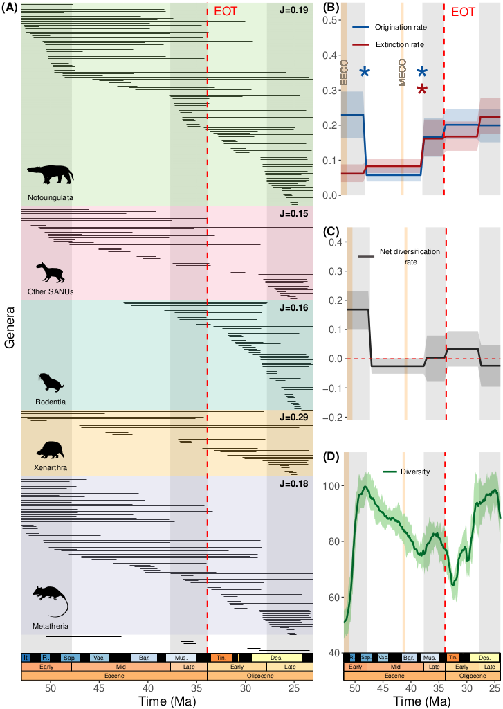
Figure 1. Bayesian inferences of taxon longevities (A), diversification (B-C) and diversity (D) dynamics of South American Mammals from the early Eocene to the late Oligocene (genus level).
The plot on the left (A) shows the longevity–i.e., interval between origination and extinction times–of each Eocene-Oligocene (373 out of 529 genera) South American mammal genus estimated with PyRate. J-values are Jaccard’s similarity indices between the Eocene and Oligocene assemblages for each of the five groups. The right part of the panel shows the origination (blue) and extinction (red) rates through time (B), the net diversification rate (origination minus extinction) (C), and diversity (D) of all South American mammals throughout the study period. Full lines represent median estimates and ribbons their associated 95% higher posterior density. Light brown vertical bands indicate two key climate events, the Early Eocene Climate Optimum (EECO, ~53-51 Ma) and the Middle Eocene Climate Optimum (MECO, ~41.5-41 Ma). Stars on the (B) plot indicate significant rate shifts. Organisms’ silhouettes are from PhyloPic (https://www.phylopic.org) and were added thanks to the R package rphylopic (88). Silhouettes were contributed by Julián Bayona, 2016 (CC BY-SA 3.0), Kai R. Kaspar (CC BY-SA 3.0), Milena Cavalcanti, Patricia Pilatti & Diego Astúa (CC BY 4.0). Geological and South American Land Mammal Ages (SALMA) timescales were depicted thanks to the deeptime R package (89).
Abbreviations for SALMA. Des: Deseadan, Ting: Tinguirirican, Must: Mustersan, Bar: Barrancan, Sap: “Sapoan Fauna”, R: Riochian, It: Itaboraian. The small band between Tinguirirican and Deseadan is the “La Cantera fauna”.
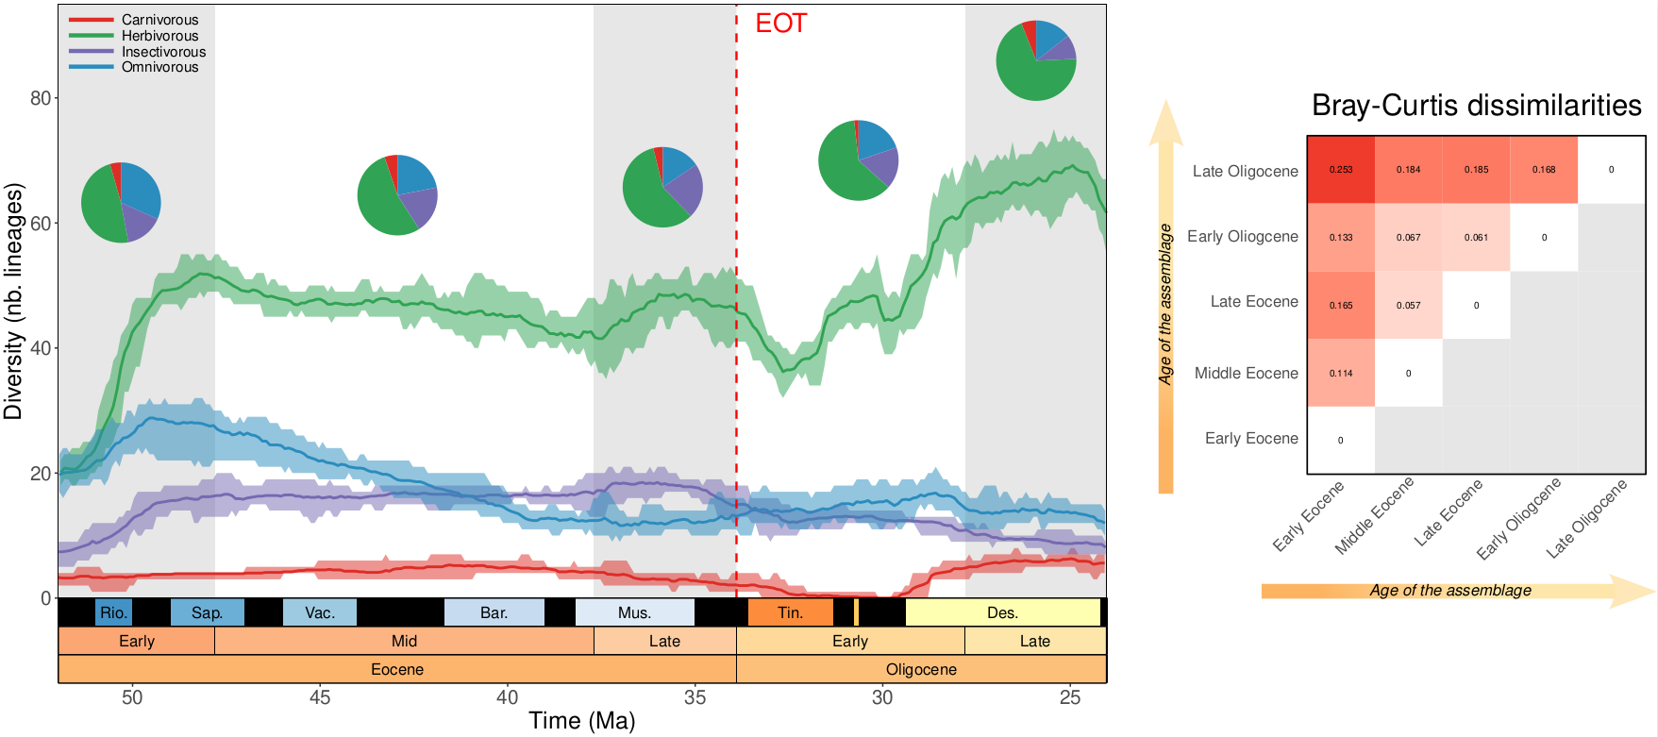
Figure 2. Evolution of genus-level functional assemblages between the Eocene and the Oligocene. The plot on the left shows the median (full line) and 95% HPD (ribbon) of estimated genus richness among the four trophic classes we defined based on dental ecomorphotypes: carnivorous (red), herbivorous (green), insectivorous (purple) and omnivorous (blue). Pie charts indicate the relative abundance of each trophic group for each sub-epoch. The matrix on the right shows pairwise Bray-Curtis dissimilarities between sub-epoch-level trophic communities, with darker color indicating higher dissimilarities. Geological and SALMA timescales were added thanks to the deeptime R package (89).
Abbreviations for SALMA. Des: Deseadan, Ting: Tinguirirican, Must: Mustersan, Bar: Barrancan, Sap: “Sapoan Fauna”, Rio: Riochian. The small band between Tinguirirican and Deseadan is “La Cantera fauna”.
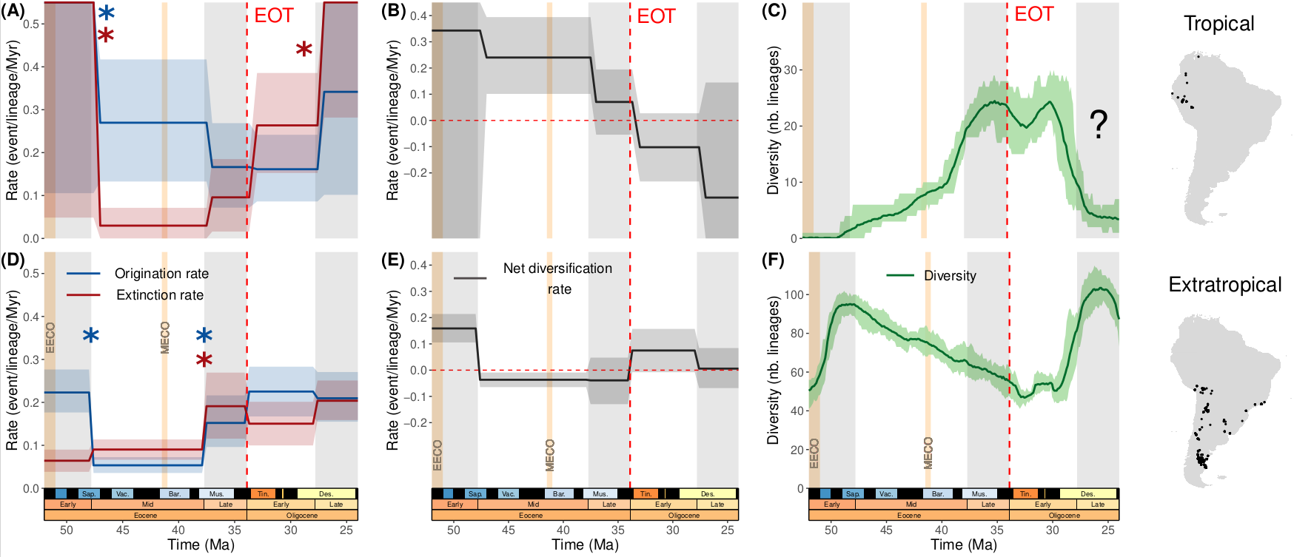
Figure 3. Diversification (A-B and D-E) and diversity (C and F) dynamics of South American mammal genera between the Eocene and Oligocene arranged by paleotropical affinity. Trends are assessed for the tropical (A-C) and extratropical (D-F) biomes. Origination and extinction rates are respectively depicted in blue and red. Stars indicate significant rate shifts. The timing and significance of rate shifts was assessed by the RJMCMC model (Fig. S36-37). Their difference, being the net diversification rate, is represented in black. Diversity through time is plotted in green. Light brown vertical bands indicate two key climate events, the Early Eocene Climate Optimum (EECO, ~53-51 Ma) and the Middle Eocene Climate Optimum (MECO, ~41.5-41 Ma). The question mark on the tropical diversity-through-time plot (C) indicates that the late-Oligocen tropical diversity decline that is observed is likely due to the quasi-absence of fossil material of Late Eocene age (Deseadan SALMA) so far unearthed. The maps on the right show the localities of our extratropical (top) and tropical (bottom) occurrences. Geological and SALMA timescales were added thanks to the deeptime R package (89).
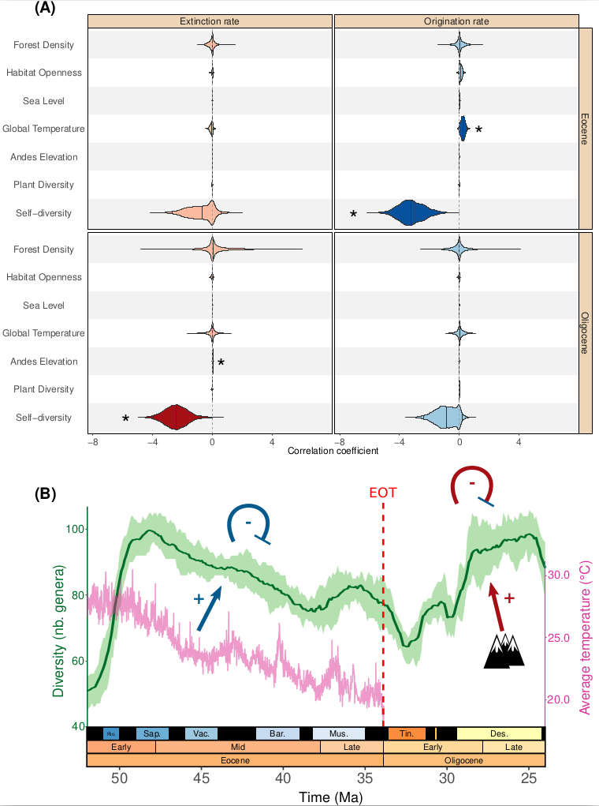

Figure 4. Bayesian estimation of correlation parameters on origination (blue) and extinction (red) rates with paleoenvironmental variables. (A) We analyzed separately the post-Early Eocene Climate Optimum (52-33.9 Ma, top row) and Oligocene (33.9-23.03 Ma, bottom row) mammal faunas, therefore not treating our dataset as a whole throughout our study period. The 2.5%, 50% and 97.5% quantiles are indicated in the distribution of each parameter by vertical lines, respectively from left to right. The interval between the leftmost and the rightmost vertical line of each parameter is therefore its 95% Highest Posterior Density (HPD). Significant correlations, i.e., having shrinkage weights higher than 0.5 and the correlation parameter not including 0 in their 95% HPD, are highlighted by stars and darker shades. Details of the environmental variables can be found in Fig. S39 and Tab. S2 (‘forest density’ refers to the relative Leaf Area Index, abbreviated rLAI). A graphical interpretation of the highlighted effects of environment covariates on South American mammal diversity is proposed in (B). Arrows with a sharp head indicate positive correlations, whereas flat heads indicate negative ones. Following color legend in (A), the arrow indicates the rate on which the correlation was found, with red being the extinction rate and blue the origination rate. Temperature during the Eocene (displayed in pink) was taken from Westerhold et al. (16).

 | Tropical Affinity |  | Dental Ecomorphotype
 | Tropical | extratropical | Carnivorous | Herbivorous | Omnivorous | Insectivorous
Nb. occurrences | 158 | 3226 | 220 | 2301 | 573 | 290
Nb. Genera | 78 | 470 | 31 | 324 | 116 | 57
Nb. Species | 116 | 1005 | 51 | 698 | 232 | 127
Table 1. Size of the different climate zones (Tropical Affinity) and diet (Dental Ecomorphotype) categories, expressed in number of occurrences, genera and species.

