

Lucas Buffan November XX^{h}, 2024
Institut des Sciences de l’Évolution de Montpellier

Dear PNAS editor-in-chief and associate editor,

We have received your decision letter concerning our manuscript (MS# 2024-19520), entitled “The fate of South America’s endemic mammalian fauna in response to the most dramatic Cenozoic climate disruption”. We would like to thank you for considering our work for publication in PNAS, as well as for giving us the opportunity to revise it before a new submission. We were extremely delighted by the editor’s and referees’ overall enthusiasm regarding our work. You may find enclosed a revised version of our manuscript and its Supporting Information, that were modified according to the comments and suggestions made by the reviewers. We should notice that we found a small caveat in our methodological pipeline while accounting for Reviewer #2’s main suggestion. We fixed it and it led to no major change in our biological interpretation of the reconstructed patterns. This minor change is detailed thereafter, in our reply to Reviewer #2.
We hope that all our changes will fit your expectations.

Below are the points raised by the Editor and the two reviewers (italicized pink), to which we respond with a normal font.

Editor’s comment:

Thanks for submitting your work to PNAS. I read your ms shortly after it was submitted and found it of potential interest to PNAS. I therefore sent it out for external review - two external expert reviewers have now seen it: both like your submission, as do I. I'm pleased to invite you to submit a revision of your ms. I do very much look forward to read the new version of your ms.

Thank you very much. We are extremely happy about your overall positive feeling regarding our work, as well as both reviewers’.
Reviewer #1:

Suitable Quality?: Yes
Sufficient General Interest?: Yes
Conclusions Justified?: Yes
Clearly Written?: Yes
Procedures Described?: Yes
Supplemental Material Warranted?: Yes
Sufficient data/samples?: Yes

Comments:
This is a data-rich, methodologically rigorous article that challenges the notion that South American mammals (SAM) experienced a major extinction crisis at the Eocene-Oligocene Transition (EOT). Instead, the authors argue that these species suffered a gradual diversity decline from the middle Eocene to the early Oligocene associated with a large taxonomic turnover. Their analyses lead them to believe that temperature change, Andean uplift, and diversity-dependent effects were likely drivers of SAM diversification. They find support for Wallace's tropical stability hypothesis and challenge the importance of the expansion of grasslands as a trigger for taxonomic turnover during the Oligocene. They describe macroevolutionary differences between tropical and extratropical lineages within South America, and they show differences between the drivers ruling Eocene vs. Oligocene evolutionary dynamics. The primary message, however, is that whereas there are clear differences between the compositions of the Eocene and Oligocene faunas of South America, there is no evidence favoring an abrupt, catastrophic extinction episode followed by rapid evolutionary replacement - the hallmarks of mass extinction. In this manner, South America differs from Europe and Asia, and this article seeks to explain these differences.
The data analyses are well documented in Supplementary Materials and the article is well written. I recommend that the manuscript be accepted with minor revisions. The authors state that this research is based on "an unprecedented fossil database." I dare say that their database is indeed extraordinary. It covers much more than the EOT itself. The article deals with the tempo and mode of mammalian species diversification in South America through the Eocene and Oligocene. They draw attention to gaps in the database and include a section in their manuscript that treats shortcomings of their own analyses, which I find refreshing. More authors should do this.
I have a few recommendations for revision, which I would leave to the discretion of the authors.

Many thanks for this positive introduction. It is a sincerely true pleasure to read.

1. Define "mass extinction" in the abstract or early in the introduction. Is it at least 75% of species in a designated taxonomic group and region going extinct within a period of several million years? A quantitative comparison of the EOT extinction episode would be of value, particularly because this article does find evidence of heightened risk of extinction for SAM during the EOT. With 19% of genera and 25% of species lost at the Eocene-Oligocene boundary, this episode clearly does not qualify as "mass" extinction, but it is not trivial. The authors state repeatedly that the recent characterization of the EOT extinction episode as the 2nd most intense mass extinction episode on earth is false, and this is clearly true. But it would be far clearer if the authors would define "mass" in this context

Thank you for this interesting comment. Given a taxonomic group, a mass extinction is originally defined a geologically instantaneous (i.e., occurring on a timescale below the resolution of the records used to study them) global-scale loss of a majority of lineages (that can vary depending on the taxonomic scale but can reach until 75% of species) (Raup et Sepkoski 1982; Hull et al. 2015). However, one can expect heterogeneity in the extent of a mass extinction with, for instance, regions that are more impacted or clades that are more affected (e.g. Guinot et Condamine 2023). The EOT is not officially recognized as a mass extinction event, but recent findings relying on a deep-learning-based analysis of the fossil record have shown that extinction rates and percentages of species loss at the EOT exceed those from well-known and recognized mass extinctions (Hoyal Cuthill, Guttenberg, et Budd 2020). We agree that a quantitative comparison of the extinction rates and species loss during the EOT would be of value, but we wonder to what extent should we compare these metrics. Colleagues have used a similar Bayesian model-based approach for European artiodactyls during the EOT and found both higher punctual extinction rates (~1 event/Myr/species) and a much higher percentage of species loss (77%; see Weppe et al. 2023). This highlights that the EOT would fit the criteria of a mass extinction, but on a regional scale. As you reported in your summary, our study challenges the generalization of this pattern to the global scale, as we did not detect any geologically-short shift in extinction rate at the geological boundary. This said, more studies would be needed to validate a general trend in the case of the EOT, with, for instance, a global-scale analysis of the fossil record of a given group with state-of-the-art methods of macroevolutionary inference.
In the revised version of our manuscript, we provide a proper definition the term “mass extinction” in the SI Appendix, of which we refer several times in the text. This definition is:
“The expression "mass extinction" has been historically introduced to characterize the punctual-in-time dramatic diversity drop-downs that could be drawn from the first global-scale compilations of the marine fossil record (Sepkoski et al. 1981). It is now admitted that, given a taxonomic group, a mass extinction event can be defined as a global loss of the majority of the lineages belonging to this group, occurring within a short time period (Raup et Sepkoski 1982). The time frame of a mass extinction is always considered as geologically instantaneous, meaning that it occurs on a timescale (10³ − 10⁵ years) below the resolution of the records used to study them (i.e., fossils, 10⁶ years) (Hull et al. 2015).”

2. Define climatic "hinge" in the abstract. This term is introduced in the abstract, and I'm not sure that all readers will be familiar with this term. Maybe just add the words "tipping point" in parentheses within the Abstract?

We agree that “climatic hinge” could be confusing for readers. We therefore chose to replace it by “shift” in the Abstract.
3. Episodes of heightened arrival of immigrant taxa, whether through transoceanic dispersal on floating vegetation, the emergence of land bridges, or changes in the dynamics of oceanic circulation, are believed to have contributed to variation in rates of species extinction and/or diversification in other parts of the world. Certainly human translocation or deliberate introduction of species has had enormous effects. High colonization frequency at the EOT has been claimed for other land masses, and primates and rodents appear to have arrived on South America at about this time. The authors comment briefly on this question; they make reference to the history of geographic isolation of South America, and to the Great Biotic Interchange associated with the closure of the Panama isthmus. I wonder if they might expand on Eocene and Oligocene arrivals in South America with comparative data. Was the EOT was a period of unusually high frequency of arrivals of immigrant species to this land mass? How would they respond to the notion that transatlantic rafting to South America increased during the opening of a dispersal window due to the global drop in sea level around the time of the EOT (Seiffert et al. on parapithecids, platyrrhines, and caviomorph rodents)? I think readers may benefit from the authors' perspective on this.

Thank you for this thoughtful comment. In our Limits and Perspectives section, we have inserted a short statement about the temporal window during which rodents are known to have reached South America, i.e., well before the EOT (see Antoine et al. 2011; Assemat et al. 2019; Antoine et al. 2021). The Eocene age of earliest caviomorph rodents has been constrained at Contamana, in Peruvian Amazonia, through radioisotopic data (Ar/Ar dating on biotite grains from a tuffaceous silt located 47 m above the main fossiliferous level in the same section, and dated to 43.44 ±2.5 Ma”; Antoine et al. 2011). Their abundance and taxonomic diversity (~30 species described) in 40 Eocene–early Oligocene localities of Peruvian Amazonia and Acre, Brazil further attest the success of their early settlement. Aside from the early Oligocene Santa Rosa primates (Bond et al. 2015; Seiffert et al. 2020), the earliest primates with an age constraint are those from TAR-21 locality in the Shapaja section, in the San Martín Department, Peru. The latest Eocene age of the concerned locality is supported by chemostratigraphy (Antoine et al. 2021).
As widely developed by Marivaux et al. (2023), instead of a global drop in the ocean level by EOT times, high-stand levels of the Middle Eocene Climatic Optimum could be responsible for an overwater dispersal of rodents and primates from Africa: “The hyperthermal conditions of the late middle Eocene climatic optimum [MECO; ∼40.5 Ma] resulted in particularly intense meteorological episodes in tropical/equatorial regions, most certainly associated with intense flooding events (e.g. Mulch et al. 2015). These particular paleoenvironmental conditions may have enhanced riverbank break-ups more frequently, increasing the likelihood that some elements of riparian biological communities may have been carried away on natural rafts. Furthermore, the shorter distance between Africa and South America in the late middle Eocene might have increased the chances of successful transatlantic crossing(s) rather than at a later time as advocated by Seiffert et al. (2020), i.e., at or near the EOT, during which a major drop in sea level is recorded, but when the two landmasses were actually much further apart.”

Minor edits:
End of first paragraph on p. 3 - this sentence doesn't make sense: "In the few subsequent millions of years, many endemic South American lineages declined, yet went totally extinct...". Was a word or phrase unintentionally omitted?

This sentence indeed lacks some clarity. Consequently, we have replaced “yet” by “or even”.

To my knowledge, the word "precise" is used as a verb rarely and then usually in the medical profession. Elsewhere, it is generally used as an adjective. In this sentence on p. 7, the authors use it as a verb: "We may precise that the superfamily Palaeothentoidea appeared in the middle-late Eocene..." I suggest substituting the word "assert" or "specify" or "state". Also, in the same paragraph, the word "occurred" is misspelled. It has two r's, not one.

We agree that this word is rarely used in evolutionary biology. Hence, we have rephrased this sentence as follows: “We may specify that the superfamily Palaeothentoidea appeared in the middle-late Eocene”.
Additionally, the word “occurred” has been corrected.
Reviewer #2:

Suitable Quality?: Yes
Sufficient General Interest?: Yes
Conclusions Justified?: Yes
Clearly Written?: Yes
Procedures Described?: Yes
Supplemental Material Warranted?: Yes
Sufficient data/samples?: Yes

Comments:
This is a review of the manuscript "The fate of South America's endemic mammalian fauna in response to the most dramatic Cenozoic climate disruption". In this manuscript the authors use a curated version of the paleobiology database to derive -through sophisticated statistical manipulation- the patterns of extinction/diversification of South American mammals throughout the Eocene and Oligocene. Surprisingly, the authors cannot discriminate the global extinction event that has been identified everywhere else at the Eocene-Oligocene transition, instead documenting a clear tropical/extra-tropical dichotomy. Then, the authors attempt to extract possible drivers for the patterns derived from the data, narrowing them to three categories, one of which I can comment on (Andean uplift). I find the manuscript very well written, very well illustrated, with extensive and thorough supplementary materials. The results of this study are undoubtedly a valuable addition to the debate regarding tropical stability through climate change, a rather significant issue today.
Thank you for this positive introductory statement. We are delighted to read about your interest, as well as the value you give to our work.

The one thing that I think deserves further investigation is the spatial distribution of the dataset. Although the manuscript states that it investigates South American patterns, the dataset really only covers the Andean domain and the southern third of the continent, with virtually no data points in the Amazon. Although it is simply what the data is, this is potentially very significant, and I would suggest to more thoroughly characterize the distribution of the existing sites. I would suggest to first add the topography to the Supplementary Figure 3. This would help the reader identify which site are today located within the Andean domain, which are cis-Andean, and which ones are trans-Andean. Then, back in time, establish which sites were located along the axis, or the foothills of the Andes (also on which side), which I suspect are most of them, including their paleoelevation, if available.
Thank you for raising this point. Our data are indeed highly heterogeneous spatially. We are well aware of this issue, hence the second paragraph of the Limits and Perpectives section of the main text.
The Andean orogeny has been a major driver for subsidence across South America, explaining why most of our data are located near the mountain chain in its current conformation (which, according to your advice, is now well depicted on the SI Appendix, Fig. S3). Conversely, there has been little to no active tectonic driver promoting ancient sediment exhumation within most of the current Amazon river basin. Combined with the high activity of tropical soils to recycle organic matter (hampering fossil preservation), as well as the difficulty to access any possible fossil-bearing site located deeply in the forest, this has resulted in an immense gap in the fossil record spanning most of the present-day Amazon river basin, even if it constitutes a cradle for a vast number of Neotropical groups Antonelli et al. (2018). In that respect, we should mention that the authors of this study have been conducting field expeditions for two decades in Peruvian and Brazilian Amazonia (Antoine et al. 2016; 2021; Marivaux et al. 2023), discovering >100 Cenozoic fossil-yielding localities in a dozen of distinct sections. Although most of these localities are located near the andean mountaneous areas (=Western Amazonia), these studies have provided unprecedent information to understand the past of South American tropical ecosystems. Without the concerned results, the fossil record would be even more imbalanced, especially regarding the Eocene–Oligocene time interval.
In order to account for this spatial bias, we conducted several sensitivity analyses consisting of data subsampling, which resulted in no major difference in both the reconstructed diversity and diversification patterns (Fig. S14 and S33). We hope that our work will encourage and stimulate further fieldwork in this region to increase and improve the fossil record in South America, especially for the Amazon river basin region.
In the revised version of the main text, we have clarified the distribution of existing sites, and added topographic information on the Fig. S3, based on data from (Boschman 2021) (see Supp. Fig. 1).

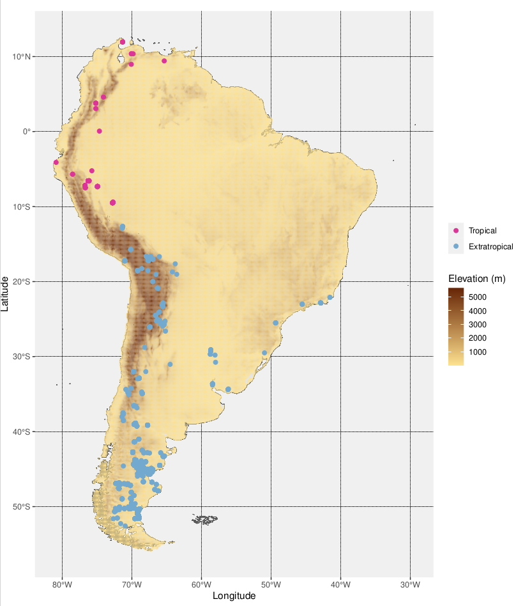

Supporting Figure 1. Map of the fossil-bearing localities considered in this study (435 collections). A major part of them are located close to or high in the Andes in their current conformation. In contrast, very few low-latitude localities are situated in the lower Amazon and the Orinoco basins, or on the Guianese and Brazilian shields, mostly due to the nature of local sedimentary cover or lack thereof. Present-day elevation data were taken from (Boschman 2021).

Additional detail before moving on to the next comment

While revising our time-stratified Multivariate Birth-Death (MBD) analyses, we realized that our pipeline comprised a small caveat regarding epoch assignation. Indeed, the MBD model takes as input a table containing the origination and extinction times (resp. T_{s} and T_{e}) of each lineage, estimated by PyRate from ages randomly drawn within each fossil occurrence’s interval between minimal and maximal time boundaries. In order to best capture variability, we replicated this random sampling of occurrence’s age 20 times in our pipeline (see Methods section of our manuscript). Therefore, we naturally ended up having as many T_{s} and T_{e} estimates in the MBD starting table as we had replicates − that converged. However, until now, the way we assigned lineages an Oligocene or Eocene age was arbitrarily relying on the estimated T_{s} and T_{e} of first replicate. Hence, we corrected this by making this partitioning rely on the average T_{s} and T_{e} per taxa. Accordingly, we re-ran our MBD analyses, resulting in no change in the previously-described environmental correlations, but an additional positive correlation of Eocene extinction rate with the Andean uplift arose from this new set of analyses (Supp. Fig. 2). This suggests a prominent role of the Andean uplift in shaping SAM diversity during our entire study period (as highlighted in the SI Appendix, Fig S.34), and not only restricted to the Oligocene. The aforementioned updates were therefore included in the revised version of the manuscript.

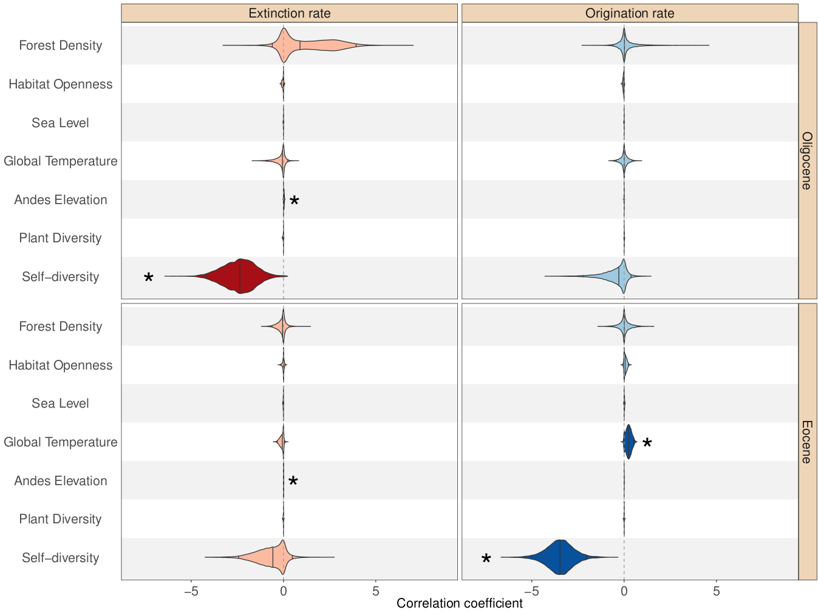
Supporting Figure 2. Bayesian estimation of correlation parameters on origination (blue) and extinction (red) rates with palaeoenvironmental covariates, based on our updated time-stratified dataset. 2.5%, 50% and 97.5% quantiles are indicated in the distribution of each parameter by vertical lines, respectively from left to right. Significant correlation coefficients, i.e., having shrinkage weights > 0.5 and not including 0 in their 95% HPD are highlighted by stars and darker shades.

Further, since Andean topographic growth is inextricably linked to subduction, I would suggest to discriminate the sites by flat-slabs (non-volcanic with isolated basement massifs such as the Peruvian and central Chilean segments), versus normal subduction with volcanic arcs. There are excellent compilations that show both datasets and modelling back in time of the slab dip, the timing of initiation of orogeny and the possible deformation rates along the margin (I can think of a few such as Faccenna et al., 2017, Earth and Planet. Science Letters; Schepers et al., 2017, Nature Communications; Chen et al., 2019, Nature). In any case, those datasets are quite different from the linear Andean uplift graph (Fig. 39b) shown as a possible driver. The one thing that is becoming clear is that Cenozoic Andean uplift was spatially heterogeneous and diachronous, so a linear average may not capture the richness of this processes. Since, as I suspect, most of the tropical sites may be located in an Andean position, a more spatially and temporally detailed "Andean driver" may yield interesting results. Of course, it is variable for different sites. In essence, I think the distribution of the dataset would allow to make inferences regarding an extra-tropical vs tropical Andean domains, not tropical vs extra-tropical.

Thank you for approaching this very relevant issue. As stated in the previous point, we are aware about the spatial heterogeneity of the Andean uplift, as greatly illustrated in the references that you recommend, as well as in the recent compilation made by Boschman (2021). We chose to use the monotonic curve presented in Fig. S39 as a first-order continent-scale approximation of the pace of the uplift of the mountain chain, mostly in order to be as conservative as we could by taking advantage of every single datum, thus limiting the effect of the loss of data in the detection of macroevolutionary signals. We agree that it does not capture any regional heterogeneity, which may in turn affect the outcome of the MBD model.
According to your suggestions, we decided to test for the effect of the uplift’s regional heterogeneity on our MBD analyses by dividing the Andes into two main regions of shared latitude and tectonic history (based on Boschman 2021), merely matching our tropical vs. extratropical domains, and to extract the pace of the uplift within each region (Supp. Fig. 3, left). Of course, it would have been more precise to proceed to a finer subdivision, for instance discriminating − as you suggested − data located in foreland basins, active margin arcs or forearcs − both in low and high latitudes −, but we were afraid the resulting reduction in the size of the datasets to be too important not to hamper the accuracy of our subsequent macroevolutionary inference (see next paragraph). We further re-ran our time-stratified MBD anlayses after splitting our dataset by latitude, using the regionalized Andean paleoelevation thereby obtained (Supp. Fig. 3, right).
We were stroke by the scarcity of low-latitude data, in particular in the Eocene (Supp. Fig. 3, top right). Consequently, we believe the outcome of the low-latitude analysis not to be interpretable in itself. Regarding the analyses carried out from high-latitude taxa − having more reasonable sample sizes −, interesting things arose. We recovered the same diversity-dependent effects as those described from the total dataset. In addition, using this new regionalized estimate in conjunction to the data restricted to high latitudes, the Andean uplift was still found positively correlated to the extinction rate in the Eocene, but no longer in the Oligocene. Also, we lost the Eocene positive correlation of origination rate with global temperature that we largely discussed in our manuscript. Furthermore, new effects involving factors previously not found to be correlated to any of the diversification rates arose from this new set of analyses, in particular for the Oligocene epoch. The most striking one is the positive correlation of extinction rate with the relative Leaf Area Index (rLAI, Dunn et al. 2015), a proxy for forest density. Also, a significant negative correlation of origination rate with the relative abundance of open habitats in Patagonia (Strömberg et al. 2013) and a negative correlation of Neotropical plant diversity (Jaramillo et al. 2006) with extinction rate are to be mentioned.
Particularly in the framework of this Bayesian multivariate analysis, it is hard to disentangle true macroevolutionary signals from scale effects, or even spurious correlations. This said, these new results may call for a more nuanced view of the link between land opening and SAM diversification, at least during the Oligocene epoch. Indeed, the aforementioned positive correlation between forest density and high-latitude Oligocene SAM extinction rate (which we surprisingly also find for low-latitude Oligocene SAM, but in that case it is likely spurious as the environment covariate comes from Patagonia) would suggest that less dense − i.e., more open − habitats were associated with a reduced extinction rate among Southern SAM faunas. Also, the use of a regionalized Andean uplift curve in conjunction to a latitudinal partitioning of our dataset resulted in the loss of any Eocene correlation of origination rate with temperature, and any Oligocene correlation of extinction rate with the Andean uplift. These are yet recovered from the analysis of the whole dataset with a continental-averaged proxy (Supp. Fig. 2). As stated earlier, telling whether the loss of these relations is due to the heterogeneity present in our dataset, scale effects or any other random noise is hard.
We therefore added some nuance to the paragraph of the Drivers section of our manuscript dealing with the effect of land opening on SAM diversification. We included the Supp. Fig. 3 in the SI Appendix, and referred to it in the main text.

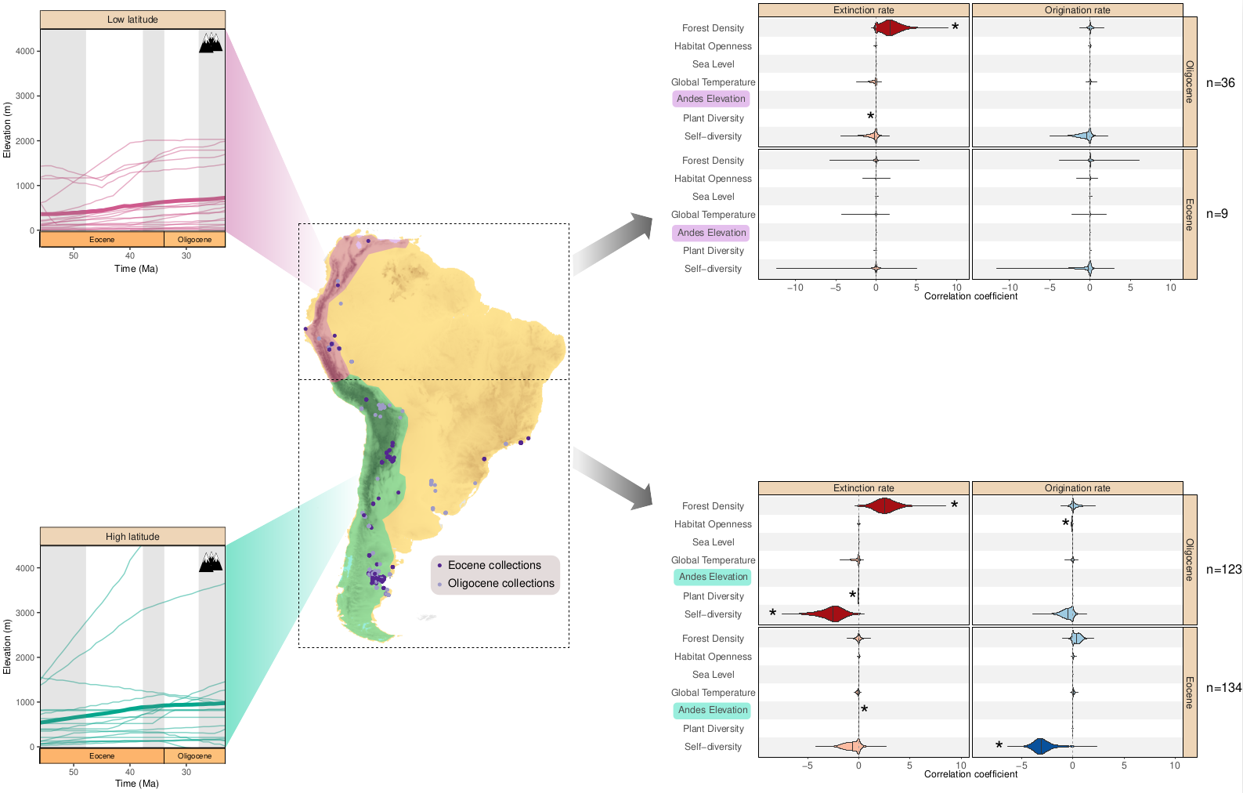
Supporting Figure 3. [Left side] Paleoelevation of the two main Andean domains we defined based on latitude and uplift history, adapted from Boschman (2021). Thick lines represent each domain's average elevation, and thin lines show each individual region considered. More details available in Boschman (2021) and Boschman et Condamine (2022). Low and high latitudes are respectively shown in light pink and light green. [Right side] Posterior estimates of the Multivariate Birth-Death (MBD) correlation parameters on origination (blue) and extinction (red) with paleoenvironment variables. We separately analyzed post-EECO (52−33.9 Ma, “Eocene”) and Oligocene (33.9−23.03 Ma) faunas, splitted by latitude, with high latitudes (extratropical) shown at the top and low latitudes (tropical) at the bottom. On the right side of each MBD panel are represented the number of taxa considered in each condition.

Additionally, there are hypothesis that call for a land-bridge during Eocene-Oligocene times through the great arc of the Caribbean (Gaarlandia hypothesis, Iturralde et al., 2023, Geologica Acta). It would be interesting to discuss this possibility as it falls squarely within the timeframe investigated in this manuscript.
Thank you again for this comment. We agree and we are well aware of the GAARlandia hypothesis, given that several authors of the current study were part of a multidisciplinary funded project in the last decade, focused on the colonization of the Antilles by terrestrial mammals over Cenozoic times. This project (GAARAnti) was involving both geological aspects (onshore and offshore; published works include Cornée et al. 2021; Philippon et al. 2020 on GAARlandia and GrANoLA hypotheses, respectively) and palaeontological-biological investigations (published works include Delsuc et al. 2019; Tejada et al. 2024 on sloth biogeography; Marivaux et al. 2020 on chinchilloid rodents of strong Proto-Amazonian affinities recovered from lower Oligocene deposits of Puerto Rico). Indeed, both tectonics-induced vertical movements and eustasy-related littoral emersion due to peri-EOT sea-level drop may have promoted the formation of this ephemeral land-bridge and facilitated biotic dispersal events for terrestrial mammals and other vertebrate clades during earliest Oligocene times (e.g. Eleutherodactylus frogs; Blackburn et al. 2020), mostly from northeastern South America to the (Greater) Antilles. Unfortunately it remains hard to test for the effect of the onset of this continental bridge on SAM diversification dynamics with the current data and tools. We further feel that resolving this issue falls beyond the scope of the present manuscript, and that it would deserve being fully exploited in another article instead.
However, in the revised Limits and Perspectives section of the main text, we have added a paragraph where we discuss, together with the third point raised by Reviewer #1, the intercontinental dispersal episodes involving South America that could have been promoted by the environmental changes occurring at the EOT.

One suggestion following geologic usage: in Fig. 4a Eocene should be below the Oligocene.
Thank you for pointing this out. We have now corrected Figure 4a and Eocene plots are placed below Oligocene plots, following the stratigraphic chart and, more broadly, stratigraphic conventions.

Fig. Supp 24 caption calls for maps, but there are no maps in the figure.
Good catch, thank you. We added the missing maps to the Supp. Figure 24.

Camilo Montes
Literature cited

Antoine, Pierre-Olivier, M. Alejandra Abello, Sylvain Adnet, Ali J. Altamirano Sierra, Patrice Baby, Guillaume Billet, Myriam Boivin, et al. 2016. « A 60-million-year Cenozoic history of western Amazonian ecosystems in Contamana, eastern Peru ». Gondwana Research 31 (mars):30-59. https://doi.org/10.1016/j.gr.2015.11.001.
Antoine, Pierre-Olivier, Laurent Marivaux, Darin A. Croft, Guillaume Billet, Morgan Ganerød, Carlos Jaramillo, Thomas Martin, et al. 2011. « Middle Eocene rodents from Peruvian Amazonia reveal the pattern and timing of caviomorph origins and biogeography ». Proceedings of the Royal Society B: Biological Sciences 279 (1732): 1319-26. https://doi.org/10.1098/rspb.2011.1732.
Antoine, Pierre-Olivier, Johan Yans, Angélica Aliaga Castillo, Narla Stutz, M. Alejandra Abello, Sylvain Adnet, Michele Andriolli Custódio, et al. 2021. « Biotic Community and Landscape Changes around the Eocene–Oligocene Transition at Shapaja, Peruvian Amazonia: Regional or Global Drivers? » Global and Planetary Change 202 (juillet):103512. https://doi.org/10.1016/j.gloplacha.2021.103512.
Antonelli, Alexandre, Alexander Zizka, Fernanda Antunes Carvalho, Ruud Scharn, Christine D. Bacon, Daniele Silvestro, et Fabien L. Condamine. 2018. « Amazonia Is the Primary Source of Neotropical Biodiversity ». Proceedings of the National Academy of Sciences 115 (23): 6034-39. https://doi.org/10.1073/pnas.1713819115.
Assemat, Alexandre, Myriam Boivin, Laurent Marivaux, François Pujos, Aldo Benites-Palomino, Rodolfo Salas-Gismondi, Julia V. Tejada-Lara, et al. 2019. « Restes inédits de rongeurs caviomorphes du Paléogène de la région de Juanjui (Amazonie péruvienne): systématique, implications macro-évolutives et biostratigraphiques ». Geodiversitas 41 (1): 699-730. https://doi.org/10.5252/geodiversitas2019v41a20.
Blackburn, David C., Rachel M. Keeffe, María C. Vallejo-Pareja, et Jorge Vélez-Juarbe. 2020. « The earliest record of Caribbean frogs: a fossil coquí from Puerto Rico ». Biology Letters 16 (4): 20190947. https://doi.org/10.1098/rsbl.2019.0947.
Bond, Mariano, Marcelo F. Tejedor, Kenneth E. Campbell, Laura Chornogubsky, Nelson Novo, et Francisco Goin. 2015. « Eocene Primates of South America and the African Origins of New World Monkeys ». Nature 520 (7548): 538-41. https://doi.org/10.1038/nature14120.
Boschman, Lydian M. 2021. « Andean mountain building since the Late Cretaceous: A paleoelevation reconstruction ». Earth-Science Reviews 220 (septembre):103640. https://doi.org/10.1016/j.earscirev.2021.103640.
Boschman, Lydian M., et Fabien L. Condamine. 2022. « Mountain Radiations Are Not Only Rapid and Recent: Ancient Diversification of South American Frog and Lizard Families Related to Paleogene Andean Orogeny and Cenozoic Climate Variations ». Global and Planetary Change 208 (janvier):103704. https://doi.org/10.1016/j.gloplacha.2021.103704.
Cornée, Jean-Jacques, Philippe Münch, Mélody Philippon, Marcelle BouDagher-Fadel, Frédéric Quillévéré, Mihaela Melinte-Dobrinescu, Jean-Frédéric Lebrun, et al. 2021. « Lost islands in the northern Lesser Antilles: possible milestones in the Cenozoic dispersal of terrestrial organisms between South-America and the Greater Antilles ». Earth-Science Reviews 217 (juin):103617. https://doi.org/10.1016/j.earscirev.2021.103617.
Delsuc, Frédéric, Melanie Kuch, Gillian C. Gibb, Emil Karpinski, Dirk Hackenberger, Paul Szpak, Jorge G. Martínez, et al. 2019. « Ancient Mitogenomes Reveal the Evolutionary History and Biogeography of Sloths ». Current Biology 29 (12): 2031-2042.e6. https://doi.org/10.1016/j.cub.2019.05.043.
Dunn, Regan E., Caroline A. E. Strömberg, Richard H. Madden, Matthew J. Kohn, et Alfredo A. Carlini. 2015. « Linked canopy, climate, and faunal change in the Cenozoic of Patagonia ». Science 347 (6219): 258-61. https://doi.org/10.1126/science.1260947.
Guinot, Guillaume, et Fabien L. Condamine. 2023. « Global impact and selectivity of the Cretaceous-Paleogene mass extinction among sharks, skates, and rays ». Science 379 (6634): 802-6. https://doi.org/10.1126/science.abn2080.
Hoyal Cuthill, Jennifer F., Nicholas Guttenberg, et Graham E. Budd. 2020. « Impacts of Speciation and Extinction Measured by an Evolutionary Decay Clock ». Nature 588 (7839): 636-41. https://doi.org/10.1038/s41586-020-3003-4.
Hull, Pincelli M., Simon A. F. Darroch, et Douglas H. Erwin. 2015. « Rarity in Mass Extinctions and the Future of Ecosystems ». Nature 528 (7582): 345-51. https://doi.org/10.1038/nature16160.
Jaramillo, Carlos, Milton J. Rueda, et Germán Mora. 2006. « Cenozoic Plant Diversity in the Neotropics ». Science 311 (5769): 1893-96. https://doi.org/10.1126/science.1121380.
Marivaux, Laurent, Francisco R. Negri, Pierre-Olivier Antoine, Narla S. Stutz, Fabien L. Condamine, Leonardo Kerber, François Pujos, et al. 2023. « An eosimiid primate of South Asian affinities in the Paleogene of Western Amazonia and the origin of New World monkeys ». Proceedings of the National Academy of Sciences 120 (28): e2301338120. https://doi.org/10.1073/pnas.2301338120.
Marivaux, Laurent, Jorge Vélez-Juarbe, Gilles Merzeraud, François Pujos, Lázaro W. Viñola López, Myriam Boivin, Hernán Santos-Mercado, et al. 2020. « Early Oligocene chinchilloid caviomorphs from Puerto Rico and the initial rodent colonization of the West Indies ». Proceedings of the Royal Society B: Biological Sciences 287 (1920): 20192806. https://doi.org/10.1098/rspb.2019.2806.
Mulch, Andreas, C. P. Chamberlain, Michael A. Cosca, Christian Teyssier, Katharina Methner, Michael T. Hren, et Stephan A. Graham. 2015. « Rapid Change in High-Elevation Precipitation Patterns of Western North America during the Middle Eocene Climatic Optimum (MECO) ». American Journal of Science 315 (4): 317-36. https://doi.org/10.2475/04.2015.02.
Philippon, Mélody, Jean-Jacques Cornée, Philippe Münch, Douwe J. J. van Hinsbergen, Marcelle BouDagher-Fadel, Lydie Gailler, Lydian M. Boschman, et al. 2020. « Eocene Intra-Plate Shortening Responsible for the Rise of a Faunal Pathway in the Northeastern Caribbean Realm ». PLOS ONE 15 (10): e0241000. https://doi.org/10.1371/journal.pone.0241000.
Raup, David M., et J. John Sepkoski. 1982. « Mass Extinctions in the Marine Fossil Record ». Science 215 (4539): 1501-3. https://doi.org/10.1126/science.215.4539.1501.
Seiffert, Erik R., Marcelo F. Tejedor, John G. Fleagle, Nelson M. Novo, Fanny M. Cornejo, Mariano Bond, Dorien de Vries, et Kenneth E. Campbell. 2020. « A parapithecid stem anthropoid of African origin in the Paleogene of South America ». Science 368 (6487): 194-97. https://doi.org/10.1126/science.aba1135.
Sepkoski, J. John, Richard K. Bambach, David M. Raup, et James W. Valentine. 1981. « Phanerozoic Marine Diversity and the Fossil Record ». Nature 293 (5832): 435-37. https://doi.org/10.1038/293435a0.
Strömberg, Caroline A. E., Regan E. Dunn, Richard H. Madden, Matthew J. Kohn, et Alfredo A. Carlini. 2013. « Decoupling the Spread of Grasslands from the Evolution of Grazer-Type Herbivores in South America ». Nature Communications 4 (1): 1478. https://doi.org/10.1038/ncomms2508.
Tejada, Julia V, Pierre-Olivier Antoine, Philippe Münch, Guillaume Billet, Lionel Hautier, Frédéric Delsuc, et Fabien L Condamine. 2024. « Bayesian Total-Evidence Dating Revisits Sloth Phylogeny and Biogeography: A Cautionary Tale on Morphological Clock Analyses ». Systematic Biology 73 (1): 125-39. https://doi.org/10.1093/sysbio/syad069.
Weppe, R., F. L. Condamine, G. Guinot, J. Maugoust, et M. J. Orliac. 2023. « Drivers of the artiodactyl turnover in insular western Europe at the Eocene–Oligocene Transition ». Proceedings of the National Academy of Sciences 120 (52): e2309945120. https://doi.org/10.1073/pnas.2309945120.

