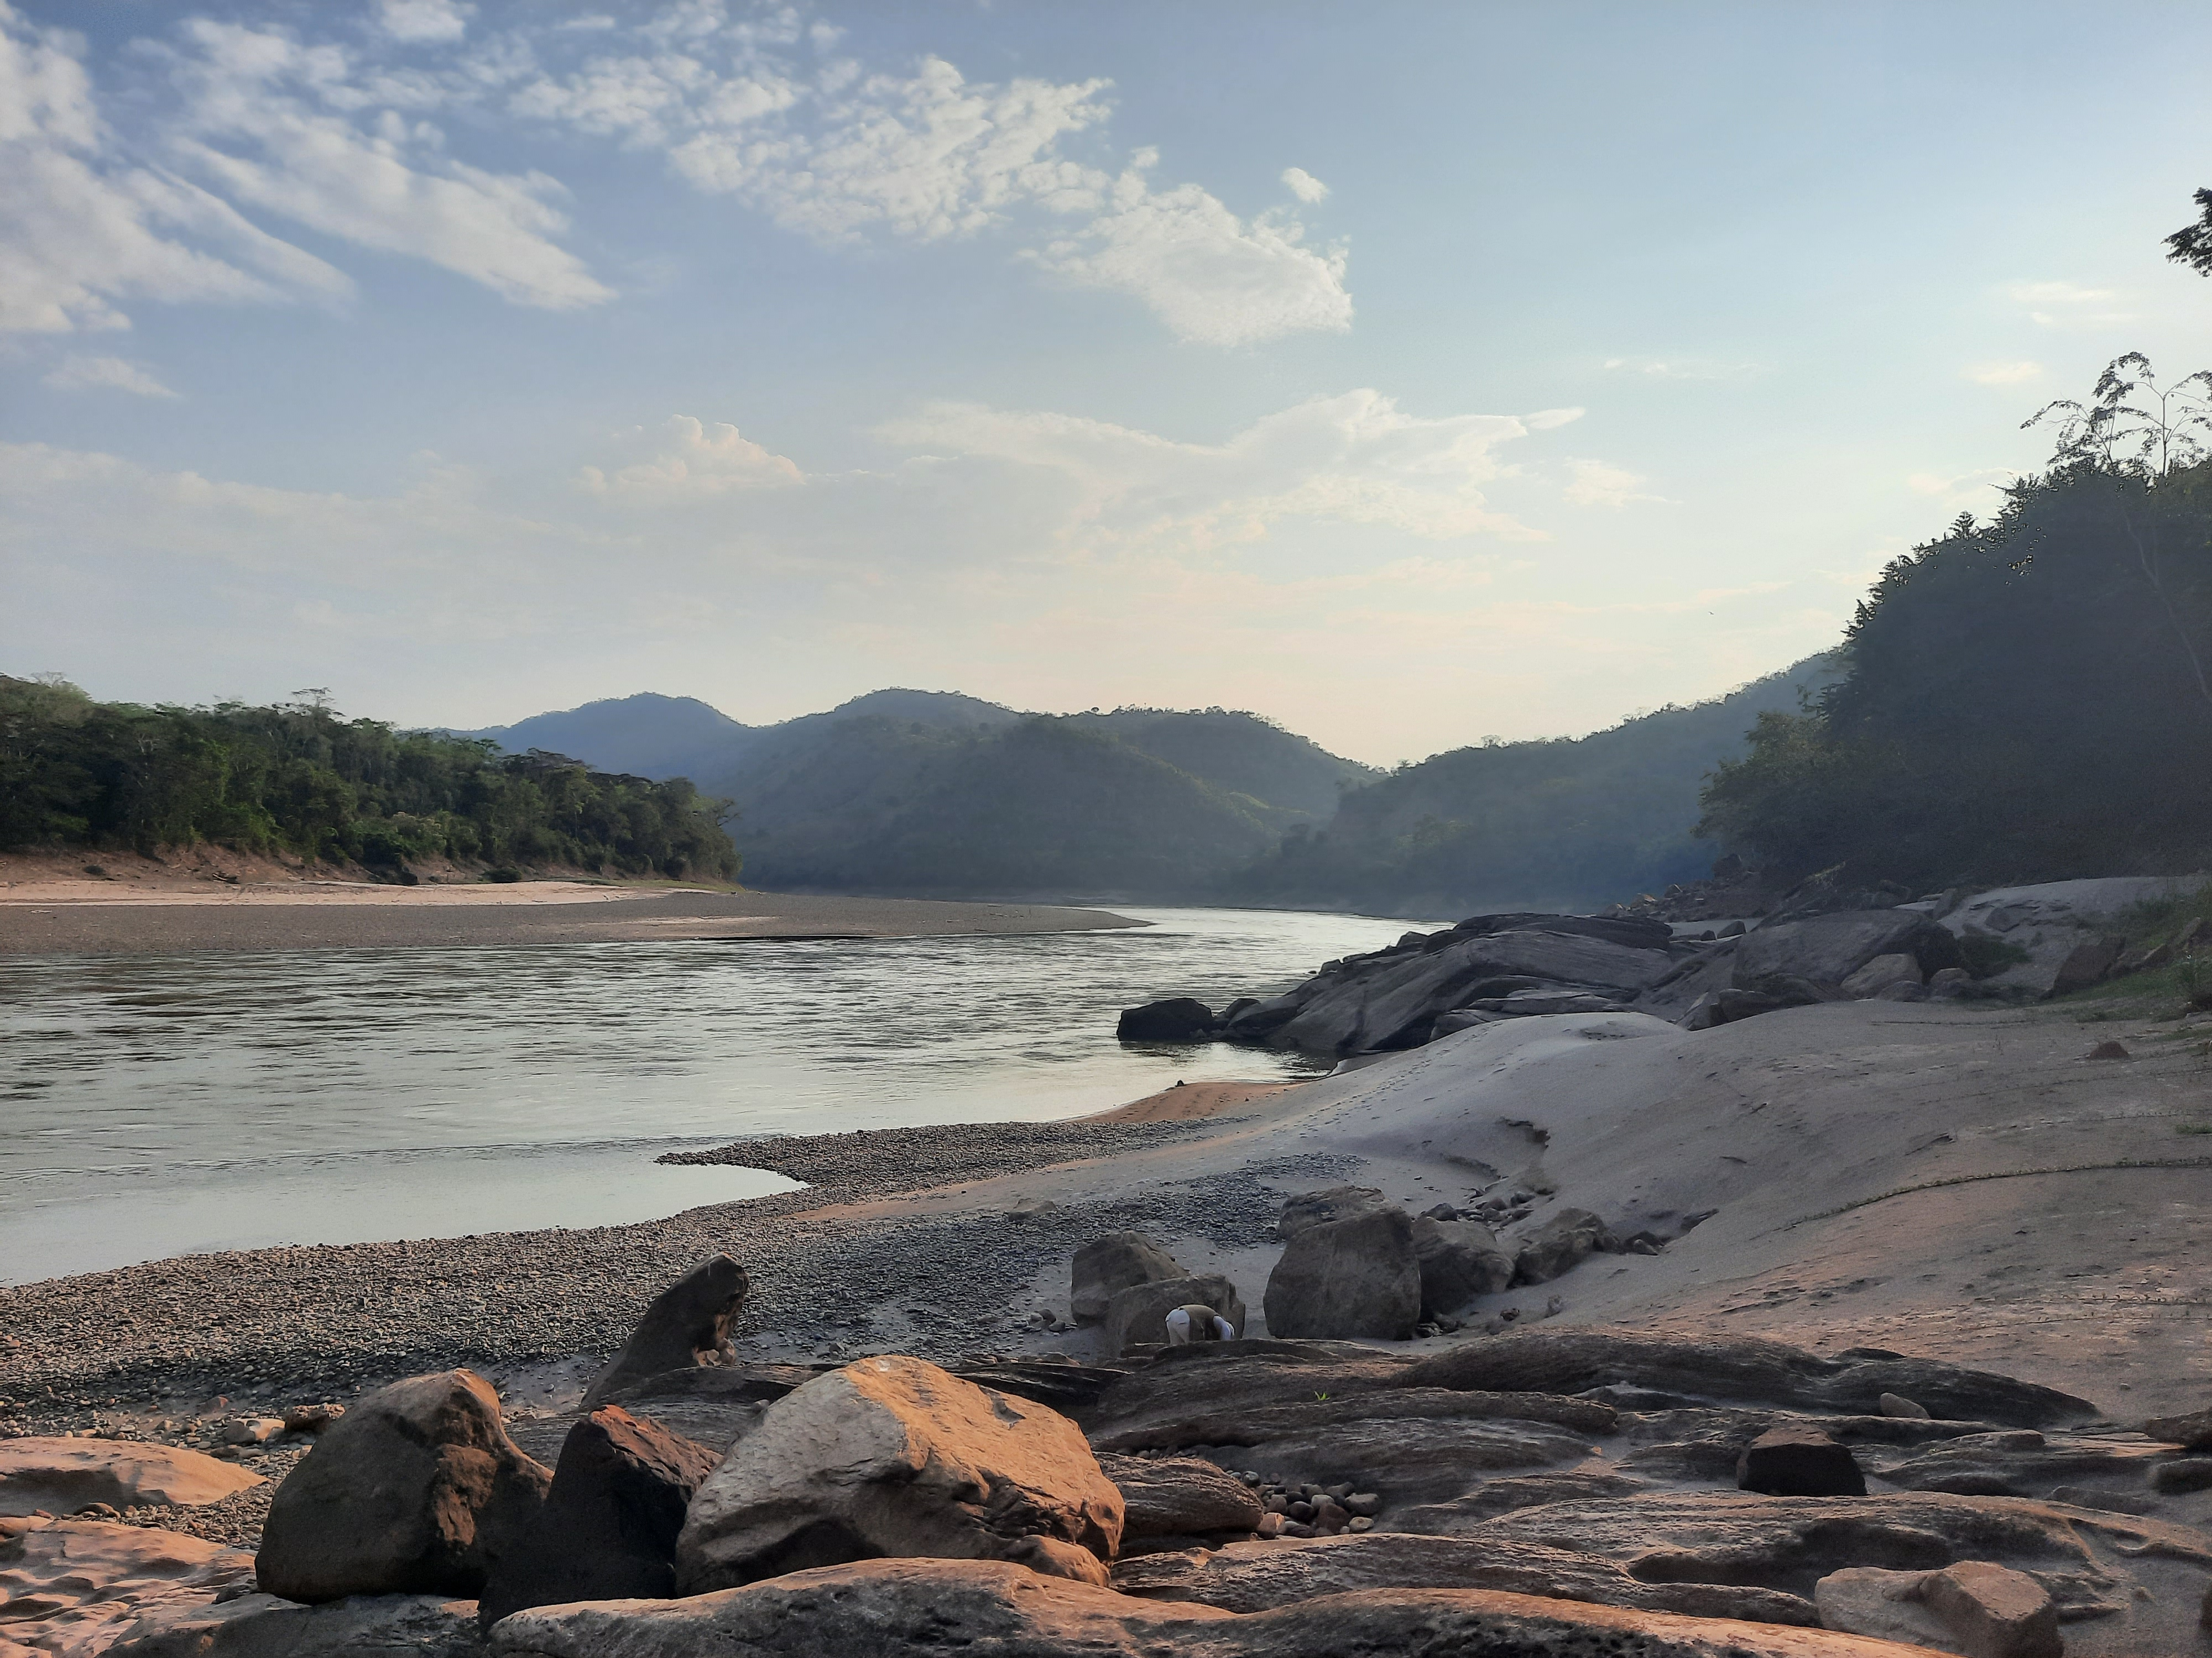

A fossil-bearing locaility from the Peruvian Amazonia, Shapaja region

