**Buffet2gether**

Context Diagram

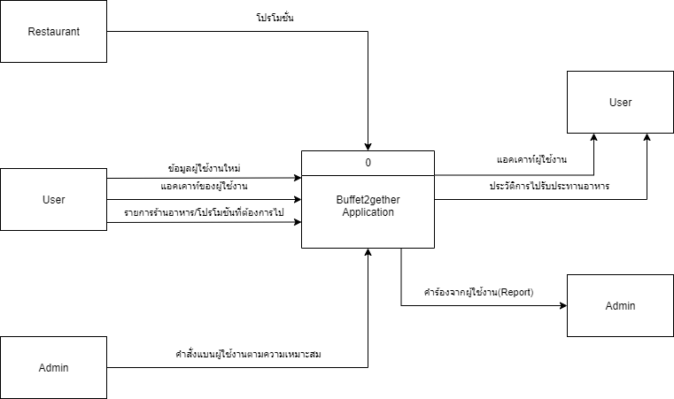

**Buffet2gether**

Data Flow Diagram Level 0

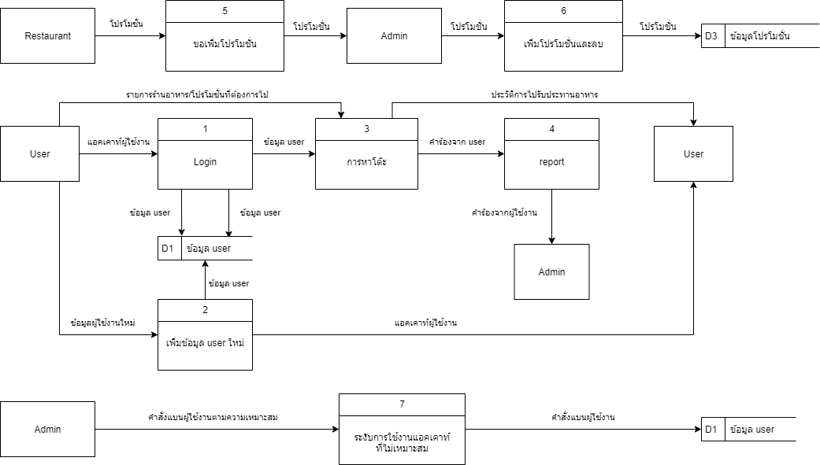

**Buffet2gether**

Data Flow Diagram Level 1

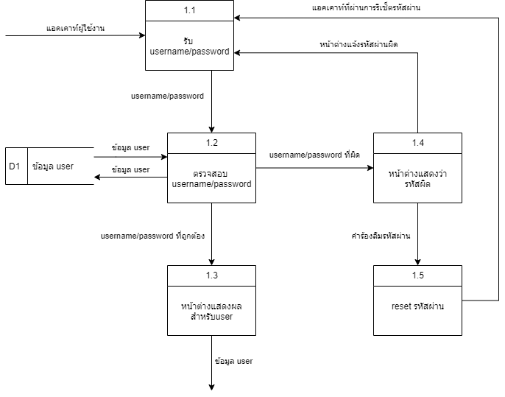

**Buffet2gether**

Data Flow Diagram Level 3

