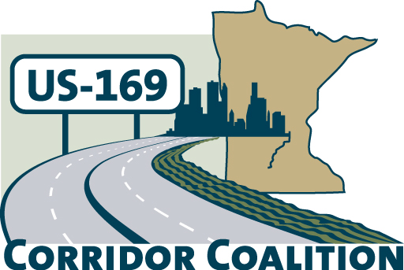
US Hwy 169 Corridor Coalition
Working together to enhance safety, reduce congestion and maximize economic development along the US Highway169 inter-regional corridor.

To: US Hwy 169 Corridor Coalition Executive Committee
From: Technical Committee Members
Date: March 8, 2012
Re: Project Evaluation
Introduction:
The US Hwy 169 Corridor Coalition Board directed the Technical Committee to create a tool to be used to evaluate the identified projects along the 169 corridor. Not all projects are created equal; some are shovel ready, some require one or more studies, and some are right-of-way acquisition projects. With the evaluation matrix, the Technical Committee attempted to measure each project based on its contribution to the overall corridor goals and benefits. With this assessment, the Corridor Coalition Board can review which projects should be supported as funds become available.
Evaluation Criteria:
Each project was ranked on its consistency with the corridor goals, and on the benefits the project brings to the entire Highway 169 corridor. In some instances, we were able to obtain empirical data in each of the categories, such as crash data, traffic counts, and project timing, to provide a score. In other cases, such as corridor benefits, the Technical Team scored each project based on our knowledge of the project and the region. The final score identified on the matrix is the sum of all of the points each project received.
The matrix also identifies the development stage of each project. The matrix recognizes that each of the projects may be in a different phase of development. Some have had multiple studies and preliminary plans completed, while others recognize the need for further study. There is no ranking in this segment; rather, the matrix identifies where the project stands.
Evaluation Summary:
The attached matrix identifies the scores for each project. A project with a total score of 10 or less has little or no technical merit. All of the projects on our list score well above ten.
Of the 18 projects on the list, 7 scored more than 20 points. Six of the 18 projects had scores of 18 and 19 points, and the remaining 5 all scored above 14. Based on these scores, the Technical Committee concluded all of the projects have merit. The lower scoring projects tend to be the longer range projects.
The real value of the evaluation matrix is that it positions the Corridor Coalition and its partners to be ready to take advantage of funding opportunities for all of the projects. Generally, there are limited funding sources for projects of the magnitude along the 169 corridor. The matrix allows the Corridor Coalition to steer those limited resources towards the higher scoring projects. The matrix also allows the Corridor Coalition to provide support to local jurisdictions for projects where additional funding may become available.
Requested Board Action:
Tonight, the Board members will be given the opportunity to score each of the projects. One representative of each jurisdiction will indicate their choices for the top 3 projects by placing a dot on the matrix. The Technical Committee will review the final tally and report the results at the April meeting.

