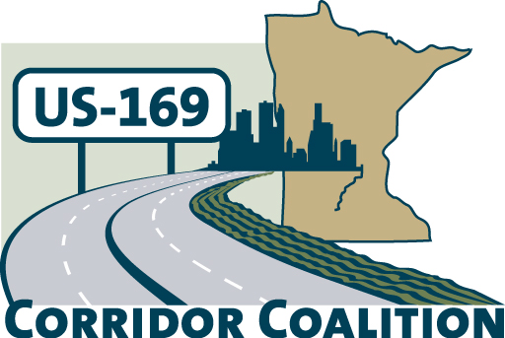
US Hwy 169 Corridor Coalition
Working together to enhance safety, reduce congestion and maximize economic development along the US Highway169 inter-regional corridor.

BOARD MEETING AGENDA
May 9, 2013
7:00 P.M.

Scott County Government Center
200 Fourth Avenue West, Board Room
Shakopee, MN 55379

- Welcome/Introductions – Jon Ulrich, Chair, Scott County Commissioner
- Adoption of Agenda
- Educational Programs:
- Funding Opportunity: Federal EDA flood mitigation project, Ronda Allis Community and Economic Development Director & Transportation Planner with Region 9 Development Commission
- MnPASS: Brad Larsen, MnPASS Policy & Planning Program Director with MnDOT

- Adoption of March 7, 2013 Minutes
- Financial Report for March and April 2013

- Corridor Advocate Update
- Outreach Event: Tuesday June 18th Breakfast from 7:15-8:30 a.m. in Mankato.

- Highway Transitway Study Update
- Executive and Technical Committee Report
- Potential Studies
- Work Plan
- Bylaw Revision and Membership Considerations

- Other Items
- Next Meeting, July 11, 2013, 7:00-9:00 p.m.

- Adjournment

