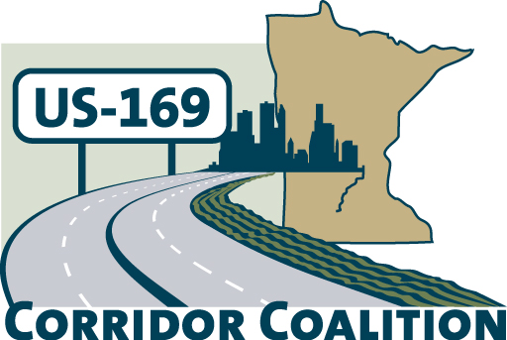
US Hwy 169 Corridor Coalition
Working together to enhance safety, reduce congestion and maximize economic development along the US Highway169 inter-regional corridor.

Executive Committee Meeting
May 9, 2013
5:30 p.m. – 7:00 p.m.

Scott County Government Center
Board Conference Room
Shakopee, MN

AGENDA

- Welcome/Introductions – Jon Ulrich, Chair, Scott County Commissioner
- Adoption of Agenda

- Adoption of Minutes from March 14, 2013 and April 11, 2013

- Financial Report for April 2013

- Coalition Focus

  - Studies
    - Long Haul Transit
    - Corridor of Commerce Study
  - Coalition Direction for 2013-14
    - Membership
    - Work plan
  - Administrative Service

  - Bylaw Revision and Membership Considerations

- Corridor Advocate Update
  - Outreach Event: Tuesday June 18th Breakfast from 7:15-8:30 a.m. in Mankato.

- Next Meeting – Joint Executive and Technical Committee Meeting June 13, 5:00 – 7:00 p.m.
Next Board Meeting – July 11, Topic for the Meeting and location need to be determined.

- Adjournment

