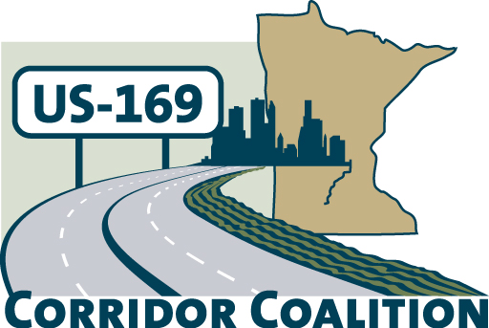
US Hwy 169 Corridor Coalition
Working together to enhance safety, reduce congestion and maximize economic development along the US Highway169 inter-regional corridor.

BOARD MEETING
Minutes

August 8, 2013

Members Present:

First Name | Last Name | Title | Agency
Bob | Broeder | Mayor | City of LeSueur
Ed | Shukle | City Administrator | City of Jordan
Gene | Abbott | Council Member | City of Savage
Jim | Gates | Deputy Director Public Works | City of Bloomington
Jim | Hovland | Mayor | City of Edina
John | Powell | Public Works Director | City of Savage
John | Schmitt | Former Mayor | City of Shakopee
Jon | Ulrich | Commissioner | Scott County
Khani | Sahebjam | Vice President | HDR
Lisa | Freese | Transportation Program Director | Scott County
Lisa | Schickedanz | Associate Planner | Scott County
Mark | McNeill | City Administrator | City of Shakopee
Terry | Genelin | R-9 ACT | Region 9 Development Commission
Tom | Hulting | Council Member | City of Bloomington
Vance | Stuehrenberg | Commissioner | Blue Earth County
Thompson | Nick | Director of Policy, Safety & Strategic Initiatives | MnDOT
Hyland | Emily | Public Involvement Manager | HDR
Petersen | Dana | Stakeholder Outreach Coordinator | HDR

The meeting was called to order at 7:02 PM by Board Chairman, Commissioner Jon Ulrich.

- Welcome/Introductions – Jon Ulrich, Chair, Scott County Commissioner
Mayor Jim Hovland provided an overview of the meeting location site in the City of Edina.

- Adoption of Agenda
City Administrator Ed Shukle made a motion to approve the agenda with the modification of moving the Introductions of the Communications/Technology and Administrative Support Services staff to the beginning of the agenda. The motion was seconded by Mayor Bob Broeder and approved.

The Board welcomed Emily Hyland and Dana Petersen from HDR Engineering, Inc. for introductions

- Educational Programs:
Corridor of Commerce: Nick Thompson, Director of Policy, Safety & Strategic Initiatives Division with MnDOT. Presentation and handout will be posted on the website.

- Adoption of May 9, 2013 Minutes
Mayor Jim Hovland made a motion to approve the minutes. The motion was seconded by Mayor Bob Broeder and approved.

- Financial Report for May, June, July 2013

Lisa Freese presented the financial reports for May, June, and July 2013. Commissioner Vance Stuehrenberg made a motion to approve the financial reports. The motion was seconded by Council Member Gene Abbott and approved.

- Executive and Technical Committee Report
Recommendation for Communications/Technology and Administrative Support Services: Selection Committee members gave an overview of the selection of the candidates. The Coalition received eight proposals and three candidates were selected for interviews. The recommendation by the selection committee was HDR Engineering, Inc.

Mayor Jim Hovland made a motion to enter into a two year contract with contact with HDR Engineering, Inc. as set forth in their letter dated July 22, 2013. The motion was seconded by Public Works Director John Powell and approved.

  - Corridor Advocate: Commissioner Vance Stuehrenberg made a motion to not continue services for corridor advocacy and to give WSB written notice that their contacted ended June 30, 2013. The motion was seconded by Bob Broeder and approved.

  - 2014 Dues Structure
    - Governmental Units: City Administrator Ed Shukle made a motion to move forward with the recommended dues structure for the Governmental Units. The motion was seconded by Council Member Tom Hulting and approved.

    - Affiliate members: Provided an overview of the modification to the affiliate membership information which was approved at the March 2013 Board meeting.

- Highway Transitway Study Update – Lisa Freese provided an update on Metropolitan Council Highway Transityway Study. The Metropolitan Council plans on looking more in depth at the US Hwy 169 corridor in the southwest metro.

- Other Items:
At the August 20th Scott County Board workshop there will be discussion on sales tax for transportation funding and Cities in Scott County are encouraged to attend.

- Next Meetings
  - September 12th Board meeting, 7:00-9:00 p.m. in St. Peter, suggested topics- meet with colleges, St. Peter/Mankato Flood mitigation project, and Corridor of Commence
  - November 14th Board meeting, 7:00-9:00 p.m., potential topic –169 Transitway Study

- Meeting adjourned at 8:05 PM
Mayor Bob Broeder moved to adjourn the meeting. The motion was seconded by Commissioner Vance Stuehrenberg and approved.

Respectfully submitted by Lisa Schickedanz, Scott County

