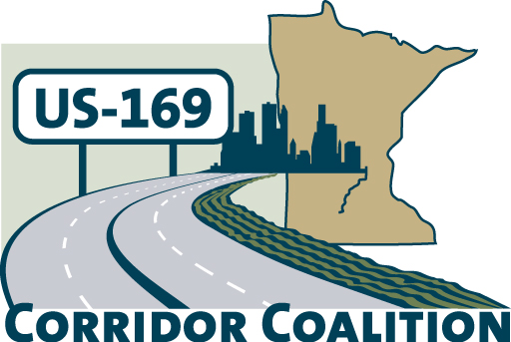
US Hwy 169 Corridor Coalition
Working together to enhance safety, reduce congestion and maximize economic development along the US Highway169 inter-regional corridor.

BOARD MEETING AGENDA
April 12, 2012
7:00 P.M.

Scott County Government Center
Board Conference Room
Shakopee, MN

- Welcome/Introductions – James Hovland, Chair, City of Edina
- Adoption of Agenda
- Educational Programs:
Commissioner Mark Phillips, Department of Employment & Economic Development

- Adoption of March 8, 2012 Minutes
- Financial Report for March 2012

- Project Priority Matrix – results of dot activity

- Corridor Advocate Update
- Technical Committee Report
- 2012 Board Meeting Schedule

- Other Items:
- Next Meeting, May 10, 2012, 7:00-9:00 p.m.
Shakopee, MN

- Adjournment

