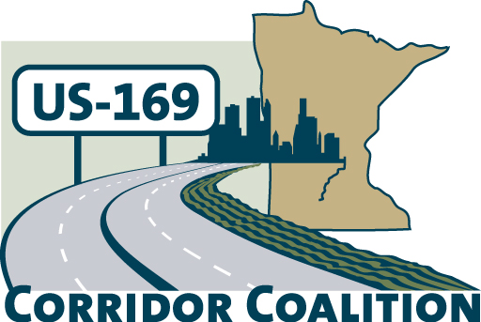
US Hwy 169 Corridor Coalition
Working together to enhance safety, reduce congestion and maximize economic development along the US Highway169 inter-regional corridor.

Membership Board Meeting
Minutes

April 12, 2012

The meeting was called to order at 7:00 p.m. by Vice Chair, Commissioner Ulrich.

Members Present:

Name | Title | Agency
Jim Hovland | Mayor | City of Edina
Jon Ulrich | Commissioner | Scott County
Lisa Freese | Transportation Manager | Scott County
Tom Hulting | Council Member | City of Bloomington
Jim Gates | Deputy Director Public Works | City of Bloomington
Vance Stuehrenberg | Commissioner | Blue Earth County
Ron Jabs | Board Representative | City of Jordan
Ed Shukle | City Administrator | City of Jordan
Ed Tschida | Executive Director Le Sueur Dev. Inc. | City of Le Sueur
Brian Malm | City Engineer | City of North Mankato Bolton & Menk
Jane Kansier | Assistant City Administrator | City of Prior Lake
Ronda Allis | Comm & Economic Dev Director | Region 9 Development Commission
Cy Wolf | Chair | Sand Creek Township
Gene Abbott | Council Member | City of Savage
John Powell | Public Works Director | City of Savage
Michael Leek | Community Dev Director | City of Shakopee
Matt Lehman | Council Member | City of Shakopee
John Schmitt | Citizen Representative | City of Shakopee
Brandi Popenhagen | Corridor Advocate | WSB & Associates

- Welcome/Introductions

Jim Hovland, Chair, welcomed the Board members and guests. Members and guests provided introductions to the group.

- Adoption of Agenda

A motion was made by John Powell to approve the agenda. Jon Ulrich seconded the motion, which the Board passed by unanimous vote.

- Educational Program:
Commissioner Mark Phillips, Department of Employment and Economic Development

Mayor Hovland provided an introduction for Commissioner Phillips. Commissioner Phillips discussed the economic benefits of the Highway 169 Corridor:
- 40 percent of Minnesota’s employment exists within 10 miles of this corridor
- this equates to 1,000,000 employees
- 12 of the Minnesota’s 20 Fortune 500 companies are headquartered within 10 miles of the US 169 Corridor
Commissioner Phillips also discussed the TED (Transportation & Economic Development) program, which is a joint effort between Mn/DOT and the Department of Employment and Economic Development.

- Adoption of March 8, 2012 Minutes

Council Member Gene Abbott motioned for the approval of the March 8, 2012 meeting minutes. City Administrator Ed Shukle seconded the motion, which the Board passed by unanimous vote.

- Financial Report for March 2012

Lisa Freese presented financial statements for March 2012.

- Project Priority Matrix activity

Chair Hovland discussed the status of the project priority matrix ranking activity. He indicated that the Executive Committee has requested that the Technical Committee provide further analysis by reviewing “next steps”, short term vs. long term, etc. The Technical Committee will provide an update on their activity at the May meeting.

Chair Hovland also discussed two requests for letters of support. The City of Belle Plaine and Scott County were both requesting a letter of support for upcoming TED applications. Jon Ulrich made a motion to submit letters of support for both TED projects. The motion was seconded by Council Member Matt Lehman, which the Board passed by unanimous vote.

The Board also discussed the need to develop a “process” for supporting future requests for letters of support.

- Corridor Advocate Update

Brandi Popenhagen, Corridor Advocate, distributed a “169 Coalition Membership Recruitment Log” to members. The log identified who had been contacted and any follow-up that was made. WSB will continue to provide a recruitment log at future meetings.

- Technical Committee Report

2012 Board Meeting Schedule

Members received an updated 2012 Board meeting schedule. It was noted that USDA Rural Development Director for Minnesota, Colleen Landkamer, will be our speaker in May and the July meeting will be cancelled.

Members were asked to provide other guest speaker ideas to the Technical Committee.

- Other Items:

Lisa Freese discussed the upcoming CIMS (Corridor Investment Management Strategies) meetings that will be held around the State of Minnesota. The Highway 169 Corridor will be split between two meetings, one in Mankato on May 14th and one in Edina on May 29th. Members were encouraged to attend both meetings if possible. Lisa will send more information out to Board members as it becomes available.

- Next Meeting Date

The next meeting will be on May 10, 2012 at 7:00 pm at the Scott County Government Center.

- Meeting adjourned at 9:10 p.m.

Respectfully submitted by Ronda Allis, Region Nine Development Commission

