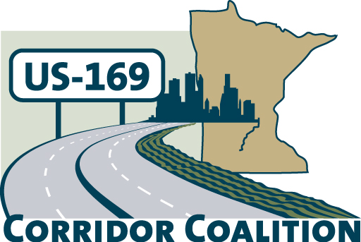
US Hwy 169 Corridor Coalition
Working together to enhance safety, reduce congestion and maximize economic development along the US Highway 169
inter-regional corridor.

Executive Committee Meeting Minutes

April 12, 2012

Name | Title | Agency
Jim Hovland | Mayor | City of Edina
Jon Ulrich | Commissioner | Scott County
Vance Stuehrenberg | Commissioner | Blue Earth County
Tom Hulting | Council Member | City of Bloomington
Lisa Freese | Transportation Manager | Scott County
Ronda Allis | Comm & Ec Dev Dir | Region 9 Dev Comm
Ed Shukle | City Administrator | City of Jordan
Brandi Popenhagen | Corridor Advocate | WSB
Jim Gates | Technical Committee | City of Bloomington

The meeting was called to order at 5:40 p.m. by Chair, Mayor Jim Hovland

- Welcome and Introductions– James Hovland, Chair, City of Edina

- Financial Reports for March 2012 – The financial report for March 2011 was distributed and reviewed. Lisa Freese provided an overview of the financials. She noted that Affiliate members are not invoiced on a calendar year basis, like local units of government, but instead are invoiced on their “anniversary” date. Vance Stuehrenberg made a motion to approve the financial reports. The motion was seconded by Jon Ulrich and approved.

- Technical Committee Report:

Project Priority Matrix – Lisa Freese provided an update/overview on the project priority ranking process. The results of the dot activity in Mankato and the on-line survey responses were combined into a final ranking. The Technical Committee then reviewed the totals and combined the projects into a top tier (three projects) and a second tier (seven projects).

The Executive Committee would like the Technical Committee to review the list again and focus on:
- Identify “next steps” for each project – do they need funding? Further study? Etc..
- Categorize as “short term” (0-5 years) or “medium term” (6 – 10 years), or “long term” (10+ years).
- Review low cost, high impact options
- Create a list of potential funding sources

Next the Executive Committee discussed two requests for letters of support. The City of Belle Plaine and Scott County were both requesting a letter of support for upcoming TED applications. Motion by Vance Stuehrenberg, second by Jon Ulrich to provide a letter of support, on behalf of the US Highway 169 Corridor Coalition, for both of these TED projects.

The Executive Committee also reviewed the 2012 US 169 Coalition Meeting Schedule. It was noted that USDA Rural Development Director, Colleen Landkamer, would be the speaker at the May meeting. They also agreed to cancel the July meeting, pending approval from the full Board.

- Corridor Advocate Update
Brandi Popenhagen distributed an updated 169 Coalition Membership Recruitment Log. She noted that HDR Engineering has joined the coalition.

- Other Items:

- Next Executive Committee Meeting, May 10, 2012, 5:30 – 7:00 p.m.
Scott County Government Center, County Board Room

- Executive Committee adjourned at 6:55 p.m.

Respectfully Submitted by Ronda Allis – Region Nine Development Commission.

