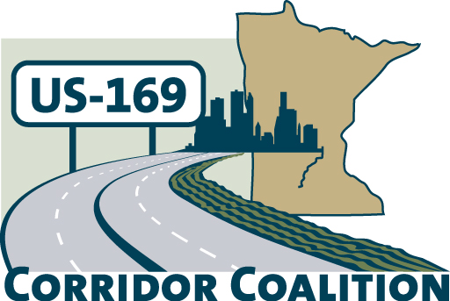
US Hwy 169 Corridor Coalition
Working together to enhance safety, reduce congestion and maximize economic development along the US Highway169 inter-regional corridor.

Executive Committee Meeting
April 12, 2012
5:30 p.m. – 7:00 p.m.

Scott County Government Center
Board Conference Room
Shakopee, MN

AGENDA

- Welcome/Introductions – James Hovland, Chair, City of Edina
- Financial Reports for March 2012

- Technical Committee Report
- Project Priority Matrix – results of dot activity
- 2012 Board meeting schedule
- No meeting in July

- Corridor Advocate Report
- Other Items
- Next Meeting – May 10, 2012, 5:30 – 7:00 p.m.
Shakopee, MN

- Adjournment

