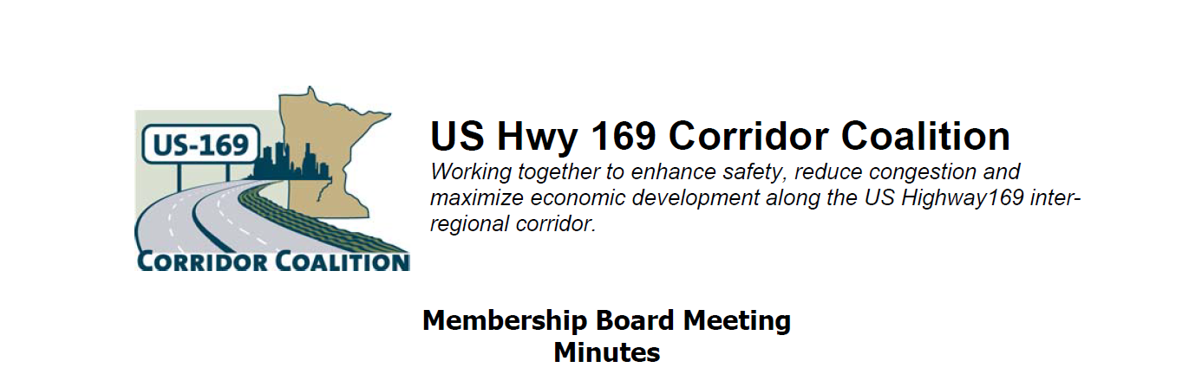
August 9, 2012
Members participated in a tour of the New Sweden Dairy Farm prior to the business meeting.
The business meeting was called to order around 9:20 p.m. by Vice Chair, Commissioner Ulrich.
Members Present:
Name | Title | Agency
Jon Ulrich | Commissioner | Scott County
Lisa Freese | Transportation Manager | Scott County
Terry Genelin | R-9 ACT | Region 9 Development Commission
Ed Shukle | City Administrator | City of Jordan
Vance Stuehrenberg | Commissioner | Blue Earth County
Scott Schneider | City Council | City of Belle Plaine
Alan Forsberg | County Engineer | Blue Earth County
John Weckman | Chair | Louisville Township
Scott Thompson | Traffic Engineer | MnDOT D7
Zachary Tess | Project Manager | MnDOT D7
Russ Wille | Community Development Director | City of St. Peter
Jane Kansier | Director of Bldgs/Trans Svcs | City of Prior Lake
Mike Laven | Council President | City of Mankato
Lewis Giesking | Director of Public Works | City of St. Peter
Tom Hulting | Council Member | City of Bloomington
Gene Abbott | Council Member | City of Savage
Mark McNeill | City Administrator | City of Shakopee
Ben Leonard | Executive Director | Minnesota Historical Society – St. Peter
Cy Wolf | Chair | Sand Creek Township
Janelle Borgen | ITS Manageer | WSB & Associates

1) Welcome/Introductions
Vice Chair Jon Ulrich welcomed the Board members. Members provided introductions to the group.

2) Adoption of Agenda
A motion was made by to approve the agenda. A second to the motion was made, which the Board passed by unanimous vote.

3) Educational Program: Prior to business meeting, the group toured the New Sweden Dairy.

4) Adoption of June 14, 2012 Minutes
A motion was made by to approve the June minutes. A second to the motion was made, which the Board passed by unanimous vote.

5) Financial Report for June/July 2012
Lisa Freese presented financial statements for June and July 2012. A motion was made by to approve the June and July financial statements. A second to the motion was made, which the Board passed by unanimous vote.

6) July Executive Committee Report – Performance Review
Lisa Freese presented an update that at the July Executive Board meeting it was agreed to extend WSB’s contract another six months and that WSB would be helping with the administrative tasks of the coalition.

7) Corridor Advocate Update
Janelle Borgen introduced herself. Vice Chair Ulrich prompted Janelle that an advocate update report is expected at the September meeting.

8) Technical Committee Report – No meeting or Report
No update provided as there was no meeting.

9) Other Items:
The Board discussed US 169 through North Mankato and St. Peter. It was states that local business owners are concerned about access during construction. Scott Thompson and Zach Tess from MnDOT District 7 discussed several upcoming projects.

Scott noted that access to local businesses will continue to be considered as part of project development.

10) Next Meeting Date
The next meeting will be on September 13, 2012 at 7:00 pm at the Bloomington Council Chambers of Civic Plaza, 1800 West Old Shakopee Road, Bloomington, Mn.

11) Meeting adjourned about 9:50 p.m.

Respectfully submitted by Janelle Borgen, WSB & Associates

