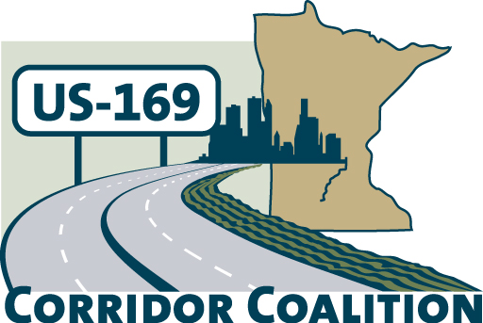
US Hwy 169 Corridor Coalition
Working together to enhance safety, reduce congestion and maximize economic development along the US Highway169 inter-regional corridor.

Executive Committee Meeting
May 9, 2013
5:30 p.m. – 7:00 p.m.

Scott County Government Center
Board Conference Room
Shakopee, MN

Minutes

First Name | Last Name | Title | Agency
Jon | Ulrich | Commissioner | Scott County
Bob | Broeder | Mayor | City of LeSueur
Vance | Stuehrenberg | Commissioner | Blue Earth County
Tom | Hulting | Council Member | City of Bloomington
Jan | Callison | Commissioner | Hennepin County
Jane | Kansier | Assistant City Manager | City of Prior Lake
Jim | Gates | Deputy Director Public Works | City of Bloomington
Michael | Leek | Community Dev. Director | City of Shakopee
Ronda | Allis | Comm & Economic Dev Director | Region 9 Development Commission
Doug | Weiszhaar | Corridor Advocate | WSB & Associate
Lisa | Schickedanz | Associate Planner | Scott County

The meeting was called to order at 5:30 PM by Chairman, Commissioner Jon Ulrich.

- Welcome/Introductions – Jon Ulrich, Chair, Scott County Commissioner
- Adoption of Agenda

Mayor, Bob Broeder made a motion to approve the agenda. The motion was seconded by Commissioner, Vance Stuehrenberg and approved.

- Adoption of Minutes from April 11, 2013

Community Development Director, Michael Leek made a motion to approve the minutes. The motion was seconded Council Member, Tom Hulting by and approved.

- Financial Report for April 2013

Commissioner, Jan Callison made a motion to approve the April 2013 Financial Report. The motion was seconded by Council Member, Tom Hulting and approved.

- Coalition Focus

  - Studies
    - Long Haul Transit: Reviewed and discussed the one pager on the Long Haul study.
      - The cost of the study would be a range or a not to exceed amount.
      - Partners would be needed for funding the study. Counties/Cities could do outreach in their area to colleges and hospitals. Have a future meeting in St. Peter to reach out to colleges.
      - The Greater Mankato Transit study was completed within the last 12 to 18 months (potential presentation item for future Board meeting).
    - Corridor of Commerce Study: Would educate people on the importance of the corridor with market and data analysis.
      - Would be used as a funding tool and for future analysis/other studies.
      - The cost of the study could be in $50,000-$60,000 range.
    - There is more interest by the Executive Committee members in doing a Long Haul Study.
  - Coalition Direction for 2013-14
    - Membership:
      - Lobbyist: It was decided not to hire a lobbyist. Lobbing is something the elected official should do.
      - Outreach Events: There are three outreach events this year. Could have events/meetings at businesses along the corridor.
      - Another way to attract members is by getting projects delivered along the corridor and having publicized public events on the project.
    - Work plan: Jurisdictions along the corridor should be providing their success stories to be included on the website and newsletters.
Updates to Work Plan
      - Goal 1 – #1 a. & b. combine and delete reference to Executive Committee meeting annually with each district engineer ect...
      - Goal 1 - #2 iii delete this item
      - Goal 2 - #2 c delete May and delete item d.
      - On page 4 under #3 have a separate number for the administrative items listed under c.

There was discussion with future work plans to prioritize items and then go back to correlate what administrative services/social promotion services are needed to complete the items in the work plan. This will assist in determining the budget.
  - Administrative Service: The Committee discussed including the social media aspect with the job. With the proposed job description and travel time to meetings there would need for more than 20 hours a month, 30 hours a month would be more realistic. Will need to put out a RFP for the administrative services. May need to find one or two people to provide the services that are needed. It is anticipated there would be 20 hours a month of administrative services and 10 hours a month for website/social promotion. Anticipated monthly budget of $900 per month.

  - Bylaw Revision and Membership Considerations: Michael Leek provided some revisions to Bylaws, shown in underline and strikeout. The modifications will be brought to the membership at the Board meeting.

Commissioner, Vance Stuehrenberg made a motion to approve the Bylaw Revisions. The motion was seconded by Mayor, Bob Broeder and approved.

- Corridor Advocate Update
  - Outreach Event: Tuesday June 18th Breakfast from 7:15-8:30 a.m. at Heritage Hall, South Central College, North Mankato. Vance Stuehrenberg will be a presenter.

- Next Board Meeting – have in St. Peter and getting input from colleges on Long Haul Study.

- The meeting was adjourned at 6:53 p.m.

Respectfully submitted by Lisa Schickedanz, Scott County

